1. Using vehicle hierarchy created in previous assignment, create an application for Insurance company
Develop a Policy class with method displayInsurance() that will display insurance amount for any vehicle.
Create class Admin to represent admin tasks ->
1. Printing insurance amount for given vehicle
2. Create Array of vehicles and generate report that displays Insurance amount for each vehicle in the array
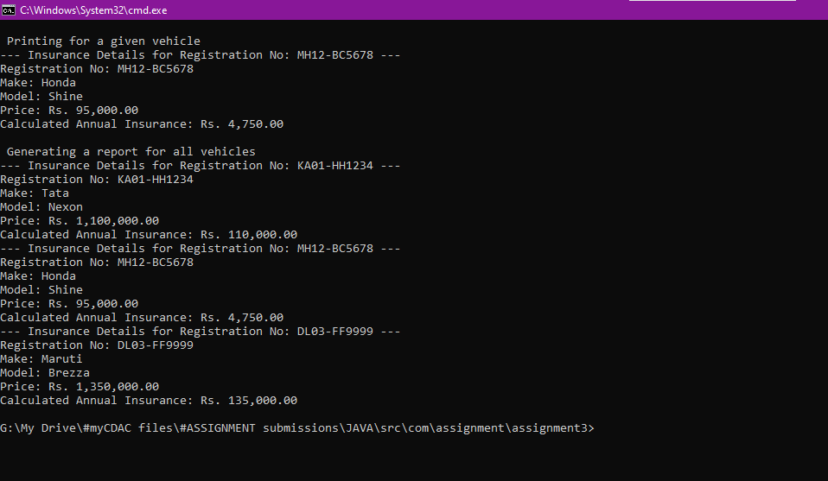

2. Create an interface Rentable with rent(int hrs) method. Vehicles can be rented with following rules:

For two wheelers the rent is rs. 300 per hour max upto 3 hrs, after that late fee of rs 100 per hour
For four wheelers the rent is rs. 500 per hour max upto 3 hrs, after that late fee of rs 200 per hour

Create objects of different vehicles and display their rent

Use Scanner class to read the hrs for rent.
