ASSIGNMENT-6

Q.1 Create a File to Store Books -> books.txt
Book class should have
int regno
String title
boolean isissued
Store some initial data in the file
Create IssueBook(File books, Book b) method to issue books
Check the file data to see if book is already issued (isissued = true)
if true display message "Book already issued"
else change the value of isissued = true and save in the file.
Display message "Booked Issued"

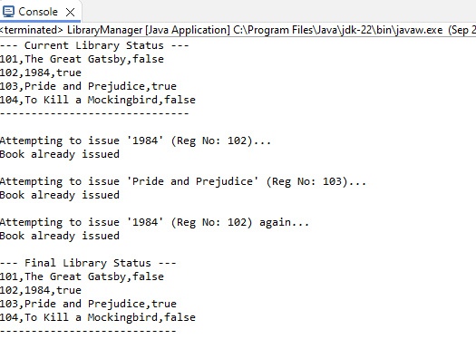

Q.2 Using inteface Function which contains a method int apply(int n)
Write lambda expression for the following:
Create a method operateOnNumbers(Function func, List<Integer>numbers)
Using the above method ->
1. Calculate sqaure of a number
2. Calculate Factorial of a number
3. print nearest even number (if number is even return the same) in the list

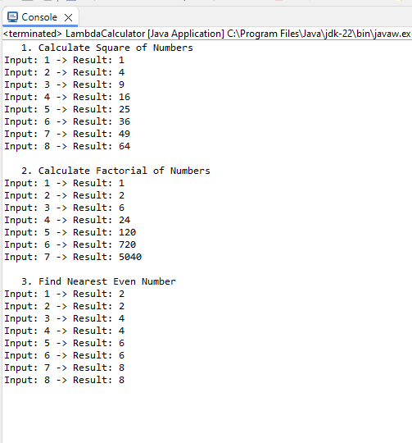

Q.3 for a list of colors: {"Red", "orange", "Yellow", "green", "Blue", "indigo", "Violet"};

Create list of colors in Uppercase and lowercase
Create a list of colors less than "m" in ascending order [first alpha of the color should be before 'm']
Create a list of colors with 5 alphabets' of less in ascending order

