ASSIGNMENT-1

1. Loop/conditions : Write program for checking prime number, calculating factorial (Iterative)
Prime number check-
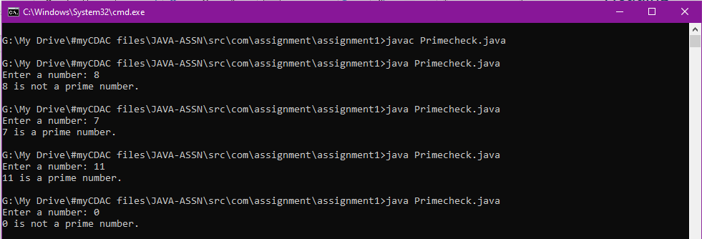

Factorial check
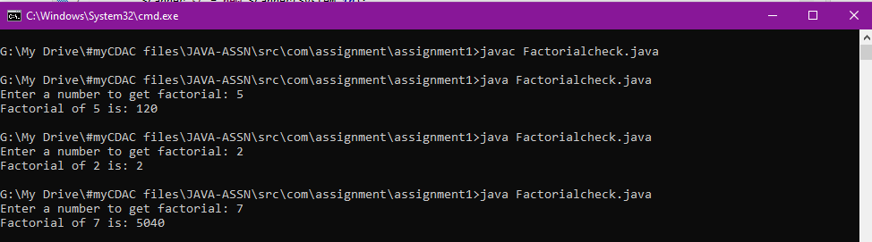

2. Create a Student class with name and rollno, total marks
Implement default as well as parameterized constructor
Implement getter - setter and toString method
Note : The rollno should be auto generated based on number of student objects created
Display the count of total students using displyStudentCount method

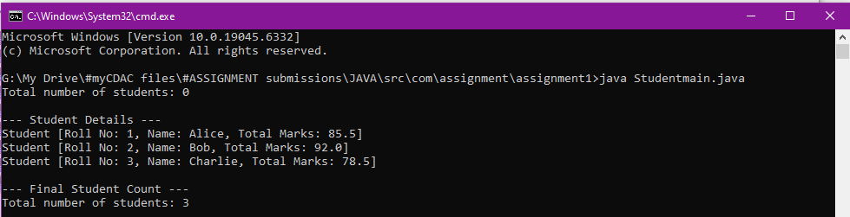

3. Create a Department class with Student array
1. Calculate Average marks for all student
2. Calculate percentage
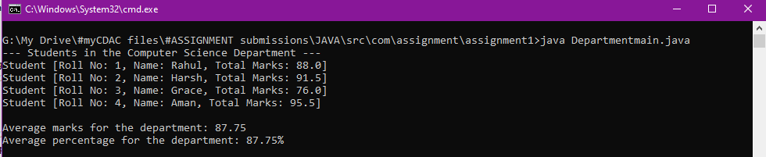

Additional - Binary Search
Any sort algorithm

