ASSIGNMENT-7
Q1-----------------------------------------------
Perform following operations for a website that maintains articles
An article should have
a. srno
b. subject
c. Year of publishing
d. no of views
e. Category (one article can belong to many categories
e.g. healthcare/covid/children health

1. List all the articles that were created in year 2023
2. List all the articles by subject
3. Count the articles by Subject
5. List the articles that got more than 10k views
6. Print the top 5 trending articles
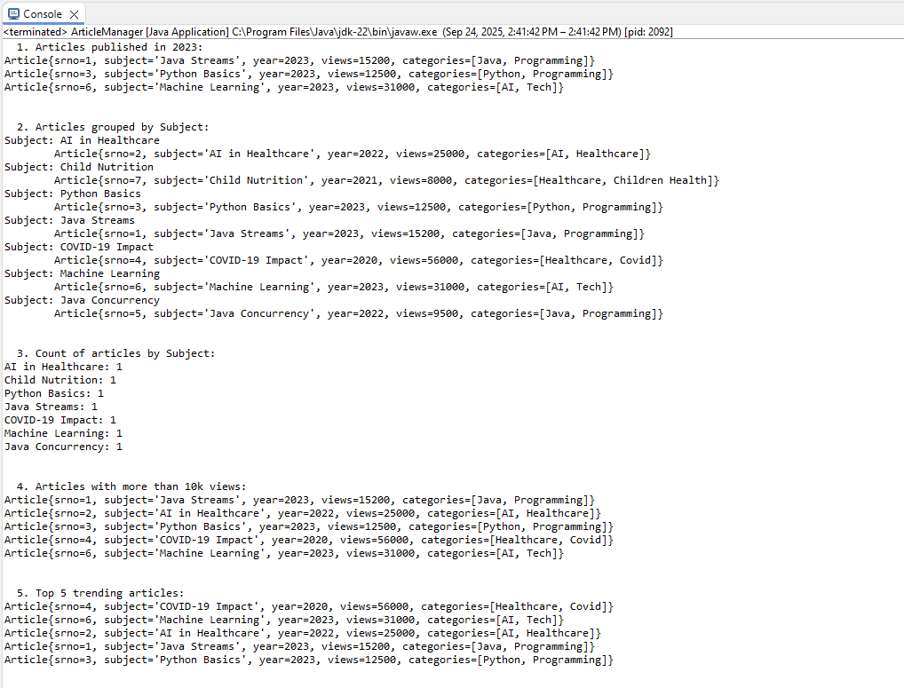

Q2----------------------------------------------------------------

1. Calculate your age in no of days, months, years
2. Compute programmers day without using plusDays
3. Find out all the Fridays that fall on 13th in current year
