ASSIGNMENT-4

Linux Shell Programming

1. Write a shell script that accepts a filename as an argument and displays whether it is a directory, a regular file, or something else.
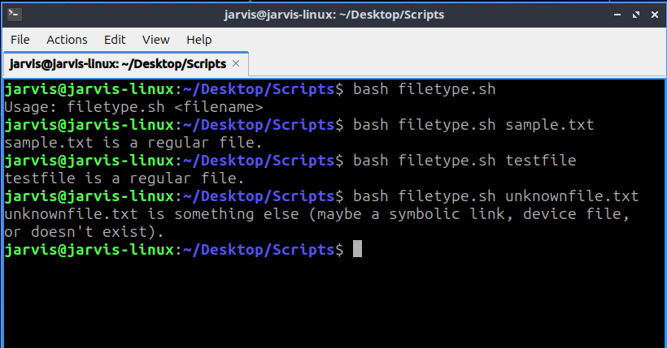
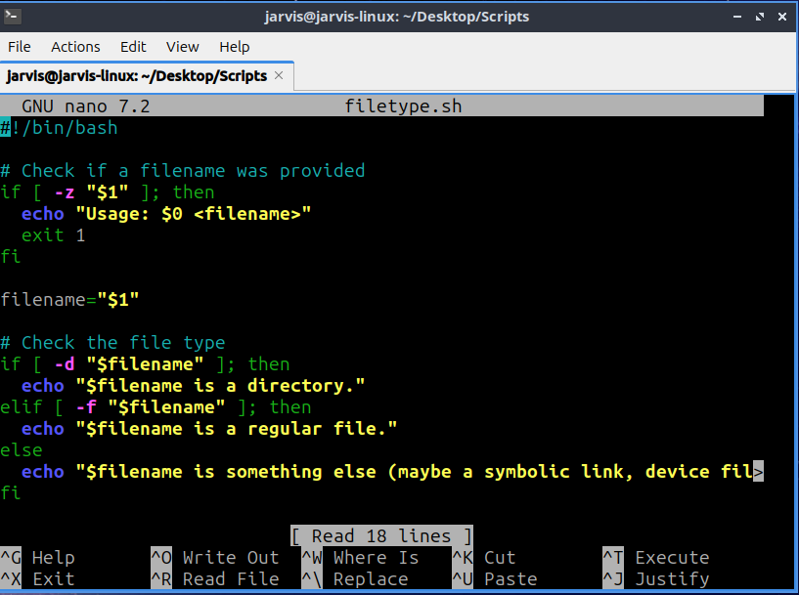

2. Write a script that reads a number and prints whether it is positive, negative, or zero.
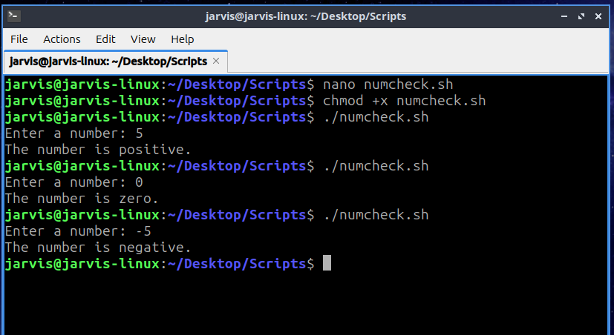
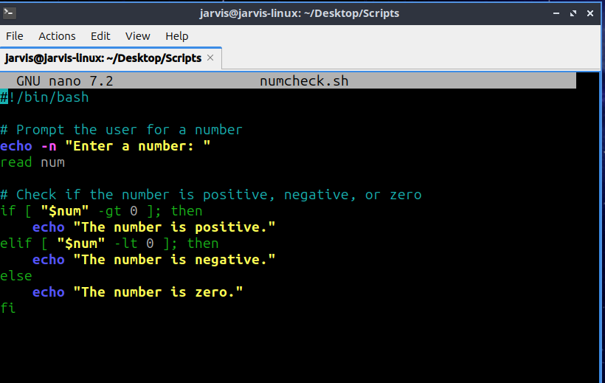

3. Write a script that accepts a username and checks whether the user is currently logged in.
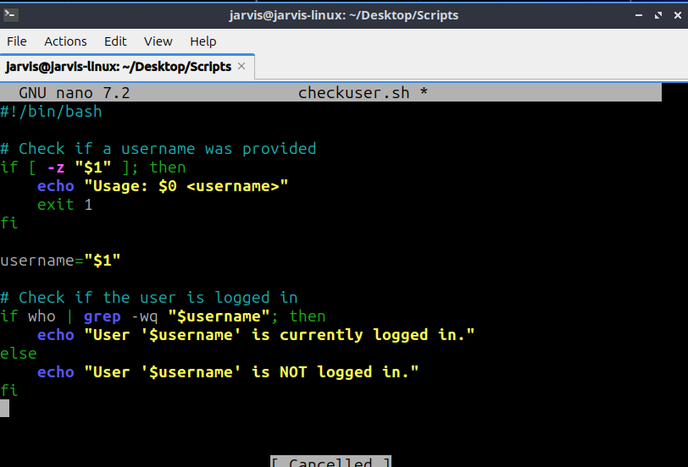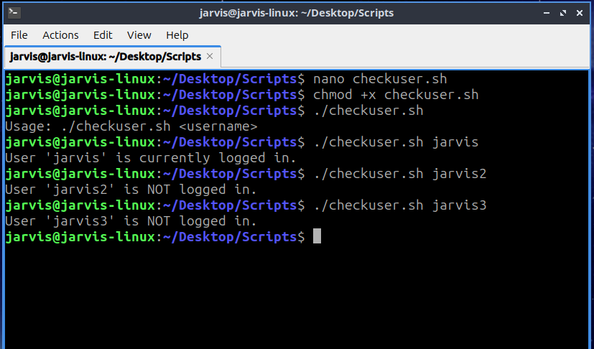

4. Write a script that prints the first 10 natural numbers using `until` loop.
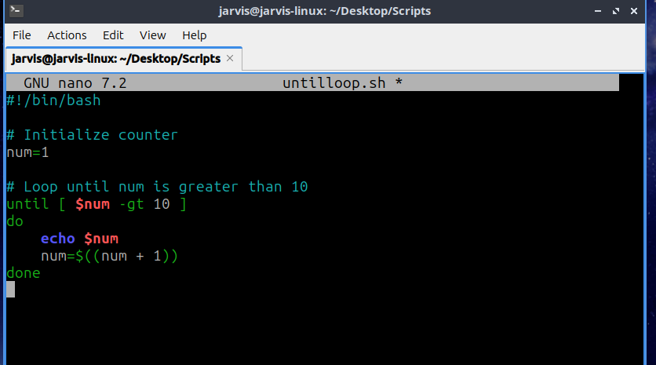
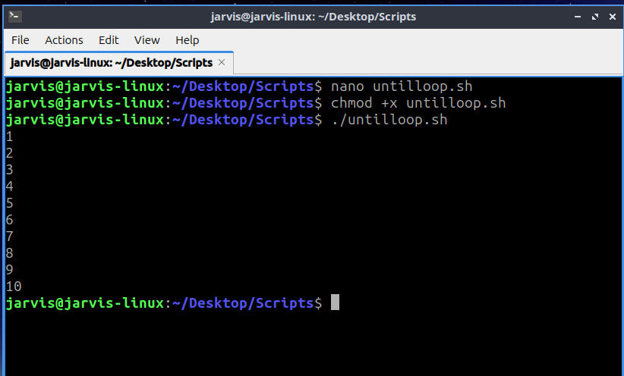

5. Write a script that demonstrates use of functions by creating one for addition and one for subtraction.
