ASSIGNMENT 5

(Git / GitHub)

1. Install Git and configure username and email.
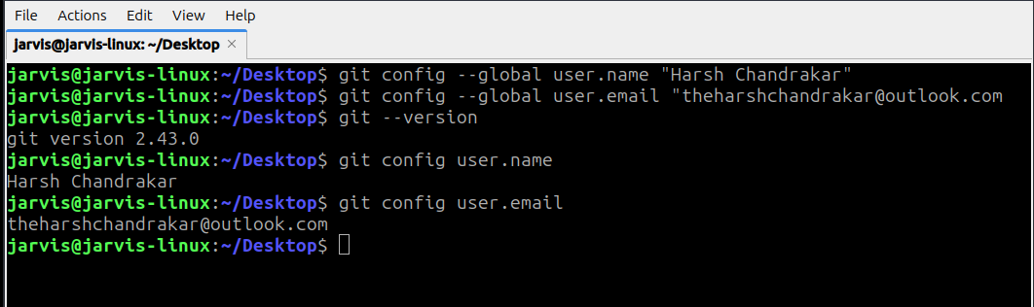

2. Create a local repository, add a file, and commit changes.
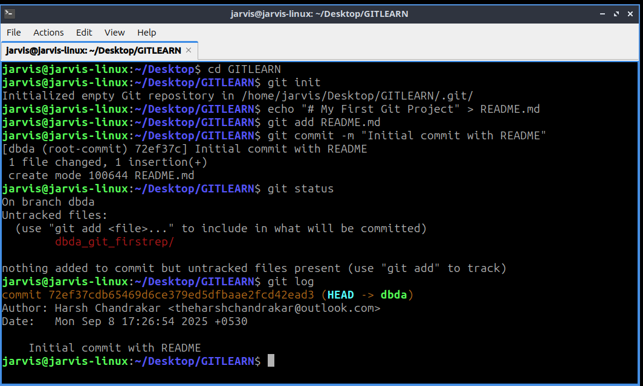

3. Create a new branch, switch to it, make changes, and merge it with `main`.

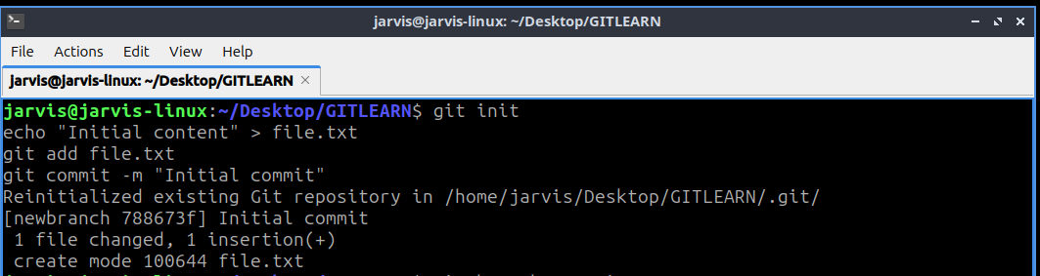

4. Push the local repository to GitHub using command line.
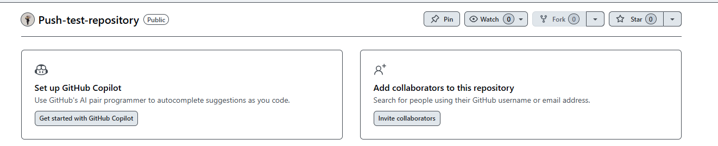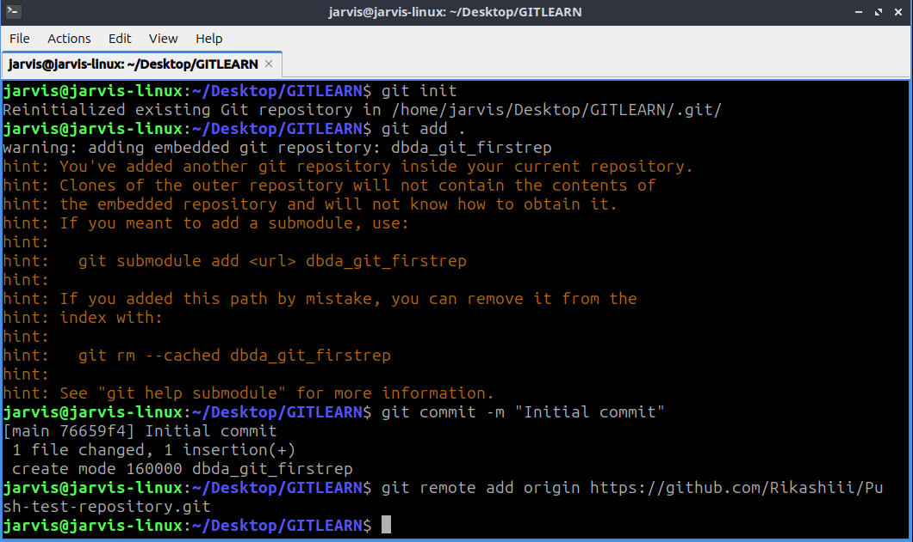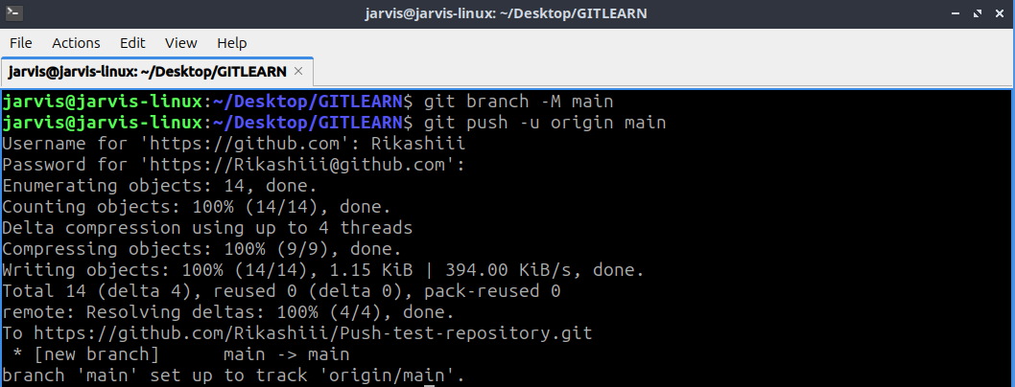
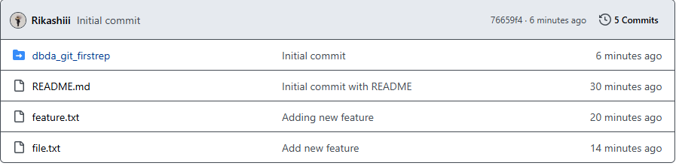

5. Clone a repository from GitHub, edit files, and push changes back.
