ASSIGNMENT 6

(Git / GitHub)

1. Install Git and configure username and email.
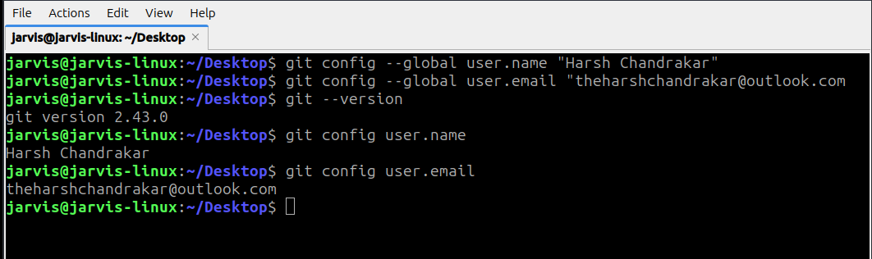

2. Create a local repository, add a file, and commit changes.
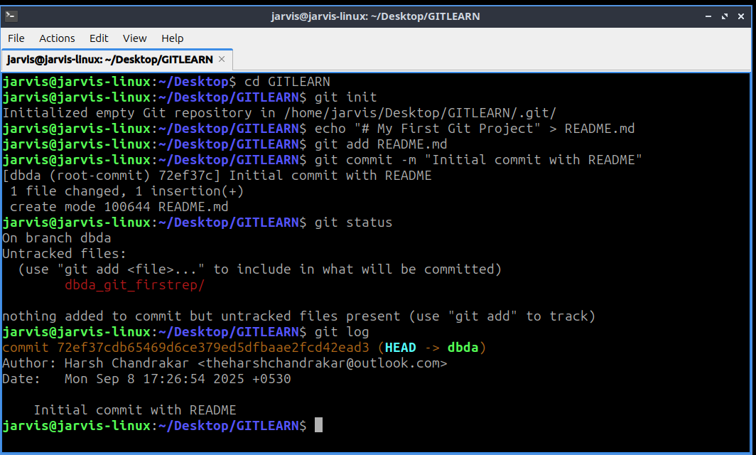

3. Create a new branch, switch to it, make changes, and merge it with `main`.

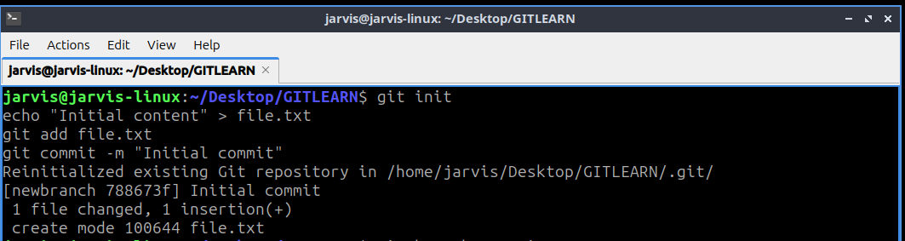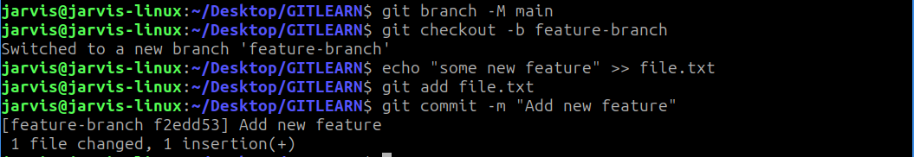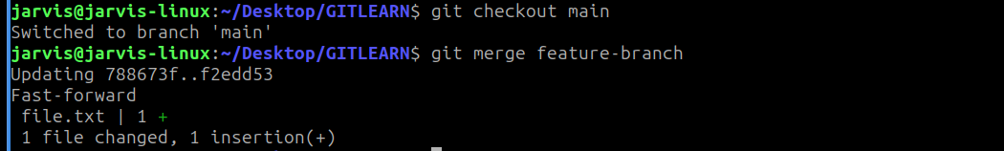

4. Push the local repository to GitHub using command line.
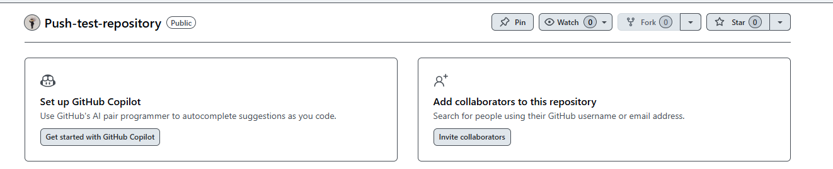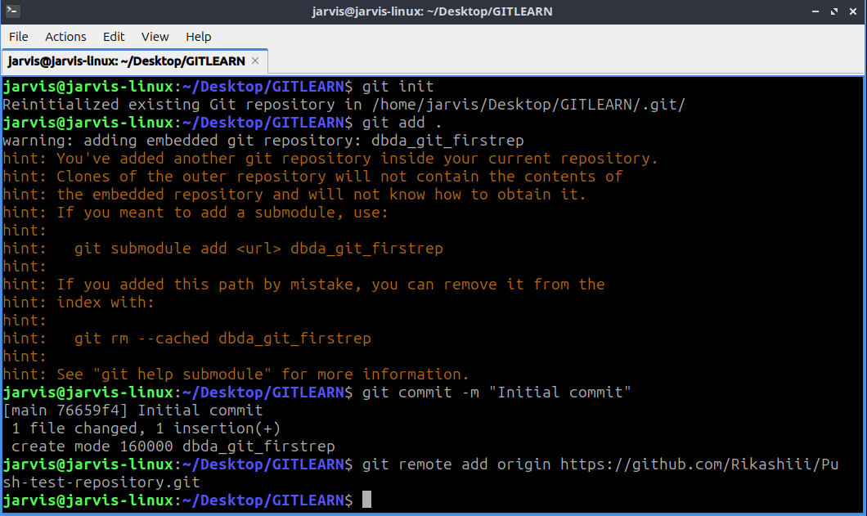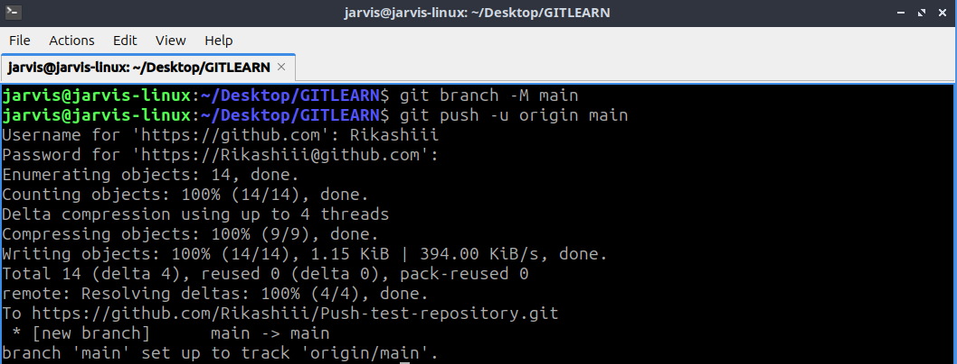
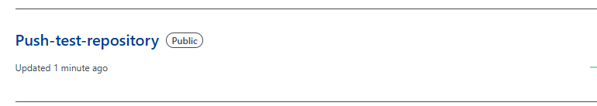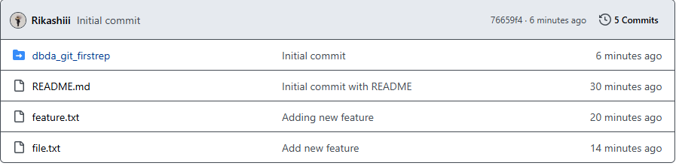

5. Clone a repository from GitHub, edit files, and push changes back.
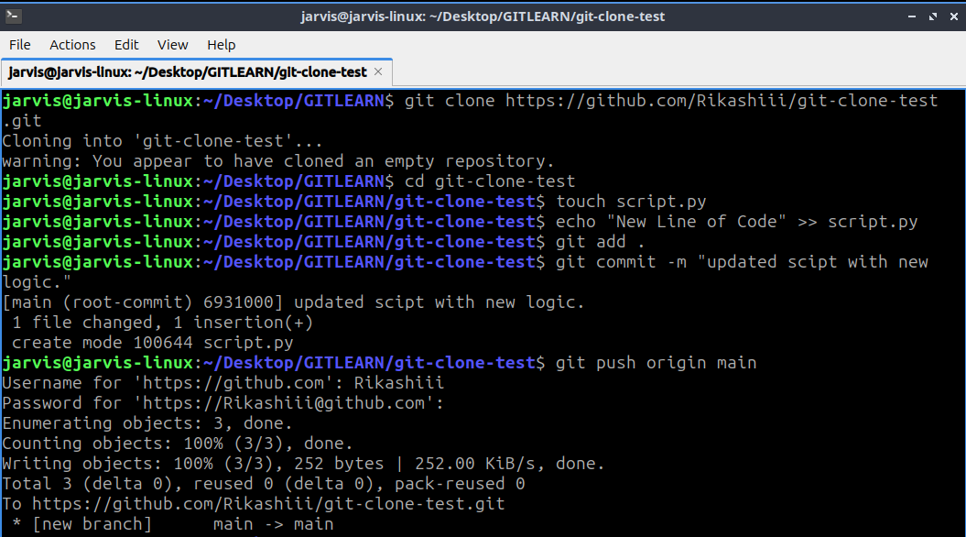

Cloud (AWS)

6. Create a free-tier AWS account and explore the dashboard.
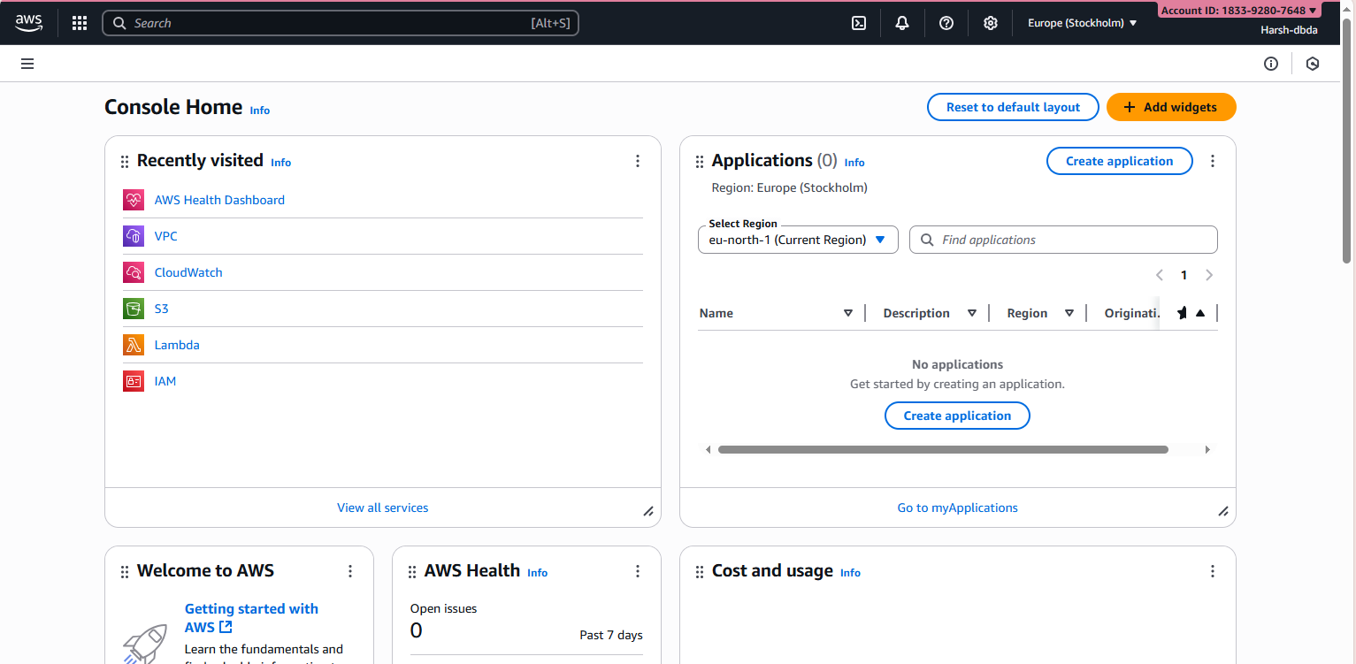

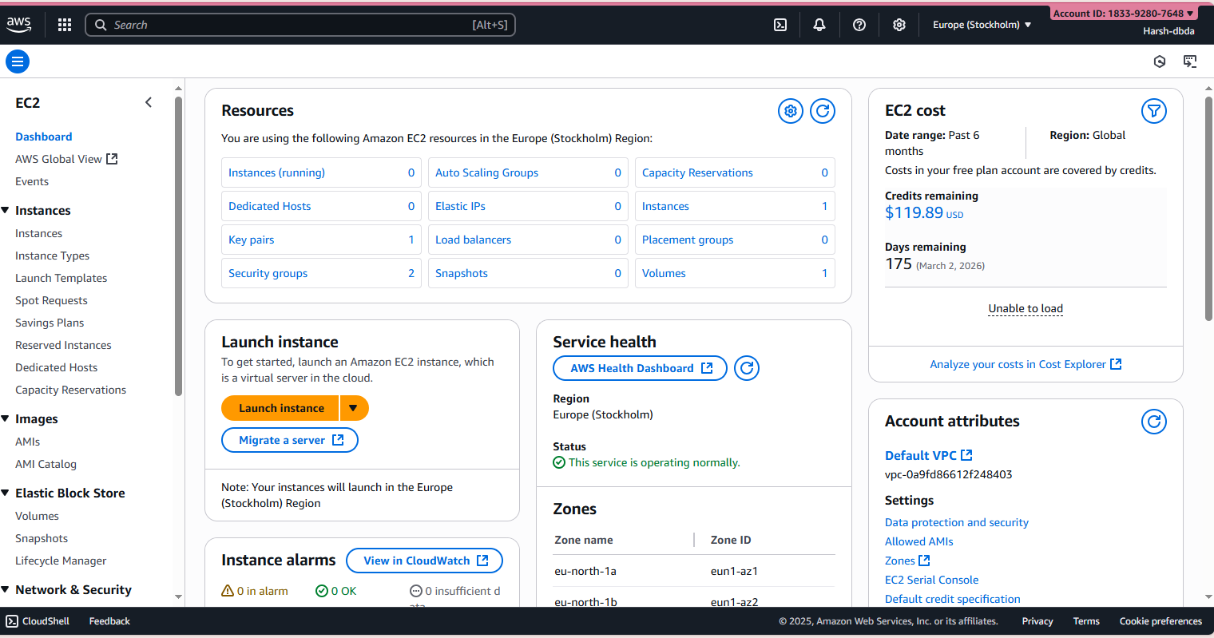

7. Deploy a simple static HTML page on AWS S3.
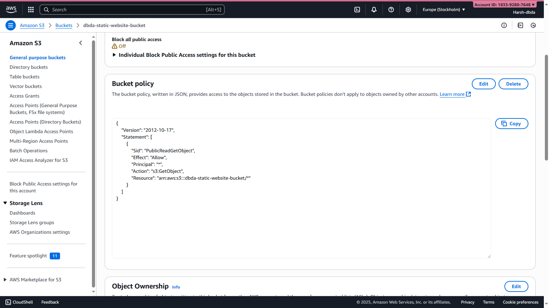
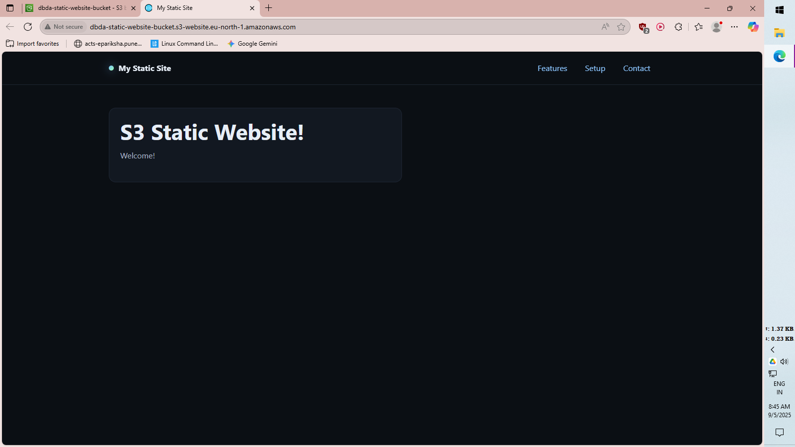

8. Launch an EC2 instance using AWS Management Console.
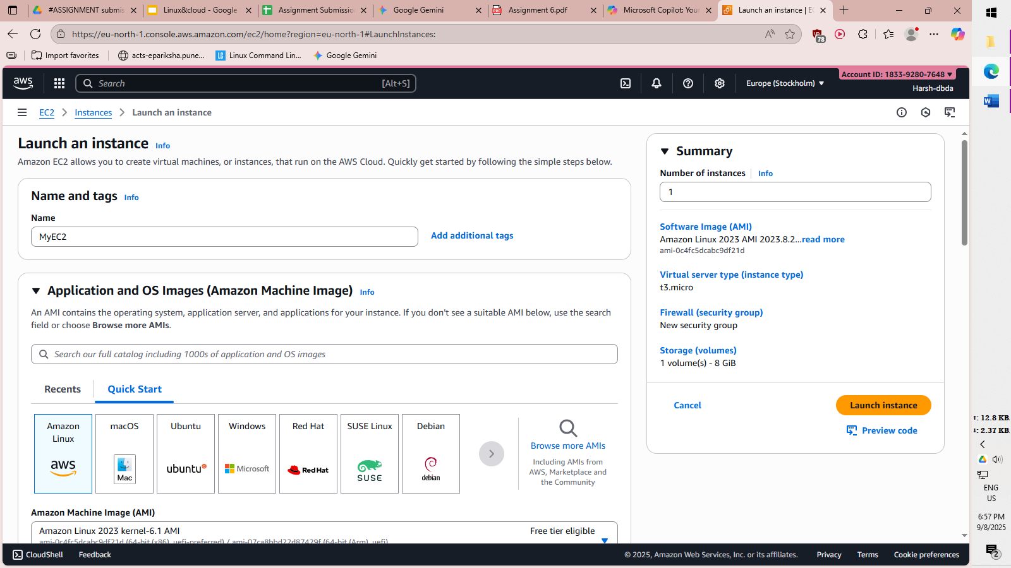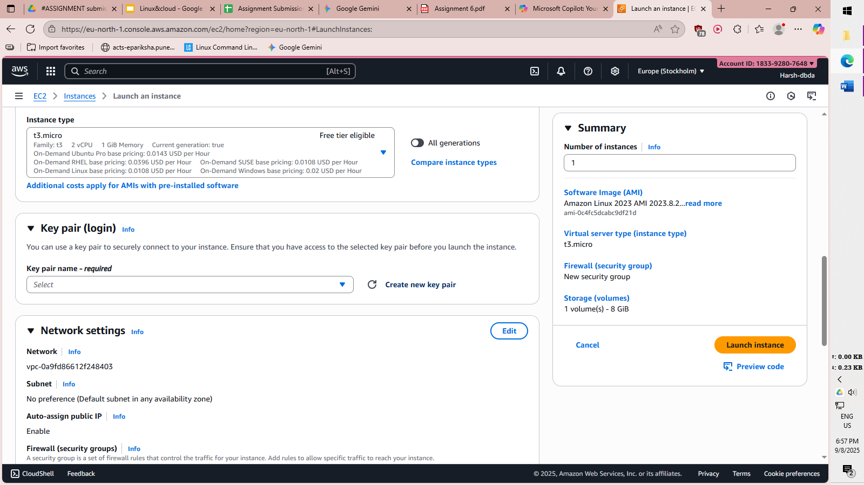

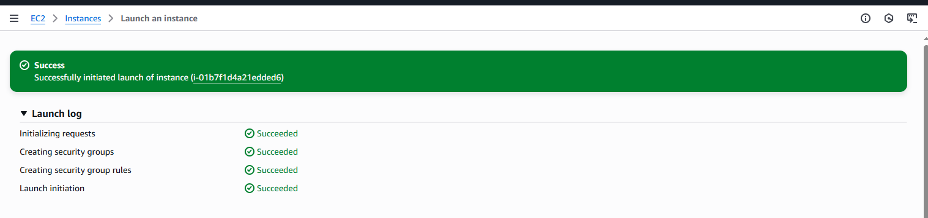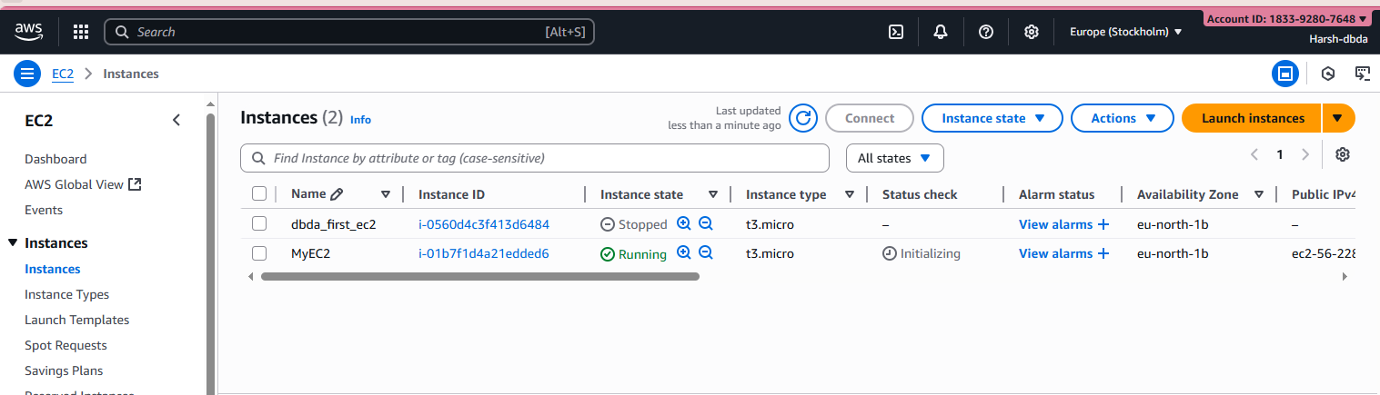

9. Connect to the instance using SSH from your terminal.
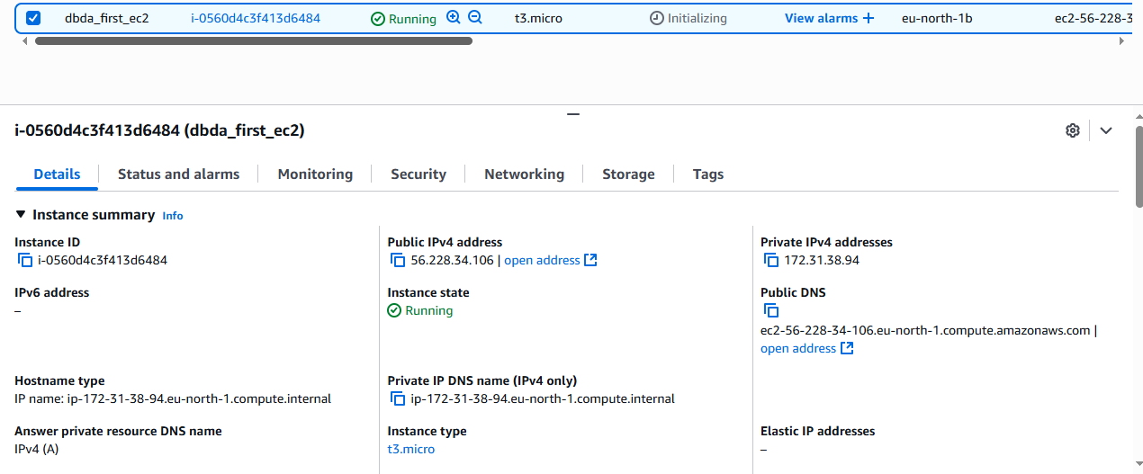
Through Putty
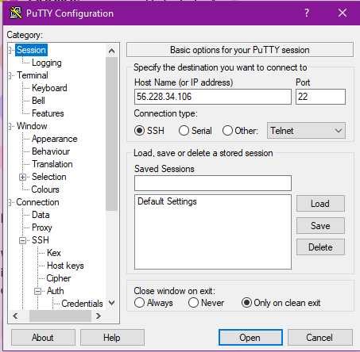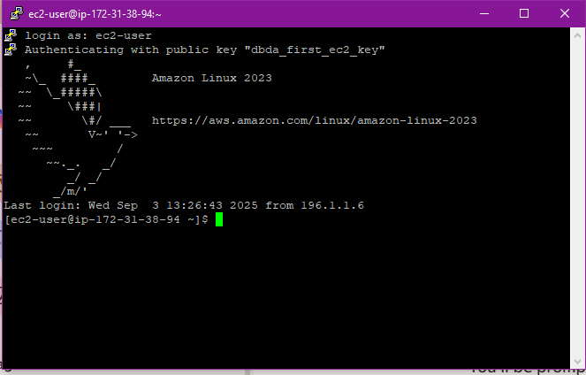
Through Terminal
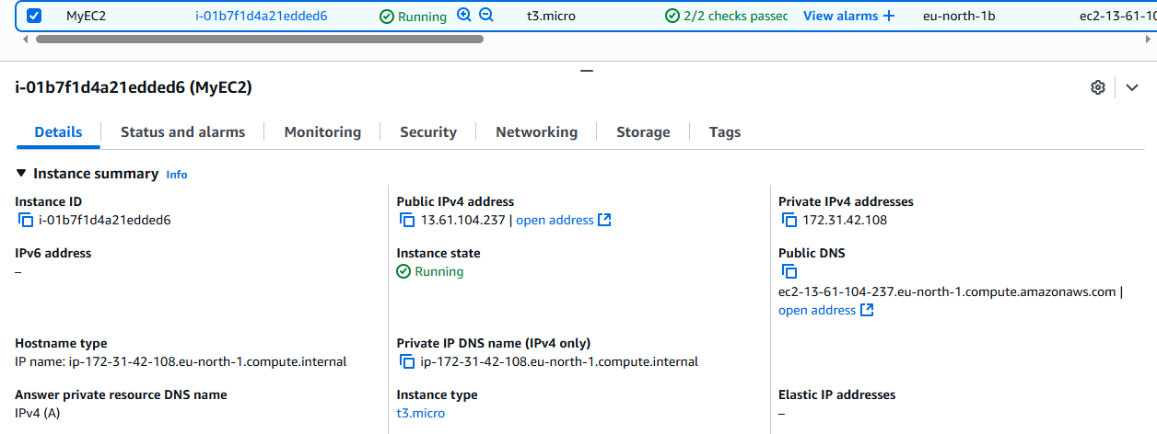
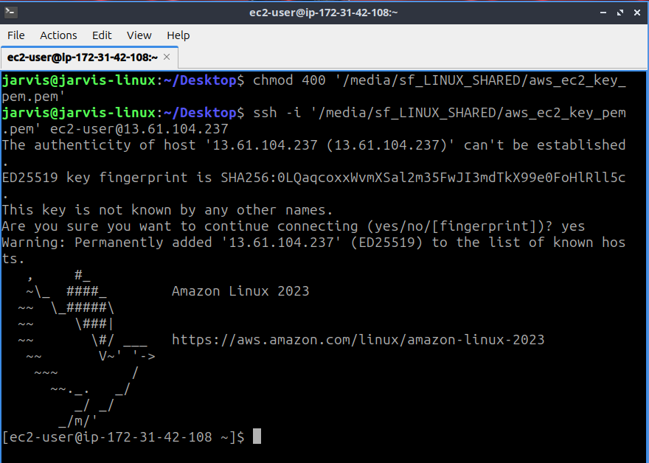

10. Install Apache/Nginx on the EC2 instance and host a webpage
