12-11

Histogram
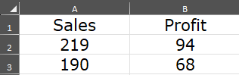

Create the table below-
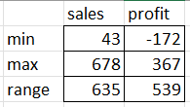
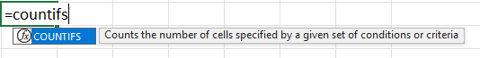
=COUNTIFS(A$2:A$101,">=1",A$2:A$101,"<=100")
…. Do it for al conditions.
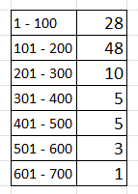
Add a Histogram.
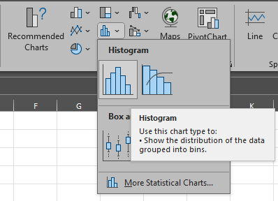

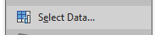

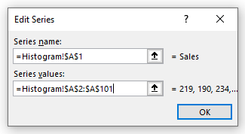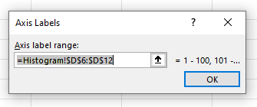
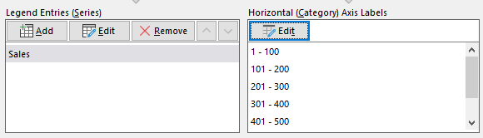

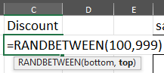

LOOKUP
- VLOOKUP

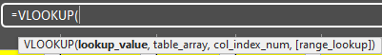
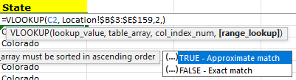
=VLOOKUP(C2, Location!$B$3:$E$159,2,FALSE)
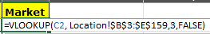
=VLOOKUP(C2, Location!$B$3:$E$159,3,FALSE)

HLOOKUP
 & 
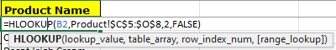
=HLOOKUP(B2,Product!$C$5:$O$8,2,FALSE)
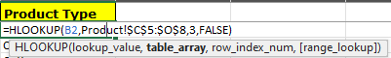
=HLOOKUP(B2,Product!$C$5:$O$8,3,FALSE)

Ctrl + T
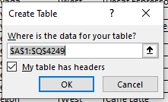
….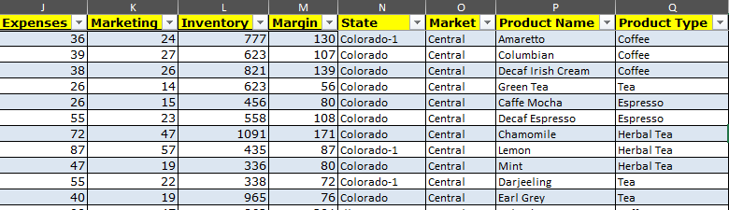

Pivot Table
Select product_name, sum(profit)
From table
Group by product_name
Order by product_name;
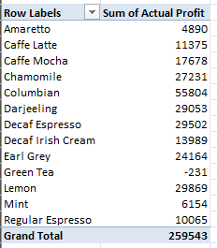
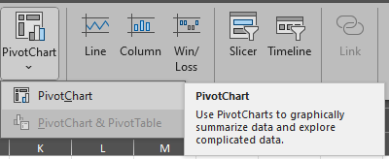
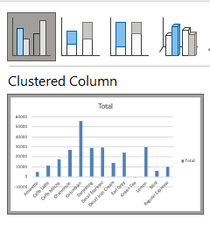

5) Create pivot table to show no. of records for each state.
Drag State in both places
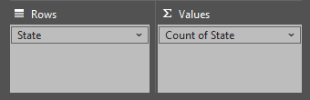
It will result in
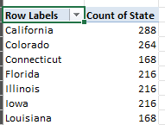…
Add Product_Type to Filters
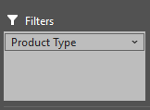
It will show this new row
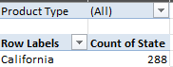
Select the filter
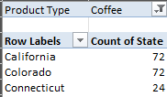
Drag col from filters to columns
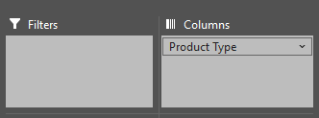
Add a Pivot-Chart- horizontal bar chart
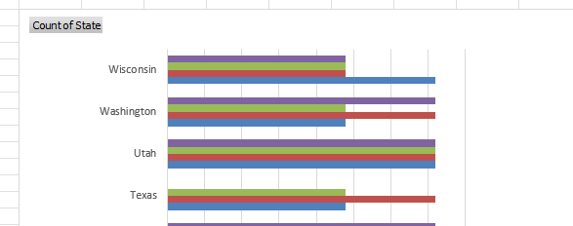

6) Create pivot table to show no. of records for each product type & Market.
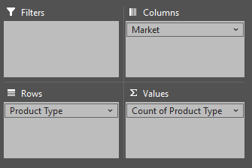
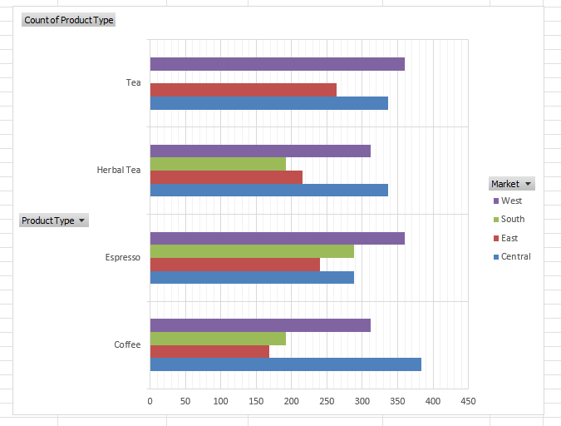
7) Create line chart to display monthly sales value (Jan to Dec)
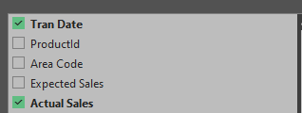
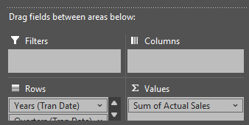
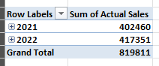

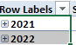
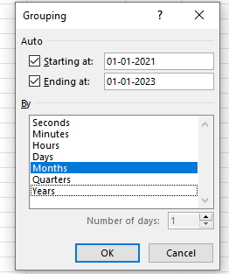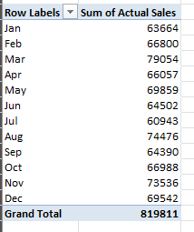

Add a Line Chart
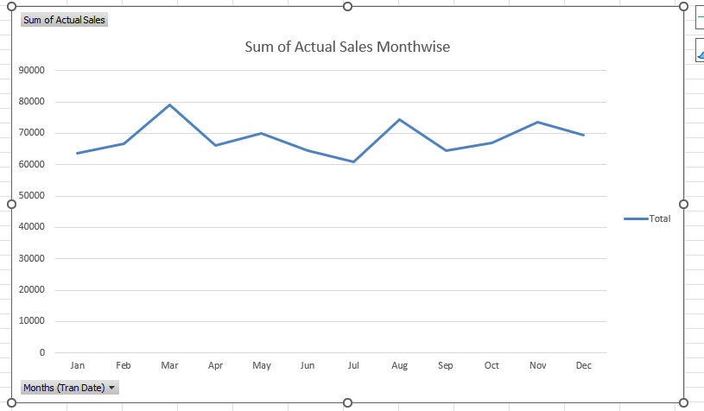
For chart, add Market in Legends

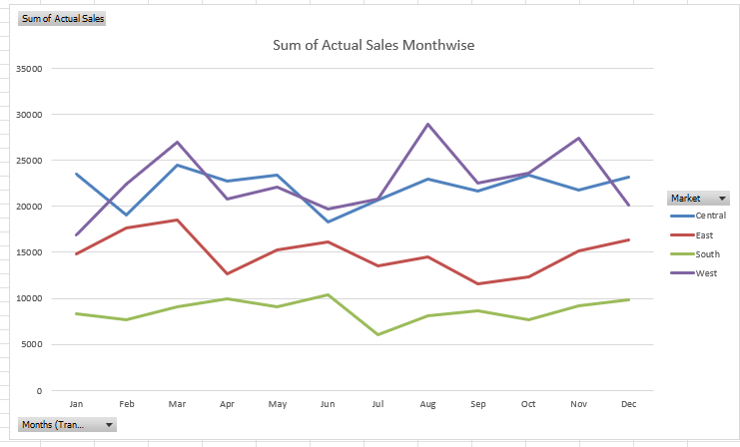
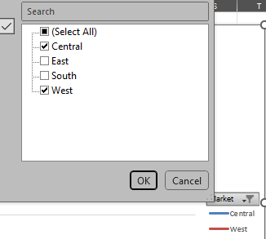
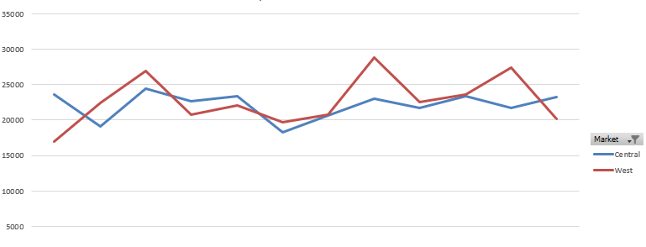
8) Create line chart to display monthly profit value (Jan to Dec). Add Product Type on Filter
Create a pivot table
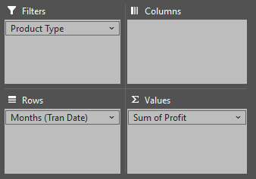
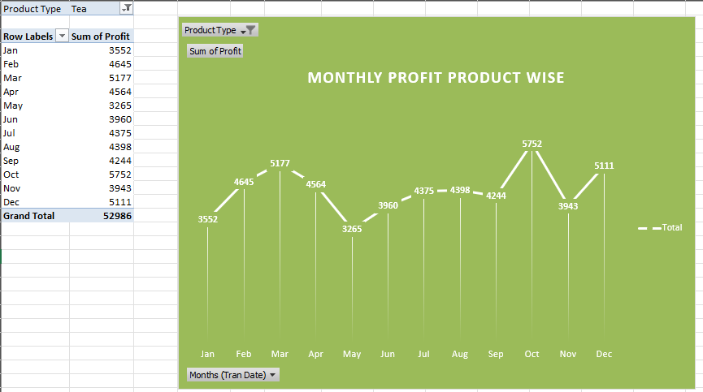
9) Create line chart to display monthly inventory value (Jan to Dec). Add Market on Filter
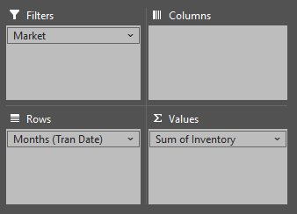
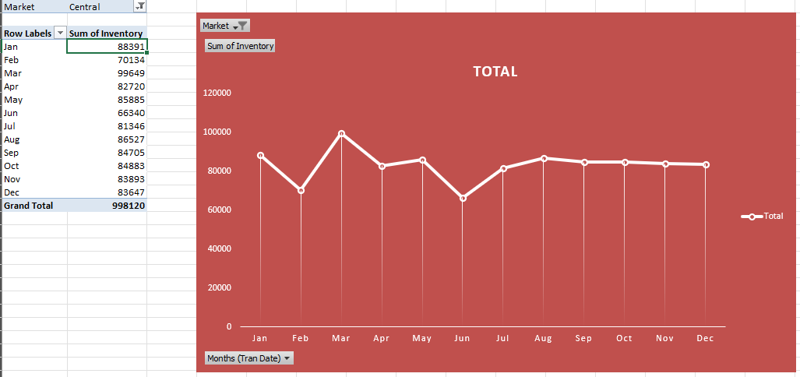
- New Blank sheet
- Data Menu
- 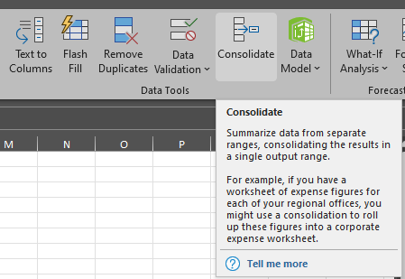
- 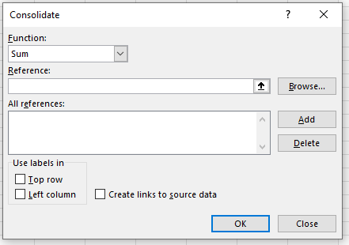
- 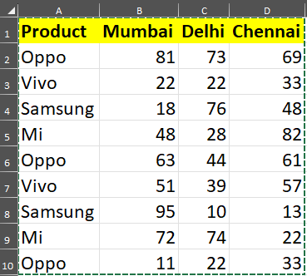
- 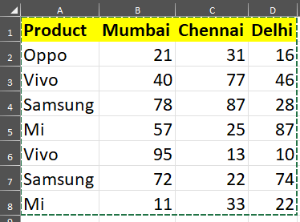
- 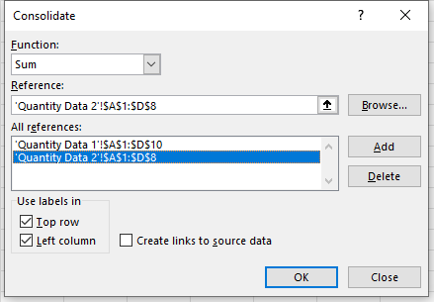
Result
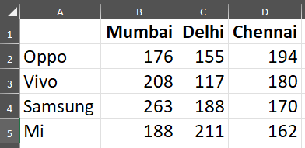

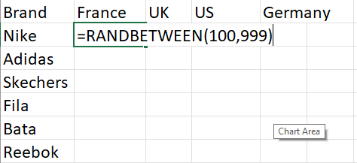
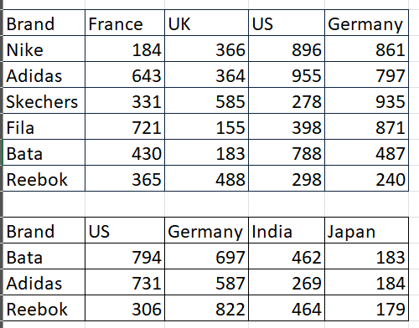
Consolidate into a new Sheet
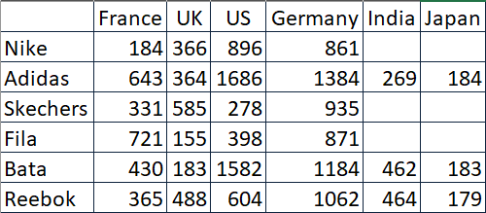

Scatter-Plot
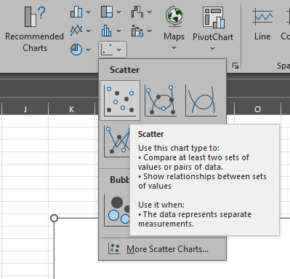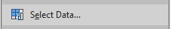
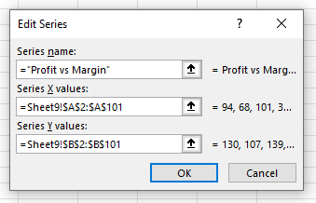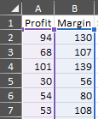

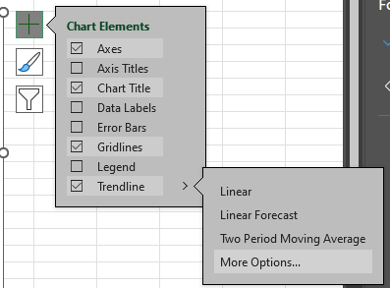

Profit vs Margin
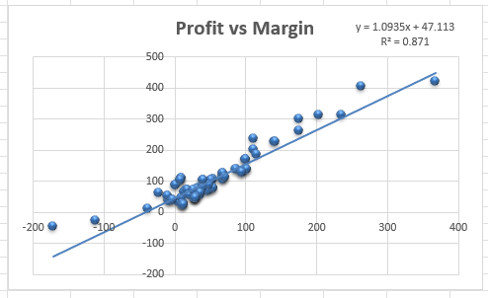
Profit vs Sales
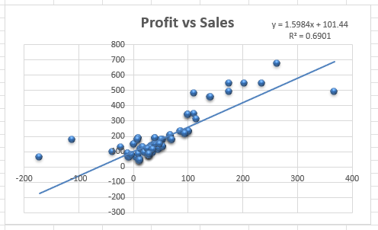
1) Sales vs Inventory

2) COGS vs Marketing

3) Profit vs Expenses

4) Expenses vs Marketing

5) Marketing vs Inventory

Profit vs Sales
Sales = (1.5984 * Profit) + 101.44
Coefficient of Profit is 1.59 i.e. if profit increases by 1, sales is liekly to increase by 1.59.
profit
100 | 261.2800
101 | 262.8784
 | 1.5984


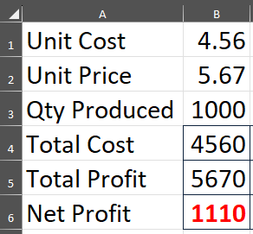
Goak Seek

We want to make profit of 1500/-
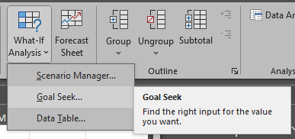
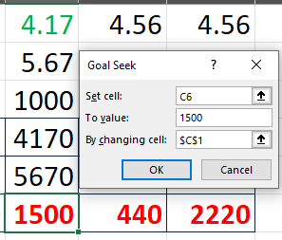
Similarly
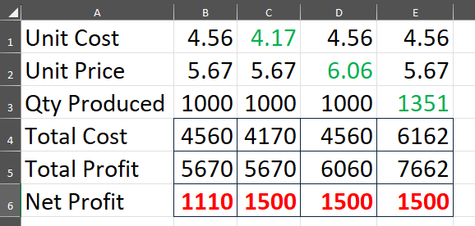
Lunch break------------------

Financial functions in excel
1. PMT - to calculate monthly EMI of a loan.
2. FV - to calculate maturityy amount of a fixed deposit (FD)
3. PV - to calculate current investment needed for future needs
parameters-
1. amount
2. annual interest rate
3. duration
Q. A customer has applied for loan of 20 Lakhs from a bank at interest rate of 9% for 7 years. Calculate monthly EMI for this customer
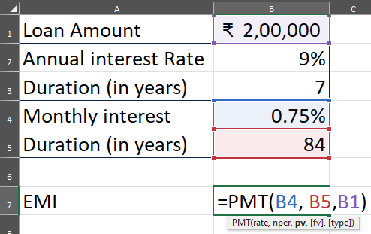
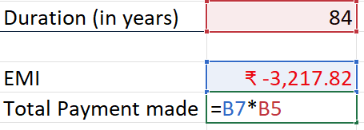
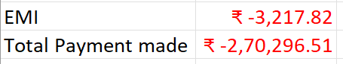

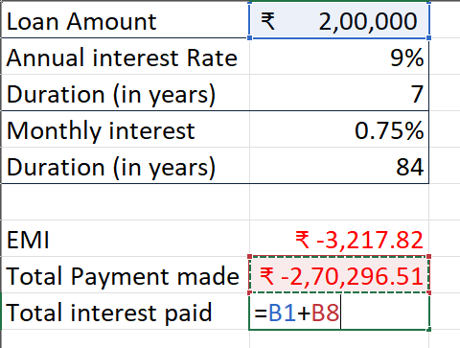

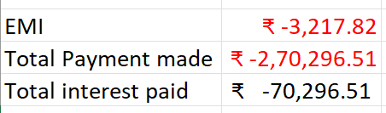

FV (for FD)
Q1. Person A has deposited amount of 3 Lakhs in a bank as FS for 6 years at IR of 4.75%. how much money he will receive at the end of 6 years?
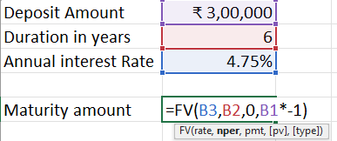
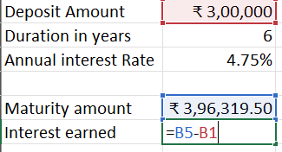
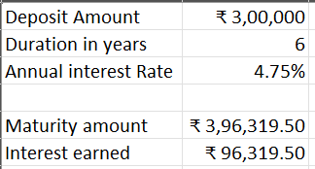

Q2. Person B has deposited amount of 4.85 Lakhs in a bank as FD for 4.5 years at IR of 3.85%. how much money he will receive at the end of 4.5 years?

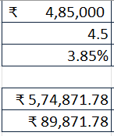
Q3. Person A has deposited amount of 6,11,200 in a bank as FD for 4 years at IR of 4.15%. how much money he will receive at the end of 4 years?
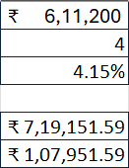
----FV----
Q1. Person A wants to receive 8 Lakhs for education after 9 years at interest of 4.6 %. How much money should he currently invest?
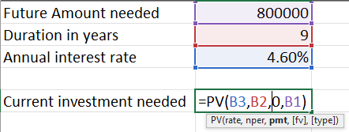

-----10 min break at 2:40-----
Q. In Financial sample file, add 3 new columns Q,R & S with headings = Item Name, Segment Name & Country name. Populate these columns from their respective sheets using appropiate LOOKUP function.
=VLOOKUP([@[Item_ID]],Item!$A$2:$B$7,2)
=VLOOKUP([@[Segment_ID]],Segment!$A$2:$B$6,2)
=VLOOKUP([@[Country_ID]],Country!$A$2:$B$6,2)
Tasks
1) Create pivot table using 3 fields - country name in rows, segment name in column, & unit sold in values. side by side bar chart.
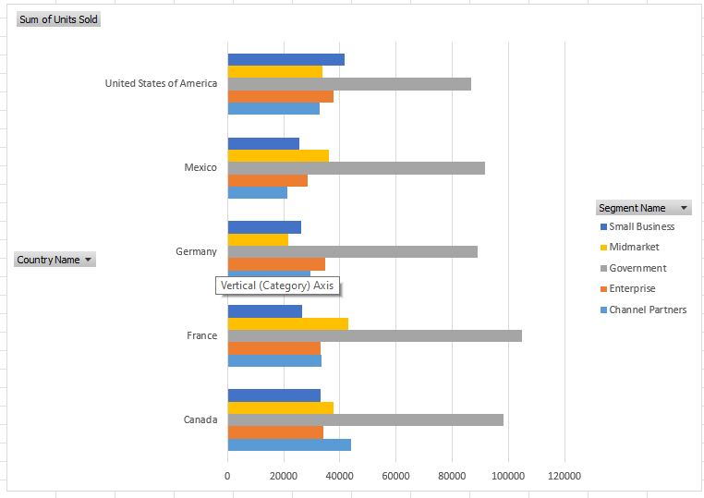
2) Create pivot table to find out Average Gross sales for each discount band show using pie chart.
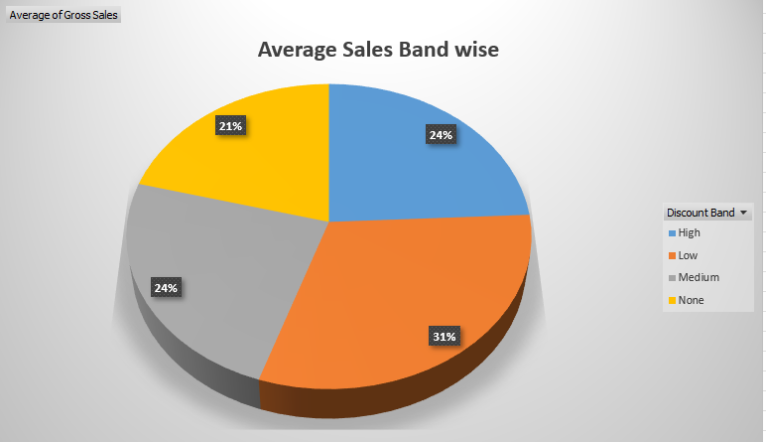
3) create pivot table to find average actual profit by each month - Jan to Dec and show line chart. add item name in filter.
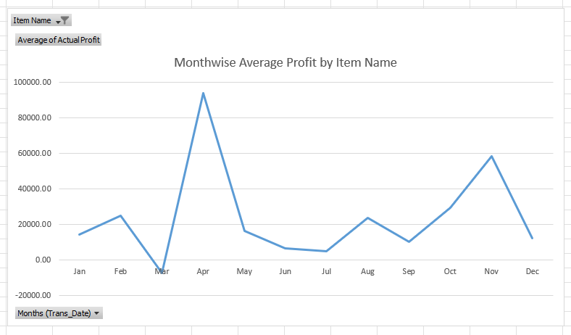

4) Create interval bins for unit sold as below-
a) 0 to 1000
b) 1001 to 2000
c) 2001 to 3000
d) 3001 to 4000
e) 4001 to 5000
and create histogram using bar chart.
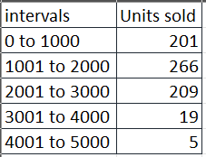
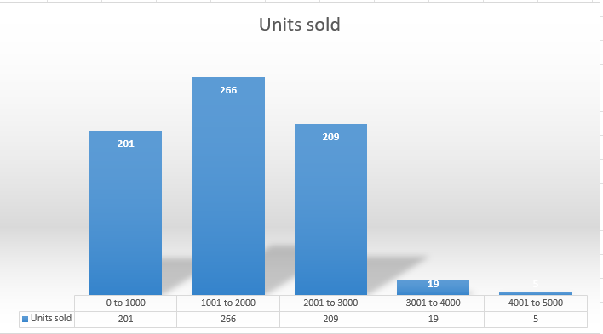

5) Add a new column T with name "Profit Status". If actual profit is negative, show "Loss" in this column otherwise show "Profit".
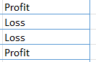
6) Create a new pivot table to show no. of records by Profit Status and show using Pie Chart. Then add Country Name on filter.
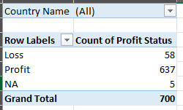
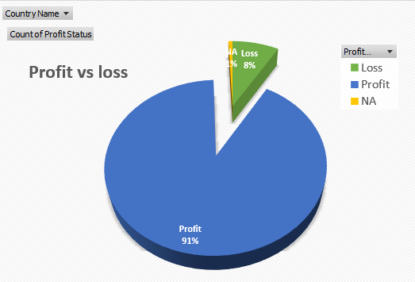
7) Add a new sheet. here create scatter plot of actual revenue on X axis vs actual profit on y axis. show R square & line equation.
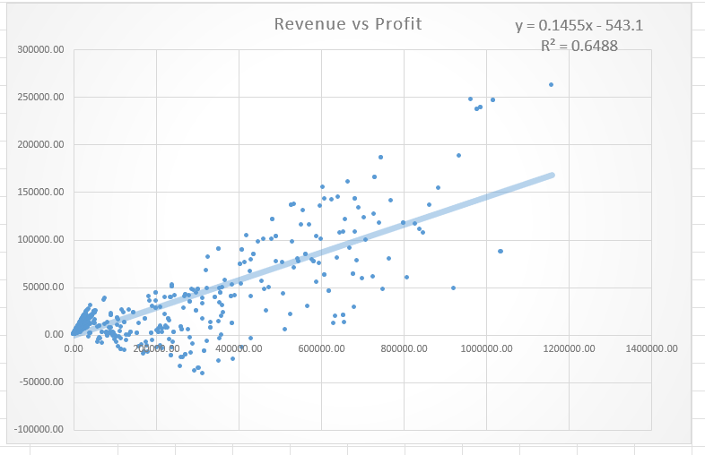
8) using above equation, predict the profit for revenue 12,00,000
(174056)
9) If company wants profit of 180000 then how much revenue is required?
(12,40,846)
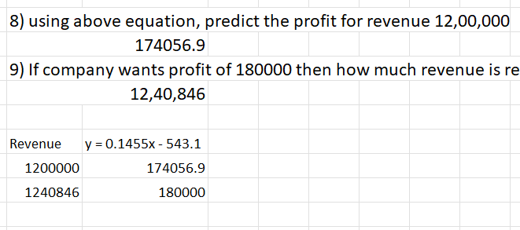
10) add units sold on x axis, actual profit on y axis.
