13-11-2025
C:\Users\user_name\Documents\My Tableau Repository\Datasources
save the Global Superstore.xlsx in this directory
Orders Sheet
cols = 28
rows = 51290
Returned Orders
`Order Id` is the connection
Managers
`Region` is the connection
Measure - Any numeric column (with or without decimal) on which maths or stats operations can be performed to generate meaningful result in business.
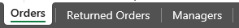
Mean and Median common stats operation.
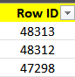 Not a measure, because add two Rows IDs give no meaningful result.
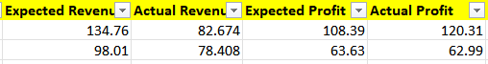
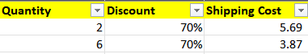
All these 7 columns are measures.
e.g. Profit, tax, discount, quantity, cost, expense, …
Dimension - Any numeric or character or data column which is not a measure and can be used to aggregate measures.
e.g. department, name, address, city, categories, DOB, joining date, rating, etc.
Any primary or foreign key column is always considered as Dimension.
Only numeric dimension allowed on DIMENSION is COUNT.
Union() - Doesn't show duplicates
UnionAll() - Shows Duplicate
Measures - 7
Dimension - 21
Tableau shows measures in GREEN color and dimensions in BLUE color.
Measures | Dimension

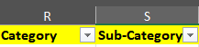 Parent Child relationship



Data Source Type
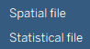
Spatial file(.shb) => images taken from drone, surveys
Very huge files
Statistical file=> IBM SPSS Statistics(.sav), R file (.R)

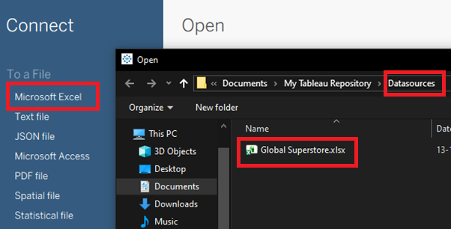

--How to join tables in Tableau (Old vs New)?
Old Technique - JOIN
New Technique – RELATIONSHIP
JOIN
Drag Orders in the main area
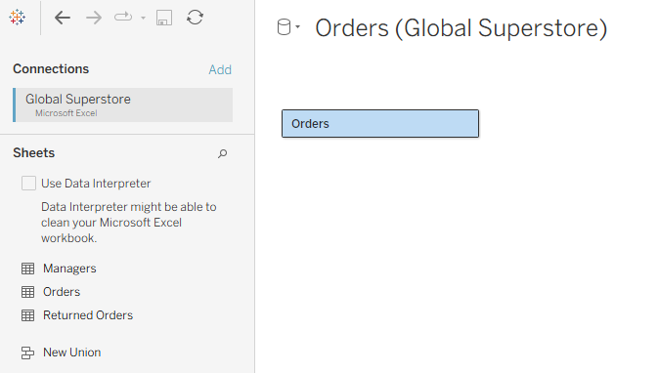

Double Click
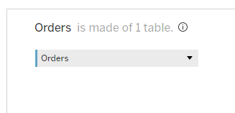
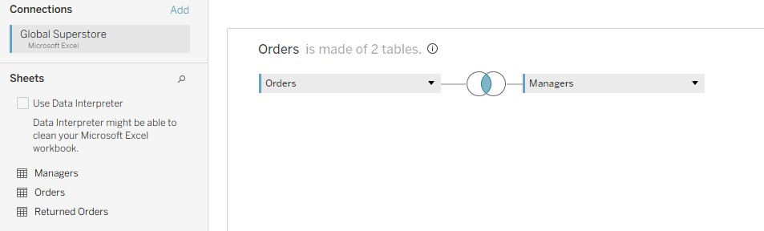
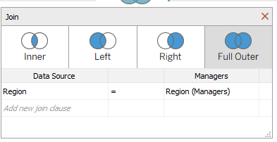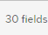 instead of 28
RELATIONSHIP (New Technique)
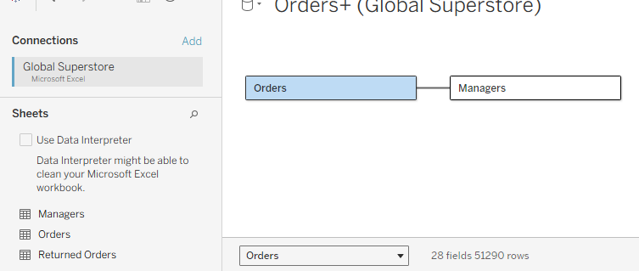
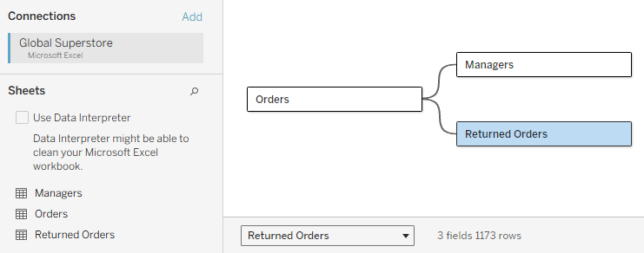
Data Types in Tableau
1) Numeric
2) String
3) Date
4) Geographic
5) Boolean T/F
Three types of sorting in Tableau
1. Ascending
2. Descending
3. Default
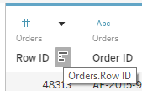
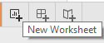
Three components of Tableau
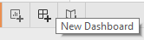
1. Worksheet
2. Dashboard
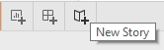
3. Story

Story can be created using Worksheet & dashboard can't be created using Story.
Click on Go to Worksheet
Nine Sections on Tableau main screen -
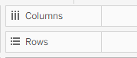
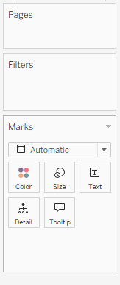
1. Dimension
2. Measure
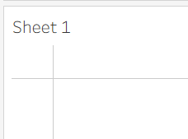
3. Page
4. Filter
5. Marks
6. Rows
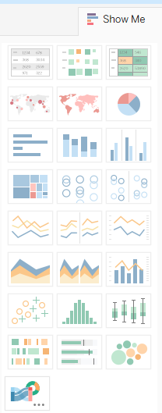
7. Columns
8. Canvas
9. Show Me
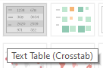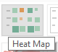
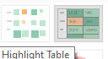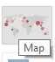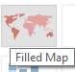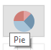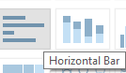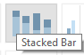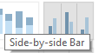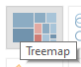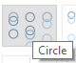
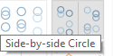

Drag Subcategory to Rows
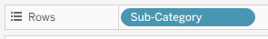
Click Once on Actual Revenue
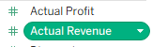
Drag into Marks => 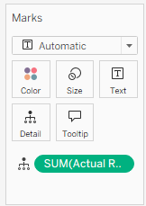

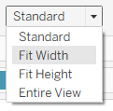
Four Layout Styles in worksheet-
- Standard (Default)
- Fit Width
- Fit Height
- Entire View
-
Keep Fit height

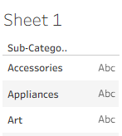
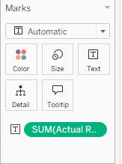
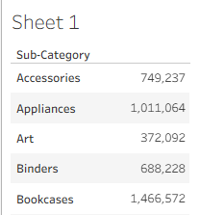
Double Click “Sheet 1” => give a new title.
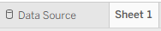
Or the one at top
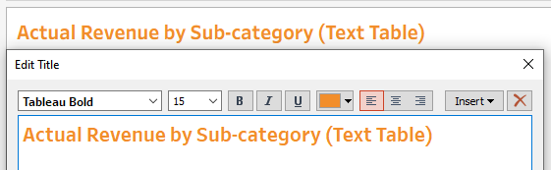
Add Currency Symbol
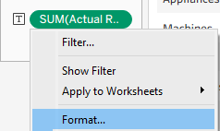
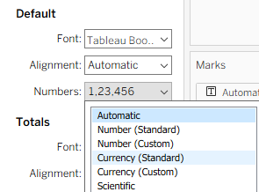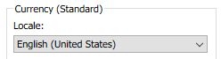
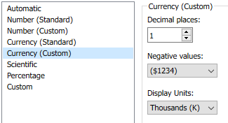
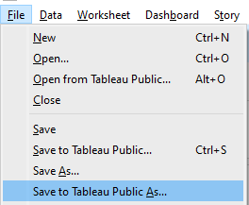
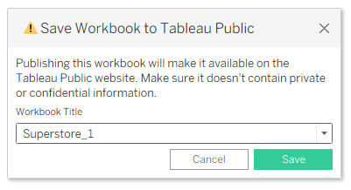
--- 10 am breakfast break ---
How to convert a dimension to a measure by showing count?
Normal count vs Distinct count
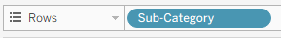
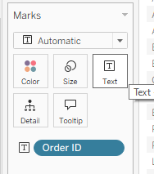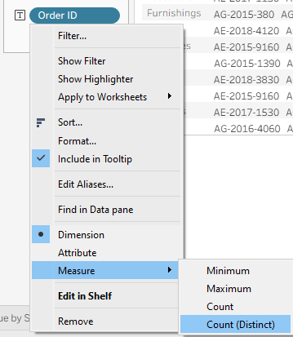

No. of Orders by Sub-category (Text Table)
1) No. of Customers by Sub-category (Text Table)
2) No. of Products by Sub-category (Text Table)
3) No. of Countries by Market (Text Table)
4) No. of Orders by Region (Text Table)

Highlight Table
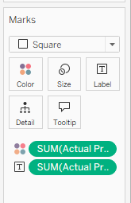
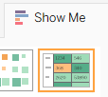
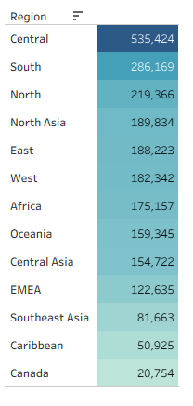
Profit by Region (Highlight table)
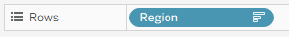

HTML Color Codes

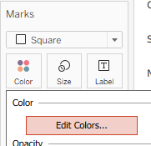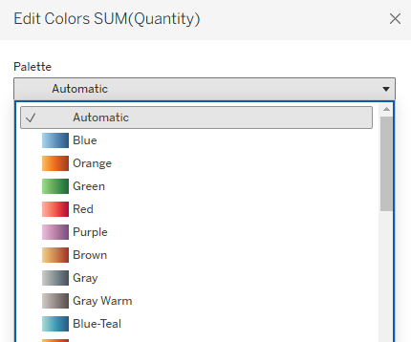
How to use highlight table for decision making?
- Highlight all values where revenue is above 100k and below 100k.
- 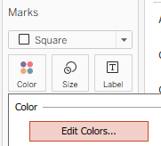
- Look for Diverging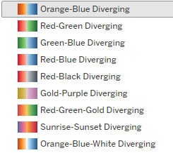
- 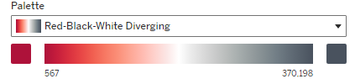
- 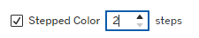
- Set Center 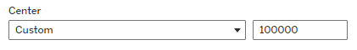
- Palette to light and dark color 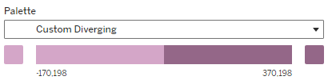
Looks like this
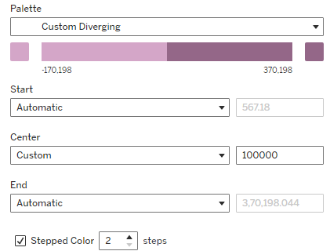

Rename the Sheet to ` Revenue by Sub-category and Region (Above 100k)`

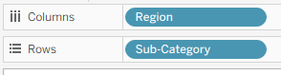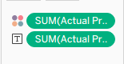
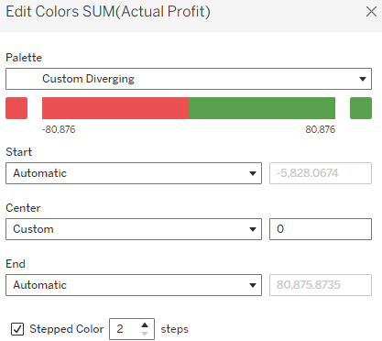
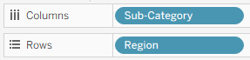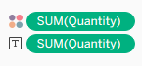
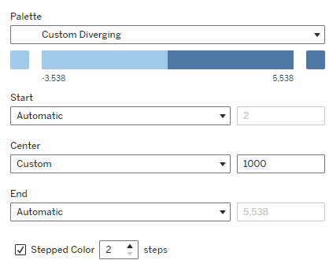
Pie Chart
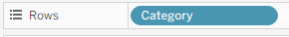
Select Pie Chart
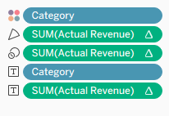
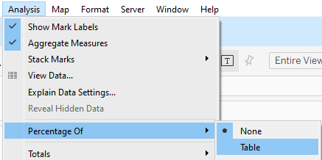
Colors
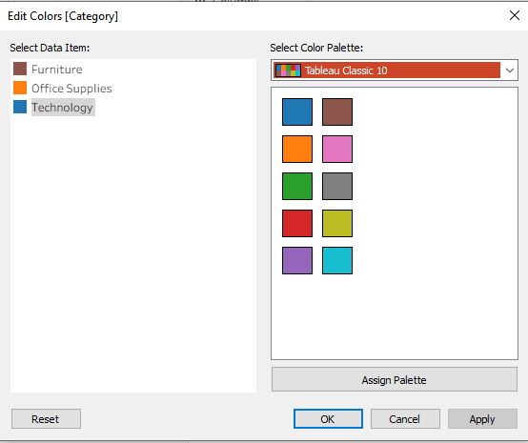
Bar Chart
3 types-
- Simple
- Side-by-Side
- 100% Stack
Horizontal Bar
1) Profit by Sub-category (Bar chart)
2) Shipping Cost by Region (Bar chart)
3) No. of Products by sub-category (Bar chart)
Vertical Bar
4) Profit by Market (Bar chart)
5) No. of orders by Market (Bar chart)
6) No. of customer by Region (Bar chart)

How to create bar chart for decision making?

Create horizontal bar chart of no. of orders by Sub-category. Using colour, identify the subcategories where no. of orders ae more than 3000.
No. of Orders by Sub-Category (above 3000)
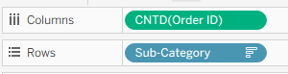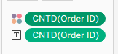
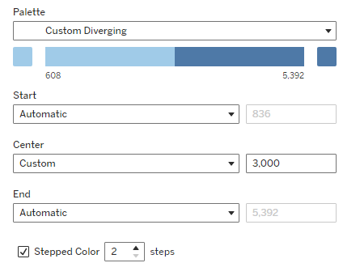
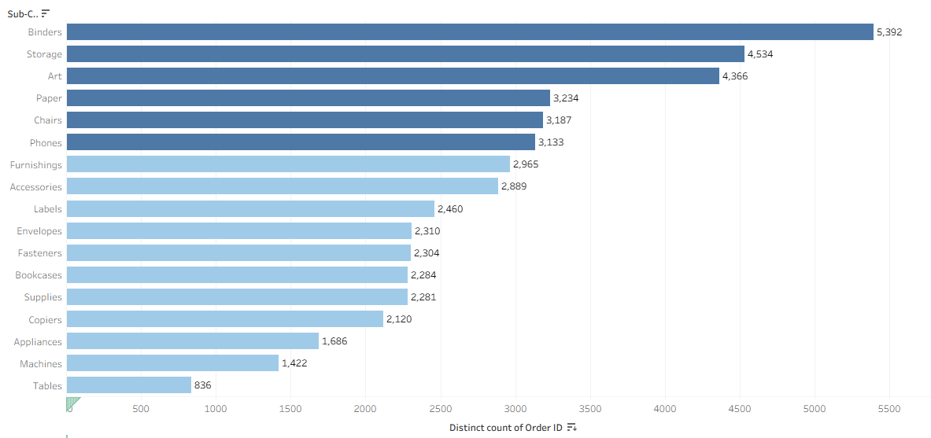

shipping cost and sub-category
Shipping Cost by Sub-category (less than 50k)
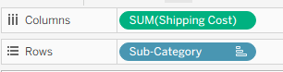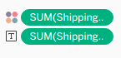
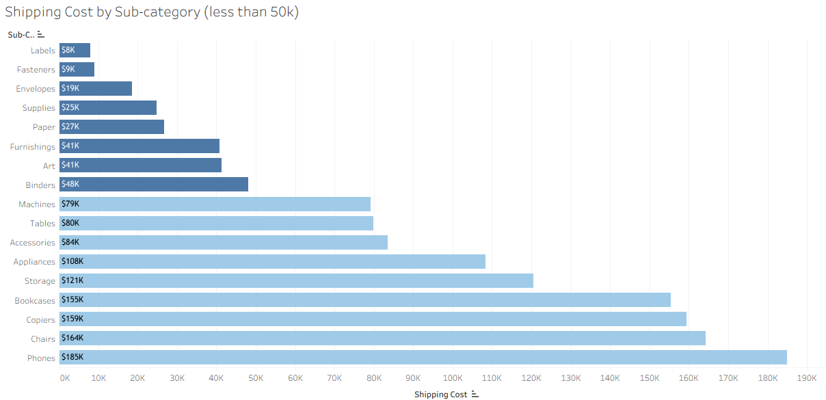
Side-by-side bar chart
This chart is used to compare one-dimension values inside other dimension with measure. Number of bars created here are no. values in dimension 1 x no. of values in dimension 2.
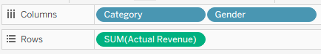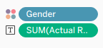
(Keep the Legend here)
Revenue by Category & Gender (Side by side bar)
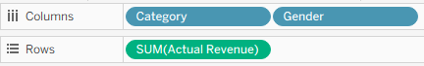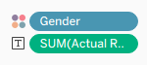
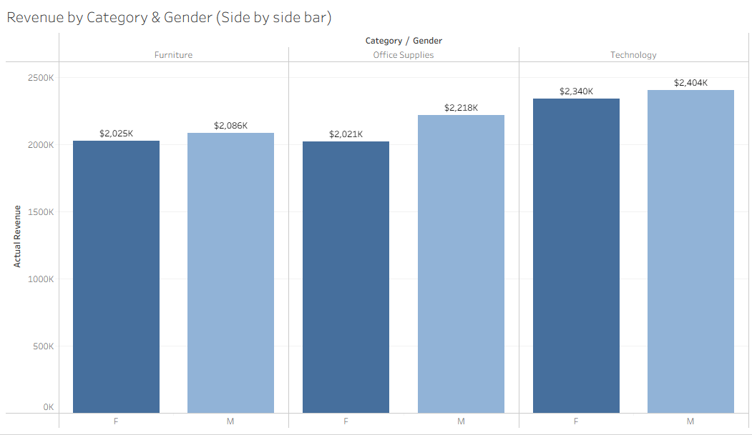
1) Profit by Category & Gender (Side by side bar)
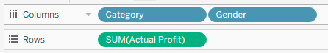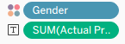
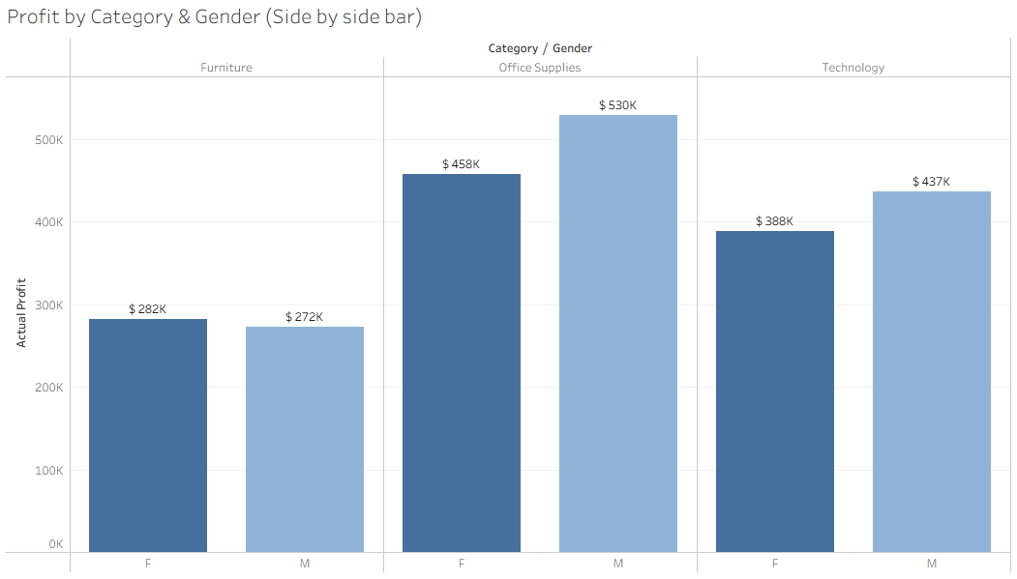
2) Profit by Segment & Order Priority (Side by side bar)
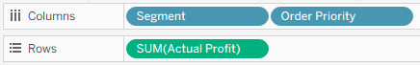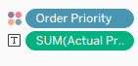
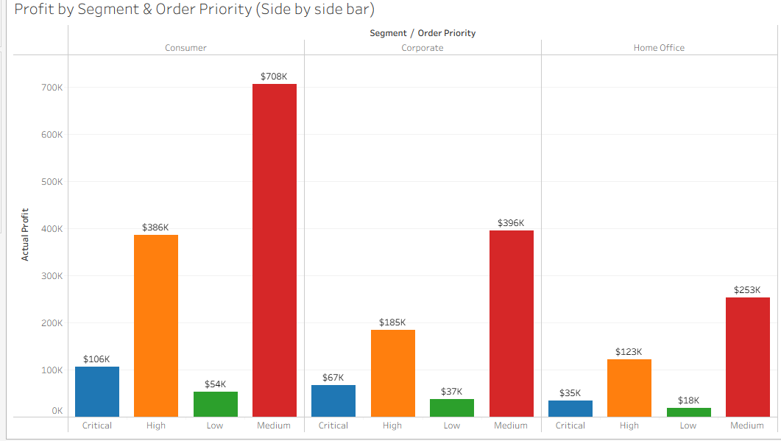
3) Shipping cost by Order Priority & Category (Side by side bar)
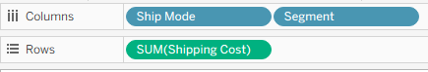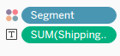
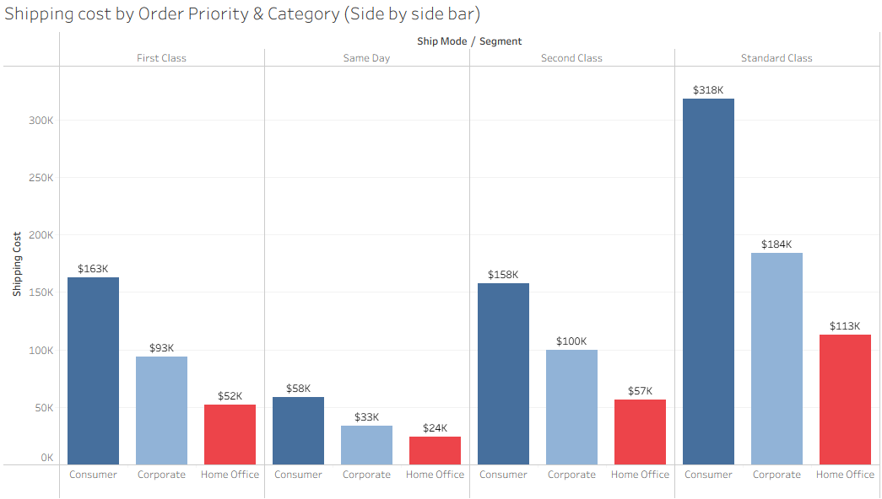
4) Quantity by Ship Mode & Segment (Side by side bar) (Horizontal)
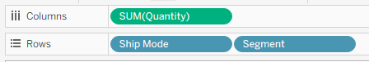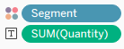
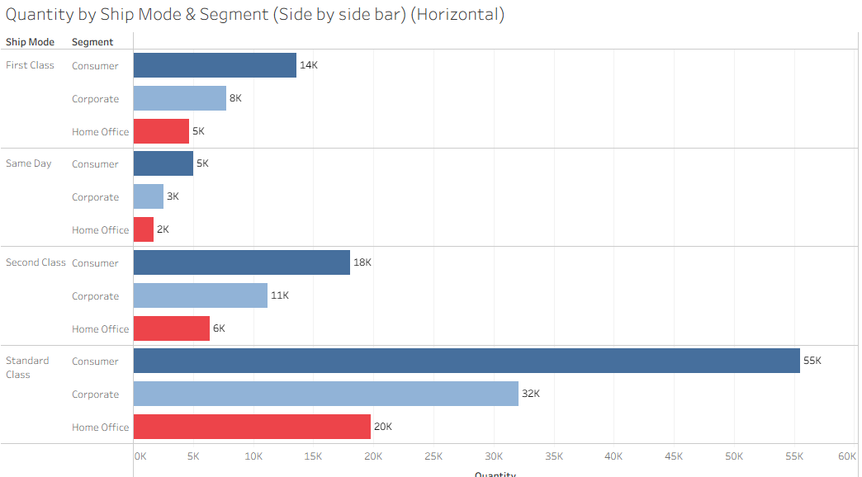
5) No. of orders by Segment & Category (Side by side bar) (Horizontal)
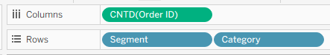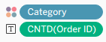
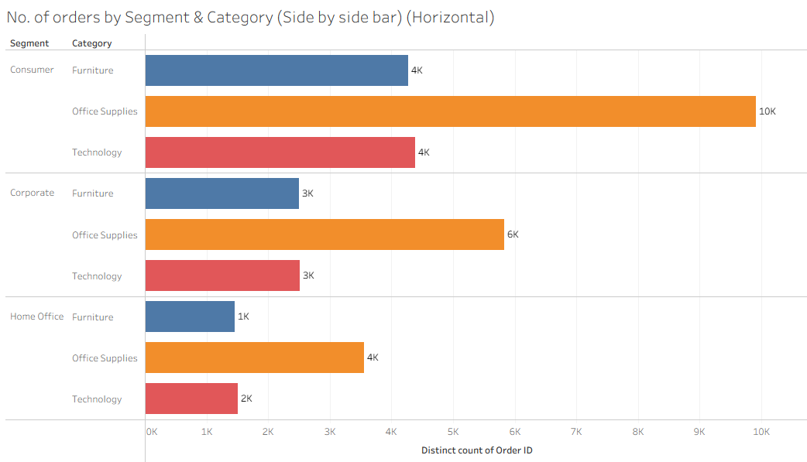
100% Stack bar chart -
Same as side by side but the here one dimension values are stacked on top of other values in second dimension

Which dimension to choose for color?
any dimension having more number of values should start first, color on less number of values.

for horizontal- for analysis-> percentage select row
for vertical - for analysis-> percentage select column
Profit % by Region & Ship Mode (100% stack)
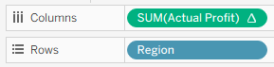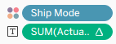
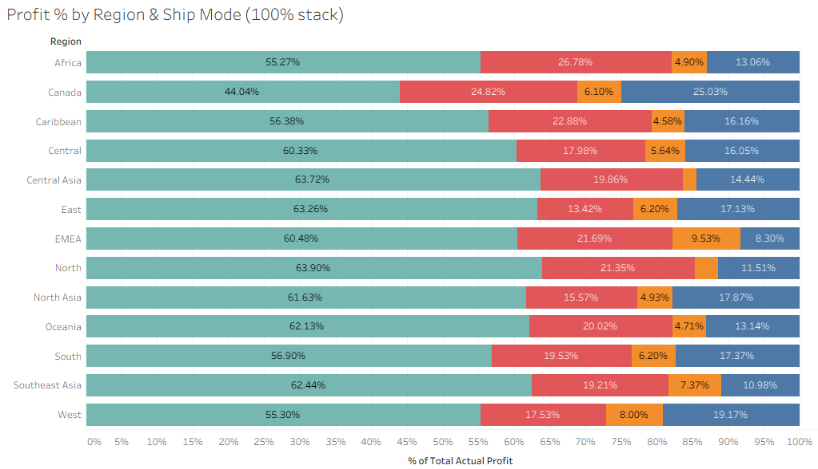
1) Create 100% stack bar using Sub-category & Ship mode with profit.
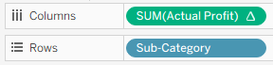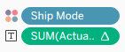
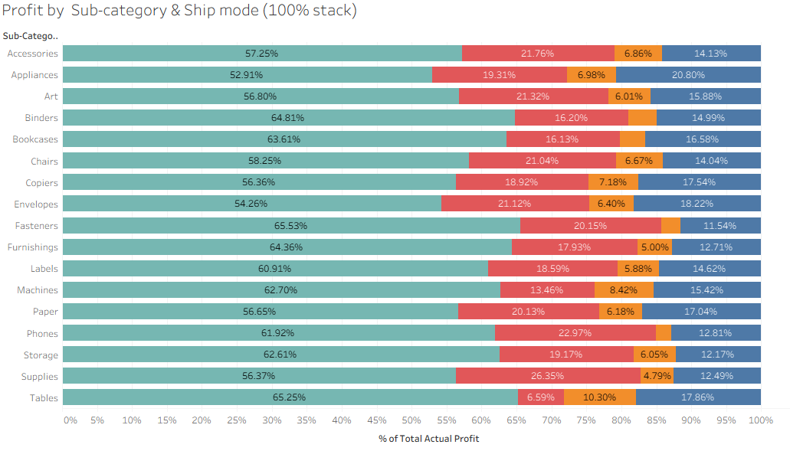
2) Create 100% stack bar using Sub-Category & Order Priority with quantity.
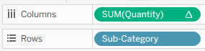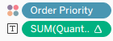
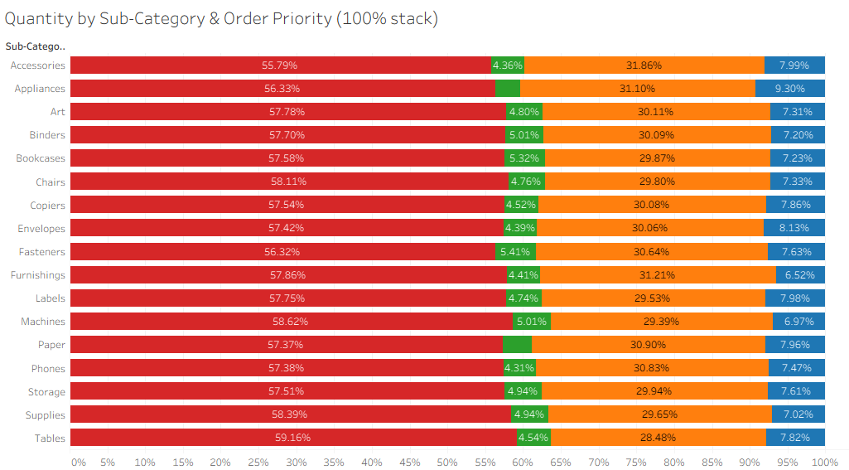
3) Create 100% stack bar using Sub-Category & Order Priority with profit.
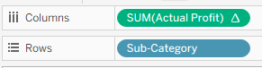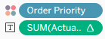
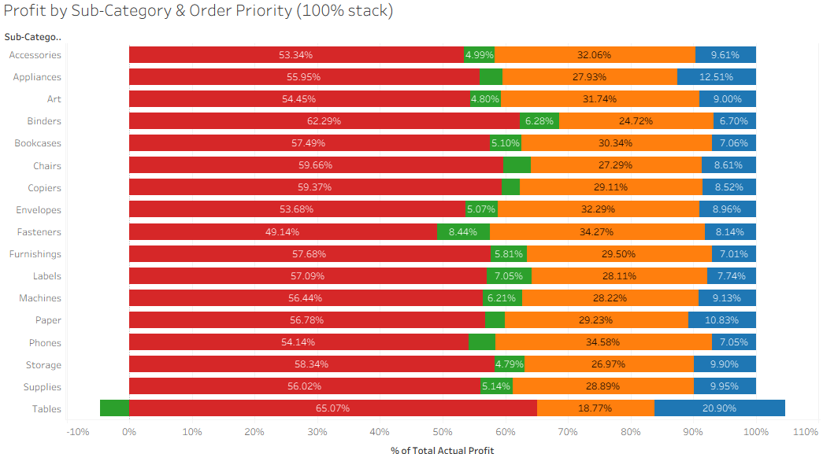
4) Create 100% stack bar using Market & Gender with No. of orders.
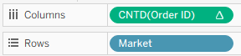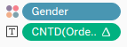
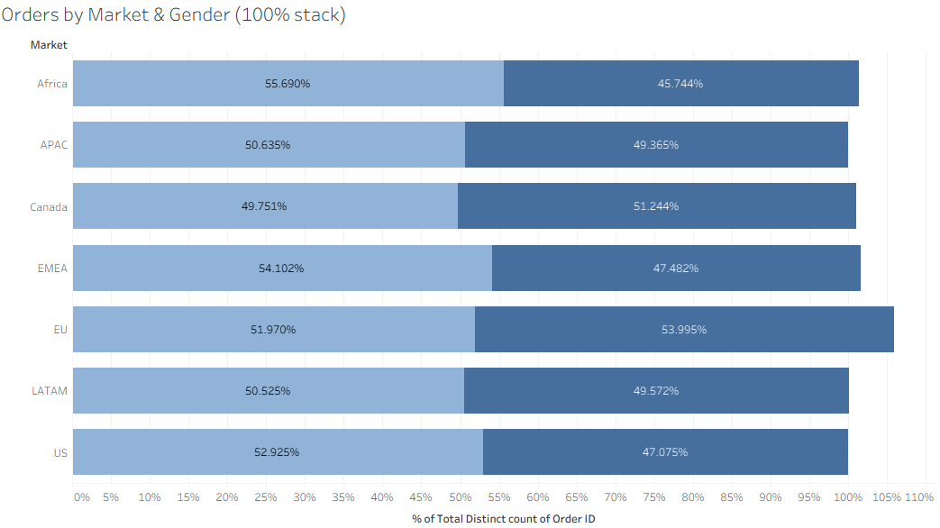
5) Create 100% stack bar using Market & Category with No. of Products.
