14-11
--------------------------------------------
Tree Map
similar to Bubble char except that it shows each value as rectangle.
Shows Rectangle
Value Big => rectangle bigger
Value Big => Colour darker
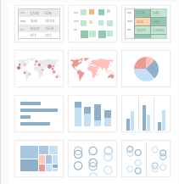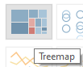
Two types of treemap –
- Without group
- With group
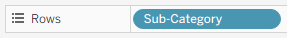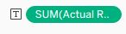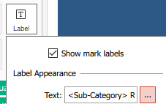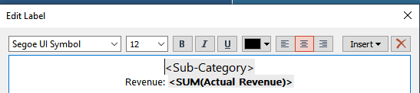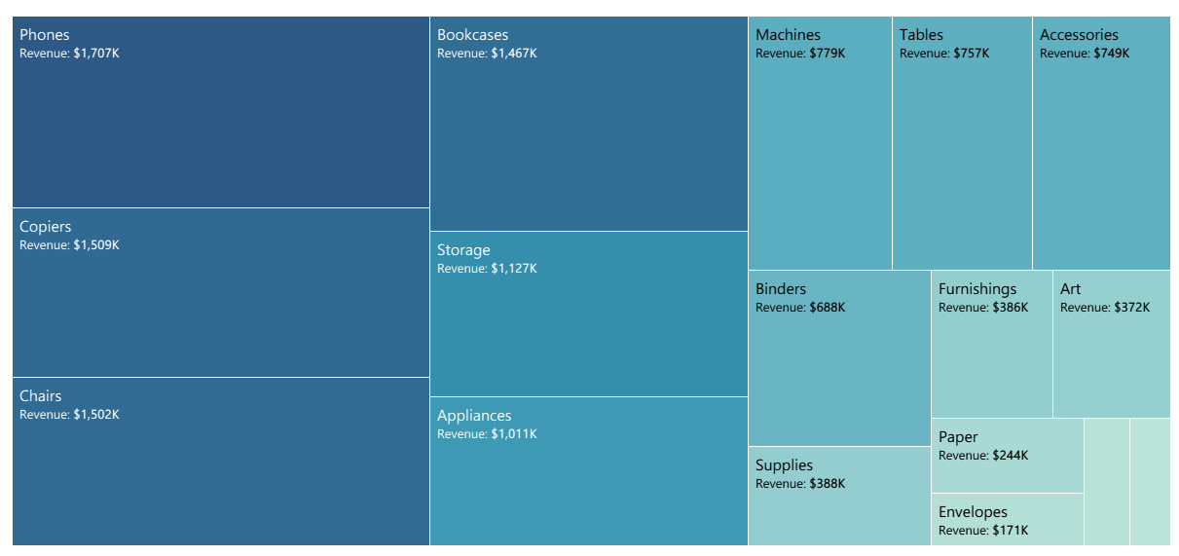
Revenue by Sub-category (Treemap)

1) Profit by Sub-category (Treemap)
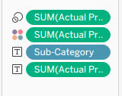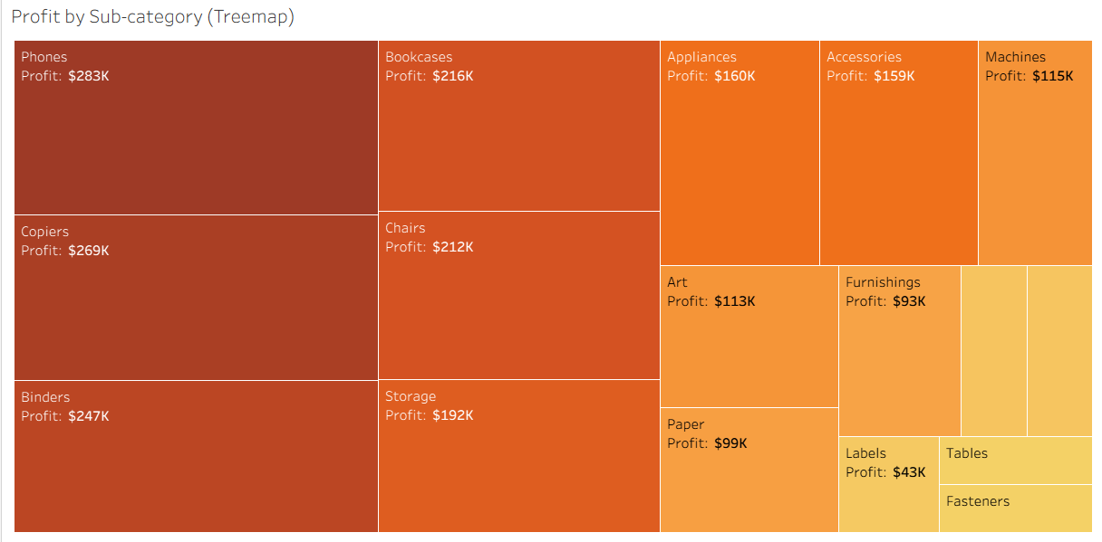
2) Profit by Region (Treemap)
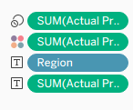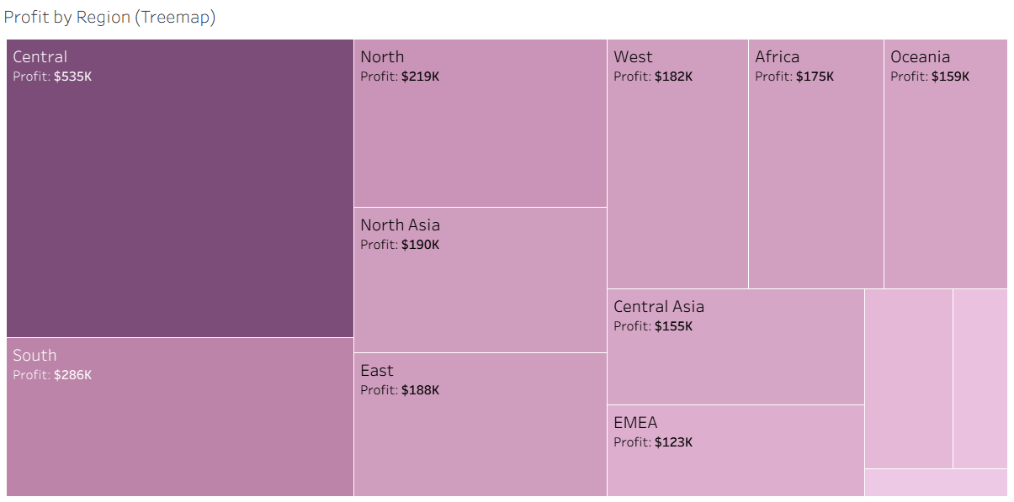
3) Quantity by Region (Treemap)
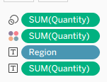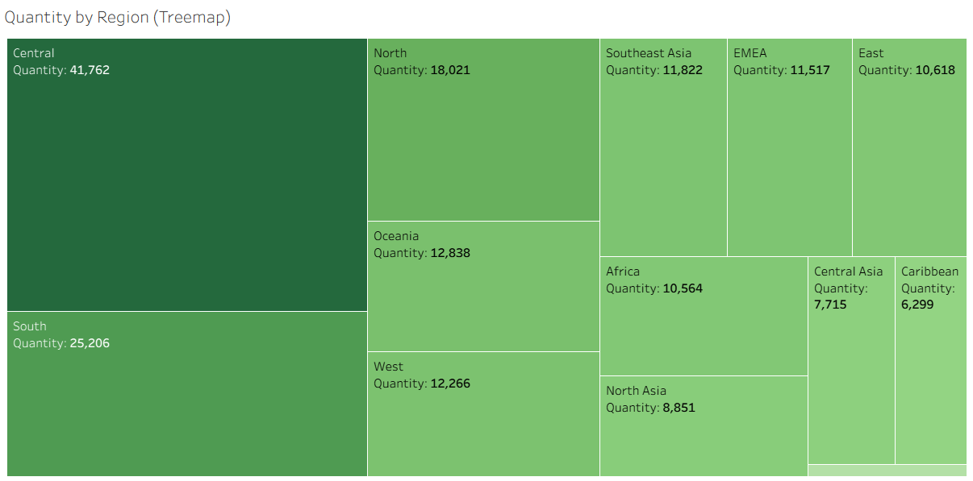
4) No. of orders by Sub-category (Treemap)
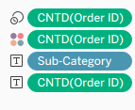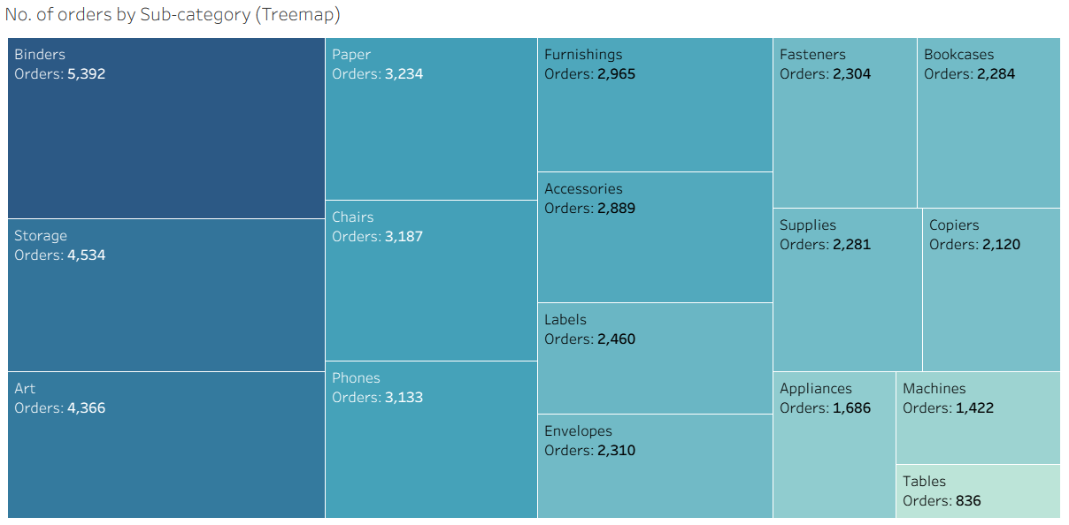
How to use TreeMap for decision making?

Create treemap of shipping cost by sub-category.
Identify all sub-categories having shipping cost more than 100k.
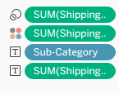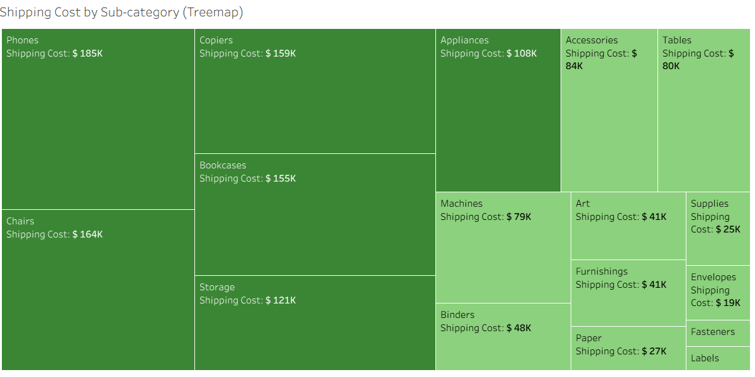

Treemap- Sub-category by No. of Products. Identify the sub-categories where no. of products are below 500.
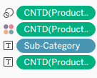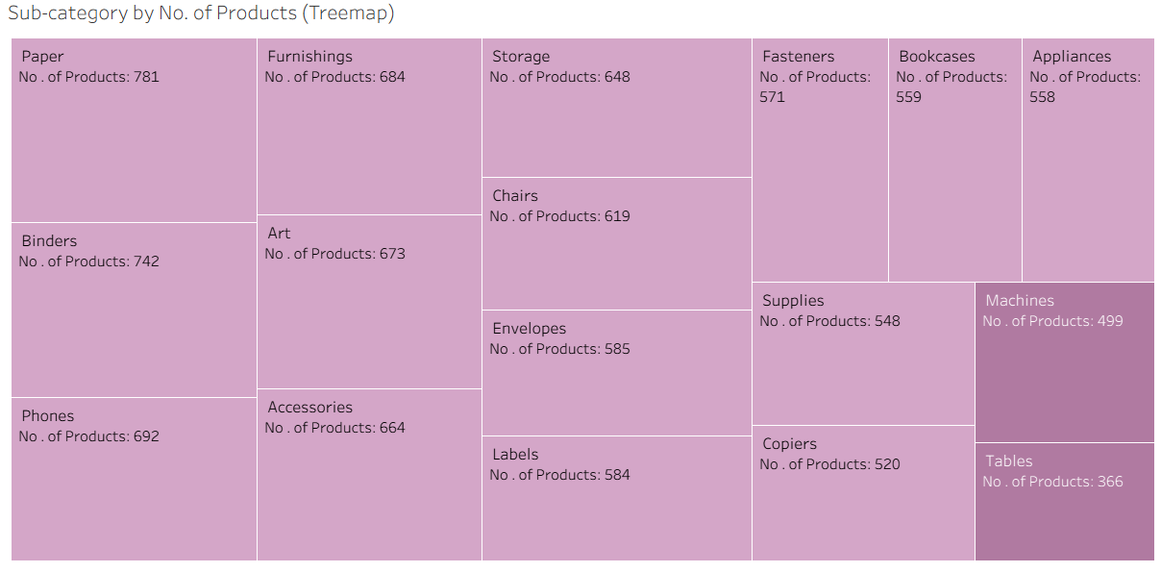

Grouping in Treemap
Profit by Market group by Gender (Treemap)
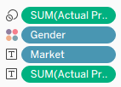
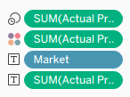
Add gender to color=>

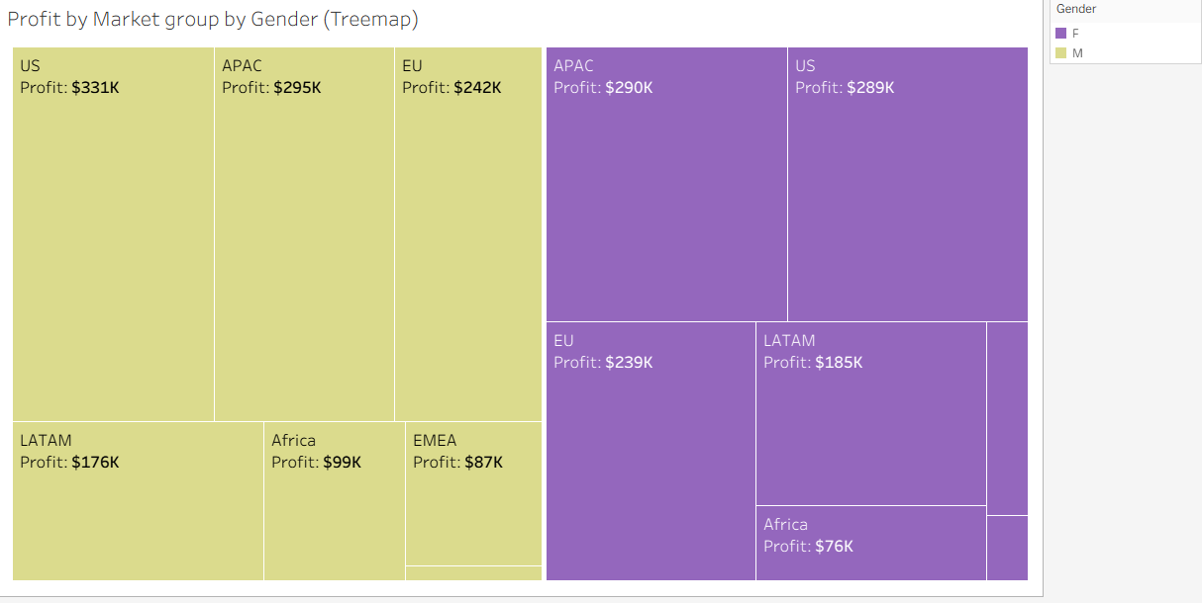

1) Profit by Order Priority group by Segment (Treemap)
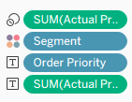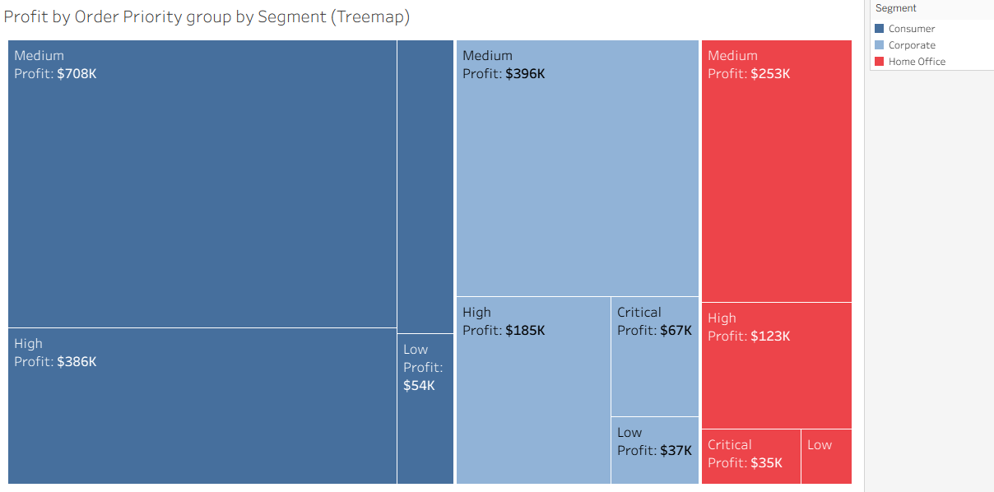
2) Quantity by Ship Mode group by Category (Treemap)
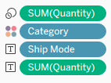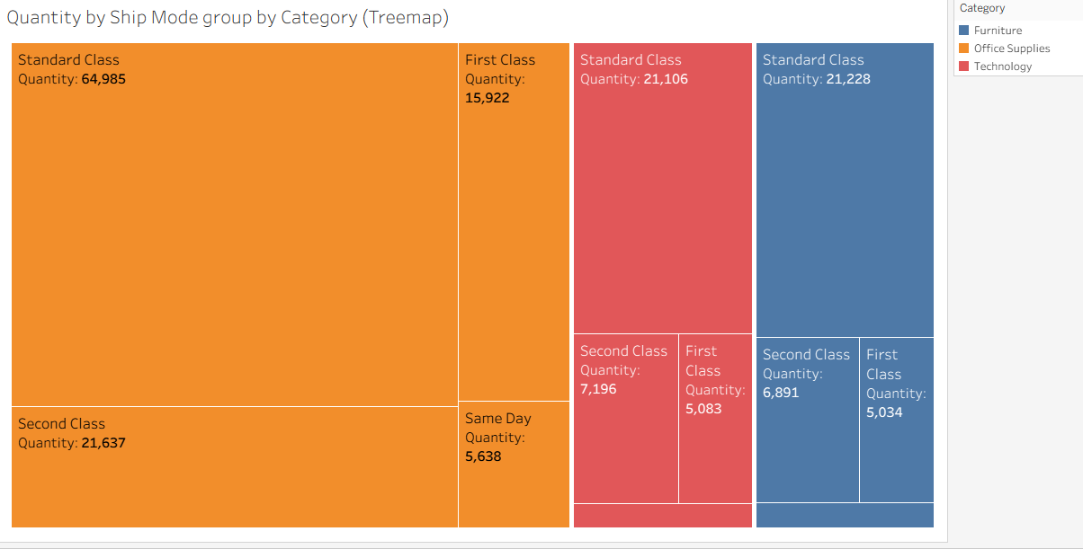
3) No. of orders by Region group by Gender (Treemap)
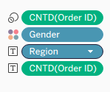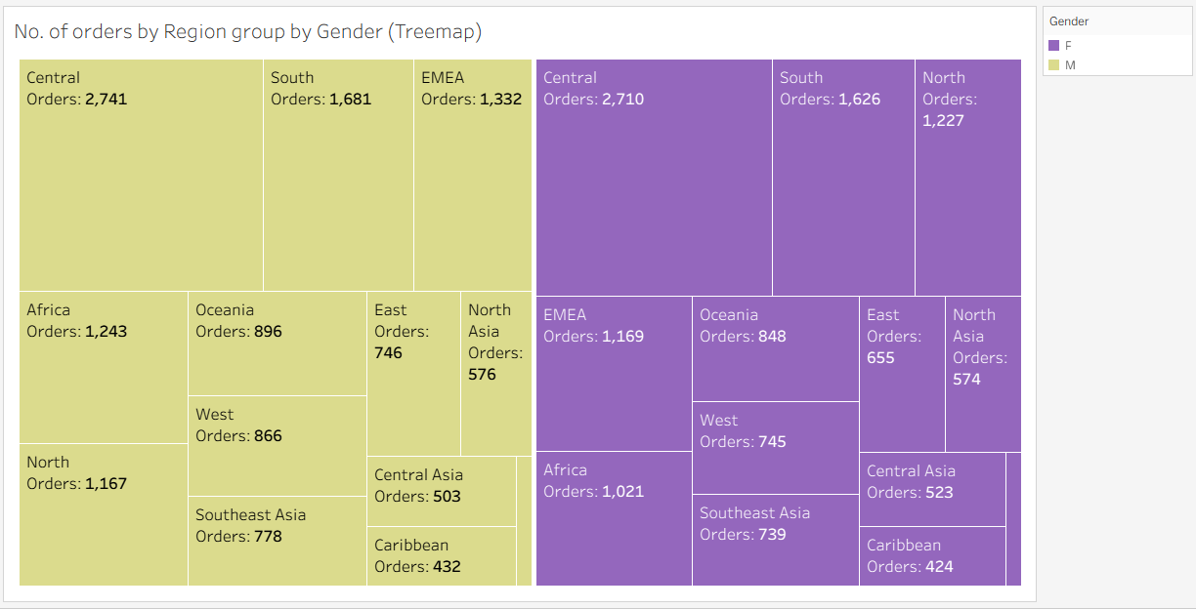
Example- Profit value asked
1. Year 1
Roll up
2. Quarter 4
Drill down
3. Month 12
4. Week 52
5. Days 365

Line Chart – used to represent data of time series

To create line chart, use one date field and one measure. Always add the date field in column and measure in row for line chart.
what is Time series data?
Data which is recorded/separated by uniform time intervals.
Line Chart – used to represent data of time series

To create line chart, use one date field and one measure. Always add the date field in column and measure in row for line chart.

Two varieties of line chart-
1. Discrete - Here the line chart is created for individual date part e.g. day, month, quarter, etc.
Shown in BLUE color.
2. Continuous - Here the line chart is created using year and individual date part month or quarter.
Shown in GREEN color.
Revenue by Order Date
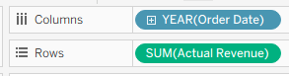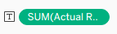
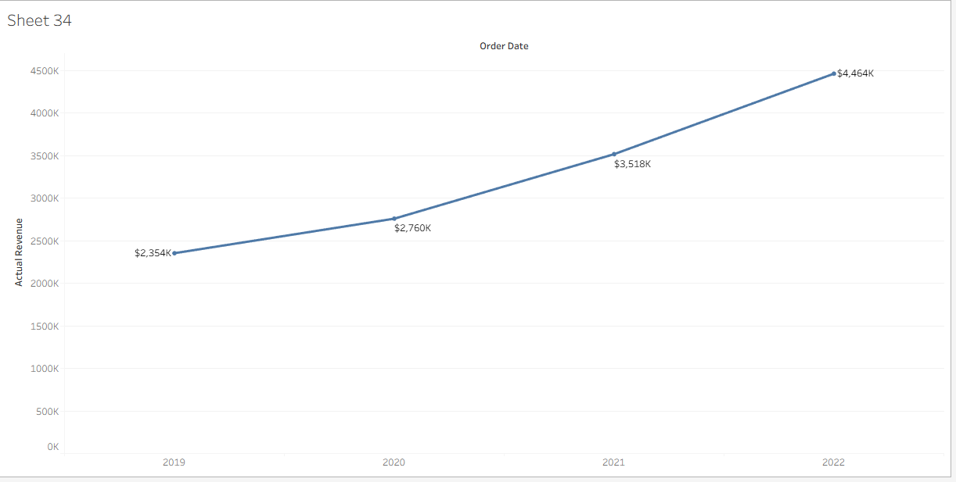
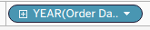 Click on the Plus sign 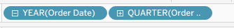
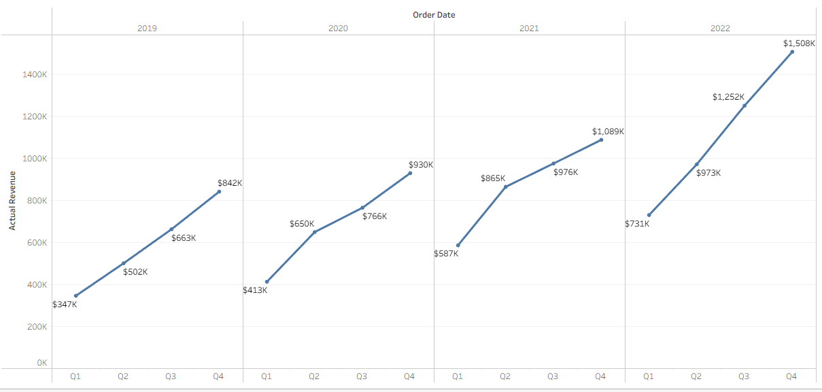
Click again on QUARTER(..)
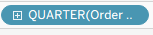 =>
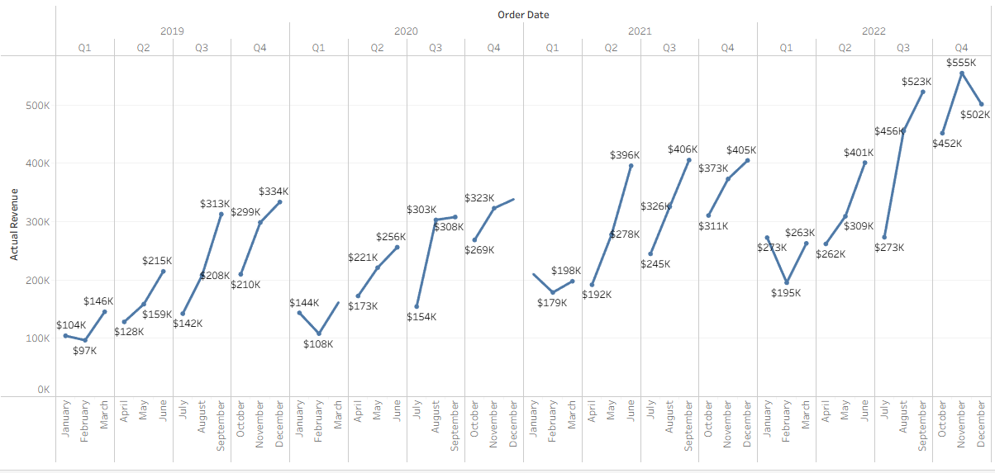
Click once on MONTH(..) to get 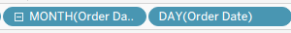
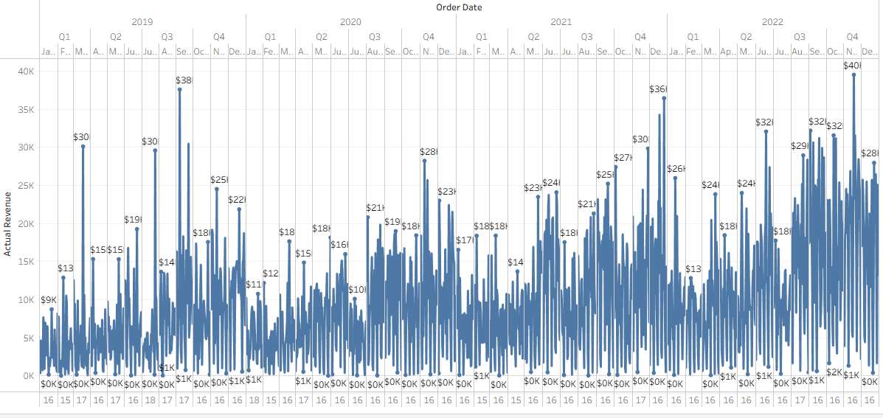
Quarterly Revenue for each year (Discrete line)

Come back to Quarters
Create a new sheet with exact same details
Right click on YEAR.
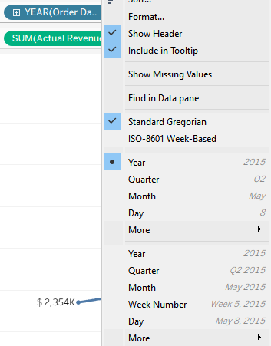
Continuous
Discrete
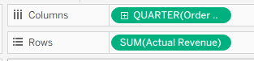
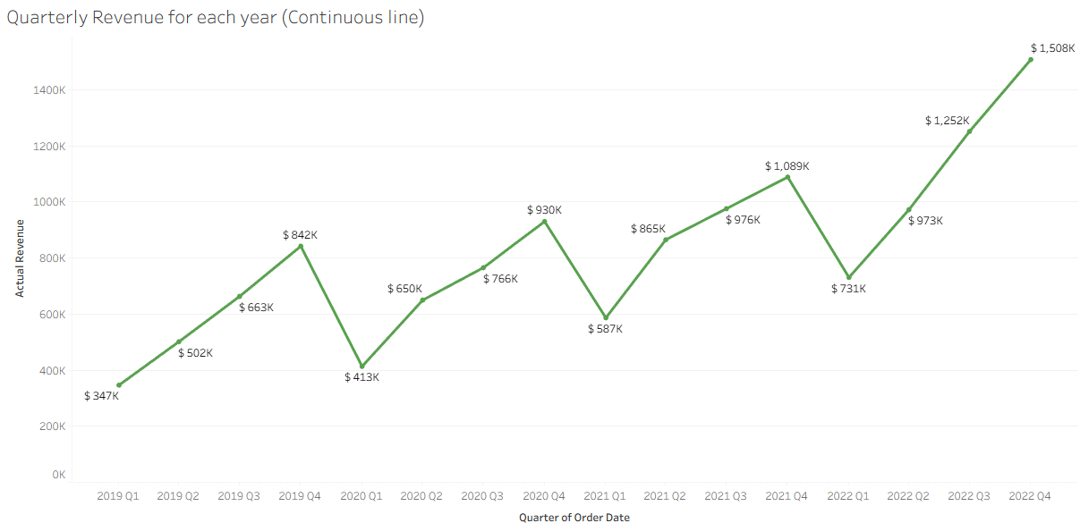

1) Quarterly Profit for each year (Discrete line)
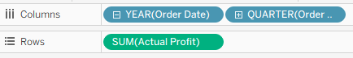
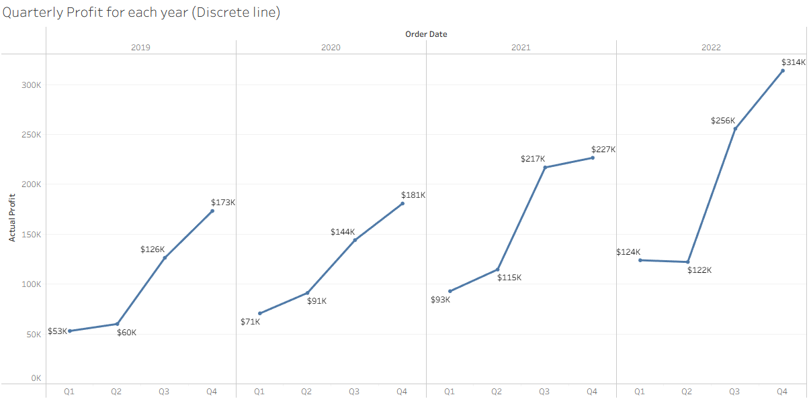
2) Quarterly Quantity for each year (Continuous line)
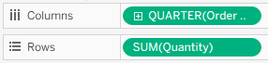
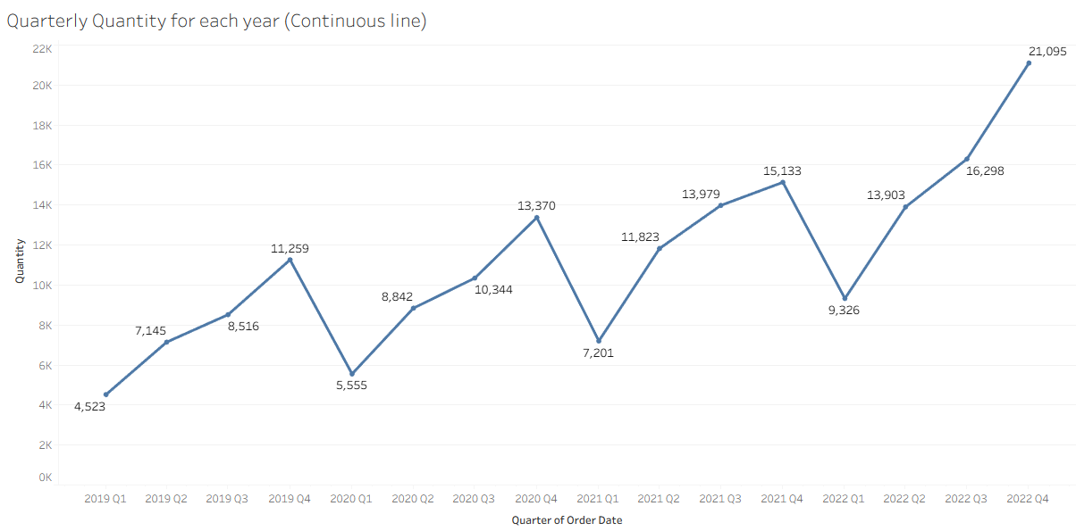
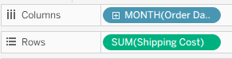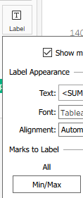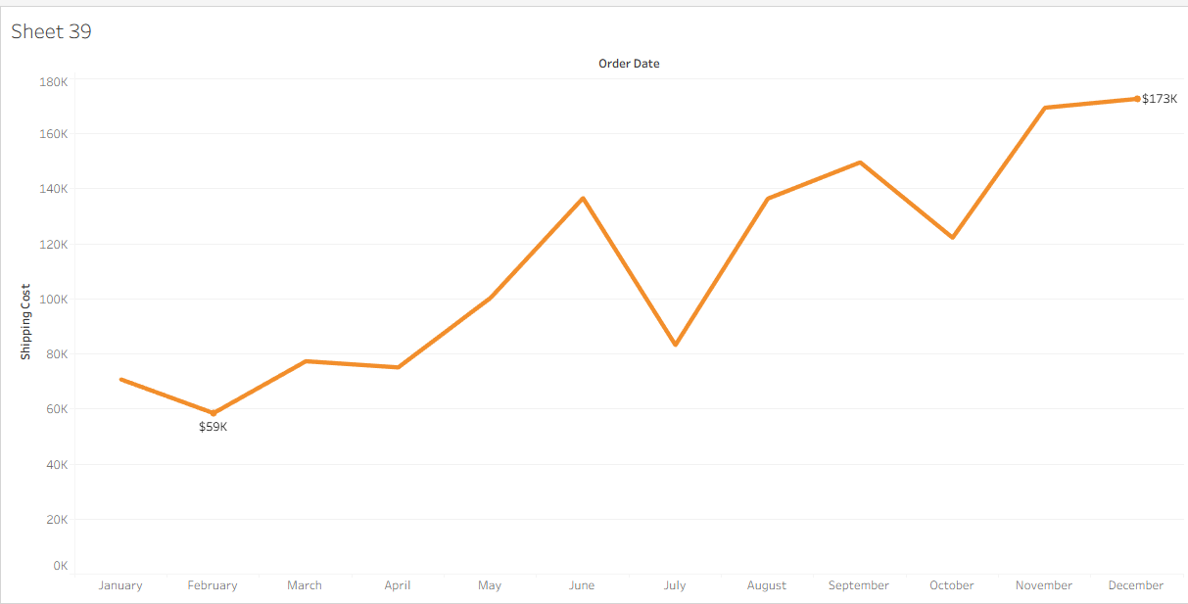

How to add comments on the chart using Annotations?
1. Specific comments
2. General comments
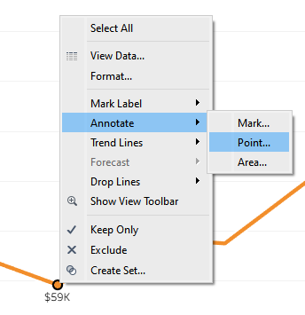

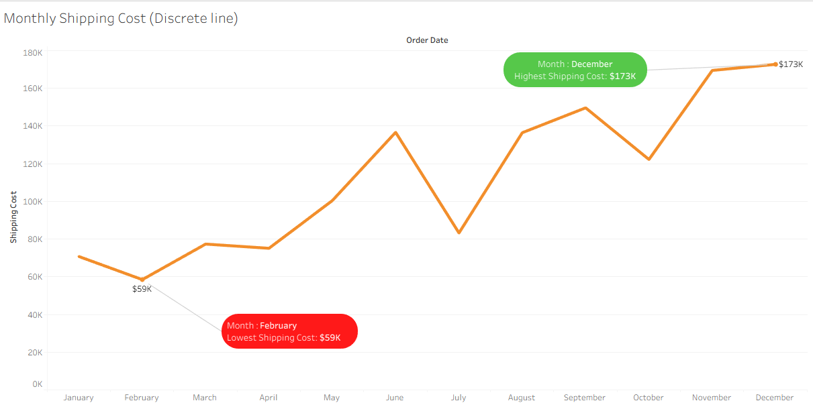
How to add dimension on a line chart
1) Create a line chart of discrete month order date and quantity. min/max labels. Add category on color button.
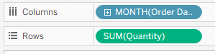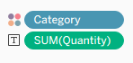
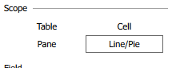 gives min/max for all 3 lines/category
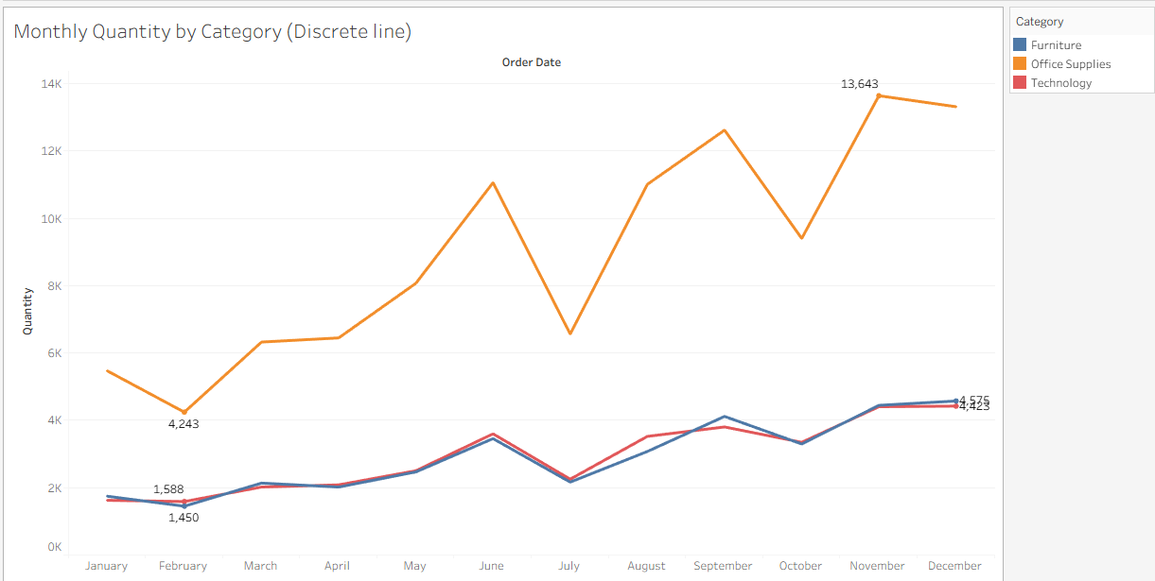
General Comments
Right Click on Blank Area
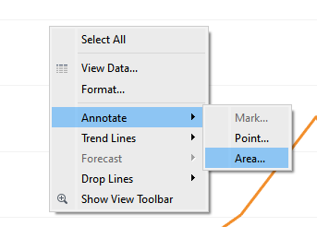
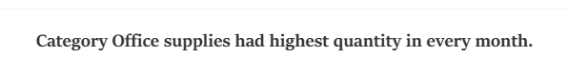
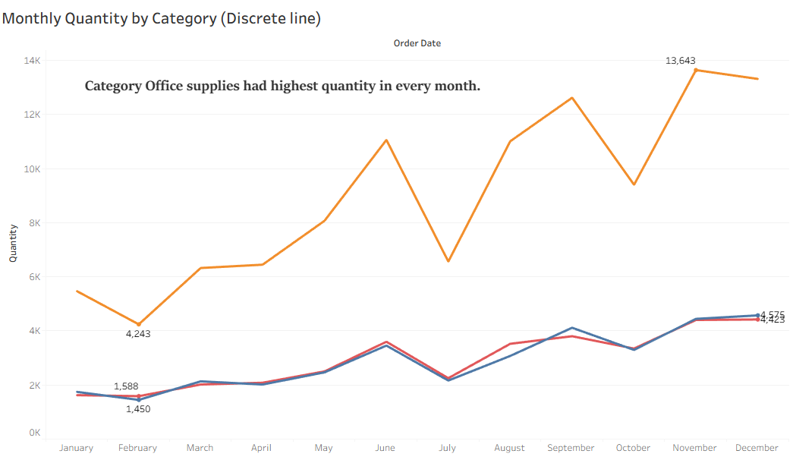

10 am break
Dual Charts
Dual line & Dual combo
These charts are used to compare target (expected) values against the actual values. These charts require one data field and two measures.
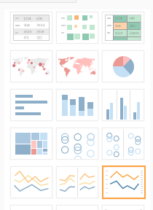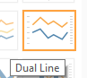
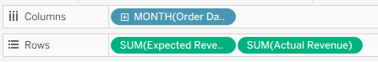
Click again on
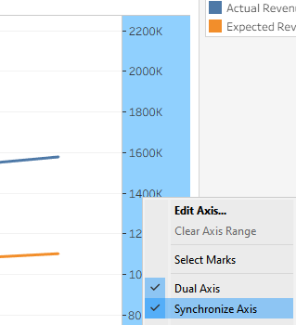
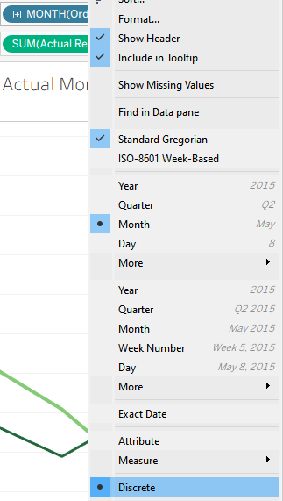
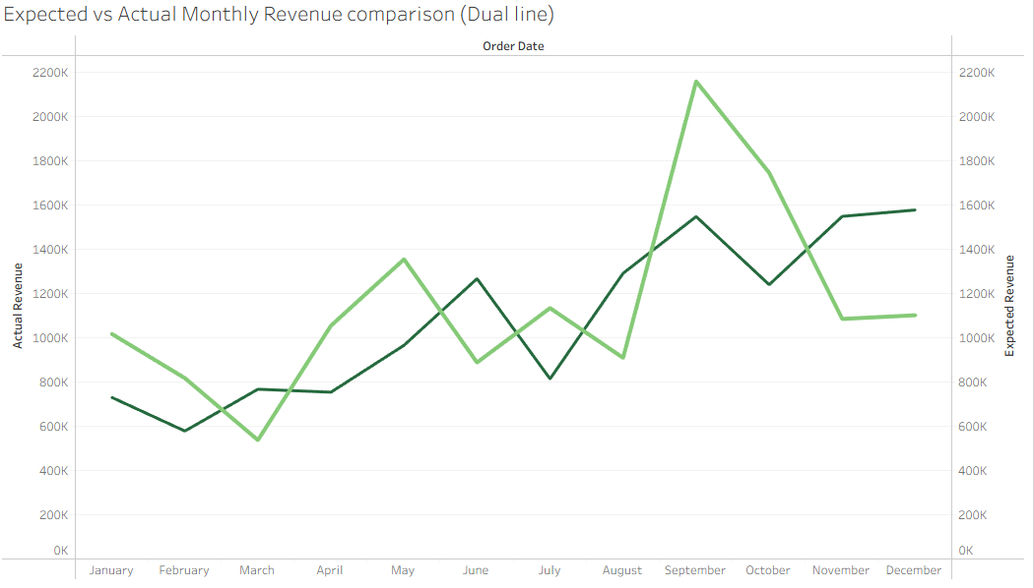
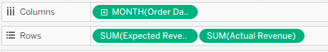
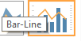
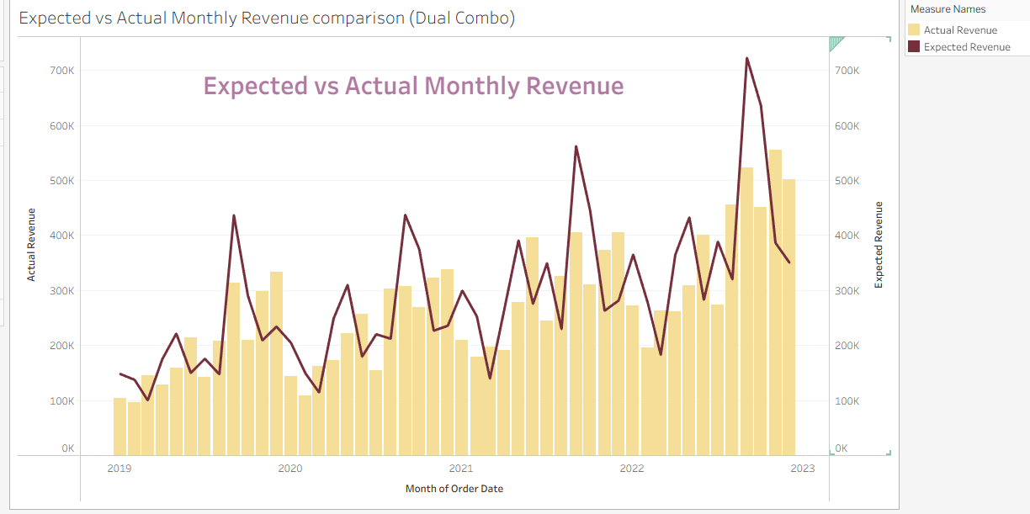

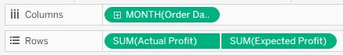
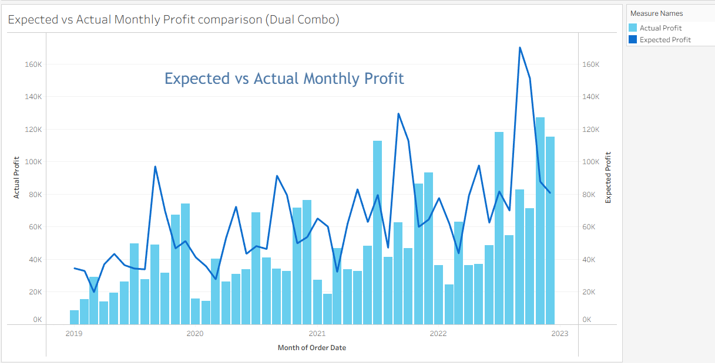

Area Chart
Area chart is alternate to line chart and comes in two varieties - Discrete & Continuous.
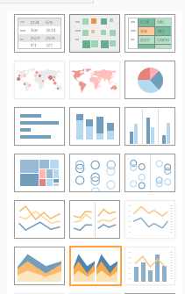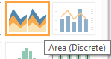
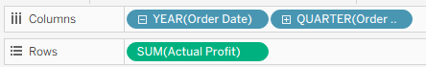
Quarterly Profit for each year (Discrete area)
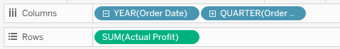
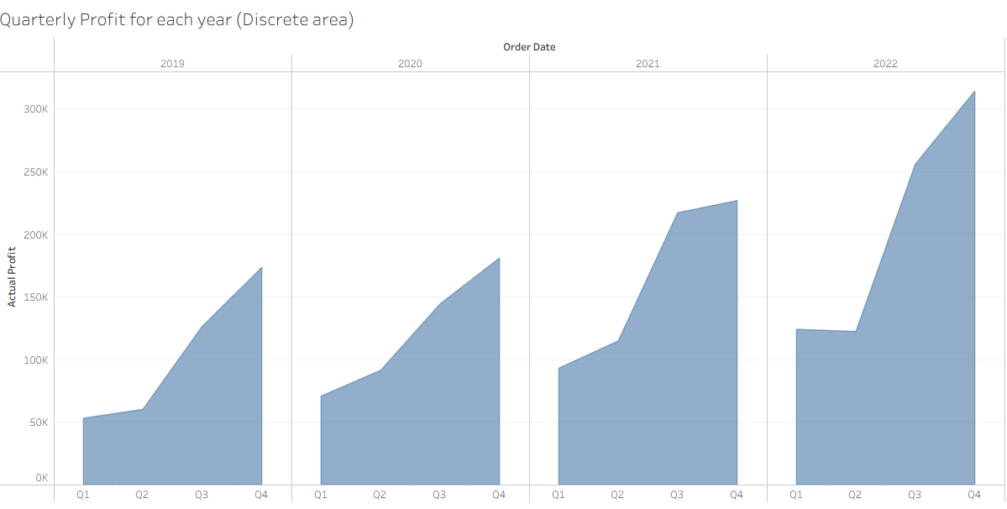
1) Create area chart of continuous month order date using Revenue and show min max labels.
Monthly Revenue for each month (Continuous area)
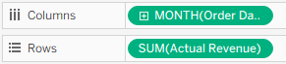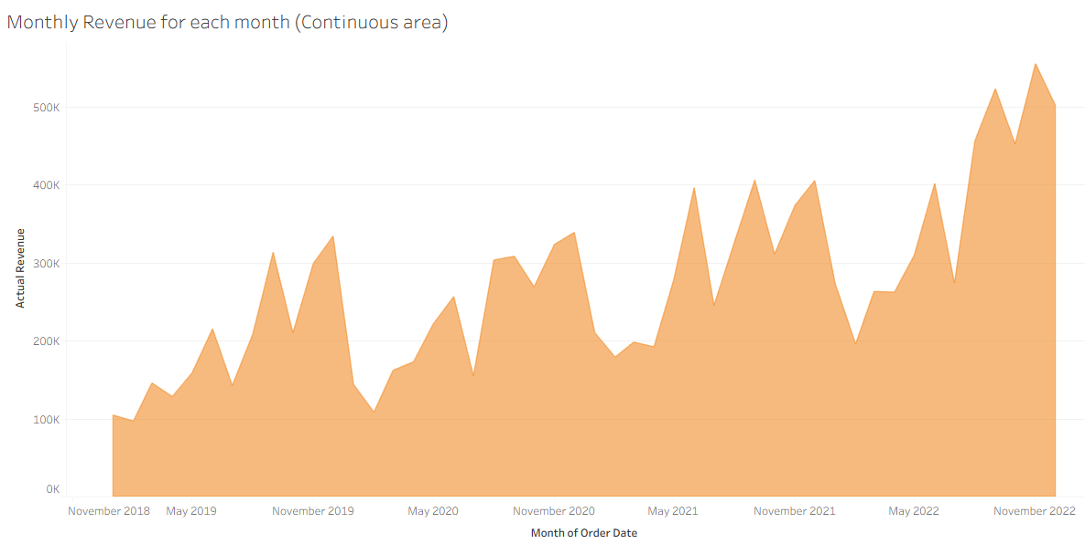
2) Create area chart of continuous month order date using Quantity and show min max labels.
Monthly Quantity for each month (Continuous)
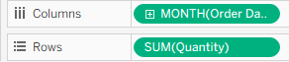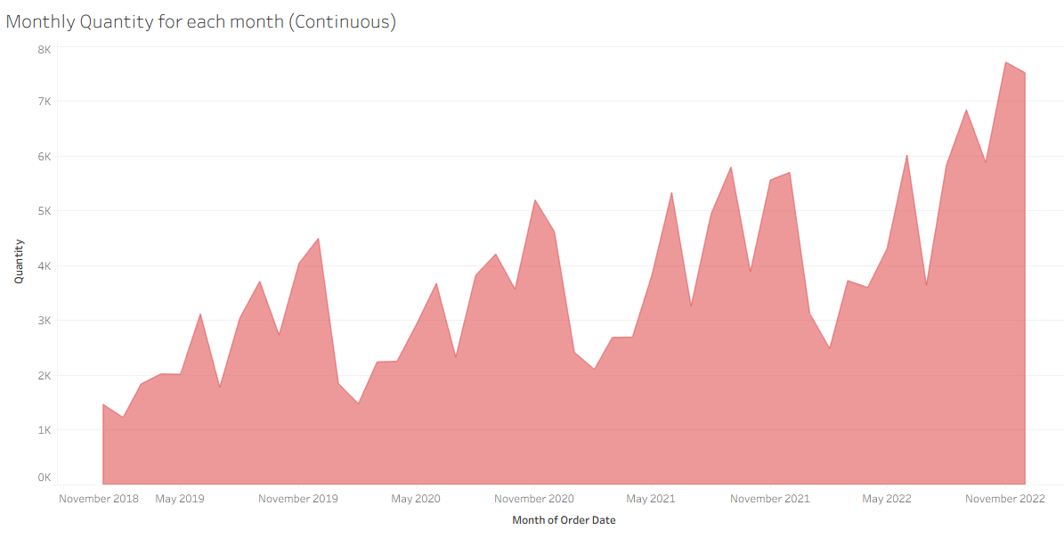
2) Create area chart of continuous month order date using no. of orders and show min max labels.
Monthly Orders for each month (Continuous)
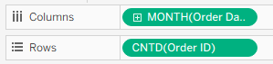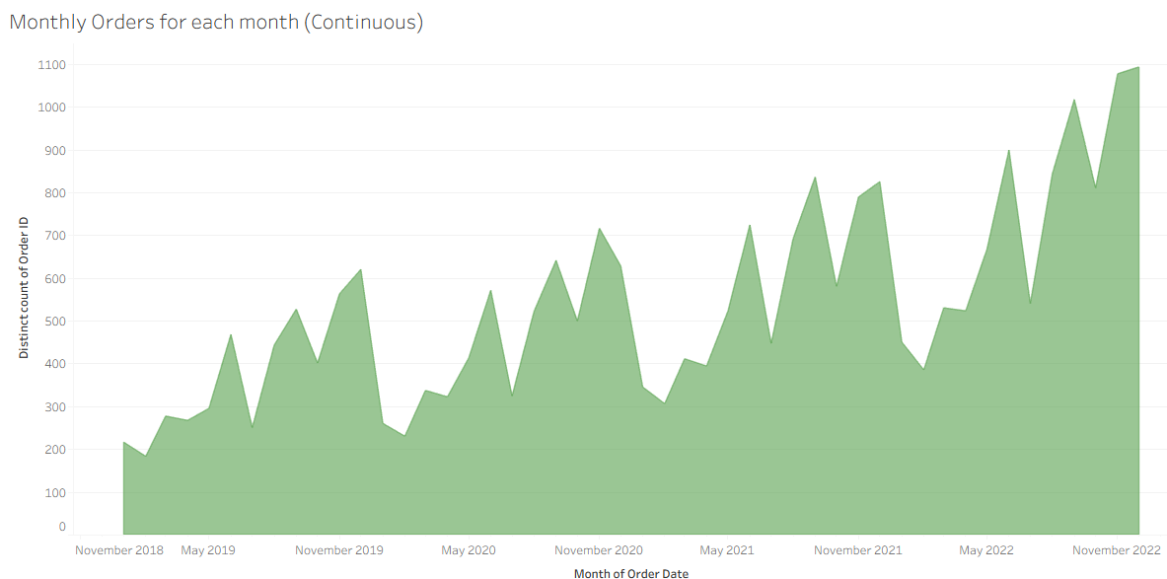

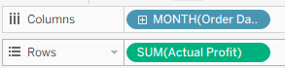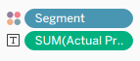
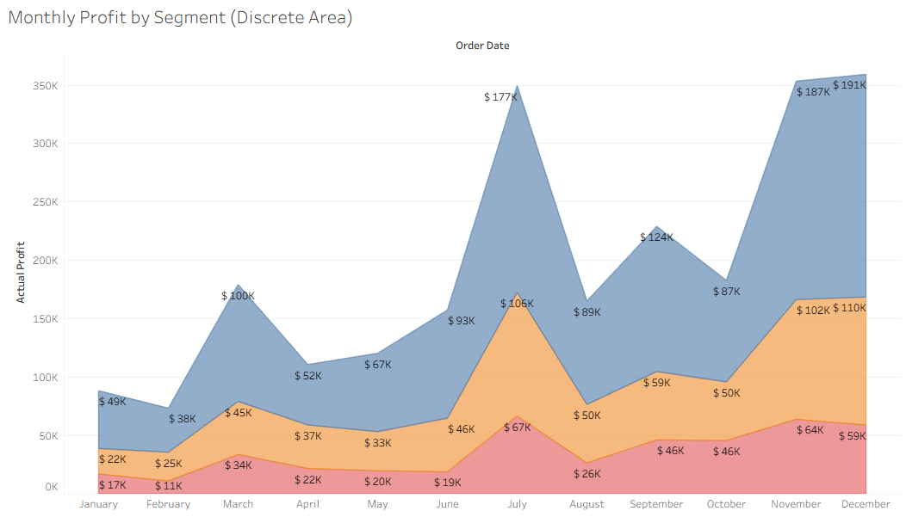

Completed Proj_2
SAVE the Project

