Filters in Tableau-
- Data Source
- Quick
- Dimension
- Measure
- Date
- Top/Bottom
- Context
Data Source Brazil out of all Countries (Why Import all?)

Quick - without selecting filter option
Data Source
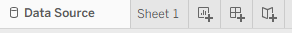
Even before we start
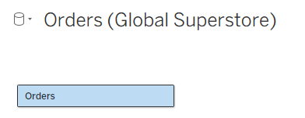
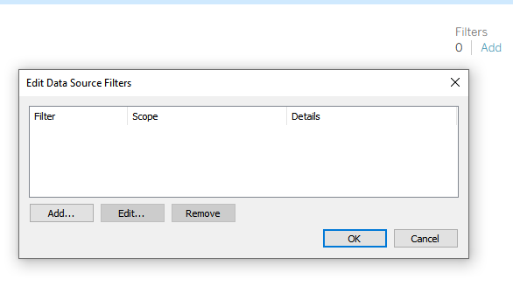
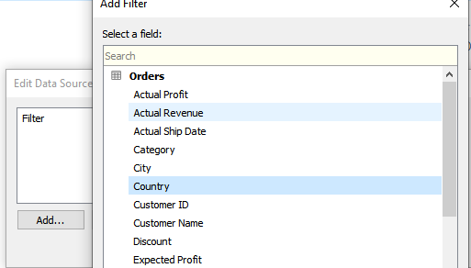
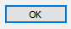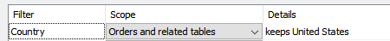
Also Select Furniture
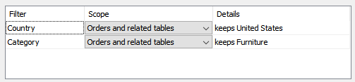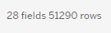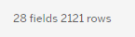
Remove both the filters
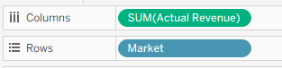 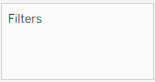
Select EMEA & Africa (with Ctrl)
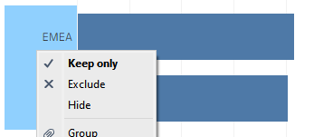
Dimension Filter
Dragging and dropping the col into Filter
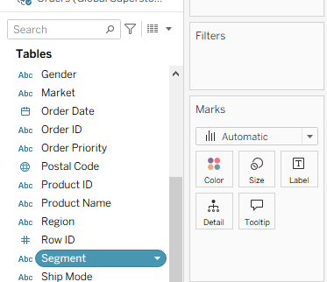 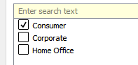
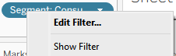
Six styles of dimension filter-
- Multi value list
- Multi value dropdown
- Single value list
- Single value dropdown
- Single value slider
- Wildcard match
Multi is like ( in )
Single is like ( = )
Wildcard is like ( regexp )
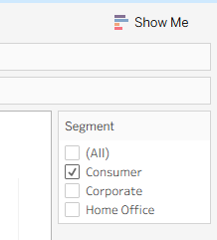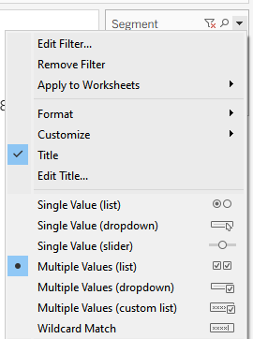

- Multi value list 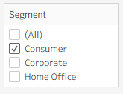
- Multi value dropdown 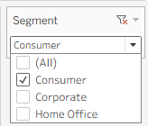
- Single value list 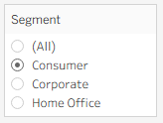
- Single value dropdown 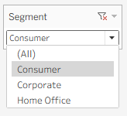
- Single value slider 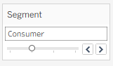
- Wildcard match 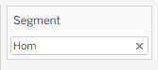 like “%Hom%”

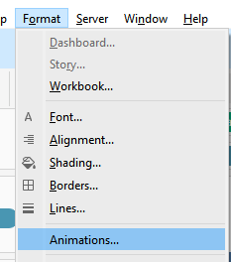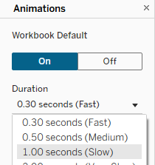
Name for above sheet – Revenue by Market
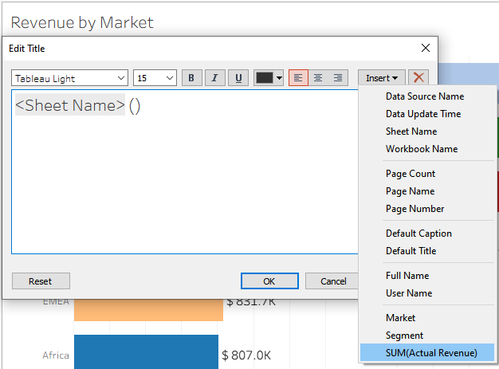
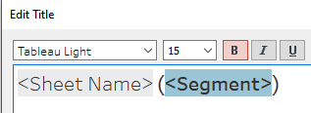
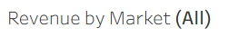
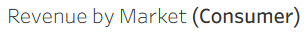
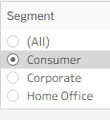
1) Create a treemap of sub-category & profit. Add two fields on the filter - Gender & Market. Show both filters as single value list. Set sheet name as "Profit by Sub-category" and make title dynamic to display selected gender & market.
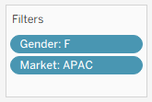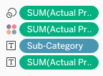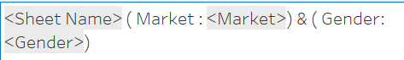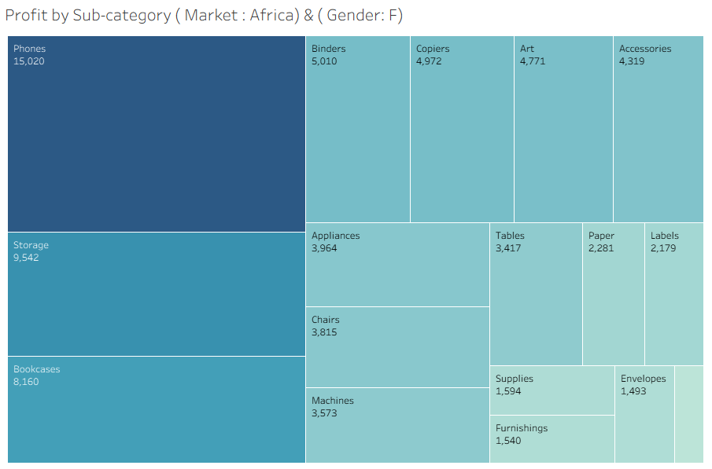
2) Create a discrete are chart using order date month and quantity. Show Min/Max Labels. Add filters - Category & Order priority. Show both filters as single single value dropdown. Make title dynamic.
Monthly Quantity
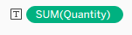
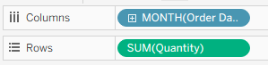
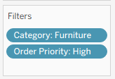
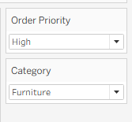
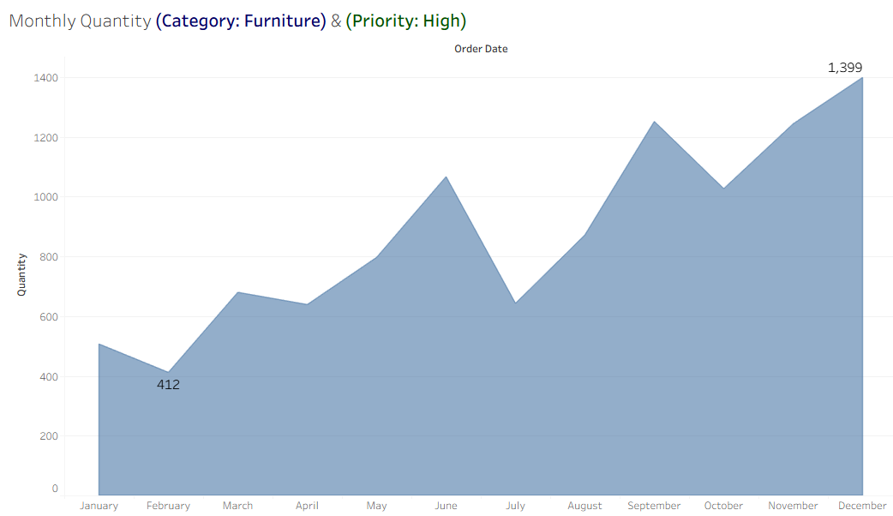

4. Filter by Dimension
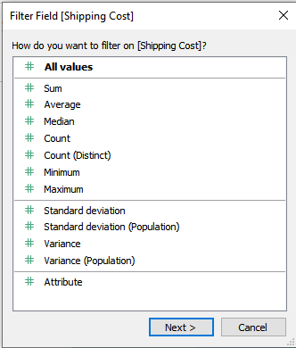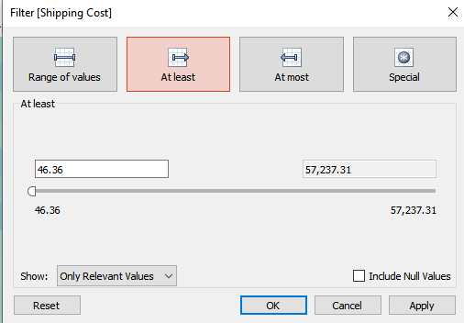
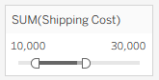
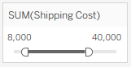
Shipping cost by sub-category & Market
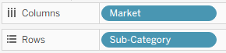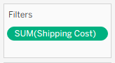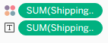
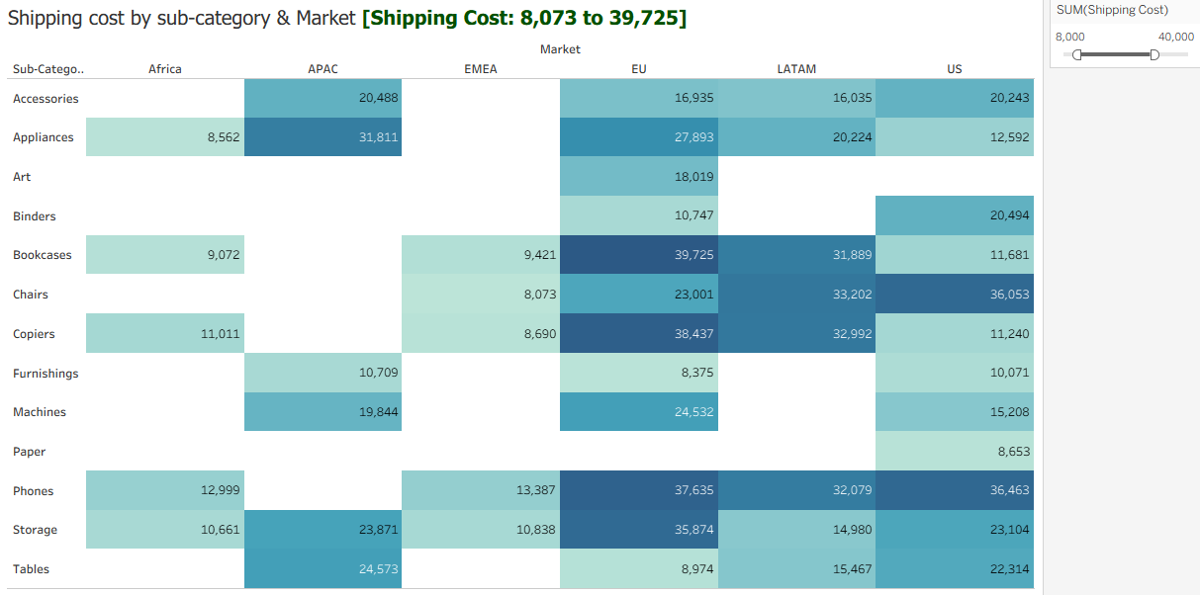
1) Create side-by-side bar chart using Segment, Ship Mode and Revenue. Show labels for revenuw. Then add revenue on filter and show it. Make title dynamic.
Revenue by Segment & Ship Mode.
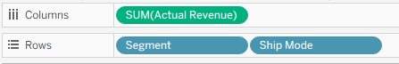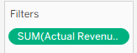
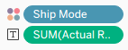
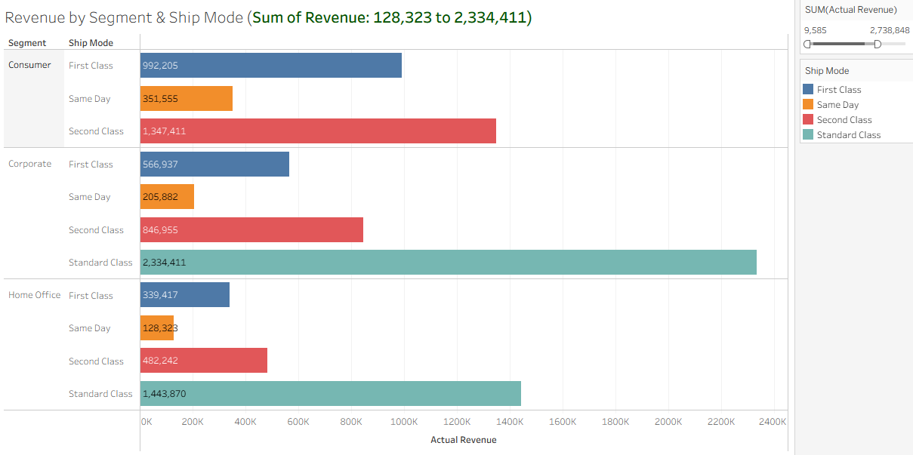
5. Date
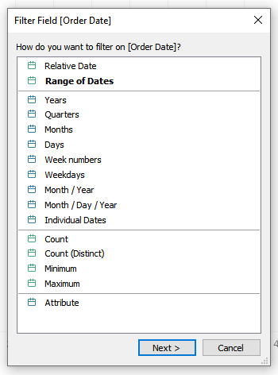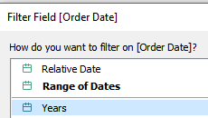
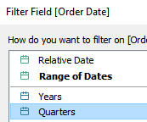 Quantity by Region
1) Create solid map of country & profit. Use diverging color for profit & loss. Add order date filter of type – Month/Year. Show filter as single value slider. Make it dynamic
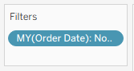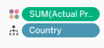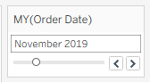
Profit by Country
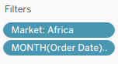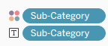
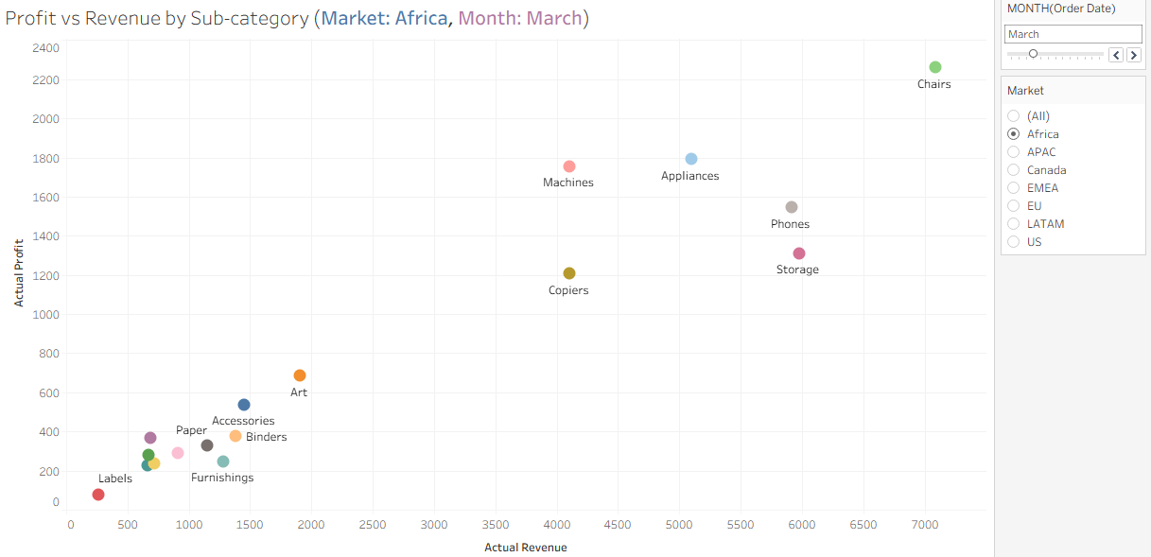
Profit vs Revenue by Sub-category
6. Top/Down
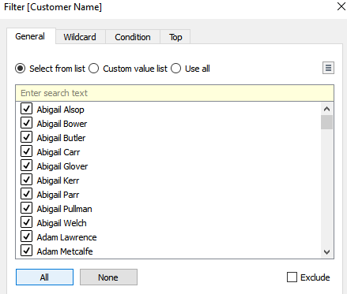
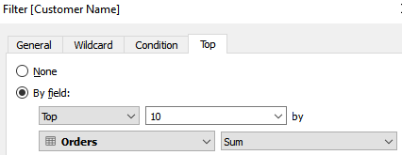
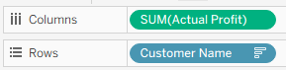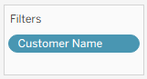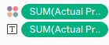
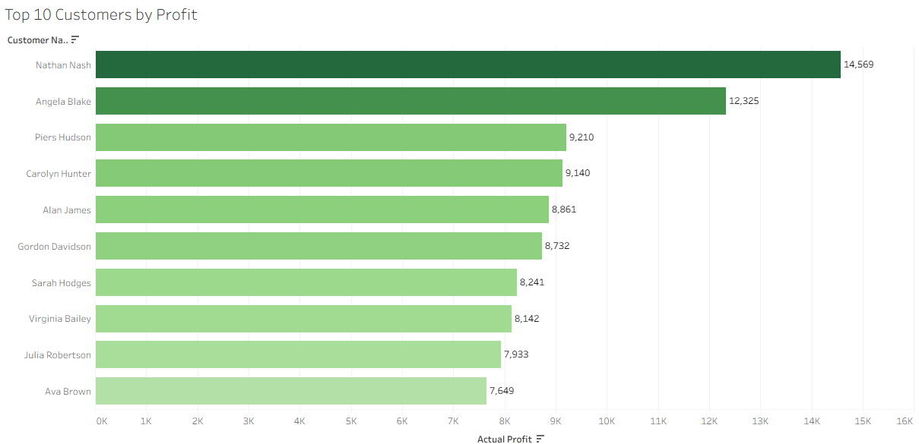
Top 10 Customers by Profit
1) Create a treemap of top 15 customers by shipping cost.
Top 15 Customers by Shipping cost
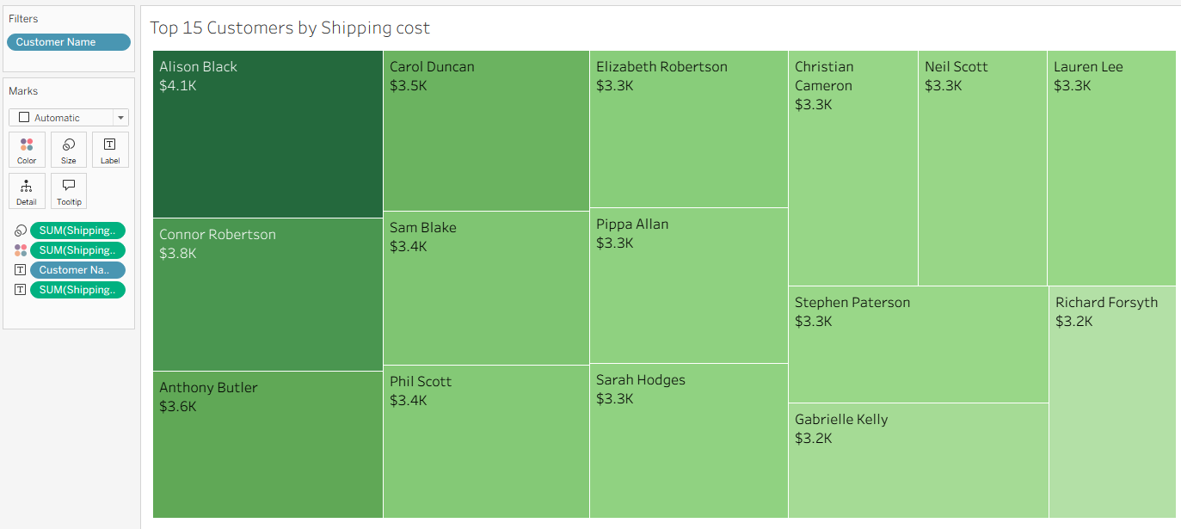
2) Create bubble chart of bottom 8 product names by revenue.
Bottom 8 Products by Revenue
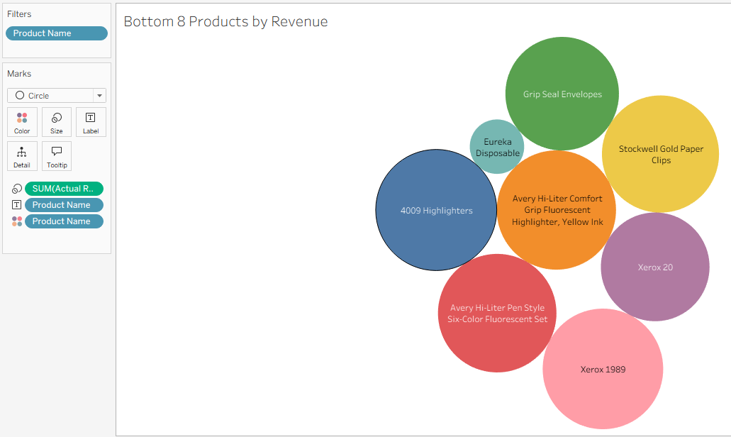
3) Create a bar chart of bottom 12 products by quantity.
Bottom 12 Products by Quantity
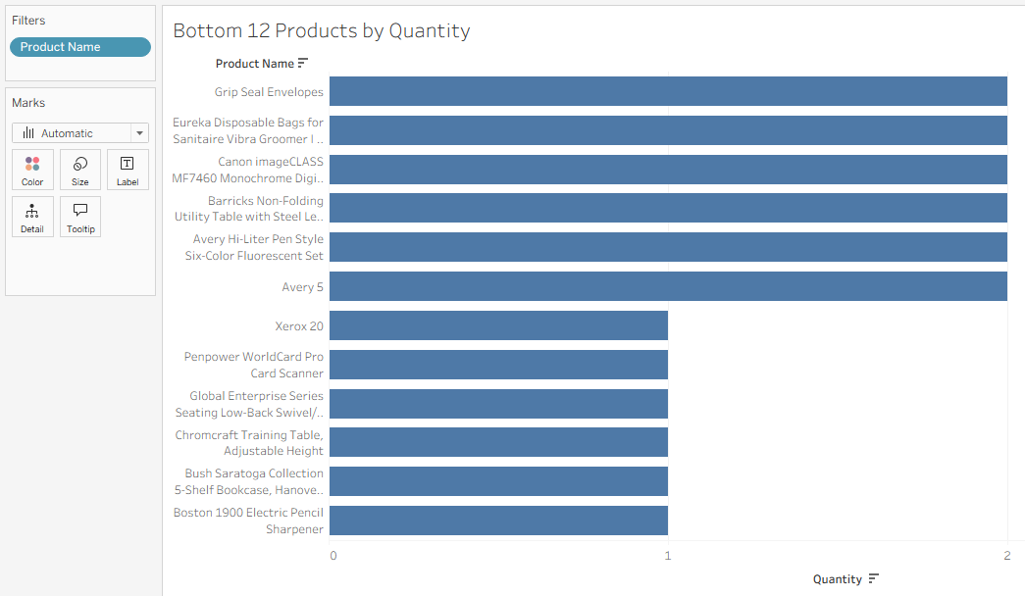
4) Top 5 Countries by No. of Orders
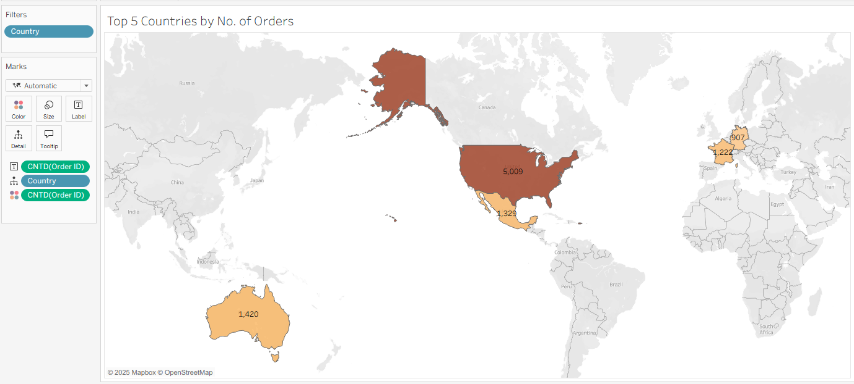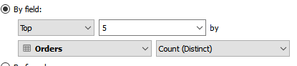
7. Context Filter
This type of filter is needed when regular filter is added to existing top/bottom filter to fox no. of records returned

Top bottom filter with regular filter,
then regular filter becomes context.
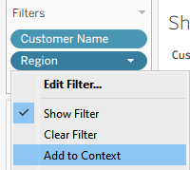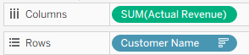
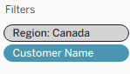 Becomes grey
Top 10 customers by Revenue (Context Filter)
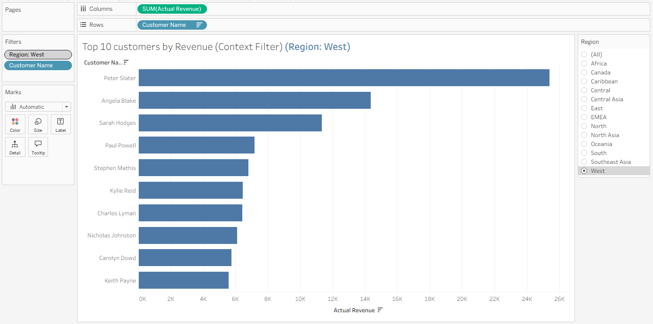
1) Display bottom 5 sub-categories by profit. Add region filter. And verify 5 sub-categories for each region.
Bottom 5 sub-categories by Profit (Context Filter)

2) Top 10 countries by Shipping cost (Context Filter)
solid map
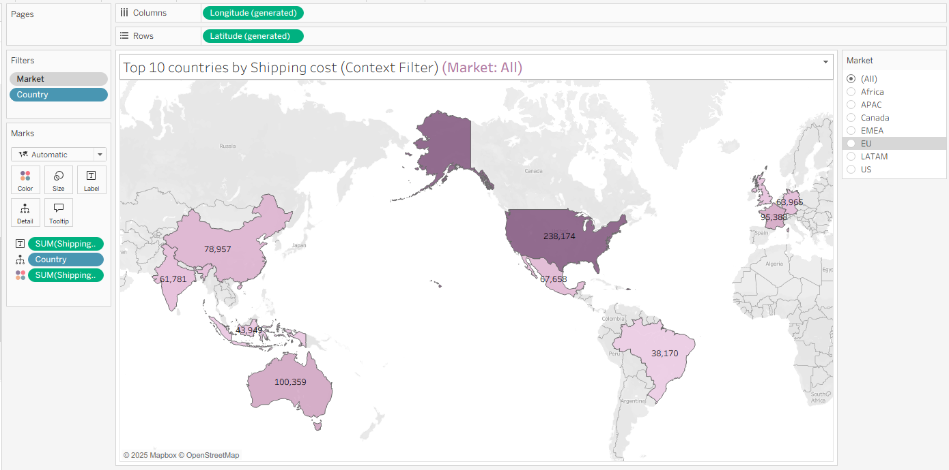

How to create custom groups in Tableau?
Create 4 groups of sub-categories as below
- SubCat Grp 1 – Accessories, labels, Storage & Phones
- SubCat Grp 2 – Tables, Appliances, Paper & Art
- SubCat Grp 3 – Furnishing, Copier, Binder & Machine
- SubCat Grp 4 – Chair, Bookcases, Envelope, Fastner & Supplies
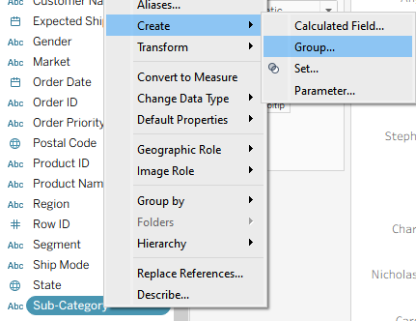
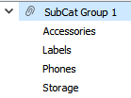
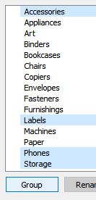 Add other groups accordingly
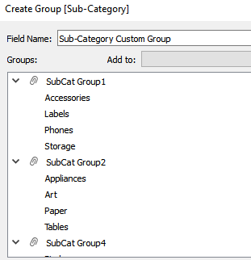

Create a tree map of Sub-Cat & Profit
Profit by Sub-Category Custom Group
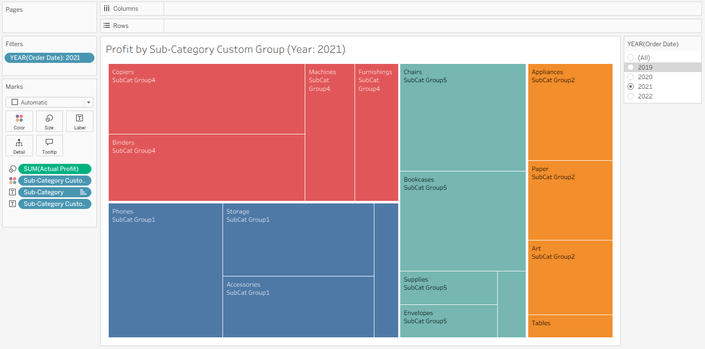
1) Discrete Month (Order Date) line chart of Quantity. min/max of Qty
Monthly Quantity by Sub Category Group
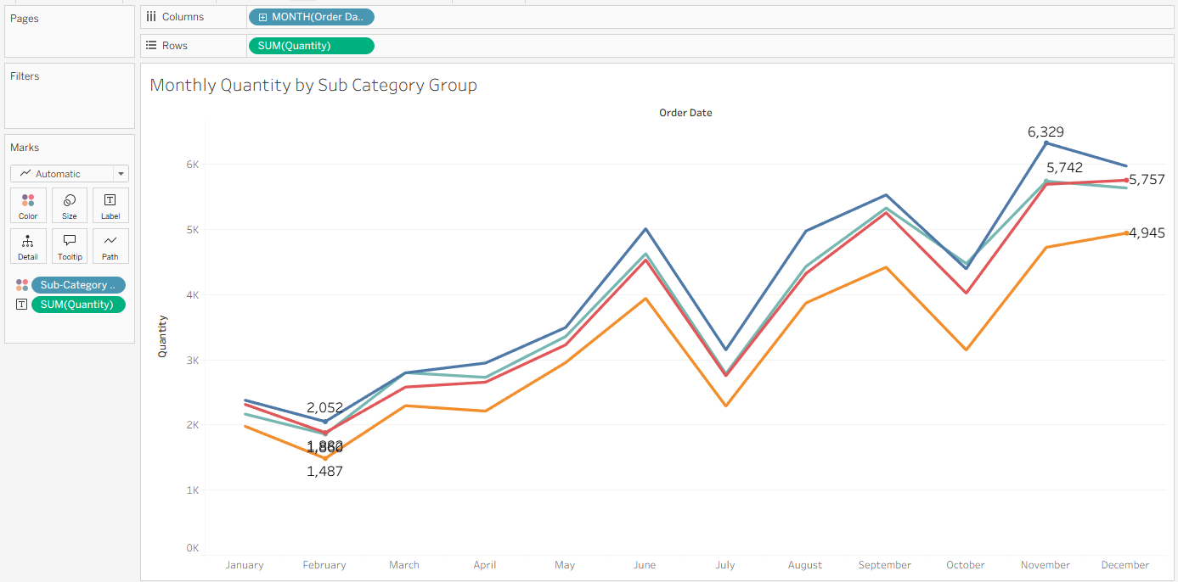
Create 4 Custom Groups using Region as below-
1) Region Group 1 - South, Central asia, EMEA & West
2) Region Group 2 - Central, Canada, Caribbean, East
3) Region Group 3 - North, Oceania, North Asia, Southeast Asia & Africa

Then using these groups, create following charts
a) Create discrete monthly line chart using Profit. Add custom group to color.
Monthly Profit by Region Group
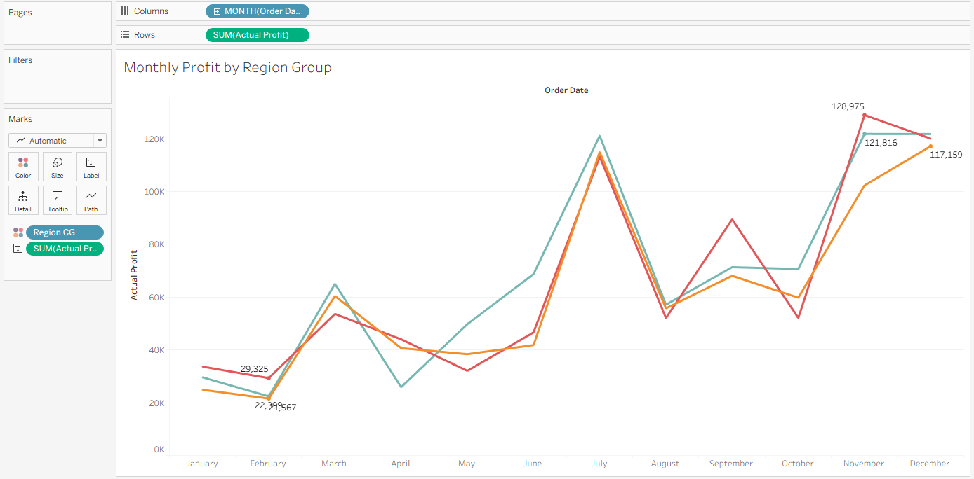
b) Create Treemap using Region & Quantity. Add custom group to color.
Quantity vs Region
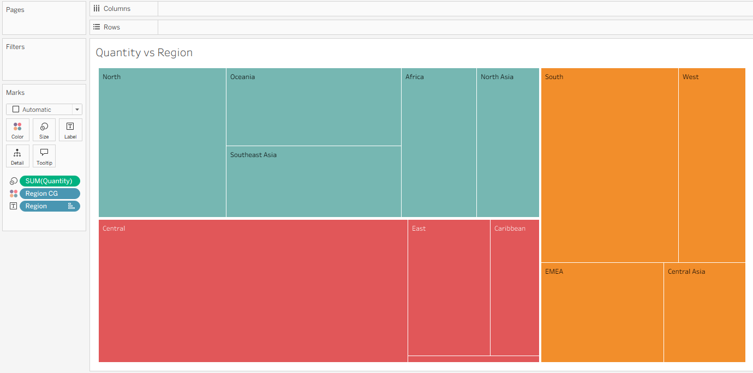

Parameters in Tableau
two types of parameters-
1. Regular parameter
2. Reference line parameter
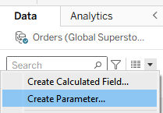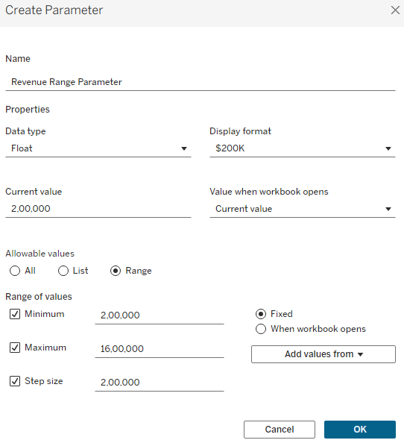
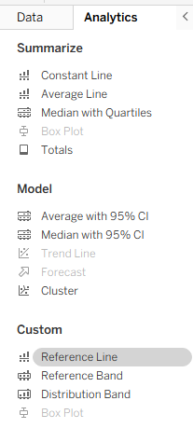 Double Click it
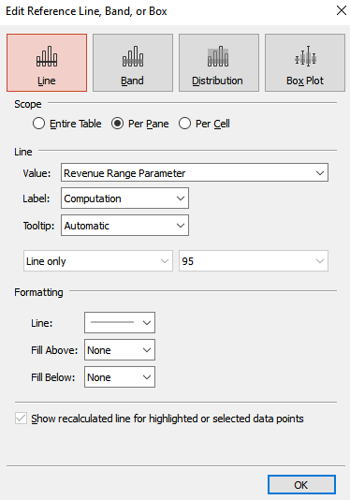
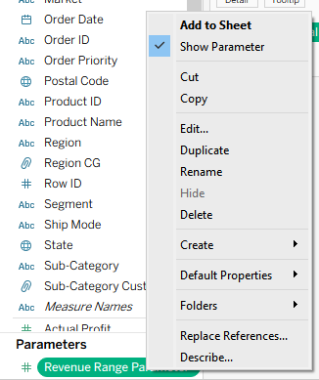
Right click on the line 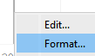 Format
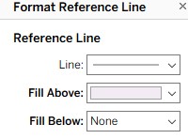 Select Light color
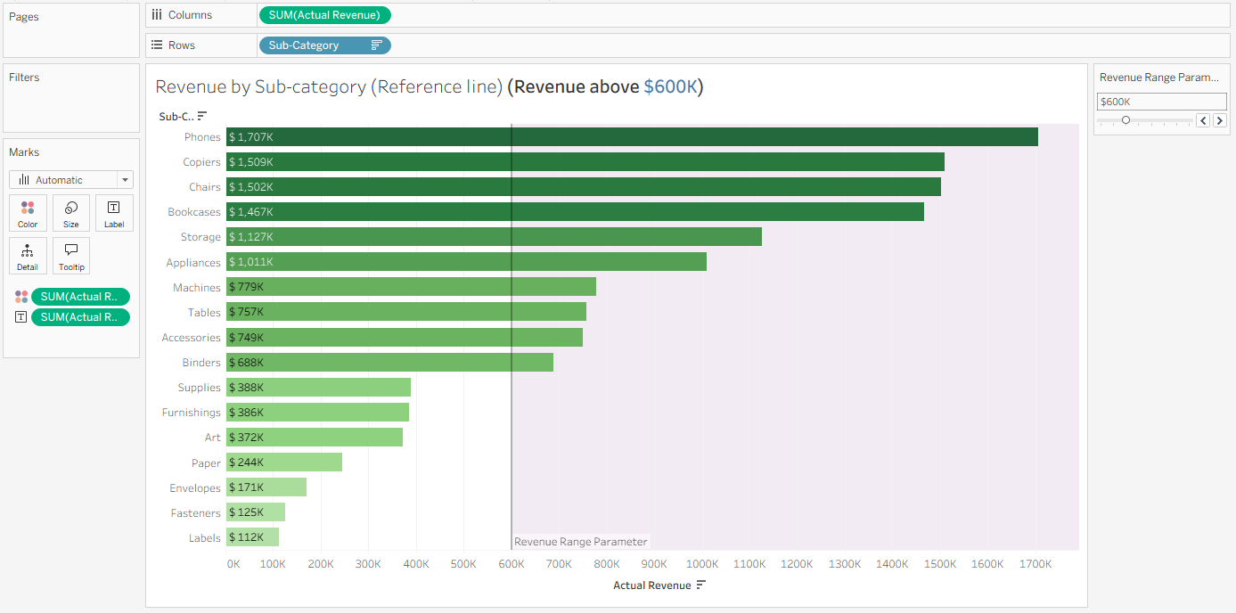
This is with edit color

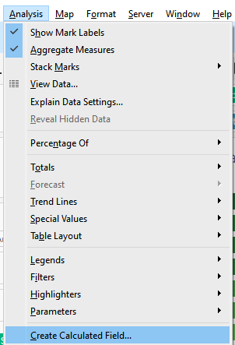
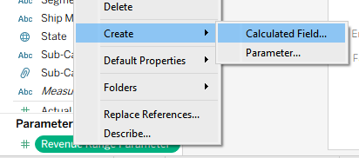

OR

SUM([Actual Revenue]) > [Revenue Range Parameter]
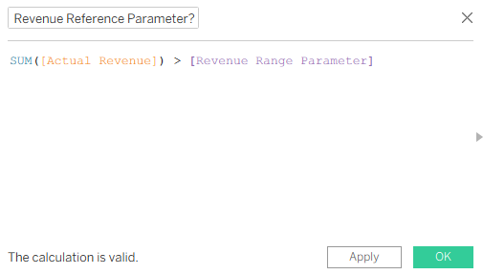
Here the min is 112k and max is 1707k
Took ref value as 200k and 1600k, then the step size as 200k.
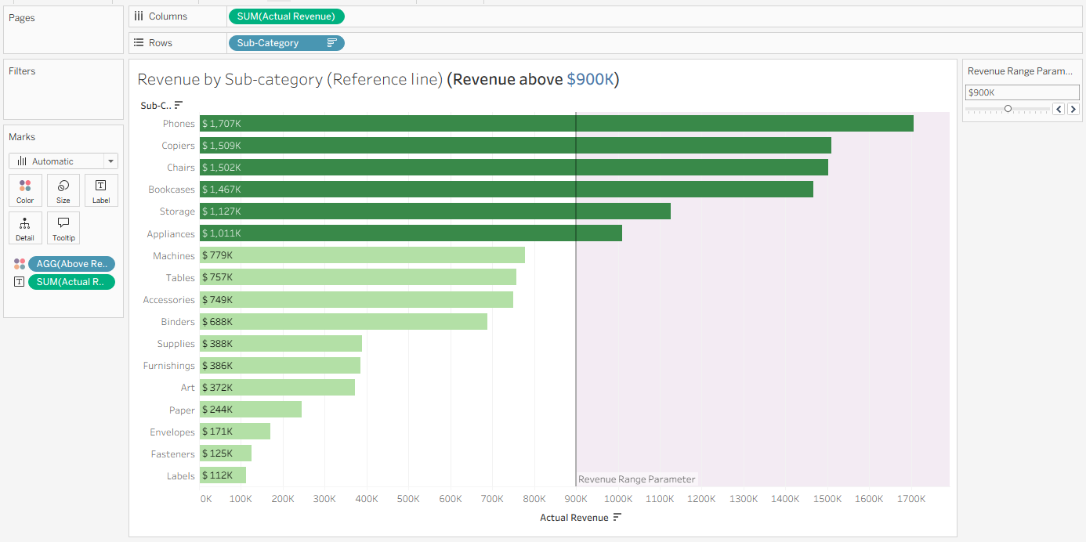
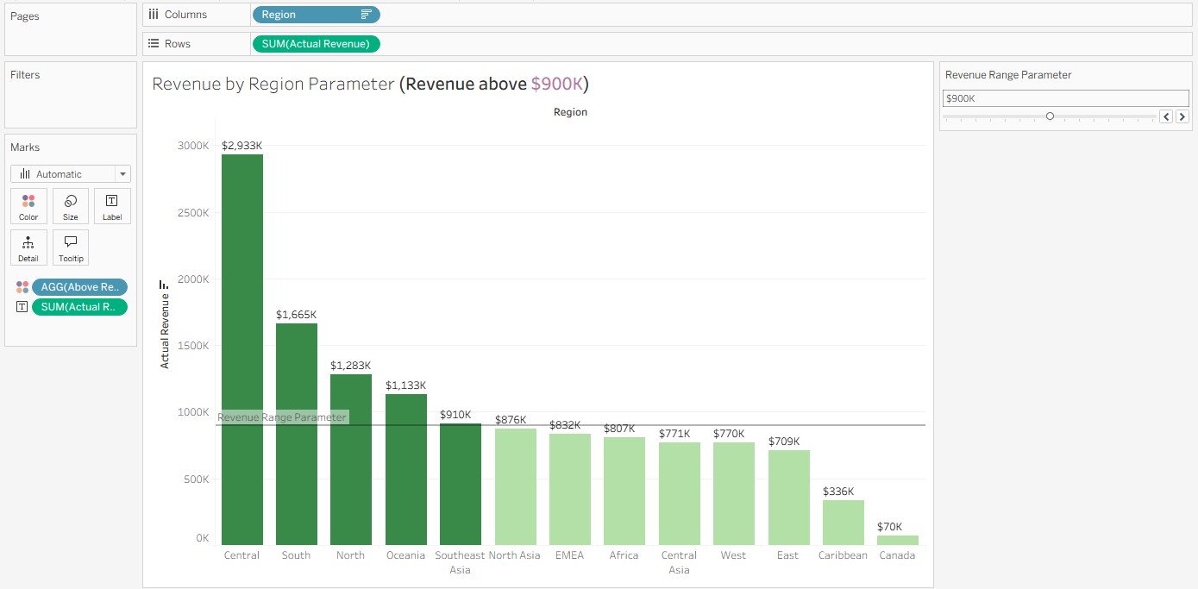
New parameter created-
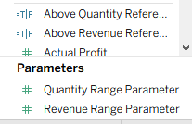
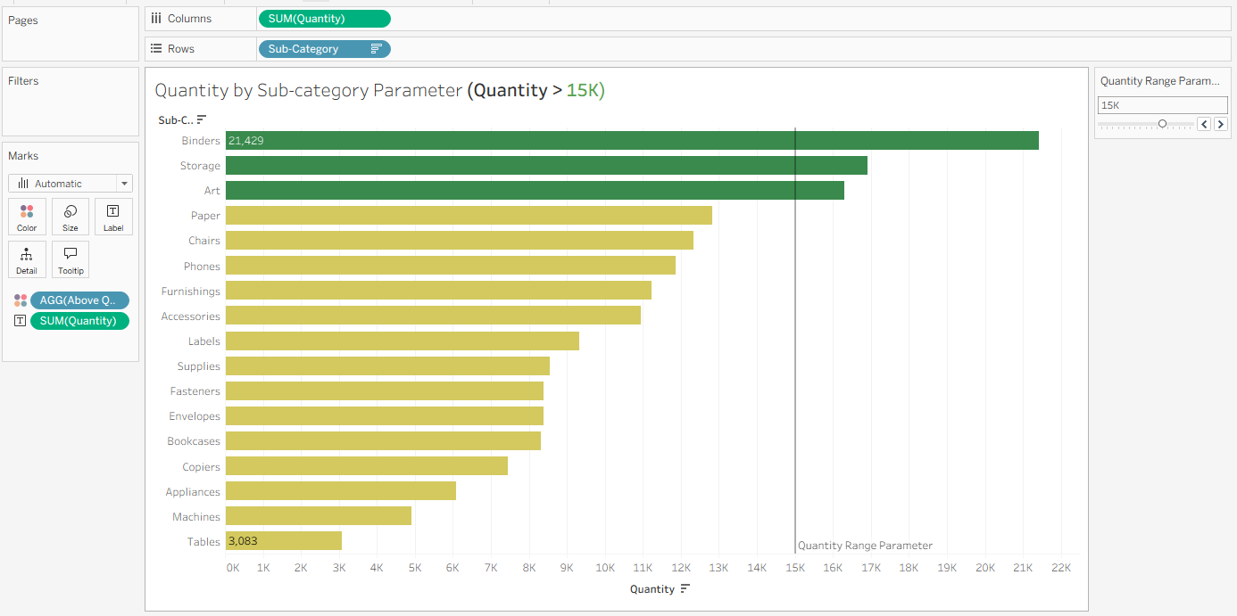
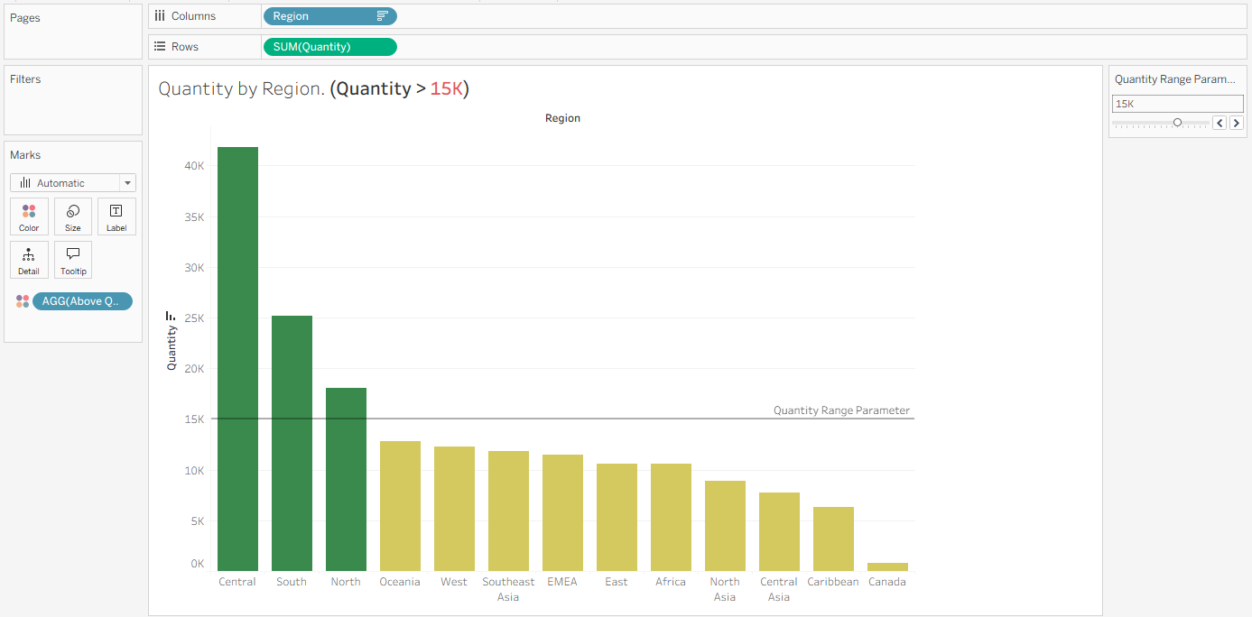

Calculated fields
Calculated fields – used to create custom calculations in Tableau e.g. to build KPIs

Two types of calculated fields –
- Regular fields
- Fields with parameters

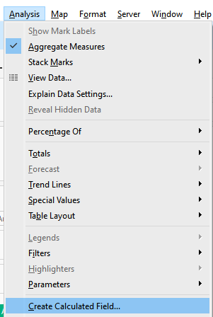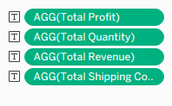
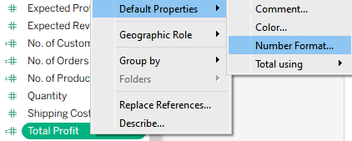

Total Revenue
Total Profit
Total Quantity
Total Shipping Cost
Avg Discount
No. of Orders
No. of Products
No. of Customers
Order Delayed?

1) Create a treemap of Region and avg discount. Add Segment filter.
Avg. Discount by Region
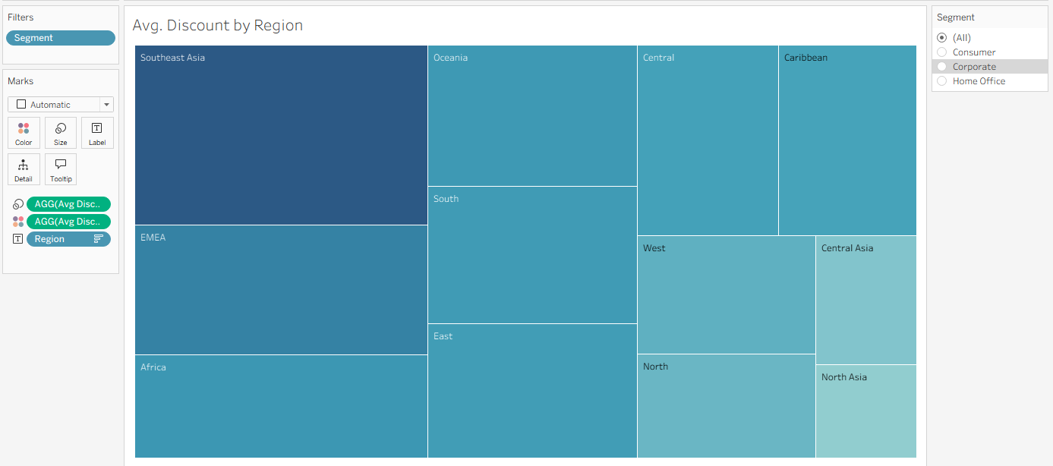
2) Create vertical bar chart of Market and no. of customers. Add filters - Category & Gender
No. of Customers by Market
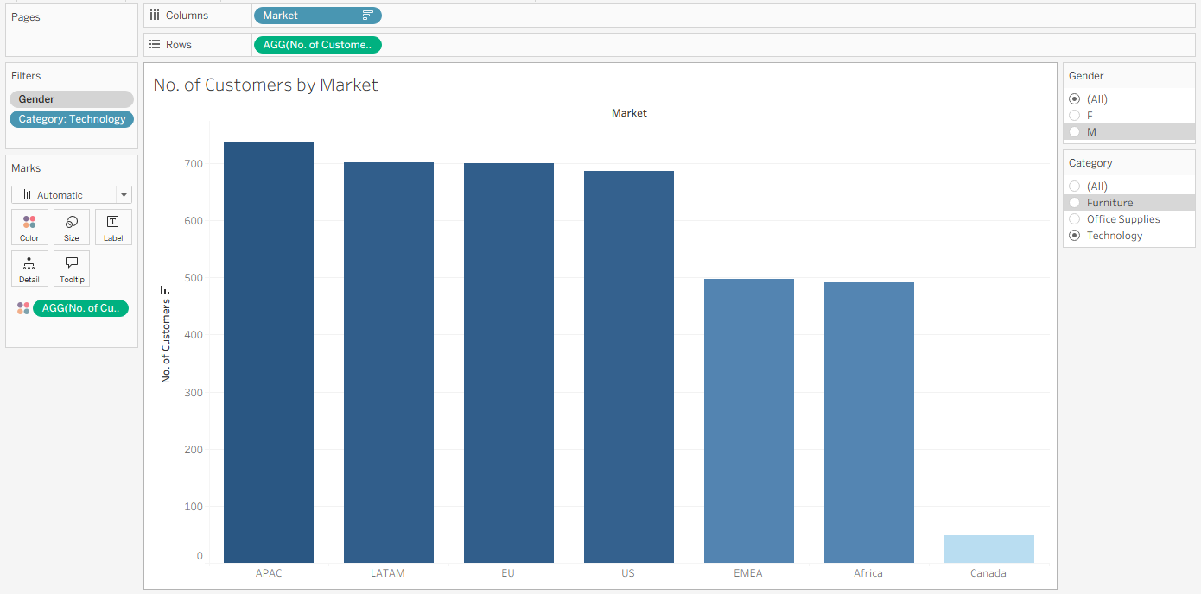
3) Create area chart of discrete month order date and total profit. Add filters - Region. Show min/max
Monthly Profit
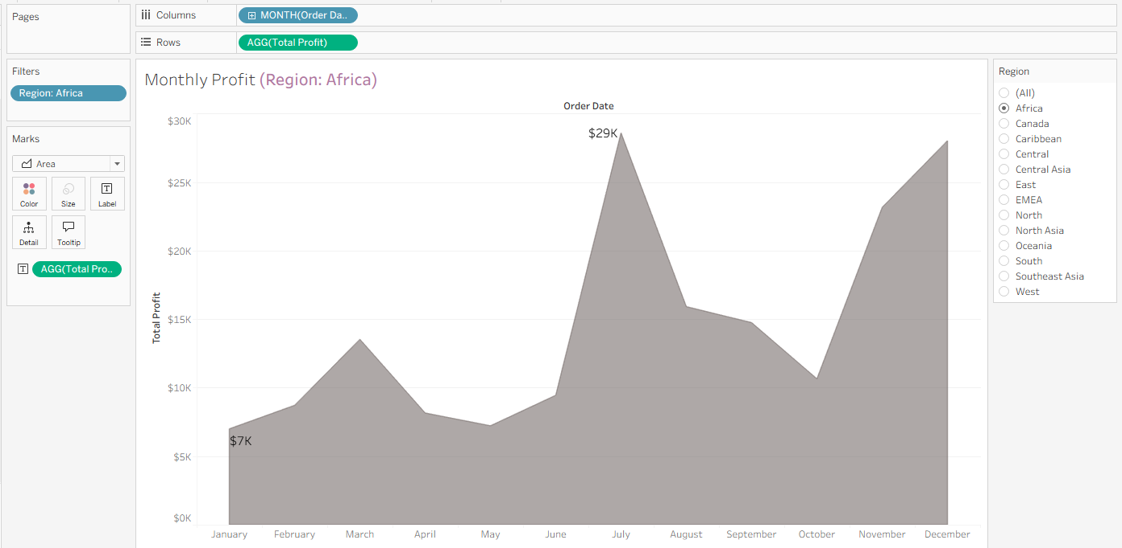
4) Create solid map of country and total quantity. Add filters- Market and Order Date year.
Total Quantity by Country
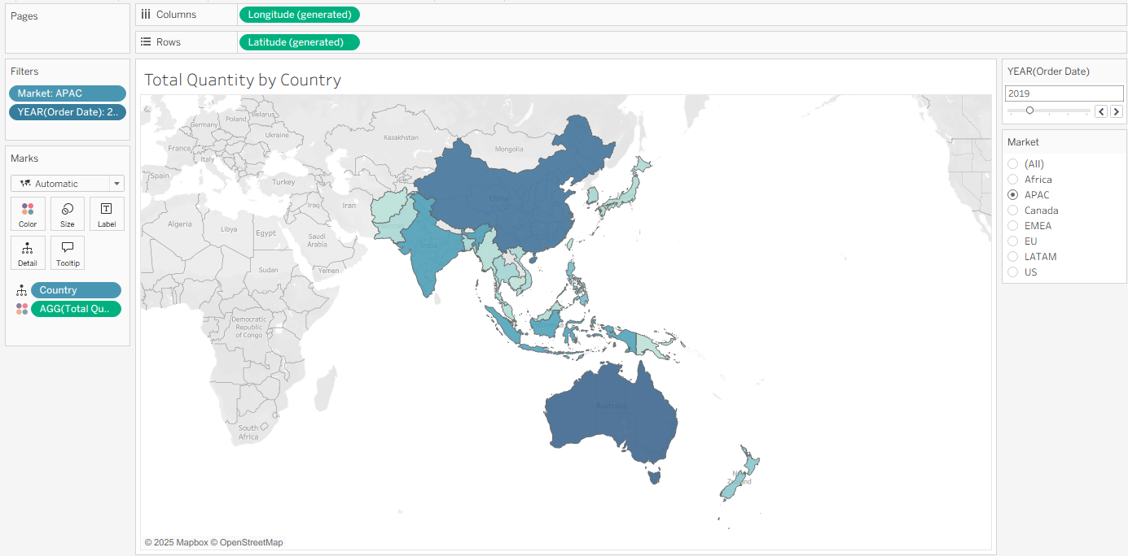
5) Create pie chart of two fields - Order Delayed and no. of orders
Order Delayed vs No. of Orders
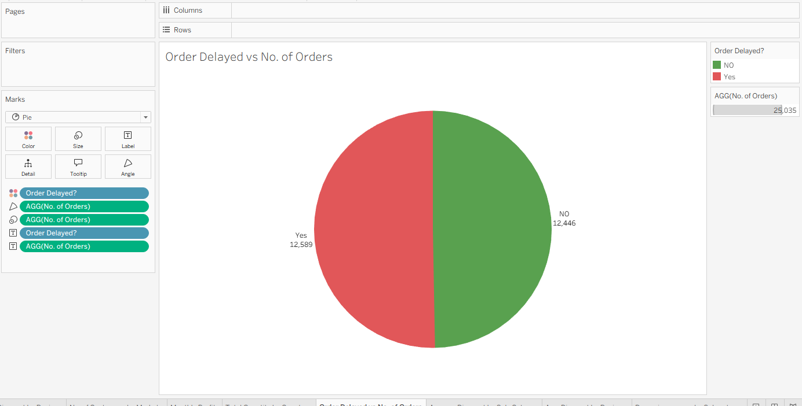
Create a new calculated field - avg(delay days)

6) Treemap of sub-cat and avg. discount. display label. Differentiate between Discounts by 15%
Average Discount by Sub-Category

Create a new parameter for Avg Discount - Avg Discount Parameter
Avg. Discount by Region

How to create parameters with measure & dimension names?
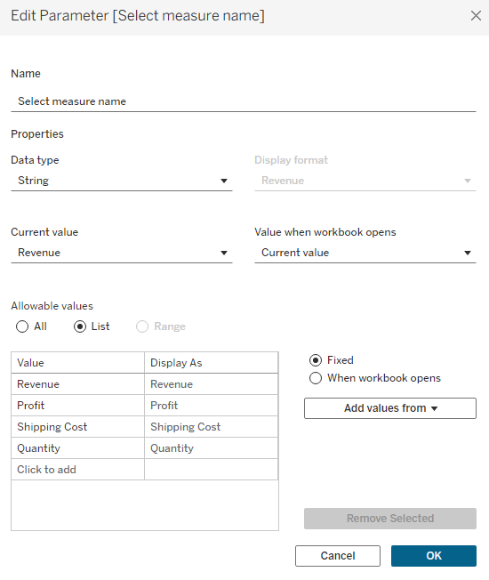
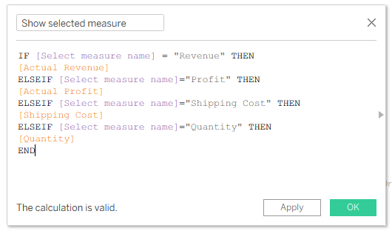
Show Parameter 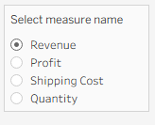
Change Tooltip: 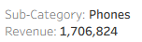
Change X-Axis Title 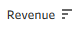
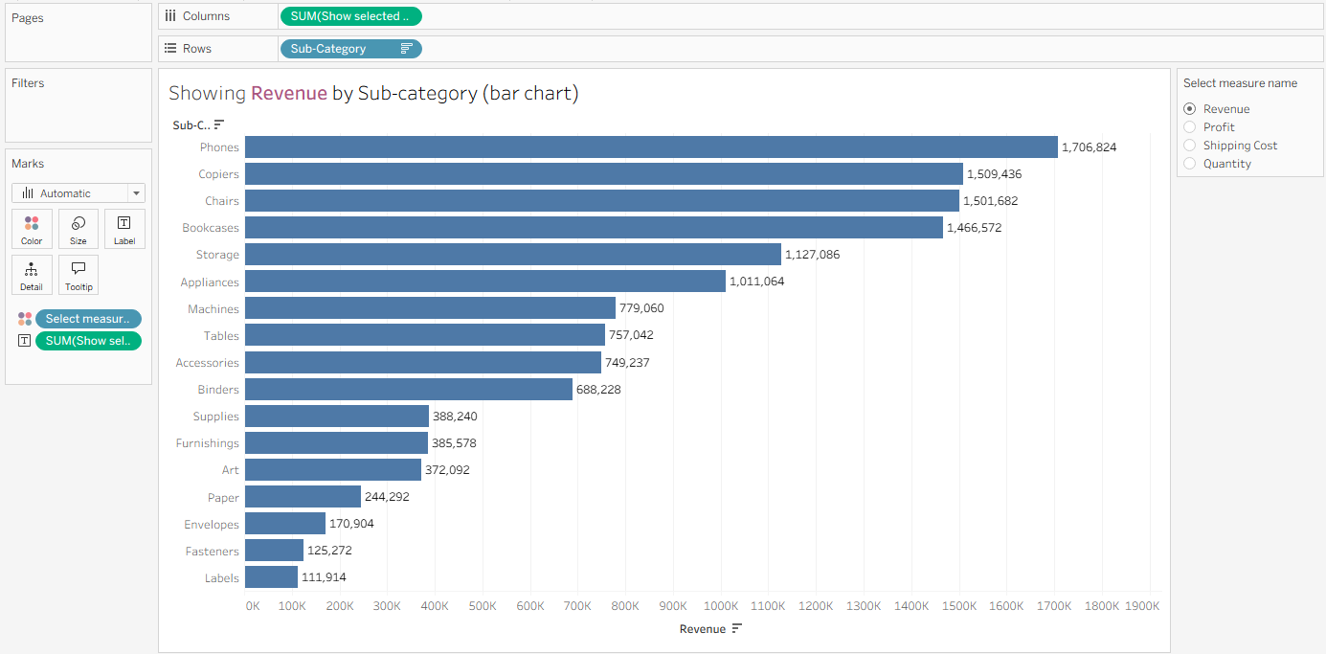
Dynamic measure by Sub-category (bar chart)
create a treemap using region
Dynamic measure by Region (tree map)
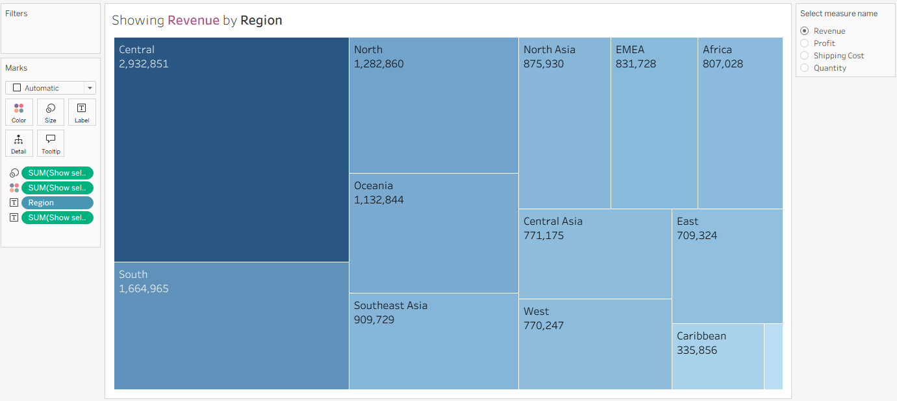
Category
Segment
Ship Mode
Order Priority
1) Create a new parameter "Select dimension name" of string data type with above 4 values.
2) Then create calculated field "Show selected dimension" using this parameter.
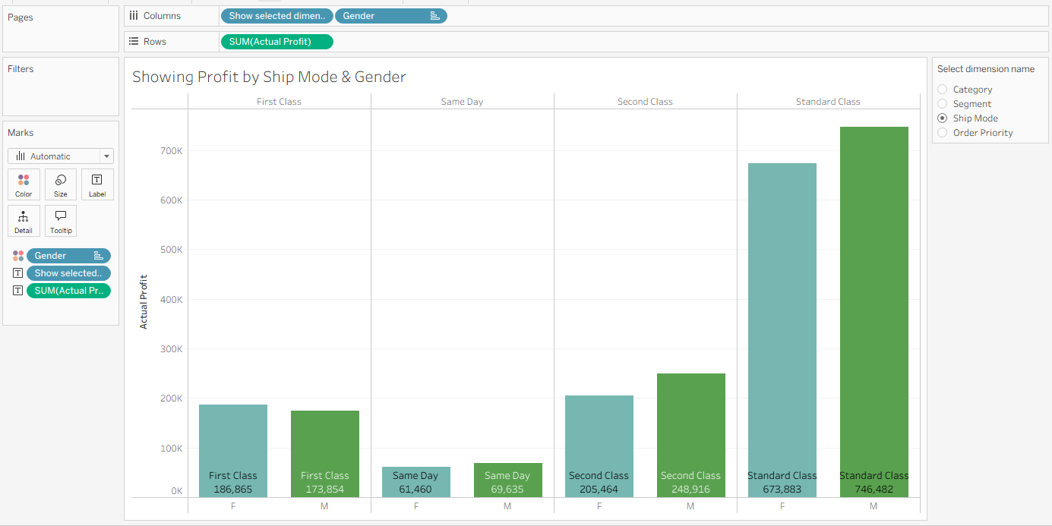
Profit by Dynamic Dimension
name- Dynamic measures and dimensions
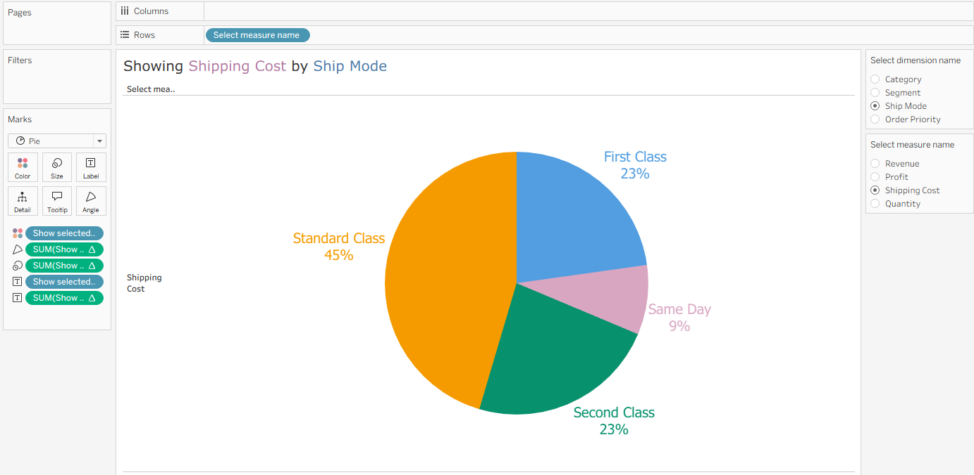
Completed Project_4

