5. Clustering
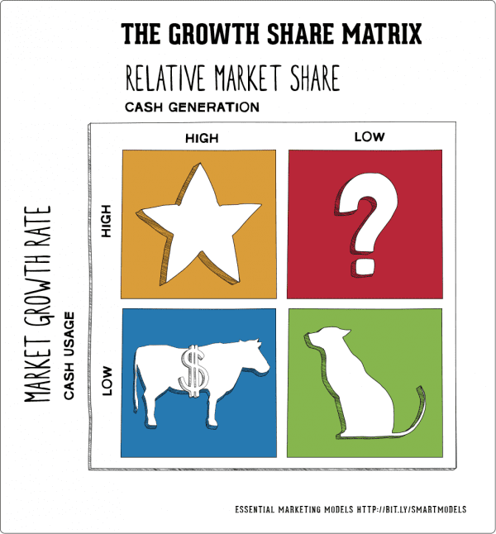

BCG Matrix

Constant line is used to identify values or below a specific target.
Average line is used to identify values above or below average values.
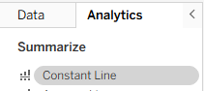
- Using constant line, identify the regions where revenue is between 1000k to 2000k.
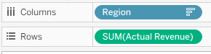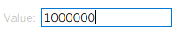
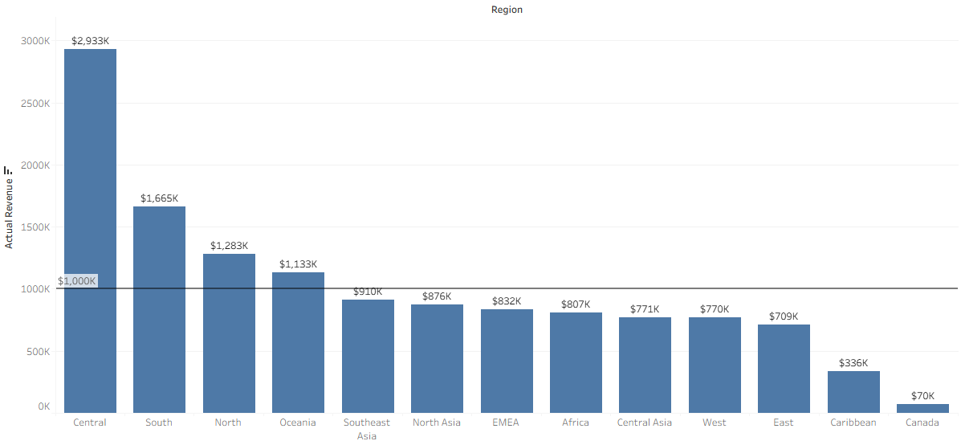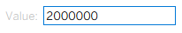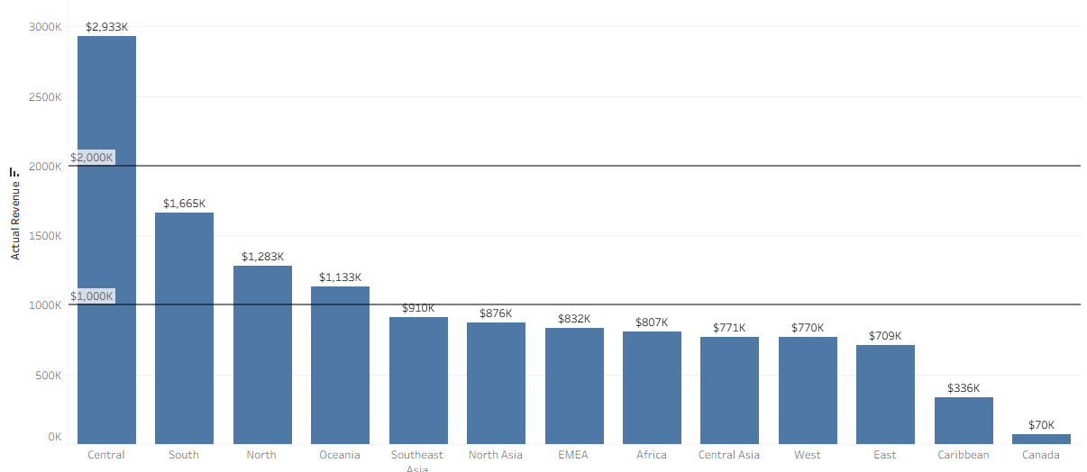
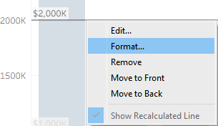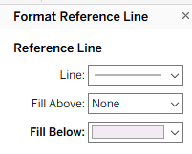
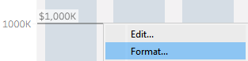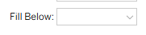
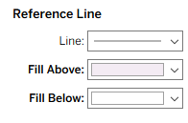
Didn’t work.

For the 1000k line

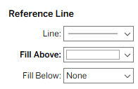
For the 2000k line

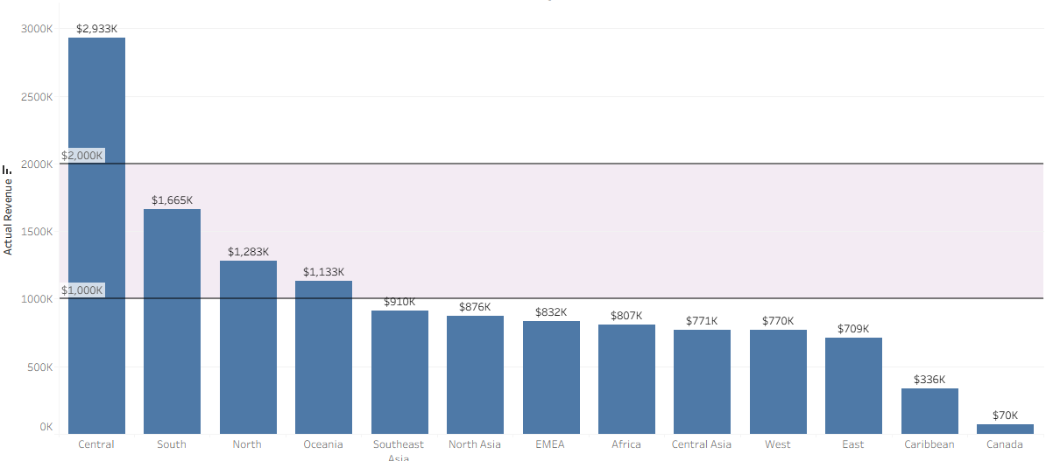
Add a Area Annotation
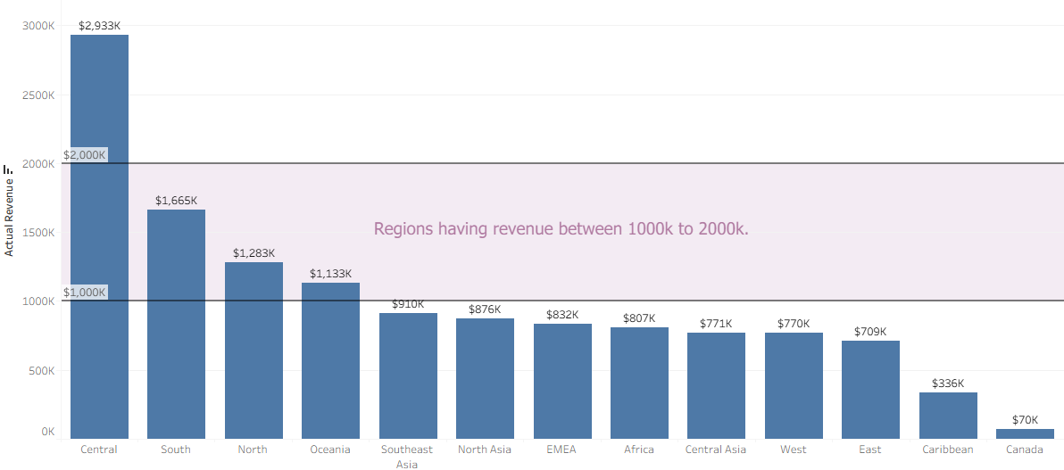
Regions having revenue between 1000k to 2000k (Constant line)
Scatter plot of revenue vs profit
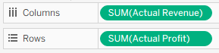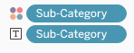
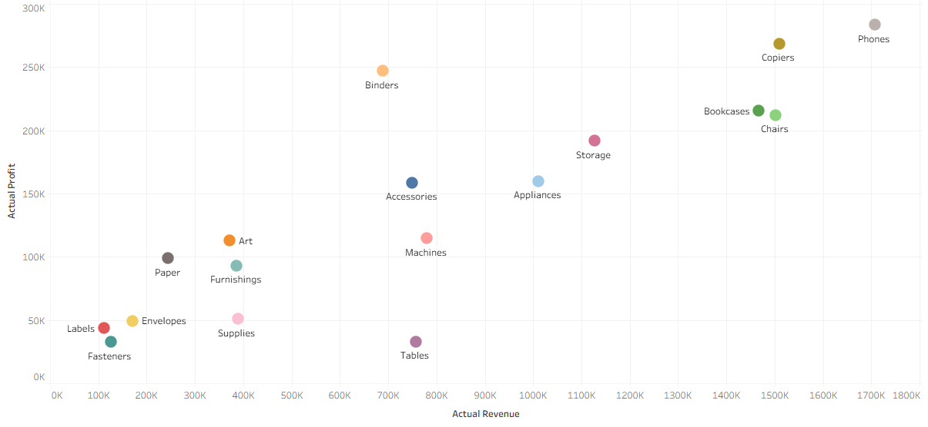
- Using constant line, identify the sub-categories having revenue more than 600k and profit more than 150k.
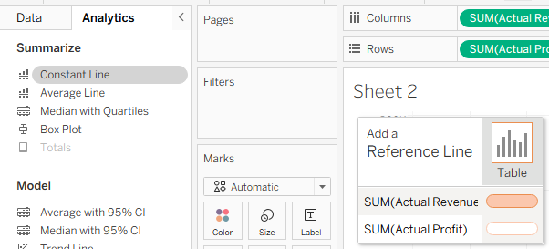
Give value as 600k.
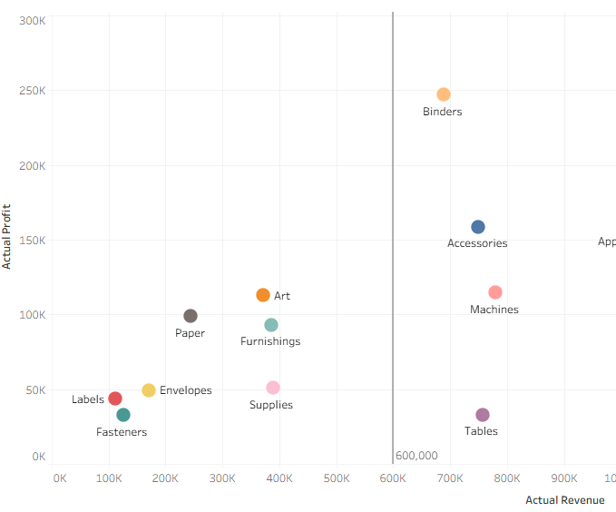
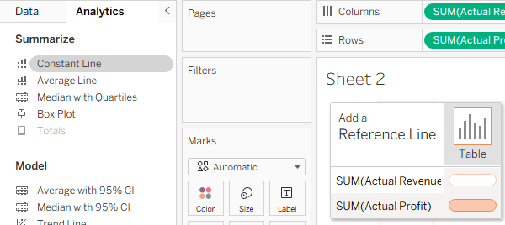
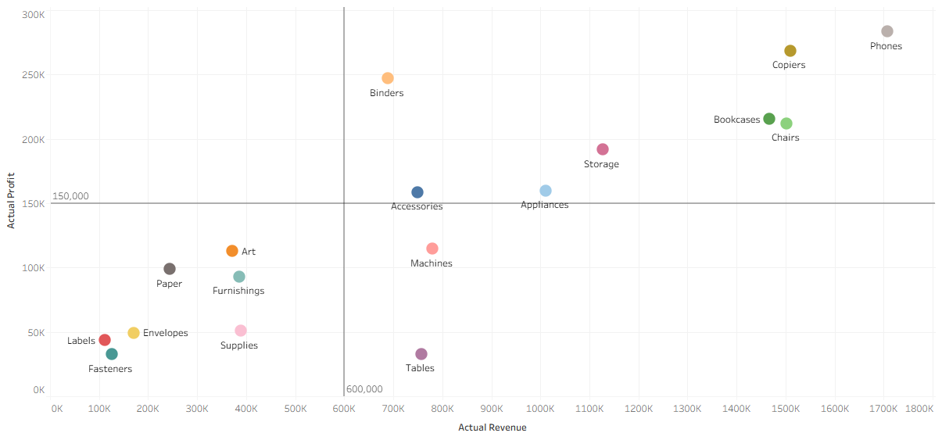
Vertical line – above – add color
Horizontal line – below- white
Add Annotation
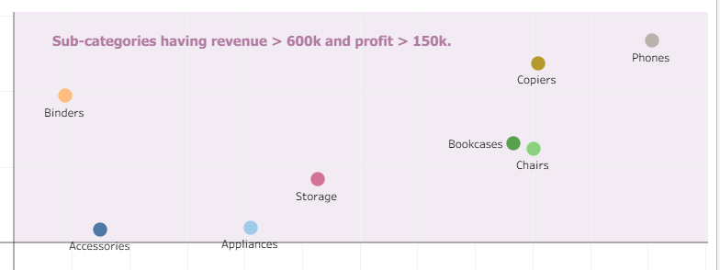
New
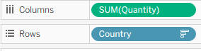
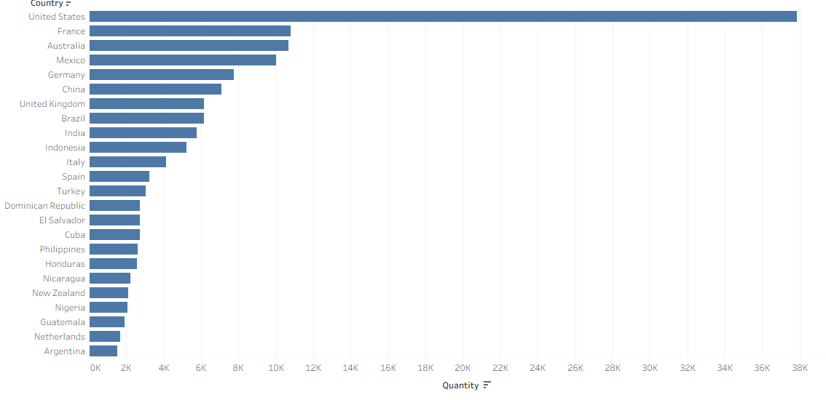
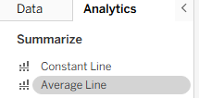 Double click Average Line
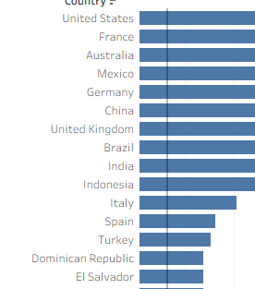
Try selecting some countries
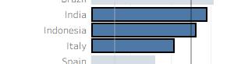New Average for the selected countries
Add Filter – Market – Show filter
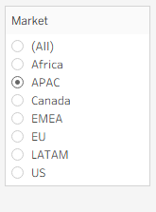
- Countries having quantity above average (Average line)

- Create scatter plot of revenue vs profit by region. Then add average lines on both axis.
Regions having Revenue & Profit above Average
Trendline
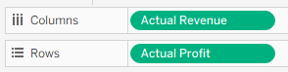 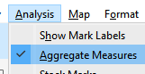 Uncheck this
Add Trendline
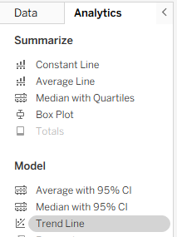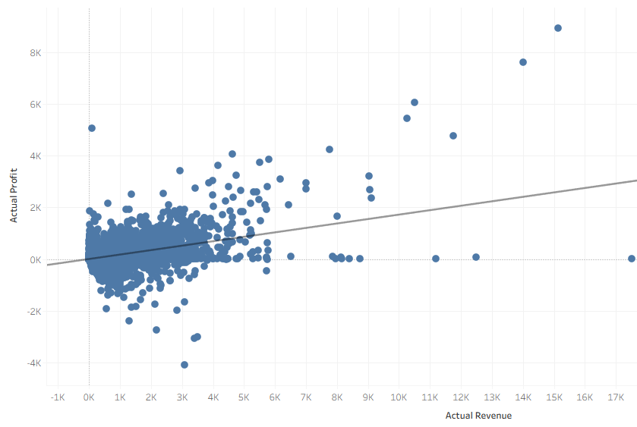
Add Market- > Filter
Trendline-> Describe Trendline-> Copy Eq.
EU
Equation:Actual Profit = 0.100409*Actual Revenue + 17.7333
LATAM
Equation:Actual Profit = 0.182556*Actual Revenue + -4.50673
What if both markets achieve revenue of 10k, how much profit they will earn?
EU = 1004+17.7 = 1013
LATAM = 1825-4 = 1821
R2 of LATAM is 0.28 is better than 0.09 of EU.

Forecasting
Predictive Analytics vs Forecasting
Forecasting has to deal will future time period.
TCSI Trend Cyclic Seasonal Irregular
Component | Question Answered | Nature | Duration
Trend (T) | What is the overall long-term direction? | Sustained upward or downward slope. | Very Long (Years)
Cyclical (C) | What are the multi-year swings around the trend? | Wavelike fluctuations; not fixed in length. | Long (2+ Years)
Seasonal (S) | What are the fixed, repeating patterns? | Regularly occurring peaks and valleys within a year. | Short (Within a Year)
Irregular (I) | What is the unforeseen, random noise? | Erratic, short-term variation; unexplainable. | Very Short (Random)
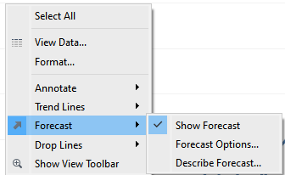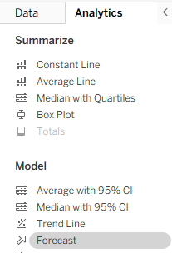
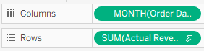
1) Using monthly revenue data, forecast revenue for next 12 months.
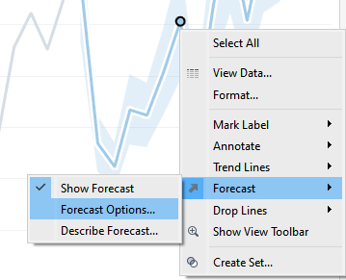
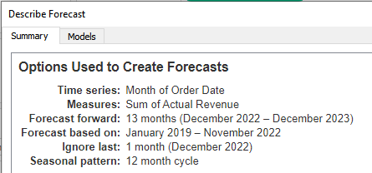
need to change 13 months to 12 months.

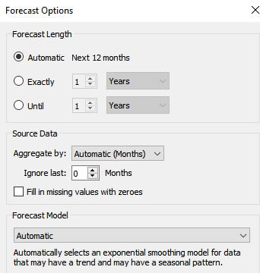

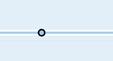
Canada has a flat line

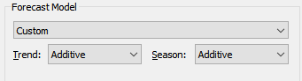
Tuning the forecast

Revenue Forecasting for next 12 months
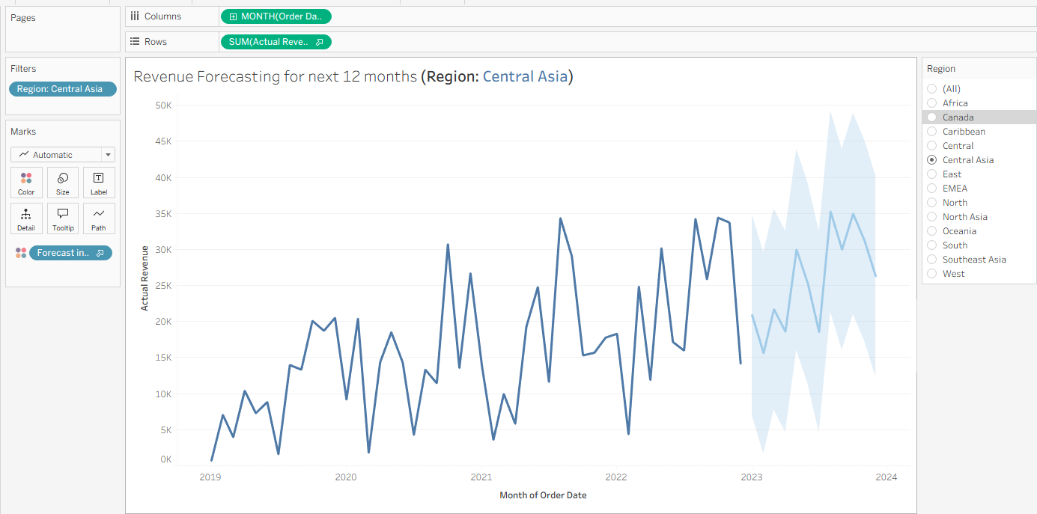
2) Create continuous month line chart using order date and no. of orders. Do dorecast settings and forecast no. of orders for next months.
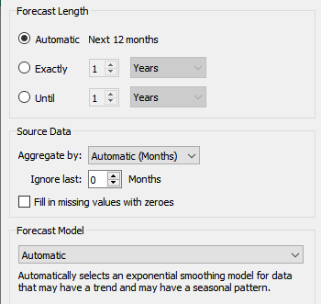

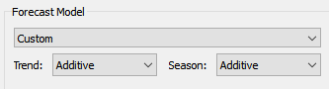

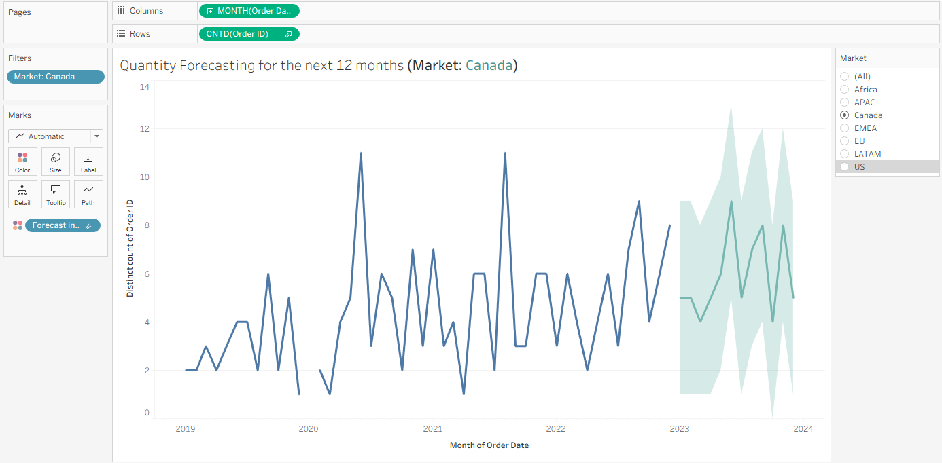
3) Create continuous month line chart using order date and Profit. Add forecasting options. Then add two filters - segment & Category. Do forecasting for next 12 months.
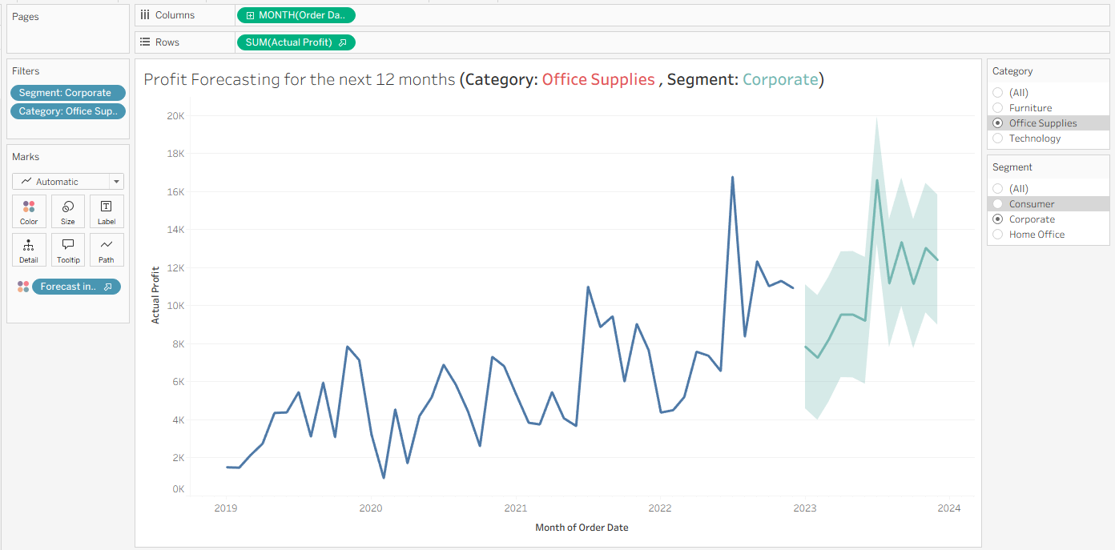
Clustering
Clustering is a fundamental task in unsupervised machine learning that involves grouping a set of data points so that data points in the same group (cluster) are more similar to each other than to those in other groups.
It's essentially finding hidden structure or natural groupings within unlabeled data.

🧩 Analogy: Sorting Laundry
Imagine you have a large pile of unsorted laundry.
Clustering is like automatically sorting that pile into separate baskets (clusters).
- Each piece of clothing is a data point.
- The clustering method uses rules (like color, fabric type, and size) to determine similarity.
- The final groups—the piles of white shirts, dark jeans, and socks—are your clusters.
The goal is to ensure all the white shirts end up together and are separate from the dark jeans.
The centroid in clustering is the average position of all the data points belonging to a cluster.
It serves as the center point that defines the cluster's location, and it's used to assign data points—a point goes into the cluster with the closest centroid.
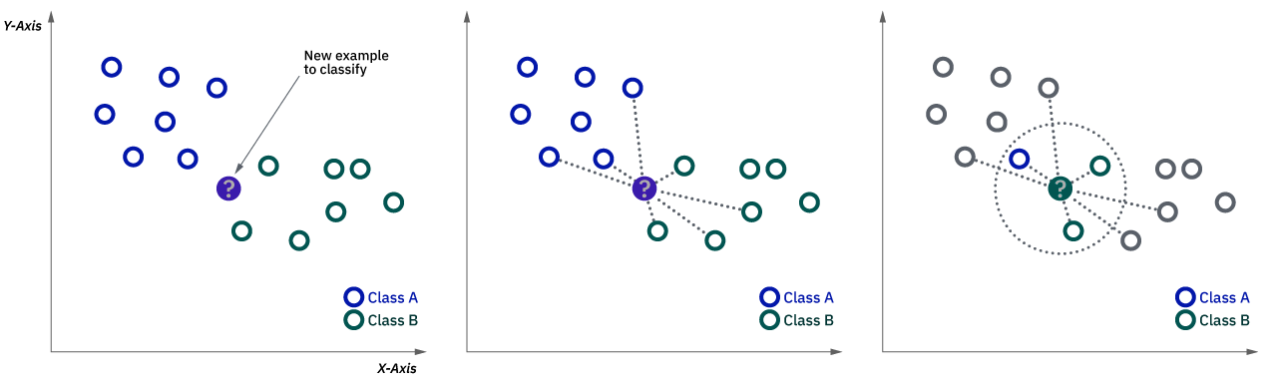
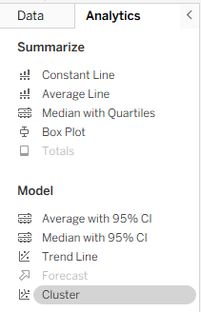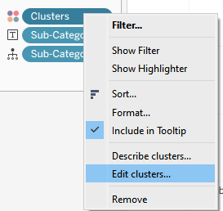
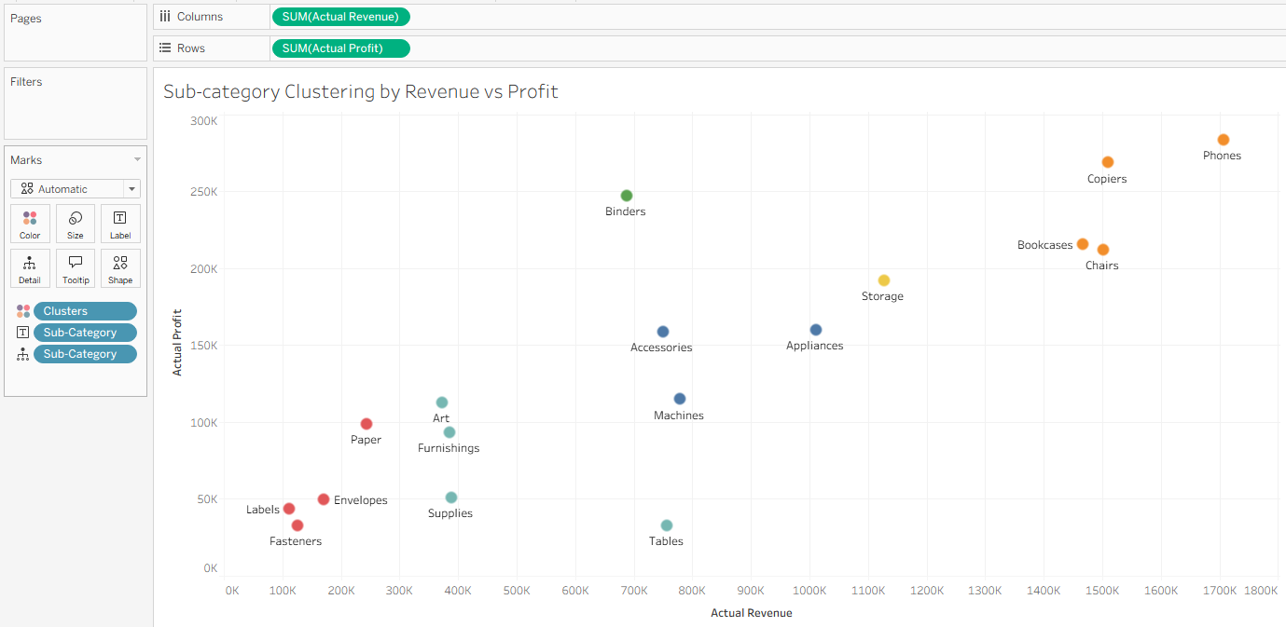
1) Create a scatter plot of shipping cost (x axis) vs profit (y axis) by Region and add atleast 4 clusters.
Region Cluster by Shipping Cost vs Profit
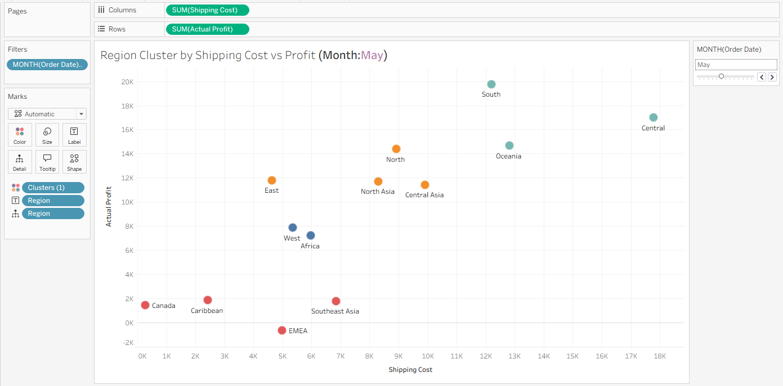
Table Calculations -
1. Running Total
2. Difference
3. 3% Difference
4. Rank
5. Moving Average
6. YoY Growth (Year over Year)
Except Rank, all other require Date field.
- Running Total- Cumulative Total
It's a progressive sum where each new data point is added to the total of all preceding data points.
5. Moving Average
A moving average (MA) is a statistical technique used to smooth out short-term fluctuations in a time series data set and reveal longer-term trends.
It is calculated by taking the average (mean) of data values over a specific, fixed time period (window), and then iteratively calculating that average as the window moves forward one period at a time.
Goal: To eliminate "noise" and identify the underlying direction of the data.
Simple Example: A 5-day moving average of stock prices would be the average of the last five days' prices. Tomorrow, it would drop the oldest price and include the newest price.
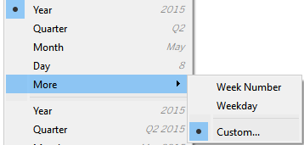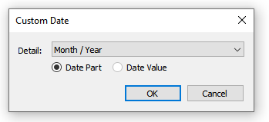

Add Table Calculations
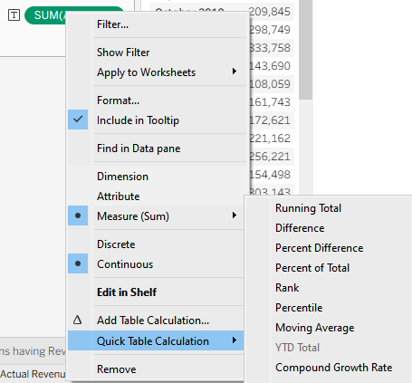

Here the Triangle is Calculation (TRUE)

Add Actual Revenue again (Double clicking it)
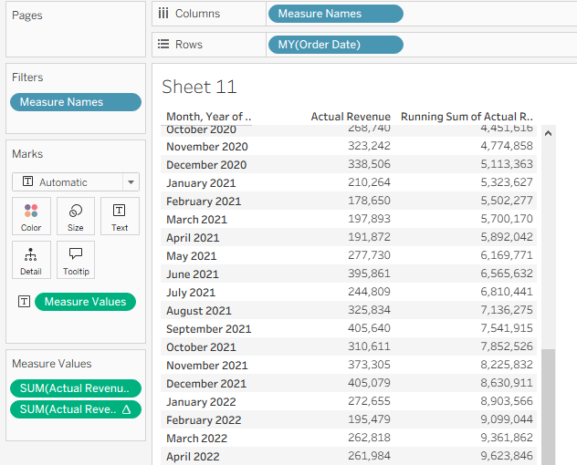
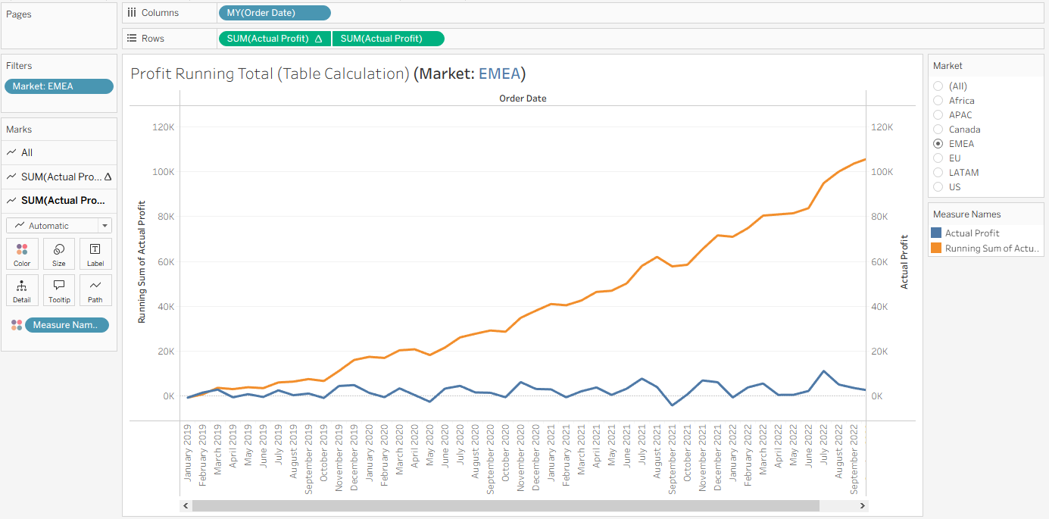
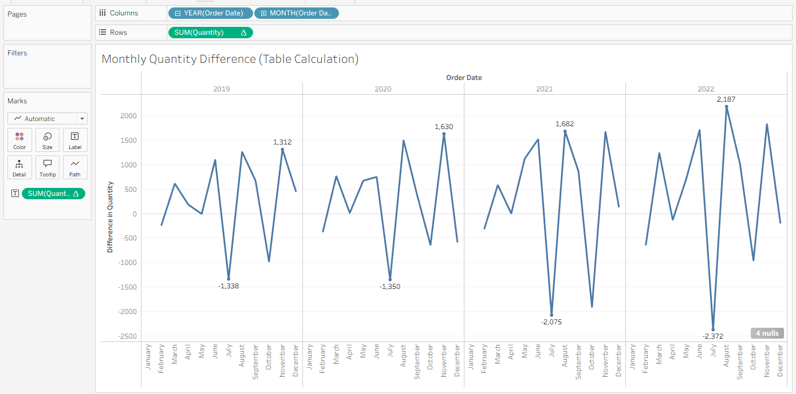
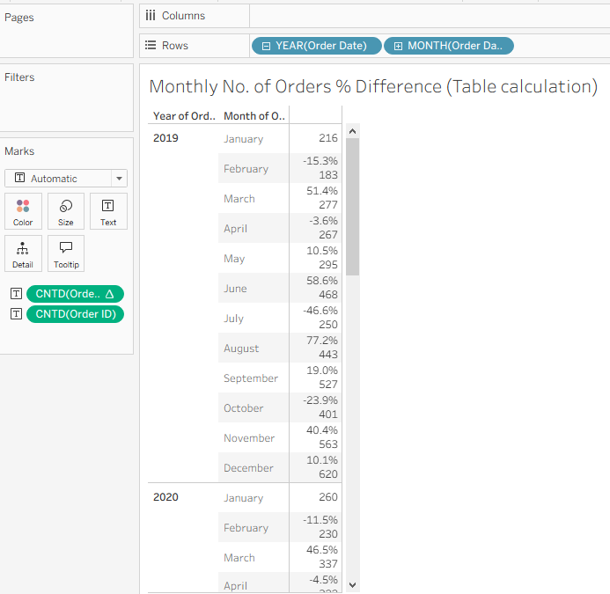
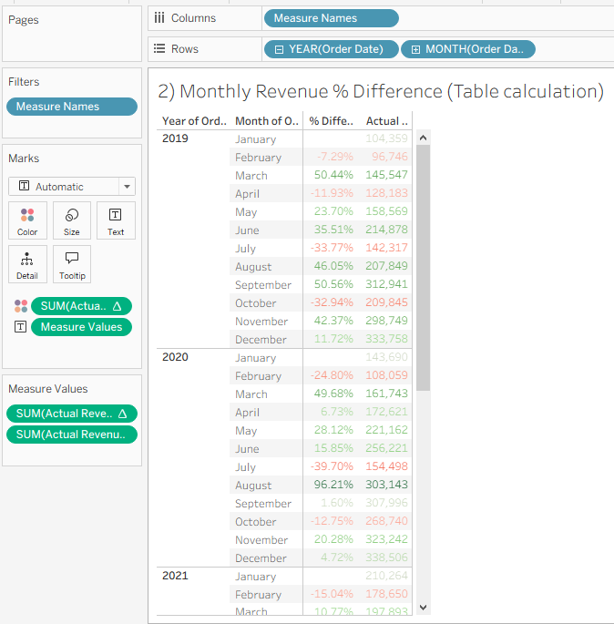
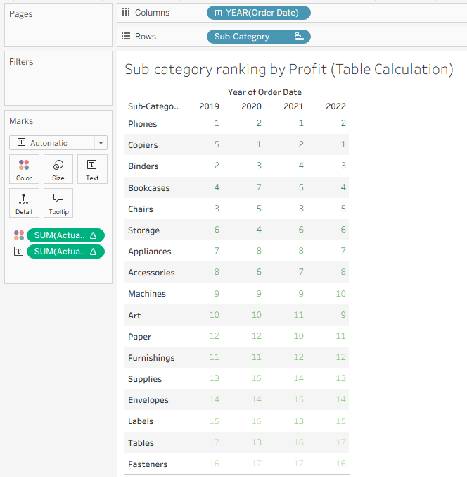
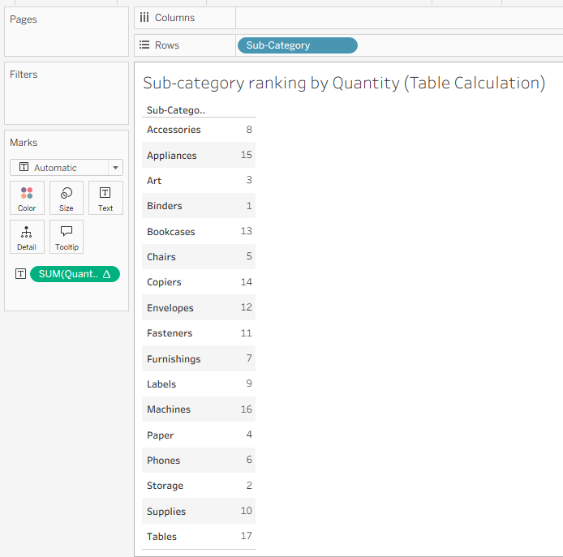
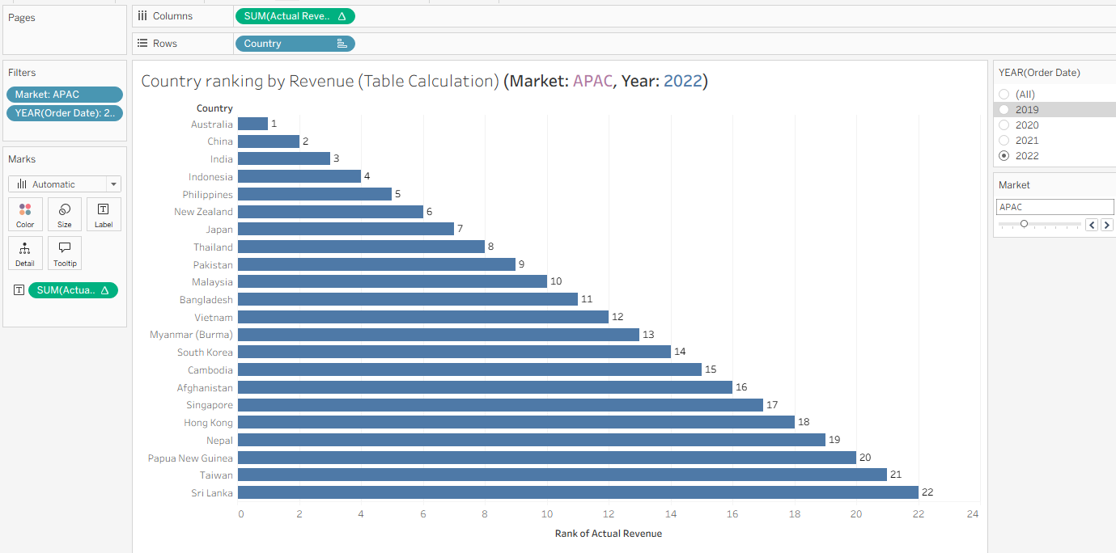
Moving Average -
Line Smoothening technique - reduces short-term changes in the data
Default moving average in Tableau is 3 period moving average (average of current & 2 previous values)
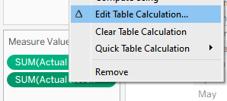
If changing previous considered values
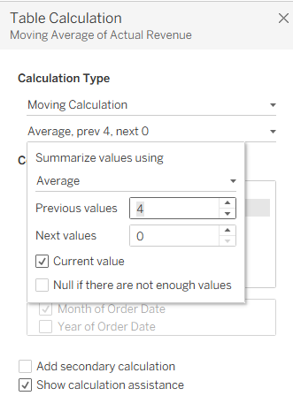

6. YoY Growth
A moving average in time series analysis is a calculation used to smooth out short-term fluctuations and highlight longer-term trends by creating a series of averages of different subsets of the data.
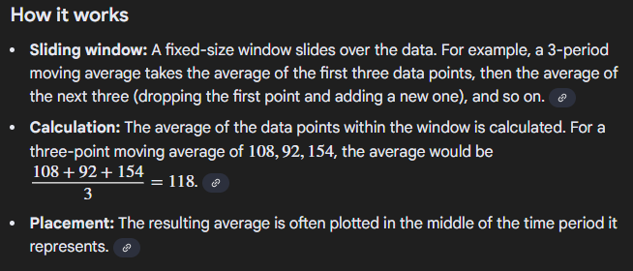

Completed Proj_5

