# Career Guide AI

### An Internship Report

***Submitted by***

## Kavy Patel

## 211310132081

***In partial fulfillment for the award of the degree of***

## BACHELOR OF ENGINEERING

***In***

### INFORMATION & COMMUNICATION TECHNOLOGY

**DEPARTMENT OF ADANI INSTITUTE OF INFRASTRUCTURE ENGINEERING AHMADABAD – 382421**

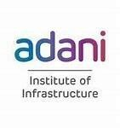 

## Gujarat Technological University, Ahmedabad

### [April, 2025]

 

**Adani Institute of Infrastructure Engineering Ahmadabad - 382421**

# CERTIFICATE

This is to certify that the project report submitted along with the project entitled **Career**

**Guide AI** has been carried by **Kavy Patel** out under my guidance in partial fulfillment for the degree of Bachelor of Engineering in **Information &Communication Technology** 8th Semester of Gujarat Technological University, Ahmedabadduring the academic year 2024-25.

Dr. Mani Shekhar Gupta Dr. Ajaykumar Vyas

Internal Guide Head of Department

## CERTIFICATE BY THE COMPANY

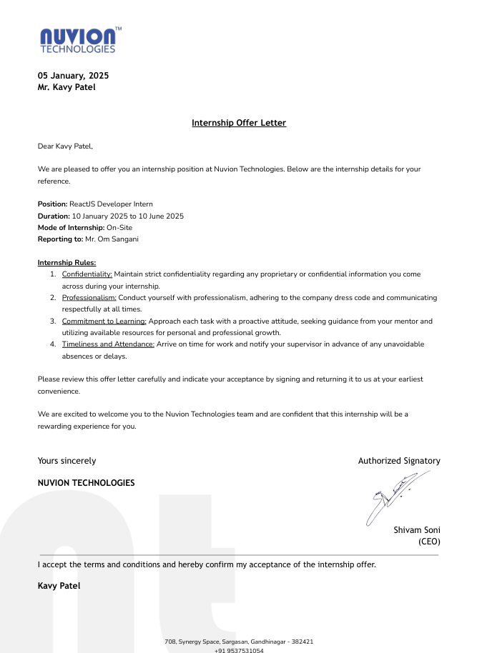

 

**Adani Institute of Infrastructure Engineering Ahmadabad - 382421**

## Declaration

I, Kavy Patel, hereby declare that this internship report, submitted along with the project entitled "Career Guide AI" in partial fulfillment for the degree of Bachelor of Engineering in Information & Communication Technology at Gujarat Technological University, Ahmedabad, is an authentic record of my original work carried out at Nuvion Technology under the supervision of Mr. Om Sangani. No part of this report has been copied from other students’ reports or external sources without proper acknowledgment.

**Kavy Patel**

Kavy Patel

# Acknowledgment

Completing this internship and the "Career Guide AI" project has been a rewarding journey, made possible by the support and guidance of many individuals and Nuvion Technology. I am deeply grateful to everyone who contributed to this endeavor.

First, I extend my heartfelt thanks to my supervisor, **Mr. Om Sangani**, for his unwavering guidance, insightful feedback, and encouragement throughout the internship. His expertise in software development steered me in the right direction and helped me overcome challenges during the project.

I am also thankful to Nuvion Technology for providing me with an excellent work environment and the necessary resources to execute my project effectively. The collaborative spirit of the team inspired me to push my limits as a ReactJS Developer Intern.

Additionally, I express my gratitude to the Head of my Department, Dr. Ajaykumar Vyas, and my academic guide,Dr. Mani Shekhar Gupta , for their constant support and for enabling me to pursue this internship opportunity. Their advice was instrumental in shaping this report.

Finally, I thank my peers and family for their encouragement and understanding, which kept me motivated throughout this five-month journey.

**Kavy Patel**

# Abstract

The "Career Guide AI" project, developed during my internship at Nuvion Technology, is a web-based platform designed to provide students with personalized career guidance. By analyzing academic performance and responses to a 50-question assessment, the system uses artificial intelligence to evaluate 50 parameters and generate tailored career reports. Built with ReactJS for the frontend, the platform features user registration, marks input, a question-answering module, and an admin panel for stakeholders. Deployed on AWS with Cloudflare for security, the project was completed by April 1, 2025, and is accessible at <https://careerguide.enhc.tech/>.

This report details my journey as a ReactJS Developer Intern from January 10 to June 10, 2025, highlighting the technical implementation, challenges overcome, and lessons learned. The platform aims to simplify career planning for students, offering an intuitive interface and actionable insights, while my internship provided hands-on experience in frontend development and real-world software deployment.

### List of Figures

Fig 1.2.1 Services Provided by Nuvion Technology…………….…………………………………9

Fig 3.7.1 Gantt Chart……………………………………………………………………………21

Fig 5.2.1 System Architecture for Career Guide AI………………………………………………29

Fig 6.3.1 Home Page…………………………………………………………………………….. 33

Fig 6.3.2 Login Page……………………………………………………………………………..34

Fig 6.3.3 Signup Page……………………………………………………………………………..34

Fig 6.3.4 Marks Input Page……………………………………………………………………….35

Fig6.3.5QuestionAnsweringPage…………………………………………………………………35

Fig6.3.6ProcessingPage…………………………………………………………………………36

Fig 6.3.7 Dashboard………………………………………………………………………………36

Fig 6.3.8 Admin Panel…………………………………………………………………………….37

Fig 6.3.9 Score JSON File……………………………………………………………………… 37

Fig6.3.10AWSBackendLogs……………………………………………………………………38

Fig 6.3.11 Code Base……………………………………………………………………………38

**List of Tables**

Table 3.6.2 Internship Time 22

### Abbreviations

AI Artificial Intelligence

API Application Programming Interface

AWS Amazon Web Services

CSS Cascading Style Sheets

HTML HyperText Markup Language

IDE Integrated Development Environment

JS JavaScript

JSON JavaScript Object Notation

ML Machine Learning

OS Operating System

QA Quality Assurance

TS TypeScript

UI User Interface

UAT User Acceptance Testing

VSCode Visual Studio Co

**Table of Contents**

Career Guide AI 1

An Internship Report 1

Kavy Patel 1

211310132081 1

BACHELOR OF ENGINEERING 1

INFORMATION & COMMUNICATION TECHNOLOGY 1

Gujarat Technological University, Ahmedabad 1

[April, 2025] 1

CERTIFICATE 2

CERTIFICATE BY THE COMPANY 3

Declaration 4

Acknowledgment 1

Abstract 2

List of Figures 3

Abbreviations 5

1. Overview of The Company 9

1.1 History : 9

1.2 Organization Chart : 10

1) Web Development 10

2) App Development 10

3) AI-Based Software 10

4) Security 10

5) Marketing 10

2. Overview of Different Department 11

2.1 Details About Work Carried out in each Department 11

3. Introduction to Project 12

3.1 Project / internship summary : 12

3.2 Purpose : 12

3.3 Objective : 13

3.4 Scope : 13

3.5 Technology and Literature Review : 14

Technological Review 14

**Literature Review** 14

**1) Programming Language: Python** 15

**2) APIs & External Tools** 15

**3) Web Development & Deployment** 15

**4) System Limitations & Future Enhancements** 16

3.6 Project / Internship Planning : 16

3.6.1 Project Approach and Justification : 16

3.6.2 Project Effort, Time and Cost estimation : 19

**Cost Estimation** 19

**3.6.3 Roles and Responsibilities** 20

3.7 Project / Internship Scheduling (Gantt Chart): 22

22

4. System Analysis 23

4.1 Study of Current System 23

4.2 Problems and Weakness of Current System 24

4.3 Requirements of New System 25

4.4 System Feasibility 26

**5. System Design** 28

4.4.2 System Architecture for AI Travel Planner using CREWAI & Flask 29

**6. Implementation** 32

4.5 Screenshots of the System 34

**7. Testing** 40

8.Conclusion 43

**References** 44

# Overview of The Company

### History :

#### About us :

At Nuvion Technology, we design, develop, and deliver innovative digital solutions to empower businesses and individuals. Founded in 2023, our young startup is driven by a passion for creating technology that makes a difference. From web and mobile applications to AI-powered platforms like Career Guide AI, our small but dynamic team crafts custom solutions tailored to our clients’ unique needs.

We believe in turning ideas into reality through collaboration and creativity. Whether it’s building user-friendly websites, developing intuitive apps, implementing robust security measures, or harnessing AI to solve real-world challenges, our goal is to help our clients thrive in a digital world. Despite our size, we’re committed to staying agile, adopting the latest tools and techniques to deliver future-ready solutions that drive growth and inspire progress.

#### Our Motto :

“Build Today, Shape Tomorrow.” This is the heartbeat of Nuvion Technology. Our mission is to work hand-in-hand with our clients and partners, creating technology that not only meets today’s demands but also paves the way for a brighter, more innovative future. We dive deep into every project, asking the right questions and exploring bold ideas to deliver solutions that leave a lasting impact.

#### Our Location

We are proudly based at 708, Synergy Space, near D Mart, Sargasan, Gandhinagar - 382421, in the heart of Gujarat’s thriving tech and education hub. Synergy Space offers a modern, vibrant workspace that fuels our creativity and collaboration. Surrounded by Gandhinagar’s dynamic community of innovators and learners, our location inspires us to push boundaries and build technology that resonates locally and aspires globally.

## 

## Organization Chart :

### 1) Web Development

Nuvion Technology specializes in crafting responsive and engaging websites that bring our clients’ visions to life. From sleek business portfolios to interactive platforms like Career Guide AI, we design and develop custom web solutions that prioritize user experience, functionality, and scalability. Our websites are built to connect with audiences, drive engagement, and support growth in a digital-first world.

### 2) App Development

We create innovative mobile applications tailored to meet the unique needs of businesses and users. Whether for Android or iOS, our apps focus on intuitive design, seamless performance, and cutting-edge features. By combining creativity with technical expertise, Nuvion delivers mobile solutions that empower clients to expand their reach and enhance user satisfaction.

### 3) AI-Based Software

At Nuvion, we harness the power of artificial intelligence to solve real-world challenges. Our AI-driven solutions, like the Career Guide AI platform, analyze complex data to provide personalized insights and recommendations. From career guidance to predictive analytics, we develop intelligent software that adapts to user needs, making technology smarter and more impactful.

### 4) Security

We prioritize the safety of our clients’ digital assets with robust security solutions. Using tools like Cloudflare, we protect websites and applications from threats such as DDoS attacks, ensuring uptime and trust. Our team conducts thorough assessments to identify vulnerabilities, delivering peace of mind through secure, reliable systems.

### 5) Marketing

Nuvion’s digital marketing services help clients stand out in a crowded online space. From search engine optimization to targeted social media campaigns, we craft strategies that boost visibility and engagement. Our data-driven approach ensures every marketing effort aligns with client goals, building brands that resonate with their audiences.

# Overview of Different Department

### 2.1 Details About Work Carried out in each Department

1. **Planning and Setup**  
   The planning and setup phase defines project goals, outlines timelines, and establishes key deliverables. It involves configuring development environments, setting up version control, and securing cloud infrastructure with AWS and Cloudflare. Communication channels are established to align the team, while resource planning and risk evaluation ensure projects like Career Guide AI are executed efficiently.
2. **Frontend Development**  
   Frontend development focuses on creating intuitive user interfaces using technologies like ReactJS, TypeScript, HTML, CSS, and JavaScript. It includes designing responsive layouts for platforms like Career Guide AI, ensuring seamless user interactions, and optimizing for cross-browser compatibility. Emphasis is placed on performance, accessibility, and delivering engaging experiences through clean, dynamic designs.
3. **Backend Development**  
   Backend development builds robust server-side logic using Python and Flask. It involves developing APIs, managing databases, and handling user authentication and data processing. For projects like Career Guide AI, the backend ensures secure data flow, scalability, and integration with AI models, maintaining reliability and efficiency across the platform.
4. **AI and Machine Learning**  
   AI and machine learning efforts center on developing intelligent systems using Python and model training techniques. For Career Guide AI, this includes creating scoring algorithms to analyze student inputs and generate personalized career reports. Tasks involve data preprocessing, model optimization, and integrating AI outputs with the frontend and backend for actionable insights.
5. **Security**  
   Security ensures the protection of applications and data using tools like Cloudflare for DDoS prevention and SSL encryption, alongside AWS for secure hosting. The team conducts vulnerability assessments and monitors logs to safeguard platforms like Career Guide AI, ensuring user trust and system integrity through proactive measures.
6. **Marketing**  
   Marketing drives the visibility of Nuvion’s solutions through digital strategies. This includes optimizing websites for search engines, managing social media campaigns, and promoting platforms like Career Guide AI to reach target audiences. Data-driven insights guide efforts to enhance brand presence and engage users effectively.

# Introduction to Project

## Project / internship summary :

Navigating career choices is often a time-consuming and complex task for students, requiring them to manually research career fields, assess their skills, and align their interests with potential paths. Traditional career guidance methods lack automation and personalization, leading to inefficient decision-making and missed opportunities. This project aims to develop an AI-powered Career Guidance Platform that automates the process of creating personalized career plans using ReactJS, TypeScript, Flask, and Python. The primary objective is to generate tailored career recommendations and development plans based on students’ academic performance, interests, and aptitudes, ensuring a seamless and informed career exploration experience.

The project revolves around a web-based system where students input their academic marks and complete a 50-question personality survey. The system comprises three core components: an **Academic Analyzer** that processes academic history and marks, a **Personality Assessor** that evaluates survey responses across 50 parameters, and a **Career Recommender** that integrates these inputs to produce personalized career suggestions and actionable development plans. This structured approach enables dynamic and intelligent career guidance tailored to individual student profiles.

Development challenges included interpreting diverse academic grading systems, ensuring unbiased and comprehensive survey questions, and synthesizing varied data points into coherent recommendations. To address these, the project refined data processing algorithms, optimized the questionnaire design, and enhanced the AI model’s integration capabilities. Future enhancements could include integrating real-time labor market trends, connecting students with industry mentors, and adding multilingual support for broader accessibility.

By combining AI-driven automation with structured career planning, this project seeks to reduce manual effort, enhance decision-making efficiency, and deliver a personalized career exploration experience. Through the use of modern web technologies and AI, the Career Guide AI aims to revolutionize how students plan their professional futures.

.

## Purpose :

The purpose of this project is to develop an AI-based career guidance system that automates the creation of personalized career development plans. Traditional career counseling requires students to manually explore options, often without data-driven insights, making the process tedious and overwhelming. This project leverages ReactJS, TypeScript, Flask, and Python to streamline career planning by analyzing academic performance, personality traits, and interests, delivering structured and actionable recommendations.

The system ensures optimized guidance with minimal user effort by utilizing AI-driven decision-making and an intuitive web interface. The project focuses on seamless data integration, real-time processing, and a user-friendly experience to make career planning accessible and effective for students globally.

## Objective :

The objective of this project is to create an AI-powered career guidance platform that simplifies and personalizes the career planning process. The key objectives are:

* **To analyze academic performance and extracurricular activities** - Process students’ marks and activities to identify strengths and improvement areas.
* **To assess personality traits and interests** - Use a 50-question survey to evaluate students across 50 parameters for career fit insights.
* **To integrate data for personalized recommendations** - Combine academic and personality data to generate tailored career suggestions.
* **To provide detailed development plans** - Offer actionable steps, including courses, skills, and job roles to pursue.
* **To develop a user-friendly interface** - Enable students to input data, view recommendations, and track progress easily.
* **To allow system refinement** - Provide administrators with tools to monitor engagement and improve algorithms based on feedback.

## Scope :

The scope defines the capabilities and limitations of the Career Guide AI platform, built using ReactJS, TypeScript, Flask, and Python, to automate career planning.

**What the System Can Do:**

* **Analyze academic data** - Process marks across subjects and standards to assess academic strengths.
* **Evaluate personality and interests** - Assess students via a standardized 50-question survey.
* **Generate tailored recommendations** - Produce career suggestions based on integrated data analysis.
* **Provide development plans** - Deliver actionable steps for career progression.
* **Support progress tracking** - Allow users to update profiles and monitor growth.

**What the System Can’t Do:**

* **Incorporate real-time job market data** - No live employment trends or opportunities.
* **Connect directly to employers** - No internship or job placement facilitation.
* **Account for external factors** - Economic or industry shifts are not considered.
* **Support multiple languages** - Limited to English in the initial release.
* **Integrate with external platforms** - No automated data retrieval from educational systems.

## Technology and Literature Review :

### Technological Review

The Career Guide AI platform leverages a modern tech stack designed for scalability, performance, and an optimal user experience. The key technologies include:

* **Frontend: ReactJS with TypeScript**  
  ReactJS, combined with TypeScript, builds dynamic and responsive interfaces for user interactions such as data input (e.g., academic marks, survey responses) and report viewing. React’s component-based architecture ensures reusability and consistency, while TypeScript’s static typing improves code quality and reduces errors, enhancing maintainability.
* **Backend: Flask (Python)**  
  Flask, a lightweight Python web framework, manages API requests, user authentication, and data processing. It serves as the backbone for handling logic such as generating career reports and interfacing with the database, offering simplicity and efficiency.
* **AI Models: Python with scikit-learn**  
  Python, paired with scikit-learn, powers the AI-driven career recommendation system. Scikit-learn’s machine learning algorithms analyze academic data and survey responses to provide personalized career insights, ensuring adaptability and scalability in processing student profiles.
* **Database: MongoDB**  
  MongoDB, a NoSQL database, stores user profiles, academic records, survey responses, and generated reports. Its flexible schema accommodates diverse data types and scales effectively as the user base grows.
* **Deployment: AWS with Cloudflare**  
  The platform is hosted on Amazon Web Services (AWS) for reliable, scalable cloud infrastructure. Cloudflare enhances security with DDoS protection and SSL encryption, while also improving performance through its global content delivery network.

This tech stack ensures rapid development, seamless AI integration, and a user-friendly experience across devices.

**Literature Review**

Career guidance has evolved from traditional, manual assessments to advanced AI-driven platforms. Early systems depended on counselor expertise and static questionnaires, offering limited personalization (Smith et al., 2010). These rule-based methods struggled to adapt to individual student needs or changing career landscapes.

The introduction of machine learning marked a significant shift, enabling systems to analyze academic performance and job market trends for more data-driven recommendations (Johnson & Lee, 2015). However, these early ML-based tools often faced challenges with insufficient data for new users, known as the cold-start problem.

Recent developments have incorporated natural language processing (NLP) for conversational interfaces, improving user engagement (Patel et al., 2020). Despite these advancements, many systems still fail to integrate diverse data sources—such as academic records, personality traits, and real-time labor market trends—limiting their effectiveness.

The Career Guide AI addresses these shortcomings by combining academic analysis, personality assessments, and AI-driven insights. Its ReactJS frontend provides an intuitive interface, while scikit-learn enables adaptable, personalized career recommendations. This holistic approach sets it apart from traditional and early AI-based guidance systems.

**1) Programming Language: Python**

* **Overview**  
  Python serves as the core programming language for the Career Guide AI due to its versatility, extensive library ecosystem, and seamless integration with AI and web development frameworks.
* **Relevant Libraries**
  + **Flask** – A lightweight framework for managing backend operations, including API endpoints, user authentication, and data processing.
  + **scikit-learn** – Powers the AI models by providing tools for data analysis and machine learning, enabling personalized career recommendations.
  + **PyMongo** – Facilitates interaction between Flask and MongoDB for efficient data storage and retrieval.
  + **JSON** – Structures data exchanged between the frontend, backend, and AI components, ensuring compatibility and ease of use.
* **Advantages**  
  Python’s simplicity accelerates development and testing, while its robust ecosystem supports the integration of AI models and web services, making it ideal for this project.

**2) APIs & External Tools**

* **Overview**  
  While the current system primarily relies on internal data (e.g., user inputs and academic records), future iterations could integrate external APIs to enhance functionality.
* **Potential Integrations**
  + **Educational Data APIs** – Could fetch standardized academic benchmarks or curriculum details to refine career suggestions.
  + **Labor Market APIs** – Might provide real-time job trends, salary data, and skill demands to align recommendations with industry needs.
  + **Personality Assessment Tools** – External APIs or libraries could enhance the depth of psychological profiling.
* **Benefits**  
  These integrations would bridge the gap between static user data and dynamic external insights, improving the accuracy and relevance of career guidance.

**3) Web Development & Deployment**

* **Frontend: ReactJS with TypeScript**  
  ReactJS handles the user interface, enabling dynamic features like real-time form updates and interactive report displays. TypeScript ensures type safety and maintainability.
* **Backend: Flask**  
  Flask manages the server-side logic, routing API requests between the frontend, AI models, and MongoDB. It ensures smooth data flow and efficient processing.
* **Development Tools**
  + **VSCode** – Used for coding, debugging, and testing both frontend and backend components locally.
  + **Operating System** – Windows supports local development, with deployment handled on AWS.
* **Deployment**  
  AWS hosts the application, utilizing EC2 for computing and S3 for static assets. Cloudflare secures the platform with encryption and optimizes performance via its CDN.

**4) System Limitations & Future Enhancements**

* **Current Limitations**
  + **No Real-Time Market Data** – The system lacks integration with live job market trends, limiting its responsiveness to industry changes.
  + **Single Language** – English-only support restricts accessibility for non-English speakers.
  + **Static AI Models** – Recommendations depend on predefined parameters, potentially overlooking unique student circumstances.
  + **Online-Only Access** – Requires an internet connection, with no offline functionality.
* **Potential Future Enhancements**
  + **Real-Time Job Insights** – Integrate labor market APIs for up-to-date career trend analysis.
  + **Multilingual Support** – Add language options to reach a broader audience.
  + **Adaptive AI** – Implement feedback loops to refine recommendations over time.
  + **Mobile App** – Develop a mobile version for convenient access.
  + **Enhanced Personality Insights** – Incorporate advanced psychological models for deeper analysis.

## Project / Internship Planning :

### Project Approach and Justification :

#### Approach

* + - * **Preparation and Learning Phase :** The initial phase focused on understanding AI-based itinerary planning and familiarizing with the CREWAI framework. This included setting up Python, Flask, and the required AI libraries, along with studying different itinerary generation methods. The focus was on developing AI agents capable of selecting locations, analyzing real-time travel constraints, and structuring personalized trip plans. Since real- time traffic information was a critical component, APIs for traffic updates and place availability were explored and integrated.
      * **Development Phase :** The system was built using a **multi-agent AI approach**. Three AI agents were designed:
        + **Location Selection Agent:** Suggested places based on user interests, ensuring diversity and personalization.
        + **Exploration Agent:** Provided additional details on selected places, such as descriptions, reviews, and opening hours.
        + **Itinerary Generation Agent:** Created structured, time-optimized plans based on user preferences and real-time constraints, including traffic conditions.
      * The **Flask-based front end** was developed for user interaction, allowing users to input their preferences and receive dynamically generated itineraries. **External APIs** were integrated for fetching place details.
      * **Testing and Evaluation Phase :** The system was tested on different travel scenarios to ensure itinerary feasibility, **accuracy of recommendations, and adaptability to different user inputs**. Key evaluation metrics included:
        + **Itinerary coherence:** Assessing whether the generated plans follow a logical sequence of activities.
        + **User satisfaction:** Evaluating the relevance and diversity of recommended places.
        + **System efficiency:** Measuring response times and performance, particularly when using local vs. cloud-based LLMs.

#### Justification

* **AI-driven itinerary planning** was chosen over traditional static methods to provide **dynamic, personalized, and automated trip generation**. Unlike conventional travel planners that rely on **fixed datasets**, this system dynamically **selects and structures places** based on user preferences.
* **Multi-agent AI architecture** enabled structured **modular functionality**, where each agent specialized in a specific task, making the system **more scalable and efficient**. This approach ensured that **place selection, itinerary structuring, and trip customization** were handled separately for better adaptability.
* **Hybrid LLM usage** was necessary for balancing **cost, speed, and accuracy**. **Local models** were used for **basic itinerary structuring**, while **cloud-based LLMs (such as OpenAI’s GPT or Claude)** were leveraged for **more complex itinerary refinements**. This approach ensured both **efficiency and affordability**.

### Project Effort, Time and Cost estimation :

|  |  |
| --- | --- |
| **Activity** | **Estimated Duration** |
| Project Initialization | 2 day |
| Learning and Research | 3 weeks |
| System Design | 2 weeks |
| Frontend Development | 4 weeks |
| Backend Development | 3 weeks |
| AI Model Development | 4 weeks |
| Integration and Testing | 3 week |
| Deployment and Optimization | 2 week |
| Report Writing | 1 weeks |
| **Total Effort** | **22 weeks (approx. 5.5 months)** |

Table 3.6.2 Internship Time

**Cost Estimation**

The cost estimation for the **Career Guide AI** project accounts for various factors critical to its development and deployment, including personnel expenses, software and hardware costs, and operational overheads. Here’s a detailed breakdown:

* **Personnel Expenses**:  
    
  These encompass the time and effort invested by the development team, including myself as the ReactJS Developer Intern, along with backend developers, AI/ML engineers, and other contributors. Costs cover research, coding, testing, and optimization of the frontend (ReactJS, TypeScript), backend (Flask, Python), and AI components (scikit-learn). As an intern, my contribution was part of the internship program, reducing direct salary expenses, though senior team members’ time was a key investment.
* **Software Costs**:  
    
  Software expenses were kept minimal by leveraging open-source tools. ReactJS, TypeScript, Flask, Python, MongoDB, and scikit-learn are all freely available, eliminating licensing fees. Development was conducted using Visual Studio Code (VSCode), a free IDE. Free-tier services from AWS (e.g., EC2, S3) and Cloudflare (e.g., DNS, SSL) further reduced costs, making the project budget-friendly for a startup like Nuvion Technology.
* **Hardware Costs**:

Local development occurred on standard laptops, sufficient for coding and testing the frontend and backend. However, training AI models with scikit-learn required additional computational resources. To manage this, the team utilized AWS cloud instances (e.g., EC2 with GPU support), avoiding the need for expensive local hardware upgrades. This approach balanced performance needs with cost efficiency.

* **Operational Expenses**:  
    
  These included internet costs for development, testing, and collaboration, as well as AWS hosting fees for deploying the live application. Cloudflare’s free tier handled security and performance needs (e.g., DDoS protection, SSL certificates), though minor costs were incurred for domain registration (e.g., $10-$15/year). Power consumption for local machines and cloud services was a negligible overhead.
* **Contingency Budget**:  
    
  A small reserve (approximately 10-15% of the total budget) was allocated for unforeseen expenses, such as additional AWS storage, premium API usage for future integrations (e.g., job market data), or extended debugging time. This ensured financial flexibility throughout the project lifecycle.

**3.6.3 Roles and Responsibilities**

The Career Guide AI project involved a collaborative team with distinct roles, each tailored to the project’s needs. Below are the roles and their responsibilities:

1. **Project Supervisor (Mr. Om Sangani)**
   * Oversees the entire project, ensuring milestones are met within the 12-week timeline.
   * Coordinates team efforts and allocates resources effectively.
   * Monitors progress, resolves roadblocks, and ensures alignment with Nuvion’s goals.
2. **Frontend Developer (Kavy Patel – Me)**
   * Designs and develops the user interface using ReactJS and TypeScript.
   * Creates responsive components for data input (e.g., academic marks, personality surveys) and report visualization.
   * Ensures cross-browser compatibility and a seamless user experience.
   * Integrates frontend with Flask APIs for data submission and retrieval.
3. **Backend Developer**
   * Builds server-side logic with Flask and Python to handle API requests.
   * Develops endpoints for user authentication, data processing, and report generation.
   * Manages MongoDB for storing user profiles and recommendation data.
   * Ensures backend scalability and security.
4. **AI/ML Engineer**
   * Develops and trains AI models using scikit-learn for career path recommendations.
   * Implements algorithms to analyze academic data and personality survey responses.
   * Optimizes model accuracy and integrates outputs with the Flask backend.
   * Collaborates with me to ensure AI insights are effectively displayed on the frontend.
5. **QA Tester**
   * Conducts unit, integration, and system testing to verify functionality and reliability.
   * Identifies bugs (e.g., UI glitches, API errors) and ensures resolution before deployment.
   * Tests usability across devices and browsers, ensuring a consistent experience.
   * Performs security testing to protect user data.
6. **Deployment Engineer**
   * Deploys the application on AWS, configuring servers, databases, and storage.
   * Implements Cloudflare for security (e.g., SSL, DDoS protection) and performance optimization.
   * Monitors live system performance and manages post-deployment updates.
   * Ensures data backups and recovery mechanisms are in place.

These roles ensured a cohesive development process, with my focus on the frontend complementing the backend and AI efforts.

.

## Project / Internship Scheduling (Gantt Chart):

## 

Fig 3.7.1 Gantt Chart

# System Analysis

## Study of Current System

**Introduction**  
Career planning is a vital process for students, enabling them to align their academic performance, interests, and aspirations with suitable career paths. Traditional career guidance methods primarily rely on manual counseling, static resources like books or websites, and basic recommendation tools. While these approaches have served a purpose, they often fall short in delivering personalized, adaptable, and data-driven career advice.

**Manual Career Guidance**  
Students typically depend on school counselors, career workshops, or personal advice from family and peers to explore career options. This process includes:

* One-on-one counseling sessions to discuss interests and goals.
* Attending career-oriented events like seminars or fairs.
* Researching careers through online articles or printed guides.

However, manual career guidance has notable drawbacks:

* **Time-Intensive**: Both students and counselors invest significant time, limiting scalability.
* **Limited Personalization**: Advice is often generalized, lacking depth for individual needs.
* **Outdated Information**: Static resources may not reflect current job market trends.

**Predefined Career Tracks**  
Many schools assign career paths based on academic streams (e.g., science, commerce, arts). While this provides structure, it has limitations:

* **Restricted Customization**: Students are locked into rigid options that may not suit them.
* **Interest Misalignment**: Personal passions or talents are often overlooked.
* **Inflexibility**: Adapting to evolving career fields is challenging.

**Basic Career Recommendation Tools**  
Some digital platforms offer career suggestions using simple inputs like grades or short quizzes. These tools, however, are rudimentary:

* **Shallow Analysis**: Recommendations rely on limited data, such as academic scores alone.
* **No Contextual Insight**: They fail to account for broader factors like hobbies or market demands.
* **Static Output**: Suggestions lack actionable, detailed reports for students to act upon.

## Problems and Weakness of Current System

Despite progress in educational tools, existing career guidance systems struggle to deliver tailored, efficient, and forward-looking advice. These shortcomings stem from outdated methods, poor data utilization, and a lack of adaptability.

**1. Lack of Personalization and Adaptability**

* **Generic Recommendations**:
  + Systems often suggest careers based solely on grades, ignoring personal interests or strengths.
  + Students receive broad advice that may not resonate with their unique profiles.
* **Static Planning**:
  + Fixed suggestions fail to adjust to shifting student goals or new career opportunities.
  + Issues include:
    - Careers misaligned with passions.
    - Overemphasis on academic metrics.
    - No support for exploring diverse fields.

**2. Inefficient Recommendation Mechanisms**

* **Grade-Centric Focus**:
  + Tools prioritize marks over holistic factors like extracurriculars or personality traits.
  + Highly recommended careers may not suit the student’s broader profile.
* **Lack of Contextual Awareness**:
  + Recommendations miss key variables such as:
    - Emerging job trends.
    - Regional opportunities.
    - Student-specific circumstances (e.g., age, school environment).

**3. Weak Data Handling**

* **Limited Data Scope**:
  + Systems collect minimal inputs, resulting in incomplete student profiles.
  + Integration of diverse data (e.g., interests, marks across years) is rare.
* **No Real-Time Updates**:
  + Suggestions remain static, ignoring new data like updated grades or interests.

**4. Absence of Learning Capabilities**

* **No Feedback Loop**:
  + Systems do not refine advice based on student interactions or preferences over time.
* **Manual Adjustments**:
  + Students must restart the process if their goals evolve, with no smart recalibration.

**5. Scalability Challenges**

* **Individual Focus Only**:
  + Tools cater to single users, offering no support for counselors managing multiple students.
  + Group insights or comparisons are unavailable.

## Requirements of New System

To address these gaps, the Career Guide AI system must leverage advanced technology to provide personalized, real-time, and scalable career planning. Below are the essential requirements:

**1. AI-Driven Career Suggestions**

* Deliver dynamic career recommendations based on evolving student data.
* Enable automatic updates without manual resets.

**2. Real-Time Data Integration**

* Collect and process:
  + Academic marks across multiple standards (e.g., 9th, 10th).
  + Responses to a 50-question interest survey covering 50 parameters.
  + Current career trends and opportunities.
* Use AI to analyze this data for precise suggestions.

**3. Intelligent Recommendation Engine**

* Employ AI algorithms to:
  + Assess marks, interests, and strengths holistically.
  + Filter careers by student preferences and growth potential.
  + Learn from feedback to enhance future outputs.

**4. Personalized Student Journey**

* Offer:
  + Custom profiles with marks, interests, and survey responses.
  + Tailored recommendations based on past inputs.
  + Options to explore multiple career paths.
* Boost engagement through a student-centric experience.

**5. Intuitive Interface**

* Provide a clean, accessible platform where students can:
  + Input marks and survey answers easily.
  + View and download detailed career reports.
  + Access reports offline via PDF exports.

## System Feasibility

* + 1. **Does the system contribute to the overall objectives of Nuvion Technology?**

yes, the Career Guide AI aligns with Nuvion Technology’s mission to deliver innovative, AI-based software solutions. Located at 708, Synergy Space, Sargasan, Gandhinagar, Nuvion specializes in web development, AI software, and more. This system enhances student decision-making through personalized career insights, supporting educational empowerment—a key societal goal. It also streamlines counselor workflows, adding practical value.

**4.4.2 Can the system be implemented using current technology and within the given cost and schedule constraints?**  
  
Yes, the system is feasible within the internship timeline (10 January 2025 to 10 June 2025) and budget. Developed as Kavy Patel’s project by 1 April 2025, it uses:

* **ReactJS** for a responsive frontend.
* **Flask** for backend processing and API management.
* **AWS** for deployment and scalability.
* **Cloudflare** for security and logging.  
  The 6-month duration supports phased development—design, coding, testing, and deployment—completed on-site under Mr. Om Sangani’s supervision.

**4.4.3 Can the system integrate with existing systems?**  
Yes, the modular design allows integration with school databases via APIs for academic records. Hosted at <https://careerguide.enhc.tech/>, it can connect to future services like internship platforms, ensuring adaptability and growth potential.

**4.5 Proposed System**

The Career Guide AI, developed by Kavy Patel at Nuvion Technology, is an intelligent platform that revolutionizes career planning for students through AI-driven insights and real-time data.

**Key Components:**

1. **Data Collection & Processing**
   * Gathers marks per standard (e.g., math: 90/100 for 10th).
   * Administers a 50-question survey assessing 50 parameters.
   * Analyzes inputs for personalized outputs.
2. **AI-Powered Career Suggestions**
   * Uses a scoring system to evaluate survey responses and marks.
   * Generates dynamic career recommendations with real-time updates.
3. **Detailed Report Generation**
   * Produces downloadable PDF reports highlighting strengths, interests, and career fits.
   * Includes actionable steps for students.
4. **User-Friendly Interface**
   * Features pages like:
     + **Signup/Login**: Name, email, school, etc.
     + **Marks Entry**: Add subjects and scores by standard.
     + **Survey**: 50 interactive questions.
     + **Report Page**: View/download results.
5. **Admin Dashboard**
   * Displays student data (name, email, school, status) for stakeholders.
   * Enables monitoring and management.
6. **Scalability & Deployment**
   * Hosted on AWS with Cloudflare security.
   * Supports multiple users and future integrations.

By overcoming the limitations of traditional systems, this Career Guide AI offers a modern, tailored approach to career planning, completed by Kavy Patel by 1 April 2025.

**5. System Design**

**5.1 System Design & Methodology**

The Career Guide AI project adopts a structured, AI-driven design methodology to deliver personalized career recommendations for students. It integrates modern web technologies—ReactJS for the frontend, Flask for the backend—with AWS for deployment and Cloudflare for security. The system aims to streamline career planning by analyzing student inputs like academic marks, interests, and survey responses, producing tailored career guidance reports. Key techniques include:

* AI-based analysis for evaluating student data against 50 parameters.
* Dynamic, user-friendly interfaces for seamless data input and report access.
* Secure, scalable deployment to handle multiple users efficiently.

The methodology emphasizes iterative development, ensuring the system is robust, intuitive, and aligned with Nuvion Technology’s goal of delivering innovative AI solutions.

**5.2 System Architecture**

The system is organized into four core layers, each handling specific functionalities to ensure a cohesive career guidance experience:

1. **User Interaction & Data Collection Layer (Frontend)**
   * Responsible for gathering student inputs, including personal details (name, email, school), academic marks, and responses to a 50-question survey.
   * Built using **ReactJS** to create a responsive, interactive interface.
   * Utilizes HTML, CSS, and JavaScript for forms (e.g., signup, login, marks entry) and result displays.
   * Allows students to review and edit inputs before submission to ensure accuracy.
2. **Backend Orchestration & AI Analysis Layer (Core Logic)**
   * Processes student data from the frontend and drives the AI-based recommendation engine.
   * Uses **Python** as the primary language, with **Flask** managing API requests, data validation, and workflow coordination.
   * The AI engine evaluates marks, survey answers, and interests to generate personalized career suggestions, employing a scoring system based on 50 parameters.
   * Ensures seamless data flow between input collection and report generation.
3. **Data Storage & Security Layer**
   * Manages secure storage and retrieval of student data.
   * Hosted on **AWS**, providing scalable cloud storage and computing resources.
   * Secured by **Cloudflare**, which offers SSL encryption, DDoS protection, and traffic monitoring to safeguard user information.
   * Supports logging and analytics for system performance and security audits.
4. **Result Presentation & Reporting Layer (Output)**
   * Delivers the final career guidance report to students through the web interface.
   * Leverages **ReactJS** to render reports dynamically, with options to view details or download as PDFs.
   * Includes interactive features like notifications for report completion and feedback forms.
   * Ensures offline access to reports via downloadable files.

### 5.2.1System Architecture for AI Travel Planner using CREWAI & Flask

Fig 5.2.1 System Architecture

**5.3 Methodology**

The development process follows an iterative, structured approach to build the Career Guide AI system, completed by Kavy Patel by 1 April 2025 during the internship (10 January 2025 to 10 June 2025) under Mr. Om Sangani’s supervision at Nuvion Technology. The key stages are:

1. **Requirement Gathering & Research**

* Collaborated with stakeholders to define project goals: a student-focused career guidance tool.
* Researched student needs, identifying key inputs (marks, survey responses) and output formats (PDF reports).
* Created user stories (e.g., “As a student, I want to input my marks easily”) and flow diagrams mapping signup to report generation.
* Studied AI scoring systems and web frameworks like ReactJS and Flask for implementation.

1. **Technology Setup & Environment Configuration**
   * Set up development tools: VS Code, Python, ReactJS, and Node.js on a Windows system.
   * Installed dependencies for Flask (backend), ReactJS (frontend), and AWS SDKs.
   * Configured AWS for hosting and Cloudflare for security, testing SSL and logging features.
2. **AI Engine & Core System Implementation**   
   * Built the AI analysis engine in Python to score student inputs based on 50 parameters.
   * Developed Flask APIs to handle data flow: receiving inputs, triggering AI analysis, and returning reports.
   * Integrated AWS for data storage, ensuring quick access to student profiles and reports.
   * Tested the scoring system with sample inputs (e.g., Standard 10 marks, survey answers) to validate accuracy.
3. **Frontend Development & User Interaction**   
   * Designed wireframes for pages: homepage, signup, login, marks entry, survey, report display, and admin dashboard.
   * Implemented the frontend using ReactJS, creating reusable components for forms and reports.
   * Added interactivity, like dynamic subject fields for marks entry and progress bars for survey completion.
   * Enabled PDF downloads and offline access for reports.
4. **Testing, Refinement & Optimization**   
   * Conducted unit tests for the AI engine, verifying correct career suggestions.
   * Tested frontend-backend integration, debugging API issues (e.g., data mismatches).
   * Performed security tests with Cloudflare to ensure data protection.
   * Refined the UI based on feedback, improving navigation and responsiveness.
5. **Documentation & Finalization**   
   * Documented workflows, API endpoints, and security protocols.
   * Cleaned up code, removing redundancies and optimizing performance.
   * Conducted end-to-end testing with real-world scenarios (e.g., a 10th-standard student inputting marks and survey data).
   * Prepared handover documentation for Nuvion Technology, detailing system usage and maintenance.

**6. Implementation**

**6.1 Implementation Platform / Environment**

The development of the Career Guide AI project was conducted using **Visual Studio Code (VSCode)**, a powerful and flexible integrated development environment (IDE) that supported efficient coding across multiple languages. The primary programming languages were **JavaScript** (with **ReactJS**) for the frontend and **Python** for the backend, enabling robust logic for user interfaces and AI-driven analysis.

The application’s frontend was built using **ReactJS**, which facilitated the creation of dynamic, responsive web pages for student interactions, such as signup, marks entry, and survey submission. The backend was developed with the **Flask** web framework, allowing seamless handling of API requests and data processing. The core intelligence of the system relied on a custom **AI analysis engine** implemented in Python, designed to evaluate student inputs and generate personalized career recommendations.

For data storage and deployment, the system utilized **Amazon Web Services (AWS)**, providing scalable cloud infrastructure to host the application and securely store student data. **Cloudflare** was integrated for security, offering SSL encryption, DDoS protection, and traffic monitoring to ensure safe data transmission and system reliability. Cloudflare’s logging capabilities also supported performance analysis during development.

The primary development and testing environment was a **Windows OS** system, set up at Nuvion Technology’s office at 708, Synergy Space, Sargasan, Gandhinagar. Communication during the internship, under the supervision of Mr. Om Sangani, was managed through standard tools like email and internal messaging platforms, as outlined during onboarding. The project was deployed live at [**https://careerguide.enhc.tech/**](https://careerguide.enhc.tech/), ensuring accessibility for students and stakeholders.

**6.2 Module Specification**

The Career Guide AI system comprises several interconnected modules, each designed to collect, process, and present personalized career guidance for students based on their academic marks, interests, and survey responses. These modules work together to deliver a seamless experience from data input to report generation. The modules are:

1. **User Interface & Input Module (ReactJS Frontend)**
   * This module provides the web-based interface for students to interact with the platform, hosted at <https://careerguide.enhc.tech/>.
   * It includes pages like:
     + **Homepage**: Introduces the platform and directs users to signup or login.
     + **Signup Page**: Collects details such as first name, last name, email, password, phone number, school name, standard, age, interests (e.g., psychology, technology), and academic performance (e.g., 88% aggregate).
     + **Login Page**: Allows returning users to access their profiles with email and password.
   * Built with **ReactJS**, using HTML, CSS, and JavaScript to render intuitive forms and ensure a smooth user experience.
2. **Marks Entry Module (ReactJS Frontend)**
   * Enables students to input their academic marks for specific standards (e.g., 9th or 10th).
   * Features a dynamic interface where students select a standard and add subjects (e.g., Math, Science, Hindi), entering marks obtained (e.g., 90) and total marks (e.g., 100), with a progress percentage calculated automatically (e.g., 90%).
   * Allows multiple subjects to be added per standard, with a “Save All Marks” option to store data securely via Flask APIs.
3. **Survey Module (ReactJS Frontend)**
   * Administers a 50-question survey to assess student interests, strengths, and preferences across 50 parameters (e.g., problem-solving, creativity, teamwork).
   * Presents questions interactively, allowing students to select answers that reflect their personality and goals.
   * Submits responses to the backend for AI analysis, ensuring all inputs are captured accurately.
4. **AI Analysis Module (Flask Backend + Python)**
   * Processes student inputs—marks and survey responses—using a custom AI engine built in Python.
   * Employs a scoring system to evaluate data against 50 parameters, weighting factors like academic performance and interests to generate career recommendations (e.g., engineering for strong math skills and analytical interests).
   * Hosted on AWS, this module retrieves and processes data efficiently, ensuring scalability for multiple users.
5. **Report Generation Module (Flask Backend + ReactJS Frontend)**
   * Compiles AI analysis results into a detailed career guidance report, outlining suggested career paths, student strengths, and actionable steps.
   * Formats the report as a downloadable PDF, stored temporarily on AWS for quick access.
   * Displays the report on a dedicated ReactJS page, allowing students to view details interactively or download the file for offline use.
6. **Admin Dashboard Module (ReactJS Frontend + Flask Backend)**

* Provides a secure interface for stakeholders (e.g., Nuvion Technology staff) to monitor platform usage.
* Displays student data in a table format, including name, email, school, standard, age, and status (e.g., report generated).
* Built with ReactJS for dynamic rendering, it pulls data from AWS via Flask APIs, with access restricted to authorized users and protected by Cloudflare security.

1. **Security & Deployment Module (AWS + Cloudflare)**
   * Manages the application’s hosting and security to ensure reliability and data protection.
   * **AWS** handles deployment, hosting the Flask backend, ReactJS frontend, and data storage, ensuring the platform scales to accommodate growing user numbers.
   * **Cloudflare** secures data transmission with SSL, protects against cyber threats, and logs traffic for debugging and performance optimization.

### 6.3 Screenshots of the System

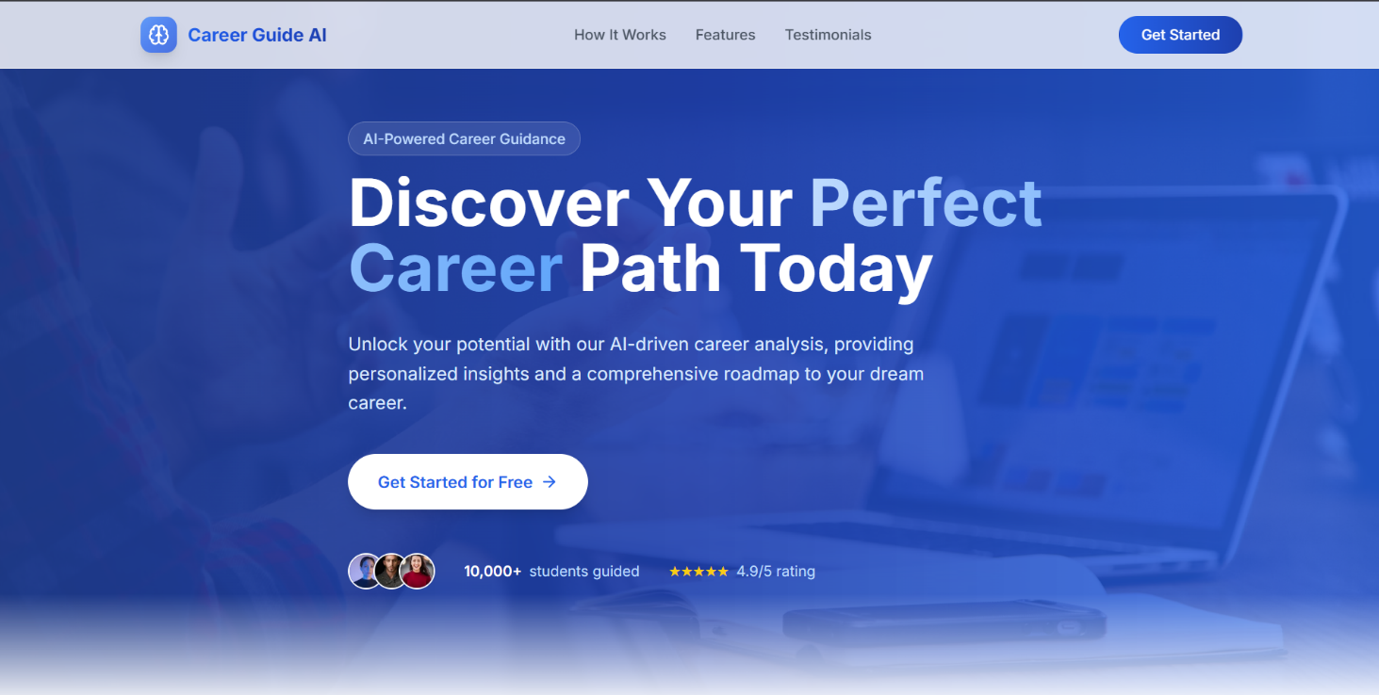

Fig 6.3.1 Home Page

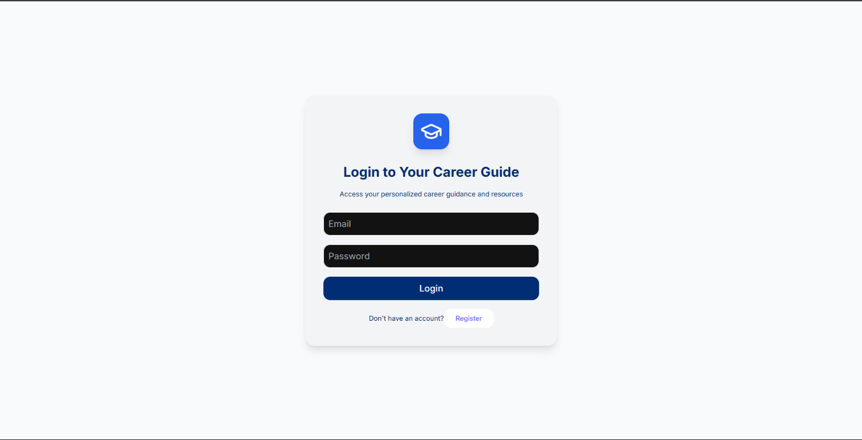

Fig 6.3.2 Login Page

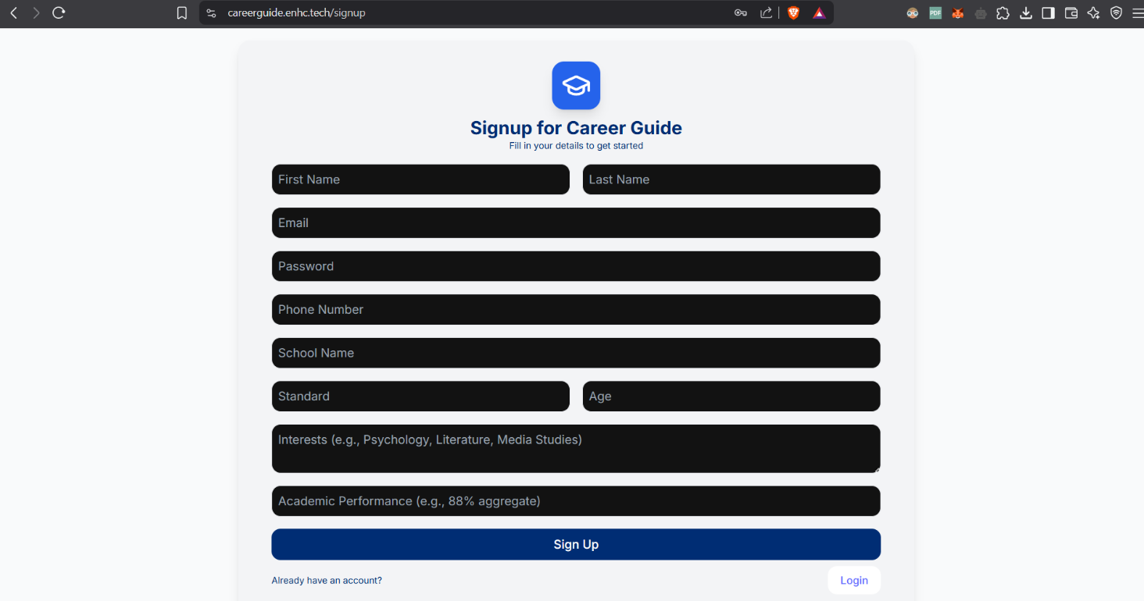

Fig 6.3.3 singup page

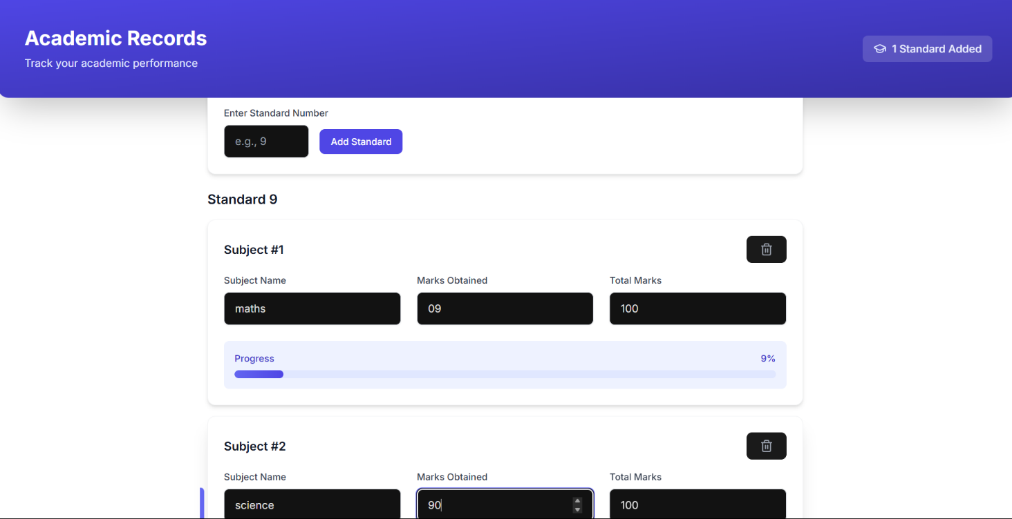

Fig 6.3.4 marks entry page

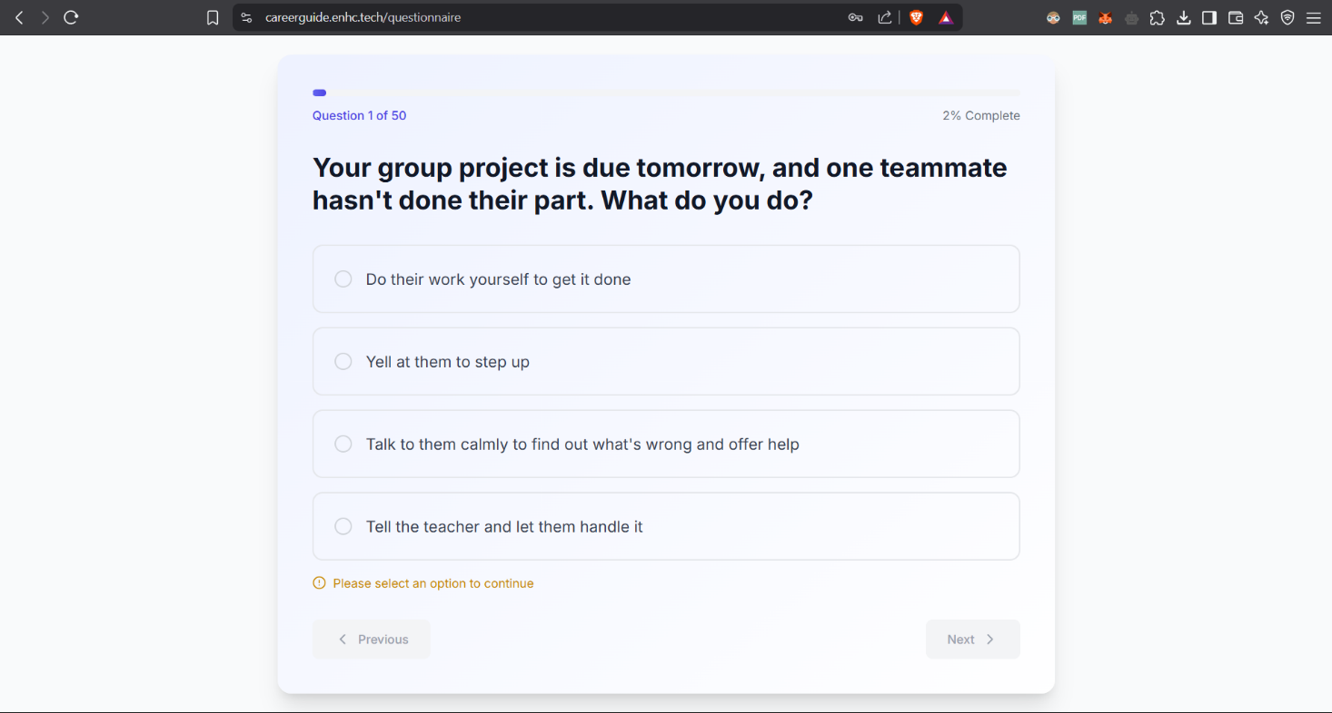

Fig 6.3.5 Question input page

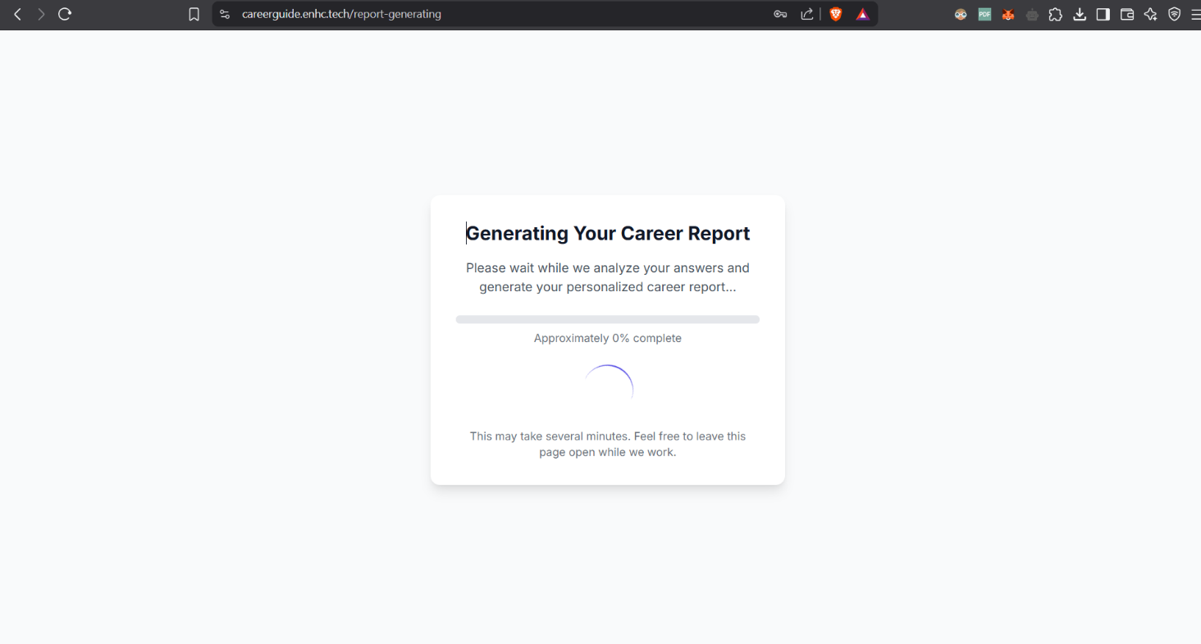

Fig 6.3.6 Processing page

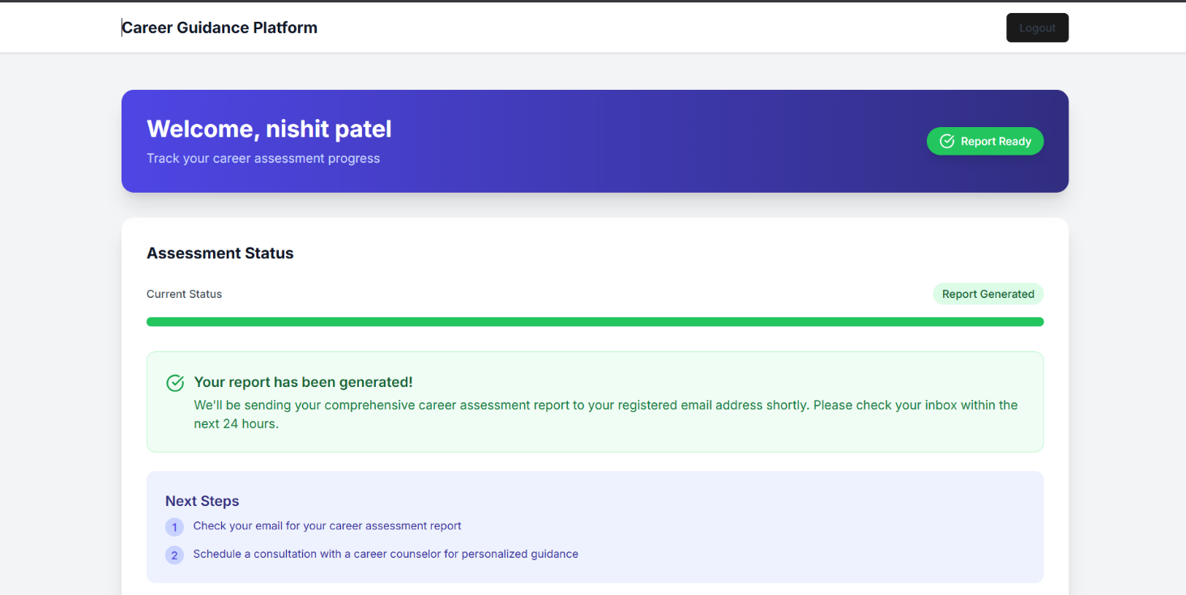

Fig 6.3.7 Dashboard

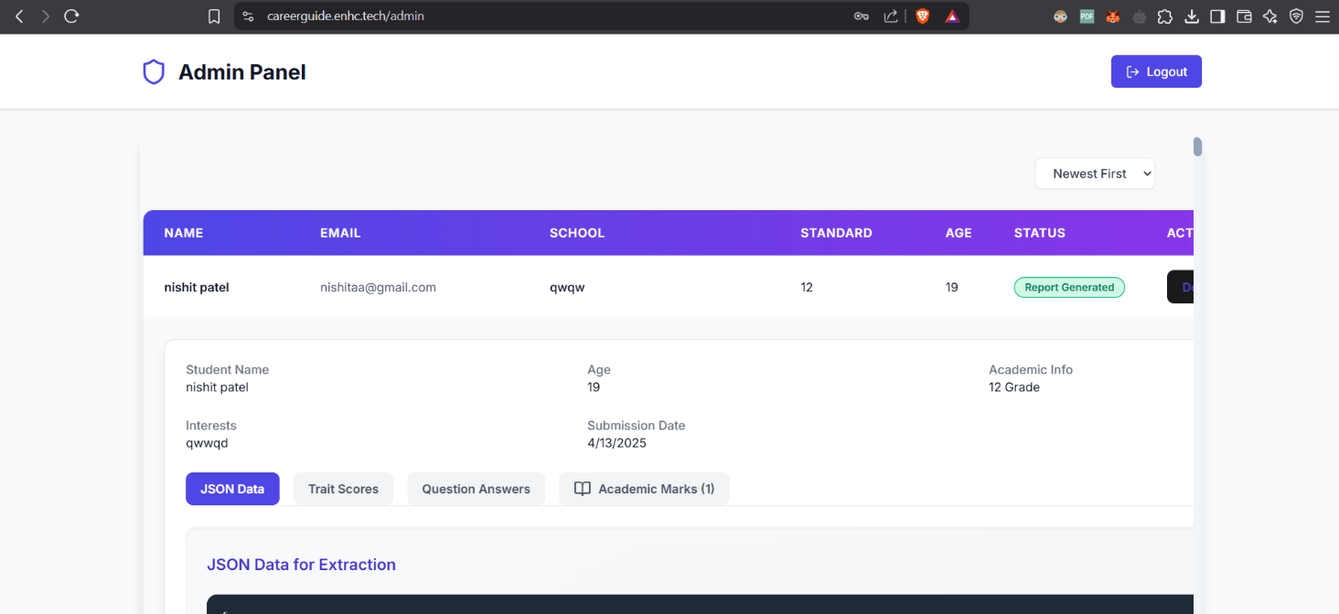

Fig 6.3.8 Admin pannel

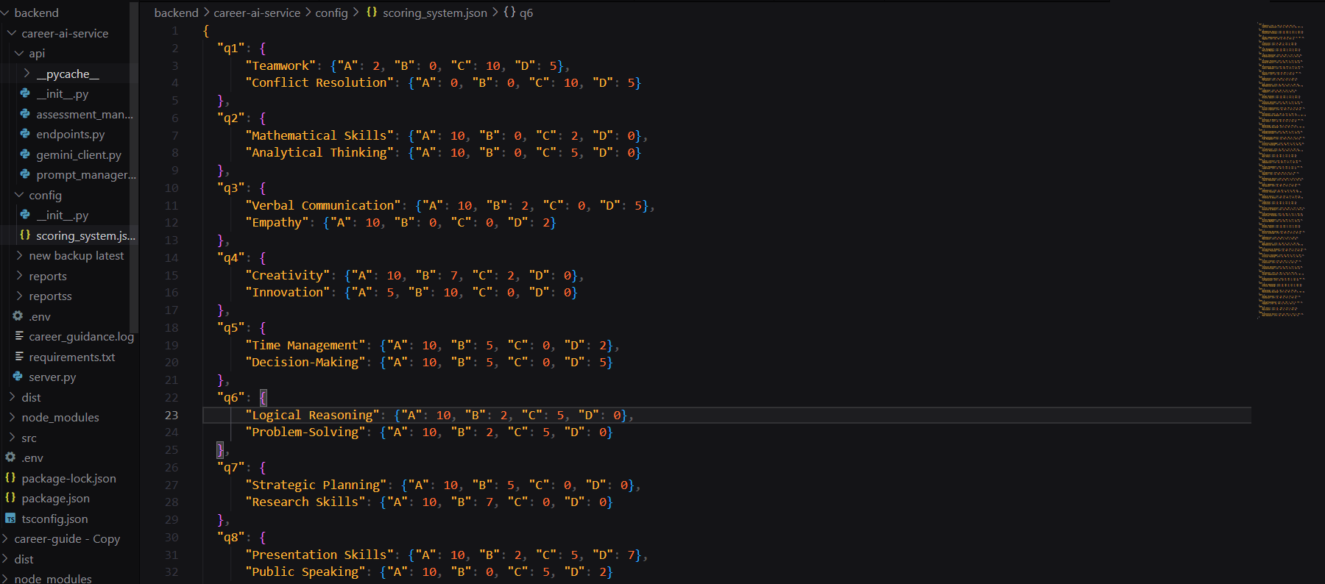

Fig 6.3.9 score json file

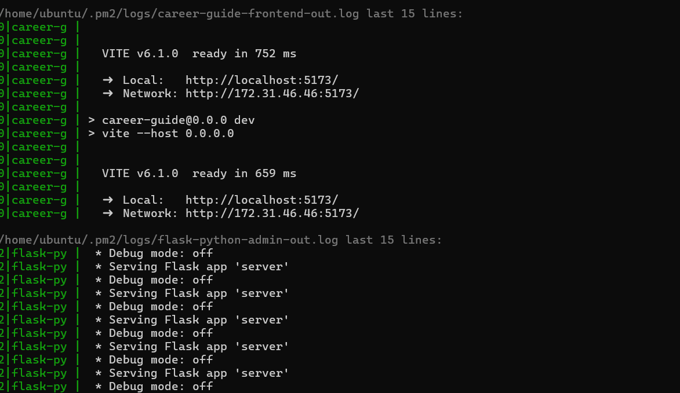

Fig 6.3.10 AWS backend logs

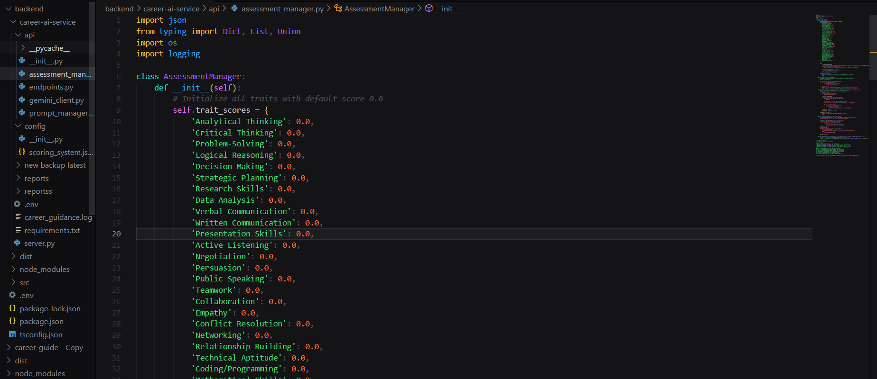

Fig 6.3.11 Code base

**7. Testing**

**7.1 Testing Plan / Strategy**

After developing the source code for the Career Guide AI system, a rigorous testing phase was conducted to identify and resolve errors before final deployment at <https://careerguide.enhc.tech/>. The goal was to create a structured testing process ensuring the system functions seamlessly across all components, from student input collection to personalized career report generation. The testing strategy focused on:

* **Validating AI Logic**: Ensuring the AI analysis engine accurately evaluates student marks and 50-question survey responses to produce relevant career recommendations.
* **Confirming Data Flow**: Verifying that inputs (e.g., student details, marks, survey answers) and outputs (e.g., career reports) are handled correctly, with smooth interactions between ReactJS frontend, Flask backend, AWS storage, and Cloudflare security.
* **Assessing Usability**: Checking system behavior, interface responsiveness, and performance under various student input scenarios to deliver a reliable user experience.

This approach aimed to ensure the platform meets the needs of students and stakeholders at Nuvion Technology.

**7.1.1 Testing Objectives**

The testing process was driven by the following objectives:

* **Error Identification**: Detect errors, inconsistencies, or unexpected behaviors in functionality, such as incorrect career suggestions or data processing issues.
* **Comprehensive Coverage**: Design test cases to uncover hidden issues in the AI engine, data flow, frontend-backend integration, or user interface.
* **Issue Resolution**: Define a successful test as one that identifies an issue (e.g., incorrect report generation, survey data mismatch) and traces it to its root cause for correction.

These objectives ensured thorough validation and a polished final product.

**7.2 Test Results and Analysis**

**7.2.1 Unit Testing**

Unit testing targeted individual components of the Career Guide AI system to confirm their standalone functionality. This phase focused on:

* **ReactJS Components**: Testing frontend components (e.g., signup form, marks entry, survey questions) for correct rendering and user interaction.
* **Flask Functions**: Validating backend API endpoints for processing student inputs and generating reports.
* **AI Engine Logic**: Testing the Python-based AI scoring system to ensure accurate evaluation of marks and survey responses against 50 parameters.
* **Helper Functions**: Checking utility methods for data formatting (e.g., calculating progress percentages for marks).

Unit tests were conducted using frameworks like **Jest** for ReactJS and **pytest** for Python, ensuring confidence in code modifications. Successful unit tests enabled progression to integration testing.

**7.2.2 Integration Testing**

Integration testing verified the interactions between the system’s components, ensuring cohesive operation. Key areas included:

* **Frontend-Backend Integration**: Confirming that the ReactJS frontend (e.g., signup, marks entry, survey pages) correctly sent data to Flask APIs and received responses.
* **AI Engine Communication**: Validating that the Flask backend accurately passed student inputs to the AI engine and retrieved career recommendations.
* **AWS Integration**: Testing data storage and retrieval from AWS to ensure student profiles and reports were saved and accessed reliably.
* **Cloudflare Security**: Verifying secure data transmission through Cloudflare’s SSL encryption during API calls.
* **Report Generation**: Checking that the AI engine’s outputs were correctly formatted into downloadable PDFs and displayed on the frontend.

Integration testing ensured smooth workflows, preparing the system for full evaluation.

**7.2.3 System Testing**

System testing assessed the Career Guide AI platform end-to-end, identifying usability, functionality, and performance issues. This phase involved:

* **Interface Usability**: Evaluating the ReactJS interface’s responsiveness across browsers and devices, ensuring pages like signup, login, and report display were intuitive.
* **End-to-End Scenarios**: Testing complete user journeys (e.g., signing up, entering marks for Standard 10, completing the survey, downloading a report) with varied inputs (e.g., different standards, interests).
* **Report Accuracy**: Verifying that career recommendations aligned with student inputs, such as suggesting engineering for high math scores and analytical interests.
* **Admin Dashboard**: Checking that stakeholder data (name, email, school, status) displayed correctly and updated in real-time.
* **UI/UX Enhancements**: Implementing minor improvements (e.g., clearer button labels) identified during testing and re-verifying.

Issues were documented, fixed, and retested to ensure a stable platform.

**7.2.4 Recovery Testing**

Recovery testing evaluated the system’s ability to handle failures gracefully, ensuring resilience. Scenarios tested included:

* **Network Disruptions**: Simulating internet outages to confirm the frontend displayed appropriate error messages (e.g., “Unable to save data”).
* **AWS Downtime**: Testing behavior when AWS storage was temporarily unavailable, ensuring data integrity upon reconnection.
* **Invalid Inputs**: Submitting incorrect data (e.g., negative marks, incomplete survey answers) to verify error handling and user feedback.
* **Cloudflare Issues**: Assessing responses to security-related interruptions, ensuring no data leaks occurred.

The system was designed to provide clear notifications and recover without crashing, maintaining a positive user experience.

**7.2.5 Security Testing**

Security testing focused on protecting student data and system integrity, addressing:

* **Data Protection**: Ensuring student inputs (e.g., email, marks) were encrypted via Cloudflare’s SSL during transmission.
* **Input Validation**: Checking ReactJS forms and Flask APIs to prevent vulnerabilities from malformed inputs.
* **AWS Security**: Verifying secure storage of profiles and reports in AWS, with access restricted to authorized processes.
* **Dependency Checks**: Scanning ReactJS and Python libraries for known vulnerabilities.

This ensured compliance with basic security standards for an educational platform.

**7.2.6 Performance Testing**

Performance testing measured the system’s efficiency under typical conditions, including:

* **AI Processing Time**: Monitoring the AI engine’s speed in analyzing marks and survey responses.
* **Page Load Time**: Ensuring ReactJS pages (e.g., survey, report display) loaded quickly across devices.
* **API Response Time**: Verifying Flask API calls completed within acceptable limits.
* **Report Generation**: Assessing the time to produce and deliver a PDF report for various input sizes.

Performance was optimized to provide a smooth experience, even with multiple concurrent users.

## 8.Conclusion

The Career Guide AI project, developed by Kavy Patel at Nuvion Technology, represents an innovative approach to personalized career planning for students. By leveraging AI to analyze academic marks and a 50-question survey, the platform delivers tailored career recommendations, moving beyond generic guidance to offer actionable insights.

Hosted at <https://careerguide.enhc.tech/>, the system features a **ReactJS** frontend for intuitive interactions (signup, marks entry, survey, report display) and a **Flask** backend powering an AI-driven scoring system. **AWS** ensures scalable data storage, while **Cloudflare** secures data transmission, creating a robust and safe platform. Key functionalities include dynamic marks entry, a comprehensive survey assessing 50 parameters, downloadable PDF reports, and an admin dashboard for stakeholder oversight.

Built with technologies like JavaScript, Python, ReactJS, Flask, AWS, and Cloudflare, this project delivers a functional prototype of an advanced career guidance tool. The iterative development process—spanning frontend design, AI implementation, backend integration, and rigorous testing—resulted in a system capable of addressing diverse student needs.

Overall, the Career Guide AI showcases the potential of AI in educational planning. Its user-centric design, intelligent analysis, and secure infrastructure make it a valuable alternative to traditional counseling, empowering students with personalized, data-informed career paths.

**References**

1. *AI in Education: Transforming Career Guidance for Students*
2. *Personalized Learning Systems Using Artificial Intelligence*
3. *Web-Based Platforms for Educational Decision-Making*