IMPACT OF AN EDUCATIONAL INTERVENTION ON MEDICAL STUDENTS’ KNOWLEDGE OF THE ROLE OF MAGNESIUM IN CARDIOVASCULAR DISEASES: A QUASI-EXPERIMENTAL STUDY
Research Project Submitted to
Department of Community Medicine
Ayub Medical College, Abbottabad
By
Name of Student | Ahmad Naeem
Roll No. | 22-016
Research Batch | A1B
Class | 4th Year MBBS
Research Supervisor | Dr. Saadia Hamid

2026

SUPERVISOR’S CERTIFICATE

I hereby certify that Ahmad Naeem, Roll No. 22-016, has successfully completed his/her research project entitled
“Impact of an Educational Intervention on Medical Students’ Knowledge of the Role of Magnesium in Cardiovascular Diseases: A Quasi-Experimental Study”
in the year 2026 at the Department of Community Medicine, Ayub Medical College, Abbottabad.
He/she has been working under my supervision. The enclosed report is prepared according to the departmental guidelines. I have read the project and have found it adequate as per the requirements of the department and Khyber Medical University (KMU).

NAME OF SUPERVISOR: Dr. Saadia Hamid
SIGNATURE OF SUPERVISOR: ______________________________
DATE OF SUBMISSION: 15/10/2026
DEPARTMENT STAMP: ______________________________
ACKNOWLEDGEMENTS
First and foremost, I am grateful to Almighty Allah, the Most Gracious and the Most Merciful, who gave me the strength, patience and opportunity to complete this research project.
I owe my deepest gratitude to my research supervisor, Dr. Saadia Hamid, Department of Community Medicine, Ayub Medical College, Abbottabad, for her constant guidance, constructive criticism and encouragement at every stage of this work, from the formulation of the research question and objectives to the analysis and final write-up. Her teaching on research methodology made this project both possible and meaningful.
I am sincerely thankful to the Head and the faculty of the Department of Community Medicine for providing a supportive academic environment and for including research as an integral part of the undergraduate curriculum. I also acknowledge the administration of Ayub Medical College for facilitating the conduct of the educational session and data collection.
I am especially grateful to my fellow 4th-year MBBS students who willingly participated in this study, attended the awareness session and completed both questionnaires with honesty and patience. This work would not have been possible without their cooperation. I also thank my research group members and colleagues who helped in preparing the educational material, organizing the session and entering the data.
Finally, I express my heartfelt gratitude to my parents and family for their prayers, unconditional love and continuous support throughout my studies.

Ahmad Naeem
Roll No. 22-016
DEDICATION

This humble effort is dedicated to
my beloved parents,
whose prayers, sacrifices and encouragement have been my greatest strength;
my respected teachers,
who taught me not only medicine but the value of asking questions;
and to all patients living with cardiovascular disease,
for whom every bit of better knowledge may one day make a difference.
LIST OF ABBREVIATIONS
Abbreviation | Full Form
AMC | Ayub Medical College
ATP | Adenosine Triphosphate
Ca²⁺ | Calcium ion
CKD | Chronic Kidney Disease
CVD | Cardiovascular Disease
DRI | Dietary Reference Intake
HDL | High-Density Lipoprotein
IQR | Interquartile Range
K⁺ | Potassium ion
KMU | Khyber Medical University
MBBS | Bachelor of Medicine and Bachelor of Surgery
MeSH | Medical Subject Headings
Mg | Magnesium
Mg²⁺ | Magnesium ion
n / N | Number of participants
Na⁺ | Sodium ion
NCD | Non-Communicable Disease
NO | Nitric Oxide
PPI | Proton Pump Inhibitor
PTH | Parathyroid Hormone
Q | Question (questionnaire item)
r | Effect size (correlation coefficient)
RDA | Recommended Dietary Allowance
SCD | Sudden Cardiac Death
SD | Standard Deviation
SPSS | Statistical Package for the Social Sciences
U | Mann–Whitney U statistic
TABLE OF CONTENTS
S. No. | Contents | Page No.
1 | Supervisor’s Certificate | i
2 | Acknowledgements | ii
3 | Dedication | iii
4 | List of Abbreviations | iv
5 | Table of Contents | v
6 | List of Tables | vi
7 | List of Figures | vii
8 | List of Appendices | viii
9 | Executive Summary / Abstract | 1
10 | Introduction | 2
11 | Literature Review | 4
12 | Objectives and Operational Definitions | 9
13 | Materials and Methods | 11
14 | Results | 14
15 | Discussion (including Limitations of the Study) | 19
16 | Conclusion | 22
17 | Recommendations | 23
18 | References | 24
19 | Appendix I: Questionnaire | 28
LIST OF TABLES
Table No. | Title | Page No.
Table I | Gender Distribution of Study Participants (N = 43) | 14
Table II | Previous Participation in Awareness Sessions among Study Participants (N = 43) | 15
Table III | Frequencies and Percentages of Participants’ Knowledge Scores before and after the Educational Intervention (N = 43) | 15
Table IV | Mean and Standard Deviation of Participants’ Knowledge Scores before and after the Educational Intervention | 16
Table V | Descriptive Statistics of Post-intervention Knowledge Scores by Gender | 17
Table VI | Wilcoxon Signed-Rank Test for Pre- and Post-intervention Knowledge Scores | 18
Table VII | Mann–Whitney U Test for Association between Gender and Post-intervention Knowledge Scores | 18
LIST OF FIGURES
Figure No. | Title | Page No.
Figure I | Pie chart showing the gender distribution of participants (N = 43) | 14
Figure II | Bar chart illustrating the distribution of knowledge scores before and after the educational intervention (N = 43) | 16
Figure III | Distribution of post-intervention knowledge scores (N = 43) | 17
LIST OF APPENDICES
Appendix | Title | Page No.
Appendix I | Questionnaire: Knowledge Survey on the Role of Magnesium in Cardiovascular Diseases | 28

EXECUTIVE SUMMARY / ABSTRACT
Background: Magnesium is essential for cardiac electrical stability, vascular tone and endothelial function, yet magnesium deficiency is under-recognized in clinical practice and receives limited emphasis in medical curricula. This study aimed to assess the baseline knowledge of medical students regarding the role of magnesium in cardiovascular diseases and to determine the effect of a structured educational intervention on that knowledge.
Materials and Methods: A one-group pre-test–post-test quasi-experimental study was conducted among 4th-year MBBS students of Ayub Medical College, Abbottabad, from April to October 2026, using consecutive sampling. A structured questionnaire containing 20 knowledge statements (maximum score 20) was administered before and immediately after a 30-minute PowerPoint-based educational session. Data were analysed using SPSS version 27. The Wilcoxon signed-rank test and the Mann–Whitney U test were applied, and p < 0.05 was considered significant.
Results: Of 43 participants, 28 (65.1%) were male and 15 (34.9%) were female. Only 11 (25.6%) had previously attended a nutrition awareness session and 6 (14.0%) a cardiovascular disease awareness session. The mean knowledge score increased from 13.05 ± 0.82 before to 18.47 ± 0.88 after the intervention (p < 0.001), with a large effect size (r = 0.88). Baseline gaps were most marked for magnesium distribution in cardiac tissue and recommended daily intake. Post-intervention scores did not differ significantly between male and female students (p = 0.509).
Conclusion: Medical students had moderate baseline knowledge with specific gaps regarding magnesium in cardiovascular health. A brief structured educational session produced a substantial short-term improvement in knowledge, irrespective of gender, supporting the inclusion of focused micronutrient teaching in the undergraduate curriculum.
Keywords: Magnesium; Cardiovascular Diseases; Magnesium Deficiency; Students, Medical; Health Education.
INTRODUCTION
Cardiovascular disease remains the leading cause of morbidity and mortality worldwide, with coronary artery disease continuing to rank among the major contributors to adverse cardiovascular outcomes [1,2]. Hypertension is the foremost global modifiable risk factor for cardiovascular morbidity and mortality; approximately one in three adults is affected, and the number of blood-pressure-related cardiovascular and all-cause deaths increased substantially between 1990 and 2015 [3]. Its prevalence is particularly high in low- and middle-income countries, where more than one billion adults are estimated to have hypertension [3]. In Pakistan, non-communicable diseases, led by cardiovascular disease, now account for a large and rising share of the national disease burden [4]. Because suboptimal dietary practices contribute to cardiovascular death and disability, prevention strategies increasingly emphasize nutrition alongside conventional risk-factor management [5,6]. The persistent burden of hypertension, coronary disease, stroke and their complications therefore makes cardiovascular prevention an enduring public health priority [2,3].
Magnesium is the second most abundant intracellular cation after potassium and is essential to cellular homeostasis [5,7]. It binds nucleotides, forms the biologically active Mg²⁺-ATP complex required for ATP-dependent reactions, acts as a cofactor for more than 600 enzymes and an activator of approximately 200 additional enzymes, and participates in glucose, lipid and protein metabolism [5]. In the cardiovascular system, magnesium contributes to electrophysiological stability, vascular tone, endothelial relaxation and blood-pressure regulation [5]. It modulates Na⁺/K⁺-ATPase, potassium channels, the Na⁺/Ca²⁺ exchanger and Ca²⁺-ATPases, while functioning as a physiological calcium antagonist through calcium-channel blockade and competition at calcium-binding and transport sites [5]. In vascular smooth muscle and endothelium, these actions reduce calcium-dependent vasoconstriction and enhance endothelial nitric oxide synthase activity and nitric oxide production [5]. Magnesium also influences prostacyclin and prostaglandin E1 synthesis and may support endothelial function through anti-inflammatory and antioxidant effects [5]. Collectively, these mechanisms provide biological plausibility for an association between magnesium status and cardiovascular health.
Hypomagnesemia is generally defined as a serum magnesium concentration below 0.6 mmol/L, although intracellular deficiency may occur despite values within the conventional reference range [5]. Low serum or dietary magnesium has been associated with hypertension, coronary heart disease, heart failure, atrial fibrillation, stroke, major cardiovascular events and cardiovascular mortality, but much of this evidence is observational and does not establish causality [5]. A meta-analysis of prospective studies reported an 8% lower risk of ischaemic stroke for each additional 100 mg/day of dietary magnesium [8], while randomized evidence has shown modest and sometimes inconsistent effects on blood pressure [3,5]. In a broad meta-analysis of micronutrient trials, magnesium supplementation reduced systolic and diastolic blood pressure and produced small improvements in triglycerides and high-density lipoprotein cholesterol [6]. Conversely, a hypertension-focused meta-analysis found a significant reduction in diastolic, but not systolic, blood pressure [3]. The evidence for arrhythmia prevention is similarly mixed: hypomagnesemia is associated with arrhythmic risk, yet a randomized trial involving 265 cardiac-surgery patients found that intravenous magnesium targeting serum concentrations of 1.5–2.0 mmol/L did not reduce postoperative atrial fibrillation [9]. In chronic kidney disease and haemodialysis, low magnesium is associated with cardiovascular events and all-cause mortality; cardiovascular disease accounts for nearly half of deaths among maintenance-haemodialysis patients, whose cardiovascular mortality is reported to be 10–20 times that of the general population [10]. Higher dialysate magnesium concentrations or oral supplementation may improve surrogate markers such as vascular calcification, stiffness, endothelial function and carotid intima-media thickness, but adequately powered trials assessing major cardiovascular events and mortality remain necessary [10].
These findings have direct educational relevance for future physicians. Nutrition is a foundational component of cardiovascular prevention, yet micronutrients differ in their benefits, limitations and potential risks, requiring clinicians to interpret dietary and supplementation evidence critically rather than treating all micronutrients as uniformly beneficial [6]. Magnesium deficiency remains under-recognized in clinical practice, partly because most body magnesium is intracellular, early symptoms may be absent, serum measurements may not reflect total-body stores, and physicians may have an incomplete understanding of magnesium physiology [5,11]. Medical students therefore need an integrated understanding of magnesium biology, diagnostic thresholds, cardiovascular mechanisms, high-risk populations, and the distinction between observational associations, surrogate improvements and proven clinical outcomes [3,5,6,9,10]. Such knowledge is necessary to support appropriate dietary counselling, laboratory interpretation and evidence-based decisions regarding supplementation.
Although magnesium’s physiological importance and its associations with cardiovascular risk are increasingly documented, the available literature does not establish how well medical students understand these concepts or whether focused teaching can improve their knowledge. Assessing baseline knowledge is important because misconceptions may lead either to neglect of clinically relevant deficiency or to overstatement of supplementation benefits unsupported by definitive outcome trials [5,6,9,10]. A structured educational intervention may help students integrate mechanistic, epidemiological and clinical evidence and recognize the limits of current knowledge. Therefore, this quasi-experimental study was conducted to evaluate the impact of an educational intervention on medical students’ knowledge regarding the role of magnesium in cardiovascular diseases.
LITERATURE REVIEW
Magnesium as a Cardiovascular Determinant
Magnesium is a predominantly intracellular cation that supports energy metabolism, membrane stability, enzymatic reactions and electrolyte homeostasis. Because less than 1% of total body magnesium is present in serum, a normal serum concentration does not necessarily exclude intracellular or total-body depletion [5,12,13]. This diagnostic limitation is clinically relevant because magnesium participates in Mg²⁺-ATP-dependent reactions and regulates Na⁺/K⁺-ATPase, potassium channels, L-type calcium channels, Ca²⁺-ATPases and the sodium–calcium exchanger [5,12,13]. Through these pathways, magnesium contributes to cardiac conduction, repolarization, excitation–contraction coupling, vascular smooth-muscle tone and endothelial function.
The cardiovascular effects of magnesium are biologically plausible but involve several interacting mechanisms. Magnesium acts as a physiological calcium antagonist, reducing calcium-dependent vasoconstriction and limiting intracellular calcium overload. It may also promote nitric oxide and prostacyclin production while moderating inflammatory signalling, oxidative stress, platelet activation and the actions of vasoconstrictors [5,12–14]. Deficiency may therefore favour electrical instability, endothelial dysfunction, hypertension, atherogenesis and thrombosis. Nevertheless, mechanistic evidence cannot by itself establish that magnesium supplementation prevents clinical cardiovascular events, particularly in individuals without demonstrated deficiency.
Dietary Requirements and Causes of Deficiency
The Recommended Dietary Allowance (RDA) of magnesium for adults is approximately 400–420 mg/day for men and 310–320 mg/day for women [15]. The richest dietary sources are of plant origin, including green leafy vegetables, nuts, seeds, legumes and whole grains, while refined and processed foods contain considerably less [7,16]. Dietary surveys suggest that a large proportion of the population consumes less than the estimated requirement, so that subclinical or chronic latent magnesium deficiency may be far more common than routine serum testing reveals [11,17].
Beyond inadequate intake, deficiency commonly results from increased gastrointestinal or renal losses. Type 2 diabetes mellitus is strongly associated with hypomagnesemia, partly through glycosuria-induced renal wasting, and low magnesium in turn worsens insulin resistance [18]. Several frequently prescribed drugs, notably loop and thiazide diuretics, proton pump inhibitors, aminoglycoside antibiotics, amphotericin B and calcineurin inhibitors, can deplete magnesium [16,19]. Long-term proton pump inhibitor use, for example, has been reported to cause severe symptomatic hypomagnesemia that resolves only after withdrawal of the drug [19]. Deficiency also disturbs potassium and calcium homeostasis: magnesium depletion promotes renal potassium wasting and impairs parathyroid hormone secretion and action, so that hypokalaemia and hypocalcaemia may be refractory until magnesium is replaced [5,7].
Magnesium Status and Cardiovascular Risk
Observational studies generally associate higher magnesium intake or circulating magnesium with more favourable cardiovascular profiles. In the Framingham Heart Study, 2,695 participants without clinically apparent cardiovascular disease underwent computed-tomography assessment of coronary and abdominal aortic calcification. Each 50 mg/day increment in self-reported total magnesium intake was associated with 22% lower coronary artery calcification, and participants in the highest intake category had lower odds of detectable coronary and abdominal aortic calcification than those in the lowest category [20]. However, the cross-sectional design, self-reported dietary exposure, residual confounding and limited population diversity prevent causal interpretation. Higher magnesium intake may also represent a healthier overall dietary pattern rather than an isolated mineral effect.
Pooled prospective data strengthen these associations. A meta-analysis of prospective studies found that higher circulating magnesium was associated with a lower risk of total cardiovascular disease, and higher dietary magnesium with a lower risk of ischaemic heart disease [21]. A larger dose–response meta-analysis of cohort studies reported that each 100 mg/day increase in dietary magnesium was associated with a 22% lower risk of heart failure and a 7% lower risk of stroke [22]. Low serum magnesium has also been linked to sudden cardiac death: in the Atherosclerosis Risk in Communities study, participants in the lowest quartile of serum magnesium had a significantly higher risk of sudden cardiac death [23], and in the Rotterdam Study a serum magnesium of 0.80 mmol/L or less was associated with higher risks of coronary heart disease mortality and sudden cardiac death [24].
Interventional evidence is more informative but remains inconsistent. A comprehensive meta-analysis of 884 randomized micronutrient trials reported moderate- to high-quality evidence that magnesium supplementation reduced systolic and diastolic blood pressure and produced small favourable changes in triglycerides and high-density lipoprotein cholesterol [6]. An earlier meta-analysis of 34 randomized double-blind placebo-controlled trials similarly found that a median dose of 368 mg/day for three months modestly lowered both systolic and diastolic blood pressure [25]. In contrast, a hypertension-focused systematic review found a statistically significant reduction in diastolic blood pressure of approximately 1.6 mmHg, but no significant effect on systolic blood pressure or pulse rate [3]. Differences across reviews may reflect baseline magnesium status, dose, formulation, treatment duration, concomitant therapy and participant risk profiles.
Evidence regarding lipid metabolism is similarly suggestive rather than definitive. A 2026 cross-sectional study of 224 adults in Western Iran found that higher serum magnesium was associated with lower odds of dyslipidaemia among participants with cardiovascular disease after adjustment for selected covariates [26]. The study simultaneously evaluated several essential and non-essential elements, used a regional sample and could not determine temporality. Consequently, the association may indicate a relationship between magnesium status and lipid abnormalities, but it does not establish that magnesium supplementation improves dyslipidaemia or reduces cardiovascular events.
Arrhythmias, Replacement and Prophylactic Supplementation
Magnesium has a well-established relationship with cardiac electrical stability, yet its clinical value depends on the indication. Hypomagnesemia, particularly when accompanied by hypokalaemia, can reduce repolarization reserve and increase susceptibility to atrial and ventricular arrhythmias. Intravenous magnesium is used as initial therapy for torsades de pointes, including in some patients with a normal measured serum magnesium concentration, because it may suppress early-afterdepolarization-mediated triggered activity [27]. This targeted use should not be generalized to routine treatment of all ventricular arrhythmias or to universal prophylactic supplementation.
A recent case report demonstrates the severity and complexity of electrolyte-related arrhythmia. A woman with Gitelman syndrome, potassium of 2.2 mmol/L and magnesium of 1.6 mg/dL developed an atrial tachyarrhythmia followed by recurrent ventricular tachycardia and approximately 35–40 implantable cardioverter-defibrillator therapies [28]. Rhythm stabilization followed potassium and magnesium replacement with beta-blockade, but aggressive repletion was complicated by rebound hyperkalaemia [28]. The report supports clinical plausibility and the need for careful monitoring, although a single case cannot quantify treatment effectiveness.
Stronger randomized evidence does not support routine perioperative magnesium for the prevention of postoperative atrial fibrillation. In the double-blind POMPAE trial, 265 adults undergoing coronary bypass or valvular surgery received continuous intravenous magnesium or placebo. Postoperative atrial fibrillation occurred in 37.9% of the magnesium group and 28.6% of the placebo group; the trial was stopped for futility, and no subgroup showed benefit [9]. The single-centre design and early termination limit precision, but the randomized methodology provides stronger causal evidence than observational associations. These results emphasize the distinction between correcting deficiency or treating a specific arrhythmia and administering magnesium to unselected, magnesium-replete patients.
Chronic Kidney Disease and Haemodialysis
Magnesium management is particularly complex in chronic kidney disease because reduced renal clearance can cause accumulation, whereas dialysis prescriptions and other factors may promote depletion. A 2026 narrative review identified 20 studies, including 10 randomized trials, evaluating serum, oral or dialysate magnesium in chronic kidney disease and haemodialysis populations [10]. Lower serum magnesium was associated with cardiovascular events and all-cause mortality, while higher dialysate magnesium concentrations or oral supplementation improved several surrogate markers, including calcification propensity, carotid intima-media thickness and vascular stiffness [10]. Most trials were small, single-centre, short in duration and heterogeneous in interventions and outcomes, and no randomized trial had established an effect on mortality or major cardiovascular events [10]. Thus, the evidence supports further adequately powered trials rather than routine adoption of higher magnesium exposure for all dialysis patients.
Nutrition Knowledge in Medical Education
Despite the central role of diet in cardiovascular prevention, nutrition remains under-represented in medical training. A national survey of United States medical schools found that most institutions failed to provide even the minimum recommended 25 hours of nutrition education [29]. A systematic review of 24 studies from several countries concluded that nutrition is insufficiently incorporated into medical education regardless of country, setting or year of training, and that students lack the knowledge, skills and confidence to provide nutrition care to patients [30]. Physicians themselves cite inadequate knowledge and training as major barriers to dietary counselling [31,32]. Micronutrients such as magnesium, whose physiology is taught in basic sciences but whose clinical relevance is rarely revisited, are particularly vulnerable to this gap.
Educational Relevance and Research Rationale
The literature presents magnesium as an important but easily oversimplified cardiovascular topic. Medical students must integrate physiology, dietary sources, serum-measurement limitations, medication-related losses, renal handling, and the coexistence of hypokalaemia or hypocalcaemia. They must also distinguish biological plausibility from causal clinical evidence, observational associations from randomized findings, and surrogate improvement from reductions in myocardial infarction, stroke, hospitalization or mortality. The contrast between clear indications, such as correction of hypomagnesemia or treatment of torsades de pointes, and negative prophylactic evidence in postoperative atrial fibrillation is especially relevant to evidence-based decision-making [9,27].
None of the clinical studies reviewed above directly assessed medical students’ baseline knowledge or evaluated a pre-test/post-test educational intervention on this topic. The existing sources therefore define the clinical knowledge that students should acquire but do not establish whether students currently understand these concepts or whether a focused educational session improves their knowledge. This gap provides the rationale for the present quasi-experimental study. Measuring the same students before and after a structured intervention can determine short-term knowledge improvement regarding magnesium physiology, deficiency, cardiovascular associations, dietary requirements and the boundaries of current evidence. Improved questionnaire scores should, however, be interpreted as an educational outcome, without assuming that knowledge gain necessarily translates into long-term retention or change in clinical practice.
Summary
Current evidence supports an important physiological role for magnesium in cardiovascular function and associates low magnesium status with hypertension, vascular calcification, dyslipidaemia, arrhythmias, sudden cardiac death and adverse outcomes in selected populations. However, supplementation effects vary by population and indication, and definitive benefits for major cardiovascular outcomes remain unproven in many settings. A focused educational intervention is justified because students must understand both the clinical relevance of magnesium deficiency and the limitations of generalized supplementation claims.
OBJECTIVES AND OPERATIONAL DEFINITIONS
Objectives
- To assess the baseline knowledge of 4th-year MBBS students of Ayub Medical College, Abbottabad, regarding the role of magnesium in cardiovascular diseases before an educational intervention.
- To assess the knowledge of the same students immediately after a structured educational intervention on the role of magnesium in cardiovascular diseases, using the same questionnaire.
- To compare the pre-intervention and post-intervention knowledge scores of the participants in order to determine the effectiveness of the educational intervention.
- To determine the association of gender with post-intervention knowledge scores.
Operational Definitions
1. Educational Intervention
A structured, 30-minute PowerPoint-based awareness session designed by the researchers to improve knowledge about the role of magnesium in cardiovascular diseases. Its content was aligned with the domains of the knowledge questionnaire, and key concepts were explained verbally and supported by presentation slides.
2. Knowledge
The participants’ understanding of the physiological role of magnesium, its dietary sources, recommended intake, causes and consequences of magnesium deficiency, and its relationship with cardiovascular diseases (such as hypertension, arrhythmias, atherosclerosis, heart failure and sudden cardiac death), as measured by a structured, self-administered questionnaire of 20 statements.
3. Knowledge Score
The total number of correctly answered knowledge statements. Each correct response was awarded 1 point, while an incorrect or “Not Sure” response was awarded 0 points, giving a possible score range of 0 to 20.
4. Baseline (Pre-intervention) Knowledge
The knowledge score obtained by a participant on the questionnaire administered before the educational intervention.
5. Post-intervention Knowledge
The knowledge score obtained by a participant on the same questionnaire administered immediately after completion of the educational intervention.
6. Knowledge Improvement
The increase in a participant’s knowledge score on the post-intervention questionnaire compared with the pre-intervention questionnaire, expressed as the difference between post-test and pre-test scores.
7. Medical Students
Full-time undergraduate 4th-year MBBS students enrolled at Ayub Medical College, Abbottabad, during the study period, who met the inclusion criteria and voluntarily provided informed consent.
8. Cardiovascular Diseases (CVDs)
Disorders of the heart and blood vessels, including hypertension, coronary artery disease, myocardial infarction, heart failure, cardiac arrhythmias and stroke, as covered in the educational intervention.
9. Quasi-Experimental Study
An interventional study in which the same group of participants undergoes a pre-test assessment, receives an educational intervention and completes a post-test assessment, without random allocation to intervention and control groups.
MATERIALS AND METHODS
Study Design
A quasi-experimental study using a single-group (one-group) pre-test–post-test design.
Study Setting
The study was carried out at Ayub Medical College, Abbottabad, Khyber Pakhtunkhwa, Pakistan, under the Department of Community Medicine.
Study Duration
The study was conducted over a period of seven months, from April 2026 to October 2026.
Study Population
The study population consisted of 4th-year MBBS students of Ayub Medical College, Abbottabad.
Sample Size
The sample size was calculated using the formula for comparison of paired means, which is appropriate for a single-group pre-test–post-test design:
n = (Z₁₋α/₂ + Z₁₋β)² × σ_d² / d²
where Z₁₋α/₂ = 1.96 for a 95% confidence level, Z₁₋β = 0.84 for 80% power, σ_d = 5.4 is the standard deviation of the paired differences, and d = 2.5 is the expected mean improvement, both drawn from earlier educational intervention studies. This gave (2.80)² × (5.4)² / (2.5)² ≈ 37 participants. After allowing for an anticipated 20% loss due to incomplete responses or failure to complete the post-test, the final required sample size was approximately 46 participants.
Sampling Technique
Non-probability consecutive sampling was used; all eligible students who presented during the data-collection period and consented were enrolled.
Selection Criteria
Inclusion Criteria
- Full-time 4th-year MBBS students enrolled at Ayub Medical College during the study period.
- Students who agreed to participate voluntarily and provided informed consent.
- Students who attended the educational intervention and completed both the pre-test and post-test questionnaires.
Exclusion Criteria
- Students who were absent or on official leave on the day of the intervention.
- Students who did not attend the educational session or did not complete the post-test assessment.
- Students who were involved in designing or conducting the intervention session.
Study Variables
- Independent variable: the educational awareness intervention on the role of magnesium in cardiovascular disease.
- Dependent variable: knowledge of 4th-year MBBS students regarding the role of magnesium in cardiovascular disease, measured as pre- and post-intervention knowledge scores.
- Other variables: gender, and previous attendance at nutrition and cardiovascular disease awareness sessions.
Data Collection Tool
A structured, self-administered questionnaire developed by the researchers was used (Appendix I). Section A recorded demographic information: gender, academic year, and previous attendance at awareness sessions on cardiovascular diseases and on nutrition. Section B contained 20 knowledge statements covering the physiological role of magnesium, causes and consequences of deficiency, its cardiovascular effects, dietary sources, recommended daily intake and related metabolic effects. For each statement, participants selected one of three responses: “Yes”, “No” or “Not Sure”. A correct answer scored 1 point, and an incorrect or “Not Sure” answer scored 0, giving a total possible score of 20.
Data Collection Procedure
- Recruitment and consent: Eligible students were assembled before the session, the purpose and procedure of the study were explained, and written informed consent was obtained.
- Pre-test: The questionnaire was administered and collected before any teaching took place.
- Educational intervention: A 30-minute awareness session was delivered, developed around the topics included in the questionnaire. It covered the physiological functions of magnesium and its significance in cellular function and metabolism; its role in regulating vascular tone and maintaining cardiovascular health; causes and risk factors of deficiency, including diabetes mellitus and certain medications; potential consequences of deficiency, including inflammation, oxidative stress, disturbances of cardiac electrical activity, sudden cardiac death, heart failure, atherosclerosis and hypertension; dietary sources such as green leafy vegetables, nuts, seeds, legumes and whole grains; the recommended daily intake for males and females; and the contribution of magnesium to potassium and calcium balance. The material was presented using PowerPoint slides, with key concepts explained verbally.
- Post-test: Immediately after the session, the same questionnaire was administered again and collected.
Data Analysis Procedure
Data were entered and analysed using IBM SPSS Statistics, version 27. Categorical variables (gender and previous attendance at awareness sessions) were presented as frequencies and percentages. Knowledge scores were presented as frequency distributions, mean ± standard deviation, and median with interquartile range (IQR). The normality of the score distributions was assessed with the Shapiro–Wilk test; because the assumption of normality was not met, non-parametric tests were used. The Wilcoxon signed-rank test was applied to compare paired pre- and post-intervention scores, and the effect size was calculated as r = Z/√N [33]. The Mann–Whitney U test was used to compare post-intervention scores between male and female participants. A p-value of less than 0.05 was considered statistically significant. Results were presented in tables, a pie chart and bar charts.
Ethical Considerations
- Ethical approval: The study was conducted under the supervision of the Department of Community Medicine, Ayub Medical College, and permission was obtained before data collection.
- Informed consent: All students were given an explanation of the study’s purpose, nature and procedures, and participation began only after informed consent was obtained.
- Confidentiality: Participants were assigned identification codes, records were stored securely, and access to data was restricted to the investigators.
- Voluntary participation: Participation was entirely voluntary, without coercion, and students were free to withdraw at any stage without any academic consequence.
RESULTS
This section presents the findings of the study evaluating the impact of an educational intervention on participants’ knowledge regarding the role of magnesium in cardiovascular diseases. A total of 43 students who completed both the pre-test and the post-test were included in the final analysis. The results include participants’ demographic characteristics and previous exposure to health awareness sessions, followed by a comparison of pre- and post-intervention knowledge scores. Descriptive and inferential statistical analyses were conducted using IBM SPSS Statistics, version 27.
Demographic Characteristics
The study included 43 participants, comprising 28 males (65.1%) and 15 females (34.9%) (Table I). The gender distribution is presented diagrammatically as a pie chart in Figure I.
Table I: Gender Distribution of Study Participants (N = 43)
Gender | Frequency (n) | Percentage (%)
Male | 28 | 65.1
Female | 15 | 34.9
Total | 43 | 100.0
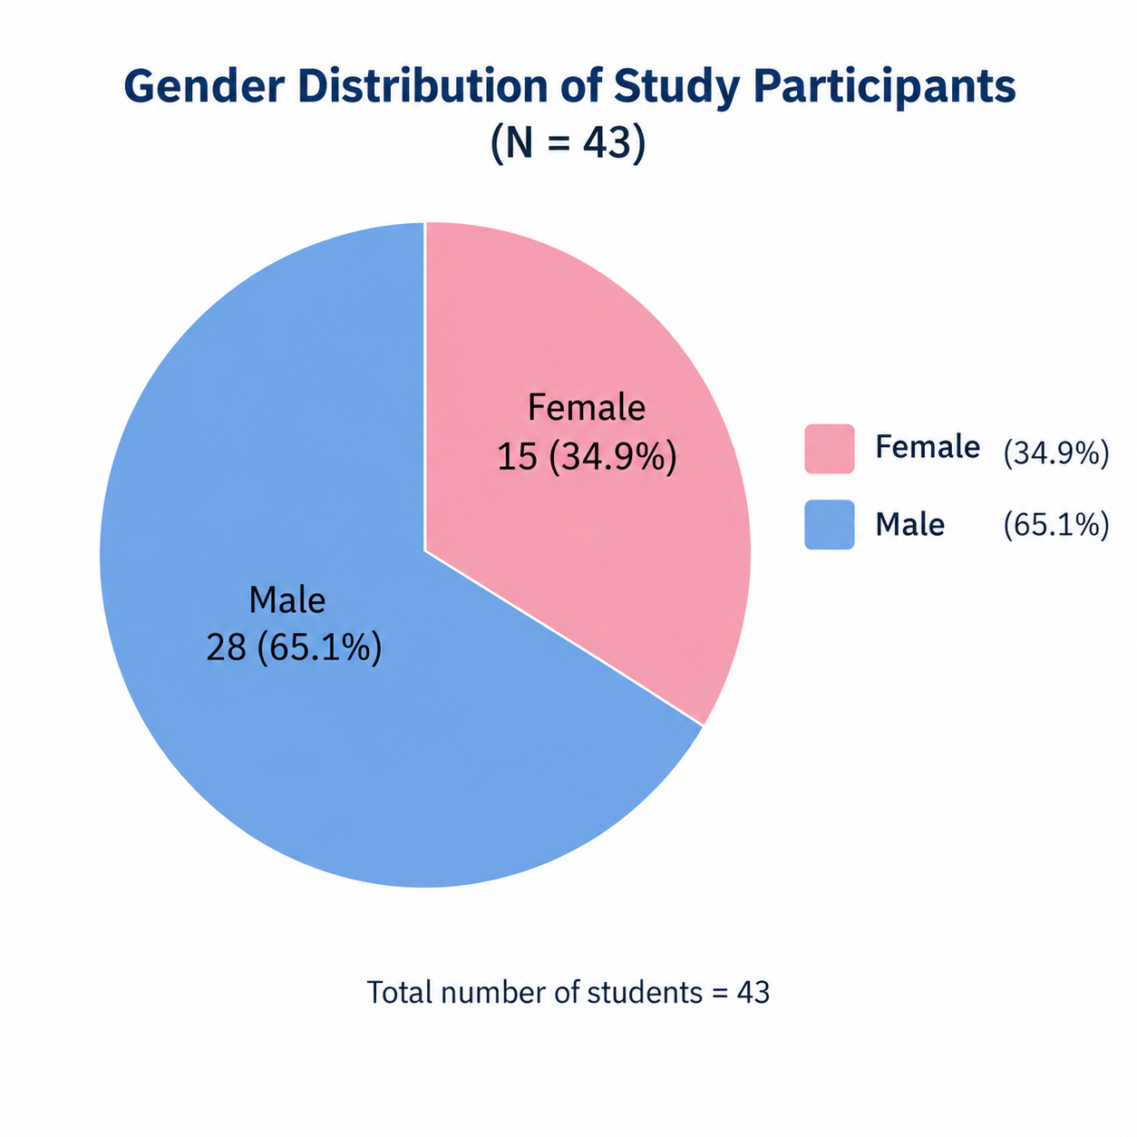
Figure I: Pie chart showing the gender distribution of participants (N = 43)
Previous Exposure to Awareness Sessions
Of the 43 students, only 11 (25.6%) had ever attended a nutrition awareness session, and only 6 (14.0%) had attended a cardiovascular disease (CVD) awareness session (Table II).
Table II: Previous Participation in Awareness Sessions among Study Participants (N = 43)
Awareness session attended | Frequency (n) | Percentage (%)
Nutrition awareness session | 11 | 25.6
Cardiovascular disease (CVD) awareness session | 6 | 14.0

Distribution of Knowledge Scores
The frequency and percentage distribution of knowledge scores is shown in Table III. The distribution demonstrated a marked improvement following the educational intervention. Before the intervention, the most frequent score was 13, achieved by 21 participants (48.8%), followed by a score of 12 among 11 participants (25.6%) and a score of 14 among 9 participants (20.9%). Only 2 participants (4.7%) achieved a score of 15, and no participant scored above 15.
In contrast, post-intervention scores ranged from 17 to 20. Scores of 18 and 19 were each achieved by 16 participants (37.2%), followed by a score of 17 among 6 participants (14.0%) and the maximum score of 20 among 5 participants (11.6%). No participant scored below 17 after the intervention; thus, every participant’s post-test score exceeded the highest score recorded at pre-test. Overall, the findings indicate a substantial upward shift in knowledge scores following the educational intervention (Figure II).
Table III: Frequencies and Percentages of Participants’ Knowledge Scores before and after the Educational Intervention (N = 43)
Knowledge score | Pre-intervention n | Pre-intervention % | Post-intervention n | Post-intervention %
12 | 11 | 25.6 | 0 | 0.0
13 | 21 | 48.8 | 0 | 0.0
14 | 9 | 20.9 | 0 | 0.0
15 | 2 | 4.7 | 0 | 0.0
16 | 0 | 0.0 | 0 | 0.0
17 | 0 | 0.0 | 6 | 14.0
18 | 0 | 0.0 | 16 | 37.2
19 | 0 | 0.0 | 16 | 37.2
20 | 0 | 0.0 | 5 | 11.6
Total | 43 | 100.0 | 43 | 100.0
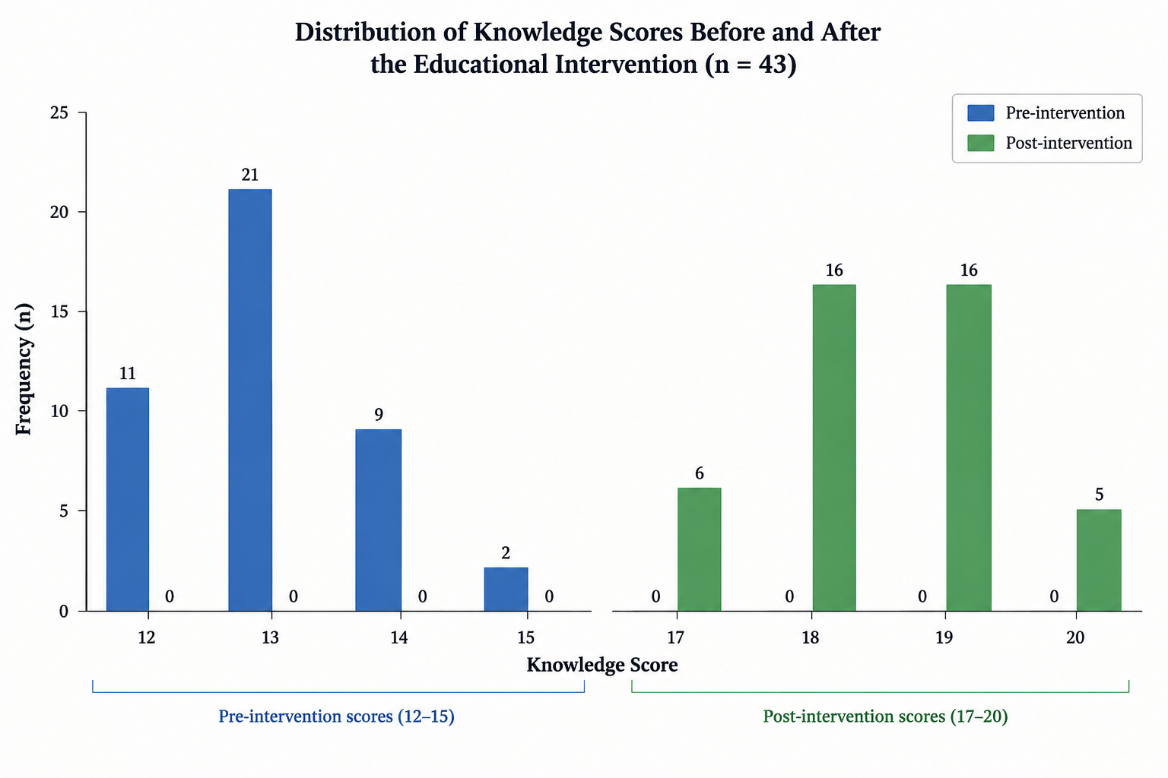
Figure II: Bar chart illustrating the distribution of knowledge scores before and after the educational intervention (N = 43)
Mean Knowledge Scores
The mean knowledge score increased from 13.05 (SD = 0.82) before the intervention to 18.47 (SD = 0.88) after the intervention, a descriptive increase of 5.42 points. Expressed as a proportion of the maximum possible score of 20, mean knowledge rose from about 65% to about 92% (Table IV).
Table IV: Mean and Standard Deviation of Participants’ Knowledge Scores before and after the Educational Intervention
Descriptive statistic | Pre-intervention | Post-intervention
Mean score | 13.05 | 18.47
Standard deviation (SD) | 0.82 | 0.88
Minimum score | 12 | 17
Maximum score | 15 | 20

Item-level Knowledge Gaps
Item-level assessment of selected questions demonstrated particularly limited baseline awareness regarding the concentration of magnesium in cardiac tissue (Q10), the Recommended Daily Allowance of magnesium for males and females (Q16), and the recommended daily intake of magnesium (Q17). Following the educational intervention, the distribution of total scores shifted towards higher values: 6 participants (14.0%) scored 17, 16 participants (37.2%) each scored 18 and 19, and 5 participants (11.6%) achieved the maximum score of 20, with no participant scoring below 17 (Figure III). This shift complements the item-level findings, indicating improved responses to the previously identified knowledge gaps.
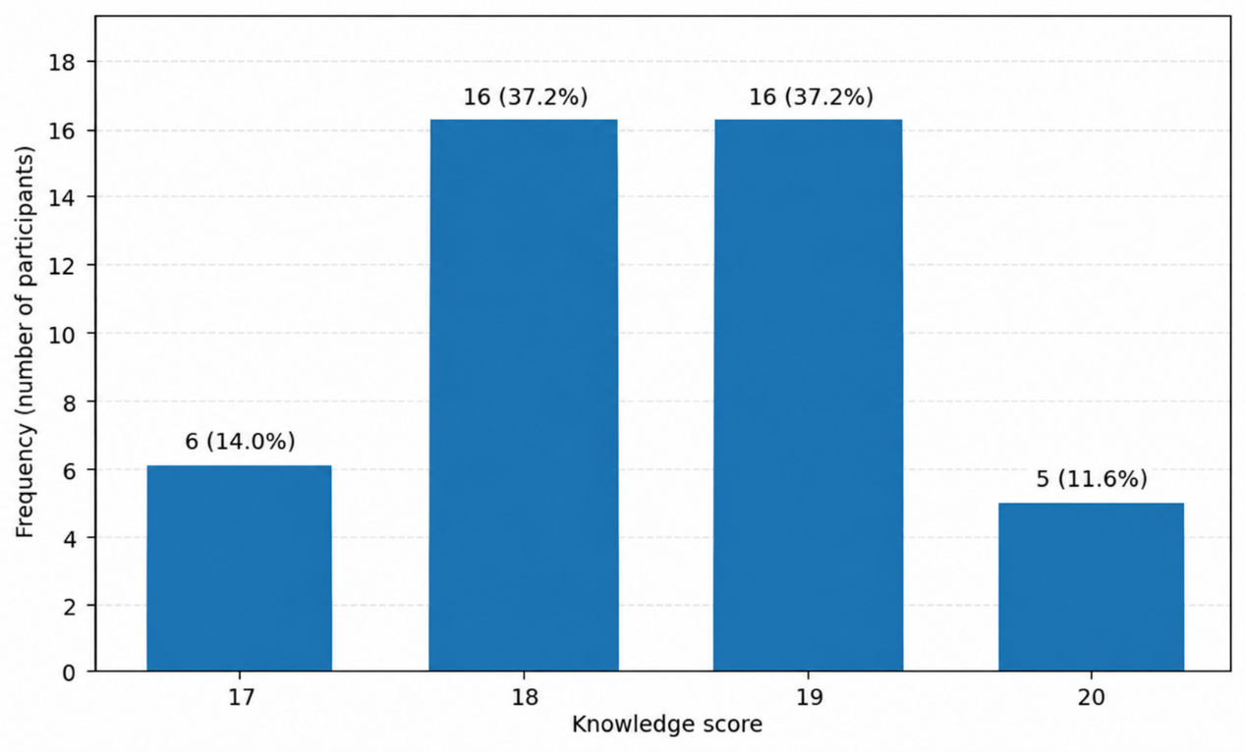
Figure III: Distribution of post-intervention knowledge scores (N = 43)
Knowledge Scores by Gender
After the intervention, female participants demonstrated a slightly higher mean knowledge score (18.60 ± 0.99) than male participants (18.39 ± 0.83) (Table V).
Table V: Descriptive Statistics of Post-intervention Knowledge Scores by Gender
Descriptive statistic | Male (n = 28) | Female (n = 15)
Mean score | 18.39 | 18.60
Standard deviation (SD) | 0.83 | 0.99

Comparison of Pre- and Post-intervention Scores
The assumption of normality was not met, so the Wilcoxon signed-rank test was used to compare the paired knowledge scores. The test demonstrated a statistically significant difference between pre- and post-intervention knowledge scores (p < 0.001), and the effect size (r = 0.88) indicated a large effect. These findings show that knowledge scores were significantly higher following the educational intervention (Table VI).
Table VI: Wilcoxon Signed-Rank Test for Pre- and Post-intervention Knowledge Scores
Statistical measure | Result
Pre-intervention mean ± SD | 13.05 ± 0.82
Post-intervention mean ± SD | 18.47 ± 0.88
Wilcoxon signed-rank test (p-value) | < 0.001
Effect size (r) | 0.88 (large effect)

Association between Gender and Post-intervention Knowledge
The median post-intervention knowledge score was 18 among males and 19 among females. However, the difference between the groups was not statistically significant according to the Mann–Whitney U test (U = 185.00, p = 0.509). The interquartile range (IQR) is presented as the 25th–75th percentile range; the IQR width was 1 point in both groups (Table VII).
Table VII: Mann–Whitney U Test for Association between Gender and Post-intervention Knowledge Scores
Statistic | Male (n = 28) | Female (n = 15) | p-value
Mean ± SD | 18.39 ± 0.83 | 18.60 ± 0.99 | —
Median (IQR) | 18 (18–19) | 19 (18–19) | 0.509

DISCUSSION
This quasi-experimental study evaluated the knowledge of 4th-year MBBS students regarding the role of magnesium in cardiovascular diseases before and after a brief structured educational intervention. The principal finding was a large and statistically significant improvement in knowledge: the mean score rose from 13.05 to 18.47 out of 20 (p < 0.001; r = 0.88), and every participant scored higher after the session than the best score recorded before it. These results indicate that a focused 30-minute session can effectively address important gaps in students’ understanding of this topic, at least in the short term.
Baseline Knowledge
At baseline, participants answered on average about 65% of the items correctly, and no student scored above 15. This reflects moderate but incomplete knowledge. Students in their fourth year have already studied the physiology of electrolytes and the pathology and pharmacology of cardiovascular disease, which probably explains their familiarity with general concepts such as magnesium being an important intracellular cation or its link with cardiac conduction. However, knowledge was weakest for the more specific and clinically applied items, particularly the distribution of magnesium within cardiac tissue (Q10), the Recommended Daily Allowance for men and women (Q16) and the recommended daily intake (Q17). The last of these is clinically important: the true RDA is approximately 420 mg/day for adult men and 320 mg/day for adult women [15], so a student who accepts that adults need 600–800 mg/day may give inaccurate dietary advice or overestimate the need for supplementation.
These gaps are consistent with the wider literature on nutrition in medical education. Surveys and systematic reviews from several countries have repeatedly shown that nutrition receives too few teaching hours and that graduating doctors feel inadequately prepared to counsel patients about diet [29,30,32]. Physicians in practice cite their own lack of nutrition knowledge as a key barrier to dietary counselling [31]. Magnesium appears to be a particularly neglected micronutrient: clinicians tend to focus on sodium, potassium and calcium, while magnesium is not part of many routine electrolyte panels and serum levels may not reflect total body stores, so deficiency frequently goes unrecognized [11,17]. Our finding that only a quarter of participants had ever attended a nutrition awareness session, and only 14% a cardiovascular awareness session, suggests that students have had few opportunities outside the formal curriculum to consolidate this knowledge.
Effect of the Educational Intervention
Following the intervention, the mean score increased by 5.42 points, scores clustered between 17 and 20, and the effect size was large. The intervention was deliberately aligned with the domains of the questionnaire and covered physiology, causes of deficiency, cardiovascular consequences, dietary sources and recommended intake. Teaching that is short, focused and directly targeted at identified gaps is known to be effective for the acquisition of factual knowledge, and interactive or active-learning approaches further enhance student performance [34]. The improvement in the items that were weakest at baseline, including those on recommended intake, suggests that the session successfully corrected specific misconceptions rather than only reinforcing what students already knew.
The content delivered in the session is supported by strong scientific evidence. Low dietary or circulating magnesium has been associated with higher risks of cardiovascular disease, ischaemic heart disease, heart failure and stroke in large meta-analyses of prospective studies [8,21,22], and low serum magnesium has been linked to sudden cardiac death in two large population cohorts [23,24]. Supplementation trials show modest reductions in blood pressure [6,25], while common clinical conditions and drugs, including diabetes mellitus, diuretics and proton pump inhibitors, are recognized causes of deficiency [16,18,19]. At the same time, the session emphasized that the evidence is not uniformly positive; for example, routine perioperative magnesium did not prevent postoperative atrial fibrillation in a randomized trial [9]. Teaching this balanced view is important so that future doctors neither ignore magnesium deficiency nor overstate the benefits of supplementation in patients who are not deficient.
The relevance of this knowledge is particularly great in Pakistan, where the burden of non-communicable diseases, including hypertension, ischaemic heart disease, stroke and diabetes, is high and rising [4]. Doctors in primary care are often the main source of dietary advice for patients, and an accurate understanding of magnesium-rich foods such as green leafy vegetables, legumes, nuts and whole grains, which are widely available and affordable in the local diet, could be translated into practical counselling for patients at cardiovascular risk.
Gender and Knowledge
After the intervention, female students had a slightly higher mean and median score than male students, but the difference was not statistically significant (p = 0.509). This suggests that the intervention was equally effective for both genders. Because all participants belonged to the same class, followed the same curriculum and received identical teaching, a large gender difference would not be expected. The small number of female participants (n = 15) also limited the power to detect a modest difference.
Interpretation of the Findings
Two features of the score distribution deserve comment. First, the post-intervention scores were tightly clustered near the maximum (17 to 20), indicating a ceiling effect. While this confirms that most students mastered the content, it also means the questionnaire could not discriminate well between students at the higher end of knowledge. Second, the post-test was administered immediately after the session, so the results reflect short-term recall rather than durable learning. Basic science knowledge is known to decline substantially over time without reinforcement [35], and further follow-up would be needed to establish how much of the gain is retained.
Limitations of the Study
This study has several limitations. First, the one-group pre-test–post-test design lacked a control group and randomization, so the improvement cannot be attributed to the intervention with the same certainty as in a randomized controlled trial; factors such as familiarity with the questions (testing effect) may have contributed to the higher post-test scores [36]. Second, the study was conducted at a single institution among students of one academic year, which limits generalizability to other medical colleges and years of study. Third, the sample of 43 participants was slightly below the calculated target of 46, and the small number of female students limited subgroup comparisons. Fourth, the post-test was conducted immediately after the session, and long-term retention of knowledge was not assessed. Fifth, the questionnaire was developed by the researchers and its reliability and validity were not formally tested; some items assessed self-reported awareness rather than objective knowledge, and the narrow score ranges produced a ceiling effect. Finally, the study measured knowledge only and did not assess attitudes, practices or the ability to apply this knowledge in patient care, and the association of previous awareness-session attendance with knowledge scores was not analysed.
CONCLUSION
This study found that 4th-year MBBS students at Ayub Medical College had only moderate baseline knowledge of the role of magnesium in cardiovascular diseases. The most important gaps concerned the distribution of magnesium in cardiac tissue and its recommended daily intake, and few students had attended any nutrition or cardiovascular awareness session outside the formal curriculum.
A brief, structured, 30-minute educational intervention produced a large and statistically significant improvement in knowledge. Every participant scored higher after the session than the best pre-intervention score, and the improvement was similar in male and female students.
These findings show that short, targeted teaching is an effective and low-cost way to correct specific knowledge gaps about micronutrients and cardiovascular health. Because magnesium deficiency is common, often unrecognized and relevant to the prevention and management of hypertension, arrhythmias and other cardiovascular conditions, future doctors need an accurate and balanced understanding of its role. Strengthening this knowledge during undergraduate training can improve dietary counselling, laboratory interpretation and evidence-based decisions about supplementation. However, as the post-test was conducted immediately after the session, longer-term studies are needed to confirm that the knowledge gained is retained and applied in clinical practice.
RECOMMENDATIONS
On the basis of the findings of this study, the following recommendations are made:
- Curriculum integration: Teaching on micronutrients, including magnesium, should be integrated across physiology, pharmacology, community medicine and clinical medicine modules, with emphasis on clinical applications such as recognition of deficiency, drug-induced hypomagnesemia, dietary sources and recommended intake.
- Short focused sessions: Brief, structured awareness sessions, workshops or case-based tutorials, similar to the intervention used in this study, should be incorporated into the curriculum as a low-cost method of addressing identified knowledge gaps.
- Reinforcement: Knowledge should be reinforced through repeated exposure, for example during clinical rotations, ward teaching and problem-based learning, to promote long-term retention.
- Nutrition counselling skills: Students should be trained not only in facts but also in practical dietary counselling, so that they can advise patients with hypertension, diabetes and other cardiovascular risk factors about magnesium-rich local foods.
- Evidence-based teaching: Teaching should present a balanced view of the evidence, distinguishing proven indications for magnesium (such as correction of deficiency and treatment of torsades de pointes) from unproven routine supplementation.
- Student-led awareness: Student societies and community medicine field activities should be used to organize awareness campaigns on nutrition and cardiovascular health for students and the general public.
Recommendations for Future Research
- Future studies should use a controlled or randomized design, with a comparison group, to strengthen causal inference.
- Multi-centre studies involving students of all academic years and of both public and private medical colleges are needed to improve generalizability.
- A delayed post-test (for example after one to three months) should be included to assess long-term retention of knowledge.
- The questionnaire should be formally validated and its reliability tested, and items of greater difficulty should be included to avoid a ceiling effect.
- Future research should also assess attitudes and practices, and explore the influence of factors such as previous awareness-session attendance on knowledge.
REFERENCES
1. Roth GA, Mensah GA, Johnson CO, Addolorato G, Ammirati E, Baddour LM, et al. Global burden of cardiovascular diseases and risk factors, 1990–2019: update from the GBD 2019 study. J Am Coll Cardiol. 2020;76(25):2982-3021. doi:10.1016/j.jacc.2020.11.010.
2. Wölbert S, Schmidt T, Wittek F, Mayer B, Raake P, Bongiovanni D, et al. One-year outcomes of bioresorbable magnesium scaffold implantation in complex coronary lesions. Front Cardiovasc Med. 2026;13:1854686. doi:10.3389/fcvm.2026.1854686.
3. Amer SA, Abo-elnour DE, Abbas A, Abdelrahman AS, Hamdy HEM, Kenawy S, et al. Calcium, magnesium, and vitamin D supplementations as complementary therapy for hypertensive patients: a systematic review and meta-analysis. BMC Complement Med Ther. 2025;25:89. doi:10.1186/s12906-025-04809-x.
4. Jafar TH, Haaland BA, Rahman A, Razzak JA, Bilger M, Naghavi M, et al. Non-communicable diseases and injuries in Pakistan: strategic priorities. Lancet. 2013;381(9885):2281-90. doi:10.1016/S0140-6736(13)60646-7.
5. Papagiannidou A, Mitropoulou M, Papantzikos K, Petropoulou D, Tsilingiris D, Magkos F, et al. Hypomagnesemia: a clinical and nutritional update. Curr Nutr Rep. 2026;15:30. doi:10.1007/s13668-026-00745-5.
6. An P, Wan S, Luo Y, Luo J, Zhang X, Zhou S, et al. Micronutrient supplementation to reduce cardiovascular risk. J Am Coll Cardiol. 2022;80(24):2269-85. doi:10.1016/j.jacc.2022.09.048.
7. de Baaij JHF, Hoenderop JGJ, Bindels RJM. Magnesium in man: implications for health and disease. Physiol Rev. 2015;95(1):1-46. doi:10.1152/physrev.00012.2014.
8. Larsson SC, Orsini N, Wolk A. Dietary magnesium intake and risk of stroke: a meta-analysis of prospective studies. Am J Clin Nutr. 2012;95(2):362-6. doi:10.3945/ajcn.111.022376.
9. Meerman M, Buijser M, Serpa Neto A, van den Berg L, van den Heuvel AM, Hoohenkerk G, et al. Magnesium sulfate to prevent perioperative atrial fibrillation in cardiac surgery: a randomized clinical trial. Crit Care Med. 2026;54(7):1635-46. doi:10.1097/CCM.0000000000007162.
10. Tannar B, Al-Hellawi H, Sontrop JM, Acedillo RR, Al-Jaishi AA, Anderson S, et al. Effects of increasing the concentration of dialysate magnesium on cardiovascular health: a narrative review. Can J Kidney Health Dis. 2026;13:20543581261454463. doi:10.1177/20543581261454463.
11. Ismail AAA, Ismail Y, Ismail AA. Chronic magnesium deficiency and human disease; time for reappraisal? QJM. 2018;111(11):759-63. doi:10.1093/qjmed/hcx186.
12. Kolte D, Vijayaraghavan K, Khera S, Sica DA, Frishman WH. Role of magnesium in cardiovascular diseases. Cardiol Rev. 2014;22(4):182-92. doi:10.1097/CRD.0000000000000003.
13. DiNicolantonio JJ, Liu J, O'Keefe JH. Magnesium for the prevention and treatment of cardiovascular disease. Open Heart. 2018;5(2):e000775. doi:10.1136/openhrt-2018-000775.
14. Liu M, Dudley SC Jr. Magnesium, oxidative stress, inflammation, and cardiovascular disease. Antioxidants (Basel). 2020;9(10):907. doi:10.3390/antiox9100907.
15. Institute of Medicine (US) Standing Committee on the Scientific Evaluation of Dietary Reference Intakes. Dietary reference intakes for calcium, phosphorus, magnesium, vitamin D, and fluoride. Washington (DC): National Academies Press; 1997.
16. Gröber U, Schmidt J, Kisters K. Magnesium in prevention and therapy. Nutrients. 2015;7(9):8199-226. doi:10.3390/nu7095388.
17. Rosanoff A, Weaver CM, Rude RK. Suboptimal magnesium status in the United States: are the health consequences underestimated? Nutr Rev. 2012;70(3):153-64. doi:10.1111/j.1753-4887.2011.00465.x.
18. Barbagallo M, Dominguez LJ. Magnesium and type 2 diabetes. World J Diabetes. 2015;6(10):1152-7. doi:10.4239/wjd.v6.i10.1152.
19. Hoorn EJ, van der Hoek J, de Man RA, Kuipers EJ, Bolwerk C, Zietse R. A case series of proton pump inhibitor-induced hypomagnesemia. Am J Kidney Dis. 2010;56(1):112-6. doi:10.1053/j.ajkd.2009.11.019.
20. Hruby A, O'Donnell CJ, Jacques PF, Meigs JB, Hoffmann U, McKeown NM. Magnesium intake is inversely associated with coronary artery calcification: the Framingham Heart Study. JACC Cardiovasc Imaging. 2014;7(1):59-69. doi:10.1016/j.jcmg.2013.10.006.
21. Del Gobbo LC, Imamura F, Wu JH, de Oliveira Otto MC, Chiuve SE, Mozaffarian D. Circulating and dietary magnesium and risk of cardiovascular disease: a systematic review and meta-analysis of prospective studies. Am J Clin Nutr. 2013;98(1):160-73. doi:10.3945/ajcn.112.053132.
22. Fang X, Wang K, Han D, He X, Wei J, Zhao L, et al. Dietary magnesium intake and the risk of cardiovascular disease, type 2 diabetes, and all-cause mortality: a dose-response meta-analysis of prospective cohort studies. BMC Med. 2016;14(1):210. doi:10.1186/s12916-016-0742-z.
23. Peacock JM, Ohira T, Post W, Sotoodehnia N, Rosamond W, Folsom AR. Serum magnesium and risk of sudden cardiac death in the Atherosclerosis Risk in Communities (ARIC) Study. Am Heart J. 2010;160(3):464-70. doi:10.1016/j.ahj.2010.06.012.
24. Kieboom BCT, Niemeijer MN, Leening MJG, van den Berg ME, Franco OH, Deckers JW, et al. Serum magnesium and the risk of death from coronary heart disease and sudden cardiac death. J Am Heart Assoc. 2016;5(1):e002707. doi:10.1161/JAHA.115.002707.
25. Zhang X, Li Y, Del Gobbo LC, Rosanoff A, Wang J, Zhang W, et al. Effects of magnesium supplementation on blood pressure: a meta-analysis of randomized double-blind placebo-controlled trials. Hypertension. 2016;68(2):324-33. doi:10.1161/HYPERTENSIONAHA.116.07664.
26. Nakhaee S, Manoochehri Z, Mahjoubian M, Khodamoradi M, Mansouri B. Association of serum essential and non-essential elements with dyslipidemia in patients with cardiovascular disease in Western Iran: an application of Bayesian kernel machine regression. BMC Cardiovasc Disord. 2026. doi:10.1186/s12872-026-06183-z. Epub ahead of print.
27. Tangvoraphonkchai K, Davenport A. Magnesium and cardiovascular disease. Adv Chronic Kidney Dis. 2018;25(3):251-60. doi:10.1053/j.ackd.2018.02.010.
28. Elganainy M, Hammami AS, Peltz J, Oriaifo OF. Atrial flutter-triggered ventricular tachycardia storm in Gitelman syndrome: a case report. Cureus. 2026;18(6):e110146. doi:10.7759/cureus.110146.
29. Adams KM, Kohlmeier M, Zeisel SH. Nutrition education in U.S. medical schools: latest update of a national survey. Acad Med. 2010;85(9):1537-42. doi:10.1097/ACM.0b013e3181eab71b.
30. Crowley J, Ball L, Hiddink GJ. Nutrition in medical education: a systematic review. Lancet Planet Health. 2019;3(9):e379-89. doi:10.1016/S2542-5196(19)30171-8.
31. Kolasa KM, Rickett K. Barriers to providing nutrition counseling cited by physicians: a survey of primary care practitioners. Nutr Clin Pract. 2010;25(5):502-9. doi:10.1177/0884533610380057.
32. Devries S, Willett W, Bonow RO. Nutrition education in medical school, residency training, and practice. JAMA. 2019;321(14):1351-2. doi:10.1001/jama.2019.1581.
33. Fritz CO, Morris PE, Richler JJ. Effect size estimates: current use, calculations, and interpretation. J Exp Psychol Gen. 2012;141(1):2-18. doi:10.1037/a0024338.
34. Freeman S, Eddy SL, McDonough M, Smith MK, Okoroafor N, Jordt H, et al. Active learning increases student performance in science, engineering, and mathematics. Proc Natl Acad Sci U S A. 2014;111(23):8410-5. doi:10.1073/pnas.1319030111.
35. Custers EJ. Long-term retention of basic science knowledge: a review study. Adv Health Sci Educ Theory Pract. 2010;15(1):109-28. doi:10.1007/s10459-008-9101-y.
36. Harris AD, McGregor JC, Perencevich EN, Furuno JP, Zhu J, Peterson DE, et al. The use and interpretation of quasi-experimental studies in medical informatics. J Am Med Inform Assoc. 2006;13(1):16-23. doi:10.1197/jamia.M1749.
APPENDIX I: QUESTIONNAIRE
Knowledge Survey: Role of Magnesium in Cardiovascular Diseases
Section A: Demographic Information
1. Gender: ☐ Male ☐ Female
2. Academic Year:
☐ First Year MBBS ☐ Second Year MBBS ☐ Third Year MBBS ☐ Fourth Year MBBS ☐ Final Year MBBS
3. Have you ever attended an awareness session on cardiovascular diseases? ☐ Yes ☐ No
4. Have you ever attended an awareness session on nutrition? ☐ Yes ☐ No
Section B: Knowledge Survey
Instructions: Please indicate your response by ticking (✓) Yes, Not Sure or No for each statement.
S. No. | Statement | Yes | Not Sure | No
1 | Magnesium is the most abundant intracellular cation and essential for maintaining normal cellular physiology and metabolism. | ☐ | ☐ | ☐
2 | Magnesium regulates vascular tone by antagonizing calcium channels. | ☐ | ☐ | ☐
3 | Magnesium deficiency can lead to increased inflammation and oxidative stress. | ☐ | ☐ | ☐
4 | I am aware about the disorders that can potentially lead to magnesium deficiency. | ☐ | ☐ | ☐
5 | I am aware about the drugs that can lead to magnesium deficiency. | ☐ | ☐ | ☐
6 | Low magnesium levels can increase the risk of sudden cardiac death. | ☐ | ☐ | ☐
7 | Diabetes mellitus may increase the risk of magnesium deficiency. | ☐ | ☐ | ☐
8 | Excessive use of antibiotics can cause magnesium deficiency. | ☐ | ☐ | ☐
9 | Magnesium is present in highest concentration in ventricles of the heart. | ☐ | ☐ | ☐
10 | Magnesium is present in highest concentration in atria of the heart. | ☐ | ☐ | ☐
11 | Low magnesium intake has been associated with an increased risk of heart failure. | ☐ | ☐ | ☐
12 | Magnesium plays a role in prevention of atherosclerosis. | ☐ | ☐ | ☐
13 | Magnesium is involved in maintaining the normal electrical conduction of the heart. | ☐ | ☐ | ☐
14 | Large number of individuals do not routinely consume foods that provide the requirement to prevent magnesium deficiency. | ☐ | ☐ | ☐
15 | Magnesium is abundantly present in green leafy vegetables, nuts, seeds, legumes, whole grains, and other plant-based foods, making these important dietary sources of magnesium. | ☐ | ☐ | ☐
16 | I am aware of Recommended Daily Allowance of Magnesium for males and females. | ☐ | ☐ | ☐
17 | Recommended daily intake of magnesium for adults is approximately 600 to 800 mg/day. | ☐ | ☐ | ☐
18 | Due to adequate knowledge about magnesium, I feel confident about guiding people around me about the benefits of magnesium in cardiovascular diseases. | ☐ | ☐ | ☐
19 | Magnesium deficiency causes disturbances in potassium and calcium balance in the body. | ☐ | ☐ | ☐
20 | Magnesium deficiency leads to increased vascular resistance and cause hypertension. | ☐ | ☐ | ☐
Scoring
- Correct answer: 1 point
- Incorrect answer: 0 points
- Not Sure: 0 points
Total possible score: 20

