Table of Contents

PRD: “Reason” — a reasoning gym for the AI era
Working title. Status: draft for review. Owner: TBD.

1. Overview
A short-form, mobile-first platform that keeps engineers’ problem-solving sharp by training the one skill AI can’t do for them: reasoning toward a solution out loud. Instead of writing code, users are given the core ask of a problem (like a friend describing it after a contest), explain their approach verbally or in text, and get a Socratic follow-up loop — hints, stress-tests, and a final verdict with suggestions — graded against a deterministic, pre-authored rubric.

2. Problem & Motivation
- AI has made code output cheap; the durable skill is decomposition, algorithmic intuition, complexity reasoning, and debugging judgment.
- Existing platforms (LeetCode/Codeforces) train writing the solution — increasingly automatable and increasingly gamed by AI.
- Engineers feel their problem-solving atrophying (“vibe coding”) and want a low-friction habit to stay sharp.
- Interviews are moving toward AI-proof, reason-out-loud formats — there’s no good training ground for that.

3. Goals & Non-Goals
Goals - Train and measure reasoning quality, not code correctness. - Build a daily habit via a personalized, swipeable short-form feed. - Make grading feel as sharp and fair as a smart friend — and be deterministic/reproducible. - Be defensibly AI-resistant (hard to cheat by pasting into an LLM).
Non-Goals (v1) - Not a full online judge / code-execution contest platform. - Not competing on problem breadth with LeetCode. - No custom/fine-tuned model, no self-hosted GPU infra at launch. - No native mobile app at launch (PWA/React Native first).

4. Target Users
- Primary: working engineers (mid/senior) fighting skill atrophy.
- Secondary: interview-preppers wanting reason-out-loud practice.
- Later: serious competitive programmers; students.
(Decide primary persona before build — it shapes problem difficulty and tone.)

5. Core Concept: the “friend after the contest” loop
The signature interaction. A state machine, not a free chat:
- The pitch — show only the core ask, stripped of constraints/examples.
- Approach capture — user explains their approach (text or voice → STT).
- Follow-up loop — AI probes reasoning: clarifying (“why end time?”), stress-testing (“what if ties?”), complexity (“can you do better?”), graduated hints when stuck.
- Verdict — correct / optimal / buggy / brute-force, with the specific gap named and a suggestion for the better path.
- (Optional) commit — code it or move on.
Rules: ask before telling; hints are graduated (nudge → leading → reveal); the reasoning is the graded artifact.
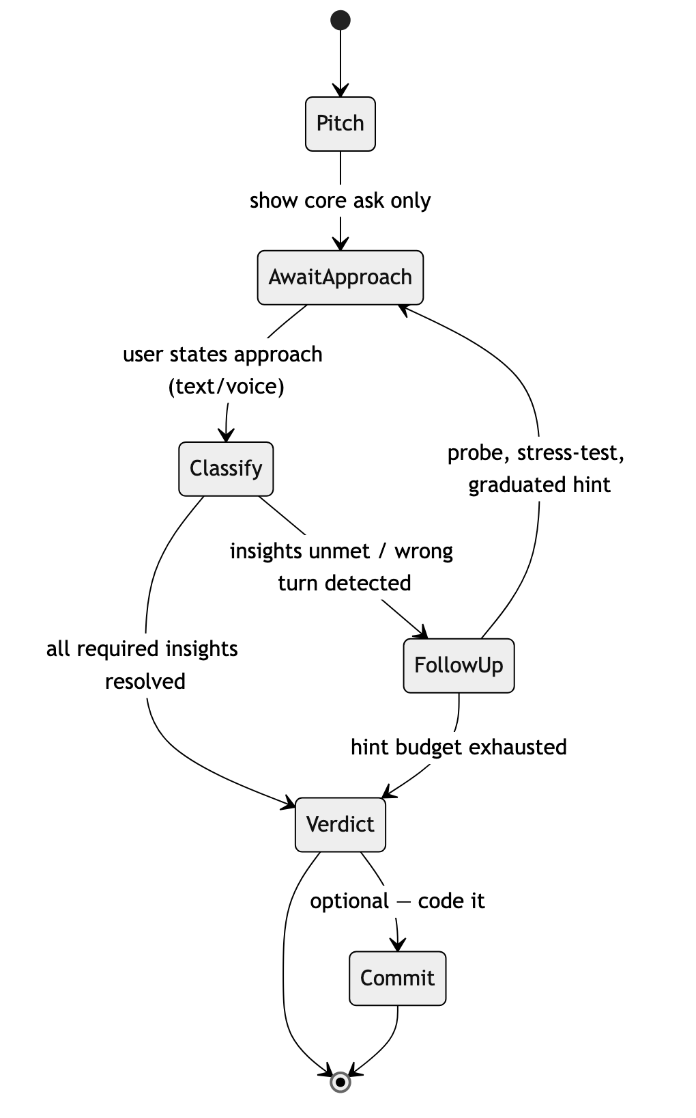
diagram

6. The Feed (engagement layer)
An infinite vertical feed, ranked by the user’s skill graph + chosen practice track:
- Card types: micro-problem, spot-the-bug (AI code with subtle flaw), predict-the-output, pattern flashcard (spaced repetition), full “boss” problem (the reasoning loop), creator/replay shorts.
- Pacing: interleave light cards (habit) with heavy reasoning cards (skill).
- Adaptive difficulty: Elo-style; target ~60–80% success (flow state); misses resurface the weak pattern on a forgetting curve.
- Hooks: daily streak (“5 cards/day”), rated speed-runs, shareable “I cracked this in 22s” challenges (viral loop).

7. UX & Wireframes
Low-fidelity wireframes for the core mobile screens. These show layout and intent, not final visual design.

7.1 The feed (vertical, swipeable)
A full-screen card per challenge; swipe up for the next. Card chrome stays consistent; the body changes by card type.
┌─────────────────────────────┐
│ 🔥 7 Greedy · 1200 ⚙ │ ← streak · topic/rating · settings
│ │
│ ┌───────── card ───────┐ │
│ │ BOSS · Reasoning │ │ ← card-type badge
│ │ │ │
│ │ "You have a list of │ │
│ │ meetings. Max you │ │ core ask only —
│ │ can attend without │ │ no constraints/examples
│ │ overlapping?" │ │
│ │ │ │
│ │ ⏱ ~2 min · 🎙/⌨ reply│ │
│ └───────────────────────┘ │
│ │
│ [ Start reasoning ▶ ] │ ← primary CTA
│ │
│ ▲ swipe for next │
│ ───────────────────────────│
│ Feed Practice Profile │ ← bottom nav
└─────────────────────────────┘
A light card (spot-the-bug) reuses the same frame:
┌─────────────────────────────┐
│ 🔥 7 Debug · 1150 ⚙ │
│ ┌───────────────────────┐ │
│ │ SPOT THE BUG │ │
│ │ for i in range(n): │ │
│ │ if a[i] > a[i+1]: │ │ ← tap the buggy line
│ │ swap(i, i+1) │ │
│ │ return a │ │
│ │ │ │
│ │ Tap the line that │ │
│ │ breaks. ⏱ 30s │ │
│ └───────────────────────┘ │
└─────────────────────────────┘

7.2 The reasoning loop (the signature screen)
A chat-like surface, but driven by the state machine — mic-first, with a text fallback.
┌─────────────────────────────┐
│ ‹ Back Greedy · 1200 │
│─────────────────────────────│
│ CORE ASK │
│ Max non-overlapping │
│ meetings you can attend. │
│─────────────────────────────│
│ │
│ 🧑 "I'd sort by start time │ ← user's approach (you)
│ and pick greedily." │
│ │
│ 🤖 "Why start time? What │ ← AI follow-up (Socratic)
│ happens with one long │
│ early meeting?" │
│ │
│ 🧑 "...hmm, it blocks short │
│ ones. Sort by end?" │
│ │
│ 🤖 "Walk me through │ ← grounded counterexample
│ [[1,10],[2,3],[4,5]]." │
│ │
│ · · · hint 1 of 3 used │ ← graduated-hint budget
│─────────────────────────────│
│ [ 🎙 Hold to speak ] [⌨] │ ← voice-first, text fallback
└─────────────────────────────┘

7.3 The verdict (graded reasoning, not pass/fail)
Shows the insight checklist, score, hint cost, and the next-step suggestion.
┌─────────────────────────────┐
│ VERDICT │
│ ✦ Optimal reached ✦ │
│ Score 82 / 100 │
│─────────────────────────────│
│ Insights │
│ ✓ Recognized sorting │
│ ✓ Sorted by END time │
│ ✓ Justified greedy │
│ ✗ Stated complexity │ ← missed
│─────────────────────────────│
│ −10 used 1 hint │
│ +5 self-corrected │
│─────────────────────────────│
│ 💡 Next: practice stating │
│ time complexity — you │
│ skipped O(n log n). │
│─────────────────────────────│
│ Rating Greedy 1200 → 1218 │ ← skill graph update
│ [ Next ▶ ] [ Code it ⌨ ] │
│ [ 🚩 Disagree with verdict ]│ ← feeds rubric improvement
└─────────────────────────────┘

7.4 Profile / skill graph (retention surface)
Visualizes streak, per-topic mastery, and decay (the loss-aversion hook).
┌─────────────────────────────┐
│ Profile 🔥 7-day │
│─────────────────────────────│
│ Skill by pattern │
│ Arrays ███████░░ 1320 │
│ Greedy ██████░░░ 1218 ↑│
│ DP ███░░░░░░ 980 ↓│ ← decaying, resurfaces in feed
│ Graphs ████░░░░░ 1100 │
│─────────────────────────────│
│ This week 24 problems │
│ ▁▃▅▂▆▇▄ (daily activity) │
│─────────────────────────────│
│ [ Share my streak ] │ ← viral loop
└─────────────────────────────┘

7.5 End-to-end user flow
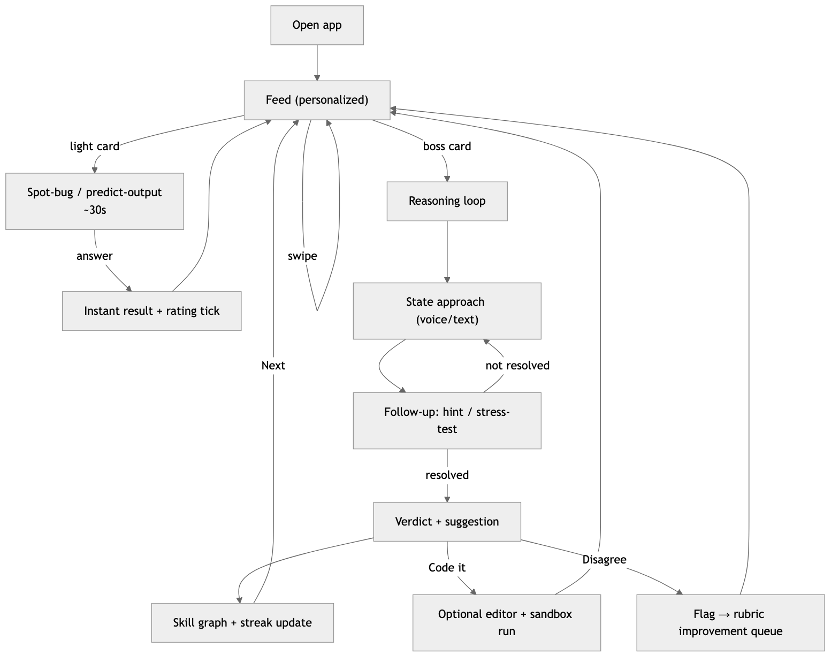
diagram

7.6 Client ↔ user interaction during a turn
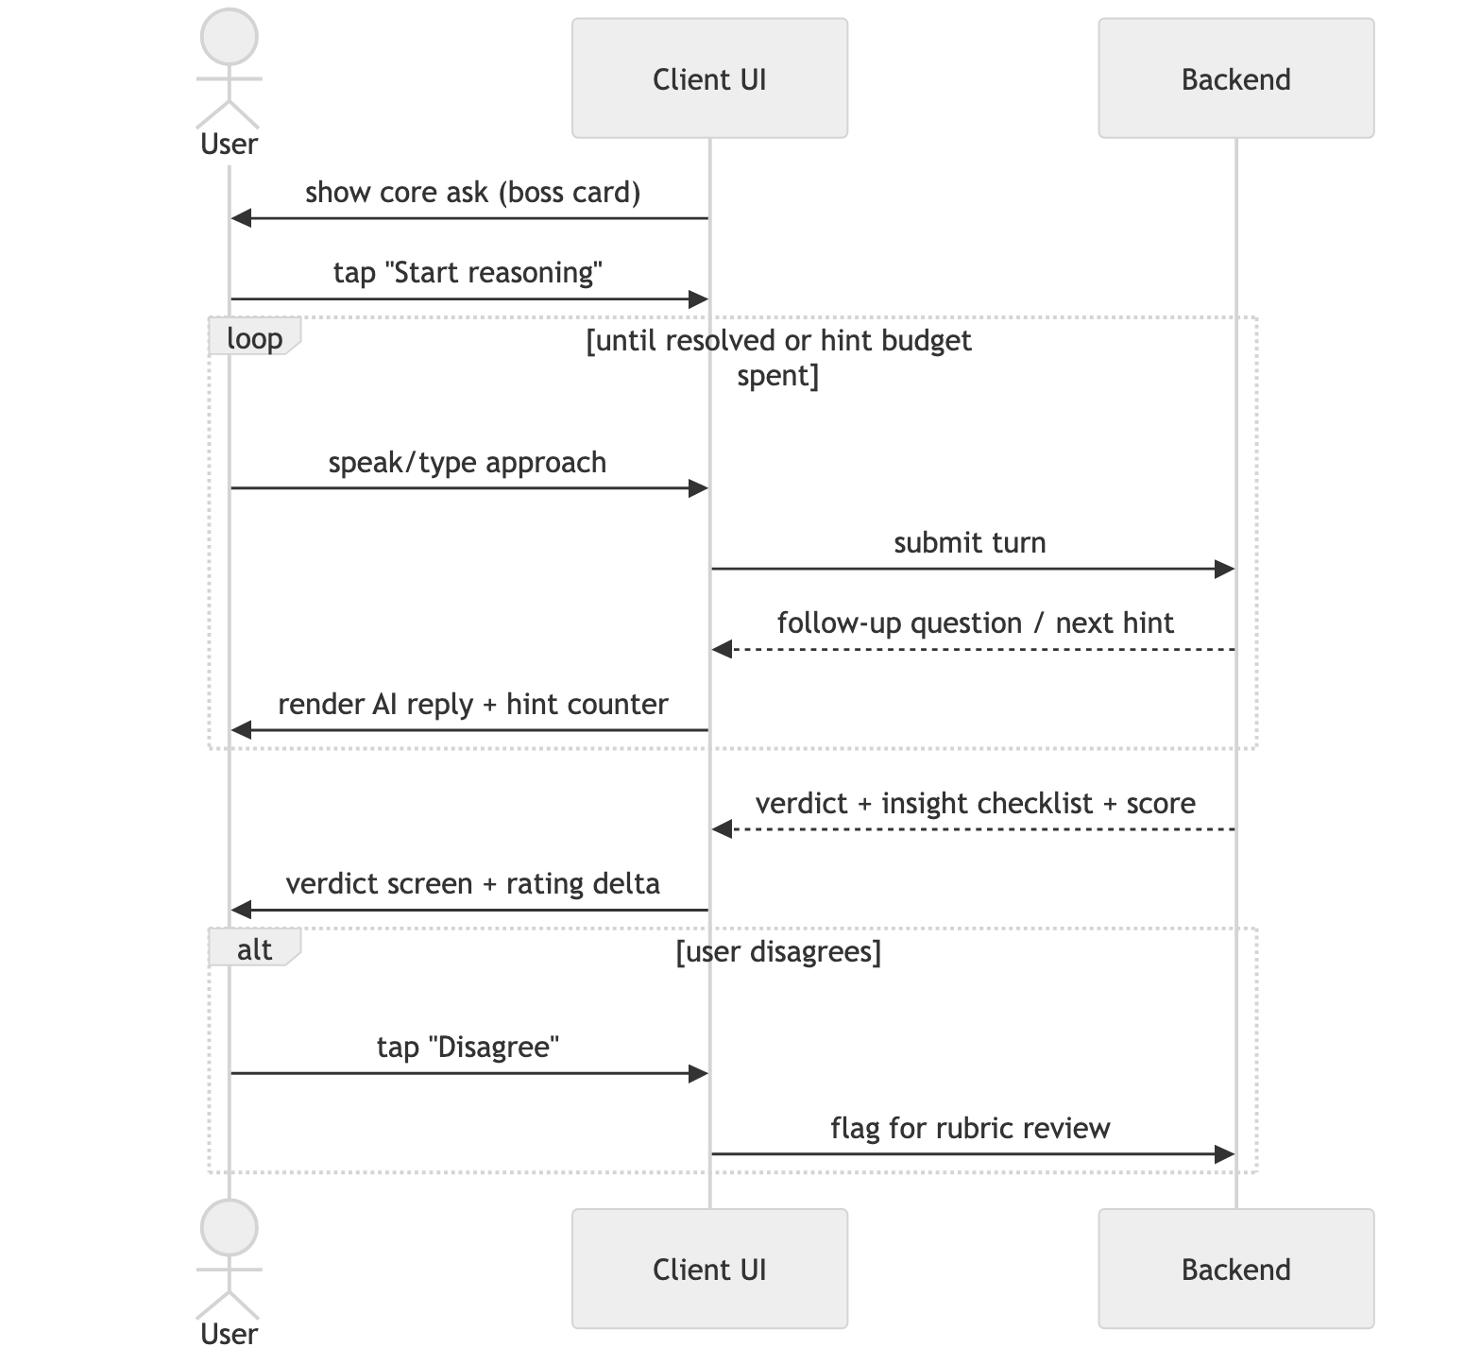
diagram

8. Grading & Determinism (the core IP)
Principle: the LLM does only a narrow fuzzy-classification step; everything the user perceives as judgment (score, hint, suggestion, verdict) is produced by deterministic code from frozen, human-verified content.
Layered validation: - Layer 1 — deterministic code: execute the rubric’s counterexample against the claimed approach (real pass/fail), keyword/complexity gates. - Layer 2 — constrained LLM classifier: per-insight yes/partial/no + evidence quote, temp 0, JSON-schema-constrained, grounded on the rubric, cached, self-consistency vote on borderline calls. - Layer 3 — deterministic engine: score math, hint-ladder lookup, verdict/suggestion text — all fixed.
Determinism levers: temp 0, cached static rubric, constrained decoding, self-consistency, cache by (rubric version, normalized approach), confidence-threshold escalation to a clarifying question.
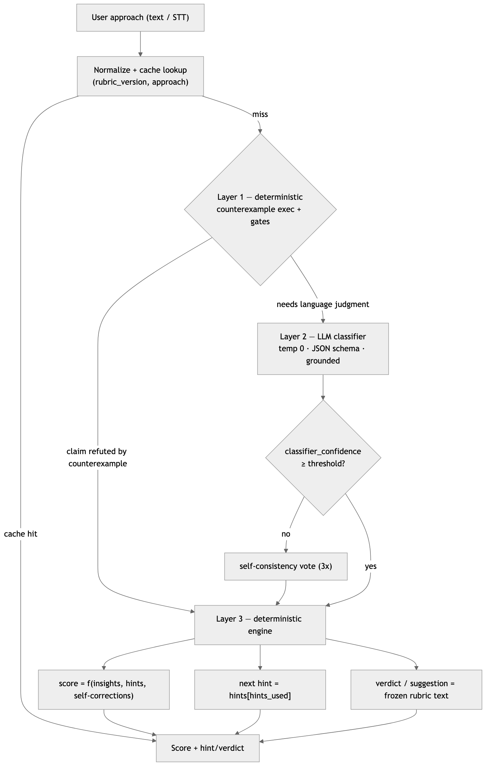
diagram
Everything the user perceives — score, hint, suggestion, verdict — is produced by deterministic code (Layers 1 & 3) from frozen content. The LLM (Layer 2) only converts natural language into a few structured booleans.

8.1 Rubric schema (the deterministic asset)
problem_id: meeting-rooms-greedy
rubric_version: 3
pattern: greedy
difficulty: 1200 # Elo-style
core_ask: "Given meetings with start/end times, find the max you can attend without overlap."
optimal:
approach: "Sort by end time; greedily pick earliest-ending non-overlapping."
complexity: { time: "O(n log n)", space: "O(1)" }
key_insight: "Earliest end time leaves the most room for future meetings."
acceptable_alternatives:
- approach: "Weighted interval scheduling DP"
note: "Correct but overkill; accept, note simpler greedy exists."
common_wrong_approaches:
- id: sort_by_start
match_signals: ["sort by start", "earliest start", "begin time"]
why_wrong: "One long early meeting blocks many short ones."
counterexample: "[[1,10],[2,3],[4,5]]" # executed in Layer 1
- id: sort_by_duration
match_signals: ["shortest", "by duration", "by length"]
why_wrong: "Shortest-first ignores position."
counterexample: "[[1,5],[4,6],[6,7]]"
required_insights:
- id: needs_sorting
desc: "Recognizes sorting is needed"
weight: 1
hints: ["Is the input order helpful as-is?",
"Would processing them in some order help?",
"You'll want to sort them first."]
- id: sort_by_end
desc: "Sorts by END time specifically"
weight: 3
hints: ["What ordering helps most?",
"Which meeting frees you up soonest?",
"Sort by end time — earliest first."]
on_fail_suggestion: "You sorted by start; a long early meeting blocks many short ones. Re-derive with end-time."
- id: greedy_justification
desc: "Justifies why greedy is optimal"
weight: 2
hints: ["Why is always taking the earliest-ending safe?",
"What does picking earliest-end guarantee about remaining time?"]
- id: complexity
desc: "States O(n log n)"
weight: 1
hints: ["What dominates the cost?", "What does the sort cost?"]
edge_cases: ["empty list", "all overlapping", "ties on end time"]
scoring:
formula: "sum(weight of insights hit) / sum(all weights)"
hint_penalty_per_reveal: 0.1
self_correction_bonus: 0.05

8.2 Layer-2 classifier prompt (sketch)
System: You are a grading classifier, not a tutor. Given a problem’s required insights and a student’s stated approach, decide for each insight whether the student’s words satisfy it. Judge ONLY against the provided rubric. Do NOT praise, do NOT give hints, do NOT add commentary. If evidence is absent, return no. Output only valid JSON matching the schema.
User: { core_ask, required_insights[], common_wrong_approaches[], conversation_so_far, latest_user_message }
Output schema:
{
"insights": [
{ "id": "sort_by_end", "status": "yes|partial|no", "evidence": "<quote or null>" }
],
"matched_wrong_approach": "sort_by_start | null",
"claims_optimal": true,
"classifier_confidence": 0.0
}
The deterministic engine consumes this JSON → updates score, picks the next hint or counterexample, or renders the verdict.

9. Rating System
- Per-topic skill rating from reasoning quality: insights reached, hints consumed (fewer = higher), self-corrections under stress-test, time-to-key-insight.
- Feeds back into feed ranking → closed loop: feed serves at your level → you reason → reasoning graded → rating updates → feed adapts.

10. Architecture
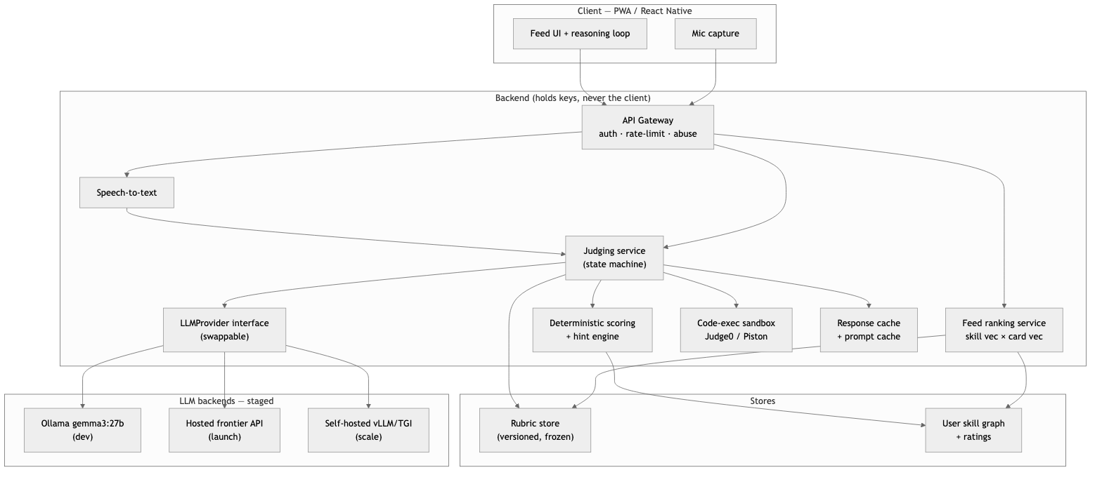
diagram
Client: PWA first (or React Native for push + app stores sooner). Mic capture on client; all LLM calls proxied through backend. Client never holds a model or key.
Backend services: - API gateway (auth, rate-limit, abuse protection). - Judging service — runs the state machine + layered validation. - LLMProvider interface — swappable: OllamaProvider (dev) / HostedProvider (launch) / vLLMProvider (later self-host). Stage changes = config, not rewrite. - Deterministic scoring/hint engine. - Code-execution sandbox (Judge0/Piston) for counterexamples + optional code commit. - Feed ranking service (skill vector × card vector). - Content/rubric store (versioned, frozen).
Inference strategy (staged): 1. Dev: gemma3:27b on local Ollama — free iteration. 2. Launch: hosted frontier API — no GPUs, cheap at low volume, best quality. Prompt-cache the static rubric. 3. Scale: self-host open model via vLLM/TGI on AWS GPUs only when sustained volume beats per-call API cost AND golden-test benchmarks pass. 4. Custom model: fine-tune on graded sessions only with data + a measured, prompt-unclosable quality gap. Likely Phase 4+.
Single judging turn (request flow):
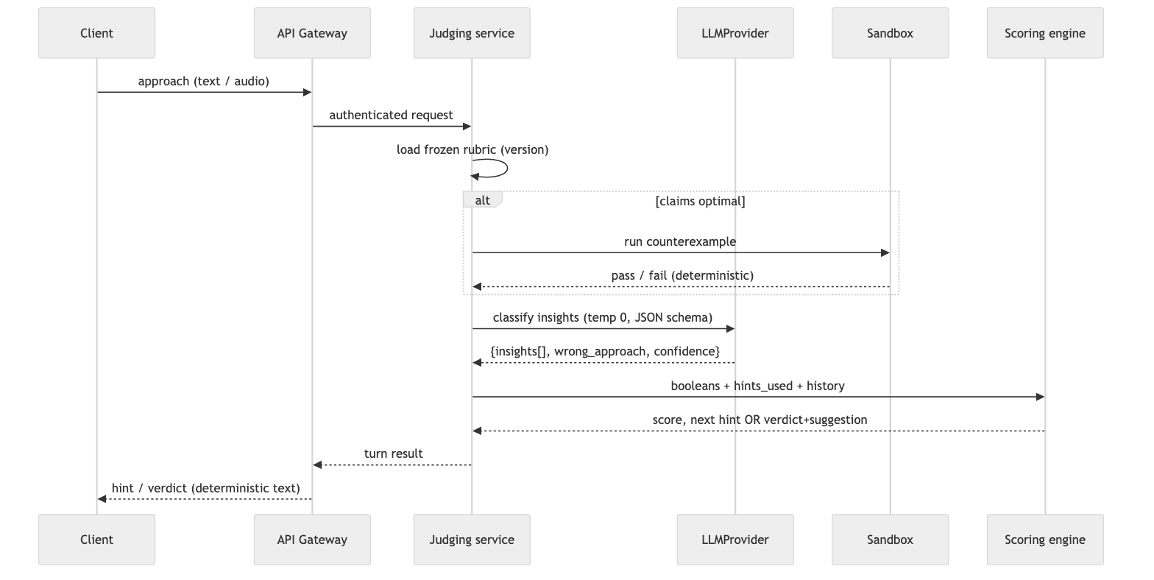
diagram

11. Tech Implementation & High-Level LLD
Design intent: a deterministic core (scoring, hint selection, state machine) kept pure and fully unit-testable, with all non-determinism (LLM, sandbox, DB, STT) pushed to the edges behind interfaces — a ports-and-adapters (hexagonal) layout. This is what makes the grading reproducible and the LLM provider swappable.

11.1 Language & stack choices
Layer | Choice | Rationale
Client | TypeScript + React (PWA via Vite → React Native later) | One language with backend; fast iteration; RN reuses most logic for native + push
API / judging service | TypeScript (NestJS) or Go | TS = shared types with client + speed to MVP; Go = stronger concurrency if throughput demands. Start TS, isolate the judging service so it can be re-implemented in Go later
Content / LLM orchestration | Python | Best LLM/eval/data ecosystem; runs the offline rubric-authoring + golden-test harness
Primary datastore | PostgreSQL | Relational integrity for users/sessions/ratings; pgvector for semantic answer-cache; JSONB for flexible turn payloads
Cache / queue | Redis | Response + prompt cache, rate-limit counters, async job queue (rubric validation, feed precompute)
Rubric store | Versioned YAML in repo → object store (S3) | Reviewed via PRs, frozen by version, loaded into Postgres index on deploy
Sandbox | Judge0 / Piston (self-host) | Counterexample execution + optional code-commit runs; never build a judge from scratch
LLM (staged) | Ollama (dev) → hosted API (launch) → vLLM (scale) | Behind one LLMProvider interface (see §10)

11.2 Data model (core tables)
users(id, handle, created_at, ...)
problems(id, slug, pattern, base_difficulty, core_ask, created_at)
rubrics(id, problem_id, version, status, body_jsonb, created_at)
-- body_jsonb = the frozen rubric (optimal, insights, wrong_approaches, hints, scoring)
-- UNIQUE(problem_id, version); a session pins exactly one rubric row
sessions(id, user_id, problem_id, rubric_id, state, score, hints_used,
started_at, ended_at)
-- state: PITCH | AWAIT_APPROACH | FOLLOW_UP | VERDICT | COMMITTED
turns(id, session_id, idx, role, content, audio_url,
classifier_output_jsonb, created_at)
-- role: USER | AI ; idempotency via UNIQUE(session_id, idx)
insight_results(session_id, insight_id, status, evidence, resolved_at_turn)
-- status: yes | partial | no (the deterministic scoring inputs)
ratings(user_id, pattern, rating, last_practiced_at, decay_at)
-- per-topic Elo; decay_at drives spaced-repetition resurfacing
verdict_flags(id, session_id, user_id, reason, created_at, status)
-- "disagree" escape hatch → rubric improvement queue
card_events(id, user_id, card_id, card_type, outcome, latency_ms, created_at)
-- feed impressions/outcomes → ranking + rating signal

11.3 Module boundaries (ports & adapters)
┌──────────────────────── Deterministic core (pure, no I/O) ───────────────────────┐
│ SessionStateMachine ScoringEngine HintSelector RubricInterpreter │
└───────▲───────────────────▲────────────────▲───────────────────▲──────────────────┘
│ ports (interfaces)
┌────────────────┴───────┬───────────────┬──────────────────┬──────────────────────┐
│ LLMProvider │ SandboxRunner │ SessionRepo │ RubricRepo / Cache │
│ (Ollama|Hosted|vLLM) │ (Judge0) │ (Postgres) │ (S3+PG / Redis) │
└────────────────────────┴───────────────┴──────────────────┴──────────────────────┘
The core takes a rubric + conversation state and returns the next action; adapters do the I/O. Unit tests exercise the core with a FakeLLMProvider returning canned classifications — no network, fully deterministic.

11.4 Key interfaces (illustrative, TypeScript)
// --- Port: the only LLM touchpoint, a narrow classifier ---
interface LLMProvider {
classify(input: ClassifyRequest): Promise<ClassifyResult>;
}
interface ClassifyRequest {
coreAsk: string;
requiredInsights: InsightSpec[];
wrongApproaches: WrongApproachSpec[];
history: TurnView[];
latestUserMessage: string;
}
interface ClassifyResult {
insights: { id: string; status: "yes" | "partial" | "no"; evidence: string | null }[];
matchedWrongApproach: string | null;
claimsOptimal: boolean;
confidence: number; // drives self-consistency / escalation
}
// --- Deterministic core: no I/O, pure function of (state, classification) ---
type TurnAction =
| { kind: "follow_up"; text: string } // a probe (from rubric)
| { kind: "hint"; insightId: string; text: string }
| { kind: "counterexample"; insightId: string; input: string }
| { kind: "verdict"; verdict: Verdict };
interface ReasoningCore {
next(state: SessionState, rubric: Rubric, c: ClassifyResult): TurnAction;
}
interface ScoringEngine {
// pure: same inputs -> same score, always
score(insights: InsightResult[], hintsUsed: number, selfCorrections: number,
rubric: Rubric): number;
}

11.5 Turn-processing algorithm (the orchestration)
handleTurn(sessionId, userMessage, idempotencyKey):
1. load session + pinned rubric (by version) # repo
2. if turn(idempotencyKey) exists -> return cached result # idempotency
3. cacheKey = hash(rubric.version, normalize(userMessage), historyHash)
if cache.has(cacheKey) -> classification = cache.get(cacheKey) # determinism + cost
else:
if classification.claimsOptimal: # Layer 1 first
run rubric counterexample in sandbox
if refuted -> short-circuit to counterexample action
classification = llm.classify(...) # Layer 2 (temp 0, JSON schema)
if classification.confidence < T: classification = selfConsistency(3)
cache.set(cacheKey, classification)
4. action = core.next(state, rubric, classification) # Layer 3 (pure)
5. persist turn + insight_results; update session.state
6. if action.kind == "verdict": update ratings (Elo + decay)
7. return action
Steps 1–2, 5–7 are I/O; step 4 is pure. The LLM is touched only in step 3 and only as a classifier — everything the user sees (hint text, verdict, score) comes from steps 3-Layer1 or 4.

11.6 API surface (REST, illustrative)
POST /sessions -> start; returns { sessionId, coreAsk }
POST /sessions/{id}/turns -> body { message | audioRef, idempotencyKey }
returns next TurnAction (follow-up | hint | verdict)
GET /sessions/{id} -> full transcript + state (resume)
POST /sessions/{id}/disagree -> body { reason } -> verdict_flags
POST /sessions/{id}/code -> optional code submission -> sandbox result
GET /feed?cursor=... -> ranked cards for the user
GET /me/skills -> per-topic ratings + decay (profile screen)
POST /media/stt -> audio -> text (voice path)

11.7 Cross-cutting best practices
- LLM reliability: strict JSON-schema validation on every classification; reject + one bounded retry on malformed output; per-call timeout; circuit-breaker + graceful degradation (fall back to a clarifying follow-up if the provider is down).
- Determinism guardrails: temperature=0, pinned model + prompt version stamped onto each session; cache by (rubric_version, normalized_approach, history_hash).
- Idempotency: client sends an idempotencyKey per turn; UNIQUE(session_id, idx) prevents double-grading on retries/flaky networks.
- Security: keys only on the backend; per-user + per-IP rate limits in Redis; sandbox runs network-isolated with CPU/mem/time caps; PII-light schema.
- Observability: trace span per turn with { provider, model, tokens, cache_hit, latency, confidence }; dashboard $/session and false-negative (disagree) rate.
- Evaluation in CI: the golden test harness (known-good/known-bad approaches per rubric) runs on every prompt/rubric change; a regression below the accuracy gate fails the build. This is the safety net for the “does grading feel fair” assumption.
- Versioning: rubrics and prompts are versioned artifacts; changing them creates a new version rather than mutating in place, so historical sessions stay reproducible.

11.8 Deployment shape
Containerized services on Kubernetes (mirrors the platform’s Helix model): stateless API + judging service (horizontally scalable), Postgres (managed), Redis, and a separately-scaled sandbox pool. The LLM is external (hosted API) at launch; a GPU node pool running vLLM is added only at the scale stage. Offline Python jobs (rubric authoring, golden-test eval, feed precompute) run as scheduled jobs, not in the request path.

12. Content Pipeline
- Source ~20–50 pattern-organized classics + canonical solutions.
- AI drafts rubric → human verifies every one (especially counterexamples).
- Mechanically validate each rubric: counterexample must pass the optimal solution and fail the named wrong approach, else reject.
- Version & freeze; sessions graded against frozen versions.
- Mine “disagree with verdict” signals → add acceptable_alternatives; rubrics improve with usage.

13. MVP Scope
In: text-only single-problem reasoning loop on 10 hand-authored rubrics; Layer-1 counterexample exec + Layer-2 classifier + Layer-3 scoring; basic streak counter; LLMProvider on local Ollama with a hosted-API benchmark.
Out (defer): feed ranking, voice, leaderboards/contests, mobile-native, self-hosted GPUs, custom model.
The one assumption MVP tests: Can an LLM, grounded on a rubric, judge a reasoning approach as sharply and fairly as a smart friend? If yes on 10 problems, everything else is build-out.

14. Success Metrics
- Validation (MVP): % of golden test approaches graded correctly (target high; the gate to proceed); user agreement with verdicts; false-negative rate on valid approaches.
- Engagement: D1/D7/D30 retention, daily streak length, sessions/user/day, completion rate of reasoning loops.
- Quality: hint-to-insight ratio, rating stability/reproducibility, share rate.
- Cost: $/session (target fractions of a cent with caching).

15. Risks & Mitigations
Risk | Mitigation
LLM sycophancy (approves wrong) | Rubric grounding + adversarial counterexample execution; test it rejects known-bad approaches
False negatives (rejects valid) | acceptable_alternatives, “disagree” escape hatch feeding rubric improvement
AI cheating | Voice loop, “explain why” cards, rated vs casual modes, integrity signals
Shallow pattern-matching vs deep skill | Feed = on-ramp; full reasoning loops are the destination
Content volume | AI-draft + human-verify pipeline; programmatic generation for light card types
Non-determinism | Layered validation; LLM confined to narrow classification; temp 0 + caching + self-consistency
Local-model quality misjudged | Golden test cases benchmarked on frontier model
GPU cost premature | API-first; self-host only when volume justifies

16. Phased Roadmap
- Phase 0 — Prototype: local Ollama, 10 rubrics, text loop, prove the judging assumption.
- Phase 1 — MVP launch: hosted API, PWA, streaks, ~30–50 rubrics, golden-test gate.
- Phase 2 — Feed & rating: adaptive feed, skill graph, light card types, spaced repetition.
- Phase 3 — Voice & social: STT/TTS reasoning loop, duels/leagues, shareable challenges; React Native + push.
- Phase 4 — Scale & moat: self-hosted open model (vLLM) when volume justifies; optional fine-tuned judging model on session data.

17. Open Questions
- Primary persona for v1 (working eng vs interview-prep)?
- Lead differentiator to market on (skill-atrophy vs AI-proof interview vs spaced repetition)?
- Voice in MVP or Phase 3? (Friction vs cheat-resistance tradeoff.)
- Monetization (subscription / B2B interview-prep / freemium)?
- Cold-start: niche community vs AI-generated-curated content seeding?

