SUBJECT | UNITED ASCENT: NC Clubs Win Big, Club Locator Launches & the TOC Stage Takes Shape
PREVIEW | Two NC teams place Top 10 at Deep South, School of Hard Knocks wins in Hershey, and Super 32 opportunities open.

UNITED ASCENT
The people, performances and progress driving North Carolina wrestling forward.
VOL. 1 | NO. 4 | AUGUST 8, 2026
COMMUNITY RESULTS  School of Hard Knocks wins in Hershey; two NC teams finish Top 10 at Deep South. | STATEWIDE PROGRESS  Club Locator launches; TOC adds Resilite mats and The NC Mat partnership.
OFFICIAL MEDIA PARTNERSHIP
The NC Mat Joins the Tournament of Champions
Rhett Hoy and Ryan Mitchell will help bring the athletes, brackets and championship matches to the North Carolina wrestling community.
UNITED ASCENT STAFF
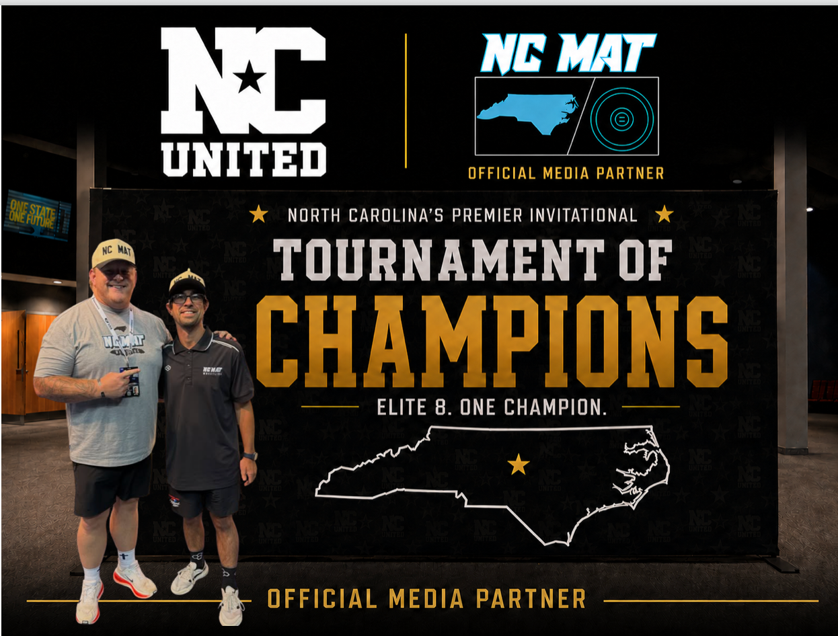
NC United is proud to announce The NC Mat as the Official Media Partner of the 2026 Tournament of Champions.
Rhett Hoy and Ryan Mitchell have become trusted voices through their photography, storytelling, interviews and event coverage.
Their role will include athlete and bracket announcements, seeding collaboration, live commentary, and tournament photography and coverage.
The partnership pairs an elite field with experienced voices who can introduce the athletes, explain the brackets and document the championship weekend.
READ MORE | Follow Tournament of Champions news

CLUB SPOTLIGHT
School of Hard Knocks Captures Chocolate Town Duals Championship
The North Carolina club went 5-0 in Hershey, Pennsylvania, with a roster made entirely of its own wrestlers.
UNITED ASCENT STAFF
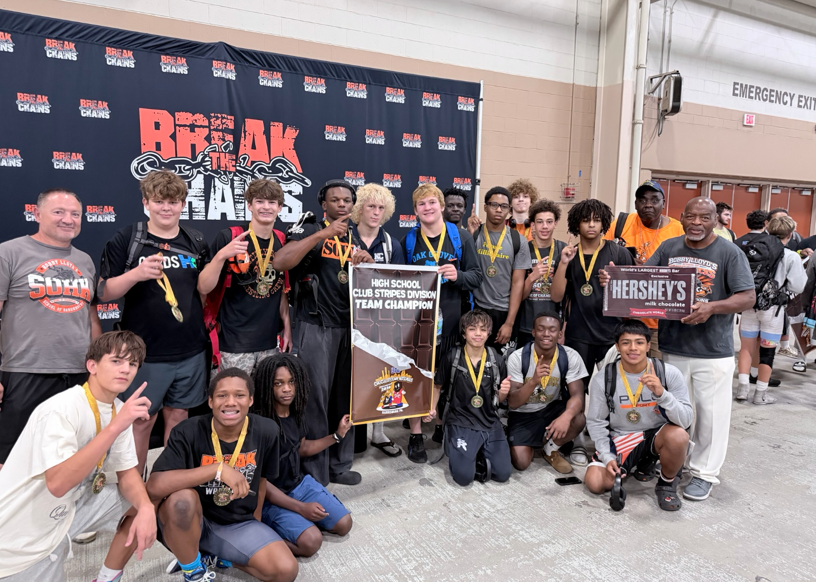
School of Hard Knocks celebrates the High School Club Division championship in Hershey.
School of Hard Knocks traveled to Pennsylvania and returned home as Chocolate Town Duals High School Club Division champions.
The club went 5-0 in Hershey with a roster made entirely of School of Hard Knocks wrestlers — a reflection of both the room's talent and its development.
One School of Hard Knocks wrestler finished 9-1, going 4-1 Saturday and 5-0 Sunday. His only loss came against a two-time Ohio champion.
Jeyvlin Palmeri lost only twice while helping School of Hard Knocks secure the championship.
Five duals. Five victories. One club championship.

RECRUITNC
Introducing Club Locator
A new interactive map makes it easier than ever to find and learn about wrestling clubs throughout North Carolina.
UNITED ASCENT STAFF
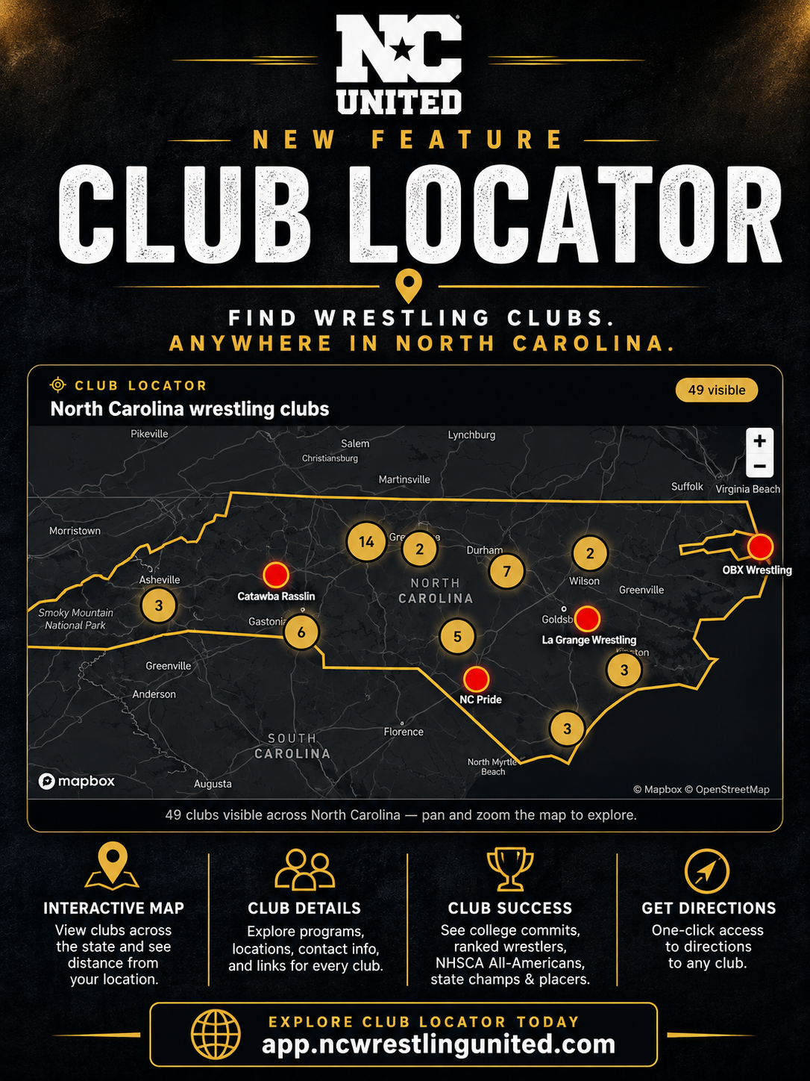
NC United has launched Club Locator on RecruitNC, an interactive statewide map that helps families find nearby wrestling clubs, compare programs and get directions.
Each participating club receives a dedicated, shareable page featuring:
- Location, distance, directions and contact information
- Programs across age groups and styles, plus affiliated athletes, commitments, rankings and championship accolades
READ MORE | Explore Club Locator

NATIONAL COMPETITION
Two North Carolina Teams Place Top 10 at Deep South Duals
Carolina Hammer Squad finished sixth and OTM Walters placed ninth against a national field of 70 teams.
UNITED ASCENT STAFF
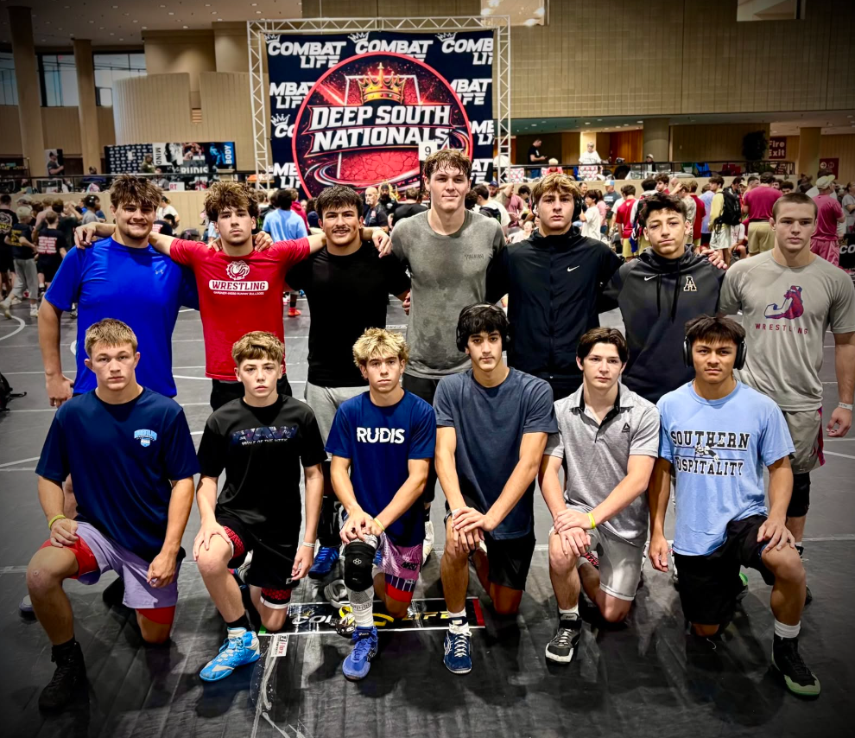
Carolina Hammer Squad competed against a 70-team field at the Deep South Duals.

Carolina Hammer Squad Finishes Sixth
Carolina Hammer Squad reached the Gold Bracket and finished sixth despite a difficult draw and surrendering a forfeit in every dual.
Brandon Lefler, Tyton Kostoff and Nash Mullis each went 8-1. Scott Swain also assisted in the corner throughout the event.

OTM Walters Places Ninth
OTM Walters finished 7-2 and placed ninth in the same 70-team field.
Connor Reece, Ayden Sumners and Manny Kahsai each completed the tournament undefeated.
Two North Carolina teams finished inside the national Top 10.

TOURNAMENT OF CHAMPIONS
Championship Stage
NC United partners with Resilite to create the signature competition surface for the Tournament of Champions.
UNITED ASCENT STAFF
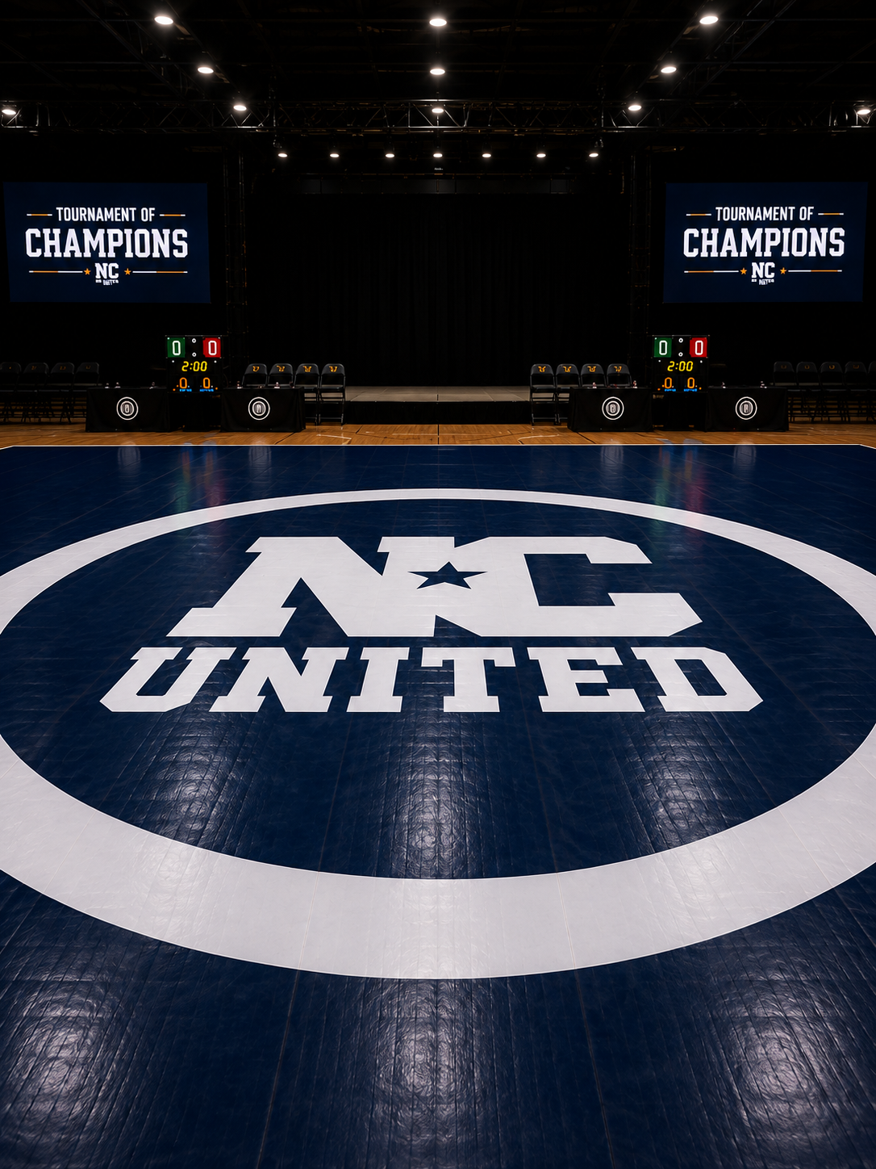
The 2026 Tournament of Champions will feature two custom 42-by-42-foot Resilite Flex 3 wrestling mats designed exclusively for the event.
Finished in navy with a bold white NC United logo at center, each mat will feature custom UltraPrint graphics and a premium surface built for high-level competition.
The two mats are among NC United's largest event investments and will give the tournament a competition surface distinct from any other high school event in North Carolina.
Hope Church | Apex, North Carolina | September 18-19, 2026
READ MORE | Learn more about the Tournament of Champions

SUPER 32
Two Paths to Super 32 Early Registration
Eligible North Carolina wrestlers can register beginning August 17, while others can earn eligibility at the state's September 5 qualifier.
UNITED ASCENT STAFF
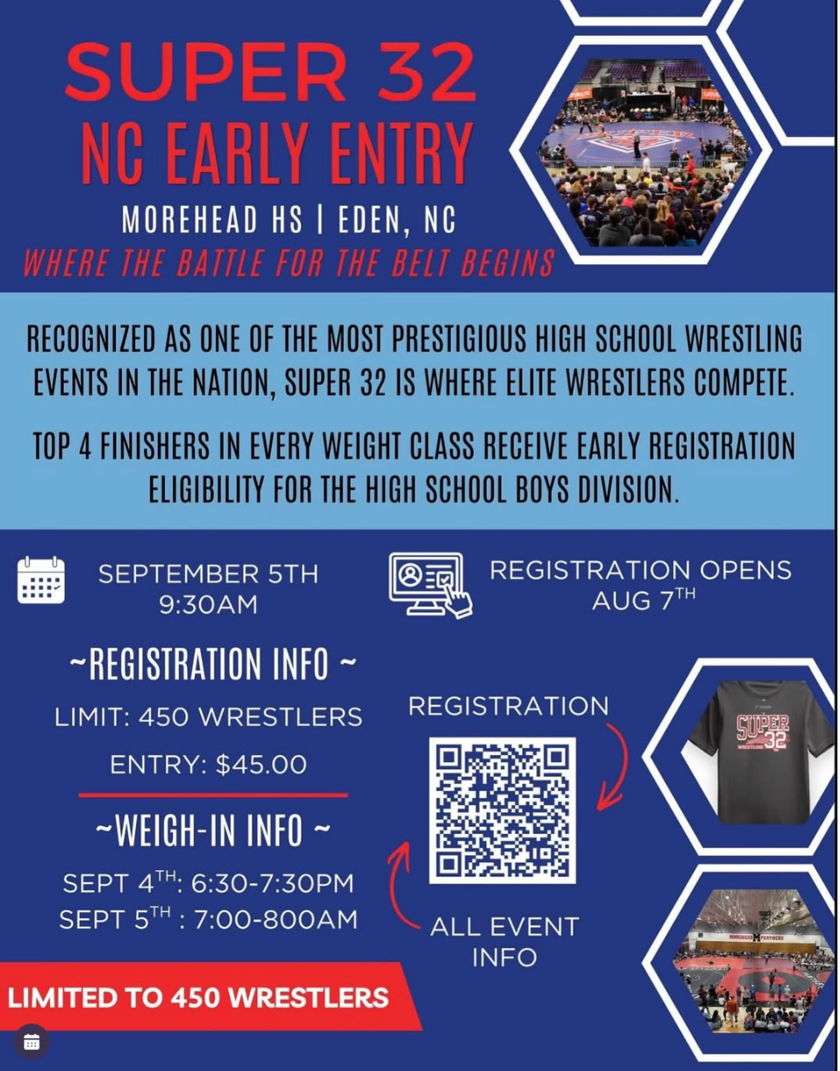

Early Registration
Early registration for the 2026 Super 32 Challenge opens Monday, August 17, at 6:00 p.m. Eastern.
Every early entry will be verified. Wrestlers who register without meeting the published criteria will be removed without a refund.
For North Carolina high school boys, early-entry eligibility includes:
- Top-two finishers at the 2026 NCHSAA individual state championships
- 2026 USA Wrestling 16U or Junior Fargo All-Americans
- Previous Super 32 High School placers or top-six Middle School placers from 2024 or 2025
- Top-six finishers at the 2026 NHSCA High School Grade-Level Nationals
- Wrestlers currently ranked in the national Top 20 by FloWrestling, InterMat or MatScouts
- Current qualifying World or Pan-American team members, or top-four finishers at an approved 2026 early-entry tournament
High school boys' early registration closes September 19 at 6:00 p.m. Eastern. Other divisions close August 29 and follow separate criteria.
READ MORE | Review the complete Super 32 early-entry criteria

North Carolina Early-Entry Qualifier
Wrestlers who do not already qualify can earn early-entry status at North Carolina's Super 32 Early-Entry Qualifier.
- Tournament: September 5 at 9:30 a.m.
- Location: Morehead High School | Eden, NC
- Entry fee: $45
- Capacity: 450 wrestlers
- Qualification: Top four finishers in each weight class
- Weigh-ins: September 4, 6:30-7:30 p.m., or September 5, 7:00-8:00 a.m.
Families should review the criteria carefully and use the link for the correct division; Super 32 cannot transfer registrations between divisions.

TOURNAMENT OPPORTUNITY
Knockout Championships Keeps the Competition Going
Wrestlers eliminated from Super 32 can enter a second tournament and gain more high-level matches before leaving Greensboro.
UNITED ASCENT STAFF
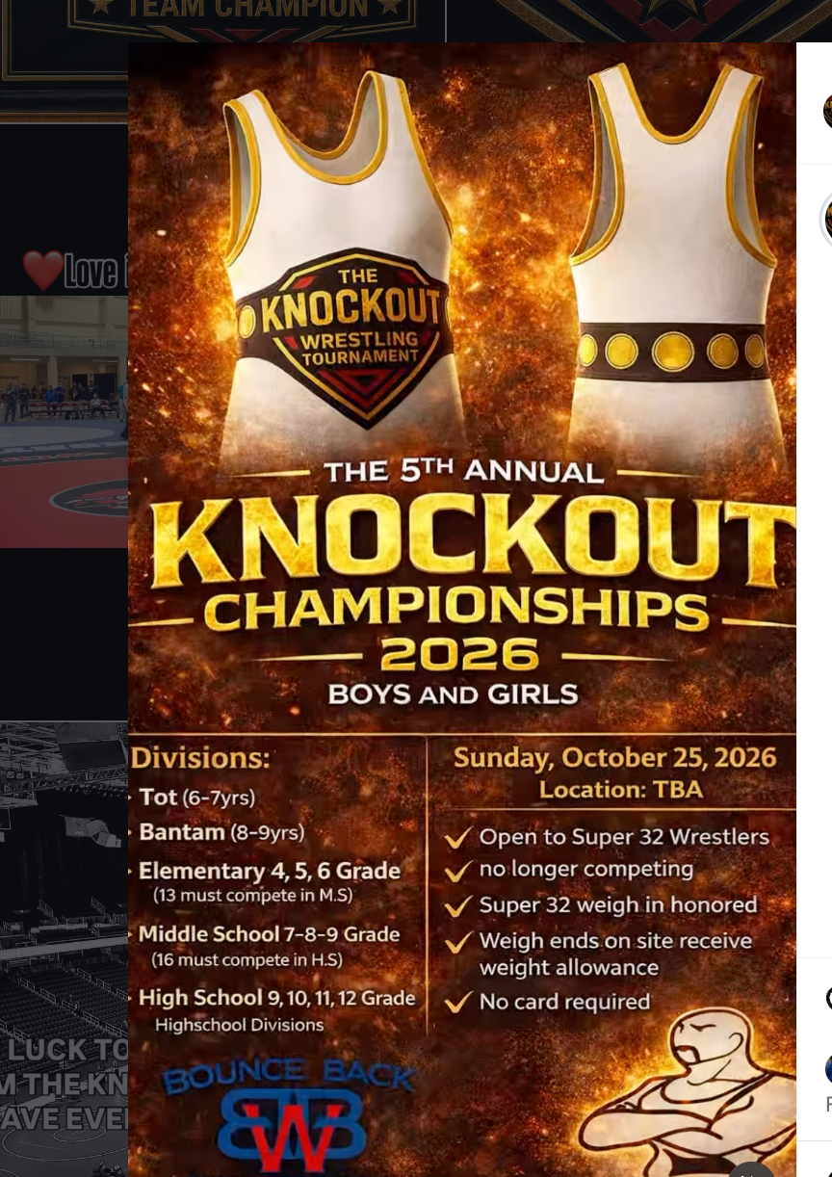
The fifth annual Knockout Championships is a second-chance tournament for boys and girls eliminated from the Super 32 Challenge. It gives families another competitive event before leaving Greensboro.
Distinctive awards and a strong field make Sunday feel like its own championship rather than a consolation bracket.
Super 32 weigh-ins will be honored, so participating wrestlers will not need to weigh in again. On-site weigh-ins include a weight allowance, and no USA Wrestling membership card is required.
Divisions: Tot, Bantam, Elementary, Middle School and High School
Sunday, October 25, 2026 | Location to be announced
For families already traveling to Greensboro, it is another opportunity to pursue a memorable award and gain valuable matches before heading home.
One loss does not have to end the weekend.

SCHOLARSHIP REMINDER
Who Comes to Mind?
Nominations remain open for the inaugural Caden Perry Warrior Scholarship.
UNITED ASCENT STAFF
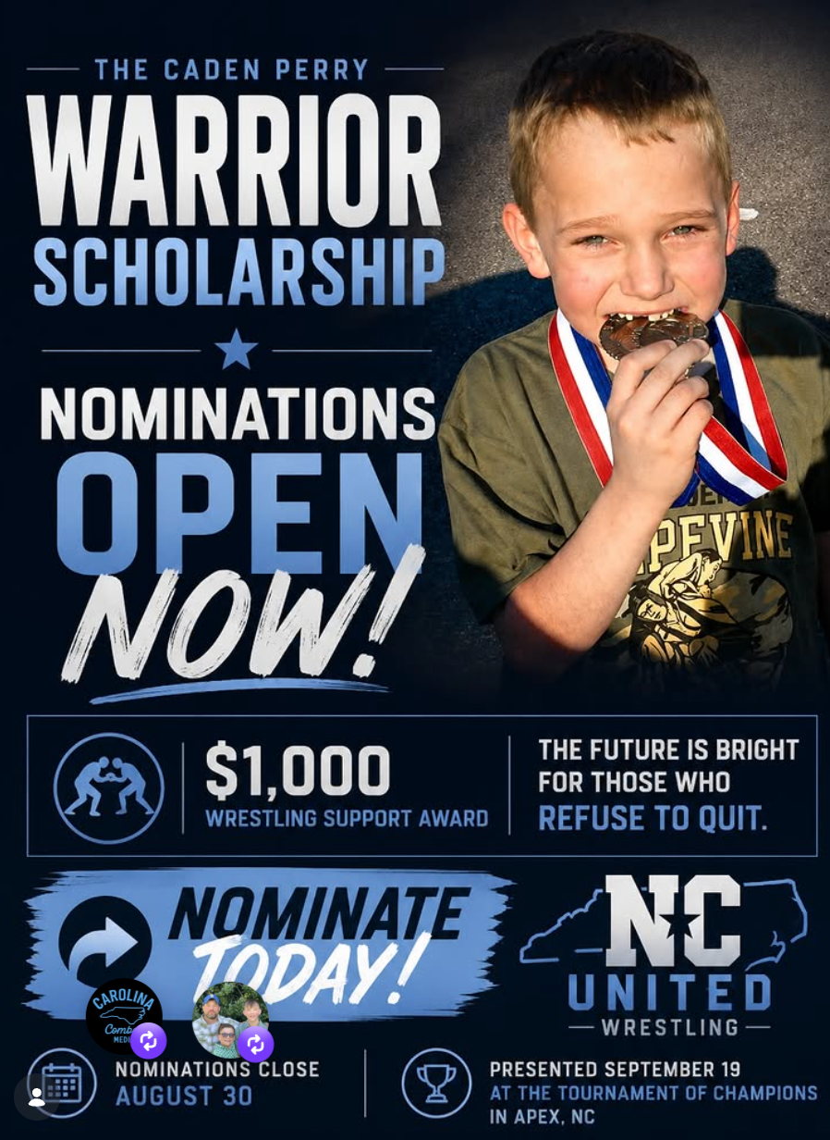
NC United is accepting nominations for the inaugural Caden Perry Warrior Scholarship, a $1,000 wrestling-support award for a North Carolina wrestler whose response to adversity reflects Caden's warrior spirit.
The award is not based on rankings, championships, recruiting status or grades. It recognizes courage, resilience, character and refusal to surrender when life becomes difficult.
The scholarship may be used for approved wrestling-related expenses, including:
- Club dues, training fees, private lessons and camps
- Tournament entry fees, travel and lodging
- Shoes, gear and equipment
Coaches, parents, teachers, counselors, teammates and community members may submit a nomination.
Nominations close August 30 | Recipient announced September 19 at the Tournament of Champions
READ MORE | Nominate an athlete

COMMUNITY CELEBRATIONS
Celebrating Jon Jon Millner and Ryan Mitchell
Happy birthday this week to Jon Jon Millner and Ryan Mitchell.
UNITED ASCENT STAFF
Jon Jon continues to invest in North Carolina wrestling through coaching, mentorship and athlete development at Darkhorse. Ryan helps tell the story of wrestling across the state through photography, media coverage and his work with The NC Mat.
Both give their time and talents to the sport and the people within it. Please join us in wishing Jon Jon and Ryan a very happy birthday!

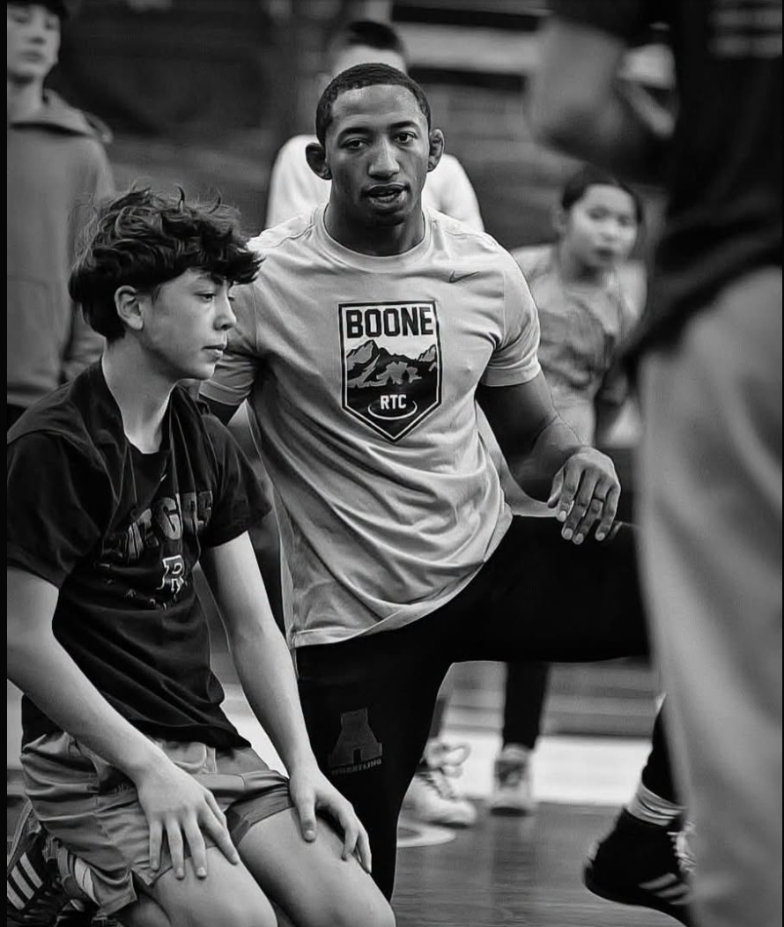  Jon Jon Millner  Coach at Darkhorse Wrestling Club | 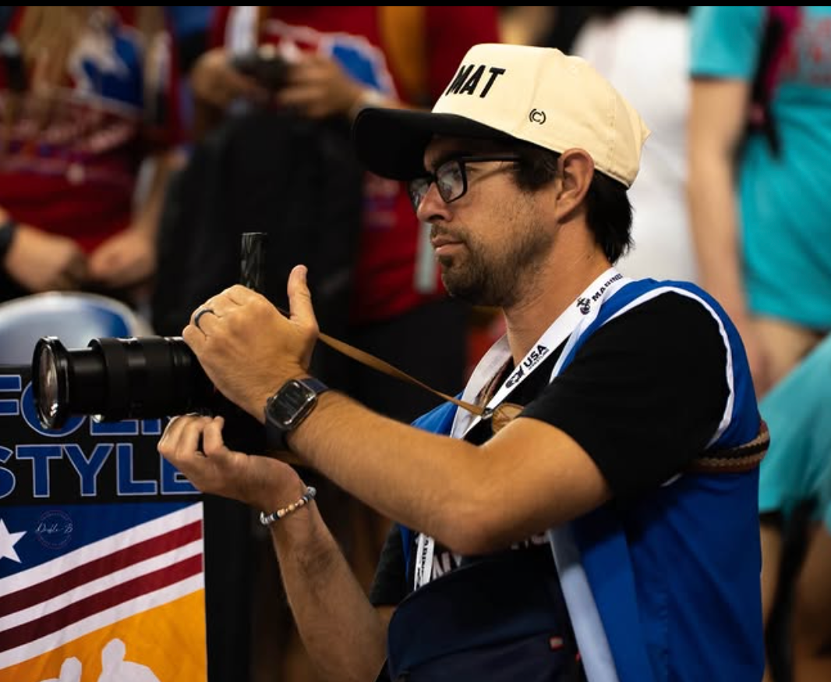  Ryan Mitchell  The NC Mat
THE ASCENT CONTINUES
North Carolina Wrestling Keeps Moving Forward
Competition. Opportunity. Innovation. Community. Character.
This week's stories show North Carolina wrestling moving forward through competition, opportunity, innovation, community and character.
School of Hard Knocks returned from Pennsylvania with a club championship, while Carolina Hammer Squad and OTM Walters both placed inside the Top 10 of a 70-team national field.
RecruitNC launched Club Locator, and the Tournament of Champions added custom Resilite mats and The NC Mat as its official media partner.
Wrestlers gained new Super 32 opportunities, and the community continued celebrating those who serve the sport while searching for the first recipient of the Caden Perry Warrior Scholarship.
NORTH CAROLINA WRESTLING IS ASCENDING - AND WE'RE COVERING EVERY STEP.
NC Wrestling United

