MotorTrend's Analysis of the Effects of Car Characteristics on MPG

S. Duffy

April 14, 2016

## Summary

## Overview

Historically, the anecdote most car drivers pass down to their children is that a vehicle with a standard transmission is more fuel efficient than a vehicle with an automatic transmission. We here at MotorTrend Magazine love and trust our dads but we wanted to see if this anecdote stands up to an analysis of the data.

We were able to obtain rare data from industry insiders and have stored it in a dataset called mtcars. The dataset has a structure like this:

str(mtcars)

## 'data.frame': 32 obs. of 11 variables:  
## $ mpg : num 21 21 22.8 21.4 18.7 18.1 14.3 24.4 22.8 19.2 ...  
## $ cyl : num 6 6 4 6 8 6 8 4 4 6 ...  
## $ disp: num 160 160 108 258 360 ...  
## $ hp : num 110 110 93 110 175 105 245 62 95 123 ...  
## $ drat: num 3.9 3.9 3.85 3.08 3.15 2.76 3.21 3.69 3.92 3.92 ...  
## $ wt : num 2.62 2.88 2.32 3.21 3.44 ...  
## $ qsec: num 16.5 17 18.6 19.4 17 ...  
## $ vs : num 0 0 1 1 0 1 0 1 1 1 ...  
## $ am : num 1 1 1 0 0 0 0 0 0 0 ...  
## $ gear: num 4 4 4 3 3 3 3 4 4 4 ...  
## $ carb: num 4 4 1 1 2 1 4 2 2 4 ...

The definitions of the columns are thus:

* mpg = Miles/(US) gallon
* cyl = Number of cylinders
* disp = Displacement (cu.in.)
* hp = Gross horsepower
* drat = Rear axle ratio
* wt = Weight (1000 lbs)
* qsec = 1/4 mile time
* vs = V/S
* am = Transmission (0 = automatic, 1 = manual)
* gear = Number of forward gears
* carb = Number of carburetors

What we're interested in is the mpg and am columns which have the following characteristics

a <- summary(mtcars$mpg)  
b <- nrow(mtcars)  
man <- sum(mtcars$am)  
auto <- b-man

The mpg column has a range from 10.4 mpg to 33.9 mpg with a mean of 20.09.

Out of the 32 vehicles in the dataset, 13 are manual transmissions and 19 are automatic transmissions.

Is there are noticeable difference in MPG in the two different transmission types? A plot shows yes. The blue line is the average for 1s, the manual transmissions and the red line is the average for 0s, the automatic transmissions.

mancars <- subset(mtcars, am == 0)  
autocars <- subset(mtcars, am == 1)  
  
plot(mtcars$am,mtcars$mpg, ylab = "MPG", xlab = "Transmission 1=auto", main = "MPG by Transmission with Avgs")  
 abline(h=mean(mancars$mpg),col = 'red')  
 abline(h=mean(autocars$mpg),col = 'blue')

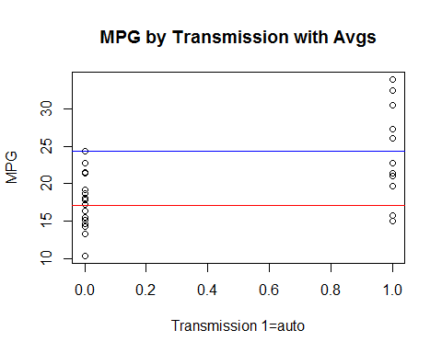

## Is an automatic or manual transmission better for MPG?

The question we'll explore is, "Is an automatic or manual transmission better for MPG?" Of course, there are a lot of moving pieces in a vehicle that can contribute to varying levels of MPG, many of which are in the dataset. First, we'll explore our question just using the two variables in the question, mpg and am.

For this section, we'll use the mpg as the dependent variable and transmission as a predictor

mdl <- lm(mpg ~ am,mtcars)  
summary(mdl)

##   
## Call:  
## lm(formula = mpg ~ am, data = mtcars)  
##   
## Residuals:  
## Min 1Q Median 3Q Max   
## -9.3923 -3.0923 -0.2974 3.2439 9.5077   
##   
## Coefficients:  
## Estimate Std. Error t value Pr(>|t|)   
## (Intercept) 17.147 1.125 15.247 1.13e-15 ***  
## am 7.245 1.764 4.106 0.000285 ***  
## ---  
## Signif. codes: 0 '***' 0.001 '**' 0.01 '*' 0.05 '.' 0.1 ' ' 1  
##   
## Residual standard error: 4.902 on 30 degrees of freedom  
## Multiple R-squared: 0.3598, Adjusted R-squared: 0.3385   
## F-statistic: 16.86 on 1 and 30 DF, p-value: 0.000285

## 

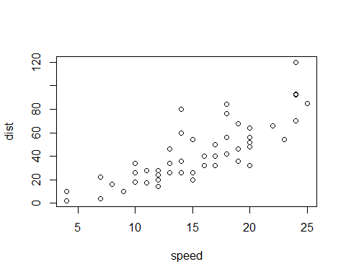  
 Note that the echo = FALSE parameter was added to the code chunk to prevent printing of the R code that generated the plot.