Table of Contents
1. Scope 2
2. System(s) Impacted 2
3. Assumption(s) / Dependencies 2
4. As-Is Business Process (via activity diagram) 2
5. To-Be Business Process (via activity diagram) 2
6. Requirements 2
7. Issues/Open Questions 2

Scope
The goal of the project is to implement ‘Online Banking’ capability so that the customers can manage their account 24X7. This will also result in significant decrease in call center volume, which not only provide better customer experience but will also reduce call center expenses.

System(s) Impacted
‘Online Banking’ capabilities shall be added as an enhancement to ‘https://bankofamerica.com’

Assumption(s) / Dependencies
N/A

As-Is Business Process (via activity diagram)

To-Be Business Process (via activity diagram)
- Requirements

6.1 Requirements: ‘Home’ Page
6.1.1 Display ‘Online Banking’ Hyperlink
System shall display ‘Online Banking’ hyperlink, which shall be located to the left of ‘security’ hyperlink.

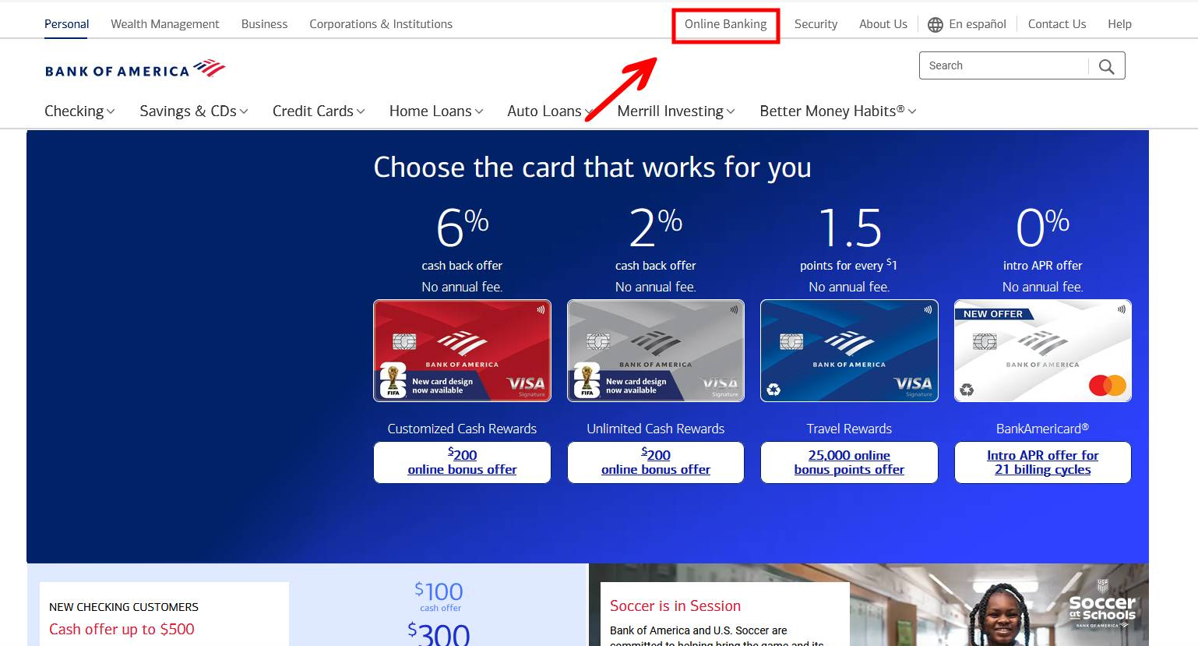

6.1.2 ‘Online Banking’ Hyperlink Navigation

On clicking ‘Online Banking’ hyperlink, system shall display ‘Online Banking’ page

in the same window.

6.2 Requirements: ‘Online Banking’ Page

6.2.1 ‘Online Banking’ page data fields

System shall display the following data fields on ‘Online Banking’ page:

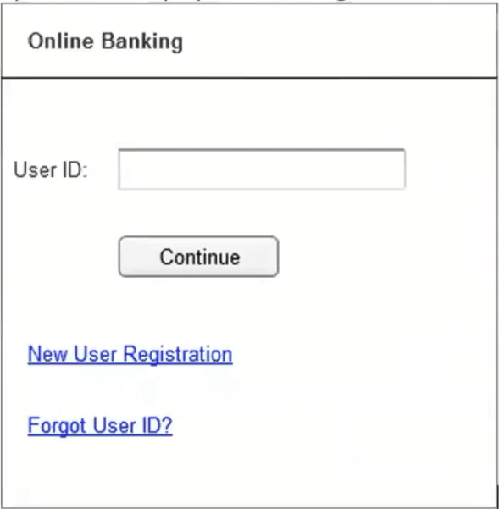
Field Name | Field Type | Content | Required Field? | Min. Char. | Max. Char. | Notes
User ID | Text Box | Alpha-numeric | No | 8 | 16
Continue | Command Button | N/A | N/A | N/A | N/A | On click, if validation passes, display ‘Password’ page else display error message
New User Registration | Hyperlink | N/A | N/A | N/A | N/A | On Click, display ‘New User Registration’ page in the same window.
Forgot User ID? | Hyperlink | N/A | N/A | N/A | N/A | On click, display ‘Forgot User ID’ pop-up/dialogue.

6.2.2 Validate User ID
In the event of user clicking the ‘Continue’ command button, system shall validate the entered user id.

6.2.2.1 If the entered User ID is valid, display ‘Password’ page in the same window.

6.2.2.2 If the entered User ID is invalid, display the following error message: Invalid User ID. “ Please re-enter a valid value”.

6.3 Requirements: ‘New User Registration’ Page
6.3.1 ‘New User Registration’ page data fields
System Shall display the following data fields on ‘New User Registration’ page:

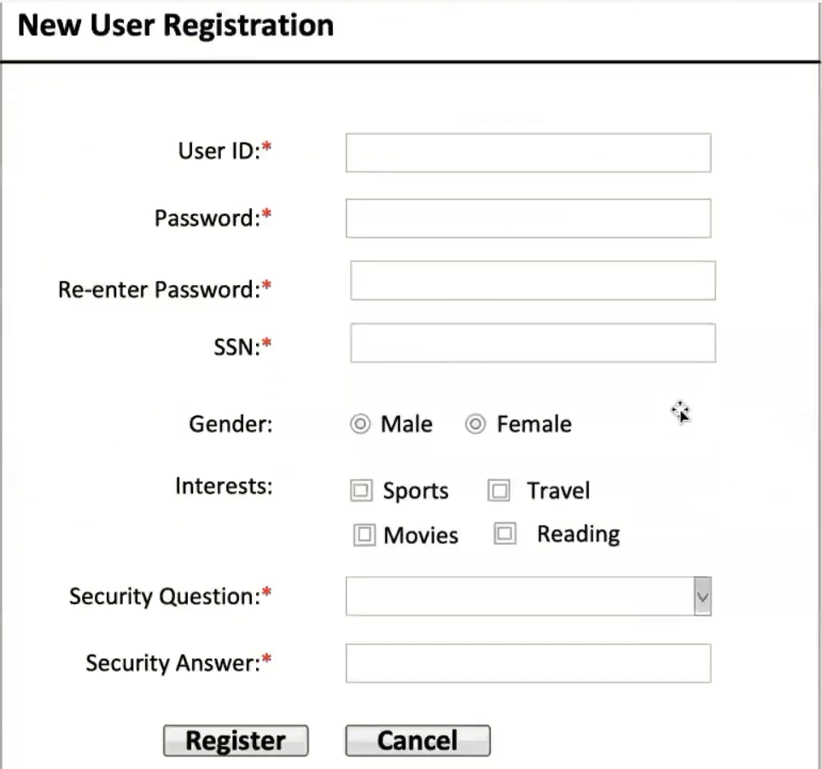
Field Name | Field Type | Content | Required Field? | Min. Char. | Max. Char. | Notes
User ID | Text Box | Alpha-numeric | Yes | 8 | 16
Password | Text Box | Alpha-numeric | Yes | 8 | 16 | Data is encrypted
Re-enter password | Text Box | Alpha-numeric | Yes | 8 | 16 | Data is encrypted
SSN | Text Box | Numeric | Yes | 9 | 9 | Encrypt the fist 5 numbers
Gender | Radio Button | Male, Female | No | N/A | N/A | No default selection
Interests | Check Box | Sports, Travel, Movies, Reading | No | N/A | N/A | No default selection
Security Question | Dropdown | What is your best friends name?  What is your mother’s maiden name?  what is the make of your first car?  What city were you born?  What is your favorite movie? | Yes | N/A | N/A | Sort the options alphabetically. No default selection
Security Answer | Text Box | Alpha-numeric | Yes | 2 | 56
Register | Command Button | N/A | N/A | N/A | N/A | On click, if all validations pass, display ‘Account Summary’ page, else display error message.
Cancel | Command Button | N/A | N/A | N/A | N/A | On click, discard the entered data and display ‘Online Banking’ Page

6.3.2 ‘New User Registration’ page data validations
On click of ‘Register’ command button, system shall perform following validations:
a. All required data is entered
b. All the entered data is valid
c. User ID is unique
d. Re-entered password matches with the entered password
e. Entered SSN is associated with an active account
f. Entered SSN is NOT associated with an active User ID
6.3.2.1 ‘New User Registration’ page data validations = Pass
In the event of passing of all the validations, display ‘Account Summary’ page in
the same window.

6.3.2.2 ‘New User Registration’ page data validations = Fail
In the event of failure of one or more validations, display the error messages as shown below
Failed Validation | Error Message Displayed
All required data is entered | <Data Field> is a required field. Please enter a value for <Data Field>
All the entered data is valid | Value for <Data Field> is invalid. Please enter a valid value for <Data Field>
User ID is Unique | <User ID> is already taken. Please enter a different user id
Re-entered password matches with the entered password | The entered password and re-entered password do not match. Please try again.
Entered SSN is associated with an active account. | The entered SSN does not have an active account in the bank. Please re-enter the SSN.
Entered SSN is not associated with an active user ID. | The entered SSN is already associated with an active user ID. You are not allowed to create multiple user IDs.

6.3.3 Cancel Registration
On Click of ‘Cancel’ command button, system shall discard the entered data and display ‘Online Banking’ page in the same window.

6.4 Requirements: ‘Password’ Page
6.4.1 ‘Password’ page data fields
System shall display the following data fields on ‘Password’ page:
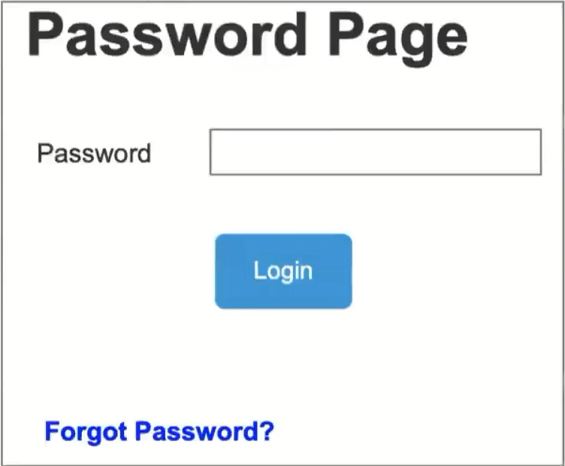
Field Name | Field Type | Content | Required Field? | Min. Char. | Max. Char. | Notes
Password | Text Box | Alpha-numeric | Yes | 8 | 16 | Data is encrypted
Login | Command Button | N/A | N/A | N/A | N/A | On click, if validation passes, display ‘Account Summary’ page else display error message
Forgot Password? | Hyperlink | N/A | N/A | N/A | N/A | On click, display ‘Forgot Password’ pop-up/dialogue

6.2.2 Validate Password
In the event of user clicking the ‘Login’ command button, system shall validate the entered password.

6.2.2.1 If the entered Password is valid, display ‘Account’ page in the same window.
6.2.2.2 If the entered Password is invalid, system shall calculate the password failure count.

6.2.2.2.1 If the password failure count is <3, display the following error message: Invalid password. Please re-enter a valid password.
6.2.2.2.2 If the password failure count = 3, system shall lock the account and display the following error message: Your account is locked. Please call 1800-XXXX-XXXX to unlock your account

Issues/Open Questions
N/A

