User Stories Document
Payment Feature (ACH Enhancement Project)

US-201 - Add and Verify External Bank Account
User Story Name
Add and Verify External Bank Account
Description
As a Digital Banking Customer, I want to add and verify an external bank account so that I can securely transfer funds using ACH.
Business Rules
- Routing Number must contain exactly 9 digits.
- External account must be verified before ACH payments can be initiated.
- Customer can have a maximum of 10 external accounts.
- Only Active and Verified accounts can be used for ACH transfers.
Acceptance Criteria
- AC-1: System should allow customers to add external bank account details including Account Holder Name, Routing Number, Account Number and Account Type.
- AC-2: System should validate routing number format and verify that the routing number belongs to a valid financial institution.
- AC-3: System should support both Instant Account Verification and Micro Deposit Verification methods.
- AC-4: Unverified accounts should display a Pending Verification status and should not be available during payment initiation.
- AC-5: Verified accounts should be available in the payment destination list.

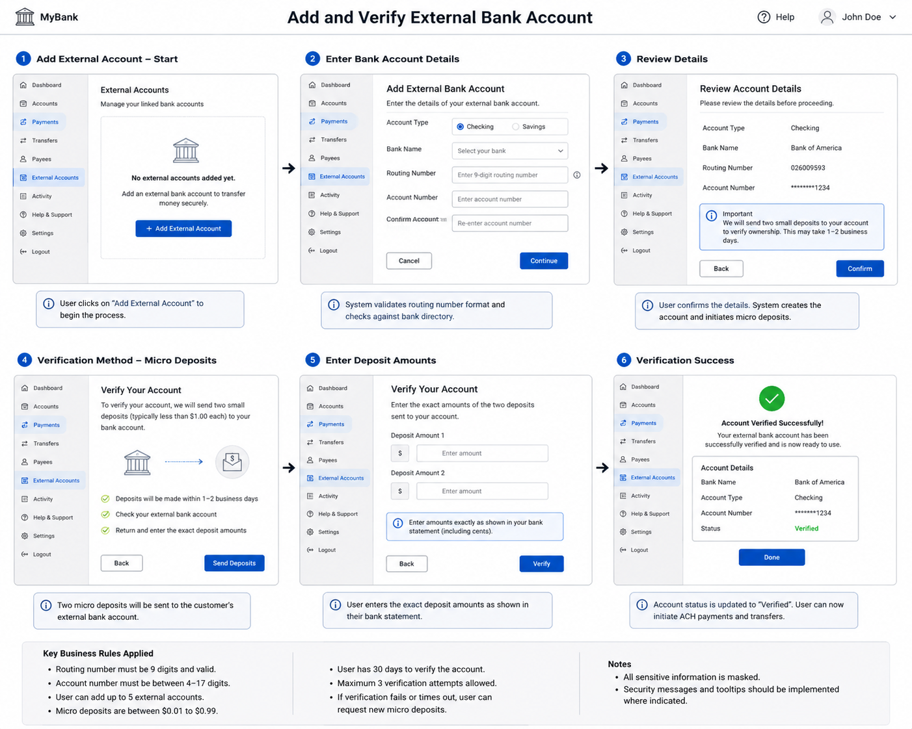

US-202 - Initiate ACH Payment

User Story Name
Initiate ACH Payment

Description
As a Digital Banking Customer, I want to initiate an ACH payment to an external account so that I can transfer money electronically between banks.
Business Rules
- Payment amount must be greater than zero.
- Customer must have sufficient available balance.
- External account must be verified.
- Daily ACH transfer limit is $25,000.

Acceptance Criteria
- AC-1: System should allow customers to select source account, destination account and payment amount.
- AC-2: System should validate account balance before payment submission.
- AC-3: System should validate ACH transaction limits before creating the payment request.
- AC-4: System should generate a unique payment reference number for every ACH transaction.
- AC-5: Successful submissions should move the payment status to Submitted and trigger a customer confirmation notification.
- AC-6: Payments exceeding daily limits should be rejected with an appropriate error message.

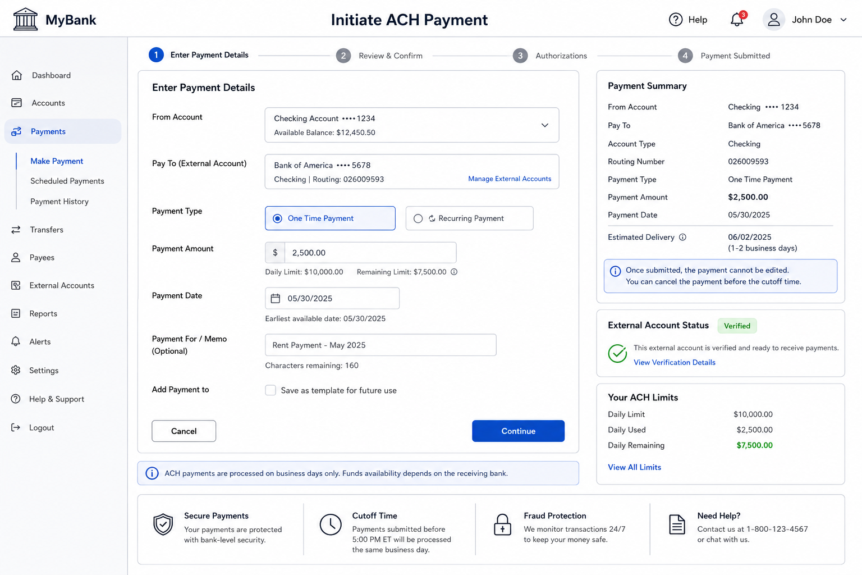

US-203 - Automated Risk Checks and ACH Processing
User Story Name
Automated Risk Checks and ACH Processing
Description
As a Payments Operations Manager, I want the system to automatically perform fraud checks and ACH processing so that payment risks are minimized and transactions are processed efficiently.
Business Rules
- Every ACH payment must pass fraud screening before submission.
- Duplicate payment detection must be executed before ACH processing.
- Failed ACH API calls should be retried up to three times.
- Suspicious transactions must be routed for manual review.

Acceptance Criteria
- AC-1: System should perform balance validation, duplicate payment detection and fraud screening before ACH submission.
- AC-2: Payments identified as potential duplicates should be blocked and recorded in audit logs.
- AC-3: Transactions exceeding predefined risk thresholds should move to Manual Review status.
- AC-4: System should generate ACH file/API requests after successful validations.
- AC-5: Failed ACH submissions should automatically retry up to three times before moving to Exception Queue.
- AC-6: All validation and risk decisions should be audit logged.

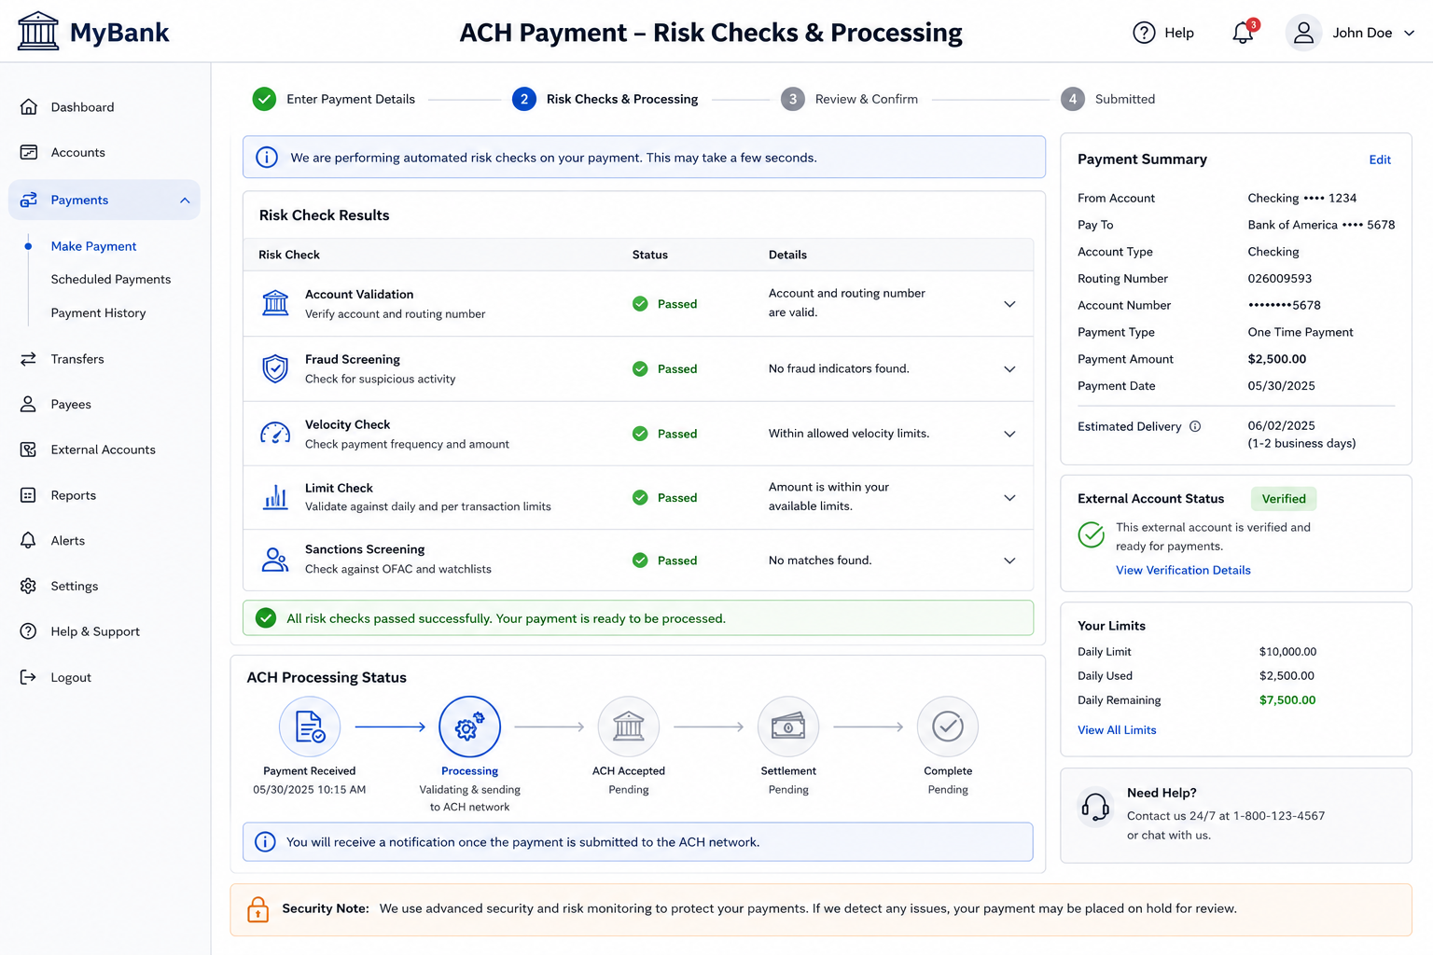

US-204 - Track Payment Status, Reversals and Notifications
User Story Name
Track Payment Status, Reversals and Notifications
Description
As a Digital Banking Customer, I want to track ACH payment status and receive notifications so that I am informed about the outcome of my payment transactions.
Business Rules
- Only valid payment state transitions should be allowed.
- Reversal requests must capture a reversal reason.
- Customer notifications are mandatory for key payment events.
- All status changes must be audit logged.
Acceptance Criteria
- AC-1: System should display payment statuses including Submitted, Processing, Settled, Returned, Failed, Cancelled and Reversed.
- AC-2: Customers should be able to view payment history and current status from the Payments Dashboard.
- AC-3: System should send SMS and email notifications when payments are submitted, settled, returned, failed or reversed.
- AC-4: Returned payments should display the return reason provided by the receiving bank.
- AC-5: Authorized operations users should be able to initiate payment reversals for eligible transactions.
- AC-6: Completed reversals should update payment status to Reversed and notify the customer automatically.
