Business Requirements Document (BRD)
Digital Account Opening Project

1. Executive Summary
Bank of America plans to modernize its retail banking onboarding process by implementing a fully digital savings account opening platform. The current onboarding process involves manual document verification, branch visits, delayed KYC processing, and manual account creation in the Core Banking System (CBS).
The proposed solution includes:
- Mobile & web-based onboarding
- OCR/API-based customer data extraction
- Digital KYC & AML verification
- Real-time CBS account creation
- Automated SMS & email notifications

2. Project Objectives
Objective | Target
Reduce account opening time | < 10 minutes
Reduce branch dependency | 80%
Increase onboarding conversion | +35%
Straight-through processing | >85%
Enable real-time KYC validation | Mandatory

3. Needs Statement
Current Business Problems:
- Manual KYC verification causes onboarding delays
- Physical branch dependency impacts customer experience
- Multiple manual handoffs increase operational effort
- Manual CBS account setup increases processing time
4. Project Scope
In Scope | Out of Scope
Savings account onboarding  Digital KYC verification  AML screening  CBS account creation  SMS & email notifications | Loan onboarding  Corporate accounts  Wealth management  Credit card onboarding

5. Business Requirements
Requirement ID | Requirement
BR-1 | Customer should open account digitally without visiting branch.
BR-2 | Onboarding process should complete within 10 minutes.
BR-3 | System should validate identity, address, and tax ID before account creation.
BR-4 | CBS should generate account number instantly after approval.
BR-5 | AML & sanctions screening must occur before account activation.

6. Key Stakeholders
Stakeholder | Role
Product Owner | Defines business priorities
Business Analyst | Requirement gathering & process analysis
Compliance Team | KYC & AML policy validation
CBS Team | Core banking integration
QA Team | Testing & validation

7. Project Constraints
- Go-live timeline restricted to 6 months
- Dependency on third-party OCR/KYC APIs
- Fixed transformation budget

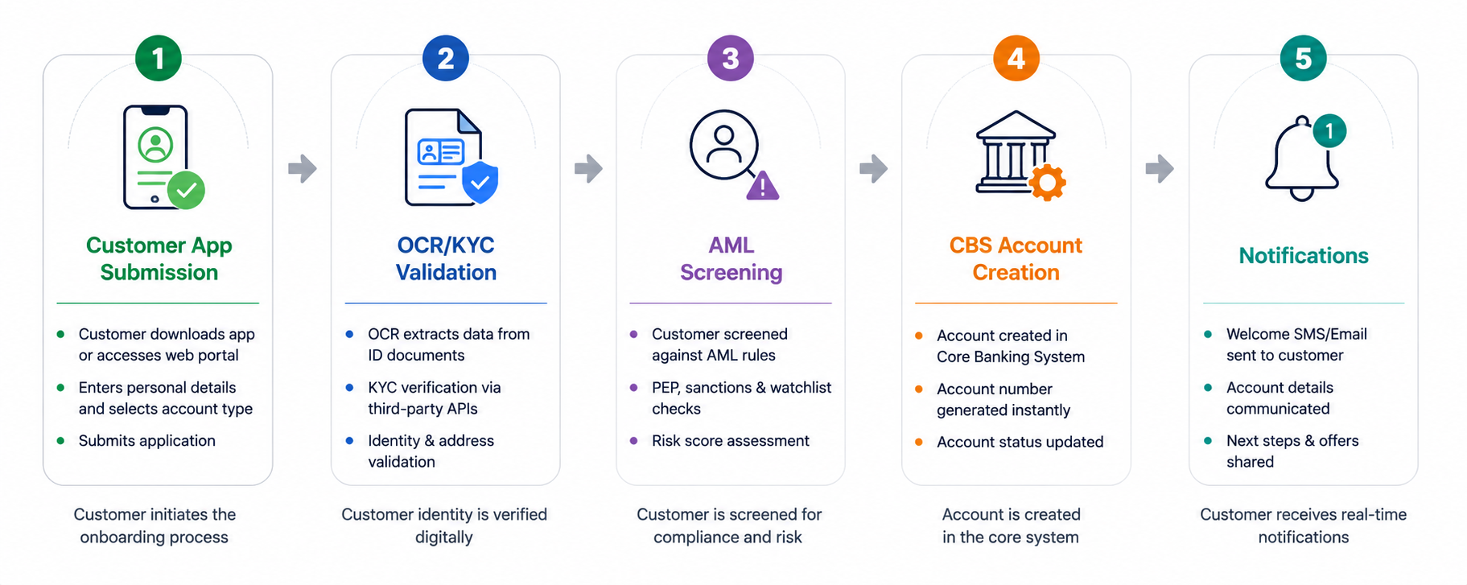
8. High-Level Digital Onboarding Flow

