Functional Requirements Document (FRD)
CBS Account Creation & Product Setup

1. Functional Overview
Objective: Enable real-time customer profile creation, savings account setup, and product mapping in the Core Banking System (CBS) during digital onboarding.

2. Document Information
Field | Value
Project | Digital Account Opening
Module | CBS Account Creation & Product Setup
Prepared By | Business Analyst Team
Version | 1.0
Status | Draft

3. Key Stakeholders
Stakeholder | Responsibility
CBS Team | Core banking integration and account setup
Business Analyst | Requirement gathering & FRD preparation
Product Team | Defines account products and onboarding flow
Operations Team | Handles failed account creation cases
Technology Team | CBS API integration implementation

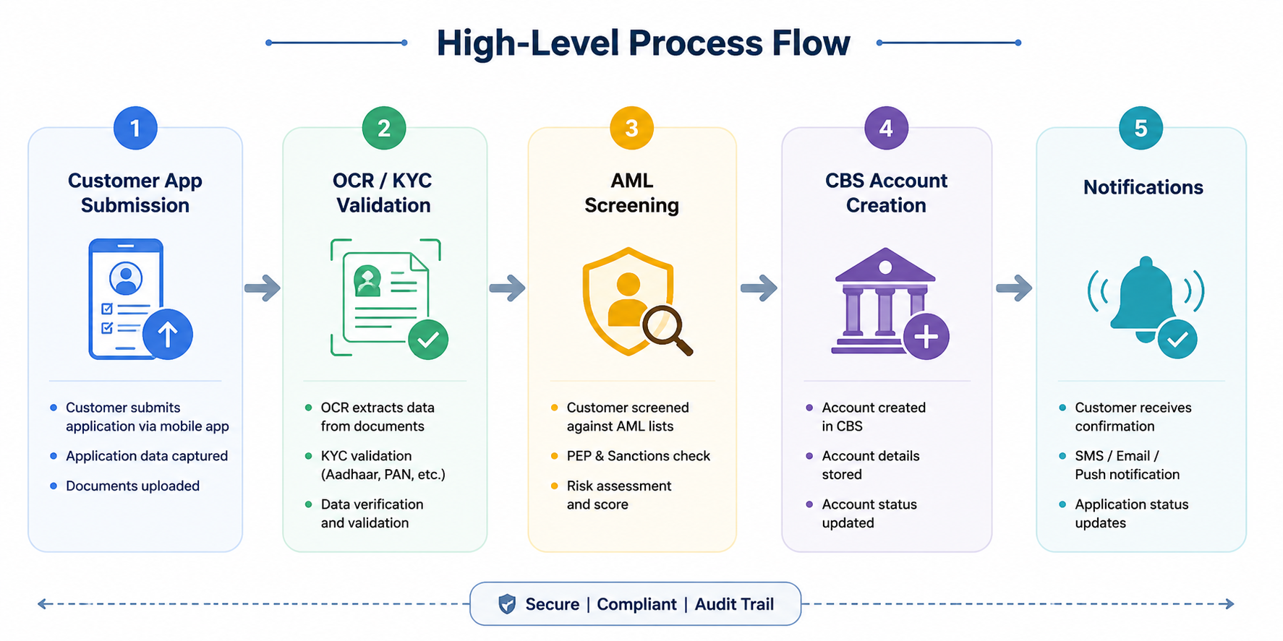
4. High-Level Process Flow

5. Mandatory Customer & Product Fields
Customer Fields | Product Fields
• Full Name  • DOB  • PAN/SSN  • Address  • Mobile Number  • Nationality | • Product Code  • Account Type  • Currency  • Branch Code  • Customer Segment

6. Functional Requirements
FR ID | Requirement | Priority
FR-301 | System shall create customer profile in CBS using verified onboarding data. | High
FR-302 | CBS shall generate savings account number instantly after successful onboarding. | High
FR-303 | Selected onboarding account type shall map automatically to predefined CBS product code. | High
FR-304 | System shall validate mandatory product configuration before account creation. | High
FR-305 | Failed CBS API responses shall move application to Operations Review Queue. | High
FR-306 | System shall trigger welcome SMS/email after successful account creation. | Medium

7. Business Rules
- KYC verification must complete successfully before CBS account creation.
- Savings account products shall be configured centrally within CBS.
- Duplicate customer profiles shall not be created.
- Minimum balance rules shall depend on selected account product.

8. Exception Handling
Scenario | System Action
CBS API Timeout | Retry API request 2 times before failure
Duplicate Customer Match | Move application to manual review queue
Product Mapping Failure | Reject onboarding and notify Operations Team
Account Creation Failure | Application moves to Pending Operations Review

9. Notifications & Downstream Actions
- Trigger welcome SMS/email after successful account creation.
- Send debit card request to card management system.
- Sync customer profile to CRM platform.
- Audit log all CBS account creation activities.

10. Non-Functional Requirements
- CBS account creation response time should be under 5 seconds.
- System should support 10,000 account creation requests daily.
- All customer data must be encrypted during transmission and storage.
- System availability should be 99.9%.

