Functional Requirements Document (FRD)
Customer Onboarding & Document Submission

1. Functional Overview
Enable customers to digitally onboard through mobile/web channels by capturing personal details, uploading identity documents, validating information using OCR/KYC APIs, and initiating onboarding workflows.

2. Document Information
Field | Value
Project | Digital Account Opening
Module | Customer Onboarding & Document Submission
Prepared By | Business Analyst Team
Version | 1.0
Status | Draft

3. Key Stakeholders
Stakeholder | Responsibility
Product Owner | Defines onboarding vision and priorities
Business Analyst | Requirement gathering & FRD preparation
Compliance/KYC Team | KYC rules and validations
OCR Integration Team | OCR extraction & API integration
CBS Team | Customer/account creation integration

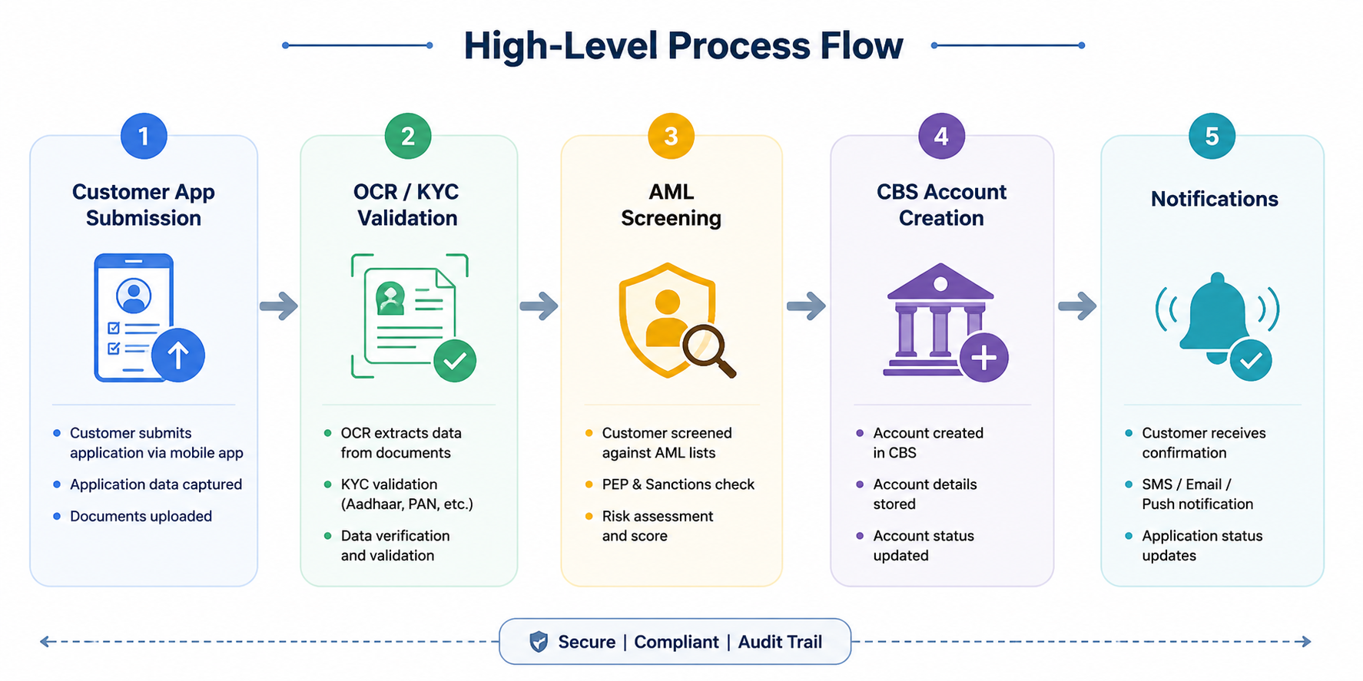
4. High-Level Process Flow

5. Functional Requirements
FR ID | Requirement | Priority
FR-101 | System shall allow upload of Passport, Driver’s License, and Utility Bill in JPG, PNG, or PDF format. | High
FR-102 | OCR engine shall extract customer name, DOB, address, and document number from uploaded documents. | High
FR-103 | System shall validate mandatory customer details before onboarding submission. | High
FR-104 | System shall allow customer to edit OCR extracted data before submission. | Medium
FR-105 | Duplicate customer validation shall occur before onboarding approval. | High

6. Business Rules
- Customers below 18 years cannot onboard digitally.
- Maximum document upload size allowed is 10 MB.
- Customers can retry failed document upload up to 3 times.
- KYC verification must complete successfully before onboarding approval.

7. Exception Handling
Scenario | System Action
OCR Failure | Prompt customer to re-upload document
Invalid PAN/SSN | Reject application
Duplicate Customer | Move application to manual review queue
KYC API Timeout | Retry API call twice before failure

8. Non-Functional Requirements
- Response time should be under 3 seconds for onboarding screens.
- All uploaded documents must be encrypted during transmission and storage.
- Platform should support 10,000 onboarding requests daily.
- System availability should be 99.9%.

