Functional Requirements Document (FRD)
Digital KYC & AML Screening

1. Functional Overview
Objective: Enable automated customer identity verification and AML screening during digital account onboarding using KYC, sanctions, and AML verification integrations.
2. Document Information
Field | Value
Project | Digital Account Opening
Module | Digital KYC & AML Screening
Prepared By | Business Analyst Team
Version | 1.0
Status | Draft

3. Key Stakeholders
Stakeholder | Responsibility
Compliance Team | Defines KYC & AML policies
Business Analyst | Requirement gathering & FRD preparation
AML Operations Team | Handles manual review cases
KYC Vendor Team | Provides KYC verification APIs
Technology Team | System integration & workflow implementation
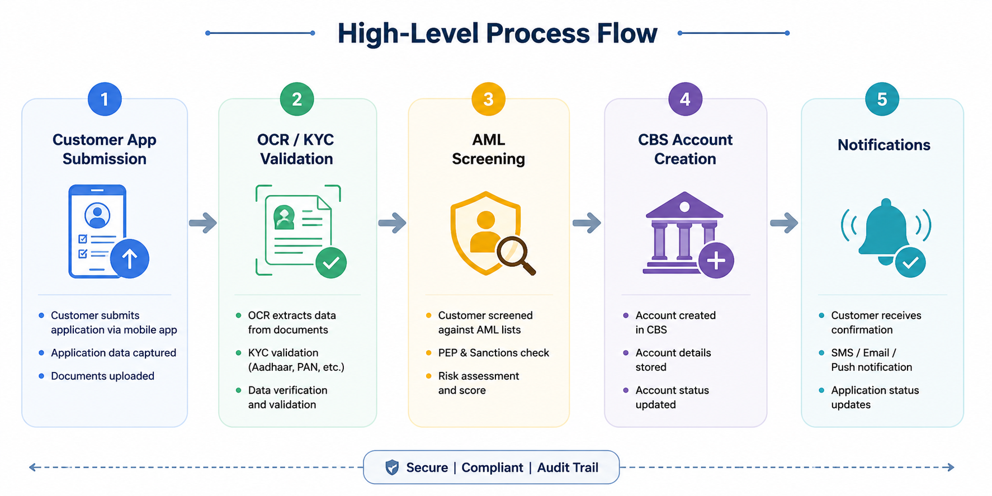
4. High-Level Screening Flow

5. Functional Requirements
FR ID | Requirement | Priority
FR-201 | System shall validate PAN/SSN details using external KYC verification APIs. | High
FR-202 | System shall screen customers against sanctions and PEP watchlists. | High
FR-203 | AML risk score shall be calculated before onboarding approval. | High
FR-204 | Applications with AML risk score above threshold shall move to Manual Review Queue. | High
FR-205 | System shall notify customer if KYC verification fails. | Medium
FR-206 | System shall retry failed KYC/AML API calls up to 2 times. | Medium

6. Business Rules
- Customers found in sanctions list shall be automatically rejected.
- Applications with AML risk score > 80 shall require manual review.
- KYC verification must complete successfully before account creation.
- Customers below 18 years cannot onboard digitally.

7. Exception Handling
Scenario | System Action
KYC API Timeout | Retry API request twice before failure
AML Screening Failure | Move application to Manual Review Queue
Invalid PAN/SSN | Reject onboarding application
Duplicate Customer Match | Trigger Operations Review Workflow

8. Non-Functional Requirements
- KYC API response time should be under 10 seconds.
- All customer data must be encrypted during storage and transmission.
- System availability should be 99.9%.
- AML screening should support real-time processing.

9. Audit & Compliance Requirements
- All KYC and AML actions must be audit logged with timestamps.
- Customer onboarding records should be retained for minimum 7 years.
- Role-based access controls must restrict sensitive customer data access.
- Customer consent capture is mandatory before onboarding submission.

