Functional Requirements Document (FRD)
Notifications & Exception Handling

1. Functional Overview
Objective: Enable customer notifications, onboarding retry workflows, operational exception handling, and escalation management during digital account onboarding.

2. Document Information
Field | Value
Project | Digital Account Opening
Module | Notifications & Exception Handling
Prepared By | Business Analyst Team
Version | 1.0
Status | Draft

3. Key Stakeholders
Stakeholder | Responsibility
Operations Team | Handles onboarding exception cases
Business Analyst | Requirement gathering & FRD preparation
Notification Team | SMS/email integration and notification templates
Compliance Team | Exception review and escalation workflows
Technology Team | Retry logic and queue management implementation

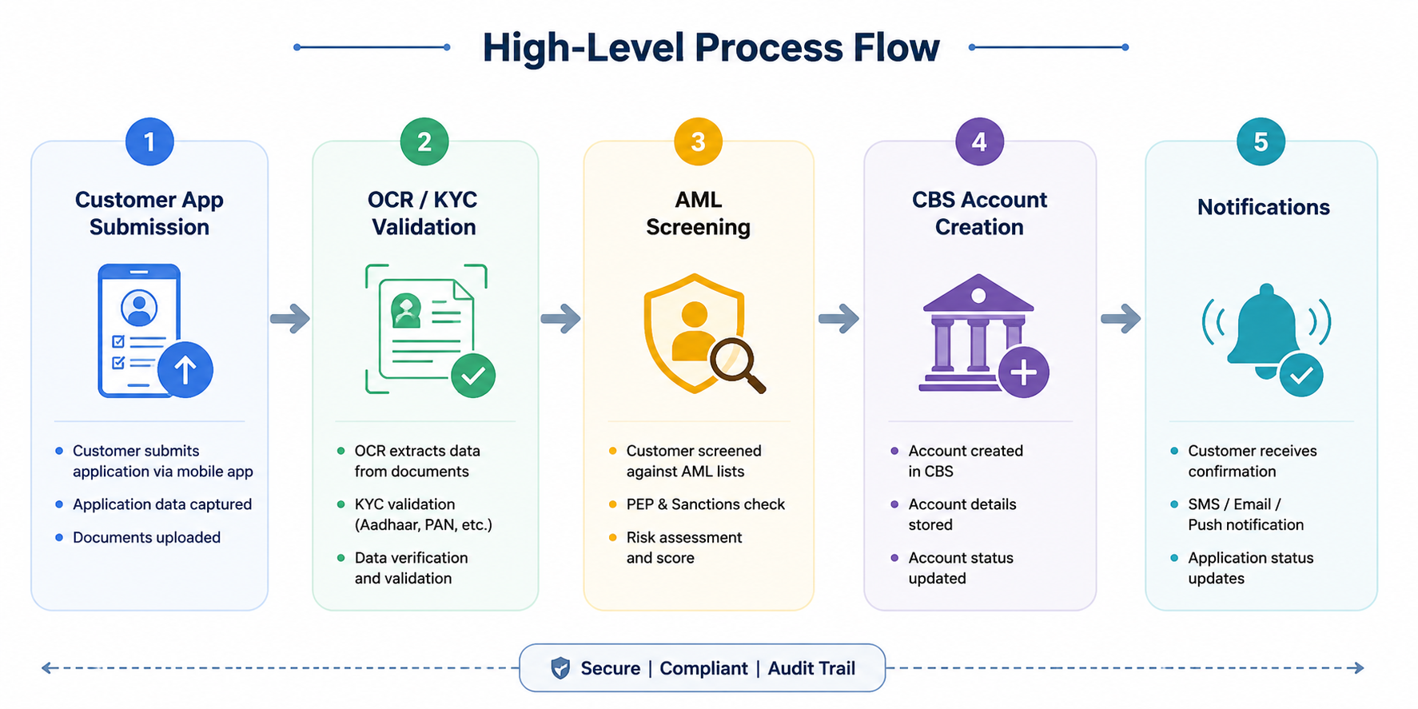
4. High-Level Process Flow

5. Functional Requirements
FR ID | Requirement | Priority
FR-401 | System shall trigger SMS/email notifications after successful onboarding. | High
FR-402 | System shall notify customer for failed KYC, AML, or CBS processing. | High
FR-403 | System shall allow up to 3 document re-upload attempts. | Medium
FR-404 | Failed API requests shall retry automatically up to 2 times. | High
FR-405 | Applications failing after retries shall move to Operations Review Queue. | High
FR-406 | Operations team shall receive exception queue notification within 2 minutes. | Medium
FR-407 | All notification and exception handling activities shall be audit logged. | High

6. Business Rules
- Customers shall receive onboarding notifications through SMS and email.
- Maximum retry attempts allowed for failed API calls shall be 2.
- Applications pending beyond 4 business hours shall escalate automatically.
- Rejected onboarding applications shall include failure reason notifications.

7. Exception Handling Scenarios
Scenario | System Action
KYC Validation Failure | Notify customer and allow document re-upload
CBS API Failure | Retry API request twice before moving to Operations Queue
AML High Risk Match | Move application to Compliance Review Queue
Notification Service Failure | Retry notification delivery automatically

8. Notification Events
- Successful onboarding completion
- KYC validation failure
- Document rejection
- Account creation success
- Manual review initiation

9. Audit Logging & SLA Requirements
- All onboarding exception activities must be audit logged with timestamps.
- Operations team should resolve high-priority cases within 4 business hours.
- Escalation workflow should trigger automatically for SLA breaches.
- Notification delivery status should be tracked and stored.

10. Non-Functional Requirements
- Notification delivery should complete within 30 seconds.
- System should support 100,000 notifications per day.
- All notification data must be encrypted during transmission.
- System availability should be 99.9%.

