User Stories Document
Loan Enhancement (LOS System) – Co-Applicant Support

US-101 - Add Co-Applicant to Loan Application
User Story Description: As a Loan Applicant, I want to add a co-applicant during loan application submission so that the bank can consider our combined financial strength while assessing loan eligibility.
Business Rules
- Maximum 2 co-applicants allowed per loan application.
- Relationship type is mandatory.
- Co-applicant PAN/SSN must be unique within the application.
- Co-applicant must be at least 18 years old.

Acceptance Criteria
- AC-1: System should provide an Add Co-Applicant button on the Loan Application screen.
- AC-2: System should capture Name, DOB, PAN/SSN, Mobile Number, Employment Type, Monthly Income and Relationship Type.
- AC-3: System should validate all mandatory fields before saving the application.
- AC-4: System should prevent duplicate PAN/SSN across applicants.
- AC-5: System should not allow more than 2 co-applicants.

WIREFRAME
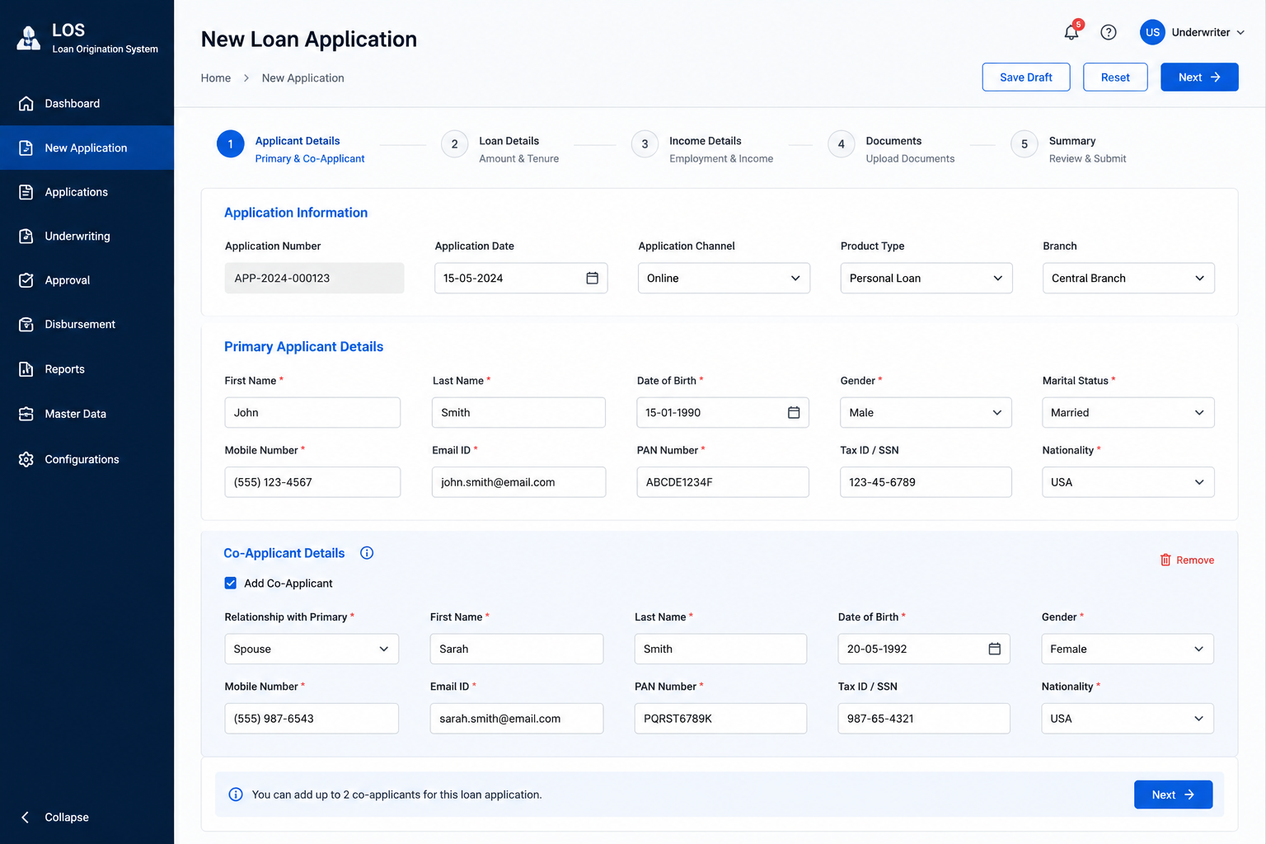

US-102 - Calculate Combined Income & Loan Eligibility

User Story Description: As an Underwriter, I want the system to calculate combined income and DTI ratio so that loan eligibility can be assessed consistently and accurately.

Business Rules
- Combined Income = Sum of income of all applicants.
- Combined EMI = Sum of existing obligations of all applicants.
- Maximum DTI threshold is 40%.
- Eligibility assessment should execute automatically.

Acceptance Criteria
- AC-1: System should automatically calculate combined monthly income.
- AC-2: System should calculate Debt-to-Income (DTI) ratio using combined income and EMI obligations.
- AC-3: System should display eligibility status on the Eligibility Assessment screen.
- AC-4: Applications exceeding DTI threshold (less than 50% and greater than 40%) should move to Manual Review.
- AC-5: Eligibility calculations should refresh automatically whenever income or liabilities are modified.

WIREFRAME
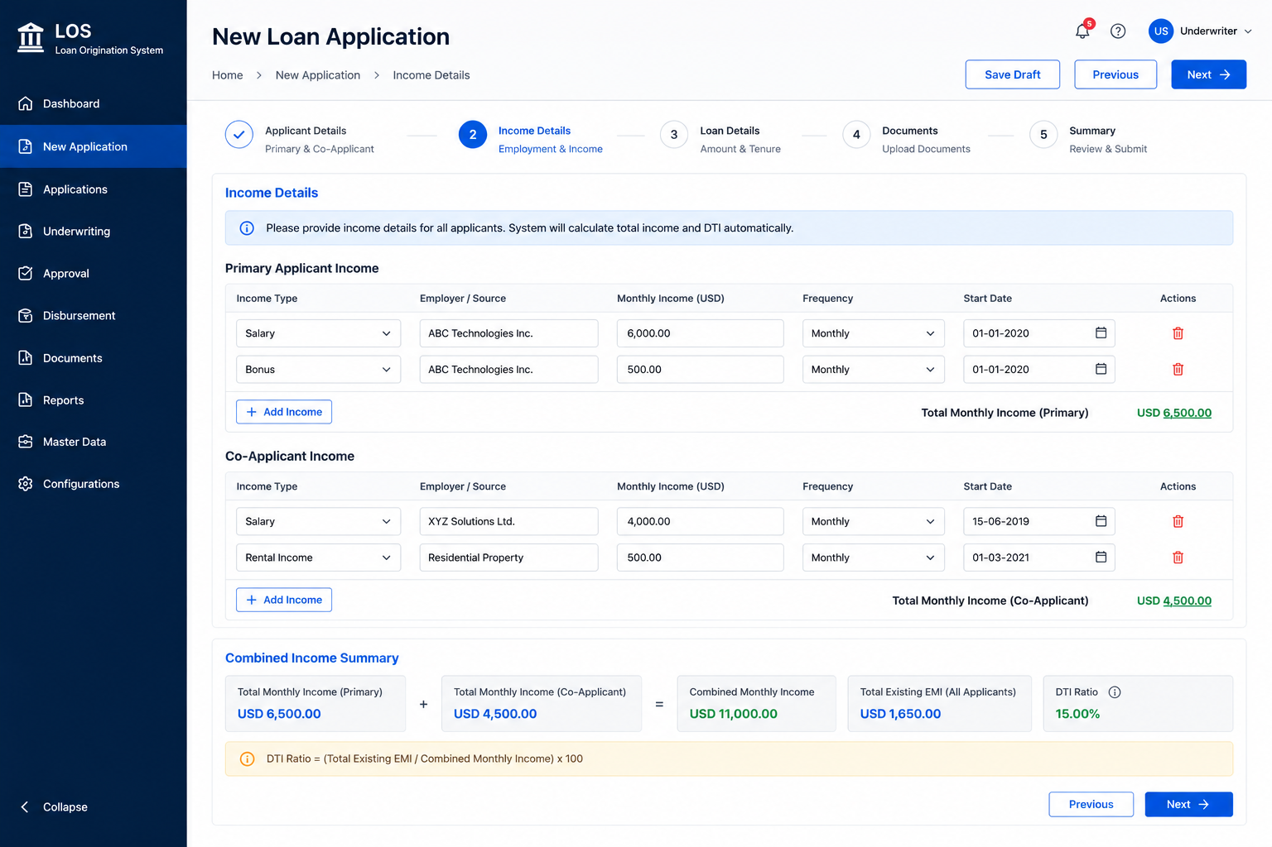

US-103 - Retrieve Credit Bureau Reports for All Applicants

User Story Description: As an Underwriter, I want the system to retrieve bureau reports for all applicants so that creditworthiness can be evaluated without manual intervention.

Business Rules
- Credit bureau checks are mandatory for all applicants.
- Bureau responses must be stored in LOS.
- Failed bureau requests should be retried twice.
- All bureau requests and responses must be audit logged.

Acceptance Criteria
- AC-1: System should initiate separate bureau requests for each applicant.
- AC-2: System should display Credit Score, Existing Loans, Delinquencies and Bureau Status.
- AC-3: Failure of one bureau request should not impact processing of other applicants.
- AC-4: Failed bureau requests should automatically retry up to 2 times.
- AC-5: Applications should move to Exception Queue if bureau requests continue to fail.

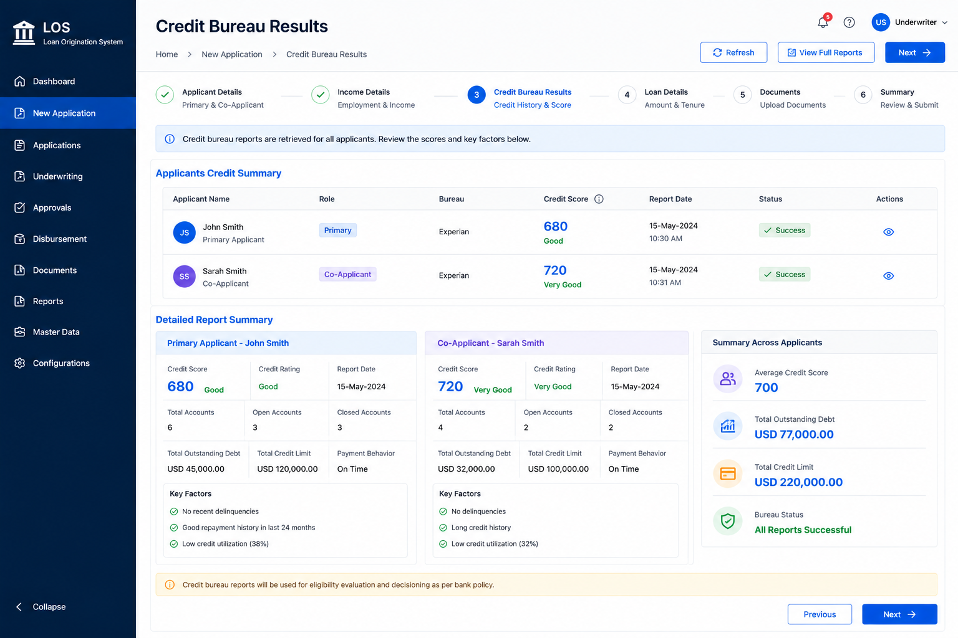
WIREFRAME

US-104 - Review Joint Application and Record Underwriter Decision

User Story Description: As an Underwriter, I want to view consolidated applicant information and eligibility results so that I can approve, reject, or manually review the loan application.

Business Rules
- Underwriter decision is mandatory.
- Rejection comments are mandatory.
- Applications failing AML checks cannot be approved.
- All decisions must be audit logged.

Acceptance Criteria
- AC-1: System should display applicant details, bureau results, eligibility results, AML status and documents on a single review screen.
- AC-2: Underwriter should be able to Approve, Reject or send the application for Manual Review.
- AC-3: Approved applications should move to the next stage of the loan workflow.
- AC-4: Rejected applications should require mandatory comments.
- AC-5: Manual Review cases should be routed to the appropriate review queue.
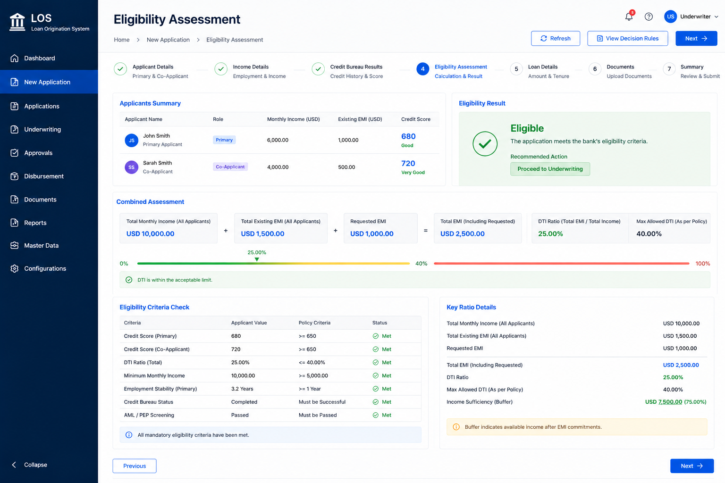
WIREFRAME
