**SCHOOL OF INFORMATION TECHNOLOGY AND ENGINEERING**

**Digital Assignment -1**

**Course Code: ITA6003 Course: MCA**

*19MCA0219*

*Harsh Jain*

**Question:**

*Create your own website using HTML and CSS. The site will contain your personal information. The information can be fictional*

*Website content:*

*• 3 pages -*

*o Home*

*o My Academic - your academic information*

*o Contact Me - your email address, and a contact form*

*• Home page:*

*o A floating header containing the following, as floating elements*

*▪ Your name at the top with h1 heading - floating at left, 40% width*

*▪ A horizontal menu bar floating at right 60% width - Home, Accomplishments, Academic, About Me, Contact Me*

*▪ Set background/other styles so that it stands out and the menu links are clickable when you scroll to other sections*

*o A container - max-width 1200px, center aligned with css, everything below will go inside this container as a section div.*

*o Section 1: height 600px with borders, write your career summary here, place your picture at top right corner as floating element, picture width 200px*

*o Section 2: Add a video with width 1000px (your intro video or any other)*

*o Section 3: your Accomplishments, use unordered list for each of them*

*o Link this accomplishment section to the menu item at top horizontal menu*

*o Section 4: About Me section, link this section to the menu at menu bar*

*o A footer: use the copyright message from assignment 1*

*• My Academic page:*

*o Use the header and footer from the home page*

*o List out your academic information like the academic part from your resume*

*o Adjust the menu links targeting on home page*

*• Contact Me page:*

*o Use the header and footer from the home page*

*o Write your email address*

*o Create a contact form*

*o Adjust the menu links targeting on home page*

Code:-

# **HTML Files**

Main Page

<html>

<head>

    <title>Webpage</title>

    <link href="styleweb.css" rel="stylesheet">

</head>

<body>

    <header>

        <h1>Harsh Jain</h1>

        <ul>

            <li><a href="webpage.html">Home</a></li>

            <li><a href="#about">About me</a></li>

            <li><a href="academic.html">Academic</a></li>

            <li><a href="#accomplishments">Accomplishments</a></li>

            <li><a href="contact.html">Contact Me</a></li>

        </ul>

    </header>

    <section>

        <div id="information">

            <img src="harsh.jpg">

            <h2>About Me</h2>

            <p>The teaching faculty is remarkable, versatile and committed. They are friends, guides and motivating spirits, inspiring hearts, who strive to foster right values and knowledge. Special emphasis is given to the professional growth of staff

                members which keeps them tuned with the latest trends and innovations in the various fields of education. Refresher courses, seminars, workshops are all part of our efforts to make our faculty more than just educators</p>

            <h2>The Teaching Methodology</h2>

            <p>The teaching methodology aims at the holistic growth of the students. The school aims to create an ethos that will encourage children to grow physically in knowledge and most importantly in curiosity, confidence, independence, resilience and

                resourcefulness. It provides an environment where the mind can grow unfettered and free of constraints.</p>

            <h2>Evolution</h2>

            <p>A system of comprehensive and continuous evaluation based on oral and written examination is practiced throughout the year. This has proved to be a very effective and accurate method of evaluation. In the Secondary and Senior Secondary classes,

                evaluation is done as per the C.B.S.E. rules</p>

        </div>

        <div id="video">

            <center>

                <h2>Me doing Skating with Basketball</h2>

            </center>

            <video width="1000" controls>

                <source src="video.mp4" type="video/mp4">

            </video>

        </div>

    </section>

    <div id="accomplishments">

        <h2>Accomplishments</h2>

        <ul>

            <li>Chess National Player</li>

            <li>Skating Gold Medalist</li>

            <li>Java Certified</li>

            <li>Python Certified</li>

            <li>Well known of c#,c,javscript,html,css</li>

            <li>Maths Olympiad Certified</li>

            <li>Have done project of website making in e-commerce of medicine</li>

            <li>Written research paper on machine learning in object detection and block chain research paper on aviation industry</li>

            <li>Worked on Load balancing algorithms</li>

        </ul>

    </div>

    <div id="about">

        <h1>About Me</h1>

        <ul>

            <h2>Personal</h2>

            <li>Punjabi Boy</li>

            <li>Skater by heart</li>

            <li>Chess</li>

        </ul>

        <ul>

            <h2>Professional</h2>

            <li>Coder in java</li>

            <li>Software Developer</li>

            <li>Expert in Python,java,javascript</li>

            <li>Web Designer</li>

        </ul>

    </div>

    <footer>

        <ul>

            <li>Contact us</li>

            <li>Links</li>

            <li>More</li>

        </ul>

        <div id="footerbottom">

            &copy; Webpage | Designed by Harsh

        </div>

    </footer>

</body>

</html>

Academics

<html>

<head>

    <title>Academics</title>

    <link href="styleweb.css" rel="stylesheet">

    <style>

        #main {

            height: 50vh;

            width: 100%;

            border: 1px solid #fff;

        }

        img {

            float: left;

        }

        #table {

            margin: 8px auto;

        }

        #table td {

            font-style: italic;

            font: bold;

            font-size: large;

        }

        table,

        th,

        td {

            border: 1px solid #fff;

            color: #E48E39;

            padding: 5px;

        }

    </style>

</head>

<body>

    <header>

        <h1>Harsh Jain</h1>

        <ul>

            <li><a href="webpage.html">Home</a></li>

            <li><a href="webpage.html#about">About me</a></li>

            <li><a href="academic.html">Academic</a></li>

            <li><a href="webpage.html#accomplishments">Accomplishments</a></li>

            <li><a href="contact.html">Contact Me</a></li>

        </ul>

    </header>

    <div id="main">

        <center>

            <h1>Academic Details</h1>

        </center>

        <table id="table">

            <tr>

                <th>S NO.</th>

                <th>Class</th>

                <th>Board</th>

                <th>School Name</th>

                <th>Marks/CGPA</th>

            </tr>

            <tr>

                <td>1</td>

                <td>HSC</td>

                <td>CBSE</td>

                <td>Greenland Day Boarding</td>

                <td>8.8cgpa</td>

            </tr>

            <tr>

                <td>2</td>

                <td>SSC</td>

                <td>CBSE</td>

                <td>Greenland Day Boarding</td>

                <td>70%</td>

            </tr>

            <tr>

                <td>3</td>

                <td>Graduation</td>

                <td>Punjabi University</td>

                <td>DAV College</td>

                <td>71%</td>

            </tr>

            <tr>

                <td>4</td>

                <td>Post Graduation</td>

                <td>VIT University</td>

                <td>VIT Vellore</td>

                <td>8.0cgpa</td>

            </tr>

        </table>

    </div>

    <footer>

        <ul>

            <li>Contact us</li>

            <li>Links</li>

            <li>More</li>

        </ul>

        <div id="footerbottom">

            &copy; Webpage | Designed by Harsh

        </div>

    </footer>

</body>

</html>

Contact Page

<html>

<head>

    <title>Contact</title>

    <link href="styleweb.css" rel="stylesheet">

    <style>

        h3 {

            color: dodgerblue;

            font-family: Verdana, Geneva, Tahoma, sans-serif;

        }

        input {

            padding: 7px;

            border-radius: 3px;

            margin: 3px;

        }

        .form {

            border-radius: 5px;

            text-align: center;

            padding: 20px;

        }

    </style>

</head>

<body>

    <header>

        <h1>Harsh Jain</h1>

        <ul>

            <li><a href="webpage.html">Home</a></li>

            <li><a href="webpage.html#about">About me</a></li>

            <li><a href="academic.html">Academic</a></li>

            <li><a href="webpage.html#accomplishments">Accomplishments</a></li>

            <li><a href="contact.html">Contact Me</a></li>

        </ul>

    </header>

    <h3>CONTACT US</h3>

    <h3 id="myemail">theharsh@icloud.com</h3>

    <div class="form">

        <form>

            <input type="email" id="email" placeholder="Your Email*"><br>

            <input type="password" id="pass" placeholder="Password*"><br>

            <textarea id="subject" style="height:100px;width:150px;resize: none;" placeholder="Write something..."></textarea><br>

            <input type="submit" value="Submit">

        </form>

    </div>

    <footer>

        <ul>

            <li>Contact us</li>

            <li>Links</li>

            <li>More</li>

        </ul>

        <div id="footerbottom">

            &copy; Webpage | Designed by Harsh

        </div>

    </footer>

</body>

</html>

# CSS FILE

body {

    margin: 0;

    overflow-x: hidden;

    background-image: url(background.jpg);

}

header {

    background-color: #0d0d0d;

    opacity: 0.9;

    padding: 20px 30px;

}

h1 {

    display: inline-block;

    color: #fff;

    width: 40%;

    font-size: 2.6vw;

    font-family: Verdana, Geneva, Tahoma, sans-serif;

}

header ul {

    display: inline-block;

    width: 50%;

    text-align: right;

}

header ul li {

    list-style-type: none;

    display: inline-block;

    font-size: 17px;

    font: bold;

}

header ul li a {

    color: #fff;

    padding: 5px 20px;

    border: 1px solid transparent;

    transition: 0.5s ease;

}

a:hover {

    background-color: #fff;

    color: #000;

    opacity: 0.9;

}

section {

    padding: 20px;

}

#information {

    width: 1200px;

    height: 600px;

    border: 1px solid #fff;

    padding: 10px;

    margin: 5px 5px;

    margin-left: 40px;

}

h2 {

    color: #fff;

}

#information p {

    color: #E48E39;

    font-style: italic;

}

img {

    float: right;

    height: 300px;

    width: 230px;

}

p {

    font-size: 25px;

}

#video {

    padding: 10px;

    text-align: center;

    margin: 10px 10px;

}

#accomplishments {

    border: 1px solid black;

    margin: 10px;

    padding: 5px;

    background-color: #0d0d0d;

    opacity: 0.8;

}

#accomplishments ul li {

    font-size: 20px;

    font-style: italic;

    padding: 5px;

    color: #E48E39;

}

#about {

    width: 80%;

    margin-left: 1%;

    margin-bottom: 1%;

    padding: 10px;

    background-position: center;

    border: 1px solid #fff;

}

#about ul li {

    color: #E48E39;

    font-size: 20px;

    font-style: italic;

    padding: 5px;

}

footer {

    background-color: #303036;

    height: 35vh;

}

footer ul {

    width: 100%;

}

footer ul li {

    color: #fff;

    border: 1px solid white;

    padding: 5px;

    float: left;

}

footer ul {

    display: inline-block;

    width: 50%;

    text-align: right;

}

footer ul li {

    list-style-type: none;

    display: inline-block;

    margin: 0 10px;

}

#footerbottom {

    height: 5vh;

    top: 21vh;

    background-color: #343a40;

    color: #686868;

    text-align: center;

    padding: 5px;

    width: 100%;

    position: relative;

}

OUPUT:

Main Page

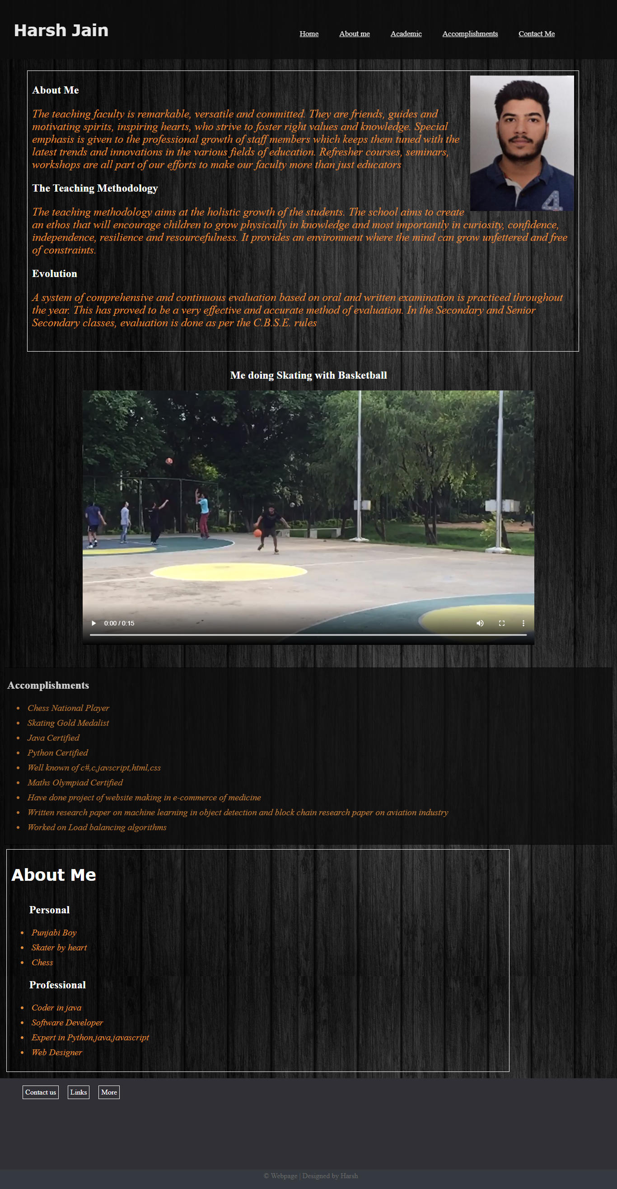

# Academics

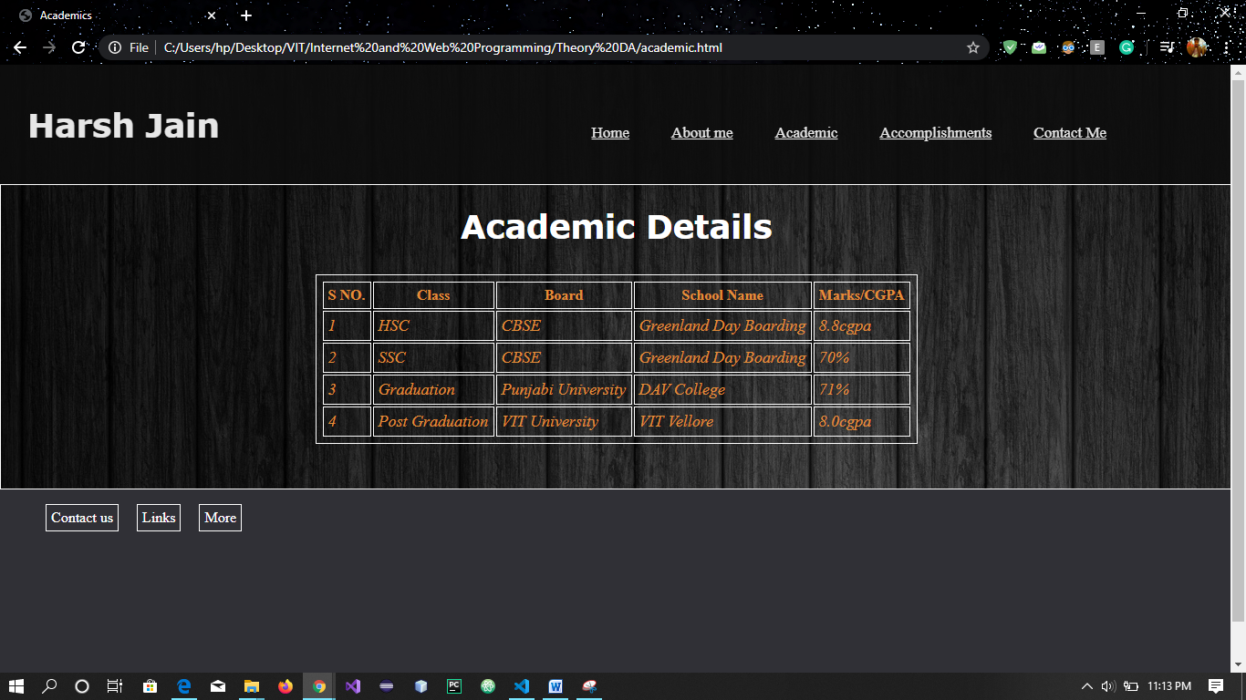

# Contact Page

