

Department of Software Engineering

Software verification & Validation

Lab Task 14

Submitted to: Lecturer Jawaria Ramzan
Submitted by: Hafiz M Faizan
Roll No: Fa-23/BSSE/6D/059

1. Project Overview
This project focuses on software security validation and compliance evidence compilation using OWASP ZAP by Checkmarx. Security scanning was performed on the target web application https://www.hafizmfaizan.site to identify vulnerabilities and organize all findings into a structured compliance dossier suitable for audit review.
The validation process included vulnerability detection, risk analysis, evidence collection, mitigation planning, and compliance documentation.
2. Summary of Security Validation
Security validation was performed using OWASP ZAP by Checkmarx on the target application www.hafizmfaizan.site.
The scan identified multiple medium, low, and informational vulnerabilities related to:
- Content Security Policy configuration
- Cross-domain security configuration
- Clickjacking protection
- Sub Resource Integrity validation
- External JavaScript inclusion
- Missing HTTP security headers
- Information disclosure
- Cache-control directives
The validation process included:
- Passive security scanning
- Vulnerability analysis
- Risk identification
- Security evidence collection
- Compliance documentation
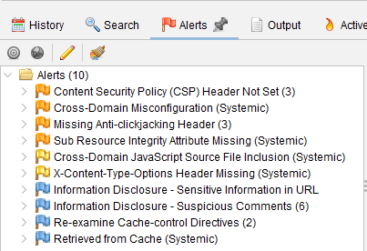
A total of 10 alerts were identified during scanning.

.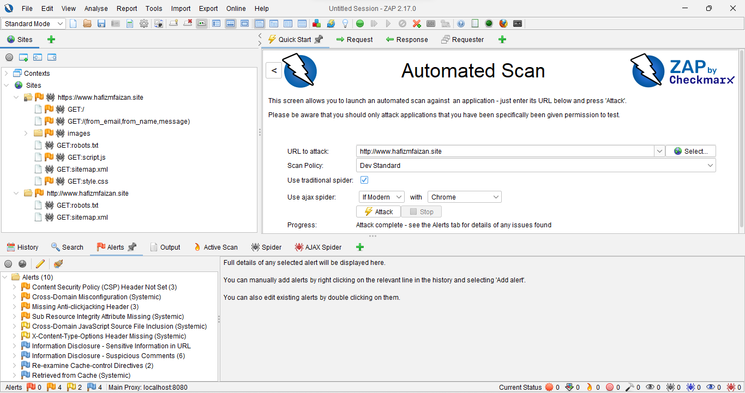
3. Risk Register
Risk ID | Risk Description | Source Evidence | Probability | Impact | Risk Level | Mitigation
VR-01 | Missing CSP header may allow unsafe script execution | ZAP Report | Medium | High | High | Configure CSP headers
VR-02 | Weak cross-domain configuration may expose APIs | OWASP Scan | Medium | High | High | Restrict CORS origins
VR-03 | Missing anti-clickjacking header may allow UI redressing attacks | Passive Scan | Medium | Medium | Moderate | Add X-Frame-Options
VR-04 | Missing Sub Resource Integrity may allow tampered external scripts | Validation Report | Medium | High | High | Implement SRI attributes
VR-05 | External JavaScript inclusion may expose third-party risks | ZAP Alert | Low | Medium | Low | Validate trusted script sources
VR-06 | Missing X-Content-Type-Options header | Security Scan | Low | Medium | Low | Configure MIME protection
VR-07 | Sensitive information exposed in URL parameters | Passive Scanner | Medium | High | High | Avoid sensitive GET parameters
VR-08 | Suspicious comments may expose internal implementation details | Validation Log | Low | Medium | Low | Remove unnecessary comments
VR-09 | Weak cache directives may expose sensitive content | ZAP Passive Scan | Low | Medium | Low | Configure secure cache policies

4. Evidence Summary
The following validation evidence was collected during the security assessment process:
- OWASP ZAP security scan report
- Vulnerability screenshots
- Alert summary evidence
- Structured validation risk register
- Security configuration findings
- Information disclosure observations
- Compliance documentation
- Validation logs and mitigation planning
All validation evidence was organized into a structured compliance dossier suitable for audit review and verification activities.
5. Mitigation Actions
Vulnerability | Mitigation Action
CSP Header Missing | Configure Content-Security-Policy header
Cross-Domain Misconfiguration | Restrict CORS origins
Missing Anti-clickjacking Header | Add X-Frame-Options
Missing Sub Resource Integrity | Implement integrity attributes
Cross-Domain JavaScript Inclusion | Validate external JS sources
X-Content-Type-Options Missing | Configure MIME protection
Sensitive Information in URL | Avoid sensitive URL parameters
Suspicious Comments | Remove unnecessary comments
Cache-Control Weakness | Configure secure cache directives

6. Conclusion
The software security validation process successfully identified multiple vulnerabilities within the target web application. All identified findings were analyzed and structured into a formal validation risk register with corresponding mitigation recommendations.
The generated compliance dossier provides organized audit evidence suitable for software verification, validation, and compliance review activities. The project demonstrates proper validation risk structuring, evidence compilation, and professional security documentation practices.
7. GITHUB Repo Link
https://github.com/thehmfpk/Validation-Risk-Compliance-Week14.git

