# Steph Curry is a Black Swan

What do the rise of the Internet, the terrorist attacks of September 11, Christmas dinner turkeys and Stephen Curry have in common? They are all Black Swans. Nassim Nicholas Taleb uses the historic discovery of a black swan, an animal thought to be an impossibility and antithetic to the angelic white swan, to help describe rare and unpredictable events. Events, so extreme in their impact, that we are forced to consider a false or misleading narrative to explain their occurrence.

In a pre-draft analysis of Stephen Curry, NBA scout Jonathan Givony said, "In the right situation, alongside the right teammates, he could be a very effective NBA player, and his excellent intangibles and winning mentality lead you to believe that he’ll find a way to carve out a successful niche." This lukewarm pre-draft assessment was glowing compared to former ESPN analyst Doug Gottlieb, who tweeted "he doesn’t have the upside of Rubio, Jennings, Flynn, Mills, Teague all more athletic." In contrast, Lebron James signed a $90 million deal with NIKE *before he graduated high school.* James’ career has justified this investment but when Magic Johnson says Curry "has a chance to be the greatest player we've ever seen” it makes Curry’s earthquake of a career seem out of place. How did this happen, and what, exactly, has happened?

In October 2014 the oddsmakers gave Stephen Curry 28/1 odds, or a 3.45% chance, to be the NBA's Most Valuable Player. The Warriors themselves had 20/1 odds winning the NBA title and the Westgate Las Vegas Superbook put the over/under on wins at 50.5. Consider that at the time of writing, the aggregate of prediction markets give Paul Ryan (R-WI) a 4% chance of being the Republican Presidential Nominee, and he is not even running.

Last year Curry won the MVP, collecting 100 of 130 first-place votes and the Warriors won the NBA title amassing 67 regular season wins, 4th best of all time. This season, Curry will win his second MVP, the team is at the footsteps of the greatest regular season of all time, and they are favorites to win the championship. There is even talk of Curry getting the leagues [most improved player](http://bleacherreport.com/articles/2594756-making-the-case-for-stephen-curry-as-nbas-most-improved-player) award. His usage rate is up 12%, his scoring average is up 6.2 points per game while his minutes and turnovers are about the same. Most impressively he is doing all this while being the most efficient shooter of all time.

The figure below compares a player's Player Efficiency Rating (PER), an overall measure of their quality of play, and their True Shooting Percentage (TS%), a statistic that is a weighted measure of free throws, two-point field goals and three-point field goals. This dataset begins with the 1979-1980 season and considers high volume shooters, players that average at least 20 shot attempts per game and players with a PER of at least 23. Essentially, this dataset consists of approximately the 10 “best” players each year from the last 36 years. Curry is all by himself with the best combination of PER and TS% during this span. The probability of him leading the league in both categories, which is what he is doing, is virtually zero. A conservative probabilistic estimate shows this occurs about once every 150 years.

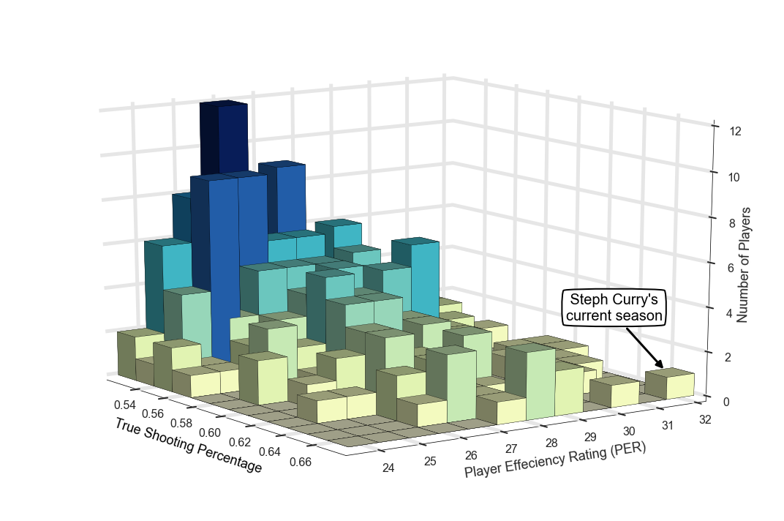

The surprise isn’t that someone is this great, necessarily, it’s how it’s being done and who is doing it. Consider the absurdity of Curry's three-point shooting. He is on pace to make 404 3-pt makes this season, breaking the previous record, his own, of 286. This 41% increase, if applied to baseball's single season home-run record, would increase the record from 73 to 103. Curry's long range shooting is, in the literal meaning of the word, unbelievable. From 28 - 48 feet Curry is making 54% of his shots while the rest of the league averages 12%. His TS% from this range is 81% meaning he is better from this range than someone making 81% of their two point shots.

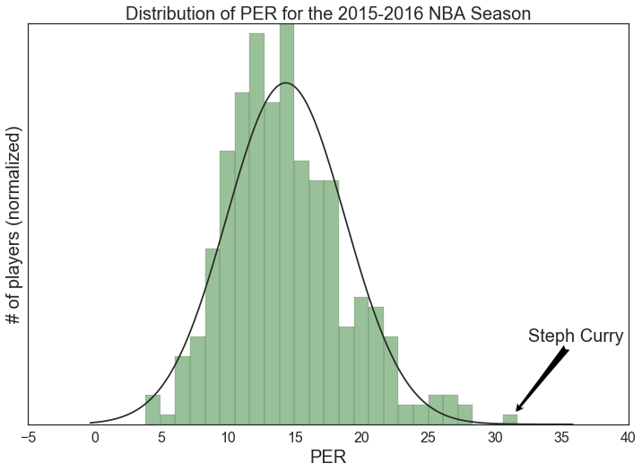

With such great success Curry, and the Warriors, are having an extreme impact on the game of basketball. Most notably, their "small ball" lineup, or "death ball" squad, which features 4 guards and a 6-6 center, has transformed the NBA. Much in the same way the Jordan rules turned the NBA into an MMA fight, the small ball lineup is changing the NBA into a track meet. There is even talk of rule changes — Dallas Mavericks owner Mark Cuban’s has argued to move the three-point line back saying “guys are shooting so far back anyways.” It’s not clear who these “guys” are outside of Stephen Curry. Even with these stats people are still skeptical.

The Warriors own GM considered Curry a “[gamble](http://nba.nbcsports.com/2012/10/31/warriors-gm-explains-teams-reasoning-behind-stephen-currys-contract-extension/)” in October 2012, when he signed Curry to a 4-year $44-million extension. [Nike’s recruiting team](http://espn.go.com/nba/story/_/id/15047018/how-nike-lost-stephen-curry-armour) didn't think Curry was important enough to resign that their recruiting slideshow included slides from their pitch to Kevin Durant. Basketball legend [Oscar Robertson](http://bleacherreport.com/articles/2619777-oscar-robertson-comments-on-stephen-curry-modern-nba-game) thinks today’s coaches “don't know anything about defenses” and insinuates Curry would be ineffective otherwise. Scottie Pippen thinks his Bulls teams of the 90’s would [sweep the Warriors](http://espn.go.com/nba/story/_/id/15123546/scottie-pippen-predicts-1995-96-chicago-bulls-sweep-golden-state-warriors) . Doc Rivers, The Los Angeles Clipper’s coach, famously said the Warriors won the championship due to [luck](http://www.si.com/nba/2015/10/19/los-angeles-clippers-doc-rivers-golden-state-warriors-luck-comment). These people are rationalizing what they can’t understand: how a 6’2’’, 185 pound, soft-spoken, baby-faced player from a mid-major school could revolutionize a sport.

The leading explanation is that Curry’s game “[isn’t new](http://www.sportingnews.com/nba-news/4689130-mark-jackson-stephen-curry-ruining-basketball-warriors-cavaliers)”, he’s more of a child prodigy and has perfected his craft. Indeed, in the Atlantic, Robert O’Connell wrote that Curry and the Warriors “solved” the game of basketball using analytics and contrasts the Warriors to the Spurs; the Spurs playing the role of Rocky Balboa and the Warriors as Ivan Drago, using science and technology to gain an inhuman advantage while the Spurs succeed with grit and heart.

The Spurs, contrary to their reputation as an old-school team, love analytics and have gone so far as to [use a device](http://www.catapultsports.com/media/select-nba-teams-will-use-scientific-devices-to-track-player-movement/), called OptimEye, to monitor their player’s nutrition and vitals during practice. This puzzle-solving argument implicitly claims other players could do it too if they just would look at the analytics. James Harden and the Rockets would disagree; The Rockets are the league’s biggest pusher of analytics and they are out of the playoffs this year.

Stephen Curry is a Black Swan. Curry’s effectiveness and his style of play along with the domination of the league by his team were unpredictable. The impact has been seismic and it has forced people to engage in a false narrative that Curry is an on-court statistician that can shoot.

The Warriors are causing a sea change. Marc Jackson, Curry’s former coach, said “I go into high school gyms, I watch these kids, and the first thing they do is run to the 3-point line.” Like all the other Black Swan’s the waves from Stephen Curry’s arrival travel far. The days of trying to be like Mike are gone. They want to splash like Steph.