Tōshirō Hitsugaya

*Captain of the 10th division*

**Race**: *Human Soul* **Alignment**: *Neutral Good* **Class**: *Shinigami Swordsman*

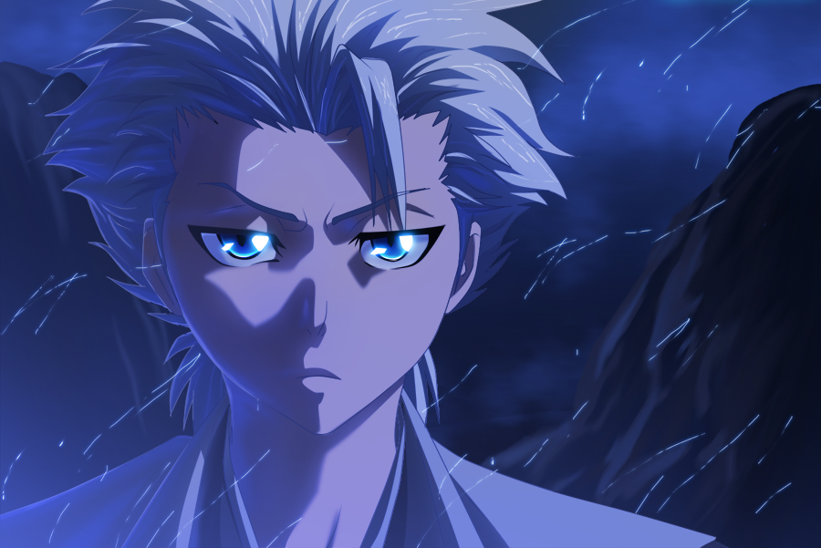

**Normal mode:**

**Abilities:**

1. ***Bakudō #63. Saju Sabaku***  
   **Active**: Toshiro renders his target rooted unable to use melee attacks this and next turn while dealing 15 ranged damage. If attack is prevented this turn, target is free in the next turn.  
   **Keywords**: Attack, Ranged, Debuff.
2. ***Shunpo***  
   **Active**: Toshiro evades one attack this turn.  
   **Keywords**: Shield.
3. ***Hadō #31. Shakkahō***  
   **Active**: Deals 25 ranged damage to a target.  
   **Keywords**: Attack, Ranged.
4. ***Cut*Active**: Deals 25 melee damage to a target.  
   **Keywords**: Attack, Melee.
5. ***Child prodigy***  
   **Passive**: First damage Hytsugaya receives is halved because nobody expects him to be strong.
6. ***Sit Upon the Frozen Heavens***  
   **Passive**: Locked until Toshiro or one of his allies is damaged.  
   **Active**: Toshiro releases his zanpakutō and enters Hyōrinmaru mode. Toshiro can use another shikai ability this turn.  
   **Keywords**: Relativistic, Haste.

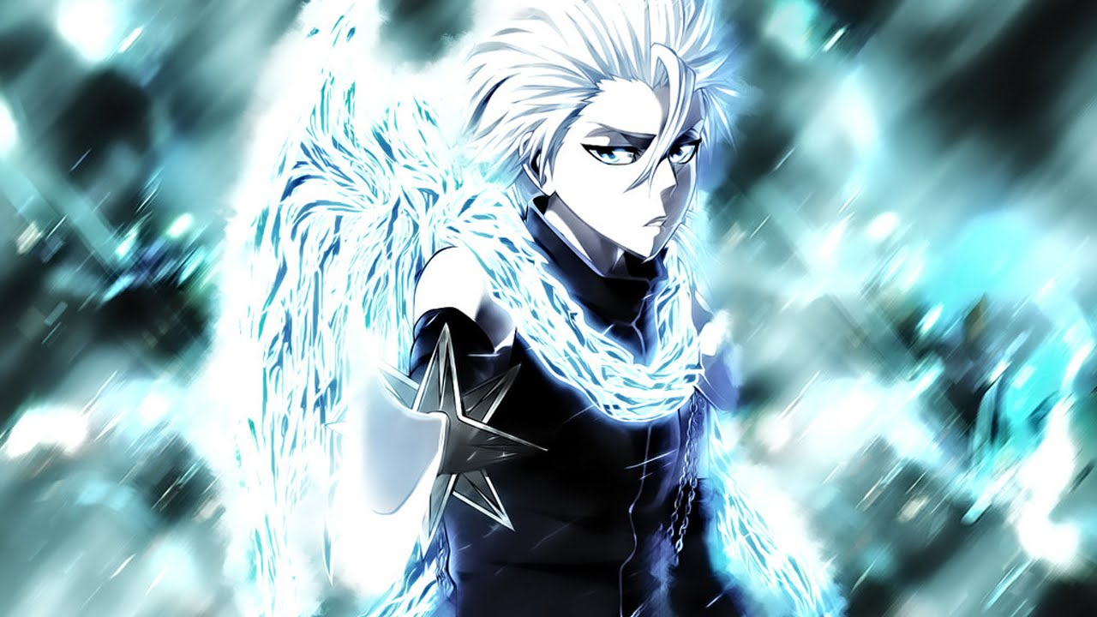

**Shikai: Hyōrinmaru mode:**

While in his shikai, Toshiro can control weather. At the start of each round, he can decide what weather will be during that round. If Toshiro enters shikai in the middle of the round, he cannot state weather until the start of the next round.

**Weather:**

1. ***Ice rain*** – At the end of this round, Toshiro enters bankai.
2. ***Rain*** – Toshiro’s attack gain hits first.
3. ***Fog*** – Ranged attacks deal half the damage.
4. ***Snow*** – Toshiro’s defensive abilities gain hits first.

**Abilities:**

1. ***Ice Dragon***   
   **Active**: Toshiro deals 35 melee damage to a target. This attack can hit flying units.  
   **Keywords**: Attack, Melee.
2. ***Ryōjin Hyōheki***  
   **Active**: Toshiro creates a wall that protects him or his ally this turn. Wall can protect from 60 dmg.   
   **Keywords**: Shield.
3. ***Rokui Hyōketsujin***  
   **Active**: First enemy that attacks Toshiro this turn is stunned.  
   **Keywords**: Trap, Relativistic.
4. ***Moon on the chain***   
   **Passive**: Every time enemy attacks Toshiro (even if its blocked with anything except “*Rokui Hyōketsujin*”), Toshiro rolls d6, if he gets 5 or 6 (4, 5 or 6 if on activation), that target cannot block Toshiro’s attacks in the next turn.   
   **Active**: Toshiro deals 20 melee damage and applies this abilities passive on a target,   
   **Keywords**: Attack, Melee,
5. ***Shinkū Tasō Hyōheki / Shinkū no Kōri no Yaiba***  
   **Odd number use**: ***Shinkū Tasō Hyōheki***  
   **Active**: Toshiro buffs himself with 3 stacks of Ice wall. Stack can be used to reduce incoming damage by 15 at any time.  
   **Keywords**: Buff.  
     
   **Even number use**: ***Shinkū no Kōri no Yaiba***  
   **Active**: Toshiro deals 10 + 12 ranged damage per ice wall stack that is active on Toshiro. Toshiro loses all ice wall stacks.   
   **Keywords**: Attack, Ranged.
6. ***Bakudō #63. Saju Sabaku*Active**: Toshiro renders his target rooted unable to use melee attacks this and next turn while dealing 15 ranged damage. If attack is prevented this turn, target is free in the next turn.  
   **Keywords**: Attack, Ranged, Debuff.

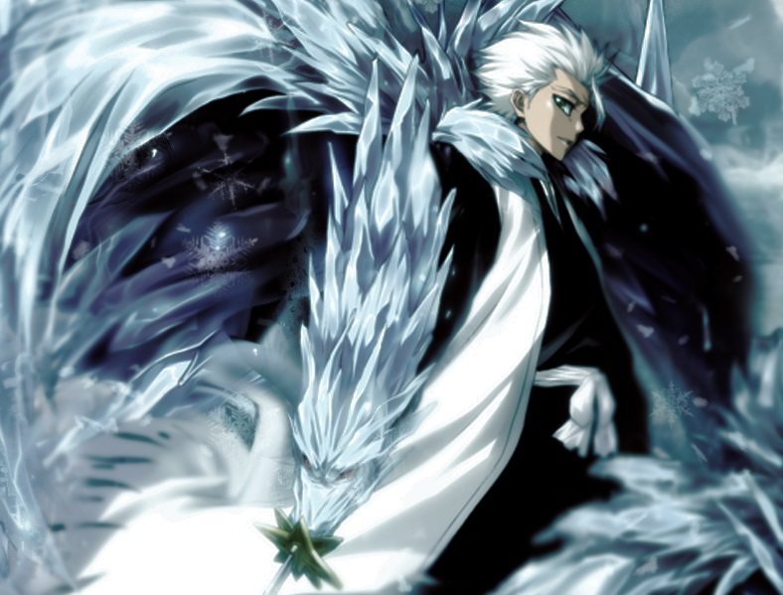

**Bankai: Daiguren Hyōrinmaru mode:**

In bankai, Toshiro still has shikai weather manipulation. Toshiro gains one Ice pillar stack.

**Weather:**

1. **Ice rain** – After two rounds of Ice rain, Toshiro enters Bankai: Completed Daiguren Hyōrinmaru mode (this mode adds two more abilities to his bankai mode). At the end of a round with this weather, Toshiro gains Ice pillar stack.
2. **Rain** – Toshiro’s attack gain hits first.
3. **Fog** – Ranged attacks deal half the damage.
4. **Snow** – Toshiro’s defensive abilities gain hits first.

**Abilities:**

1. ***Zanhyō Ningyō***  
   **Active**: Toshiro makes a clone of himself. Clones have one half of Toshiro’s current HP. Each time Toshiro is attack, a clone defends him if he rolls 4, 5 or 6 on d6. At the end of a round, each clone uses one other random normal bankai ability.  
   **Keywords**: Spawn.
2. ***Shield of Ice Wings***  
   **Active**: Toshiro blocks all attacks this turn. If 0 or 1 attack is blocked, Toshiro gains hits first on his next turn.  
   **Keywords**: Shield.
3. ***Ryūsenka***  
   **Active**: Toshiro deals 35 melee damage and applies frost mark on his target. If target is an enemy that already has frost mark on himself, that mark is consumed and he is stunned this turn in addition to the damage.  
   **Keywords**: Attack, Melee, Stun.
4. ***Sennen Hyōrō***  
   **Passive**: Whenever one round passes and whenever Toshiro skips a turn, he gains stack of ice pillar. Multiple uses of this ability increase its cost, so, the first use of the ability can be used with only 1 ice pillar stack, the second use of the ability can be used with at least 2 ice pillar stacks and so on…  
   **Active**: Toshiro consumes Ice pillar stacks to trap a target in a prison that has 30 + 30 per stack HP. While prison is alive, prisoner cannot attack anyone else except prison. AoE attacks made by prisoner deal double damage to the prison. AoE attacks made by Toshiro’s allies deal normal damage to the prison. Prisoner’s allies can target prison with their attacks. Prisoner’s allies’ AoE attacks cannot damage Prison. Prison decays from turn to turn losing 10 HP after first turn passes, 20 HP after second turn passes and so on… All Ice pillar stacks are consumed.  
   **Keywords**: Spawn.
5. ***Guncho Tsurara***  
   **Active**: Toshiro deals 3 times 15 ranged damage to a target.  
   **Keywords**: Attack, Ranged.
6. ***Hyōryū Senbi***  
   **Active**: Toshiro deals 25 ranged damage to all enemies.  
   **Keywords**: Attack, Ranged, AoE.
7. ***Hyōten Hyakkasō*** *(Ultimate)*  
   **Passive**: Can be used after using 5 -> 3(stun) -> 4 on the same target.  
   **Active**: Toshiro stuns the victim of his other abilities for 3 turns starting this turn. At the end of each turn, target rolls d6, if he gets 1, he is insta-killed.

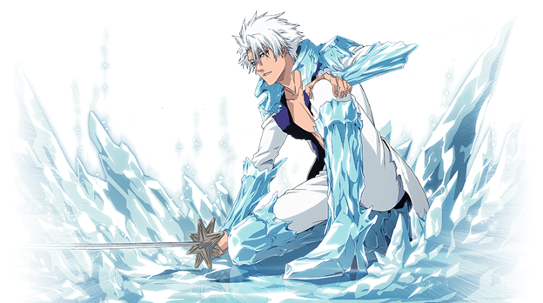

**Bankai: Completed Daiguren Hyōrinmaru mode:**

**Bonus Abilities:**

1. ***Flash-Freeze***   
   **Passive**: Dealing damage to Toshiro stuns in the next turn.  
   **Active**: Stun target this and next turn. If Ice rain is active, this ability has hits first.  
   **Keywords**: Stun.
2. ***Shikai Hyōketsu*** *(Ultimate)*  
   **Passive**: To use this ability, Toshiro must have used 7->8->3 in last round.  
   **Active**: Toshiro freezes everything in this combat for next 3 turns. He can use another ability this turn. (Allies are frozen as well.)  
   **Keywords**: AoE, Stun, Haste.

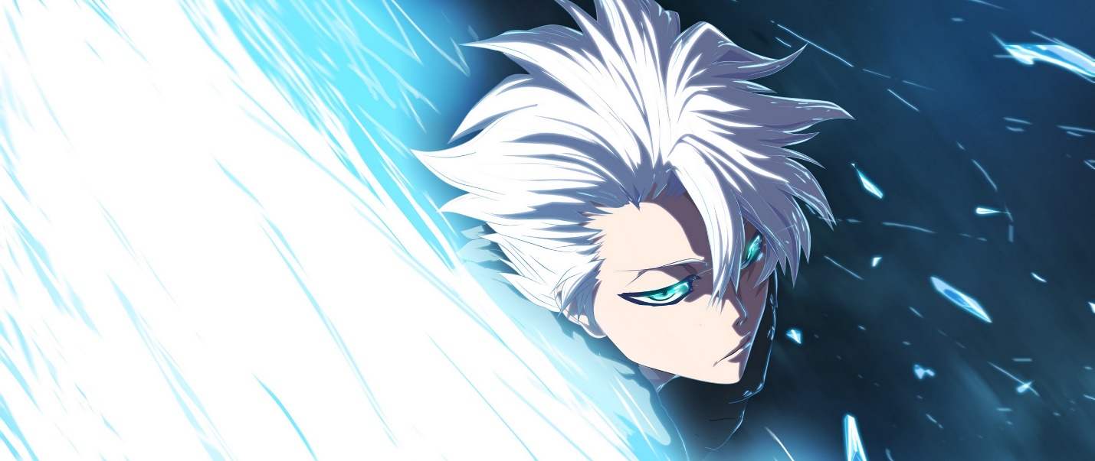

**Creator**: Bogdan Lukovic 30.8.2018.

Version 1.0: 30.8.2018.

Version 2.0: 30.8.2018.

***Shinkū no Kōri no Yaiba*** damage per stack reduced from 20 to 12.

***Moon on the chain*** passive rolls reduced from 4, 5 and 6 to 5 and 6.

***Rokui Hyōketsujin*** removed damage, it’s now *relativistic.*