Kisuke Urahara

*Captain of the 12th division*

**Race**: *Human Soul* **Alignment**: *Chaotic Good* **Class**: *Shinigami Swordsman*

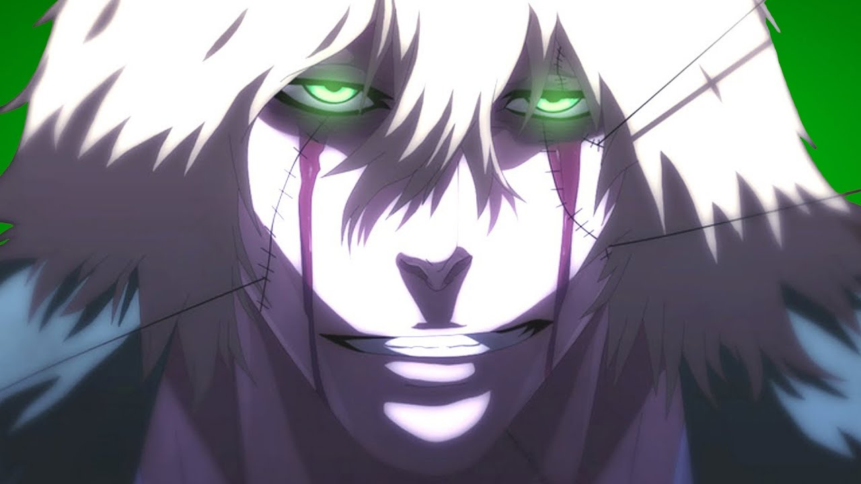

Normal mode:

Abilities:

1. ***Kisuke’s Invention***  
   **Passive**: At the start of the game, a player can choose which ability to slot in instead of this. The list is below main abilities.
2. ***Hado #91: Senju Koten Taiho***  
   **Active**: Kisuke sends 9 points of energy at targets of his choice. The damage of each point is equal to 1+ the number of points that already hit the target this turn (n*(n+1) where n is the number of points that hit the target).  
   **Keywords**: Attack, Split, Ranged.
3. ***Bakudo #99: Kin***  
   **Active**: Deal 12 damage to the target and makes the target unable to use defensive abilities for next 2 turns.   
   **Keywords**: Attack, Melee.
4. ***Benihime***:  
   a) ***Nake***  
   **Active**: Deal 25 damage to the target and 15 to all other enemies. Ranged. (Cannot be used without a target)  
   **Keywords**: Attack, Ranged, Aoe.  
     
   b) ***Kamisori***  
   **Active**: Deal 36 damage to the target. Hits first. Melee.  
   **Keywords**: Attack, Melee, Hits first.
5. ***Chikasumi no Tate***  
   **Active**: Kisuke makes a shield that blocks 50 damage this turn.
6. ***Shibari Benihime***  
   **Active**: Throws a net that prevents melee attack or dodge/evade this turn (any movement ability) and explodes dealing 20 unblockable damage if the target attempts a melee attack or dodge/evade in the next turn.  
   **Keywords**: Effect, Immobilize.
7. ***Kannonbiraki Benihime Aratame*** (*Ultimate*)  
   **Requirement**: 5-6-4b  
   **Active**: Each turn, before any action, Kisuke can split 40 points of true healing or true damage to any character in game. (For example, he can heal one of his allies for 15 and deal 15 damage to one enemy and 10 damage to another enemy) (max 20 damage or healing per target).  
   **Keywords**: Effect.

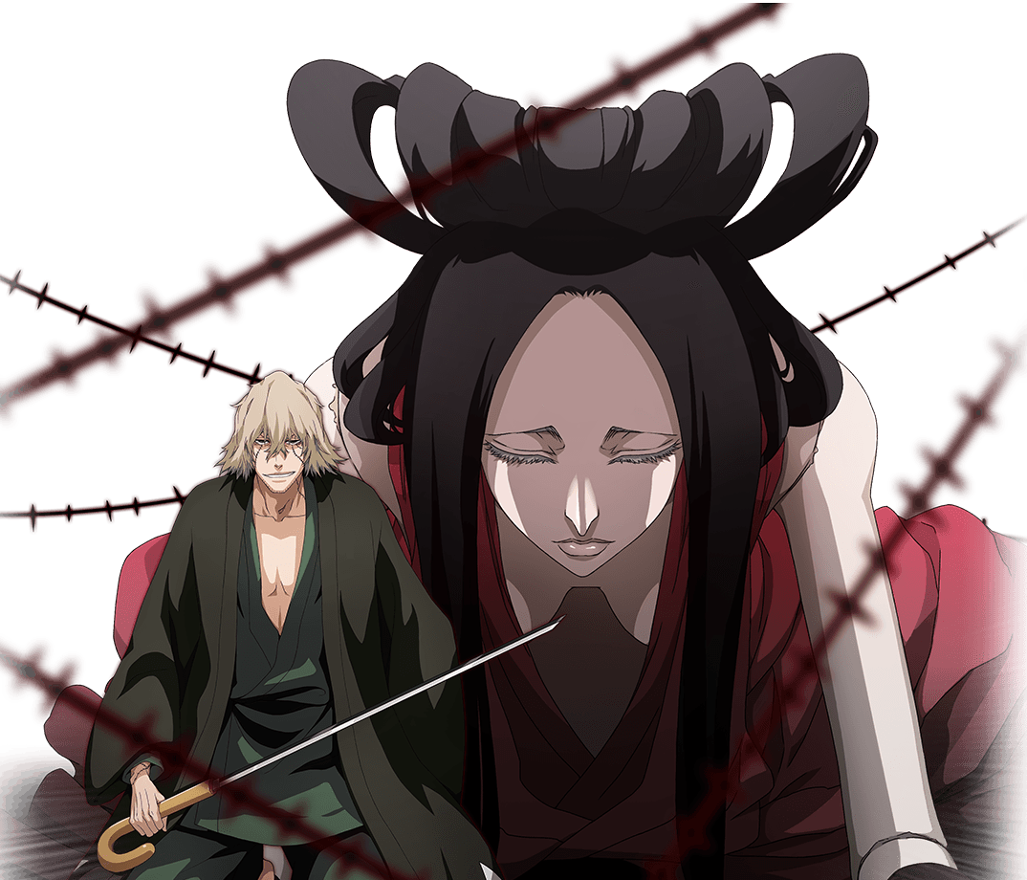

Kisuke’s Inventions:

2.1) **Portable Gigai**: ***Passive***: At the start of the combat, instead of Kisuke himself, gigai takes his place on the battlefield. When gigai is damaged, it disappears and Kisuke is back on the battlefield again.

2.2) **Reiatsu - Concealing Cloak**: ***Active***: Becomes invisible for this and the next turn. Attacking breaks the invisibility.The target is stunned in the next turn. Exhaust.  
  
2.3) **Tenkai Kecchu**: ***Active***: Can be swapped for another invention at any time. The invention is only available starting next round though. The target is stunned in the next turn.  
  
2.4) **Transformation Watch**: ***Passive***: Does nothing. Use to BM your enemy. The target is stunned in the next turn.  
  
2.5) **Beam Watch**: ***Active***: Deals 40 damage. Hits last. Exhaust. The target is stunned in the next turn.  
  
2.6) **Anti-Hierro armor**: ***Passive***: Gains +5/+5.