Rukia Kuchiki

*Captain of the 13th division*

**Race**: *Human Soul* **Alignment**: *Chaotic Good* **Class**: *Shinigami Swordsman*

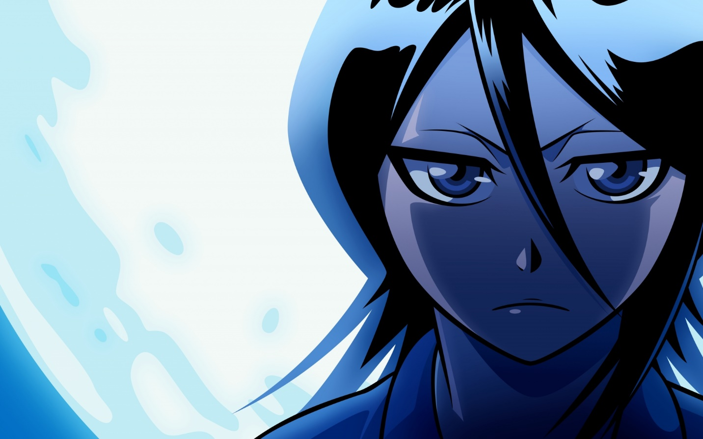

**Normal mode**:

**Abilities**:

1. ***Expert Swordsman***  
   **Active**: Deal 25 melee damage.  
   **Keywords**: Attack, Melee.
2. ***Shunpo Expert***  
   **Active**: Dodge one attack.  
   **Keywords**: Shield.
3. ***Ōken Clothing***  
   **Active**: All damage received this turn is reduced by half.  
   **Keywords**: Shield.
4. ***Hado Expert***  
   **Option** **1**: ***Hadō #4. Byakurai***  
   **Active**: Deal 10 ranged damage. Another ability may be used. If another ability is used, it will always hit last.  
   **Keywords**: Attack, Ranged, Haste.  
     
   **Option 2**: ***Hadō #31. Shakkahō***  
   **Active**: Deal 25 ranged damage.   
   **Keywords**: Attack, Ranged.  
     
   **Option 3**: ***Hadō #33. Sōkatsui***  
   **Active**: Deal 15 raged damage to two targets.  
   **Keywords**: Attack, Ranged.  
     
   **Option 4**: ***Hadō #73. Sōren Sōkatsui***  
   **Active**: Deal 25 ranged damage to two targets.  
   **Keywords**: Attack, Ranged, Exhaust.
5. ***Bakudo Expert***  
   **Option 1**: ***Bakudō # 1. Sai***  
   **Active**: If used on one target, it deals 5 damage and cancels targets attack this turn. If used as AoE, every victim must roll 4, 5 or 6 on d6 to be able to attack this turn.  
   **Keywords**: Attack, Attack cancel.  
     
   **Option 2**: ***Bakudō #4. Hainawa***  
   **Active**: Target cannot use defensive abilities this turn.  
   **Keywords**: Defenses cancel.  
     
   **Option 3**: ***Bakudō #9. Geki*Active**: Target must roll 4, 5 or 6 on d6 to be able to use abilities this turn.  
   **Keywords**: Cancel.  
     
   **Option 4**: ***Bakudō #61. Rikujōkōrō***  
   **Active**: Target is stunned this turn. Can be used only once.  
   **Keywords**: Hits first, Exhaust, Stun.
6. ***Dance: Sode no Shirayuki***  
   **Passive**: Locked until one bakudo and one kido abilities are used.   
   **Active**: Rukia enters her shikai mode. Rukia may use another ability in shikai mode.  
   **Keywords**: Transformation, Haste.

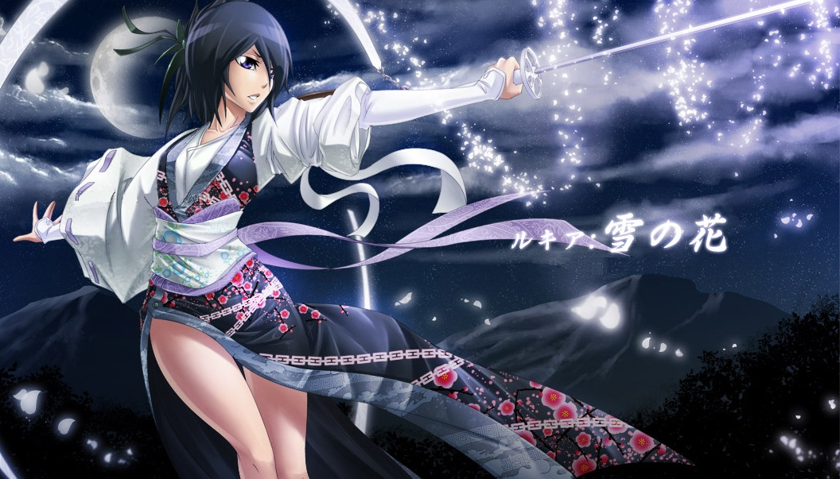

**Shikai: Sode no Shirayuki mode**:

Rukia cannot be disarmed in this mode. Rukia can fill Hado/Bakudo ability slot with one Hado/Bakudo ability she already used in her normal mode.

**Abilities**:

1. ***Absolute Zero***  
   **Active**: For this and next 2 turns, Rukia’s melee attacks hit before defensive abilities of the attacked target. Rukia is damaged for 15 at the end of every turn.  
   **Keywords**: Buff.
2. ***Cryostasis***  
   **Passive**: Can be used only when Absolute Zero is active.  
   **Active**: Rukia freezes herself this turn and is unable to take any damage (including Absolute Zero damage per turn).   
   **Keywords**: Shield.
3. ***Some no mai, Tsukishiro***  
   **Active**: Deal 25 melee damage to the target. If 5 or 6 is rolled on d6, the target is stunned. This ability can hit flying units if they are not attacking.  
   **Keywords**: Attack, Melee, Stun.
4. ***Tsugi no mai, Hakuren***  
   **Active**: Characters who attack Rukia this turn are frozen this turn and receive 10 damage at the start of the next turn.  
   **Keywords**: Counter.
5. ***San no mai, Shirafune***  
   **Active**: Rukia deals 15 damage a target and gains buff that gives her 15 bonus damage on attacks for next 3 turns or 2 uses.   
   **Keywords**: Attack, Melee, Buff.
6. ***Juhaku***  
   **Active**: Deals 35 ranged damage to a target. Cannot attack flying units.  
   **Keywords**: Attack, Ranged.
7. ***Hado/Bakudo ability***  
   **Passive**: Choose one, already used, Hado/Bakudo ability to use in this slot.
8. ***Bankai: Hakka no Togame*** *(Ultimate)*  
   **Passive**: Can be used after using 3->4->5 in one round.  
   **Active**: Rukia does not receive any damage from her Absolute Zero and gains its effect for the duration of this bankai. Rukia’s 3, 5 and 6 ability are AoE now. Enemies that attack Rukia this turn are stunned. Lasts 3 turns not including this one. This ability can be used only once.  
   **Keywords**: Transformation, Buff, Stun, Exhaust.

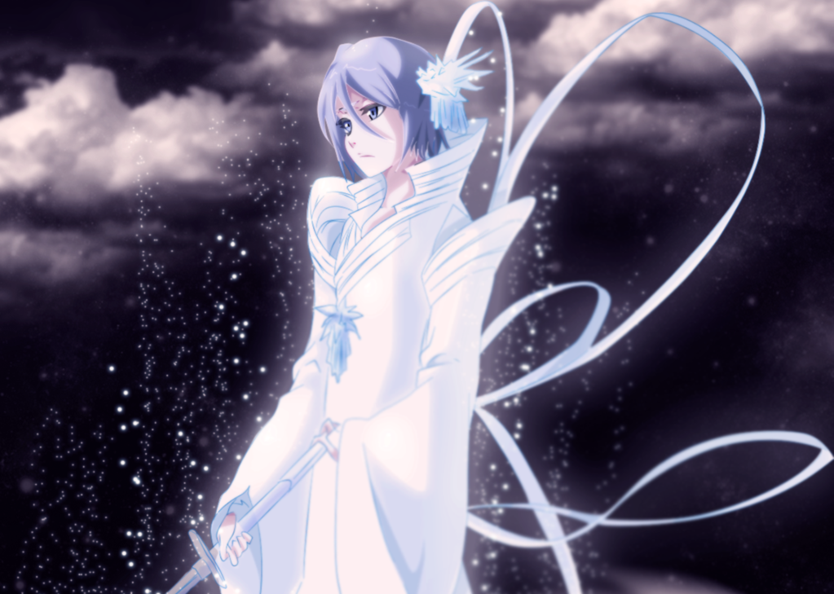

**Quotes**

**(Thinking about Ichigo Kurosaki)** "Whether I like him, whether I hate him, it's just all so troublesome. Love, companionship and friendship... it's nothing but trouble."

**(To Ichigo Kurosaki)** "Don't even try to move one step from there. If you try to follow me... I'll never forgive you!"

**(To Orihime Inoue)** "In a battle, the ones who get in the way are not the ones that lack power, but the ones that lack resolve."

**(To Sode no Shirayuki)** "I can never forgive anyone who attempts to destroy what I must protect."

**(To Riruka Dokugamine)** "You are no Hollow or Arrancar. You are human. It is the duty of a Shinigami to protect humans such as yourself. I will not raise my blade against you."

**(To Herself)** "We must not shed tears. That is the defeat of the body by the heart. Because, for us, this thing called 'the heart' can become nothing less than proof that one's existence is superfluous."[363]

**(To Herself)** "I'm not scared. I'm content with my life. Meeting Renji and the others, adopted by Nii-sama, Kaien-dono's guidance, then Ichigo's attempted rescue. No pain, no sadness, no regrets. There is nothing for my heart to linger in this world. Thank you. Thank you. Thank you. Thank you. And goodbye."

**Creator**: Bogdan Lukovic 30.8.2018.