Shunsui Kyoraku

*Captain of the 1st Division*

**Race**: *Human Soul* **Alignment**: *Chaotic Good* **Class**: *Shinigami Swordsman*

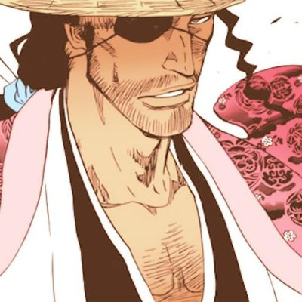

**Normal mode:**

**Abilities:**

1. ***Shunpo master***  
   **Passive:** Every ranged attack against Kyoraku rolls d6 and deals (roll/6) * attackDamage to him.  
   **Active:** Kyoraku dodges one ability/attack. If multiple abilities/attacks are targeting him, he can choose one to dodge, other abilities hit him.   
   **Keywords:** Shield, Hits first.
2. ***Play time: Katen Kyokotsu***  
   **Passive:** At the end of the round in which Kyoraku is damaged, Kyoraku enters Katen Kyokotsu mode.   
   **Keywords:** Locked, Haste, Transformation.
3. ***Hado #78: Zangerin***  
   **Active:** Kyoraku deals 15 ranged damage to all enemies.   
   **Keywords:** Attack, Ranged, AoE.
4. ***Tsukiyubi*  
   Active:** Deals 15 melee damage to a single target and dazes an enemy so that he needs to roll 4, 5 or 6 on d6 to be able to use an ability this turn.  
   **Keywords:** Attack, Melee, Save throw, Stun.
5. ***Master Strategist***  
   **Active:** Kyoraku and his target must state a number 1, 2 or 3. If stated number is the same, the target is stunned for this and next turn. If Kyoraku tells higher number, the targets turn is negated. If kyoraku tells lower number nothing happens. This action happens before any other action. Abilities negated still count towards ultimate as if they were successfully used.  
   **Keywords:** Mind-game, Stun, Relativistic.
6. ***Ukitake, please help!***  
   **Active:** Kyoraku calls Ukitake for help. Ukitake blocks an attack. If the attack was ranged, it is redirected to a random enemy dealing half if its original damage. If the attack was melee, it is just blocked and this ability cannot be used again in this combat.   
   **Keywords:** Shield, Reflect, Exhaust.

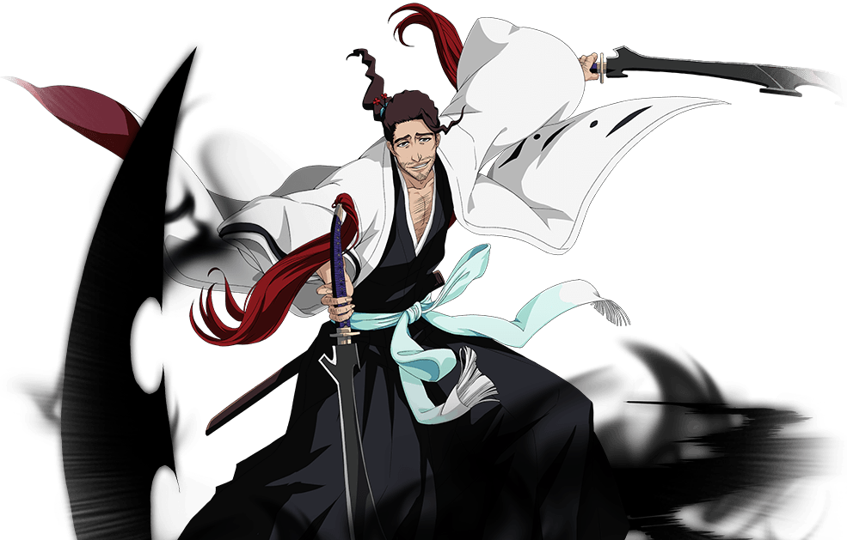

**Shikai: Katen Kyokotsu mode:**

In Shikai: Katen Kyokotsu mode, each person in fight is participating in the ‘game’ that is chosen by Kyoraku at the start of each Round. Additionally, Kyoraku has two abilities that are changed depending on which game is played. There are four games.

**Games:**

1. ***Irooni***:  
   When someone attacks, both, he and his target must state a color. If they state the same color, attack damage is doubled. If colors are different, damage is halved. Possible colors: White, Black, Blue, Yellow, Red.
2. ***Takaoni***:  
   Attacks made by units that are higher are unblockable and undeniable by any means by the opponent who is lower. Flying units are always higher than non-flying units. If both units are flying or non-flying d6 is thrown. Higher roll is higher. If both rolls are the same, no bonuses are given. Kyoraku can roll 2 times and takes a roll of his choice for resulting roll.
3. ***Daruma-san ga Koronda:***  
   Kyoraku choses a target. This target must use an attack in his next turn otherwise he receives 40 damage and needs to cast attack in his turn after or this is repeated. If the target uses an attack, its target becomes marked with this ability and needs to use an attack… Targets affected by this ability can attack allies as well. If an attack was blocked or negated in any way, mark still stays on the attacker, but the attacker does not take damage from mark.
4. ***Kageokuri***:  
   Using a non-attack or skipping turn gives you an ability to use an attack next turn that hits before hits first abilities (Speed rating of that attack changes to 5, even if its base rating is higher!).

**Abilities**:

1. ***Shunpo master***  
   **Passive:** Every ranged attack against Kyoraku rolls d6 and deals (roll/6) * (damage of an attack) to him.  
   **Active:** Kyoraku dodges one ability/attack. If multiple abilities/attacks are targeting him, he can choose one to dodge, other abilities hit him.   
   **Keywords:** Shield, Hits first.
2. ***Master Strategist***  
   **Active:** Kyoraku and his target must state a number 1, 2 or 3. If stated number is the same, the target is stunned for this and next turn. If Kyoraku tells higher number, the targets turn is negated. If kyoraku tells lower number nothing happens. This action happens before any other action. Abilities negated still count towards ultimate as if they were successfully used.  
   **Keywords:** Mind-game, Stun, Relativistic.
3. ***Bushogoma***  
   **Active:** Deals 25 ranged damage to a target. Target skips this and next turn but is unable to be attacked. This cannot be used on the same target twice.   
   **Keywords:** Attack, Ranged, Stasis, Exhaust.
4. ***Bankai: Katen Kyōkotsu: Karamatsu Shinjū***   
   **Active:** After playing 2 rounds in Katen Kyokotsu mode, this ability is unlocked. Kyoraku enters his bankai mode. Casting this renders him invulnerable this turn with the help of Katen Kyokotsu’s spirit.   
   **Keywords:** Locked, Transformation, Shield, Exhaust.
5. ***Katen Kyokotsu Game ability 1:***  
   a) ***Irooni 1***:  
   **Active:** Deal 25 melee damage. Target needs to state color before Kyoraku.  
   **Keywords**: Attack, Melee, Irooni.   
     
   b) ***Takaoni 1***:   
   **Active:** Kyoraku uses shunpo in the sky being higher than anyone else for his next attack. Dodges all attacks.  
   **Keywords:** Shield, Flying.   
     
   c) ***Daruma-san ga Koronda 1***:  
   **Active:** Kyoraku redirects an attack made by Daruma-san ga Koronda affected enemy to any other target of his choosing. If only attacker and Kyoraku are targetable, the attack is simply negated, but mark is now on Kyoraku.  
   **Keywords:** Block, Reflect.  
     
   d) ***Kageokuri 1***:  
   **Active**: Kyoraku’s next attack deals double damage**.  
   Keywords**: Buff.
6. ***Katen Kyokotsu Game ability 2:***  
   a) ***Irooni 2***:  
   **Active:** Kyoraku slashes with his swords dealing 15 + 15 melee damage. He states 2 colors, one for left hand, other for right hand. This turn Kyoraku doesn’t receive any bonus damage from Irooni game.   
   **Keywords**: Attack, Melee, Irooni.  
     
   b) ***Takaoni 2:***   
   **Active:** Kyoraku sends a shockwave that deals 15 ranged damage to all enemies.   
   **Keywords:** Attack, Ranged, AoE.  
     
   c) ***Daruma-san ga Koronda 2:***  
   **Active**: Can be used only if Kyoraku is affected by Daruma-san ga Koronda. Kyoraku transfers Daruma-san ga Koronda mark from himself to an enemy of his choosing. Kyoraku can use another ability after this, but it will always hit last. Target of this ability can change his previously intended move for this turn (if ability is changed, it will hit last).   
   **Keywords:** Haste, Hits first.  
     
   d) ***Kageokuri 2:***  
   **Active**: Kyoraku deals 30 melee damage to a target.  
   **Keywords:** Attack, Melee.

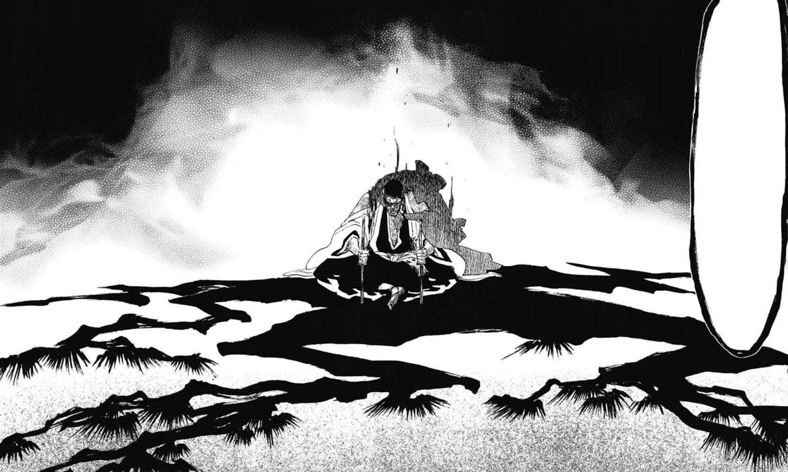

**Bankai: Katen Kyokotsu: Karamatsu Shinjū mode:**

Every fight participant, except Kyoraku, is feeling depressed, weak and dizzy and must choose only 3 abilities to use from now on. Entering another mode while being affected by this makes you choose 3 abilities in that mode as well.

1. ***Shunpo master***  
   **Passive:** Every ranged attack against Kyoraku rolls d6 and deals (roll/6) * (damage of an attack) to him.  
   **Active:** Kyoraku dodges one ability/attack. If multiple abilities/attacks are targeting him, he can choose one to dodge, other abilities hit him.   
   **Keywords:** Shield, Hits first.
2. ***Master Strategist***  
   **Active:** Kyoraku and his target must state a number 1, 2 or 3. If stated number is the same, the target is stunned for this and next turn. If Kyoraku tells higher number, the targets turn is negated. If kyoraku tells lower number nothing happens. This action happens before any other action. Abilities negated still count towards ultimate as if they were successfully used.  
   **Keywords:** Mind-game, Stun, Relativistic.
3. ***Ichidanme: Tameraikizu no Wakachiai***  
   **Active:** Kyoraku chooses a target. Any damage dealt by Kyoraku to this target will damage Kyoraku as well. Same goes other way around. He and his target cannot die by their blows except for Kyoraku’s ‘Shime no Dan: Itokiribasami Chizome no Nodobue’. Any damage inflicted between Kyoraku and his target that would be fatal will be made so that the target of that damage is alive with 1 hp. If an enemy who is not affected by this ability deals damage to Kyoraku (this damage can kill Kyoraku), enemies affected by this ability will receive that damage as well (this damage can kill them). Lasts till the end of the combat. Cannot be blocked or dispelled.   
   **Keywords:** Debuff.
4. ***Nidanme: Zanki no Shitone***  
   **Active:** Shinsui creates holes in his targets body that deal 10 true damage per turn. Lasts till the end of the combat. It is not copied on Kyoraku by ‘Ichidanme: Tameraikizu no Wakachiai’. Can be dispelled. Cannot be blocked.  
   **Keywords:** Debuff, DoT.
5. ***Sandanme: Dangyo no Fuchi*Active:** Kyoraku and his target are both covered with water. At the end of each turn if this ability is active, d6 is rolled. If roll is 1, target is released and can act freely. If anything except 1 is rolled, Kyoraku is released and can use his *Shime no Dan: Itokiribasami Chizome no Nodobue* to execute his enemy.  
   **Keywords:** Stasis.
6. ***Shime no Dan: Itokiribasami Chizome no Nodobue***  
   **Active:** Can only be used on a target after using abilities 3, 4 and 5 on that target. Unblockable and undeniable death. Hits before anything. After using this ability, Kyoraku must roll d6, if he gets 1,2 or 3, he will lose his bankai after this round ends and will be returned to his shikai mode. He cannot enter his bankai again in this fight.   
   **Keywords:** Insta-kill, Relativistic, Locked.

**Quotes**

**(To Yasutora Sado*)*** *"Then it can't be helped. Drink, my friend! Since you won't turn back, at least stay here for a while. Just a little while. All the other captains must have made their moves by now. This battle should be over soon. Until then, please stay here and drink to your heart's content."*

**(To Yasutora Sado)** *"Since you are so determined, it was impolite of me to try to dissuade you. I apologize for that. Very well then. I have no choice but to take your life."*

**(To Genryūsai Shigekuni Yamamoto)** *"But a huge matter like this isn't something you encounter every day, right? It's that fatherly love where you want to get your subordinate some experience."*

**(To Kisuke Urahara)** "*Waiting patiently and believing in your subordinates is all part of a captain's job."*

**(To Nanao Ise when asked how he remembers her name)** *"Well, you are the youngest member of the squad. And I could never forget the name of a cute young girl, now, could I?"*

**(To Katen Kyōkotsu)** *"It goes against my nature to get rough with women. I happen to be a gentleman."*

**(To Coyote Starrk regarding Tōshirō Hitsugaya's strength)** *"Well, I don't know. Captain Hitsugaya is a genius, after all. Give him another hundred or so years, and he might outdo me yet."*

**(To Coyote Starrk)** *"I'm not sure I like you deciding what is and isn't like me, Mr. Espada. If you really want to go into this, I'd say it's a lack of such distinctions that makes up my identity."*

**(To Love Aikawa)** *"Throwing away victory for the sake of manners is a rookie mistake. Captains don't have the time to waste on that kind of thing. Don't waste your time trying to play the good guy. No matter what debts you may owe, from the instant you find yourself on the battleground, both sides are evil."*

**(To Sōsuke Aizen)** *"I guess I'm just not much of a listener when it comes to guys. I get bored pretty quickly."*

**(To the Gotei 13 regarding his freeing of Aizen)** *"Honor? Is that what you are all talking about? Then let us speak instead of our duty to the Gotei 13. Honor will not protect the world. I do not believe that using evil to defeat evil is itself an evil act."*

**Creator**: Bogdan Lukovic ft. Nikola Radonjic 15.8.2018.

Version 1.0: 15.8.2018.

Version 2.0: 30.8.2018.

***Shunpo master***Passive damage received from ranged attacks is (D6/6) * attackDamage. From (D4 /4) * attackDamage.

***Play time: Katen Kyokotsu***   
This ability is now passive that is automatically activated when Kyoraku is damaged.

***Hado #78: Zangerin***Damage from 20 to 15.

***Tsukiyubi***   
Damage from 10 to 15.

***Master Strategist***“Abilities negated still count towards ultimate as if they were successfully used.” added.

***Daruma-san ga Koronda***“Attacks done by units affected by this always hit last!” – removed.   
“If an attack was blocked or negated in any way, mark still stays on the attacker, but the attacker does not take damage from mark.” – added.  
Damage changed from 25 to 40.

***Daruma-san ga Koronda 1***“If only attacker and Kyoraku are targetable, the attack is simply negated, but mark is now on Kyoraku.” – added.

***Daruma-san ga Koronda 2***Cannot be used on allies.

***Sandanme: Dangyo no Fuchi***Full rework.