Gin Ichimaru

*Captain of the 3rd division*

**Race**: *Human Soul* **Alignment**: *Chaotic Good* **Class**: *Shinigami Swordsman*

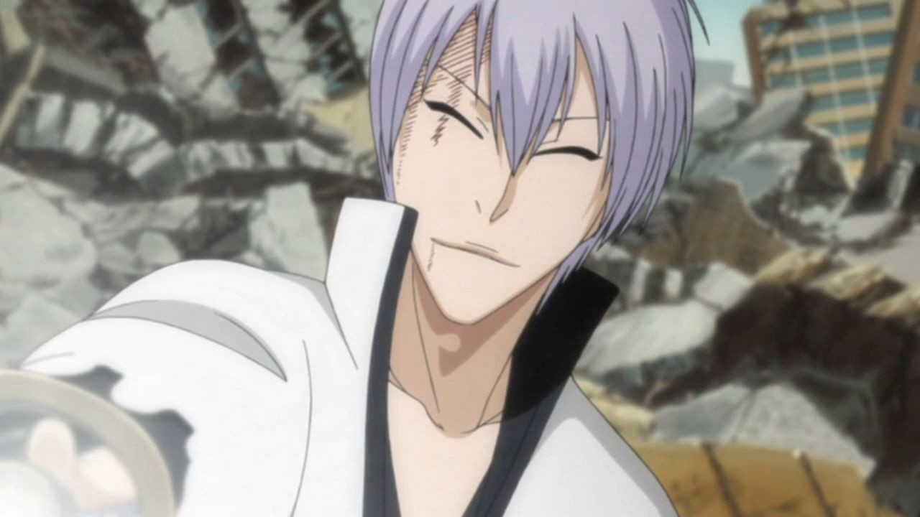

**Abilities**:

1. ***Shinso***:   
   **Passive**: Gin’s melee attacks can hit flying enemies. All Gin’s attacks have 3 parts. First part hits first, second part hits with normal speed and third past hits last.  
   Active: Deal 10 damage 3 times to an enemy.   
   **Keywords**: Attack, Melee.
2. ***Psychological Warfare***   
   **Passive**: Each time Gin counters an attack, one stack of fear is applied to the attacker. Each turn Gin deals damage to an enemy, one stack of fear is applied to the attacked enemy. For each stack of fear on a character, there is 1/6 probability that he will hit last with his ability (stacks multiplicatively). Proc-ing hit last effect removes 1 stack of fear. Maximum number of stacks of fear is 5. One stack gets removed from everyone who has them when Gin receives any damage, once per turn. When a character has 5 stacks, his damage onto Gin is halved.  
   **Active**: Gin Puts 2 stacks of fear onto his target.  
   **Keywords**: Effect.
3. ***Shoot to kill: Shinso*Active**: Deal 20 then 10 then 5 damage to a single target. First hit pierces half of the enemy’s defenses if there is one. Last hit deals true damage (this can be evaded if first attack is evaded, enemy still receives 10 damage from first hit).   
   **Keywords**: Attack, Melee.
4. ***Shunpo Expert***  
   **Active**: Gin evades all ranged attacks and one melee attack this turn.  
   **Keywords**: Evade.
5. ***Null Step: Renjin***  
   **Active**: Deal 5 damage 3 times to three targets or 12 damage 3 times to one target.   
   **Keywords**: Attack, Melee.
6. ***Kill, Kamishini no Yari***  
   **Passive**: Each time Gin inflicts damage on an enemy with any other skill, he applies a stack of poison dust.  
   **Active**: Deal 5 true damage for each stack of poison dust there is on the target.  
   **Keywords**: Effect.
7. ***Closed eyes***  
   **Passive**: Gin is immune to any ability that requires interaction with his sight. (Some abilities: Aizen shikai, Sharingan genjutsu, …)