Coyote Starrk

*Aspect of Solitude*

**Race**: *Hollow* **Alignment**: *Neutral Evil* **Class**: *Arrancar Swordsman/Gunner*

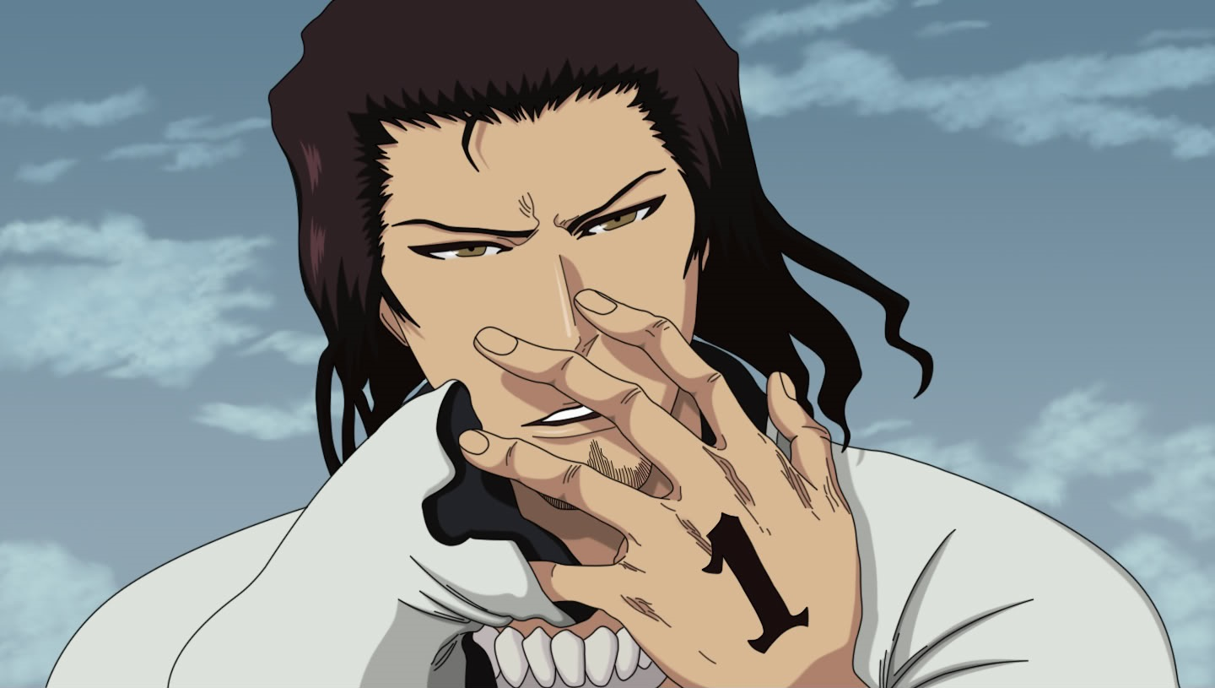

**Normal mode:**

**Abilities:**

1. ***No gesture Cero***  
   **Active**: Deals 25 ranged damage.  
   **Keywords**: Attack, Ranged, Hits first.
2. ***Colmillo***  
   **Active**: Deals 35 damage.  
   **Keywords**: Attack, Melee.
3. ***Booooring!!!***  
   **Active**: Starrk evades one attack of any type this turn. Unlocks Resurreccion: Los Lobos if an attack is dodged.  
   **Keywords**: Shield. Hits first.
4. ***Prediction***  
   **Active**: An enemy must tell Starrk his intentions for the next turn.  
   **Keywords**: Prediction.
5. ***Sonido***  
   **Active**: Starrk buffs himself for the next [d6/2] actions in which he is attacked or is being attacked. He rolls d6 when attacked and with 4, 5 or 6, attack is dodged. He rolls d6 when attacking and with 4, 5 or 6 he pierces half of enemy defenses with his attack.  
   **Keywords**: Buff.
6. ***Resurreccion: Los Lobos***  
   **Passive**: This ability starts locked.  
   **Active**: Starrk enters his resurreccion form. Now he is wielding 2 pistols and flies until combat ends. Any attack directed to Starrk this turn will hit him only if attacker rolls 5 or 6.  
   **Keywords**: Transformation, Shield.

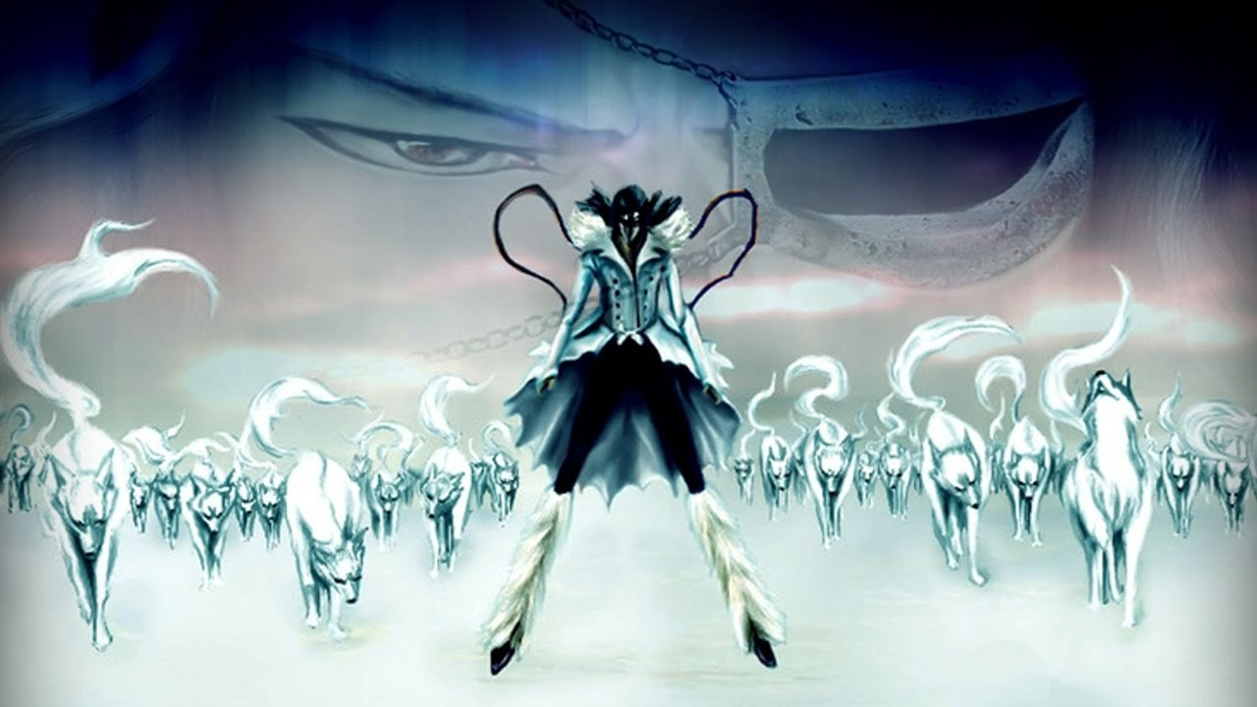

**Resurreccion: Los Lobos mode:**

In his resurreccion-e, Starrk is dual wielding pistols and flying. Starrk also spawns 15 10/5 wolves. They are invulnerable and unable to attack unless Starrk uses “*Spiritual wolves: Attack*”. Starrk can use wolves to reduce damage from any attack that is targeting him (one wolf per attack). Damage reduction is based on d6 roll as follows: 1 or 2 -> 10 damage reduced ; 3 or 4 -> 20 damage reduced ; 5 or 6 -> 30 damage reduced

1. ***Pistol Cero***  
   **Active**: Deals 20 ranged damage two times (can be used on 1 or 2 targets).   
   **Keywords**: Attack, Ranged.
2. ***Spiritual wolves: Attack***  
   **Passive**: Every time Starrk loses a wolf, he needs to roll d12. If he gets 1, all damage he does until combat ends is halved.   
   **Active**: Starrk attacks with maximum of 5 wolves one target. If a wolf does damage to an enemy, it is destroyed.   
   **Keywords**: Attack.
3. ***Cero Metralleta***  
   **Active**: Starrk fires away with his guns. Enemy rolls a dice and is damaged for 10 times d6 roll.  
   **Keywords**: Attack, Ranged, AoE.
4. ***Colmillo***   
   **Active**: Blocks a melee attack and deals 15 damage to the attacker.  
   **Keywords**: Shield.
5. ***Sonido***  
   **Active**: Starrk buffs himself for the next [d6/3] actions in which he is attacked or is being attacked. He rolls d6 when attacked and with 4, 5 or 6, attack is dodged. He rolls d6 when attacking and with 4, 5 or 6 he pierces enemies defenses with his attack.  
   **Keywords**: Buff.
6. ***Prediction***  
   **Active**: Enemy must tell Starrk his next 2 turns.  
   **Keywords**: Prediction.

**Quotes**

**(About Lilynette)** "The two of us are one and the same. Whilst when other Hollows became Arrancar, their Hollow powers separated into the form of 'body' and 'blade', we separated into two separate bodies. It is when we are reunited that our power is truly released."

**(To Shunsui Kyōraku)** "I've gone to the trouble of pulling out this damn release. I'm going to see your Bankai if I have to drag it out of you."

**(To Lilynette)** "Like I said, this ain't my thing. Let's just forget it. It's not like Aizen-sama feels like lending us a hand either. Those guys are strong. I get that already. No point fighting when it's just gonna mean more dying. So can we just go home and sleep now?"

**(To Love Aikawa and Rōjūrō Ōtoribashi)** "Ready to give it up? If you run, I'll let you go."

**(To Love and Rose)** "I see. Nothing for it, then. Not that I'm too fond of the idea, but I'll have to finish you off."

**(To himself)** "Why do I have to fight with a strong guy like this? I always envied the weak. Whenever we made friends, their souls would waste away just from being near us. Because we were so alone, we split our soul in two. I don't know which was our original form. Or perhaps, it was neither. But this was the only way we had to escape from our isolation. I so envied the weak. The weak can always find others to be around. I want to be weak. And if that's impossible, I at least want to find companions who are as strong as I."

**(To himself)** "I'm not alone. I'm not alone. I'm not alone any more..."

**Creator**: Bogdan Lukovic 28.8.2018.