Grimmjow Jaegerjaquez

*Aspect of Destruction*

**Race**: *Human Soul* **Alignment**: *Chaotic Evil*  **Class**: *Arrancar Swordsman*

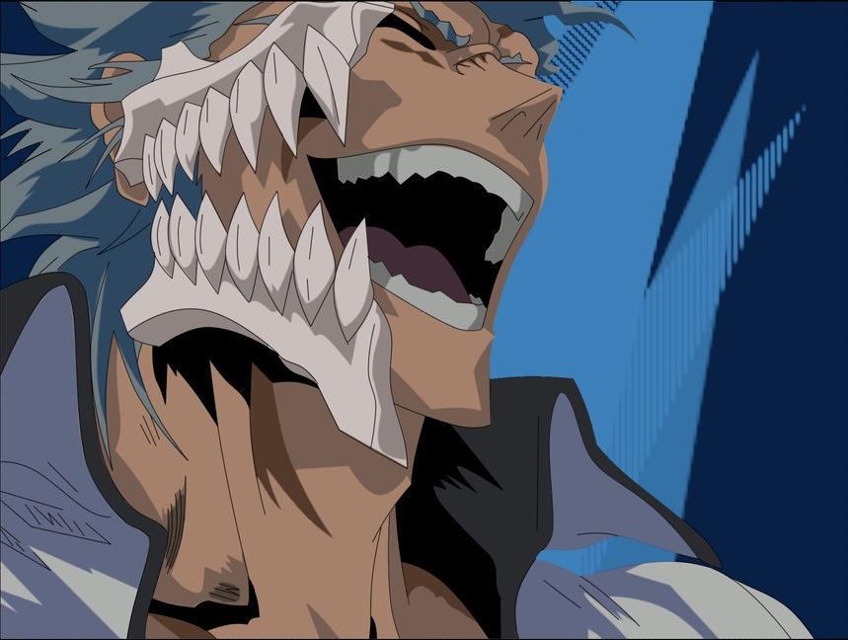

**Normal mode:**

**Abilities:**

1. ***Cero***   
   **Active**: Deal 20 ranged damage.  
   **Keywords**: Attack, Ranged.
2. ***Gran Rey Cero***  
   **Active**: Deal 35 ranged damage. After using this ability, it is replaced with another “Cero” or another “Sonido strike”.  
   **Keywords**: Attack, Ranged, Exhaust, Replace.
3. ***Sonido Strike***  
   **Active**: Deal 20 melee damage while blocking half of the damage received in this turn.  
   **Keywords**: Attack, Melee, Hits first, Block.
4. ***Death combat***  
   **Active**: Grimmjow chooses a target to fight until death. Winning (killing a death combat partner) in Death combat gives 50% damage boost until combat ends. While death combat is active, Grimmjow and his target receive only 25% damage from other characters. They must use targeted abilities on each other (AoE can still hit other characters). Cannot be used again until first one ends.  
   **Keywords**: Status.
5. ***Hierro***  
   **Passive**: Grimmjow cannot be damaged for more than 35 damage in a turn.  
   **Active**: Grimmjow reduces “Hierro” passive maximum damage by 5. This ability can be used 4 times (minimum 15 maximum damage per turn).   
   Keywords: Buff.
6. ***Grind!***  
   **Passive**: Locked until Death combat is used and Grimmjow falls below 51 hp.   
   **Active**: Grimmjow unleashes his resurreccion. Deals 15 damage to everyone who attacked him this turn.  
   **Keywords**: Transformation, Counter.

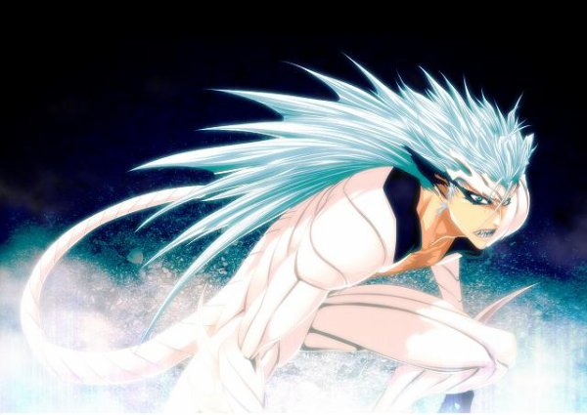

**Resurreccion: Panthera mode:**

Grimmjow gains buffed “Hierro” reduction as a passive in this mode.

**Abilities:**

1. ***Cero***  
   **Active**: Deal 25 ranged damage.  
   **Keywords**: Attack, Ranged.
2. ***Sonic Wave***  
   **Active**: Deals 25 melee damage and the target deals 10 less damage this turn.   
   **Keywords**: Attack, Melee, Reduction.
3. ***Garra de la Pantera*Active**: Deals 5 times 7 ranged damage on a single enemy. Enemy is debuffed for next turn with 25% increased damage received (5% for each hit).  
   **Keywords**: Attack, Ranged, Debuff.
4. ***Death combat***  
   **Active**: Grimmjow chooses a target to fight until death. Winning (killing a death combat partner) in Death combat gives 50% damage boost until combat ends. While death combat is active, Grimmjow and his target receive only 25% damage from other characters. They must use targeted abilities on each other (AoE can still hit other characters). Cannot be used again until first one ends.  
   **Keywords**: Status.
5. ***Enhanced Sonido***  
   **Passive**: Grimmjow wins speed ties if relevant.   
   Active: Grimmjow’s next attack deals 10 more damage and hits first.  
   **Keywords**: Buff.
6. ***Sonido Strike***  
   **Active**: Deal 20 melee damage while blocking half of the damage received in this turn.  
   **Keywords**: Attack, Melee, Hits first, Block.

**Quotes**

**(To his Fracción)** "I don't care who they are, if they show even a bit of Reiatsu, we just kill them all."

**(To Ichigo Kurosaki)** "You underestimating me, Shinigami? I still don't quite feel like killing you, yet. Get a grip and come on! Show me your Bankai. If you don't, I'll do the same thing I did to that little Shinigami over there and put a freakin' hole in you!"

**(To Shinji Hirako)** "Damn right. Who you are has nothing to do with killing you!"

**(To Kaname Tōsen)** "It's best to crush insects quickly once they've gotten inside, right?"

**(To Ichigo Kurosaki)** "Those eyes. You're always like that. No matter how much I beat you up, you've got this sense about you that you're going to beat me. You think you're freaking stronger than me! I can't freakin' stand it!"

**(To Ichigo Kurosaki)** "Whether you're a Human, or a Shinigami or an Arrancar, anyone who looks at me like they're underestimating my power, I'll smash every one of 'em into oblivion!"

**(About Ulquiorra Cifer)** "I'll show him what you get when you mess around with someone else's prey."

**(To Ichigo Kurosaki)** "You are a Shinigami and I am a Hollow! Whichever side losses will be annihilated. That's how it's always been for thousands of years. Do you need any other reason to fight? Come on. The one who remains standing will return alive. That's all it comes down to!"

**(To Ichigo Kurosaki)** "Like I'd lose... like I'd... there's no way... no way I'd lose to someone like you!"

**Creator**: Bogdan Lukovic 28.8.2018.