Itachi Uchiha

Anime: Naruto  
Race: Human  
Alignment: Neutral Good  
Class: Mage, Illusionist

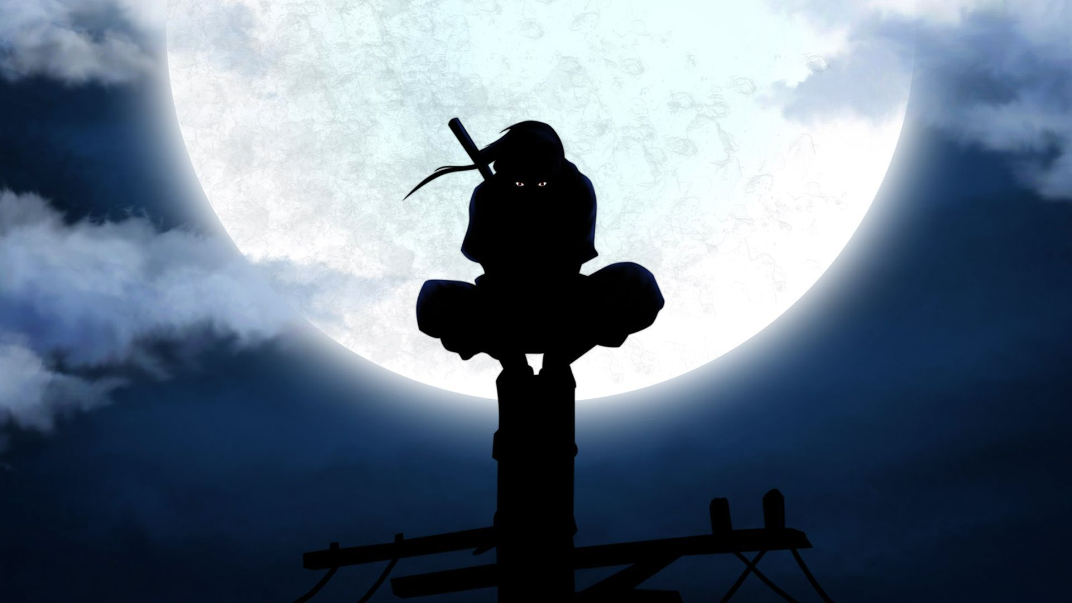

1. Fire style: If the target is frozen, it will unfreeze it.  
   a) Fireball Jutsu – Deals 30 ranged damage to the target and its summons.   
     
   b) Phoenix Flower Jutsu – Deal 20 ranged damage to all enemies.  
     
   c) Dragon Flame Jutsu – Deal 30 ranged damage to the target. If it hits, the target will receive 5 true damage in the next two turns.
2. Demonic Illusion  
   a) Mirage Crow – Itachi stuns his target.   
     
   b) Mirror Heaven and Earth Change – The first attack directed at Itachi will be evaded. If the attack is faster than normal speed, it will be reflected at the attacker.
3. Crow clone jutsu – Itachi creates a clone of himself and becomes invisible. If the enemies don’t have true sight, it would appear as if he just skipped this turn. Must be written down on paper. The clone has the same hp as Itachi at the moment of using this ability. The clone is destroyed at the first damage received and Itachi exits stealth.
4. Sharingan  
   a) Predict – Itachi can cast another ability this turn. The ability gains hits first. Relativistic.   
     
   b) Dodge – Itachi evades all attacks this turn.
5. Genjutsu: Sharingan  
   a) Ring of Reflection – Itachi writes one name on a piece of paper. That is the name of his target. If the target doesn’t attack in the next turn, it is stunned in the following one.   
     
   b) Confusion – Itachi writes two names on a piece of paper. The first name is the name of Itachi’s target. The second name is the name of the character that Itachi’s target must use an ability on in the next turn.
6. Mangekyo Sharingan – Available from the third round. If Itachi loses both of his eyes, Mangekyo Sharingan is sealed.   
   a) Amaterasu – Black Flames:
7. Deals 15 unblockable ranged damage to a target this turn. The target burns for 5 damage each turn starting this turn for the rest of the fight.
8. Places a sealed Amaterasu trap on the target that will trigger if the target performs a specific action that Itachi writes down (attack, defend etc.). Itachi must write down that he used this ability and the target is unaware of it. Deals 40 unblockable damage. Lasts 3 turns.

b) Tsukuyomi – Itachi chooses a target. He and the target enter a separate fight with refreshed health and abilities. Transformations are sealed in this fight. Itachi can choose one of three beneficial effects for himself at the start:

a) The enemy has 50 less hp.

b) Itachi can use two abilities in a turn once per round.

c) Itachi has +20/20.

If Itachi loses the fight, he deals 50% less damage, and is stunned for 1 turn. If the enemy loses, they are stunned for this and two more turns, and deal 50% less damage in the remainder of fight. Each turn of this fight, the enemy rolls a 1d12. If he rolls a 12, the battle ends in a draw, and they return to the original fight normally. 1/game.

c) Izanami – Locks all abilities of a single enemy except for the last three he used, and only the variants that he used if the abilities have variants. Is dispelled if the enemy skips three turns. Itachi loses his right eye.

d) Izanagi – Secret haste ability. Any damage taken this turn is instantly healed. Itachi cannot die this turn. Relativistic. Can cast another ability normally this turn. Itachi loses his left eye.

Ultimate: Trigger Passive, starting from round 3. If Itachi should take 50 or more damage from a single instance, he gains 50 hp before he should receive it. He enters the Susanoo mode in which he gains 3 new abilities. He also gains 10/10.

1. Yasaka Magatama – Deals 40 ranged damage to a single enemy.
2. Totsuka blade – Deals 20 unblockable damage to an enemy, also sealing a random ability of theirs.
3. Yata mirror – Reflects all attacks this turn.

Creators: Mihailo Protic and Bogdan Lukovic

11.9.2018