*## If you’re not on campus, set up the Imperial VPN by following instructions on:* [*https://www.imperial.ac.uk/admin-services/ict/self-service/connect-communicate/remote-access/virtual-private-network-vpn/*](https://www.imperial.ac.uk/admin-services/ict/self-service/connect-communicate/remote-access/virtual-private-network-vpn/)

*## Download WinSCP (*[*https://winscp.net/eng/download.php*](https://winscp.net/eng/download.php)*) and log in to HPC remote computer:*

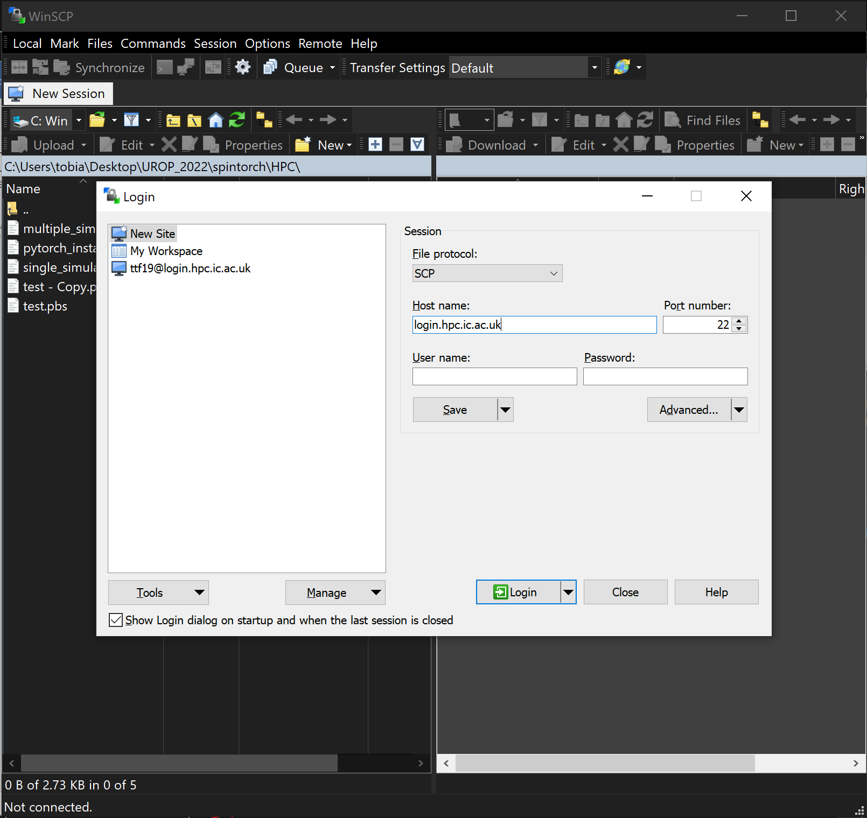

*##Organise your remote computer home directory (using WinSCP) as seen in the images below:*

*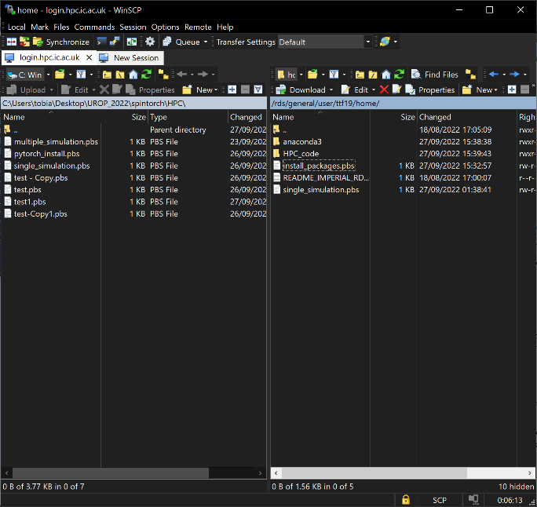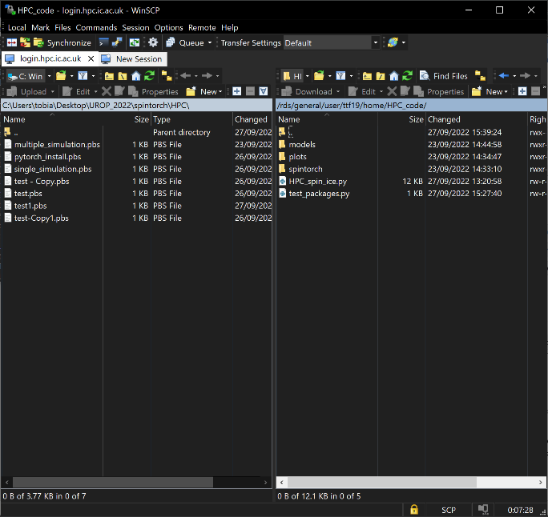##Download PuTTY (*[*https://www.chiark.greenend.org.uk/~sgtatham/putty/latest.html*](https://www.chiark.greenend.org.uk/~sgtatham/putty/latest.html)*) and log in to HPC remote computer:*

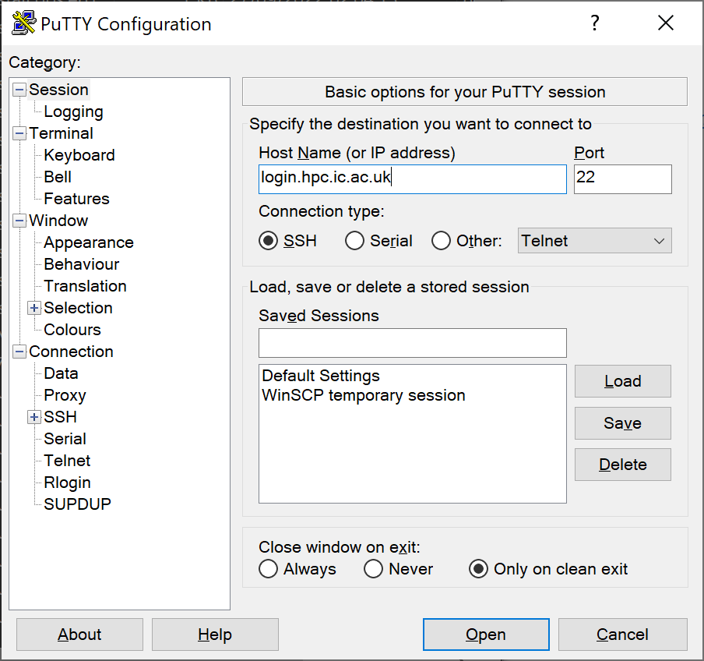

*## After logging on with PuTTY, input these lines into the terminal:*

module load anaconda3/personal

anaconda-setup

*## Install all necessary packages by running the pytorch_install.pbs file (found on):*

qsub pytorch_install.pbs

*## This is done only once. Afterwards, using “module load ananconda3/personal” will*

*setup your personal python environment. Note: you can check status of job by inputting “qstat” into command line*

*## Run your job file (ex:single_simulation.pbs):*

qsub single_simulation.pbs