
Secure Dev Lab

Ethical Hacking Task Submission
Student Information

Student Name | Husnain Fiaz | batch | 1st
Internship Track | Ethical Hacking | week | 1st
Submission date | 21/4/2026 | Instructor | Muhammad Saad Rajput
Tool Used | Nmap | File Name | husnain-fiaz-ethical-hacking-task1-report.docx

- Task Overview

Task Title :
Lab Environment Setup and Network Enumeration

Task Context :
To establish a secure virtual lab environment and perform initial reconnaissance on the target machine using industry-standard tools (Nmap) to identify active hosts and their services.
- Objective

To understand and practice Active Reconnaissance and Vulnerability Assessment in a controlled lab environment by setting up a virtual penetration testing lab and identifying potential security weaknesses in a target system

- Lab Environment and Tools

Item | detail
Operating system | Kali Linux(host machine)
Primary tool | Nmap
Scan commands | Nmap -sn 192.168.56.0/24  ping google.com(external ping test) nmap -p- 192.168.56.101 –o port_scan.txt (check open port and save in a file)
Target type | Authorize internal lab target
Evidence | Screenshots are given below

- Steps Performed

  - Lab Setup: Configured VirtualBox with Kali Linux and Metasploitable 2 on a Host-only network (192.168.56.0/24).

  - Network Connectivity: Verified network communication between Kali and Metasploitable using ping tests.

  - Host Discovery: Used arp-scan and nmap -sn to identify all active hosts on the network (192.168.56.100, 192.168.56.101, 192.168.56.1).

  - Port Scanning: Executed nmap -p- to scan all 65535 ports on target machine 192.168.56.101.

  - Service Detection: Identified 30 open ports and 22+ running services including FTP, SSH, HTTP, MySQL, PostgreSQL, and VNC.

  - Documentation: Captured screenshots and documented all findings for vulnerability assessment.

- Evidence Section

This section presents the comprehensive evidence collected during the active reconnaissance phase of the penetration testing engagement. The findings document all identified hosts, open ports, running services, and network configurations discovered on the target machine (Metasploitable 2) within the controlled virtual lab environment. The evidence is supported by screenshots, command outputs, and detailed analysis of the reconnaissance results.

Figure 1: Metasploitable 2 Network Setting

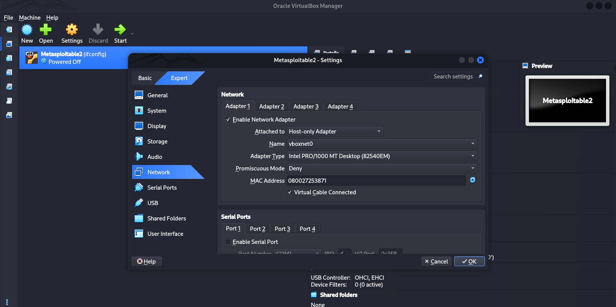

Figure 2: Metasploitable2 Network Configuration
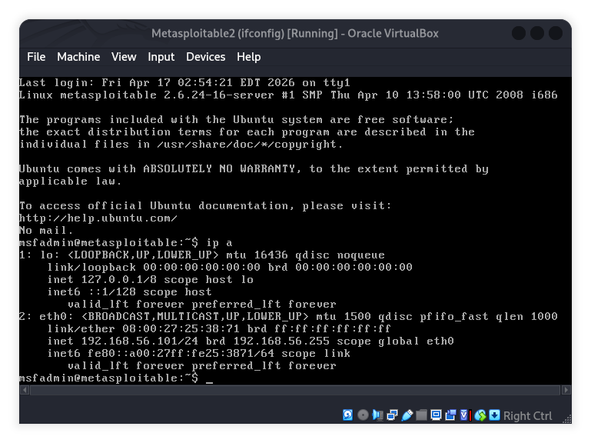

Figure 3: Kali Linux Network Configuration

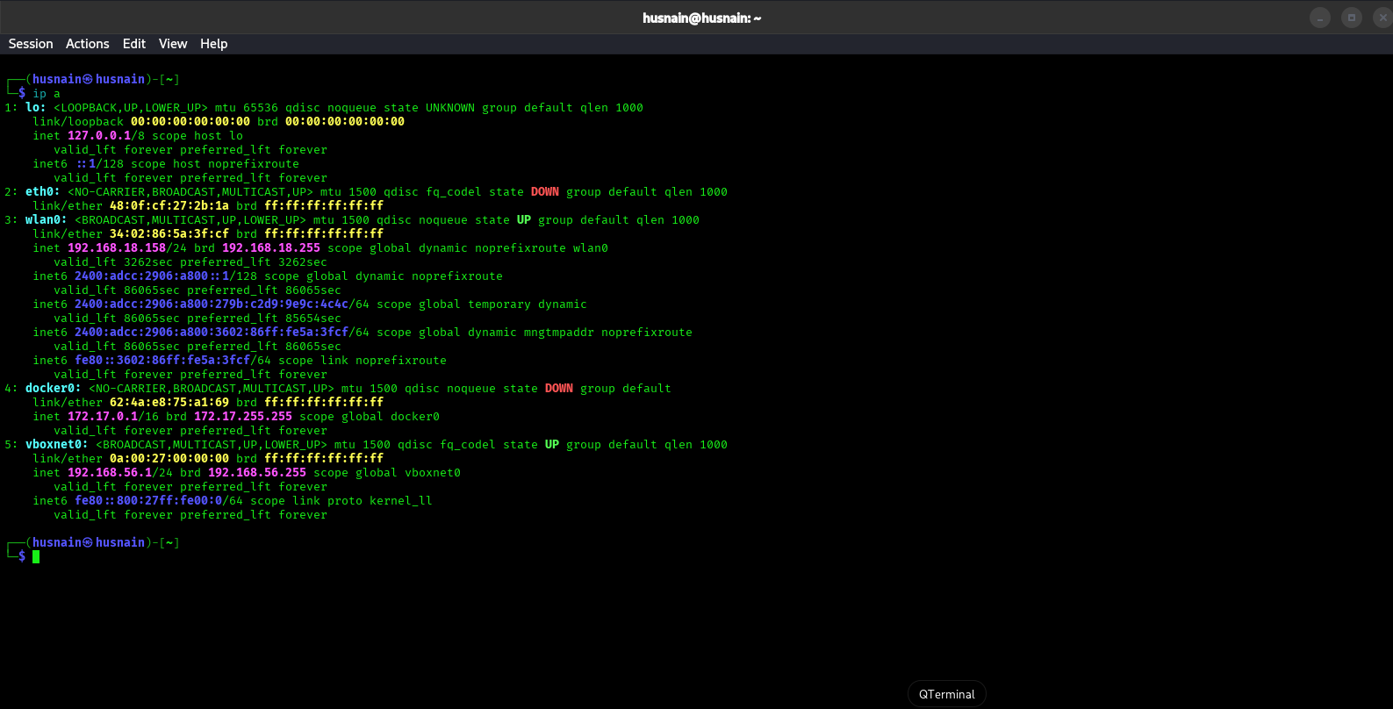

Figure 4 :Network Connectivity Test & Host Connectivity Verification

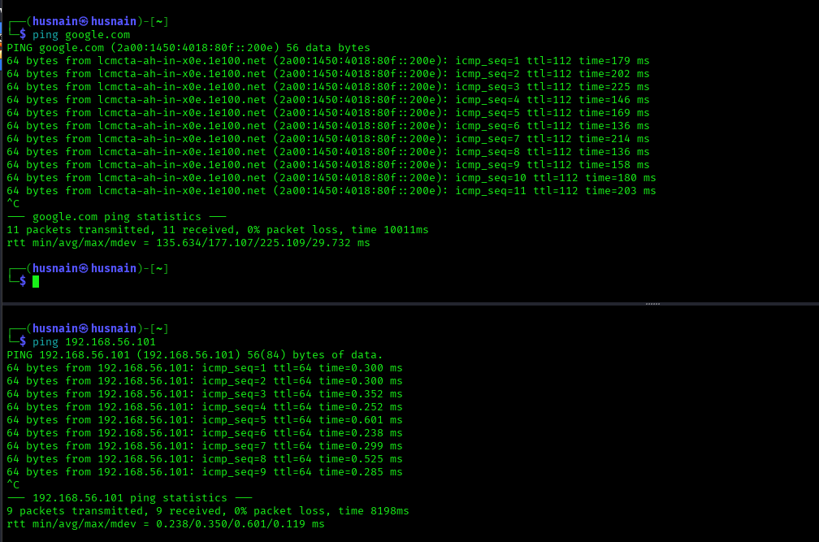

Figure 5: Network Enumeration - Nmap Ping Scan

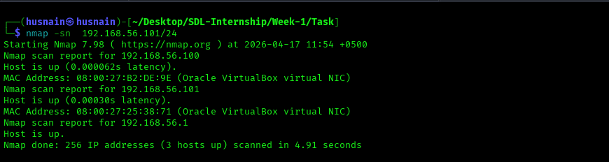

Figure 6: Port Scanning Results
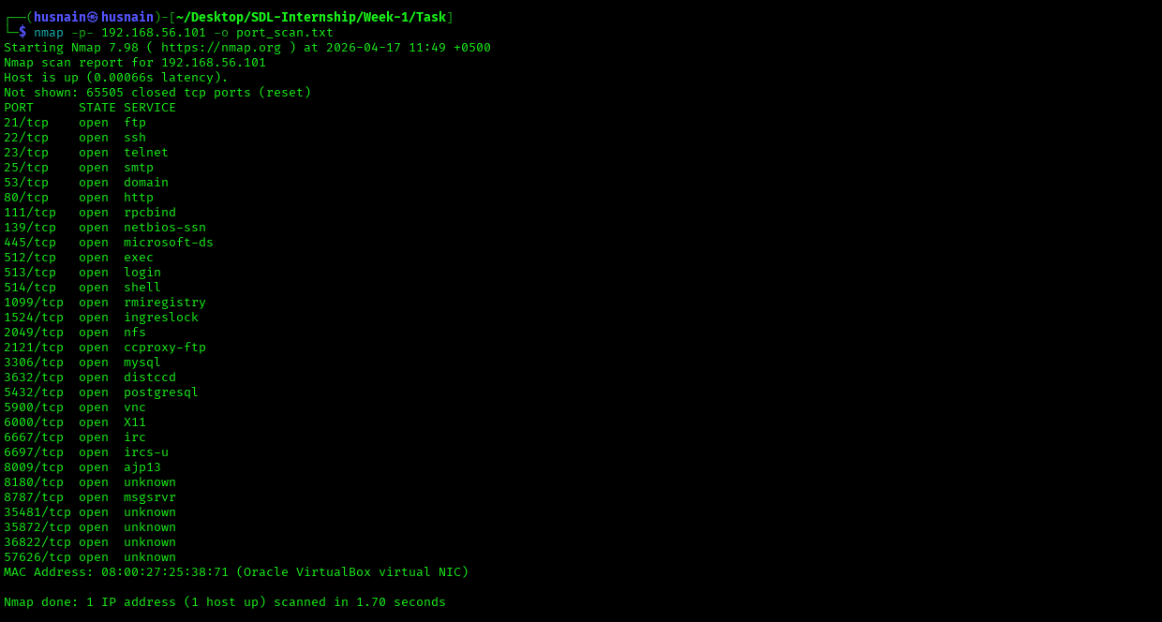

6. Findings and Analysis :

The active reconnaissance phase identified 30 open ports and 22+ running services on the target machine (Metasploitable 2 at 192.168.56.101). The following table presents the critical findings, observations, and associated security risks for the most important services discovered.
Analysis :

port | services | Observation | Possible risk
21/tcp | ftp | reachable from attacker machine. Legacy unencrypted protocol detected. | May allow weak or anonymous access if misconfigured.  Credentials transmitted in cleartext.
22/tcp | ssh | Remote administration service identified. SSH daemon actively listening. | Could be targeted for brute-force attempts if credentials are weak or default passwords exist.
23/tcp | telnet | Unencrypted remote login service detected on target. | Critical risk - Telnet transmits all traffic including passwords in cleartext. Highly exploitable.
25/tcp | smtp | Mail transfer service reachable from scanning host. | May allow email spoofing or unauthorized mail relay if not properly configured.
53/tcp | dns | Domain name service exposed on network. | Could be exploited for DNS spoofing or used as amplification vector for DDoS attacks.
80/tcp | http | Web service detected on target machine. | May expose web application weaknesses if not secured.  Potential for information disclosure.
111/tcp | RCP | Remote Procedure Call service listening. | Could allow unauthorized remote procedure execution if access controls are insufficient.
139/tcp | NetBIOS-SSN | NetBIOS service exposed on network. | Legacy protocol vulnerability - potential for SMB exploitation and lateral movement.
445/tcp | SMB | File sharing and network services exposed. | Critical risk - SMB vulnerabilities (EternalBlue, MS17-010) could lead to complete system compromise.
512/tcp | RSH | Remote shell service active. | Extremely dangerous - RSH allows unauthenticated or weakly authenticated remote command execution.
513/tcp | Login | Remote login service detected. | Legacy service - potential for unauthorized access with weak credentials or default accounts.
514/tcp | Shell | Remote shell service listening. | High risk - could allow unauthorized command execution on target system.
3306/tcp | MySQL | Database service reachable from network. | Could allow unauthorized database access if credentials are weak or default (root/root).
5432/tcp | PostgreSQL | Database service exposed. | Potential for unauthorized database access and data exfiltration if authentication is weak
5900/tcp | VNC | Remote desktop service detected. | Could allow unauthorized graphical access to target system if credentials are compromised.
6000/tcp | X11 | X Window System display service. | Potential for unauthorized remote desktop access and command execution.
8009/tcp | AJP13 | Apache JServ Protocol detected. | Could allow direct exploitation of Java application server if vulnerable versions exist.
8180/tcp | Tomcat | Apache Tomcat web application server identified. | May expose web application vulnerabilities or allow unauthorized access if admin credentials are weak.

7. Conclusion:

I ran a quick scan to see if the target machine (Metasploitable 2 at 192.168.56.101) was alive and reachable, and it turned out to be wide open. This scan found 30 open ports and over 22 services running, which gives an attacker plenty of ways in.
What really stands outs here is not just that so many services are exposed it’s that each one is a potential doorway into the system. There are old, unencrypted services like Telnet, FTP and RSH, along with weak login systems and way too many services left running. All of this makes the system a high-risk target for all kinds of attacks, like stealing passwords, breaking it without permission, grabbing sensitive data, or even taking full control of the machine.
This was just the first step finding out what’s out there. In the next phase, i will actually test the weak spots I found and try to exploit them to see how bad things really are. The result are so far make one thing clear: you really need to do thorough security checks and build multiple layers of defense to protect your network.

