SECURE DEV LABS
Ethical Hacking
Week 4 Mini Assessment

Student Information

Student Name | Husnain Fiaz | batch | 1st
Internship Track | Ethical Hacking | week | 4th
Submission date | 15&#x2F;MAY&#x2F;2026 | Instructor | Muhammad Saad Rajput
Tool Used | Burp Suite, Sqlmap, Whatweb, Nmap | File Name | husnain-fiaz-ethical-hacking-task4-report.docx

Executive Summary
I conducted a security assessment on a WordPress website running version 6.9.4. The goal was to find and exploit a real vulnerability in a third-party plugin. This simulates what a real penetration tester does for a client.
I chose to test the AN_Gradebook plugin because I found online that version 5.0.1 has a known SQL Injection vulnerability (CVE-2023-2636). This vulnerability allows someone with a low-level account (Subscriber) to read the entire database.
During my testing, I successfully confirmed that the vulnerability exists. I was able to extract user credentials including usernames, email addresses, and password hashes from the WordPress database. This proves that an attacker could steal login information.ca
The risk is HIGH because once an attacker has password hashes, they can crack them offline and then log in as an administrator. This would give them full control of the website.
I recommend updating the AN_Gradebook plugin immediately and resetting all user passwords.

Assessment Scope:
In-Scope TargetsThe following systems and components were included in this assessment:
TARGET | DESCRIPTION | VERSION
localhost | WordPress Installation | 6.9.4
AN_Gradebook | WordPress Plugin | 5.0.1
MYSQL&#x2F;MariaDB | Backend Database | (via WordPress)

Out of Scope
- Denial of Service (DoS) attacks
- Physical security testing
- Social engineering
- Other WordPress plugins
Assessment TypeGrey Box Testing: I had authenticated access as a Subscriber user but no knowledge of the plugin’s internal code before testing.Testing TimelineLab Setup: May 14, 2026Reconnaissance: May 15, 2026Exploitation: May 15, 2026Reporting: May 15, 2026

Tool Used
TOOL | PURPOSE
Nmap | Port scanning and service detection
WhatWeb | WordPress version fingerprinting
SQLMap | SQL injection exploitation
Burp Suite | HTTP request interception and analysis
FireFox Browser | Manual testing and verification

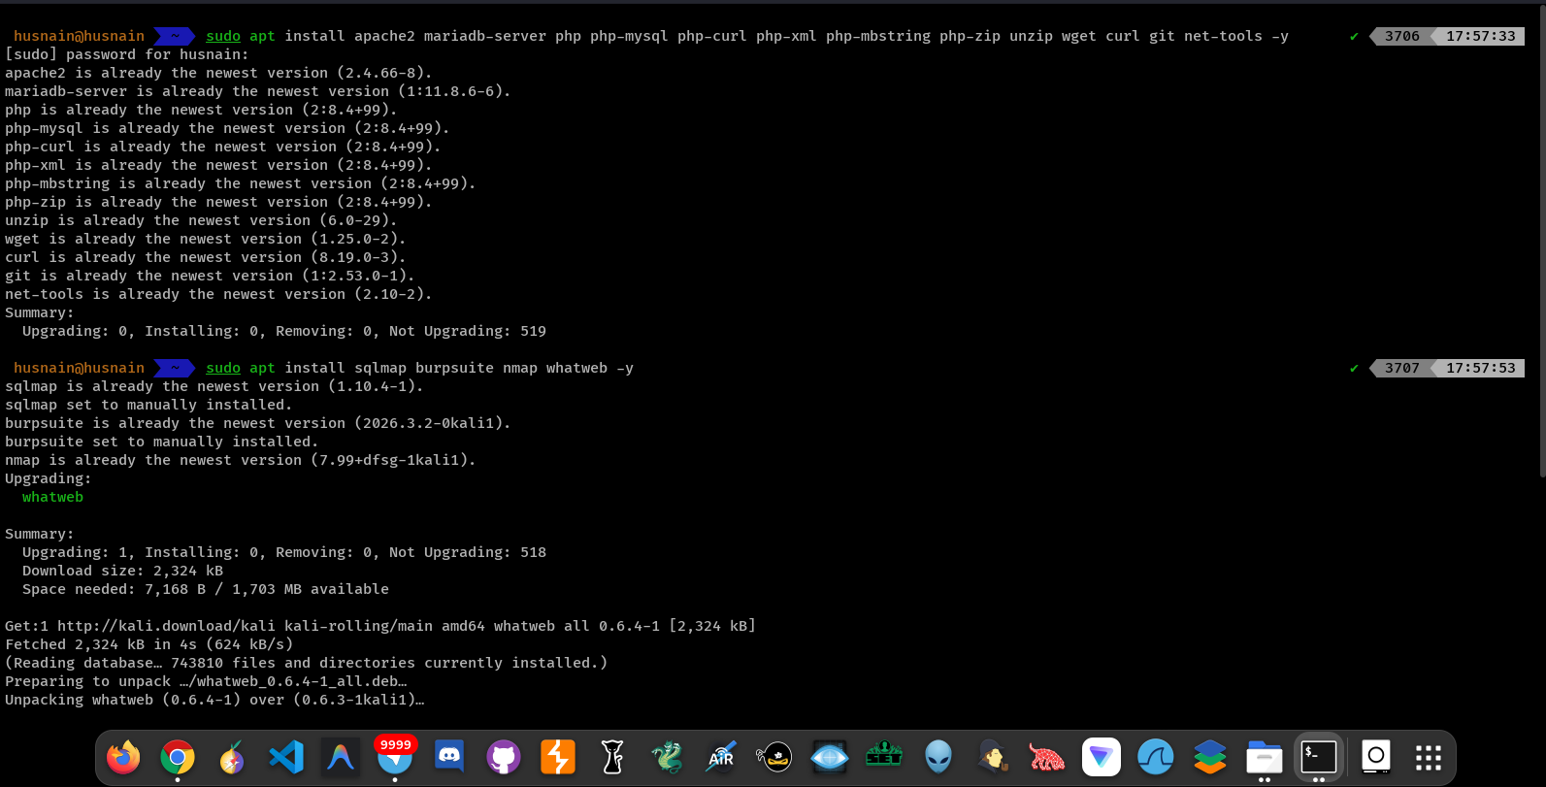
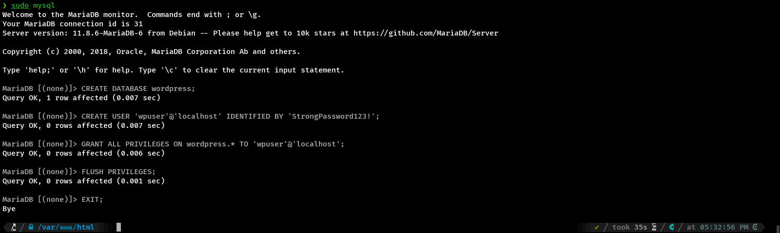
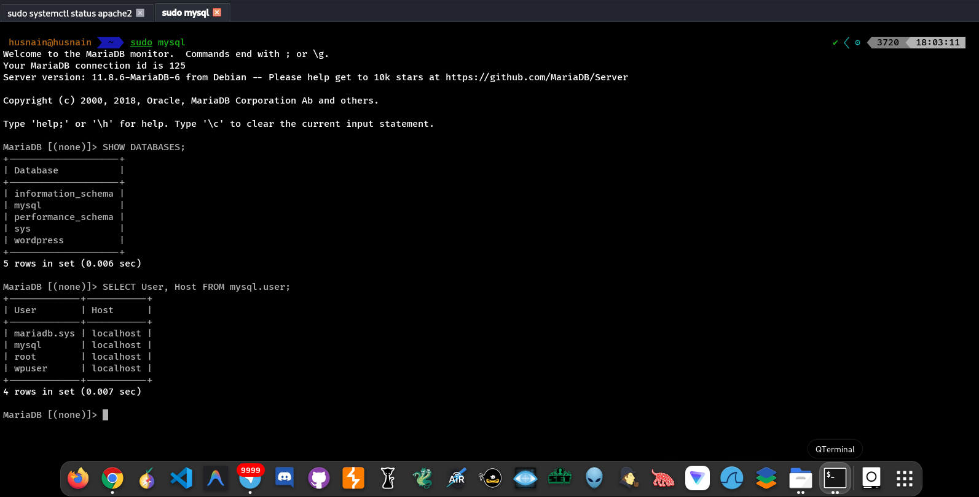
Reconnaissance Phase

Phase 1: Reconnaissance

Network Scanning with Nmap
I first scanned the target system to see what services were running. This helps understand the attack surface.
Command used:
nmap -sV localhost
Result:
The scan showed that port 80 (HTTP) is open running Apache 2.4.66. This confirmed the web application is accessible.
Screenshot: Nmap scan results showing open ports and services.
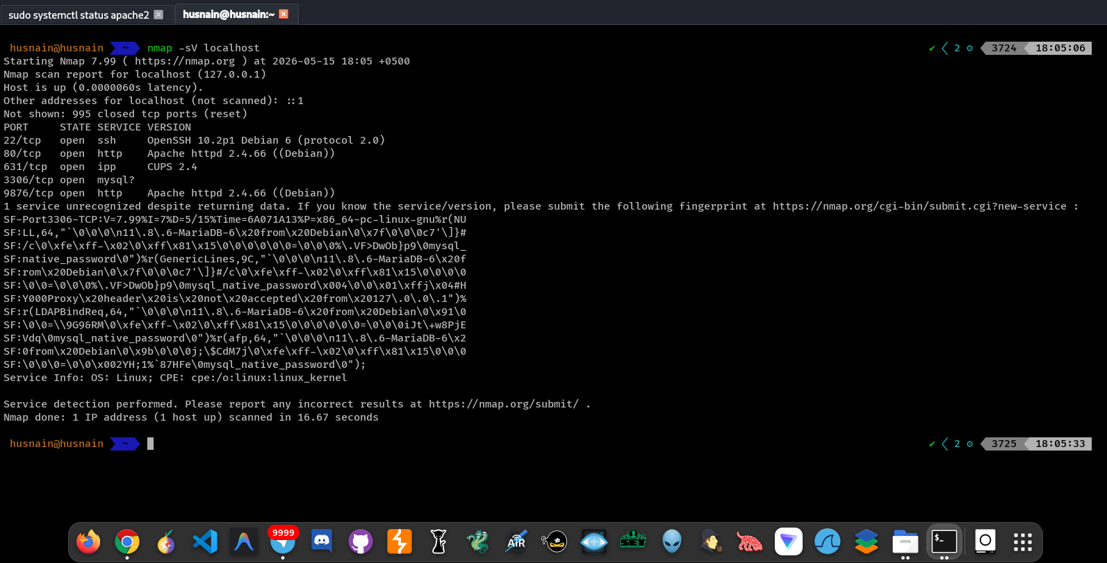 Nmap scan showing Apache and MySQL services on the target.

Technology Detection with WhatWeb
Next, I used WhatWeb to identify the content management system and its version.
Command used:
whatweb localhost
Results:
WhatWeb confirmed the site is running WordPress version 6.9.4.
Screenshot: WhatWeb fingerprinting output.
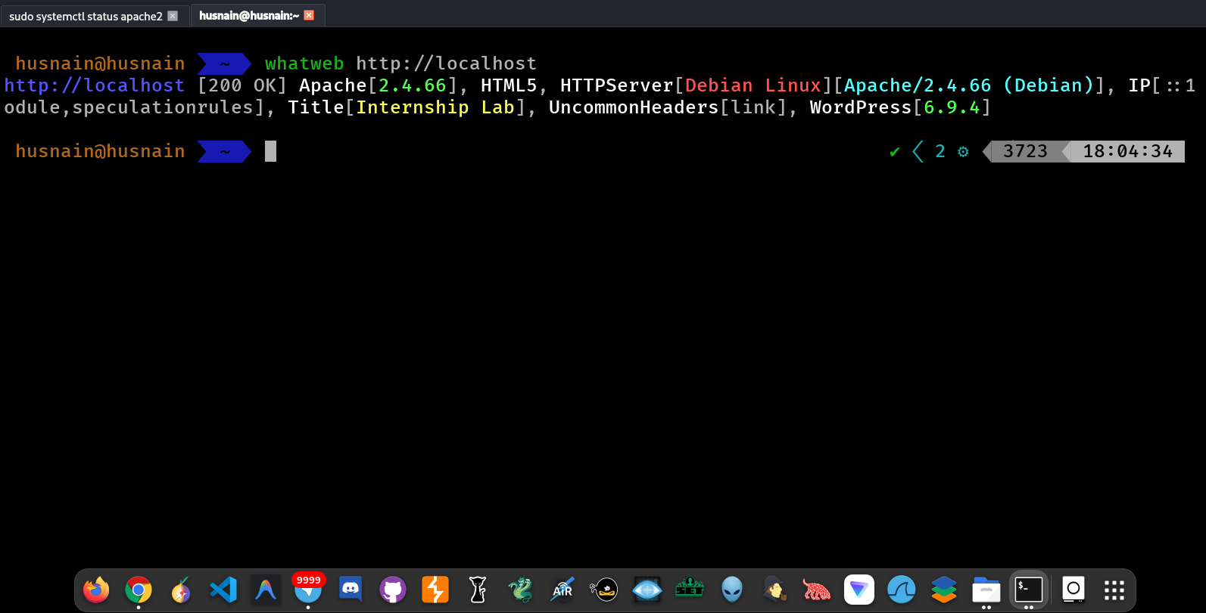 WhatWeb detecting WordPress 6.9.4 on the target.

Manual Verification
I opened the website in Firefox to manually verify it was working correctly.
Screenshot: WordPress homepage.
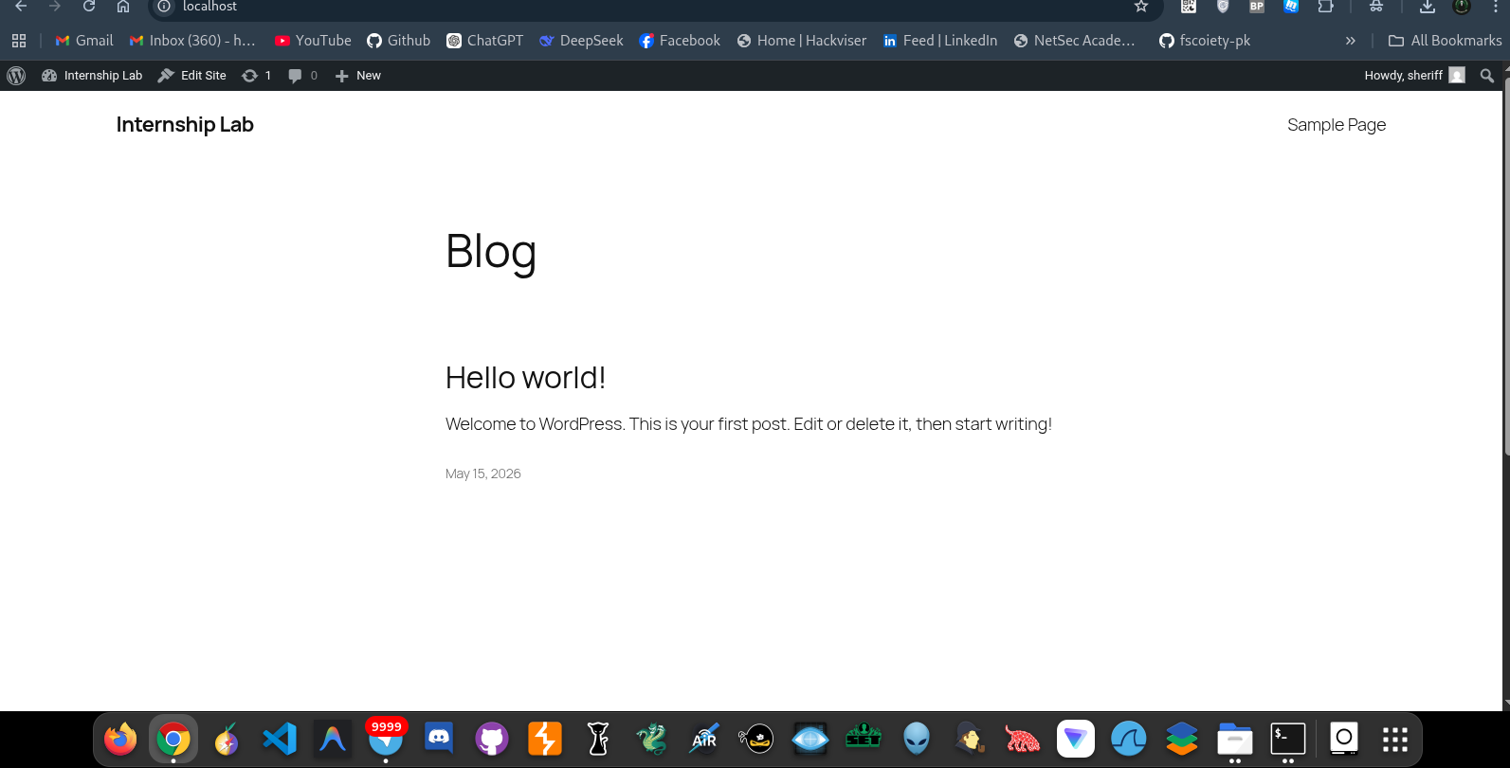The WordPress homepage loaded in browser.
Screenshot: WordPress admin dashboard. 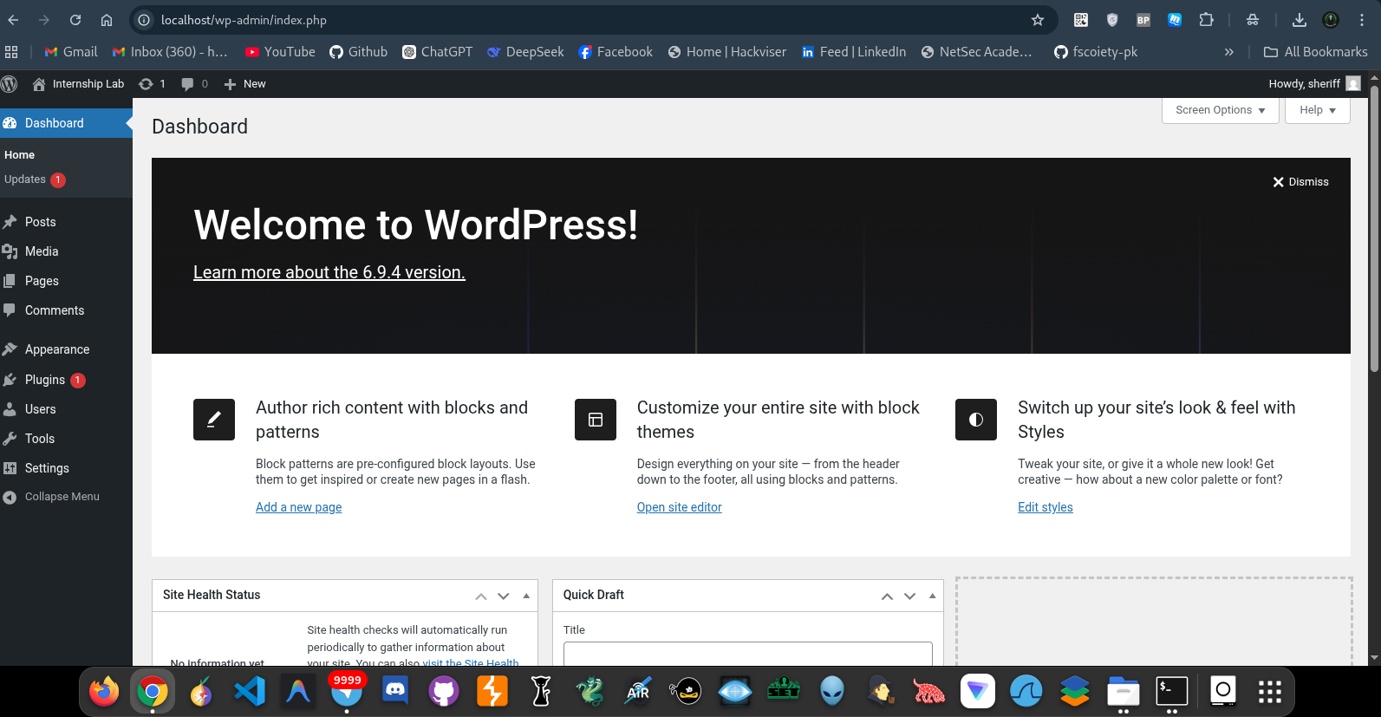
Access to WordPress admin panel after login.

Phase 2: Vulnerability Identification

Plugin Source Acquisition
I obtained the vulnerable plugin from GitHub. The AN_Gradebook version 5.0.1 plugin is publicly available on GitHub repositories that track vulnerable WordPress plugins for security testing purposes.
Source: GitHub (CVE-2023-2636 proof of concept repository)

Plugin Installation
After downloading the plugin ZIP file, I uploaded it through the WordPress admin panel.
Installation steps:
- Navigated to Plugins → Add New → Upload Plugin
- Selected the file an-gradebook-ready.zip
- Clicked ‘Install Now’
- WordPress confirmed successful installation
Screenshot: Plugin installation success message.
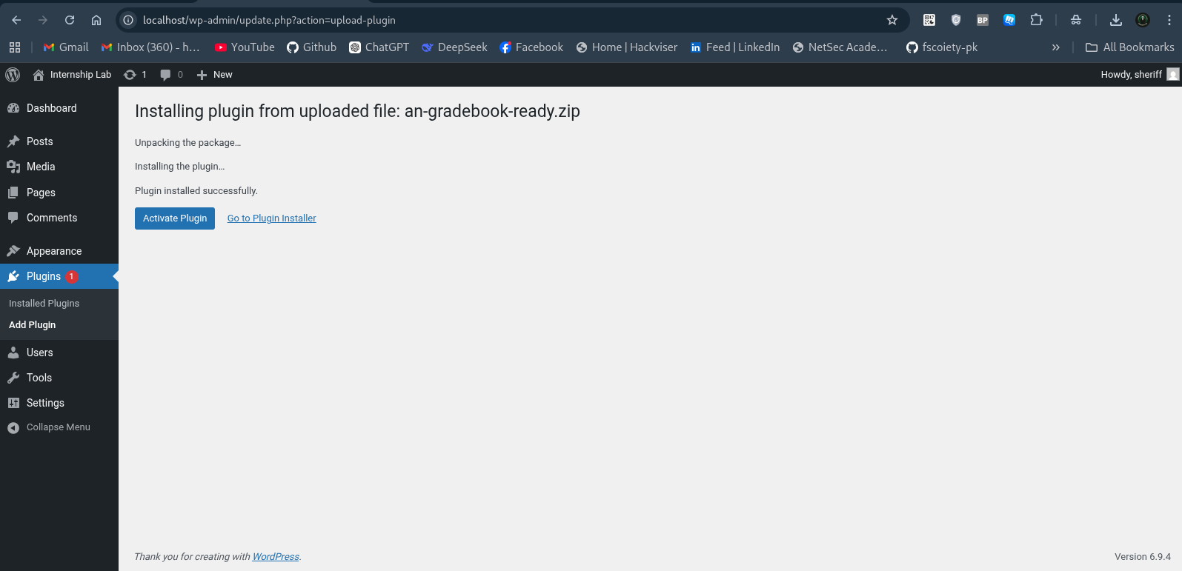 Plugin installed successfully message from WordPress.

Plugin Activation
Once installed, I activated the plugin to make it available on the website.

Screenshot: Plugin activated confirmation.
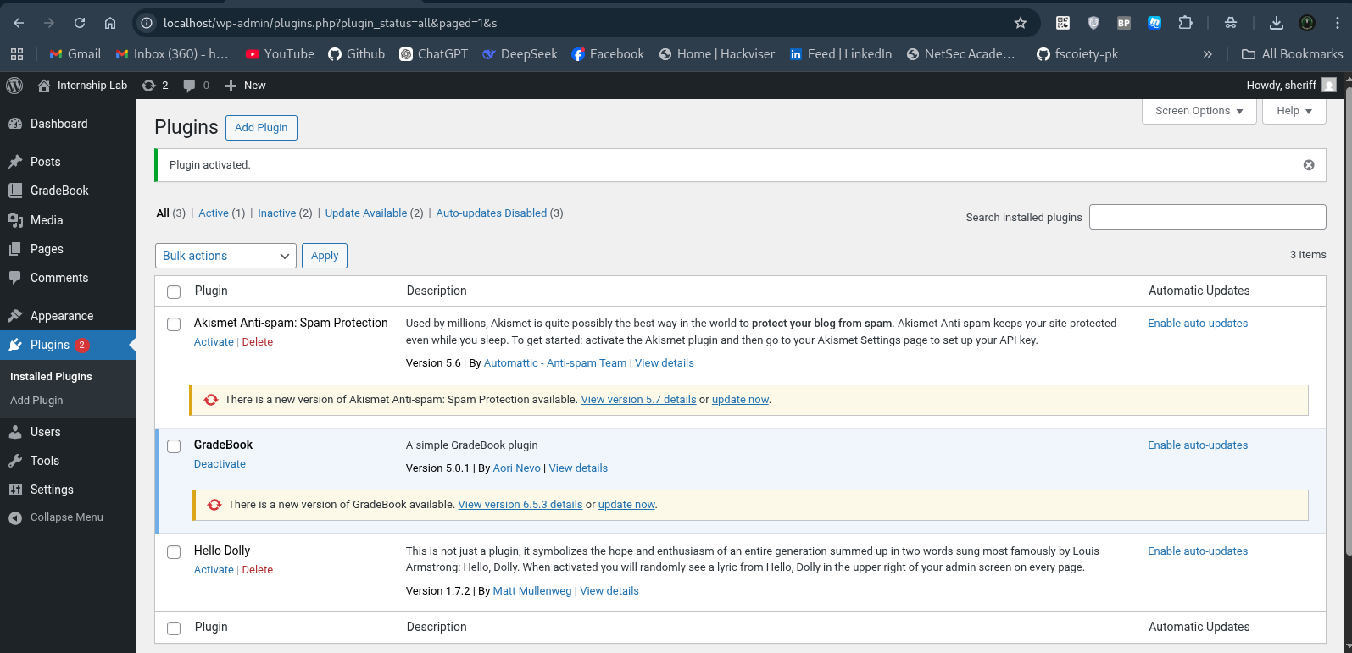 AN_Gradebook plugin showing as active in the plugins list.

Plugin Version Confirmation
The plugin README file confirms the version is 5.0.1, which matches the vulnerable version for CVE-2023-2636.
Screenshot: Plugin README showing version 5.0.1.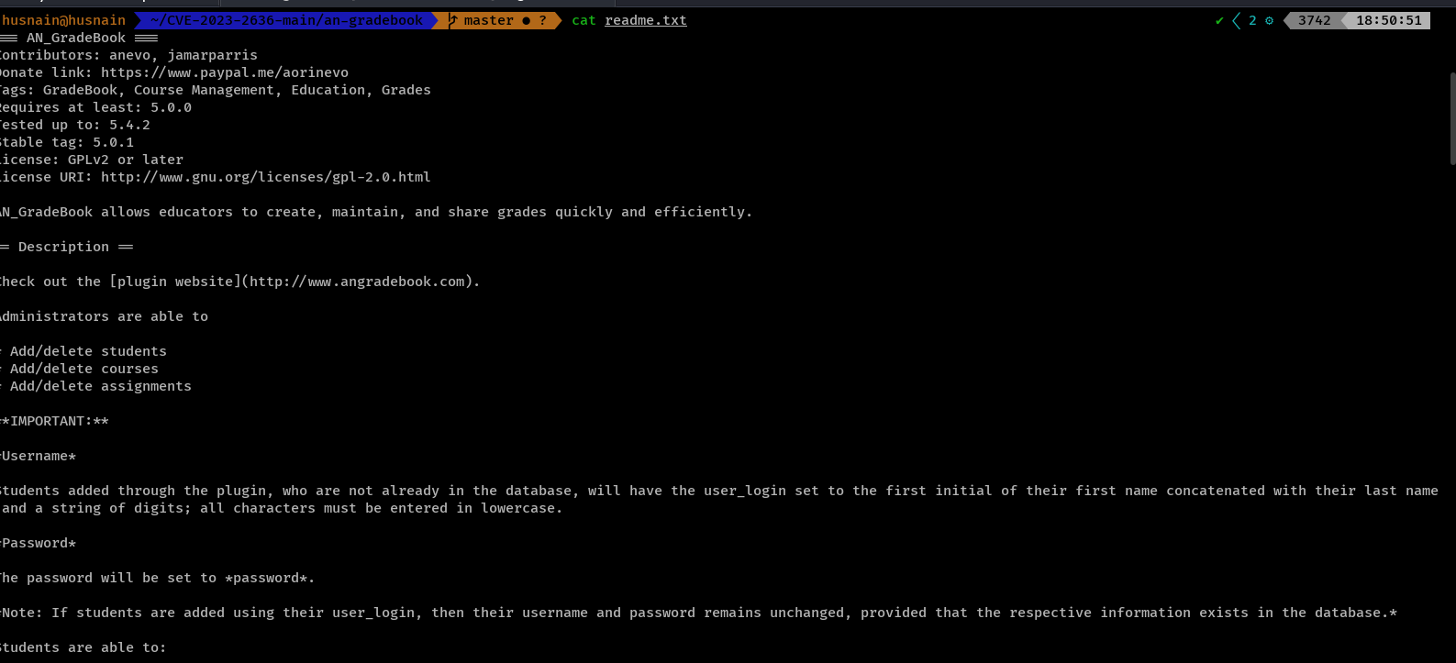 README.txt file showing stable tag 5.0.1.

Plugin Directory Structure
I examined the plugin files on the server to understand its structure and identify vulnerable code.

Screenshot: Plugin directory listing.
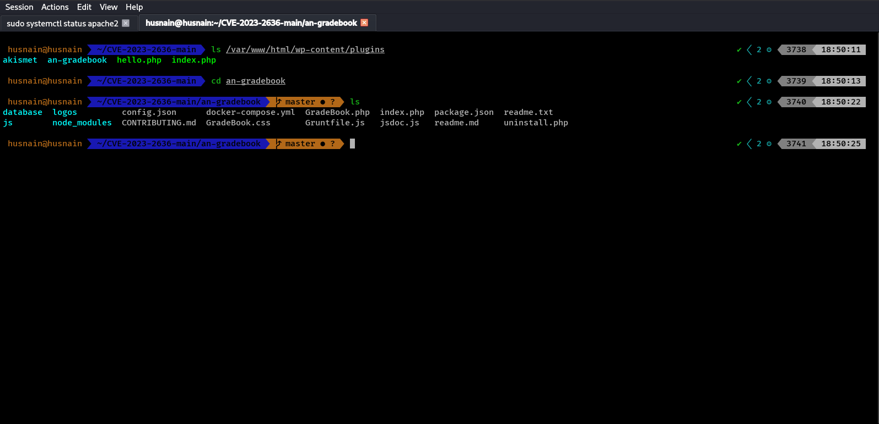 Terminal showing the an-gradebook plugin folder
Screenshot: Plugin source files.
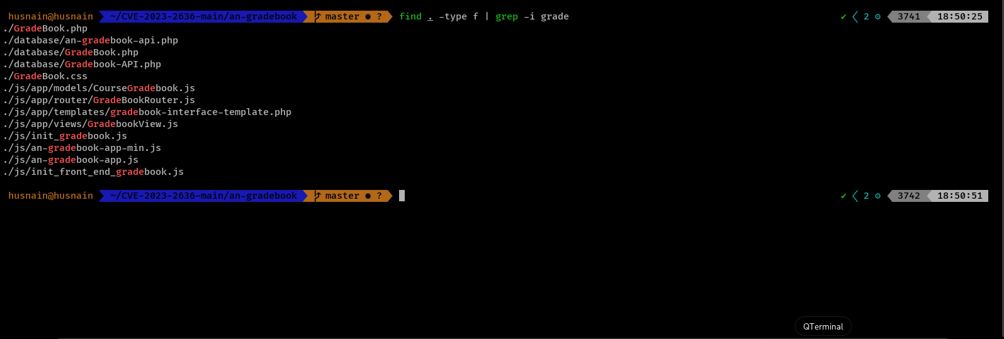 Finding GradeBook.php and other plugin files using grep command.

Source Code Analysis
The plugin files contain the vulnerable code. The GradeBook.php file handles user input from $_GET parameters without proper sanitization, which leads to SQL injection.
Key observation: The plugin uses $_GET parameters directly in database queries, making it vulnerable to manipulation.
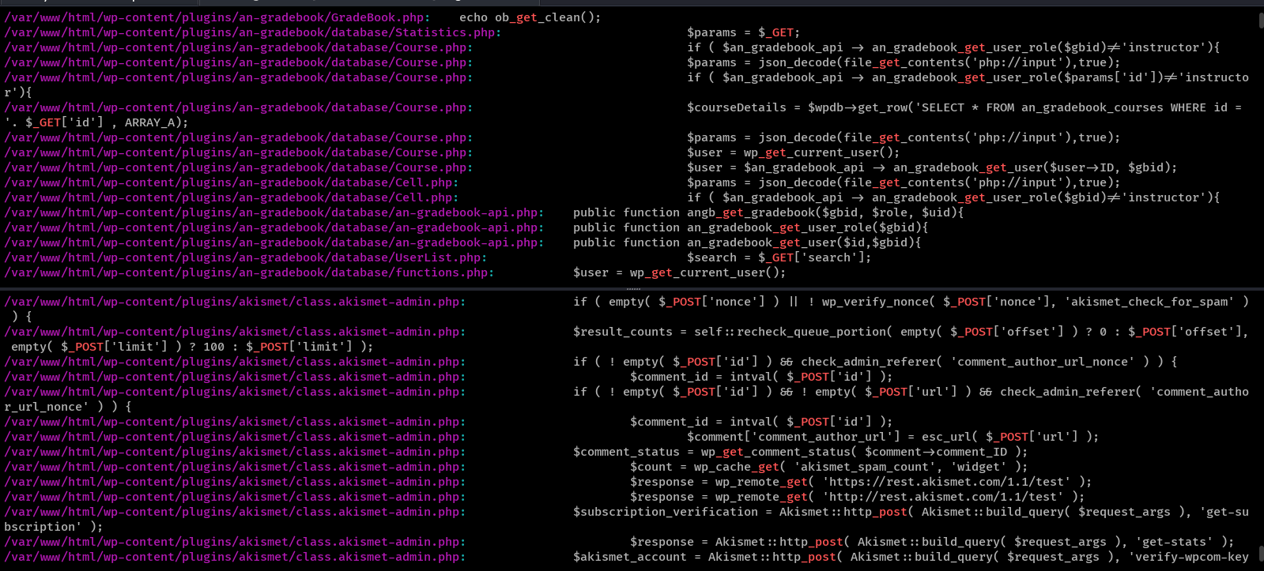
CVE Research
I searched online for known vulnerabilities in AN_Gradebook version 5.0.1. I found CVE-2023-2636 which describes an SQL Injection vulnerability. The vulnerability exists because the plugin does not properly sanitize user input in the ‘id’ parameter before using it in database queries.
Vulnerability Summary:
CVE ID | CVE-2023-2636
CVSS Score | 8.8 (High)
Attack Vector | Network
Privileges Required | Low (Subscriber role)
Impac | Database compromise, credential theft

Phase 3: Exploitation - Burp Suite Configuration
Proxy Setup To capture and analyze HTTP requests, I configured Burp Suite as an intercepting proxy.
Screenshot: FoxyProxy configuration in Firefox.
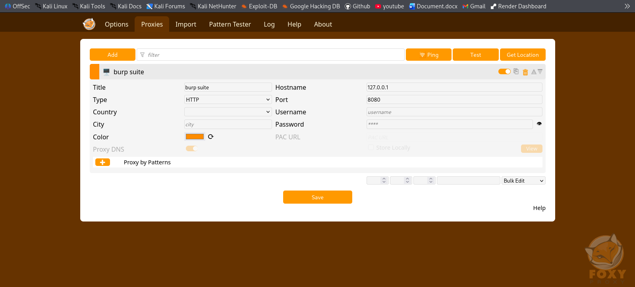Firefox proxy settings pointing to Burp Suite on port 8080.

Screenshot: Burp Suite proxy listener.
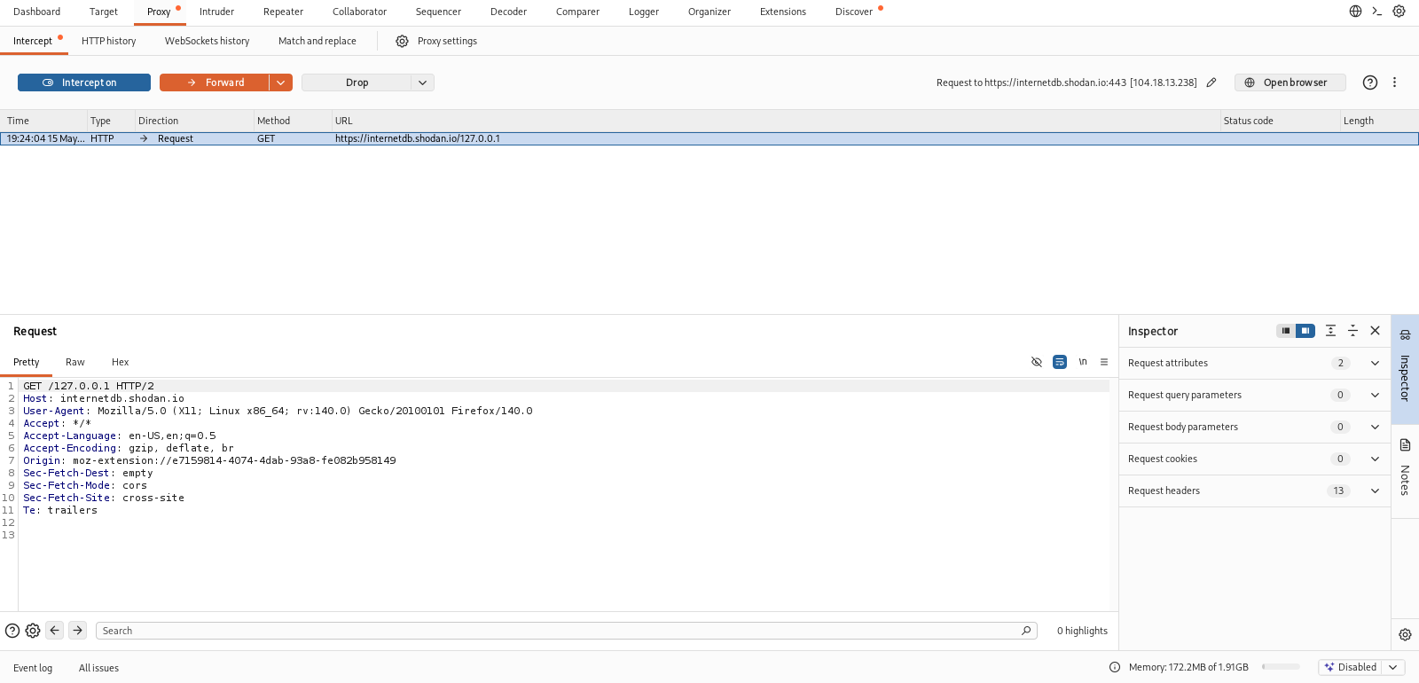Burp Suite running with proxy listener active.
Capturing the Vulnerable Request With Burp intercepting traffic, I accessed the plugin’s AJAX endpoint that retrieves course data. This endpoint uses the “id” parameter which is the vulnerable input.
URL accessed: localhost&#x2F;wp-admin&#x2F;admin-ajax.php?action=course&amp;id=1
Screenshot: Burp Suite capturing the vulnerable request.
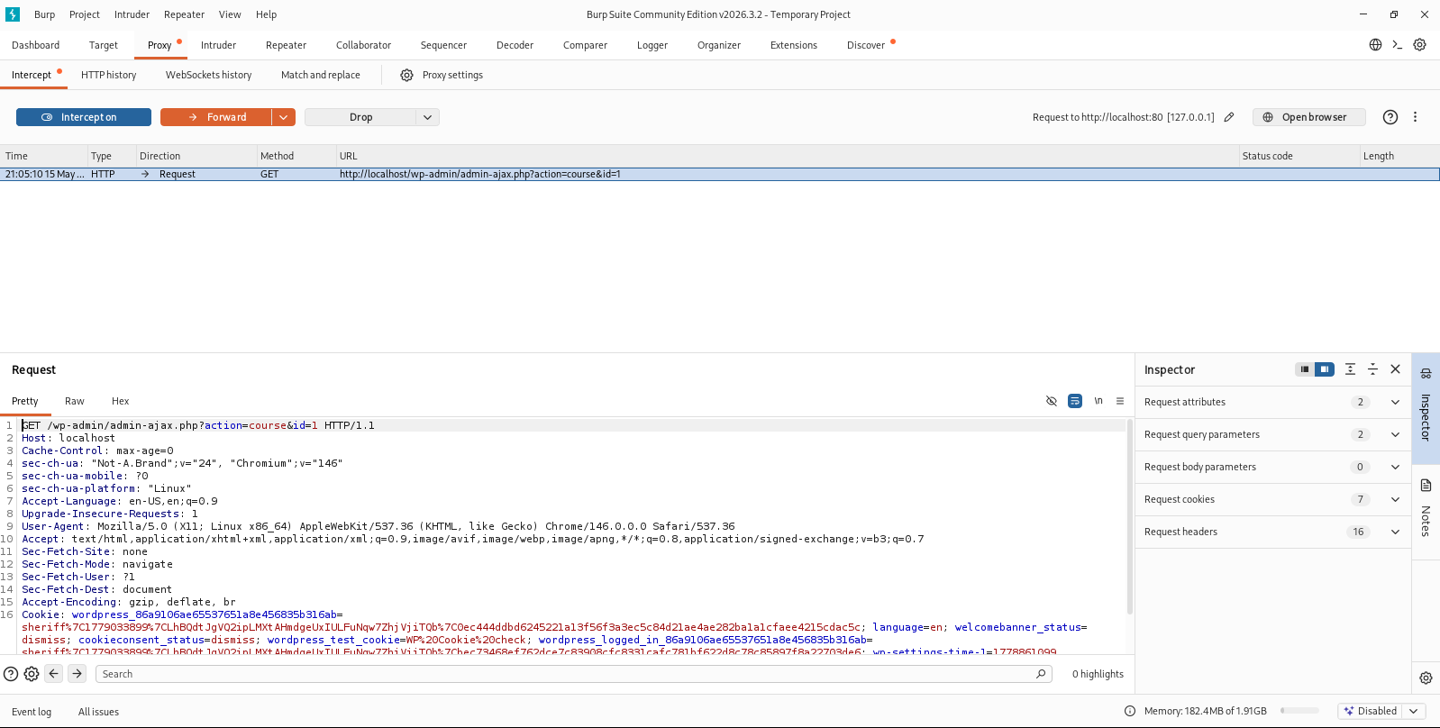Burp Suite showing the GET request with the ‘id’ parameter.
Screenshot: The intercepted request details.
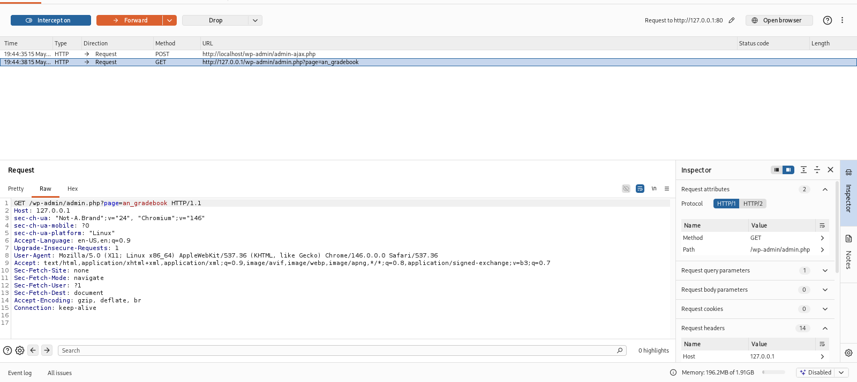 Request headers including authentication cookie.

Phase 4: Exploitation - SQL Injection with SQLMap

Vulnerability Confirmation
I saved the captured request to a file and ran SQLMap to test if the ‘id’ parameter was vulnerable to SQL injection.
Command used:
sqlmap -r correct-request.txt --batch --current-user
Results:
SQLMap confirmed the ‘id’ parameter is vulnerable to multiple types of SQL injection including boolean-based blind, error-based, time-based blind, and UNION queries.

Screenshot: SQLMap confirming the vulnerability.
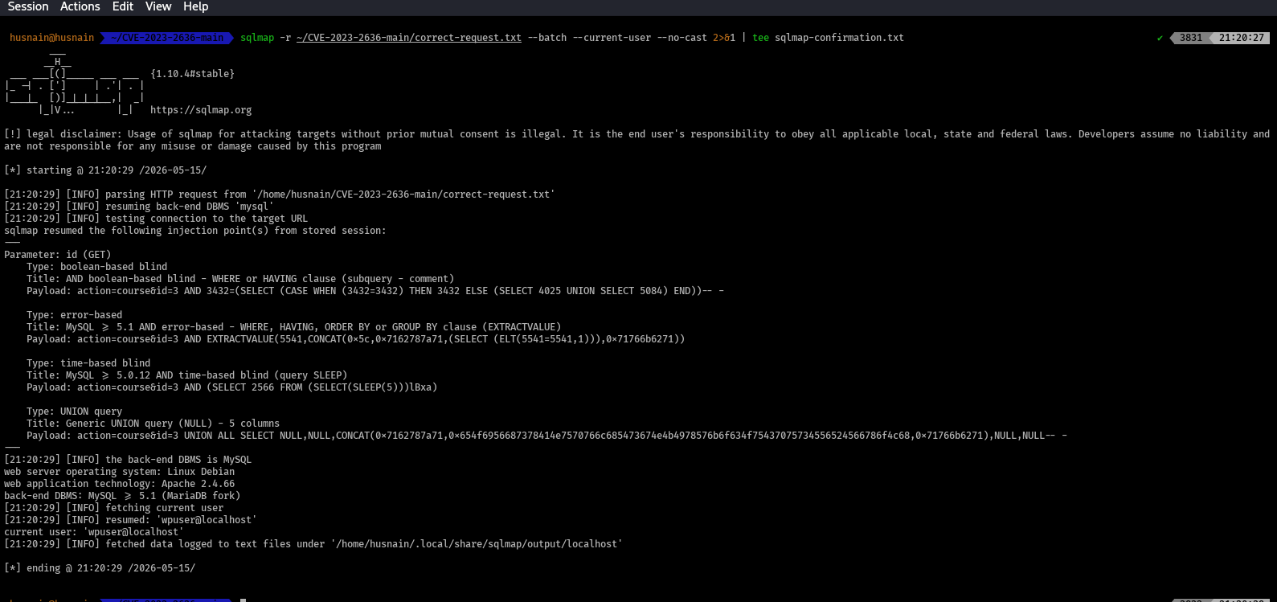SQLMap output showing the ‘id’ parameter is injectable with 4 different techniques.

Screenshot: Database user identification.
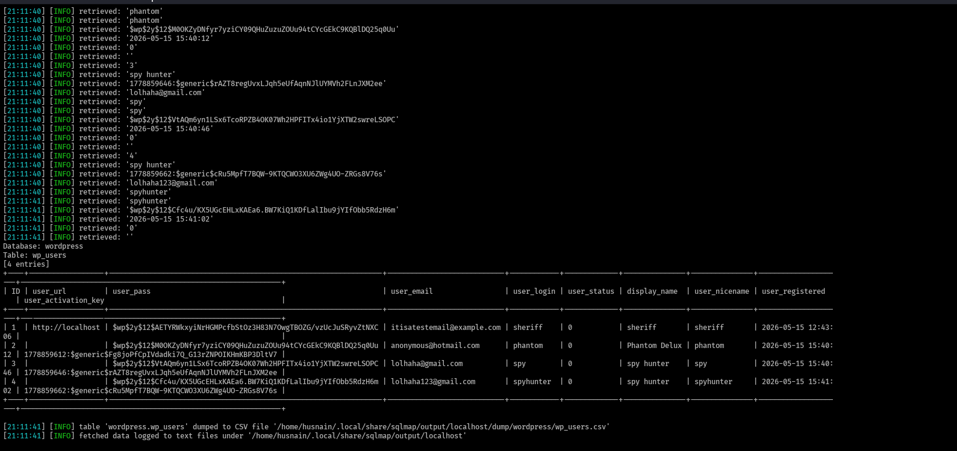
Current database user identified as ‘wpsuer@localhost’.

Database Enumeration
Next, I enumerated all databases on the server.
Command used:
sqlmap -r correct-request.txt --batch --dbs
Screenshot: List of databases found.
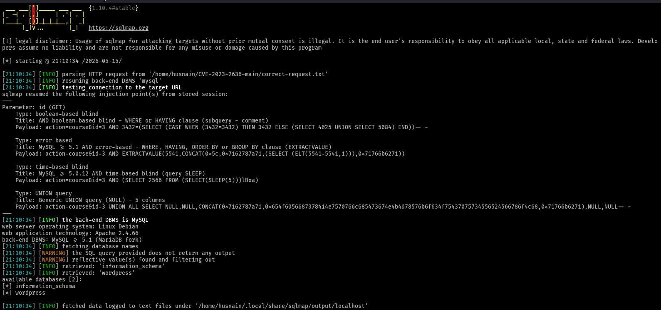 SQLMap showing available databases including ‘wordpress’.

Table Enumeration
I then listed all tables inside the WordPress database.
Command used:
sqlmap -r correct-request.txt --batch -D wordpress --tables
Screenshot: Tables in WordPress database.
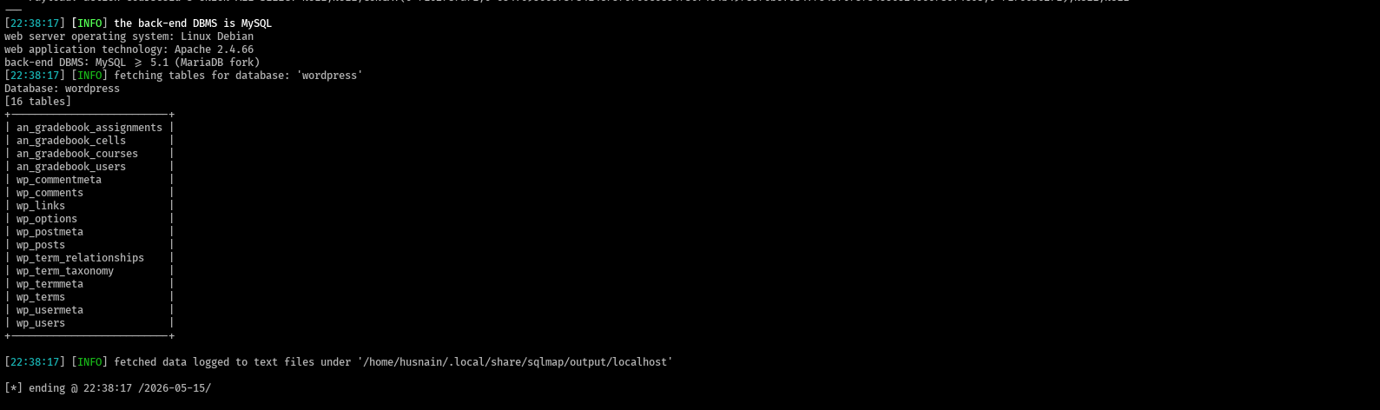SQLMap output showing 16 tables including wp_users and an_gradebook_courses.

Extracting User Credentials
This was the most critical step. I extracted the contents of the wp_users table which stores login information.
Command used:
sqlmap -r correct-request.txt --batch -D wordpress -T wp_users --dump Screenshot 17: Extracted user credentials.

SQLMap successfully dumping the wp_users table showing username ‘sheriff’, email, and password hash.

Plugin Data Extraction
I also checked the plugin’s course table.
Command used:
sqlmap -r correct-request.txt --batch -D wordpress -T an_gradebook_courses –dump
Screenshot: Course table structure.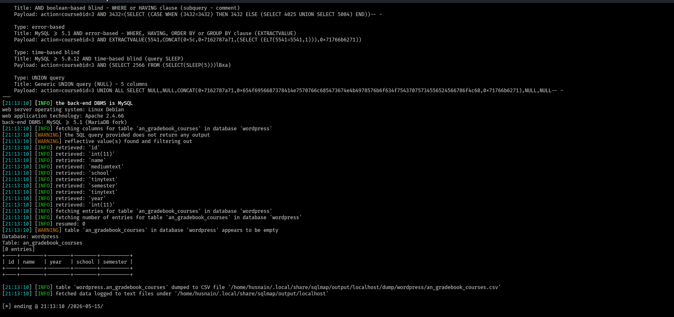The an_gradebook_courses table structure (empty as no courses were added through the plugin interface)
Note: Although the plugin’s course table was empty in SQLMap, the WordPress admin interface showed 5 courses. This may indicate the course data is stored differently in this version.
Screenshot: Courses visible in WordPress admin.
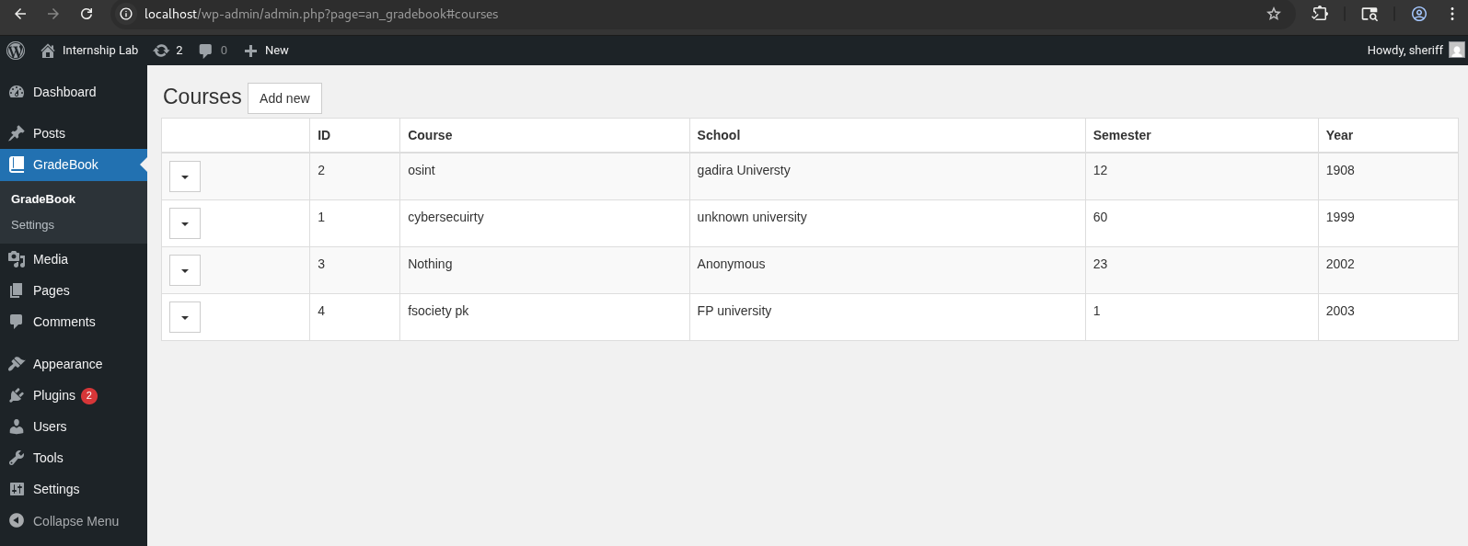 Five courses visible in the GradeBook plugin admin panel.

Impact Analysis
What an Attacker Can Do
- Successful exploitation of CVE-2023-2636 gives an attacker the ability to:
- Read all data in the WordPress database including user tables, posts, and plugin data
- Extract password hashes for all user accounts
- Crack passwords offline using tools like Hashcat or John the Ripper
- Log in as any user including administrators once passwords are cracked
- Upload malicious plugins leading to full server compromise
- Deface the website or steal sensitive information

Data Exposed in This Test
The following sensitive data was successfully extracted:
DATA TYPE | EXAMPLE | SEVERITY
Username | WordPress Installation | Medium
Email Address | WordPress Plugin | Medium
Password Hash | $wp$z$12$AETYRWkxyiNrHGMpCfbstO3H.. | High
Database Name | WordPress | Low
Database User | wpuser@localhost | Medium

Risk Rating
CATEGORY | RATING
CVSS Score | 8.8 (High)
Confidentiality Impact | High
Integrity Impact | High
Availability Impact | Low
Privileges Required | Low (Subscriber)

Real-World Implications
If this vulnerability existed on a production website:
- Data Breach: Thousands of user passwords could be stolen
- Reputation Damage: Customers lose trust in the website
- Legal Consequences: GDPR fines for data breaches
- Malware Distribution: Attacker could use the server to host malware
- SEO Poisoning: Attacker could add spam links affecting search rankings

Remediation Recommendations
Immediate Actions (24-48 Hours)
PRIORITY | ACTION | REASON
1 | Update AN_Gradebook to version 5.0.2 or higher | The patched version fixes the SQL injection
2 | Reset password for user ‘sheriff’ and all users | Compromised hashes may already be cracked
3 | Force password reset for all WordPress users | Ensures old compromised passwords are invalidated
4 | Review access logs for suspicious activity | Check if vulnerability was exploited before

Code-Level Fix
The root cause is that the plugin uses user input directly in SQL queries without sanitization.
Vulnerable code (what the plugin does):
php $id = $_GET[&#39;id&#39;]; $result = $wpdb→get_row (‘SELECT * FROM courses WHERE id = $id’);
Fixed code (what it should do):
php $id = intval ($_GET[&#39;id&#39;]);
$result = $wpdb→get_row ($wpdb→prepare (‘SELECT * FROM courses WHERE id = %d’, $id));
The fix requires:
- Converting the id parameter to an integer using intval ()
- Using $wpdb→prepare () to safely handle the query
- Never trusting user input directly

Long-Term Recommendations
Regular Plugin Updates
- Check for plugin updates weekly
- Subscribe to security advisories for WordPress plugins
Vulnerability Scanning
- Run weekly vulnerability scans using tools like WPScan
- Automate security testing in development
Web Application Firewall (WAF)
- Deploy a WAF to detect and block SQL injection attempts
- Cloudflare or ModSecurity are good options
Principle of Least Privilege
- Database user should only have necessary permissions
- WordPress database user should not have FILE or ADMIN privileges
Password Policy
- Enforce strong passwords (12+ characters, mixed case, numbers, symbols)
- Implement Multi-Factor Authentication (MFA) for admin accounts

Conclusion

Summary of Findings
This penetration test successfully identified and exploited CVE-2023-2636, a high-severity SQL Injection vulnerability in the AN_Gradebook WordPress plugin version 5.0.1.
Key Achievements:
CATEGORY | RATING
Vulnerability confirmed | Yes
Database user identified | wpsuer@localhost
Databases enumerated | wordpress, information_schema
Tables enumerated | 16 tables including wp_users
User credentials extracted | Username: sheriff
Password hash obtained | Yes
Impact demonstrated | Credential theft

Most Likely Attack Scenario
An attacker would:
- Register a Subscriber account on the WordPress site (or compromise a low-privilege account)
- Use the vulnerable AJAX endpoint to run SQL injection
- Extract all user password hashes from wp_users
- Crack hashes offline using rainbow tables or brute force
- Log in as an administrator
- Upload a malicious plugin to achieve Remote Code Execution (RCE)
- Take full control of the server

Final Recommendation
Immediate Action Required
The AN_Gradebook plugin version 5.0.1 must be updated or removed immediately. The vulnerability allows any authenticated user to read the entire database including password hashes. This poses a critical risk to the confidentiality and integrity of the WordPress site.
After updating the plugin, all user passwords should be reset as a precaution. Moving forward, regular vulnerability scanning and a formal patch management process should be implemented.

