
Secure Dev Lab

Ethical Hacking Task Submission
Student Information

Student Name | Husnain Fiaz | batch | 1st
Internship Track | Ethical Hacking | week | 2nd
Submission date | 02/5/2026 | Instructor | Muhammad Saad Rajput
Tool Used | BurpSuite | File Name | husnain-fiaz-ethical-hacking-task2-report.docx

- Task Overview

1. Vulnerable Web Application Setup (DVWA)

2. Burp Suite Practical & Theory

3. HTTP Request & Response Concepts

4. Cookies, Sessions, Authentication & Authorization

5. DNS (Domain Name System)

- VULNERABLE WEB APPLICATION SETUP
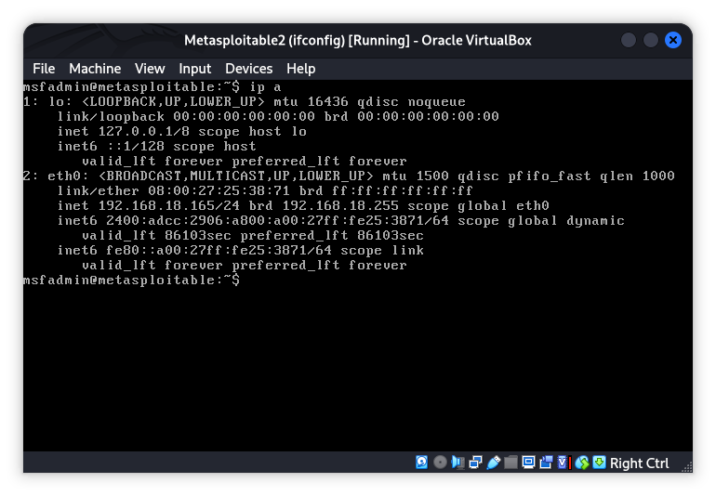
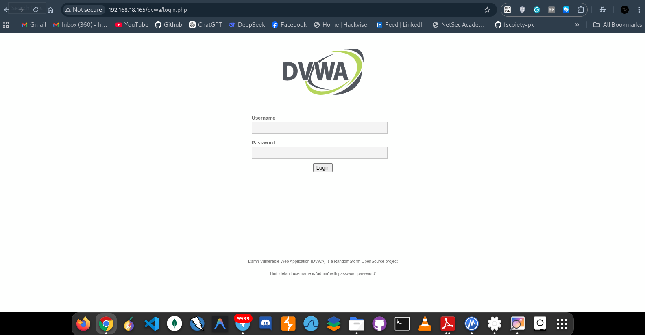
- Mapped user-controlled endpoints

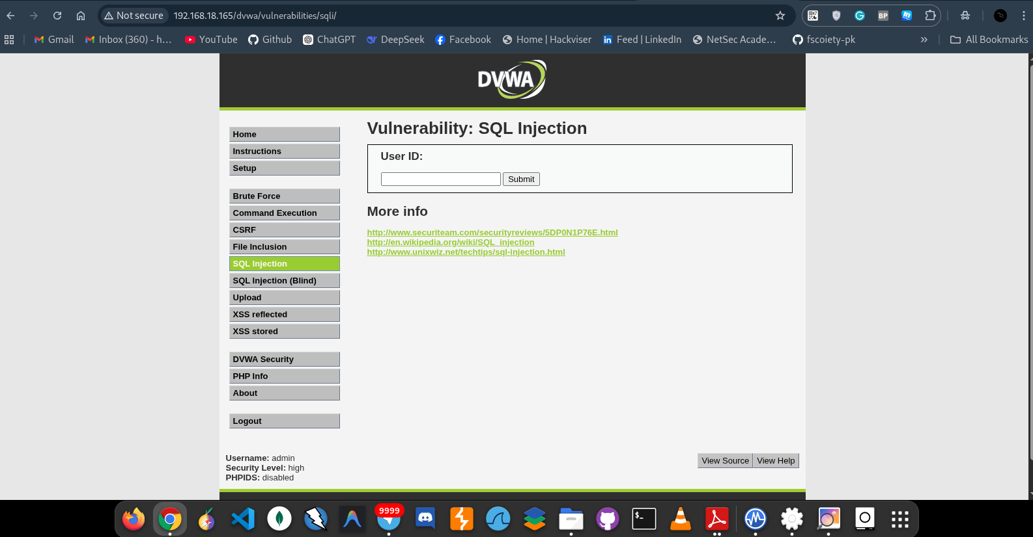
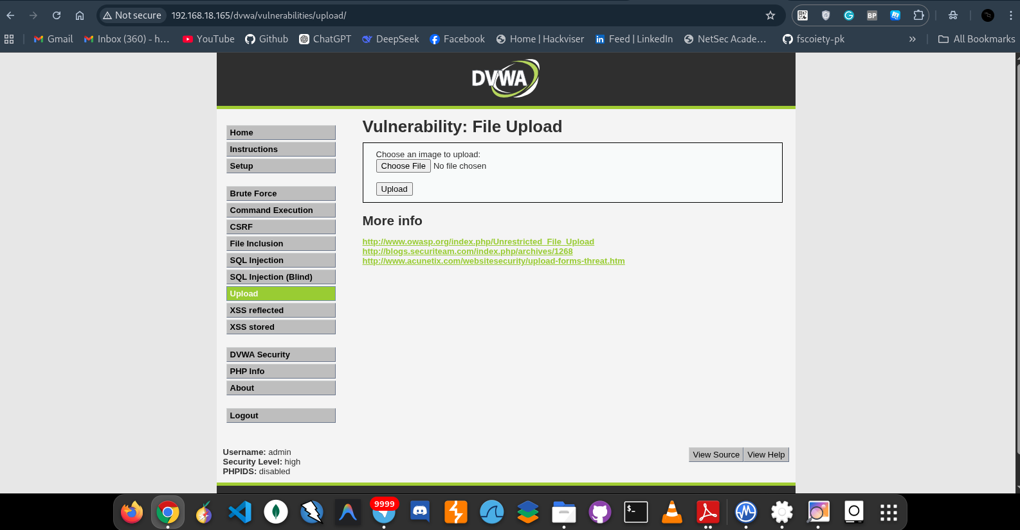

- First request captured in Burp Suite
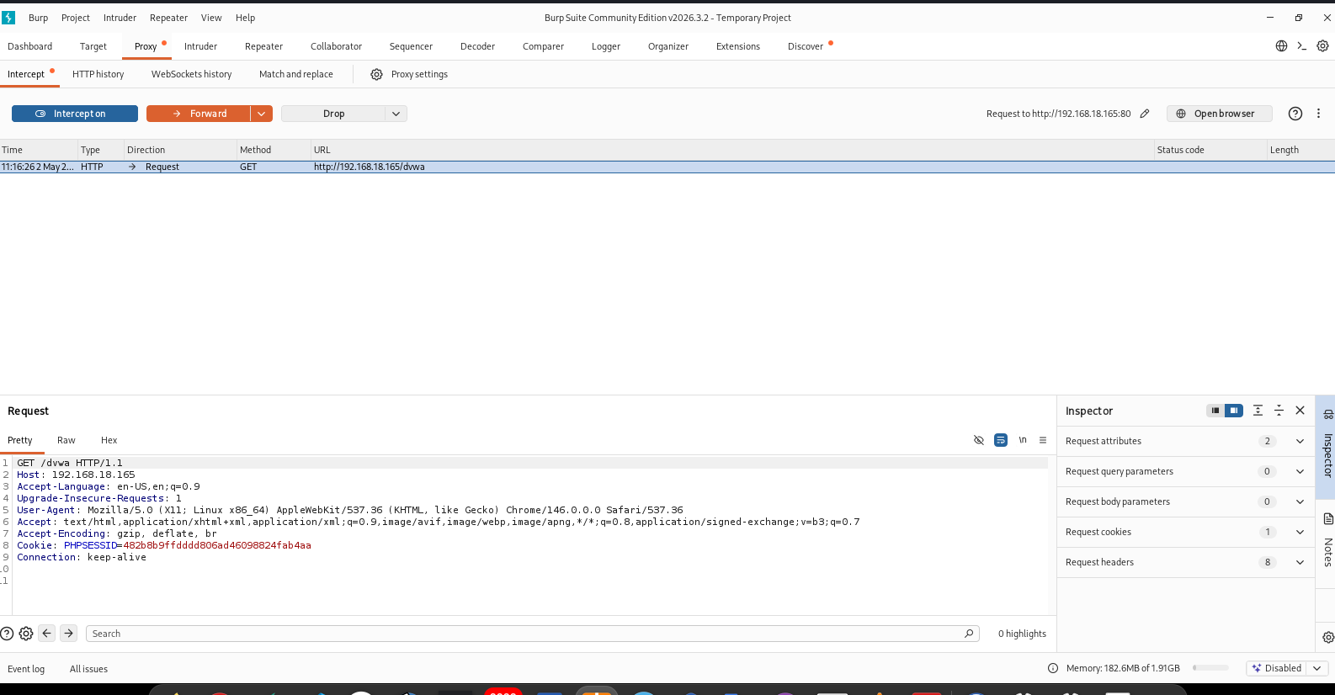

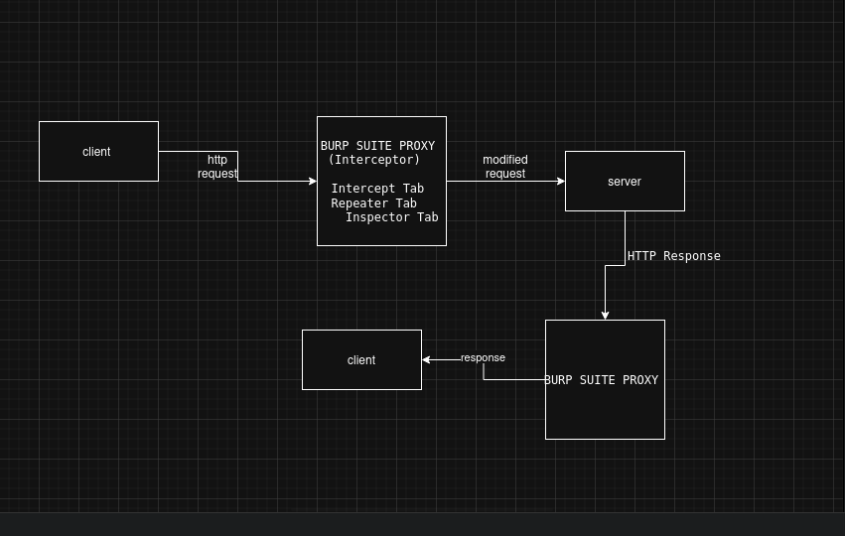
- Captured request forwarded to Repeater
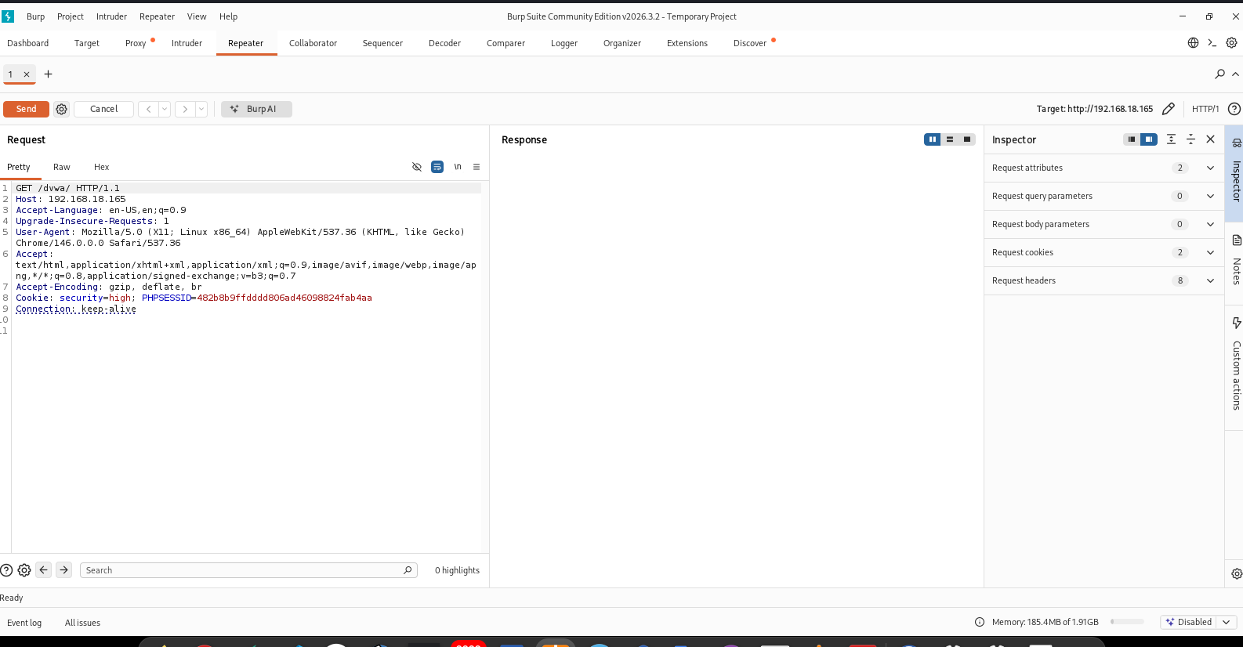
6. Browser request to website
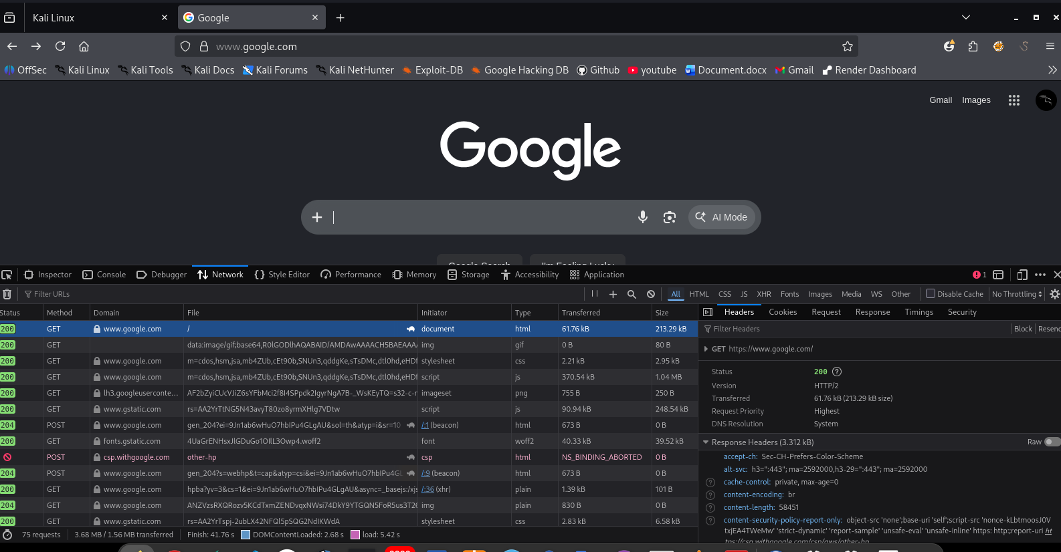
7. HTTP response from website
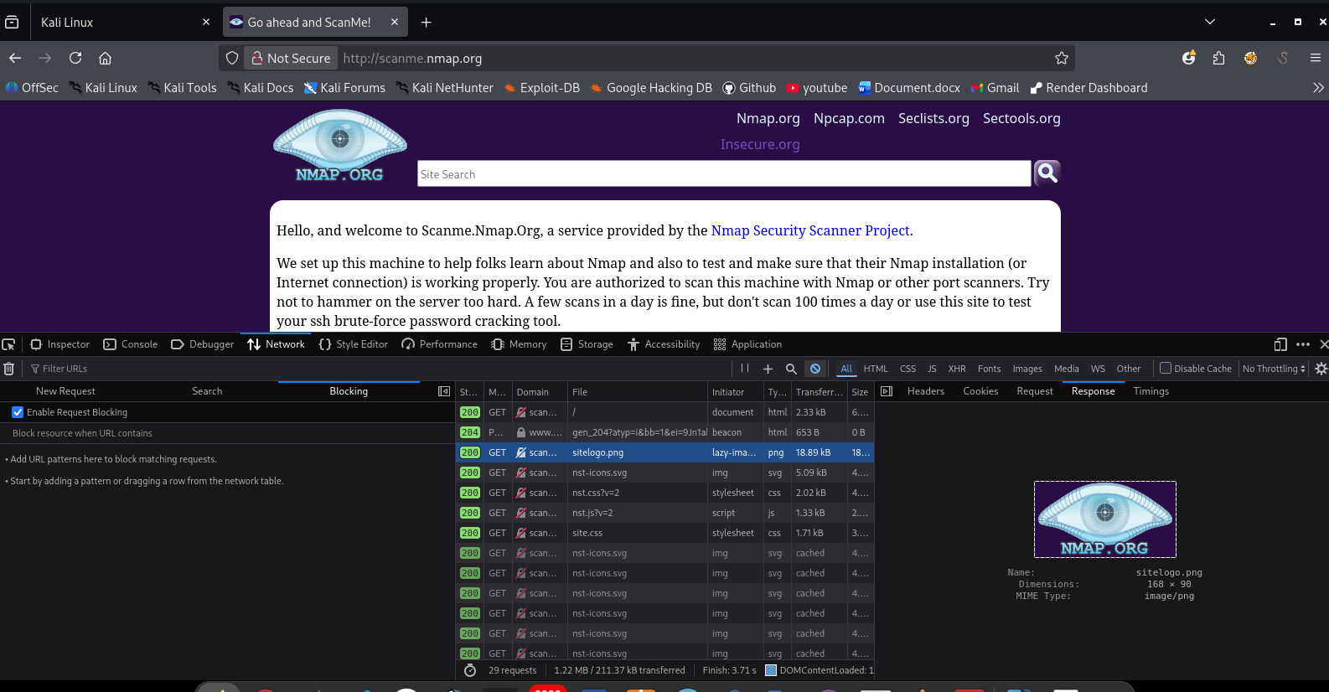

request and response concept through draw.io
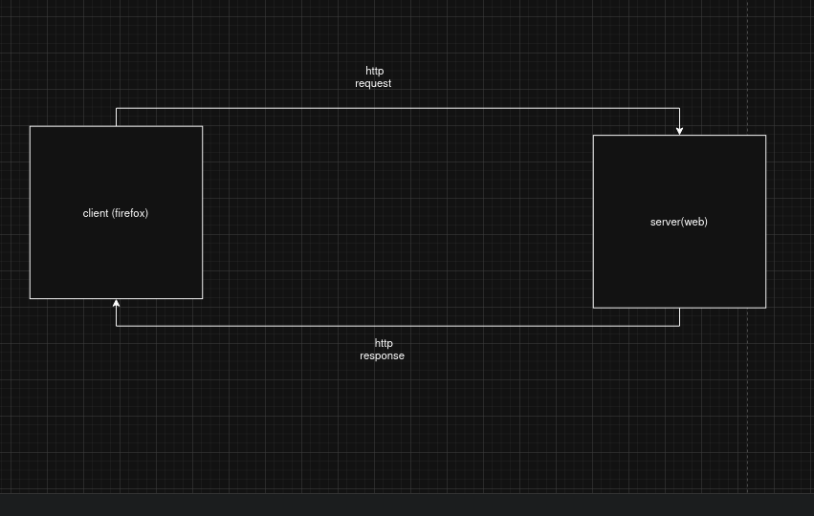

8. Login request showing cookies/session headers
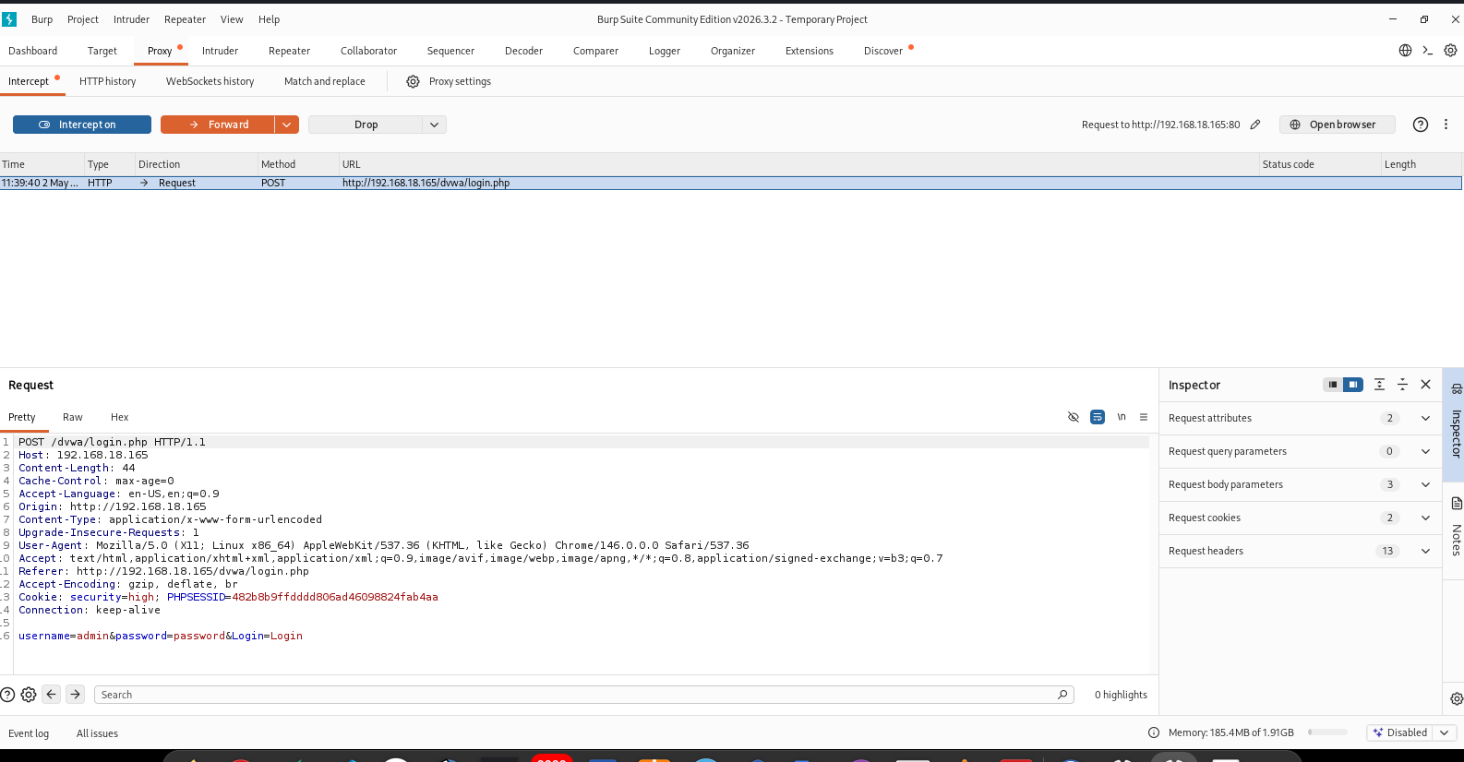

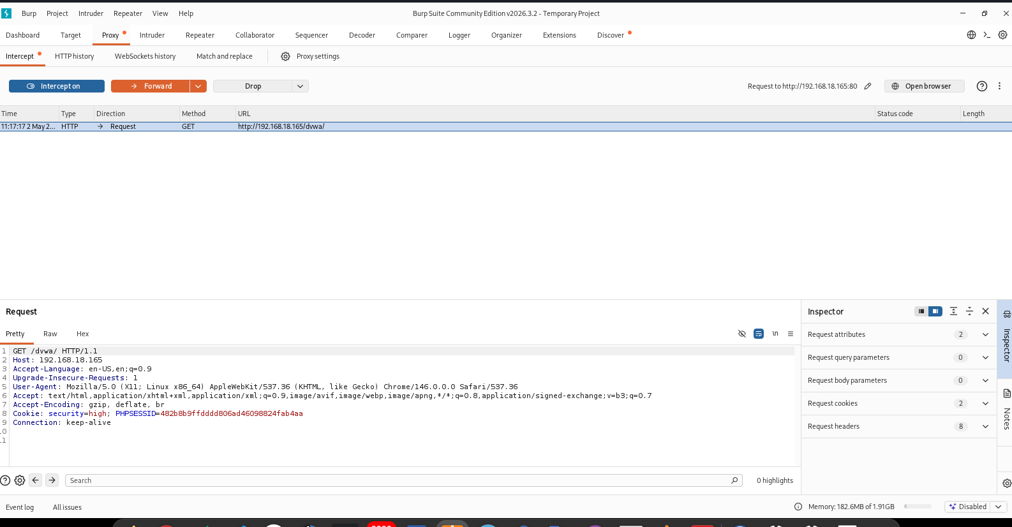

cookies concept in the draw.io

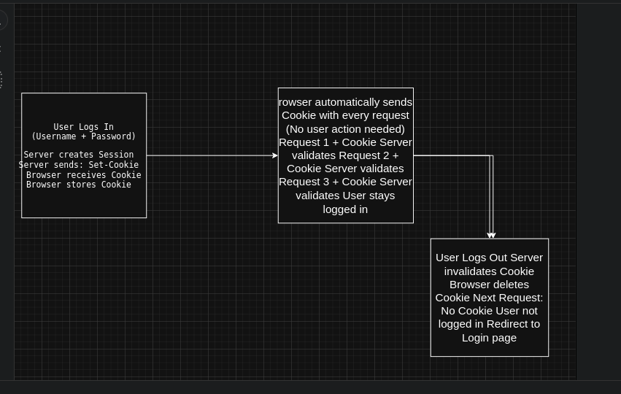
9. DNS request/result
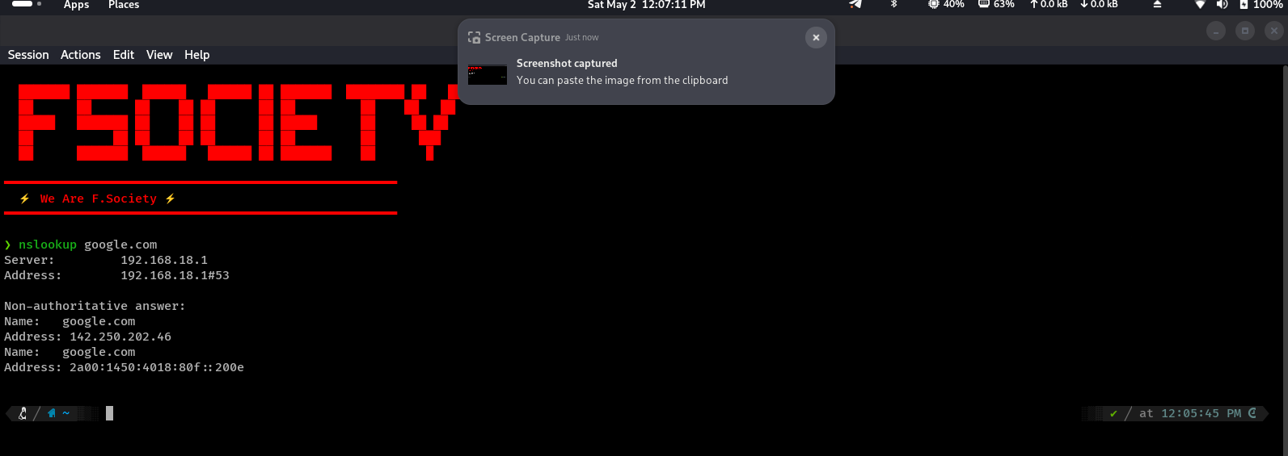

Theory :
Burp Suite is a web security testing tool used to capture, inspect, and
modify HTTP/S traffic. Nmap is primarily a
network scanner used to discover hosts, ports, and services.
Request is data sent by a client/browser to a server asking for a
resource. Response is the server reply containing
status, headers, and content.
Common HTTP response codes include 200 OK, 301 Moved
Permanently, 302 Found, 403 Forbidden, 404 NotFound, and 500 Internal Server Error.
Authentication (AUTHN) verifies identity. Authorization (AUTHZ)
determines permissions after identity is verified.
Cookies and sessions are used to remember users, maintain login
state, and personalize interactions.
DNS translates human-readable domain names into machine-
readable IP addresses

Short Conclusion:
This task improved understanding of how web applications
communicate and where user input enters the system.
Mapping endpoints, capturing traffic, and reviewing sessions are
foundational skills for later vulnerability testing.

Submission Checklist :
Student details completed
Task title and objective included
Tools and target information listed
Screenshots inserted with captions
Theory answers completed
Short conclusion written

