

Day 1 : Ethical hacking phases · Footprinting & Reconnaissance · Passive vs Active recon

Ethical Hacking Phases

1. Reconnaissance (Information Gathering)
The first phase involves collecting information about the target, such as domain names, IP addresses, technologies, employees, and network details. This can be done using passive and active reconnaissance techniques.

2. Scanning and Enumeration
In this phase, the target is scanned to identify open ports, running services, operating systems, and potential vulnerabilities. Enumeration is used to gather detailed information such as users, shares, and services.

3. Gaining Access (Exploitation)
The ethical hacker attempts to exploit identified vulnerabilities to gain access to the target system. This helps determine whether the vulnerabilities can actually be abused.

4. Maintaining Access (Post-Exploitation)
After successful exploitation, the tester evaluates what actions could be performed with the obtained access, such as privilege escalation or persistence. This phase is performed only within the agreed scope of the assessment.

5. Covering Tracks (Awareness Phase)
Traditionally, this phase demonstrates how malicious attackers may attempt to hide their activities by deleting logs or modifying evidence. Ethical hackers do not remove logs or conceal their actions on real client systems. Instead, they explain these attacker techniques to help organizations improve detection and monitoring.

6. Reporting
The final phase involves documenting all findings, vulnerabilities, proof of concept, risk levels, and recommended mitigations. A clear report enables the organization to understand the security issues and take corrective actions.
Footprinting & Reconnaissance

What is Footprinting?
Footprinting is the process of collecting information about a target before attempting any security testing. The objective is to understand the target's infrastructure, technologies, employees, domains, IP addresses, and publicly available information.

What is Reconnaissance?
Reconnaissance is the information-gathering phase of ethical hacking. It involves collecting as much relevant information as possible to identify potential attack surfaces and security weaknesses. It is the first step in the ethical hacking process.

Types of Reconnaissance

1. Passive Reconnaissance
Passive reconnaissance gathers information without directly interacting with the target system. Since no direct contact is made, it is difficult for the target to detect.

Examples:
- WHOIS lookups
- Google Dorking
- DNS record lookup
- Social media investigation
- Searching GitHub for exposed data
- Reviewing company websites and public documents

Advantages:
- Low risk of detection
- No direct impact on the target

2. Active Reconnaissance
Active reconnaissance involves direct interaction with the target to collect technical information. These activities are more likely to be detected by monitoring systems.

Examples:
- Port scanning with Nmap
- Banner grabbing
- Service enumeration
- Network scanning
- Vulnerability scanning

Advantages:
- Provides accurate and up-to-date technical information
- Identifies live hosts, open ports, and running services

Tasks
Used whois tool to gather information about a domain e.g google.com

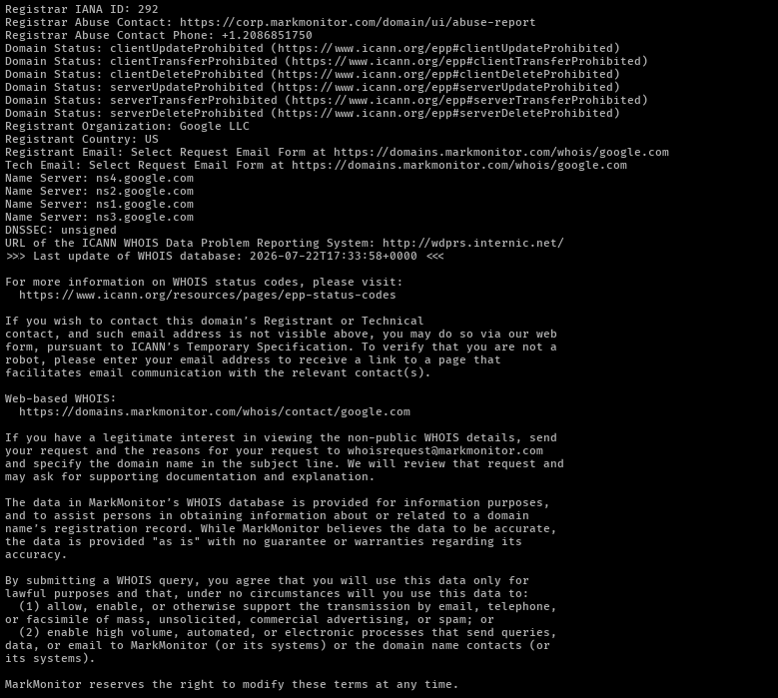
used nmap tool to check ports, servies, version and Operating System etc
