

Recon-ng Tool Report on Target domain

- Target Domain : owasp.org
- Tool Used : recon-ng
Step 1: Launching Recon-ng
Recon-ng was launched from the Kali Linux terminal using the command 'recon-ng'. This framework provides a modular environment for performing Open Source Intelligence (OSINT) and passive reconnaissance. It allows investigators to collect publicly available information about a target without interacting with or attacking the target systems.
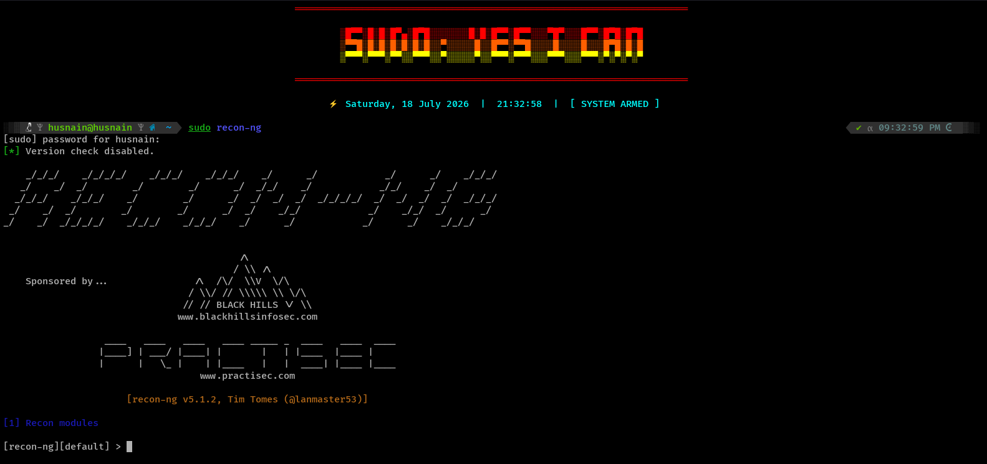
Step 2: Creating a Workspace
A new workspace named 'owasp_report' was created to keep all collected information organized. Workspaces separate different projects so that the data gathered for one target does not mix with another.
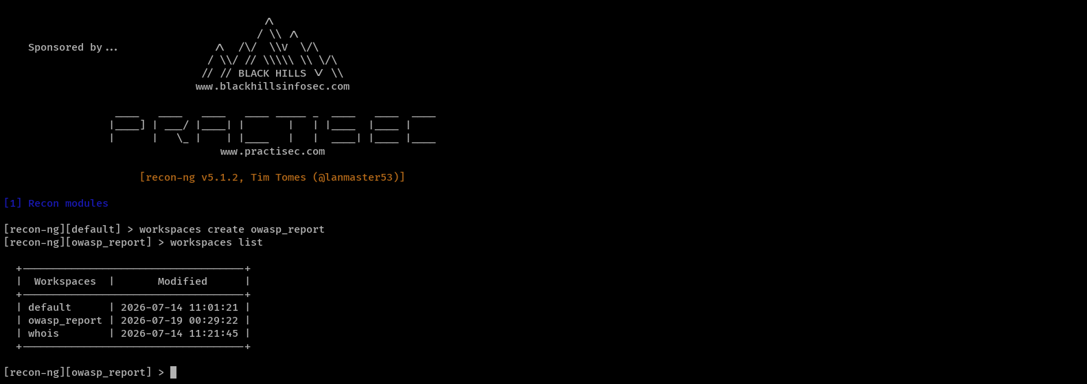
Step 3: Selecting and Adding the Target Domain
The target domain selected for this exercise was 'owasp.org'. OWASP (Open Worldwide Application Security Project) is a globally recognized non-profit organization dedicated to improving software security. It was chosen because it is a legitimate public organization with a large number of publicly available resources, making it ideal for learning passive reconnaissance techniques. The domain was added to the Recon-ng database so that reconnaissance modules could use it as the input source.
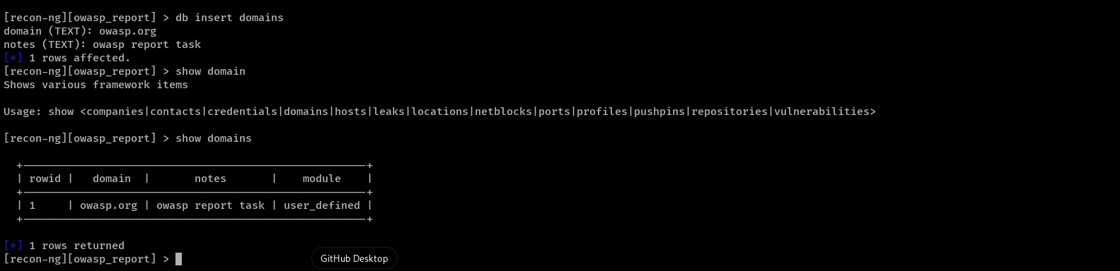
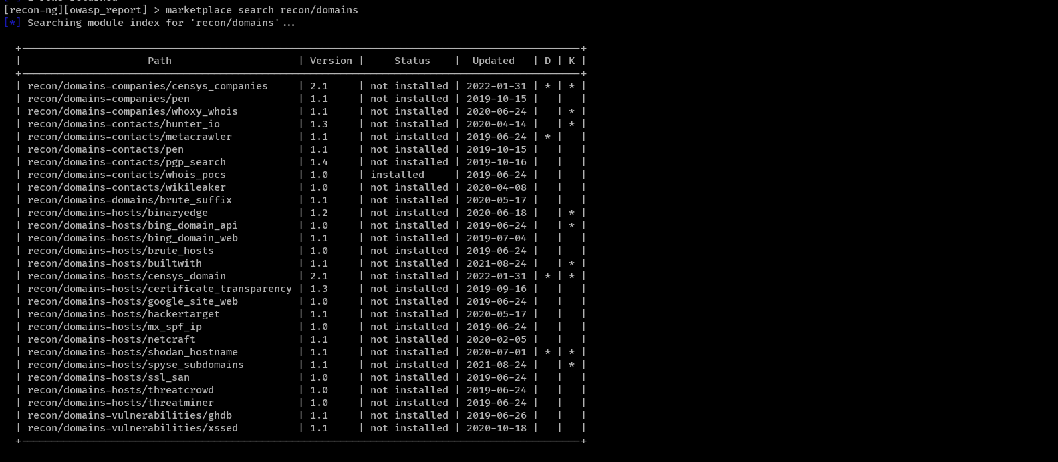
Step 4: Installing the Required Modules
Recon-ng provides many modules, but only a few are required for this assessment. The selected modules were installed because they collect information from different public sources. Using multiple modules helps validate findings and increases the amount of publicly available information collected.
Step 5: Loading and Configuring the HackerTarget Module
The HackerTarget module was loaded and configured with the target domain 'owasp.org'. This module was selected because it can discover publicly accessible hosts and subdomains together with their IP addresses. The SOURCE option was set to the target domain before executing the module.
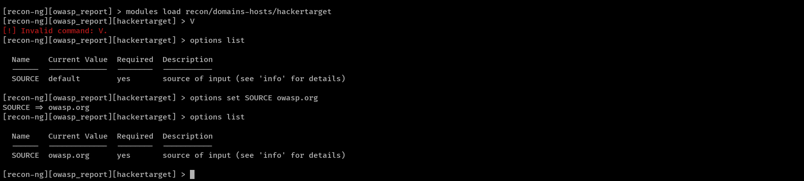

Step 6: Running the Module and Reviewing Results
The module was executed to collect publicly available information related to the target domain. After execution, the discovered hosts were stored in the Recon-ng database and reviewed using the 'show hosts' command. This step helped identify several OWASP subdomains and their associated IP addresses.
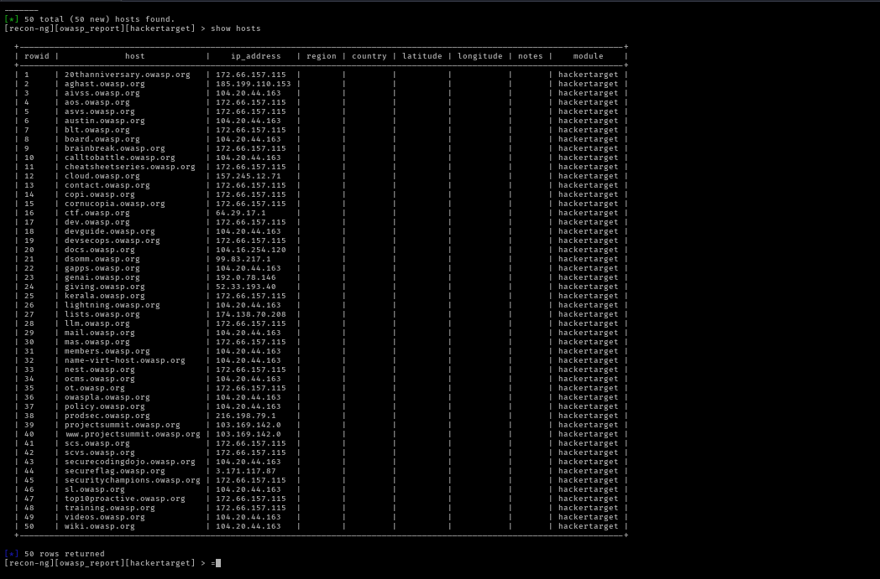
Step 7: Installing and Using the Certificate Transparency Module
The Certificate Transparency module was installed to discover additional subdomains from public SSL/TLS certificate logs. This module complements HackerTarget because certificate logs often reveal hostnames that may not appear through other public sources.
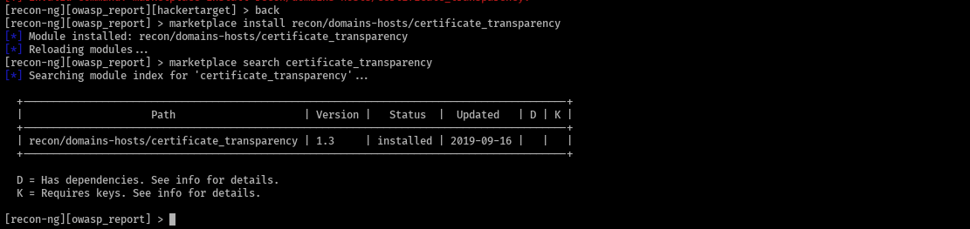

Step 6: Running the Module and Reviewing Results
The module was executed to collect publicly available information related to the target domain. After execution, the discovered hosts were stored in the Recon-ng database and reviewed using the 'show hosts' command. This step helped identify several OWASP subdomains and their associated IP addresses.
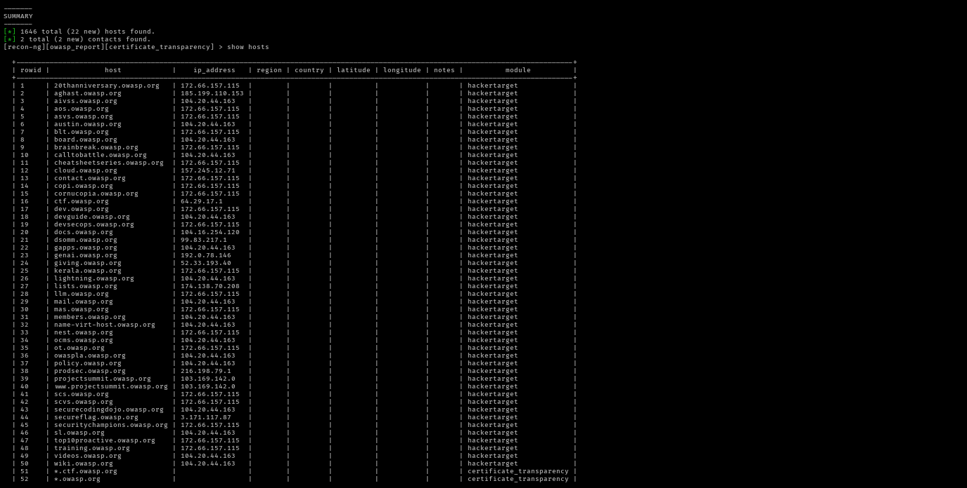
Step 8: Installing and Using the Netcraft Module
The Netcraft module was installed and configured with the same target. Netcraft maintains a large public database of websites and internet infrastructure. Running this module helped verify previously discovered hosts and identify additional publicly available hostnames.

Results and Findings
Three different Recon-ng modules were successfully used against the passive OSINT target 'owasp.org'. HackerTarget discovered 50 hosts with associated IP addresses. The Certificate Transparency module increased the total number of discovered hosts to 72 by identifying additional hostnames from public certificate logs. Finally, the Netcraft module identified 19 public hostnames that helped validate the previous findings. All information was gathered from publicly available sources only, and no intrusive scanning or exploitation was performed during this assessment.

