

Port Swigger Labs

Lab: SQL injection vulnerability in WHERE clause allowing retrieval of hidden data
This lab contains a SQL injection vulnerability in the product category filter. When the user selects a category, the application carries out a SQL query like the following:
SELECT * FROM products WHERE category = 'Gifts' AND released = 1
To solve the lab, perform a SQL injection attack that causes the application to display one or more unreleased products.
- Accessed the lab and saw some categories and products
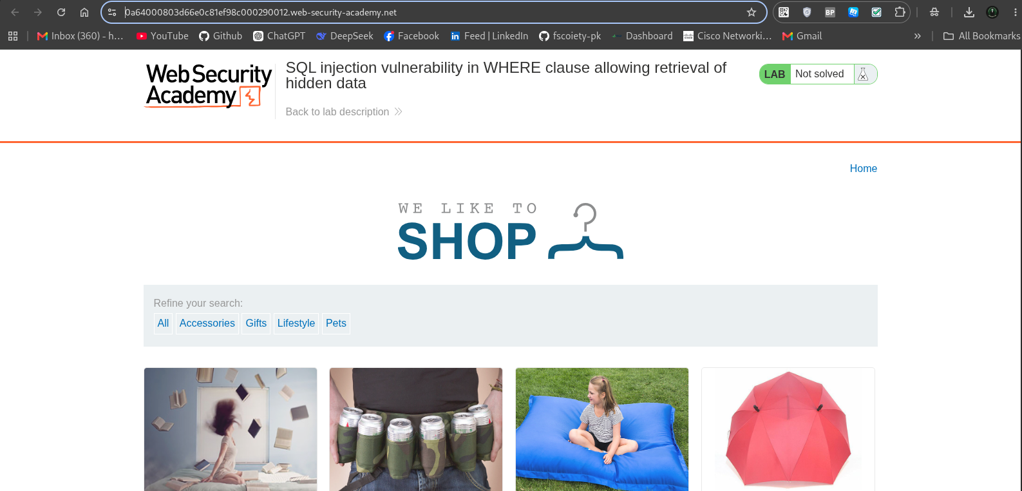
Our Goal is to retrieve all products including hidden and public products
for that i use a payload to display allproducts on the page i.e ‘ OR 1=1 - - (This payload will retrieve all porducts from the database and display on the web page)

Just adding this payload in the url i.e https://0a64000803d66e0c81ef98c000290012.web-security-academy.net/filter?category=’ OR 1=1 - -
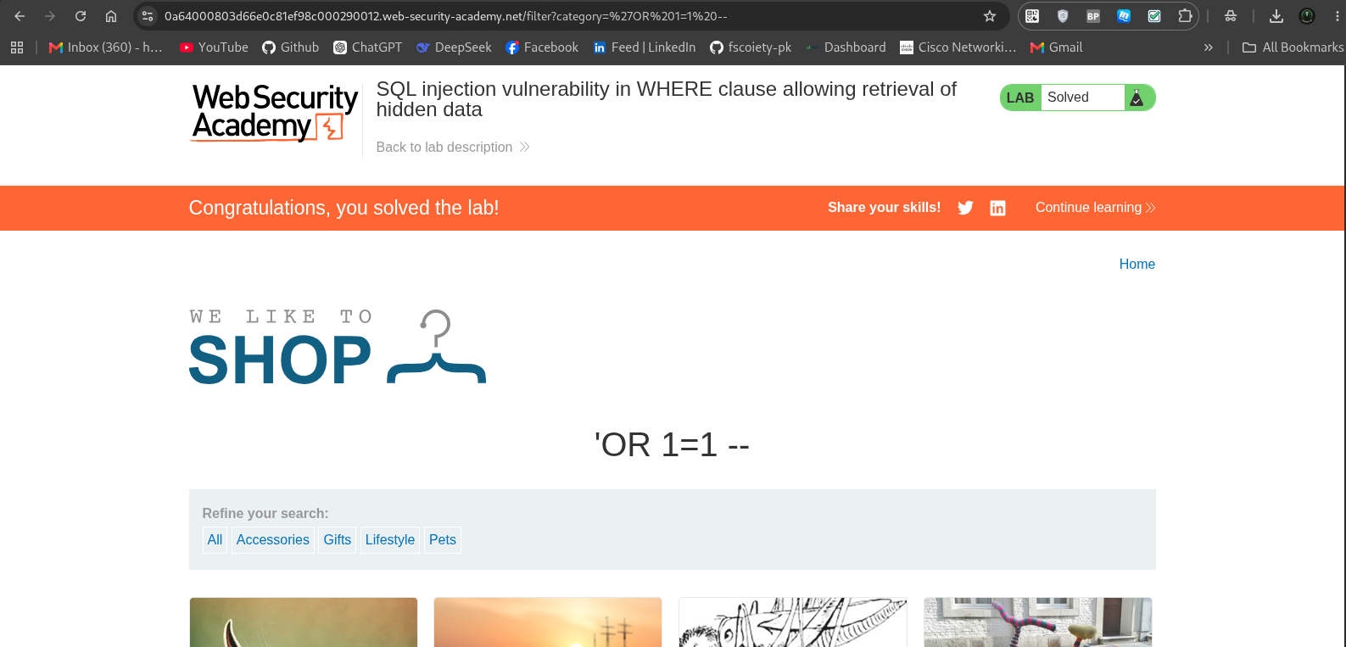

Lab: Unprotected admin functionality
This lab has an unprotected admin panel.
Solve the lab by deleting the user carlos.
I accessed the lab and sae this web page.
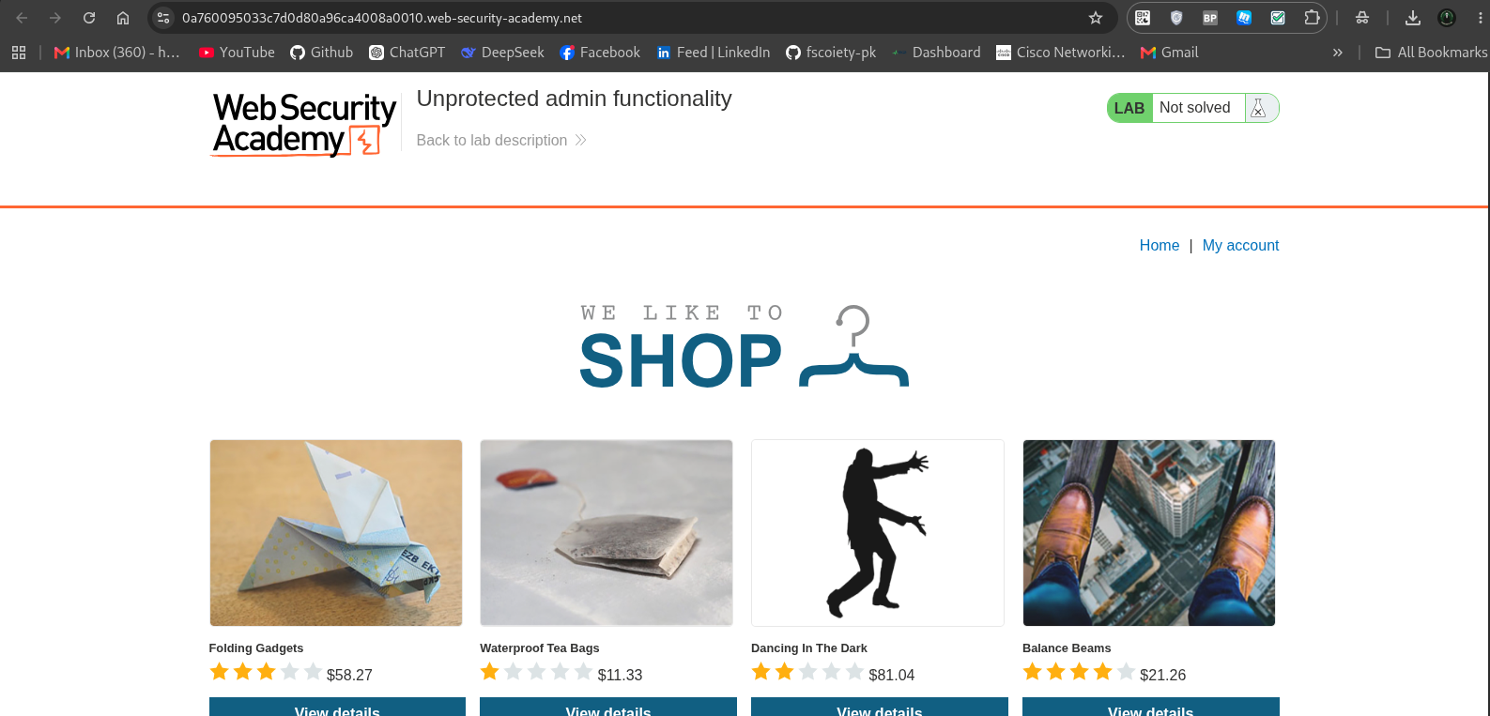
our goal is to delete the carlos user,as we know that only admin can delete the users so i just add the /admin with the url so it show 404 page not found, that’s mean there is any other route for admin.
As i study recently the hidden routes are stored in the /robots.txt route, so i quickly go to this route and found the admin page route
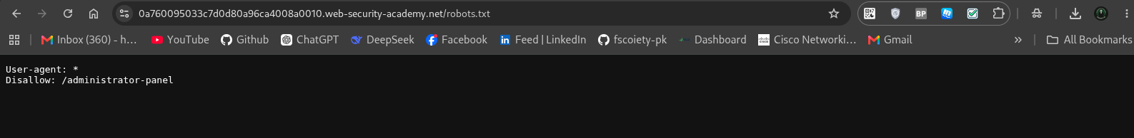
Added the hidden route in url
https://0a760095033c7d0d80a96ca4008a0010.web-security-academy.net/administrator-panel
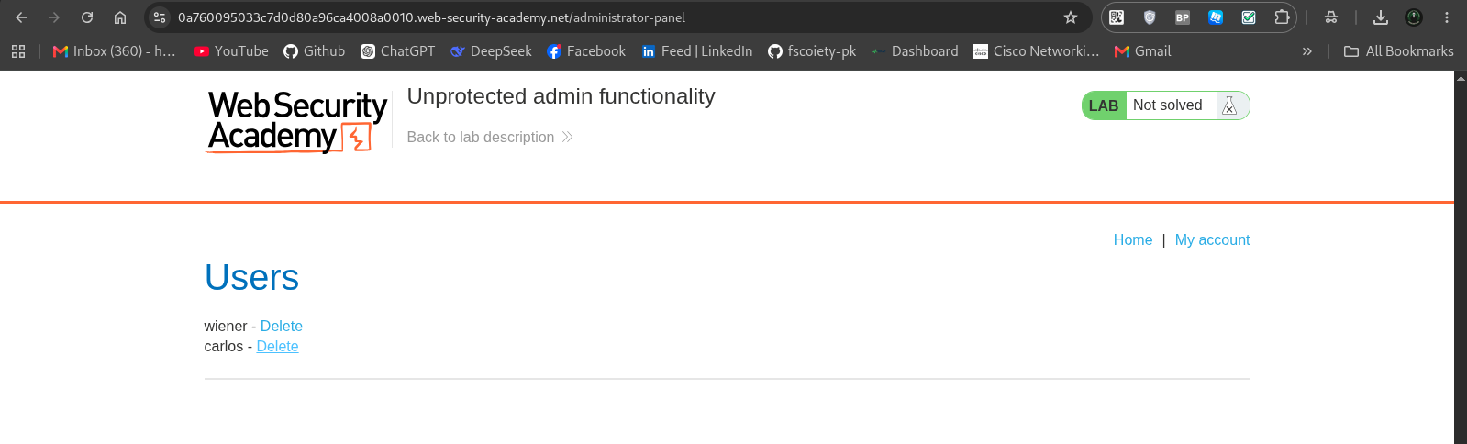
Found 2 user wiener and carlos, as our task is to delete the carlos user so i click on Delete button along carlos.
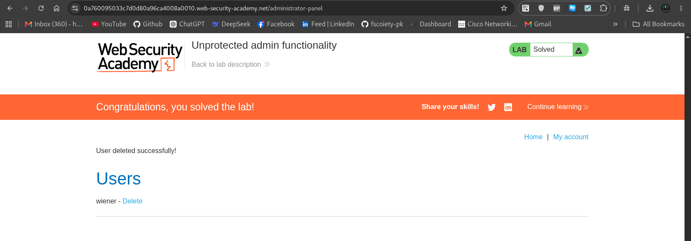

Lab: Unprotected admin functionality with unpredictable URL
This lab has an unprotected admin panel. It's located at an unpredictable location, but the location is disclosed somewhere in the application.
Solve the lab by accessing the admin panel, and using it to delete the user carlos.
In this lab there was unprotected admin panel in the homepage source code.
i just pressed Ctrl + U and analyze the source code.
in the Javascript code there is something intersting , it shows the admin route /admin-3c0sct
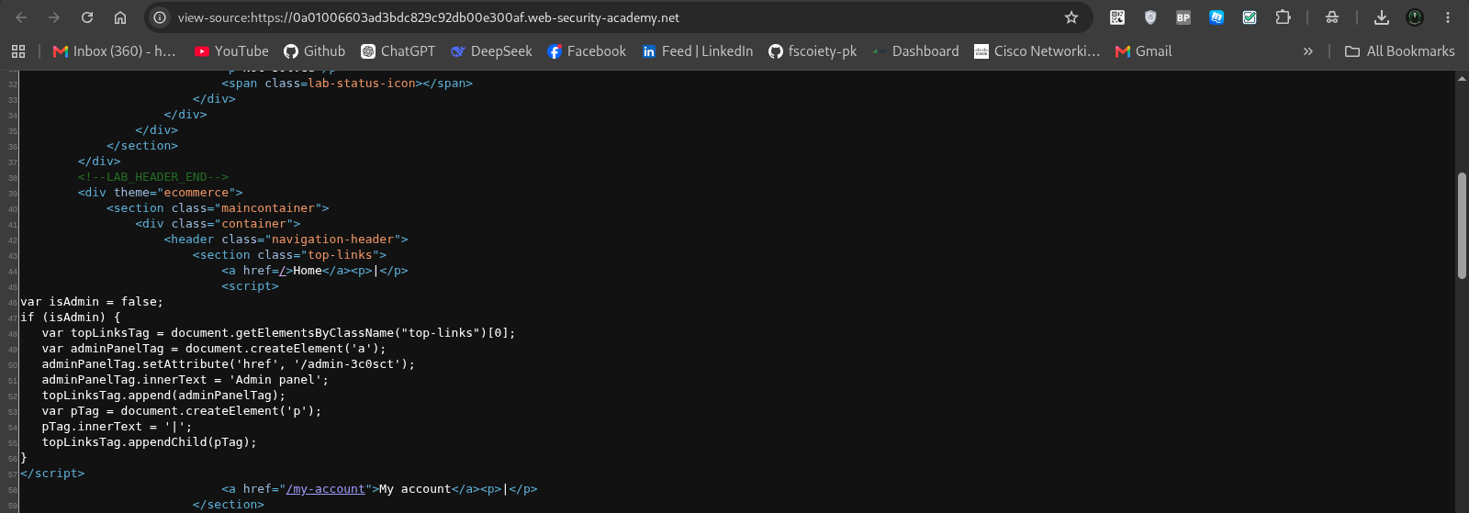
Copy the route and paste with url https://0a01006603ad3bdc829c92db00e300af.web-security-academy.net/admin-3c0sct
Deleted the user carlos as this was our goal.
