First I read the statement.
Objective

For this challenge, your goal is to retrieve the robots.txt from the main website for hackycorp.com.
The robots.txt file
The robots.txt file is used to tell web spiders how to crawl a website. To avoid having confidential information being indexed and searchable, webmasters often use this file to tell spiders to avoid specific pages. This is done using the keyword Disallow. You can read more about the robots.txt file in the Robots Exclusion Standard.
Then I go to the website hackycorp.com.

Added robots.txt at hackycorp.com/robots.txt in the URL.

Found the key `af9c328a-02b4-439d-91c6-f46ab4a0835b` for Recon 00.

Submitted the key in the Recon 00 lab.

Recon 01
Objective
For this challenge, your goal is to generate a 404/"Not Found" error on the main website for hackycorp.com.
The 404 pages
Not Found/404 pages can leak information about the web stack used by a company or application. They also allow you to detect files that exist when you start brute-forcing directories. This is why it is important to check what the 404 page looks like.

First, read the objective carefully.
Here we need to generate a Not Found response with status code 404.
That's very simple: I used the /the route and got the key `aeaee57f-2a82-41da-bc4c-d081c8cddfc8`.

Submitted the key in the Recon 01 lab.

Recon 02
Objective
For this challenge, your goal is to retrieve the security.txt from the main website for hackycorp.com.
The security.txt file
The security.txt file is used to tell security researchers how they can disclose vulnerabilities for a website. You can learn more at securitytxt.org and on Wikipedia (Security.txt).
After reading the objective, I went to the website and tried the /security.txt route, but it does not exist and returned the Recon 01 key, which was the 404 Not Found page.
Then I researched the security.txt route on Google and saw that the security.txt file is often located under a route starting with a dot ('.'), so there are many common routes.
I chose /.well-known/security.txt and found the key `99685e30-7061-4ac0-83bf-4ccc0409faac`.

Submitted the key in the Recon 02 lab.

Recon 03
Objective
For this challenge, your goal is to find a directory with directory listing on the main website for hackycorp.com.
Directory Listing
When accessing a directory on a web server, multiple things can happen:
An "index" file is present and will be returned (the file is not necessarily named index; this can be configured, but most of the time the file is named index.html).
No "index" file is present and the web server will list the content of the directory. This can obviously leak information.
Indexing directories can be disabled on most web servers. For example, with Apache, you can disable it using the -Indexes option.
To find directories with indexing enabled, you need to browse the source of the HTML pages and look at the directories used to store files. Once you have a list of directories, you can access each of them individually.

I used the gobuster tool on my Kali Linux with the command:
gobuster dir -u https://hackycorp.com/ -w /usr/share/wordlists/dirb/common.txt
This tool gave me common routes on the website.
After analyzing the output, I went to the images route and found a page with directory listing: key.txt, logo.png.
I opened key.txt and found the key `93790afa-6985-47fd-b564-aa7ba59ed6a9`.

Submitted the key in the Recon 03 lab.

Recon 04
Objective
For this challenge, your goal is to find a directory that is commonly used to manage applications.
Interesting directories
When accessing a new webserver, it often pays off to manually check for some directories before starting to brute force using a tool. For example, you can manually check for /admin/.
For this lab I simply went to the /admin route and found the key `ad1d44d6-ab73-4640-8291-c5bf2343e2a5`.

Submitted the key in the Recon 04 lab.

Recon 05
Objective
For this challenge, your goal is to find a directory that is not directly accessible.
Fuzzing directories
When assessing a new webserver, it often pays off to brute-force directories. To do this, you can use tools like patator, FFUF, or WFuzz (among many others).
For this lab I simply accessed /startpage, which is not directly accessible. Since I used gobuster in Recon 02, the /startpage route was present.

Found the key `498621b0-17fe-4ebb-8324-3de7743fea51`.

Submitted the key in the Recon 05 lab.
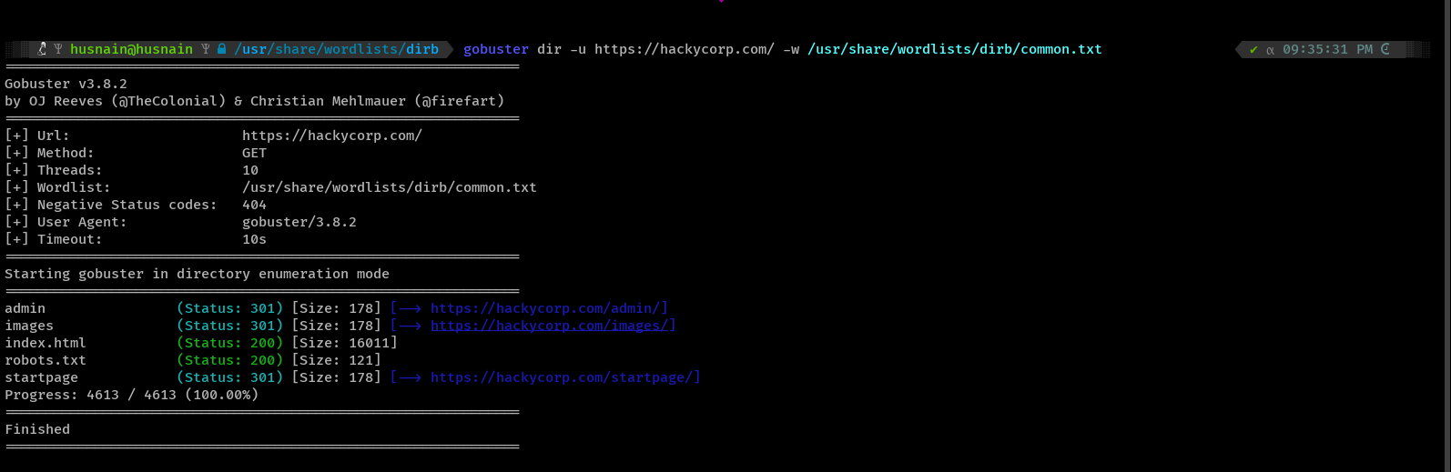
Found the Key `498621b0-17fe-4ebb-8324-3de7743fea51`
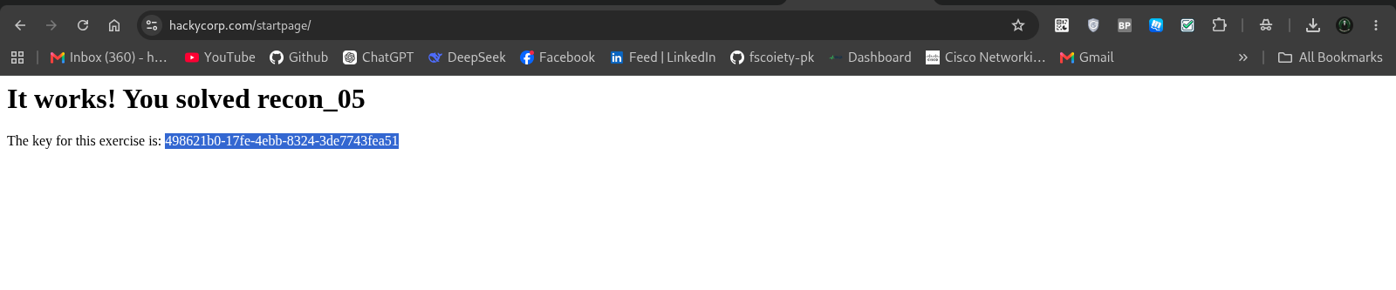
Putting Key in the Recon 05 Lab
