

Day 1: What is Cybersecurity · CIA Triad · Types of Cyber Attacks

What is Cybersecurity?
Cybersecurity is an ongoing effort in which we protect individual, organizational, or government data from unauthorized access.

The CIA Triad
The CIA Triad is a foundational information security model that consists of three core principles:

1. Confidentiality
Ensures that information is accessible only to authorized individuals.
- Goal: Prevent unauthorized access.
- Examples:
- Encryption
- Passwords and multi-factor authentication (MFA)
- Access control lists (ACLs)

2. Integrity
Ensures that data remains accurate, complete, and unaltered except by authorized users.
- Goal: Prevent unauthorized modification of data.
- Examples:
- Hashing (e.g., SHA-256)
- Digital signatures
- File integrity monitoring

3. Availability
Ensures that information and systems are accessible to authorized users whenever needed.
- Goal: Prevent disruptions to access.
- Examples:
- Regular backups
- Redundant systems
- Disaster recovery plans
- Protection against DDoS attacks

Common Types of Cyber Attacks
Cyber attacks are malicious attempts to compromise the Confidentiality, Integrity, or Availability (CIA Triad) of systems, networks, or data.
Attack Type | Description | Example
Phishing | Tricks users into revealing sensitive information such as usernames and passwords. | Fake login page or email.
Malware | Malicious software designed to damage, disrupt, or steal data from a system. | Virus, Worm, Trojan.
Ransomware | Encrypts files and demands payment to restore access. | WannaCry.
DDoS (Distributed Denial of Service) | Overloads a server with excessive traffic, making it unavailable to users. | Website becomes inaccessible.
SQL Injection (SQLi) | Inserts malicious SQL queries into a web application's database. | Login bypass or data theft.
Cross-Site Scripting (XSS) | Injects malicious JavaScript into a trusted website. | Stealing user cookies.
Man-in-the-Middle (MITM) | Intercepts communication between two parties to steal or modify data. | Fake public Wi-Fi hotspot.
Brute Force Attack | Attempts many password combinations until the correct one is found. | Automated password guessing.
Credential Stuffing | Uses stolen usernames and passwords from previous data breaches to access accounts. | Reused passwords exploited.
Zero-Day Attack | Exploits a software vulnerability before the vendor releases a security patch. | Newly discovered software flaw.

Tasks
- Completed Introduction to Cybersecurity from the CISCO Networking Academy.

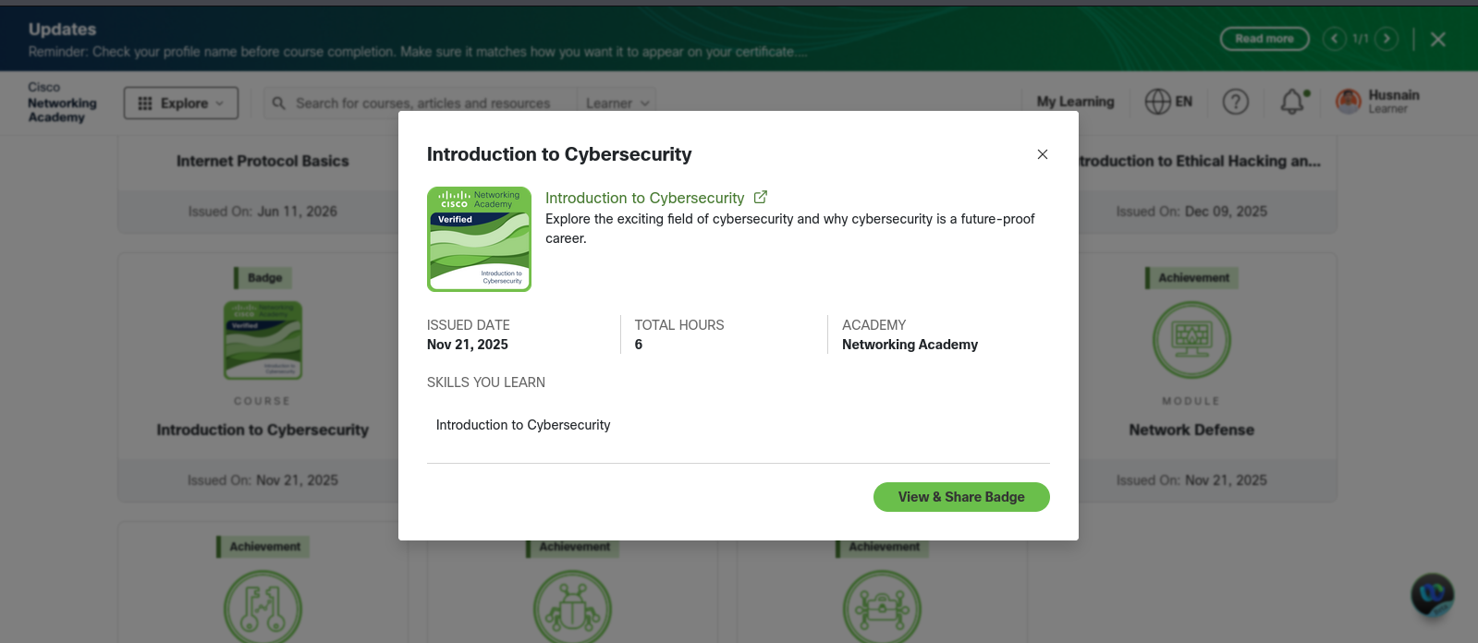
- Completed CIA Triad room from TryHackMe.

