

DAY 3: Linux Fundamentals, Bandit level 0 to 10

Linux Fundamentals

Introduction
Linux is a free, open-source operating system based on Unix. It is widely used in servers, cloud computing, embedded systems, and cybersecurity because of its stability, security, and flexibility. Most cybersecurity tools, such as Nmap, Wireshark, Metasploit, and Burp Suite, are commonly used on Linux distributions like Kali Linux, Ubuntu, and Parrot OS.

Why Learn Linux?
- Open-source and free to use.
- Highly secure and stable.
- Powerful command-line interface (CLI).
- Used by most web servers and cloud platforms.
- Preferred operating system for ethical hackers and cybersecurity professionals.

Basic Linux Concepts

1. Terminal
The Terminal is a command-line interface where users interact with the operating system by typing commands.

2. Shell
A Shell is a program that interprets user commands and communicates with the Linux kernel. The most common shell is Bash (Bourne Again Shell).

3. Kernel
The Kernel is the core of the Linux operating system. It manages hardware resources, memory, processes, and communication between software and hardware.

4. File System
Linux stores everything as files, including devices and directories.

Common directories include:
Directory | Purpose
/ | Root directory
/home | User home directories
/etc | Configuration files
/bin | Essential system commands
/usr | User programs and utilities
/var | Log files and variable data
/tmp | Temporary files

Common Linux Commands:
Command | Description
pwd | Display the current working directory.
ls | List files and directories.
ls -l | Display detailed file information.
ls -la | Show all files, including hidden files.
cd directory | Change the current directory.
cd .. | Move to the parent directory.
mkdir folder | Create a new directory.
rmdir folder | Remove an empty directory.
touch file.txt | Create an empty file.
cp source destination | Copy files or directories.
mv source destination | Move or rename files.
rm file.txt | Delete a file.
rm -r folder | Delete a directory and its contents.
cat file.txt | Display file contents.
less file.txt | View a file page by page.
head file.txt | Show the first 10 lines of a file.
tail file.txt | Show the last 10 lines of a file.
clear | Clear the terminal screen.

Task: Bandit Level 0 to 10
- Level 0
Level Goal
The goal of this level is for you to log into the game using SSH. The host to which you need to connect is bandit.labs.overthewire.org, on port 2220. The username is bandit0 and the password is bandit0. Once logged in, go to the Level 1 page to find out how to beat Level 1.
Command Used : ssh
- In terminal i run the command ssh bandit0@bandit.labs.overthewire.org -p 2220 as it is mentioned in level goal
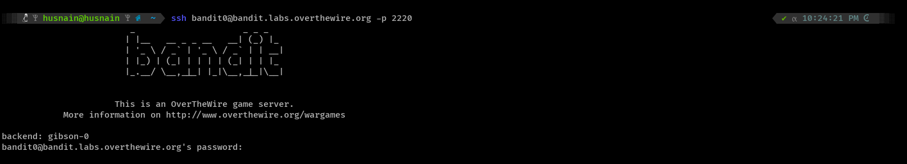
- Putting password “bandit0” as it is mentioned in the level goal and we are in !
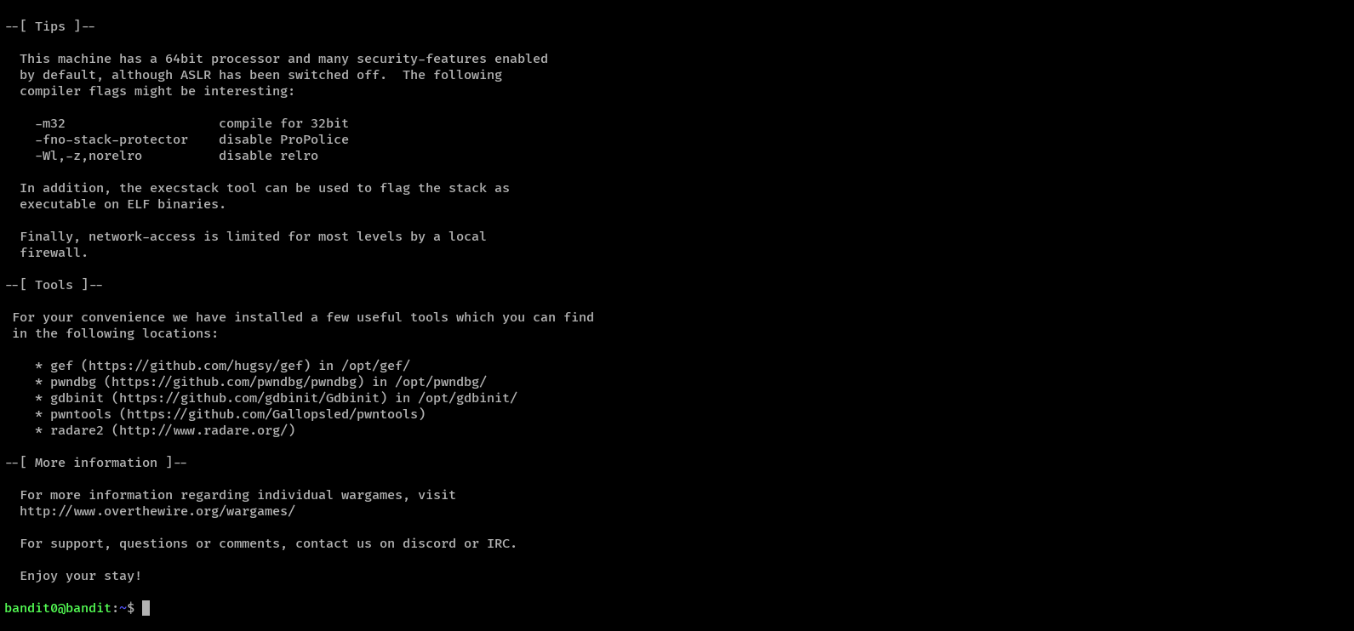

- Level 0 → Level 1
Level Goal
The password for the next level is stored in a file called readme located in the home directory. Use this password to log into bandit1 using SSH. Whenever you find a password for a level, use SSH (on port 2220) to log into that level and continue the game.
Command Used : ls, cat
- I used “ls” command in terminal to list the files and folders.
- After running “ls” command i got a readme file.
- I used “cat” command to see in the file. So readme file contain next level password
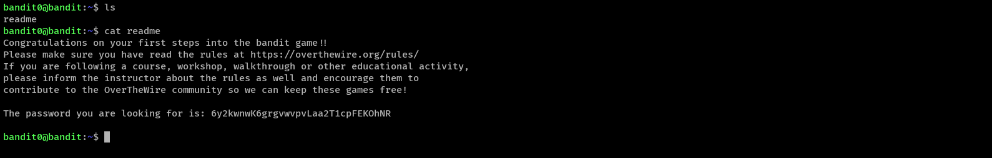
Password: 6y2kwnwK6grgvwvpvLaa2T1cpFEKOhNR

- Level 1 → Level 2
Level Goal
The password for the next level is stored in a file called - located in the home directory
Command Used : ssh, ls, cat ./-
- As we have password for bandit1 so we run the command “ssh bandit1@bandit.labs.overthewire.org -p 2220“
- after that put the password : 6y2kwnwK6grgvwvpvLaa2T1cpFEKOhNR
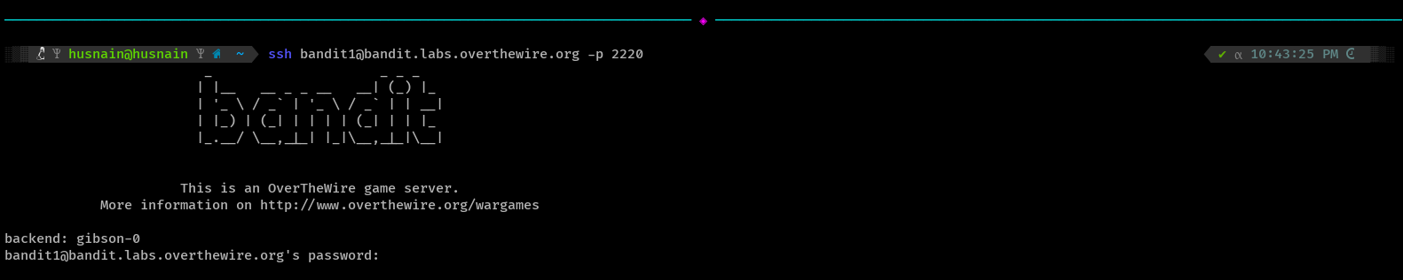
- Used “ls” command to view files and folders
- got a “-” file in this level
- i used google to learn how to open a “-“ file using “cat” command and the command is “cat ./-“
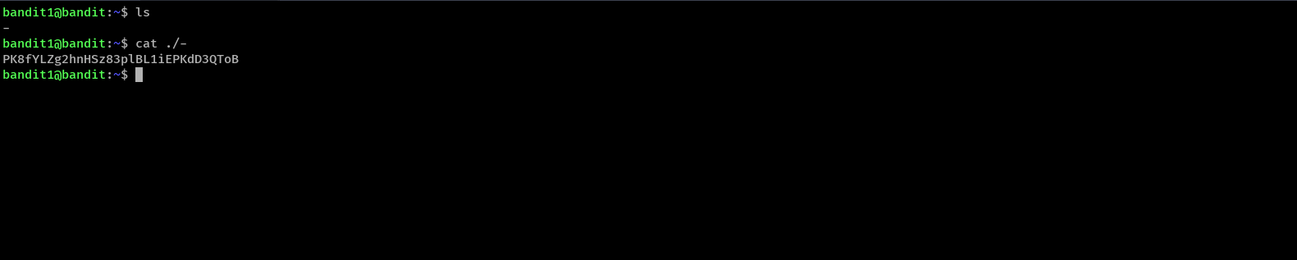
Password: PK8fYLZg2hnHSz83plBL1iEPKdD3QToB

- Level 2 → Level 3
Level Goal
The password for the next level is stored in a file called --spaces in this filename-- located in the home directory
Command Used : ssh, ls, cat with flag “- -“ to view the file
- I opened a new tab in terminal.
- Run ssh command “ssh bandit2@bandit.labs.overthewire.org -p 2220” to logged in bandit2
- Used password : PK8fYLZg2hnHSz83plBL1iEPKdD3QToB
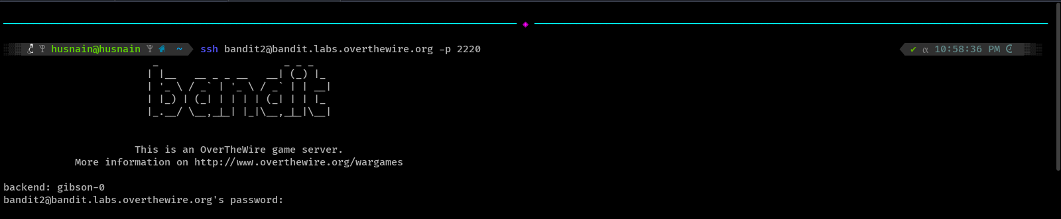
- List the files and folders.
- Got a file - - spaces in the filename - -.
- Used google to learn how to open a file with spaces in the filename.
- Used command cat - - “- - spaces in the filename - -“ to open it and got the password for next level
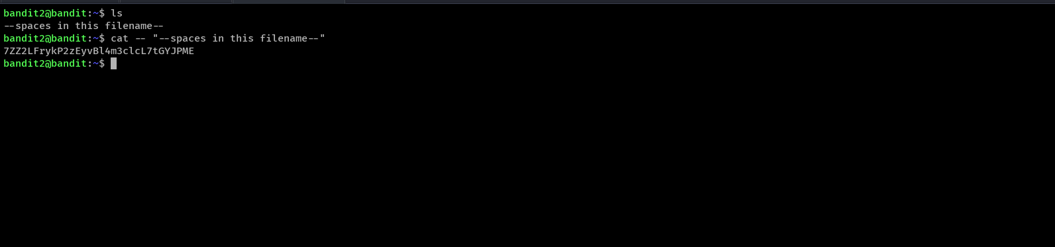
Password: 7ZZ2LFrykP2zEyvBl4m3clcL7tGYJPME

- Level 3 → Level 4
Level Goal
The password for the next level is stored in a hidden file in the inhere directory.
Command Used : ssh, ls, cd,
- I opened a new tab in terminal.
- Run ssh command “ssh bandit3@bandit.labs.overthewire.org -p 2220” to logged in bandit3
- Used password : 7ZZ2LFrykP2zEyvBl4m3clcL7tGYJPME
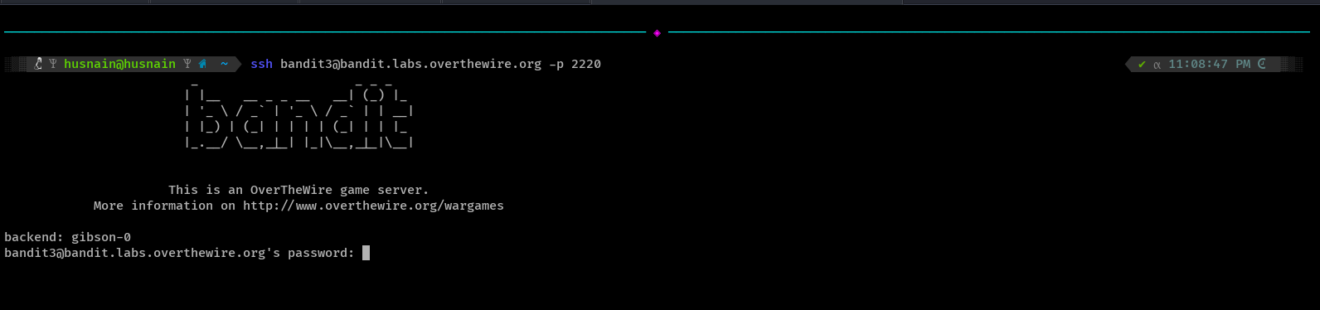
- List the files and folders using “ls”
- Got a folder “inhere”.
- Used “cd” command to get in the folder.
- Used “ls” command to list all directories, found nothing.
- Then used “ls –la” to see also hidden files.
- Got a hidden file “...Hiding-From-You”
- Then used command “cat ..Hiding-From-You” to open it and got the password for next level
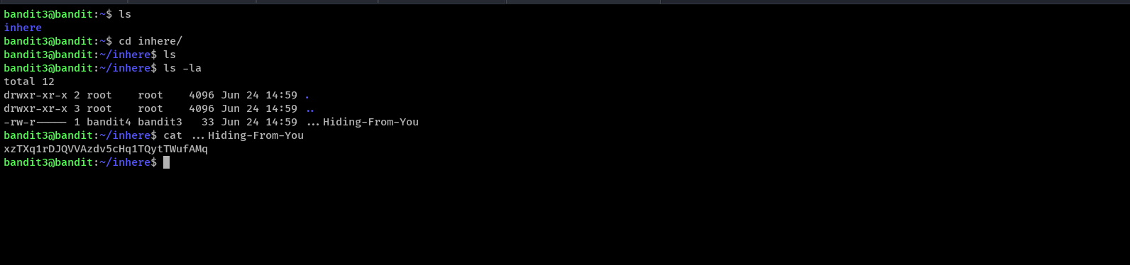
Password: xzTXq1rDJQVVAzdv5cHq1TQytTWufAMq
- Level 4 → Level 5
Level Goal
The password for the next level is stored in the only human-readable file in the inhere directory. Tip: if your terminal is messed up, try the “reset” command.
Command Used : ssh, ls, cd,cat
- I opened a new tab in terminal.
- Run ssh command “ssh bandit4@bandit.labs.overthewire.org -p 2220” to logged in bandit4
- Used password : xzTXq1rDJQVVAzdv5cHq1TQytTWufAMq
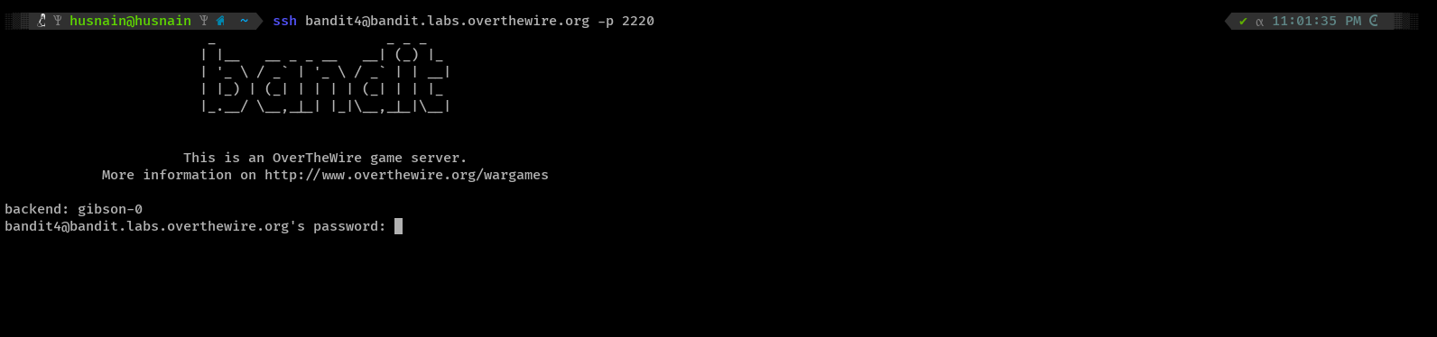
- List the files and folders using “ls”
- Got a folder “inhere”.
- Used “cd” command to get in the folder.
- Used “ls” command to list all directories, found many files.
- Then used a command to open all file at once by putting “ * “ at end — “ cat ./-file* “, it will open all files from 0 to onward all files
- After that i saw there is encrypted or dummy data in some files but in fifth line there is password for the next level
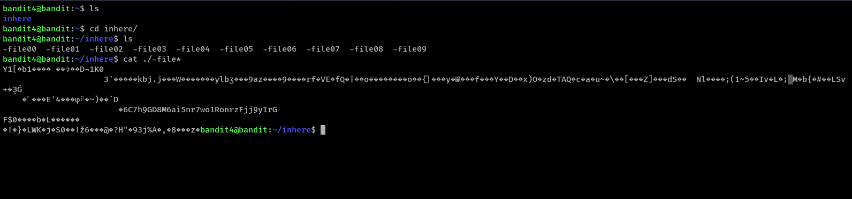
Password: 6C7h9GD8M6ai5nr7wo1RonrzFjj9yIrG

- Level 5 → Level 6
Level Goal
The password for the next level is stored in a file somewhere under the inhere directory and has all of the following properties:
human-readable
1033 bytes in size
not executable
Command Used : ssh, ls, cd, find, cat
- I opened a new tab in terminal.
- Run ssh command “ssh bandit5@bandit.labs.overthewire.org -p 2220” to logged in bandit5
- Used password : 6C7h9GD8M6ai5nr7wo1RonrzFjj9yIrG
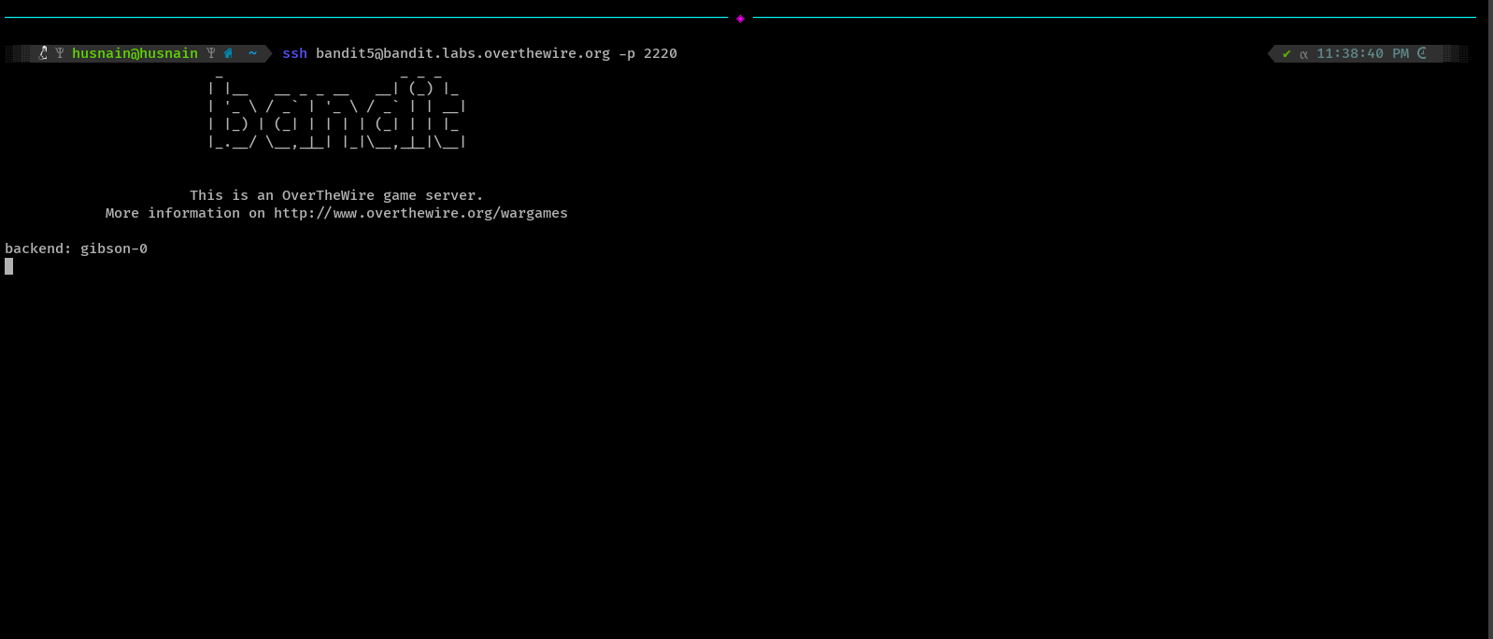
- List the files and folders using “ls”
- Got a folder “inhere”.
- Used “cd” command to get in the folder.
- Used “ls” command to list all directories, found many folders.
- Instead of looking all folders and and their files one by one, i used find command “find . -type f -size 1033c” to search the file which size is 1033 bytes as mentioned in level goal. (-type f means “find regular files” and c at end of 1033 means exact 1033 bytes)
- After running find command i got the file with 1033 bytes in the maybehere07 folder and file name is “.file2”.
- I go to the maybehere07 folder then run “ls”, so i did not see the “.file2”.
- As i know when file name is start with dot then it must be hidden so i used “ls –la” command to list all hidden files, after that i saw the .file2.
- Used cat command to view the file and got the password for the next level.
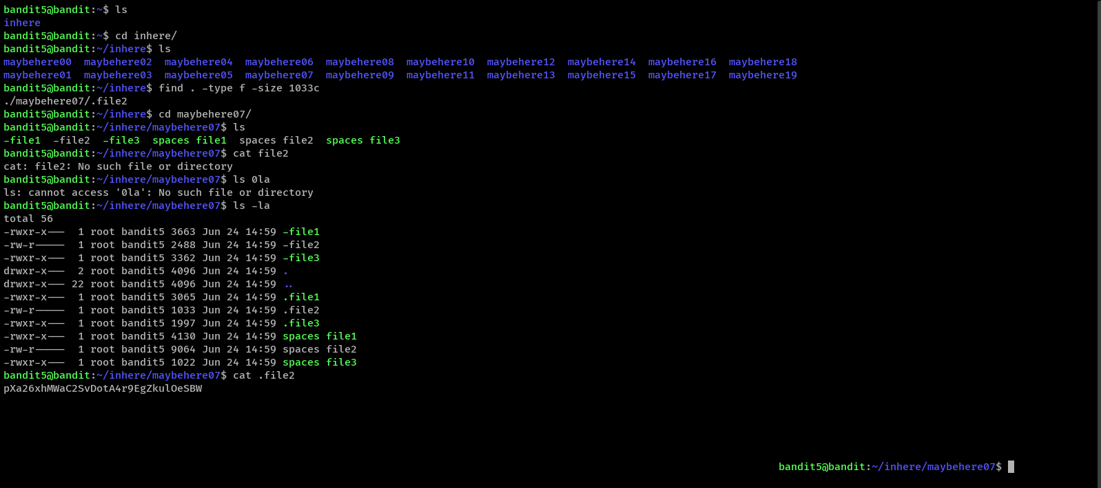
Password: pXa26xhMWaC2SvDotA4r9EgZkulOeSBW

- Level 6 → Level 7
Level Goal
The password for the next level is stored somewhere on the server and has all of the following properties:
owned by user bandit7
owned by group bandit6
33 bytes in size
Command Used : ssh, ls,ls –la, find, cat
- I opened a new tab in terminal.
- Run ssh command “ssh bandit6@bandit.labs.overthewire.org -p 2220” to logged in bandit6
- Used password : pXa26xhMWaC2SvDotA4r9EgZkulOeSBW
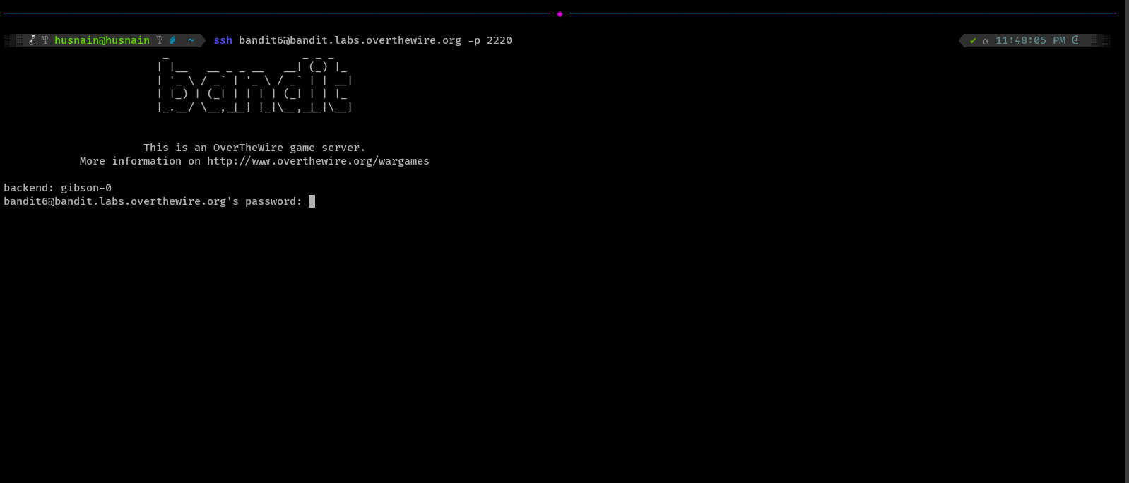
- List the files and folders using “ls”
- Got nothing then used “ls –la” command but found nothing interested.
- Review the level goal statement , so their is mentioned that password for next level is on server, owned by user bandit7 , owned by group bandit6 and file size is 33 bytes
- I asked deepseek to help and it tell me exact command to find the file “find / -user bandit7 -group bandit6 -size 33c ”, this command give me some files with their permission as output.
- As there was many files so i used “2>/dev/null” flag to skip the error files and this tell me that exact location of the file where the password stored .
- Used “cat” command to view the file and got the password for the next level.
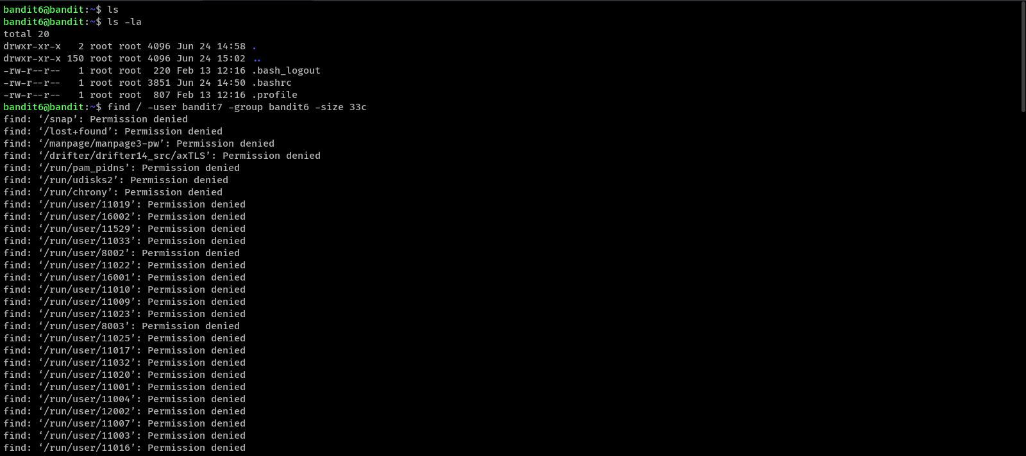

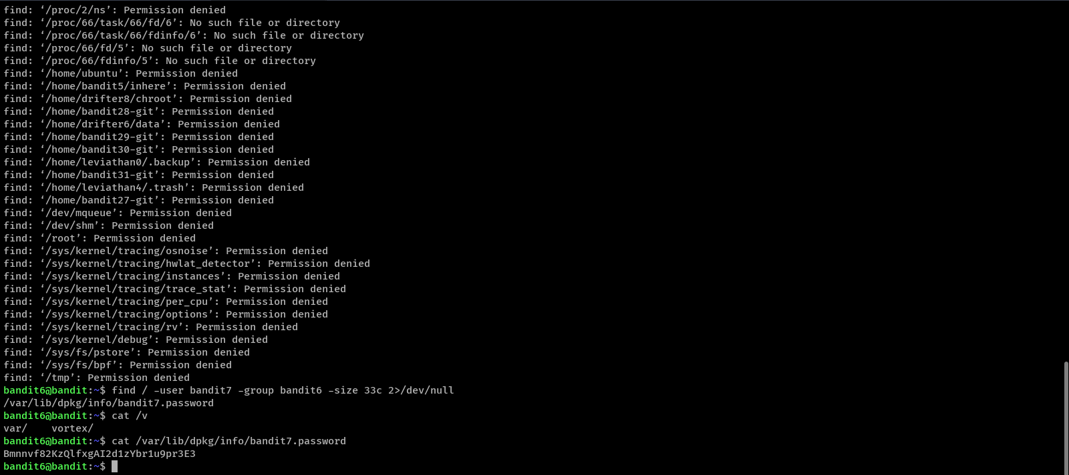
Password: Bmnnvf82KzQlfxgAI2d1zYbr1u9pr3E3

- Level 7 → Level 8
Level Goal
The password for the next level is stored in the file data.txt next to the word millionth
Command Used : ssh, ls, cat, grep
- I opened a new tab in terminal.
- Run ssh command “ssh bandit7@bandit.labs.overthewire.org -p 2220” to logged in bandit7
- Used password : Bmnnvf82KzQlfxgAI2d1zYbr1u9pr3E3
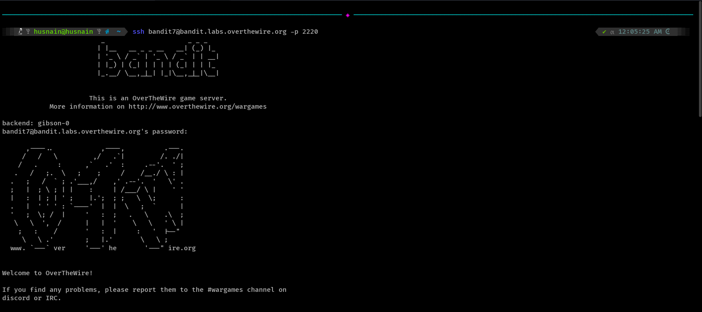
- List the files and folders using “ls”
- Got the “data.txt” file.
- Used “cat” command to see the files data but there was too many text in this file.
- Pressed Ctrl + c to stop but did not worked it show all data in the files.
- I used “grep” command that searches for lines containing specific text. Since the challenge says the password is next to the word "millionth", grep filters only that matching line.
- I used command “grep millionth data.txt” and it show the password of the next level.
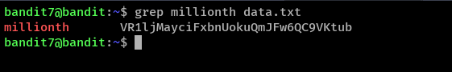
Password: VR1ljMayciFxbnUokuQmJFw6QC9VKtub

- Level 8 → Level 9
Level Goal
The password for the next level is stored in the file data.txt and is the only line of text that occurs only once
Command Used : ssh, ls, sort, uniq with –u flag
- I opened a new tab in terminal.
- Run ssh command “ssh bandit8@bandit.labs.overthewire.org -p 2220” to logged in bandit8
- Used password : VR1ljMayciFxbnUokuQmJFw6QC9VKtub
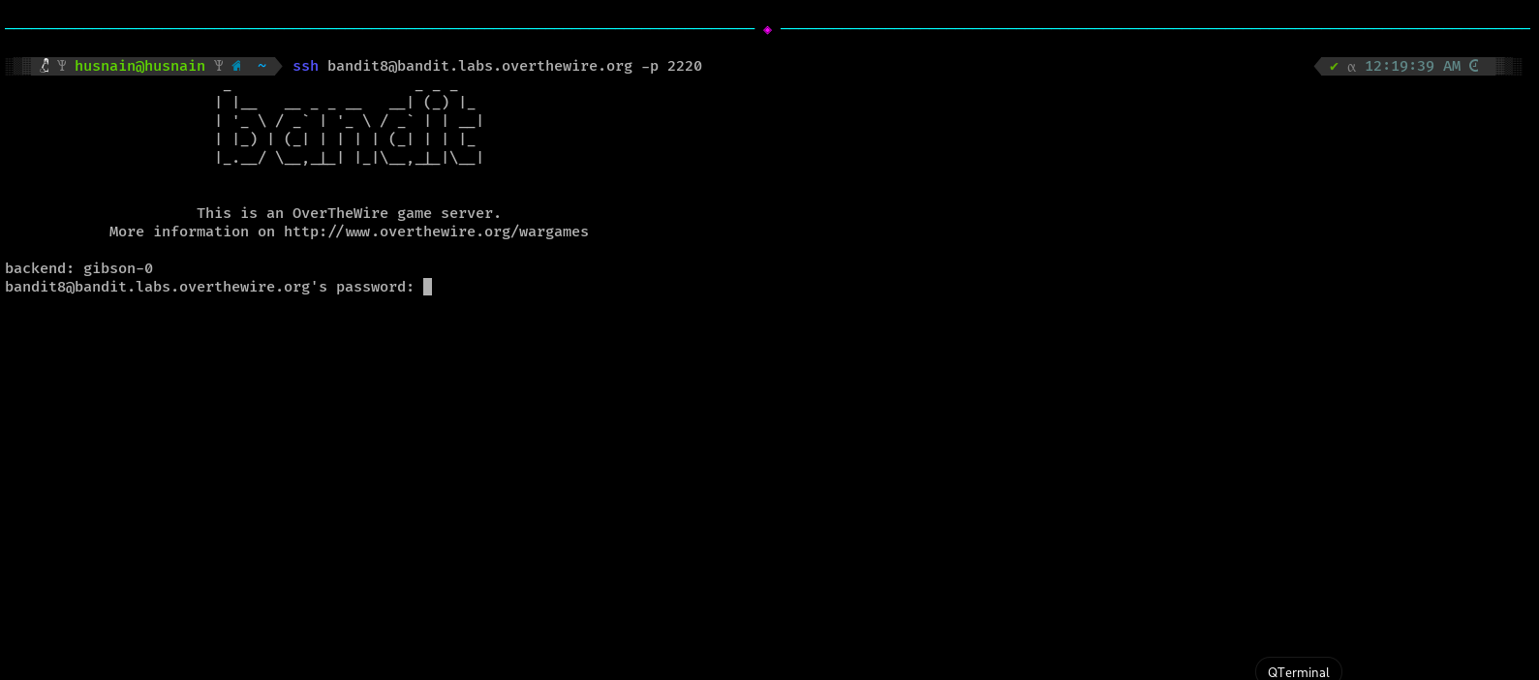
- List the files and folders using “ls”
- Got the “data.txt” file same like previous level.
- Review the level goal that says “password for the next level is stored in the file data.txt and is the only line of text that occurs only once”.
- Search on google how to check once occure line in a file using cli”, so tells me a command “sort and uniq -u”.
- Sort command sorts all lines alphabetically (required for uniq to work properly) and Uniq command shows hows only the lines that appear once (-u stands for unique)
- I used command “sort data.txt | uniq –u” then it show the password of the next level.
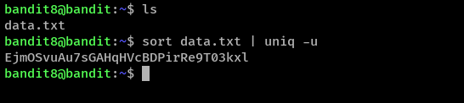
Password: EjmOSvuAu7sGAHqHVcBDPirRe9T03kxl

- Level 9 → Level 10
Level Goal
The password for the next level is stored in the file data.txt in one of the few human-readable strings, preceded by several ‘=’ characters.
Command Used : ssh, ls, strings, grep
- I opened a new tab in terminal.
- Run ssh command “ssh bandit9@bandit.labs.overthewire.org -p 2220” to logged in bandit9
- Used password : EjmOSvuAu7sGAHqHVcBDPirRe9T03kxl
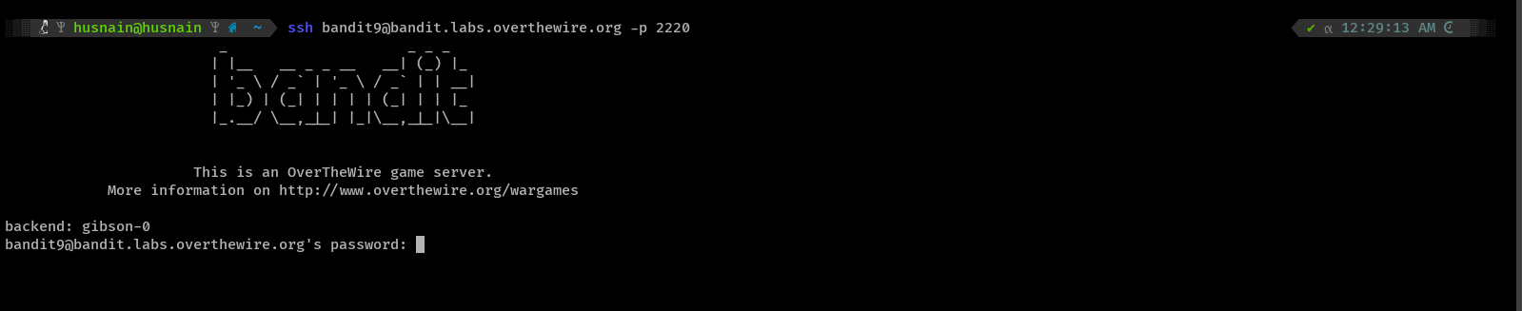
- List the files and folders using “ls”
- Got the “data.txt” file same like previous level.
- Review the level goal that says “The password for the next level is stored in the file data.txt in one of the few human-readable strings, preceded by several ‘=’ characters”.
- Study about “strings” command that extracts and displays all human-readable text from binary files.
- Also used “grep” to find the “=” that is mentioned in the level goal.
- So final command is “”strings data.txt | grep "===" which shows the password of the next level.
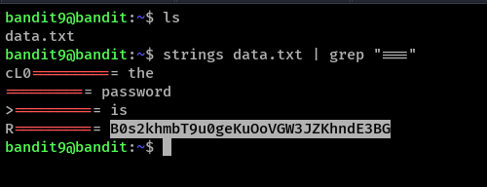
Password: B0s2khmbT9u0geKuOoVGW3JZKhndE3BG

