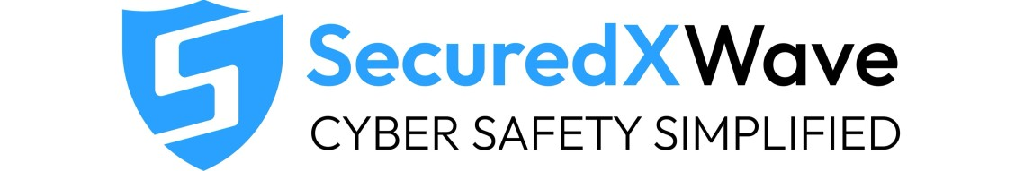

Day 5: Packet analysis theory · Wireshark filters · How traffic is captured

Section A — Getting Oriented

Question No 1 :
Open the file and identify the three main panes of the Wireshark window. What does each one show?
I opened the pcap file and saw three panes of the wireshark window in my kali linux.
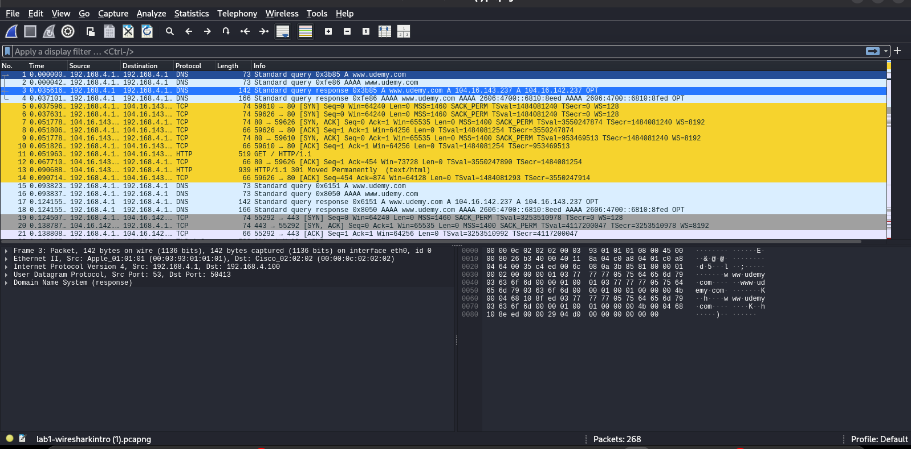
- There are 3 panes in the wireshark window.
- First, top pane shows the Time, Source IP address, Destination IP address, Protocols, Length of packets and Info about the packets
- Second, bottom left pane shows the details of selected packet and expand each protocol layer to inspect the packet.
- Third, bottom right pane shows the actual data of the packet in the hexadecimal and ASCII

Question No 2:
How many packets are in this capture, and roughly how long did the capture last?
- I go to the Statistics section on the top bar and select the Capture File Properties.
- There was mentioned that there is 268 packets in this capture file.The capture lasted approximately half a second and i verify it using the timestamps:
First packet: 2024-11-23 04:21:17
Last packet: 2024-11-23 04:21:18
- Since those timestamps only show whole seconds, they look like a 1-second difference. However, Wireshark stores timestamps with fractions of a second, and the Time span (0.474 s) is the precise capture duration.
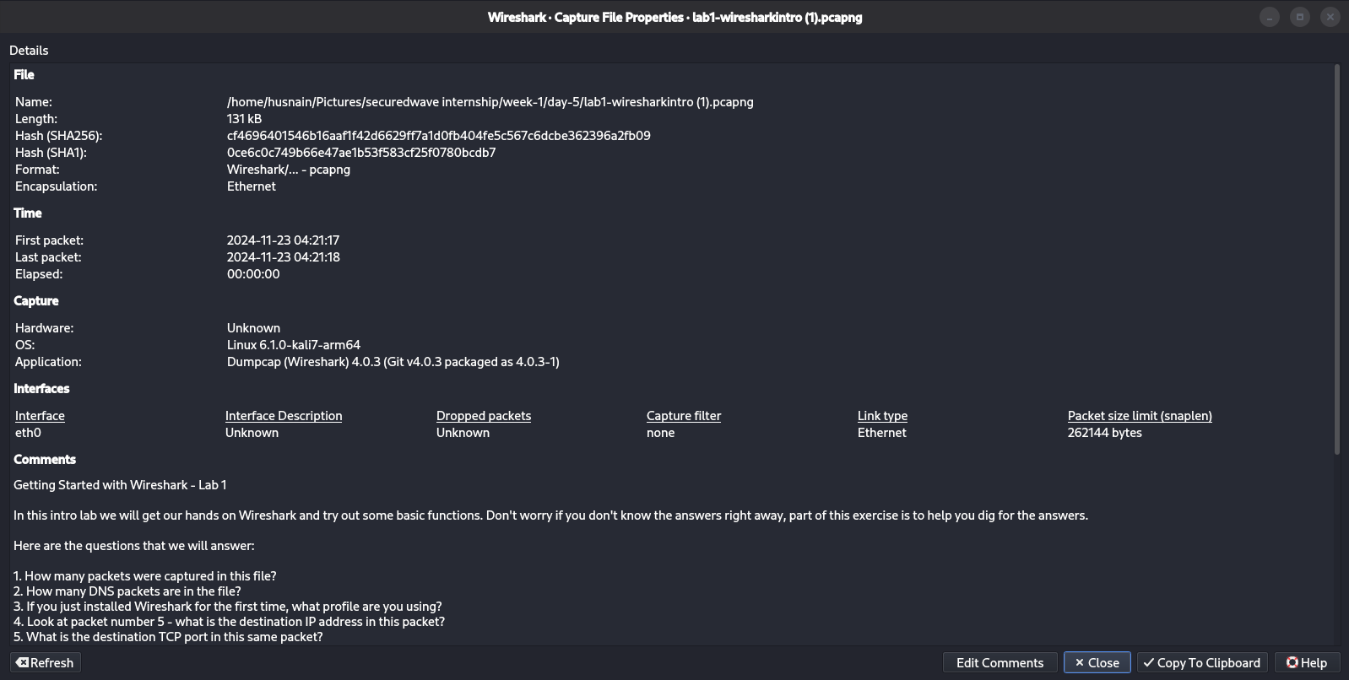

Question No 3:
What IP address belongs to "our" machine (the one doing the browsing)?
- Opened the statistics section from top bar, selected ipv4 statistics -> source and destination ipv4 statistics.
- So there is an IP 192.168.4.100 that must belong to “our” machine because it initiates DNS queries and TCP connections and appears as both the source and destination in most conversations.
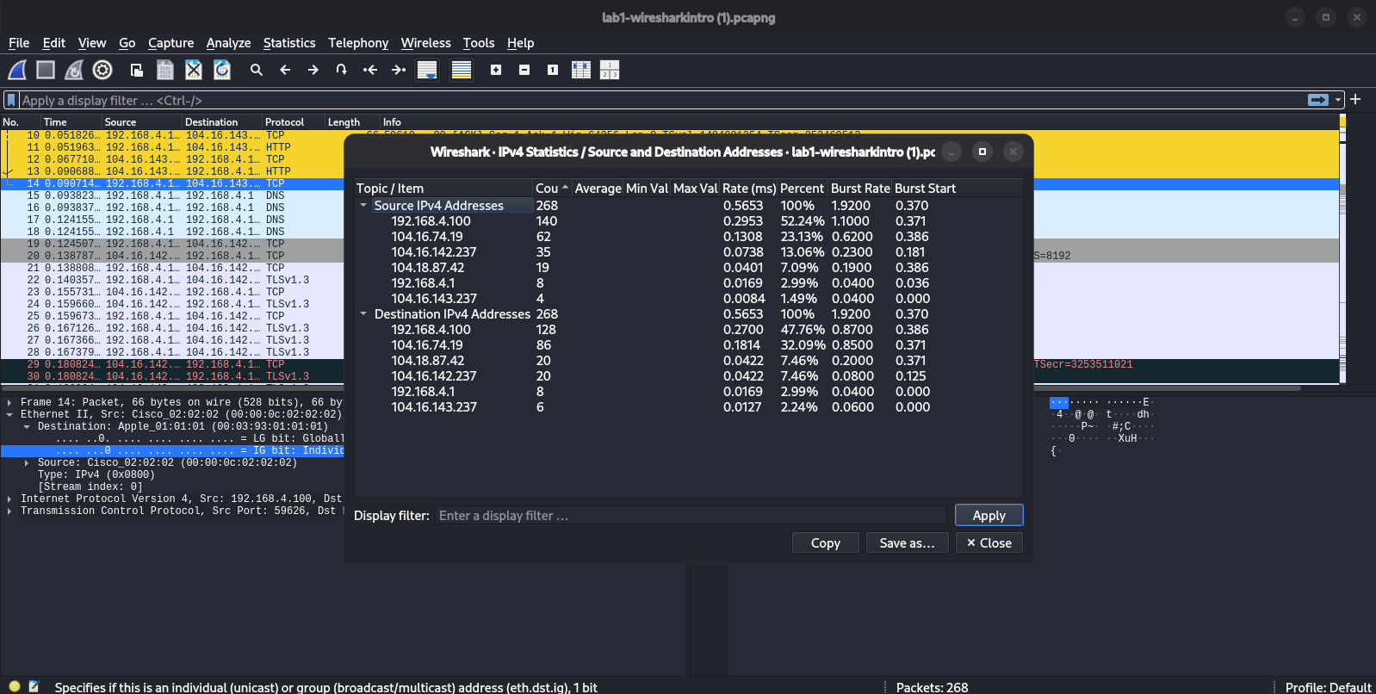

Section B — Filtering Basics

Question No 4:
Type ip.addr == 192.168.4.100 in the display filter bar. What happens, and why is this useful?
- When i type ip.addr == 192.168.4.100 in the filter section then it shows only that specific IP traffics.
- It shows the both source and destination packets of this IP.
- It is useful for filtering and specific IP packets.
- 268 packets was displayed while filtering.
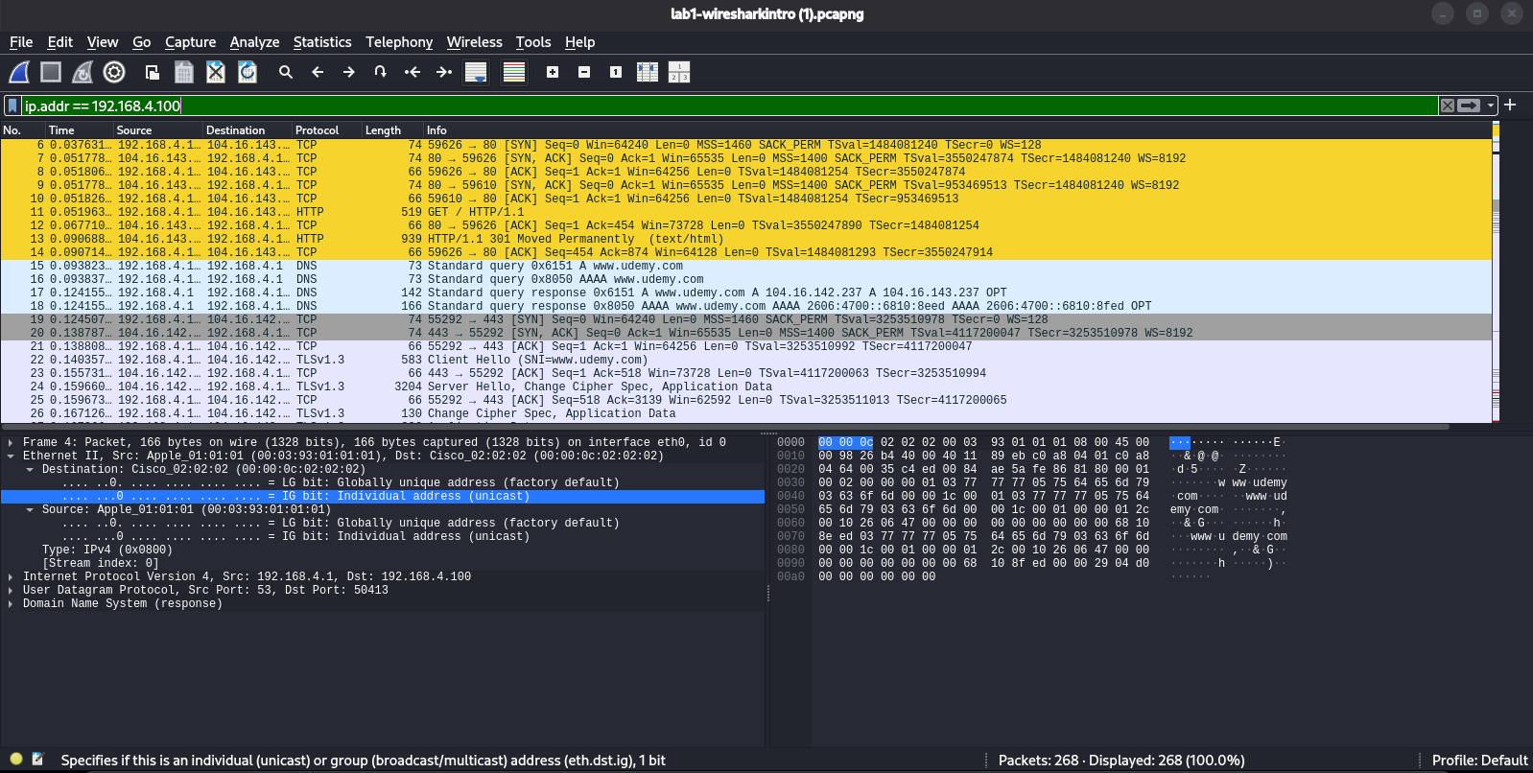

Question No 5:
What's the difference between ip.addr == 192.168.4.100 and ip.src == 192.168.4.100?
- The difference between ip.addr == 192.168.4.100 and ip.src == 192.168.4.100 is that ip.addr matches every packet where 192.168.4.100 either it is Source IP or Destination IP appears while ip.src only matches packets where 192.168.4.100 is the sender (source).
- When i apply ip,.src filter then it displayed 1440 packets that’s mean filter work correctly and shows only that packets where 192.168.4.100 is sender.
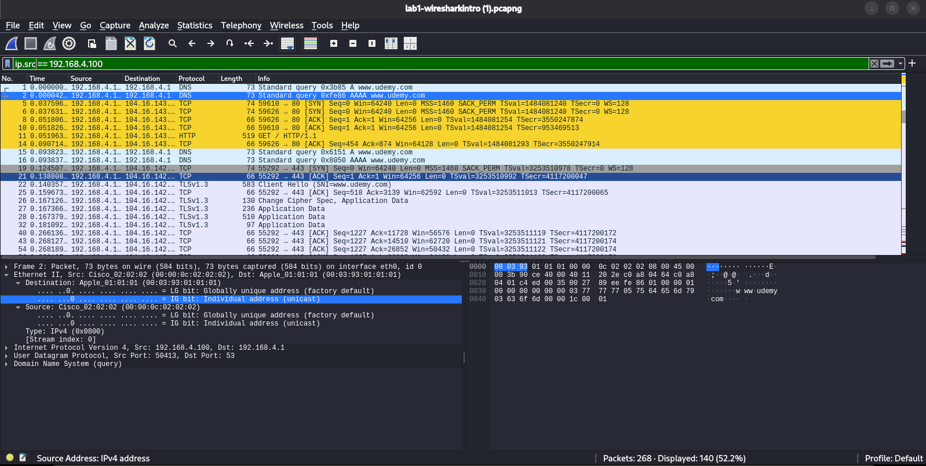

Question No 6:
Filter for tcp.port == 443. What do you see, and what does port 443 tell you about the traffic?
- After applying the filter tcp.port == 443, I observed TCP and TLSv1.3 packets, including the Client Hello, Server Hello, Change Cipher Spec, and encrypted Application Data packets.
- Port 443 indicates that the traffic is HTTPS, meaning the communication between the client and server is encrypted using TLS.
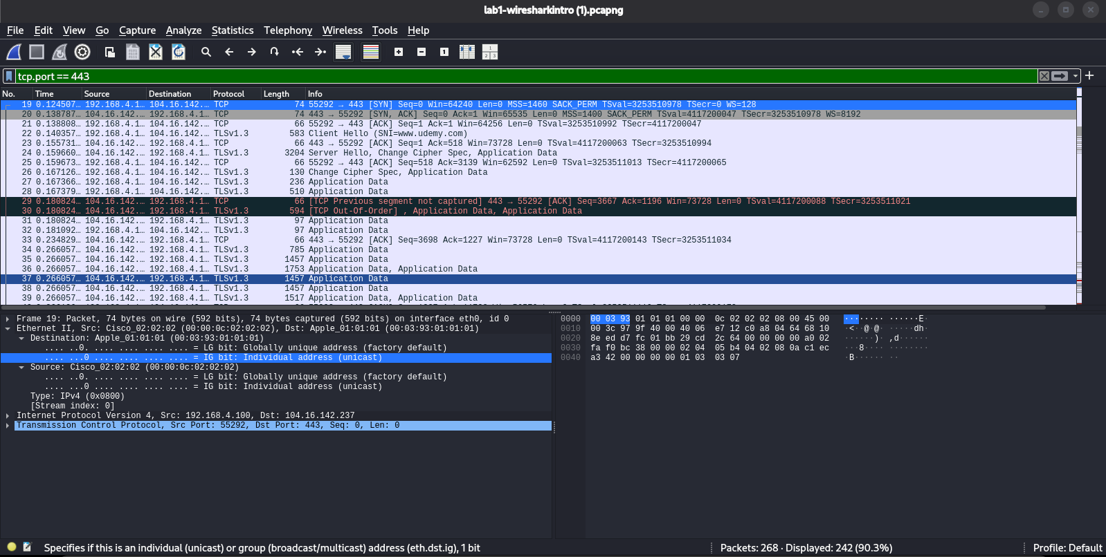

Question No 7:
Clear your filter, then filter for just dns. How many packets match?
- After clearing the filter and put “dns” in the filter, then it shows the 16 packets.
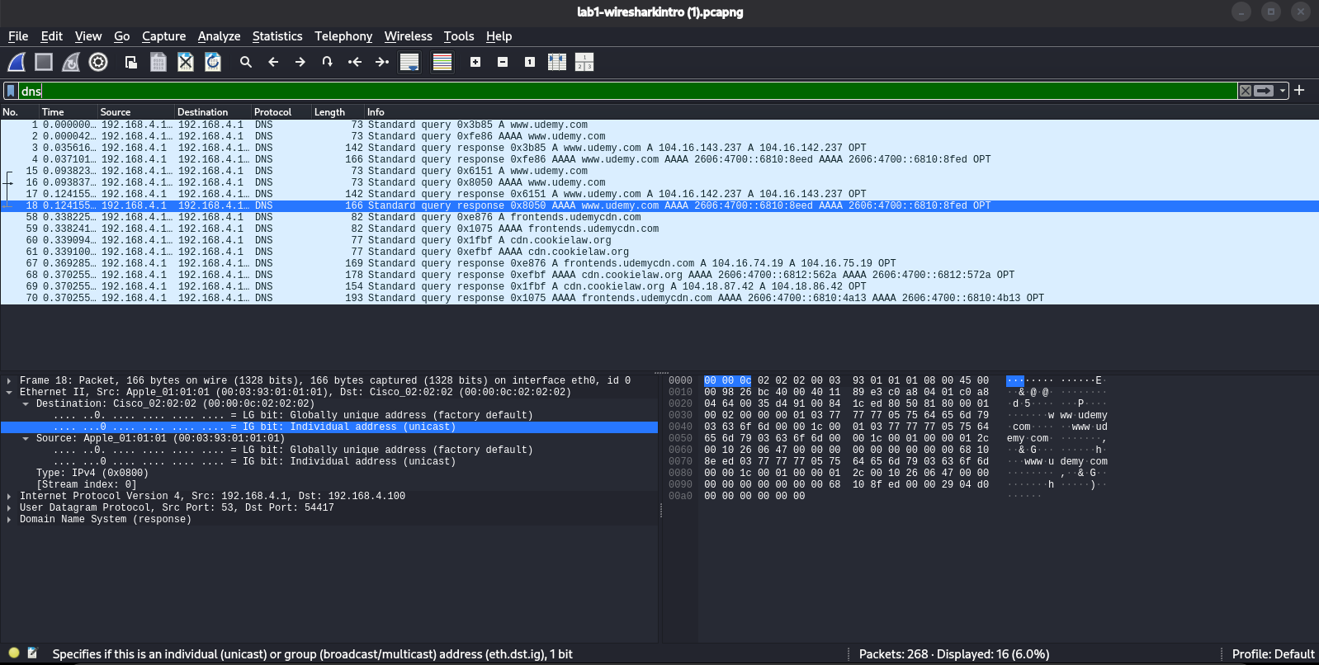

Section C — DNS

Question No 8:
With the dns filter applied, list every hostname this machine looked up.
- There are 3 hostnames when applying dns filter,
- www.udemy.com
- frontends.udemycdn.com
- cdn.cookielaw.org
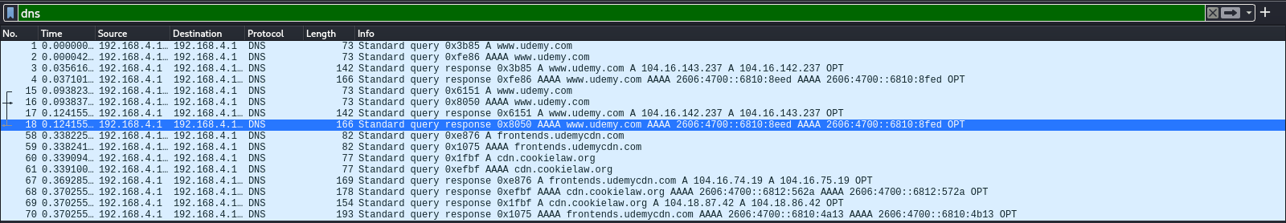

Question No 9:
Pick one DNS response packet. What IP address did the server return for www.udemy.com?
- I choosed www.udemy.com and The DNS server returned the IPv4 addresses 104.16.143.237 and 104.16.142.237 for www.udemy.com.
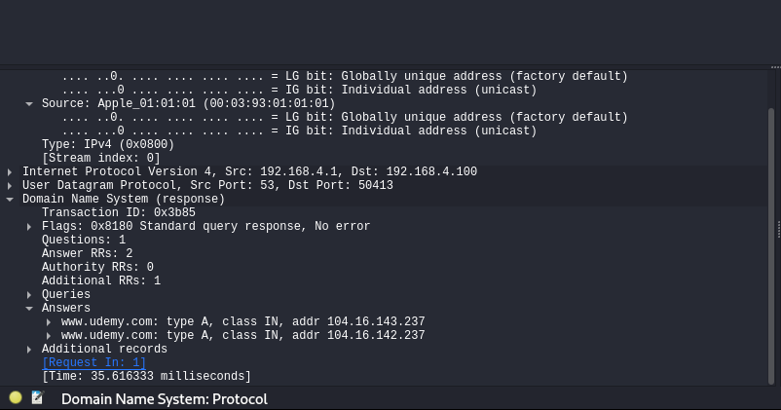

Section D — HTTP

Question No 10:
Filter for http. What do you find?
- When i apply http filter then it shows an HTTP GET request from the client and an HTTP/1.1 301 Moved Permanently response from the server.
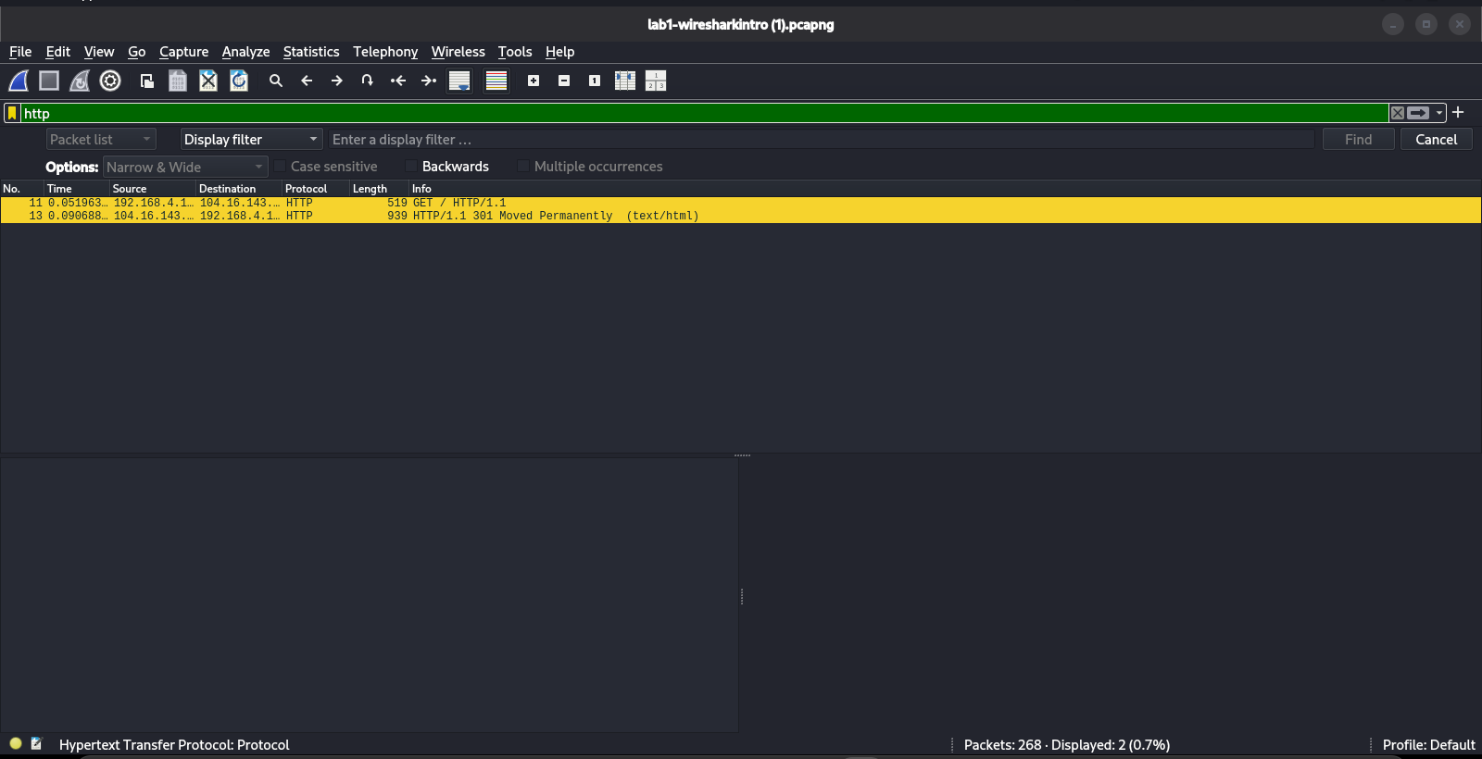

Question No 11:
Select the GET request packet and expand it fully. What can you read in plain text that you could NOT read if this were HTTPS?
- The HTTP GET request is sent in plain text. I can read the requested URL, host name (www.udemy.com), browser information (User-Agent), and HTTP headers. If this were HTTPS, this information would be encrypted and not directly readable.
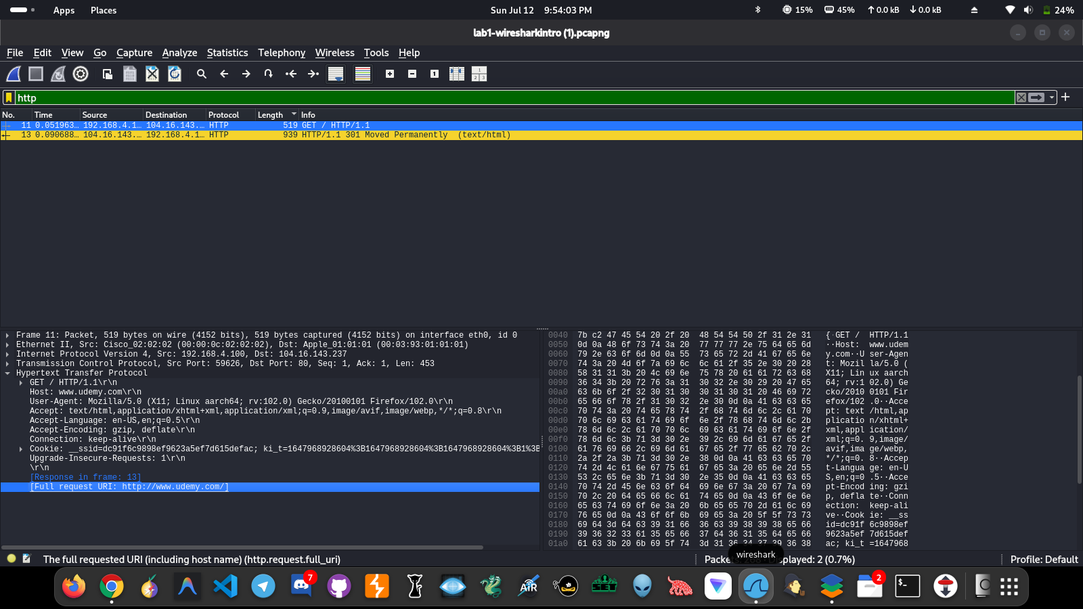

Question No 12:
Look at the server's response to that GET request. What status code does it return, and what does that mean?
- The server returns HTTP Status Code 301 (Moved Permanently). It redirects the browser from HTTP to the secure HTTPS version of the website.
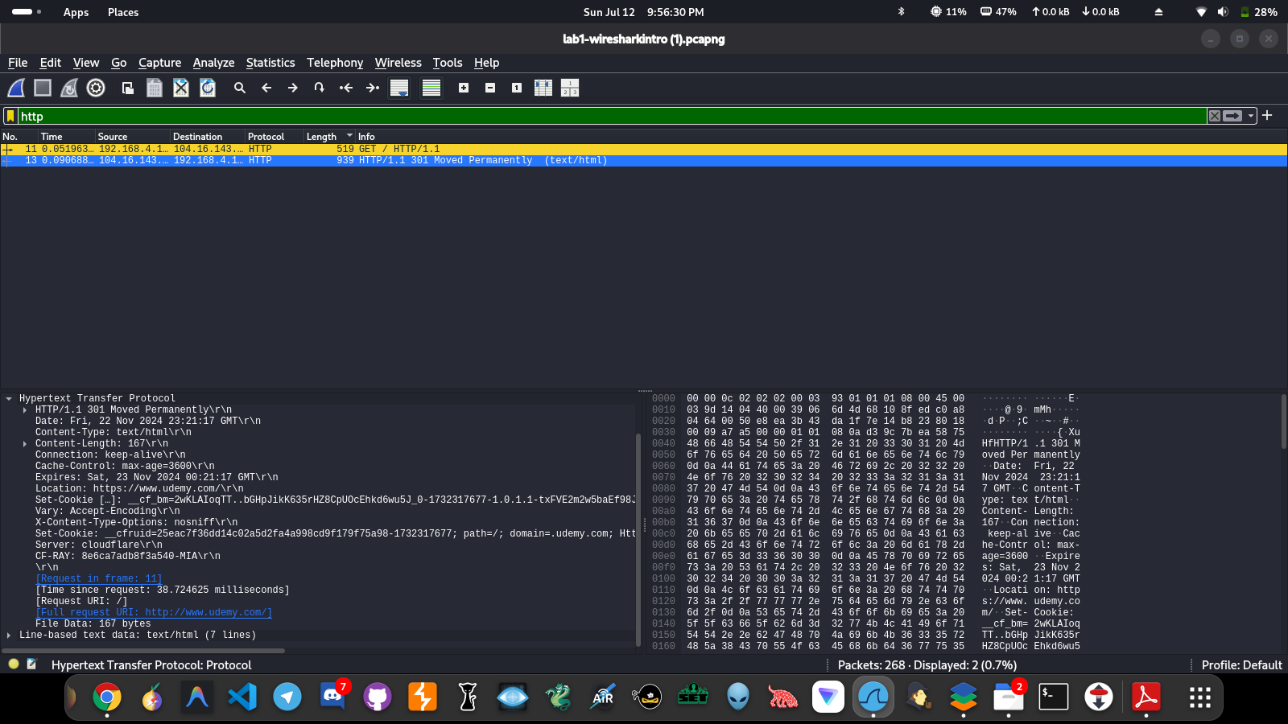

Question No 13:
Right-click the HTTP GET packet → Follow → HTTP Stream. What's different about this view compared to the packet list?
- The HTTP Stream view combines all HTTP packets into one complete conversation between the client and the server. It is easier to read than viewing individual packets because the entire request and response are shown together.
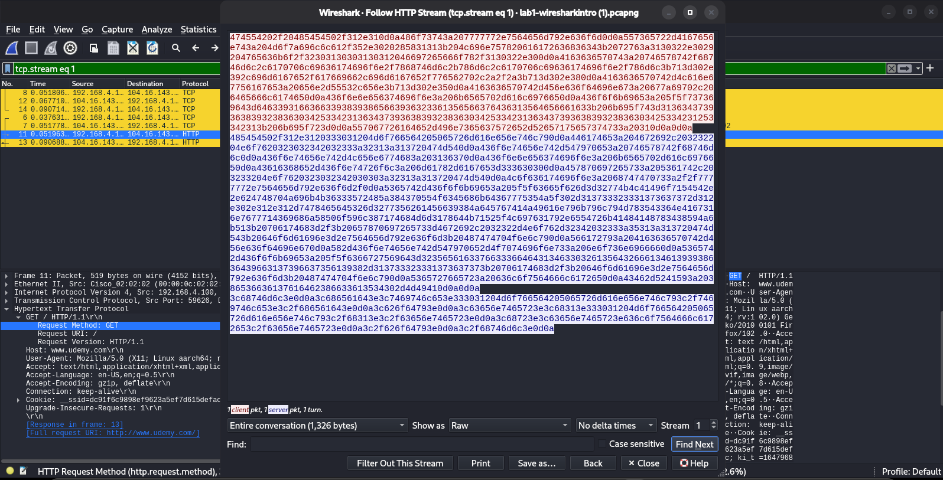
Section E — TLS/HTTPS
Question No 14:
Filter for tls.handshake.type == 1 (Client Hello). Open one and find the Server Name Indication (SNI). What does it tell you, given the packet is otherwise encrypted?
- The Server Name Indication (SNI) is www.udemy.com. Although the TLS session encrypts the communication, the SNI remains visible during the Client Hello, allowing the server to know which website the client wants to connect to before encryption is established.
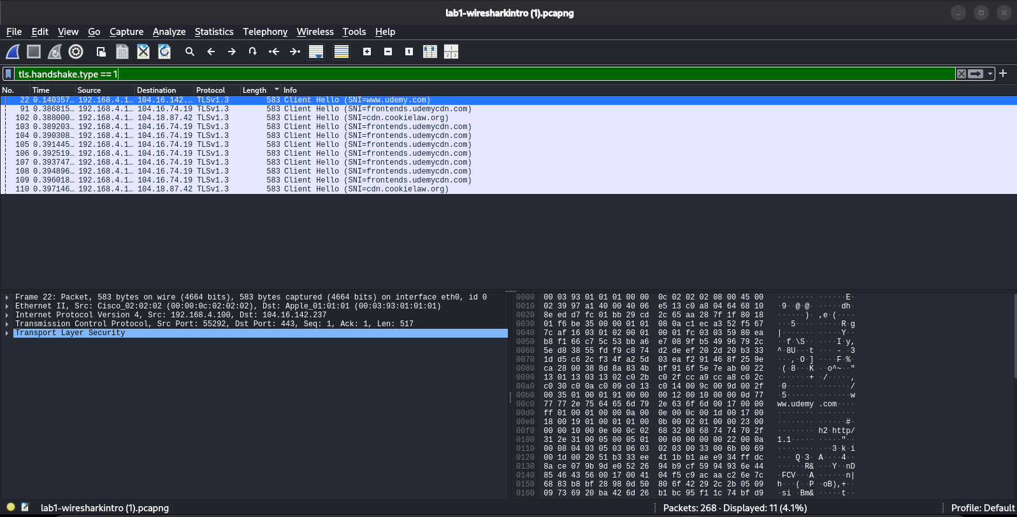
Question No 15:
Filter for tls.handshake.type == 2 (Server Hello). What is the server telling the client in this packet?
- The Server Hello tells the client which TLS version, cipher suite, and security parameters have been selected for the secure connection. This confirms how the encrypted communication will be established.
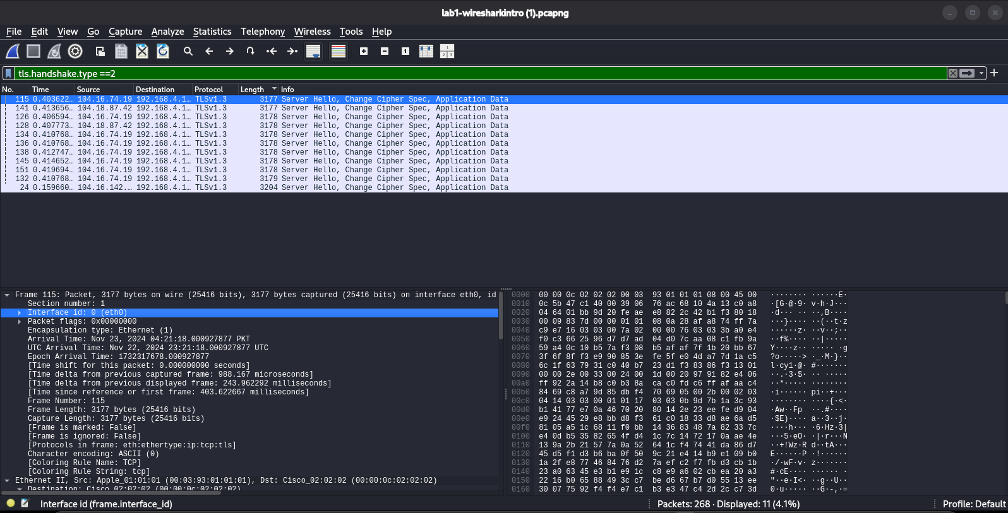

Question No 16:
Follow → TCP Stream on one of the port-443 conversations. What do you see, and why?
- When following the TCP stream on port 443, the data appears as unreadable or encrypted binary data. This is because HTTPS uses TLS encryption, which protects the contents of the communication from being read by anyone intercepting the traffic.
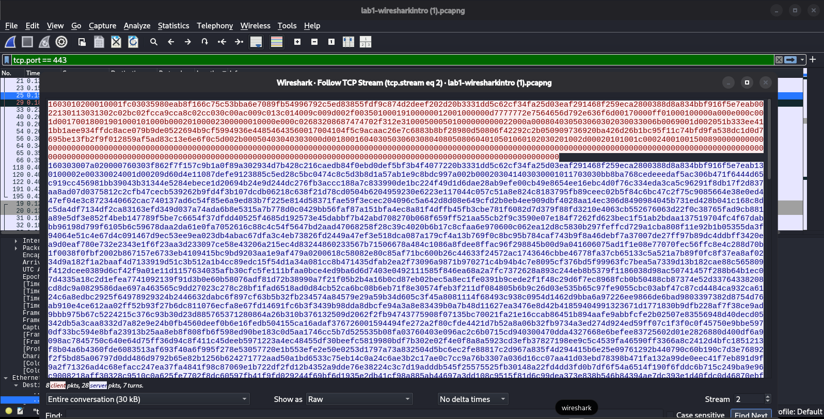

Section F — Statistics Menu

Question No 17:
Open Statistics → Protocol Hierarchy. What does this tell you about the overall makeup of the capture?
- The Protocol Hierarchy shows that the capture mainly consists of Ethernet, IPv4, TCP, and TLS traffic. Most of the communication is TLS-encrypted, with 36 out of 55 packets (65.5%) using TLS and 89.3% of the transmitted bytes being encrypted, indicating that the connection is primarily secure HTTPS traffic.
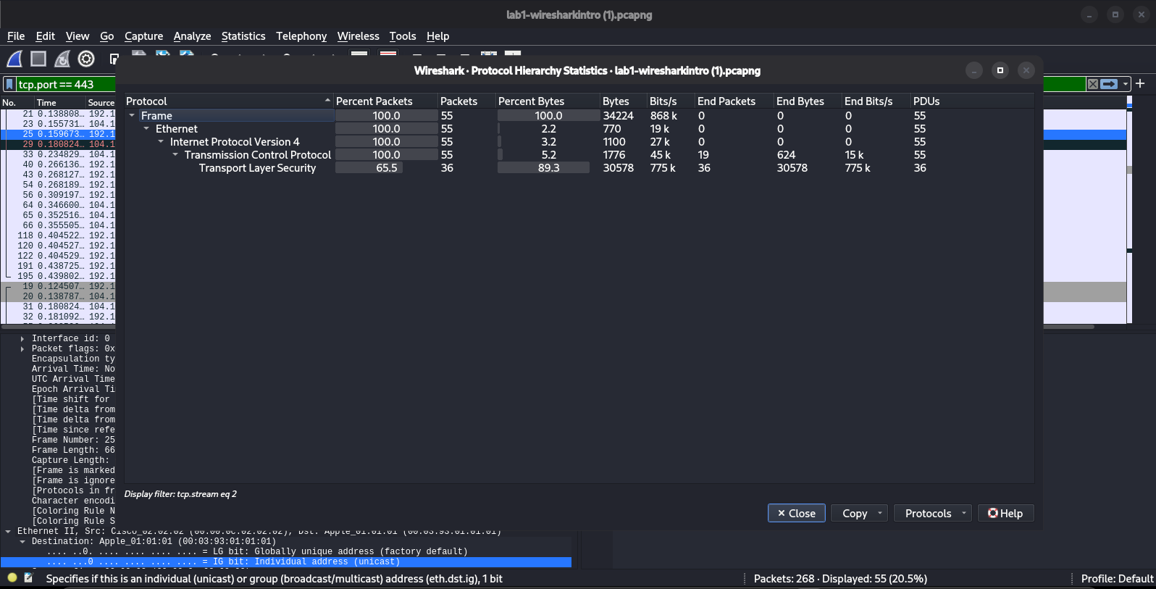

Question No 18:
Open Statistics → Conversations (IPv4 tab). Which remote host had the most packets exchanged with 192.168.4.100, and what does that suggest?
- The remote host with the most packets exchanged with 192.168.4.100 is 104.16.74.19 (148 packets). This suggests that it was the primary server the client communicated with during the capture, indicating most of the web traffic and data transfer occurred with this host.
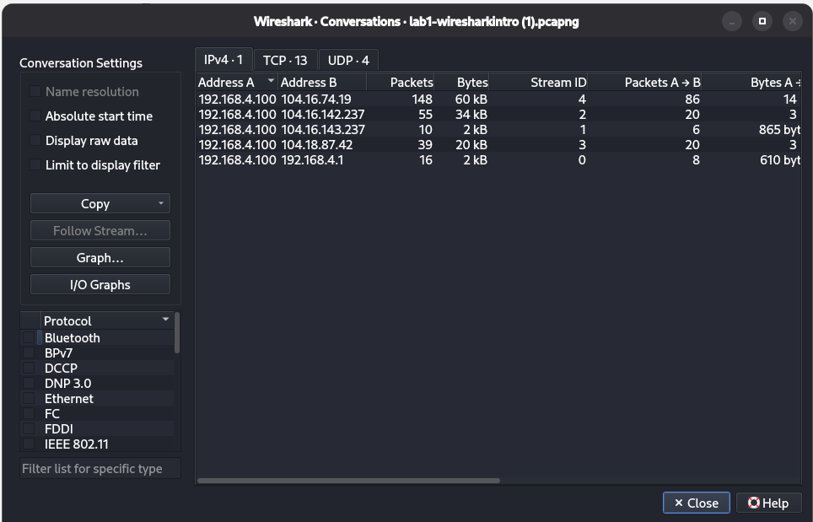

Question No 19:
Open Statistics → Endpoints. How many unique IP addresses does 192.168.4.100 talk to in this whole capture?
- 192.168.4.100 communicates with 5 unique IP addresses during the capture: one local router/DNS server (192.168.4.1) and four remote internet hosts (104.16.74.19, 104.16.142.237, 104.16.143.237, and 104.18.87.42).
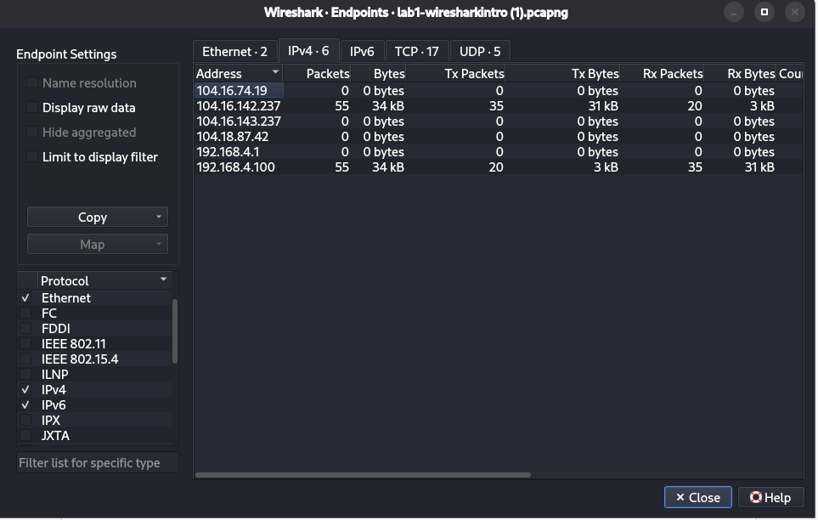

Wrap-up Discussion

Question No 20:
Walk through the full sequence of events in order: DNS lookup → TCP handshake → HTTP request → redirect → TLS handshake → encrypted data. Can you reconstruct this timeline using the packet numbers alone?
- Yes. The packet sequence shows the complete communication process:
- DNS Lookup – The client queries the DNS server to resolve www.udemy.com and receives its IP address.
- TCP Three-Way Handshake – The client and server establish a TCP connection using SYN → SYN-ACK → ACK.
- HTTP Request – The client sends an HTTP GET request on port 80.
- HTTP Redirect – The server replies with 301 Moved Permanently, redirecting the client to HTTPS.
- TLS Handshake – The client and server exchange Client Hello and Server Hello messages to establish a secure session.
- Encrypted Data – After the handshake, all application data is encrypted and exchanged over port 443.
Question No 21:
Why might a network admin still tell a user visited "udemy.com" even though the connection is HTTPS?
- Because the domain name is still visible through DNS queries and the TLS Server Name Indication (SNI) in the Client Hello packet. Although the website content is encrypted, the destination domain (www.udemy.com) can still be identified.
Question No 22:
How would you actually decrypt the TLS traffic in Wireshark if you needed to?
- TLS traffic can be decrypted by obtaining the TLS session keys (SSL Key Log File) from the client browser or application and loading the key log file into Wireshark (Edit → Preferences → Protocols → TLS → (Pre)-Master-Secret log filename). Once the correct session keys are provided, Wireshark can decrypt and display the HTTPS traffic.

