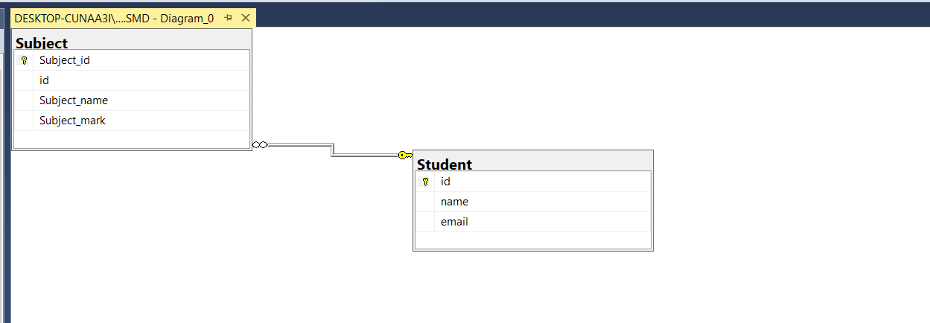

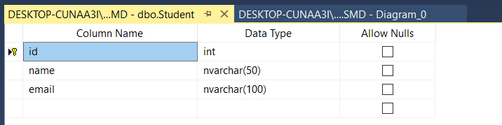

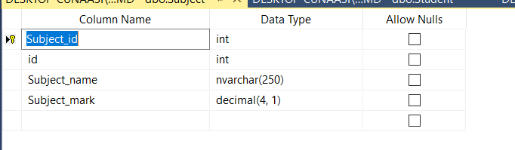

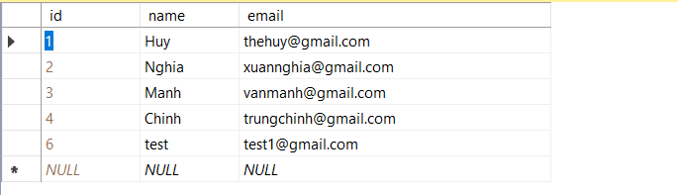

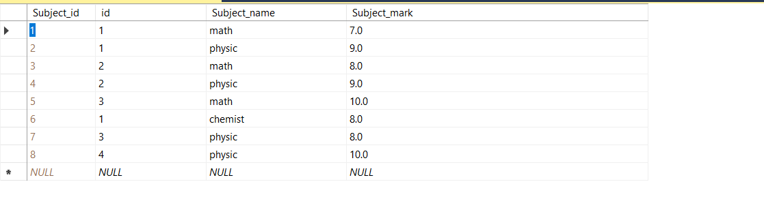

Cơ sở dữ liệu:SMD

USE [master]

GO

/****** Object: Database [SMD] Script Date: 11/6/2021 1:33:07 AM ******/

CREATE DATABASE [SMD]

CONTAINMENT = NONE

ON PRIMARY

( NAME = N'SMD', FILENAME = N'C:\Program Files\Microsoft SQL Server\MSSQL15.SQLEXPRESS\MSSQL\DATA\SMD.mdf' , SIZE = 8192KB , MAXSIZE = UNLIMITED, FILEGROWTH = 65536KB )

LOG ON

( NAME = N'SMD_log', FILENAME = N'C:\Program Files\Microsoft SQL Server\MSSQL15.SQLEXPRESS\MSSQL\DATA\SMD_log.ldf' , SIZE = 8192KB , MAXSIZE = 2048GB , FILEGROWTH = 65536KB )

WITH CATALOG_COLLATION = DATABASE_DEFAULT

GO

ALTER DATABASE [SMD] SET COMPATIBILITY_LEVEL = 150

GO

IF (1 = FULLTEXTSERVICEPROPERTY('IsFullTextInstalled'))

begin

EXEC [SMD].[dbo].[sp_fulltext_database] @action = 'enable'

end

GO

ALTER DATABASE [SMD] SET ANSI_NULL_DEFAULT OFF

GO

ALTER DATABASE [SMD] SET ANSI_NULLS OFF

GO

ALTER DATABASE [SMD] SET ANSI_PADDING OFF

GO

ALTER DATABASE [SMD] SET ANSI_WARNINGS OFF

GO

ALTER DATABASE [SMD] SET ARITHABORT OFF

GO

ALTER DATABASE [SMD] SET AUTO_CLOSE OFF

GO

ALTER DATABASE [SMD] SET AUTO_SHRINK OFF

GO

ALTER DATABASE [SMD] SET AUTO_UPDATE_STATISTICS ON

GO

ALTER DATABASE [SMD] SET CURSOR_CLOSE_ON_COMMIT OFF

GO

ALTER DATABASE [SMD] SET CURSOR_DEFAULT GLOBAL

GO

ALTER DATABASE [SMD] SET CONCAT_NULL_YIELDS_NULL OFF

GO

ALTER DATABASE [SMD] SET NUMERIC_ROUNDABORT OFF

GO

ALTER DATABASE [SMD] SET QUOTED_IDENTIFIER OFF

GO

ALTER DATABASE [SMD] SET RECURSIVE_TRIGGERS OFF

GO

ALTER DATABASE [SMD] SET DISABLE_BROKER

GO

ALTER DATABASE [SMD] SET AUTO_UPDATE_STATISTICS_ASYNC OFF

GO

ALTER DATABASE [SMD] SET DATE_CORRELATION_OPTIMIZATION OFF

GO

ALTER DATABASE [SMD] SET TRUSTWORTHY OFF

GO

ALTER DATABASE [SMD] SET ALLOW_SNAPSHOT_ISOLATION OFF

GO

ALTER DATABASE [SMD] SET PARAMETERIZATION SIMPLE

GO

ALTER DATABASE [SMD] SET READ_COMMITTED_SNAPSHOT OFF

GO

ALTER DATABASE [SMD] SET HONOR_BROKER_PRIORITY OFF

GO

ALTER DATABASE [SMD] SET RECOVERY SIMPLE

GO

ALTER DATABASE [SMD] SET MULTI_USER

GO

ALTER DATABASE [SMD] SET PAGE_VERIFY CHECKSUM

GO

ALTER DATABASE [SMD] SET DB_CHAINING OFF

GO

ALTER DATABASE [SMD] SET FILESTREAM( NON_TRANSACTED_ACCESS = OFF )

GO

ALTER DATABASE [SMD] SET TARGET_RECOVERY_TIME = 60 SECONDS

GO

ALTER DATABASE [SMD] SET DELAYED_DURABILITY = DISABLED

GO

ALTER DATABASE [SMD] SET ACCELERATED_DATABASE_RECOVERY = OFF

GO

ALTER DATABASE [SMD] SET QUERY_STORE = OFF

GO

USE [SMD]

GO

/****** Object: Table [dbo].[Student] Script Date: 11/6/2021 1:33:08 AM ******/

SET ANSI_NULLS ON

GO

SET QUOTED_IDENTIFIER ON

GO

CREATE TABLE [dbo].[Student](

[id] [int] IDENTITY(1,1) NOT NULL,

[name] [nvarchar](50) NOT NULL,

[email] [nvarchar](100) NOT NULL,

PRIMARY KEY CLUSTERED

(

[id] ASC

)WITH (PAD_INDEX = OFF, STATISTICS_NORECOMPUTE = OFF, IGNORE_DUP_KEY = OFF, ALLOW_ROW_LOCKS = ON, ALLOW_PAGE_LOCKS = ON, OPTIMIZE_FOR_SEQUENTIAL_KEY = OFF) ON [PRIMARY]

) ON [PRIMARY]

GO

/****** Object: Table [dbo].[Subject] Script Date: 11/6/2021 1:33:08 AM ******/

SET ANSI_NULLS ON

GO

SET QUOTED_IDENTIFIER ON

GO

CREATE TABLE [dbo].[Subject](

[Subject_id] [int] IDENTITY(1,1) NOT NULL,

[id] [int] NOT NULL,

[Subject_name] [nvarchar](250) NOT NULL,

[Subject_mark] [decimal](4, 1) NOT NULL,

PRIMARY KEY CLUSTERED

(

[Subject_id] ASC

)WITH (PAD_INDEX = OFF, STATISTICS_NORECOMPUTE = OFF, IGNORE_DUP_KEY = OFF, ALLOW_ROW_LOCKS = ON, ALLOW_PAGE_LOCKS = ON, OPTIMIZE_FOR_SEQUENTIAL_KEY = OFF) ON [PRIMARY]

) ON [PRIMARY]

GO

ALTER TABLE [dbo].[Subject] ADD DEFAULT ((0.0)) FOR [Subject_mark]

GO

ALTER TABLE [dbo].[Subject] WITH CHECK ADD CONSTRAINT [fk_student_subject] FOREIGN KEY([id])

REFERENCES [dbo].[Student] ([id])

GO

ALTER TABLE [dbo].[Subject] CHECK CONSTRAINT [fk_student_subject]

GO

USE [master]

GO

ALTER DATABASE [SMD] SET READ_WRITE

GO