CDM Onboarding report for the Synthea generated for 20k persons database
<author_1>,<author_2>

- Table of content

- Execution details
Detail | Value
CdmOnboarding package version | 4.0.0
Database | postgresql
CDM version | 5.4
Execution date | 2026-01-12 14:54
Execution duration | 2m 17.5s
Achilles version | 1.7.2
Achilles execution date | 2024-05-15
Snapshot | 015e1a32a1d39a5256840e2205dd7c8f
Symbols used in table/figure captions: Ⓞ=Computed directly from OMOP CDM data, Ⓐ=Computed from Achilles, Ⓢ=Estimated from system tables.
  - CDM Source Table
- Content of the OMOP cdm_source table Ⓞ
field | Values
CDM_SOURCE_NAME | Synthea generated for 20k persons
CDM_SOURCE_ABBREVIATION | Synthea20k
CDM_HOLDER | Maxim
SOURCE_DESCRIPTION | Synthetic generated data for 20k alive patients
SOURCE_DOCUMENTATION_REFERENCE | https://synthetichealth.github.io/synthea/
CDM_ETL_REFERENCE | https://github.com/OHDSI/ETL-Synthea
SOURCE_RELEASE_DATE | 2022-11-06
CDM_RELEASE_DATE | 2022-11-06
CDM_VERSION | 5.4
CDM_VERSION_CONCEPT_ID | 756265
VOCABULARY_VERSION | v5.0 31-OCT-22

- Clinical data
  - Record counts per OMOP CDM table
- The number of records in all clinical data tables Ⓞ
Table | #Records | #Persons | %Persons
measurement | 15,072,717 | 23,517 | 100%
drug_exposure | 1,483,659 | 22,478 | 95.6%
procedure_occurrence | 1,296,930 | 23,484 | 99.9%
visit_occurrence | 1,276,461 | 23,517 | 100%
visit_detail | 1,276,461 | 23,517 | 100%
observation | 465,207 | 19,815 | 84.3%
condition_occurrence | 402,721 | 23,243 | 98.8%
condition_era | 389,210 | 23,243 | 98.8%
drug_era | 178,000 | 22,478 | 95.6%
person | 23,517 | 23,517 | 100%
observation_period | 23,517 | 23,517 | 100%
provider | 1,181 | NA | NA
cdm_source | 1 | NA | NA
episode_event | 0 | NA | NA
metadata | 0 | NA | NA
fact_relationship | 0 | NA | NA
note_nlp | 0 | NA | NA
location | 0 | NA | NA
cost | 0 | NA | NA
care_site | 0 | NA | NA
episode | 0 | 0 | 0%
specimen | 0 | 0 | 0%
payer_plan_period | 0 | 0 | 0%
note | 0 | 0 | 0%
dose_era | 0 | 0 | 0%
device_exposure | 0 | 0 | 0%
death | 0 | 0 | 0%
Query executed in 0.62 seconds

  - Data density plots
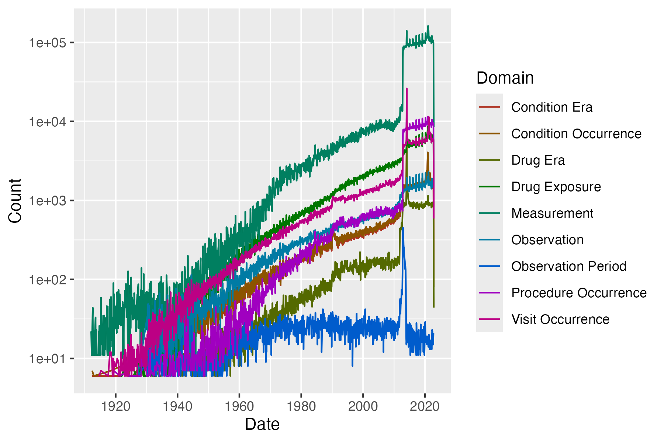
- Total record count over time per OMOP data domain. Ⓐ
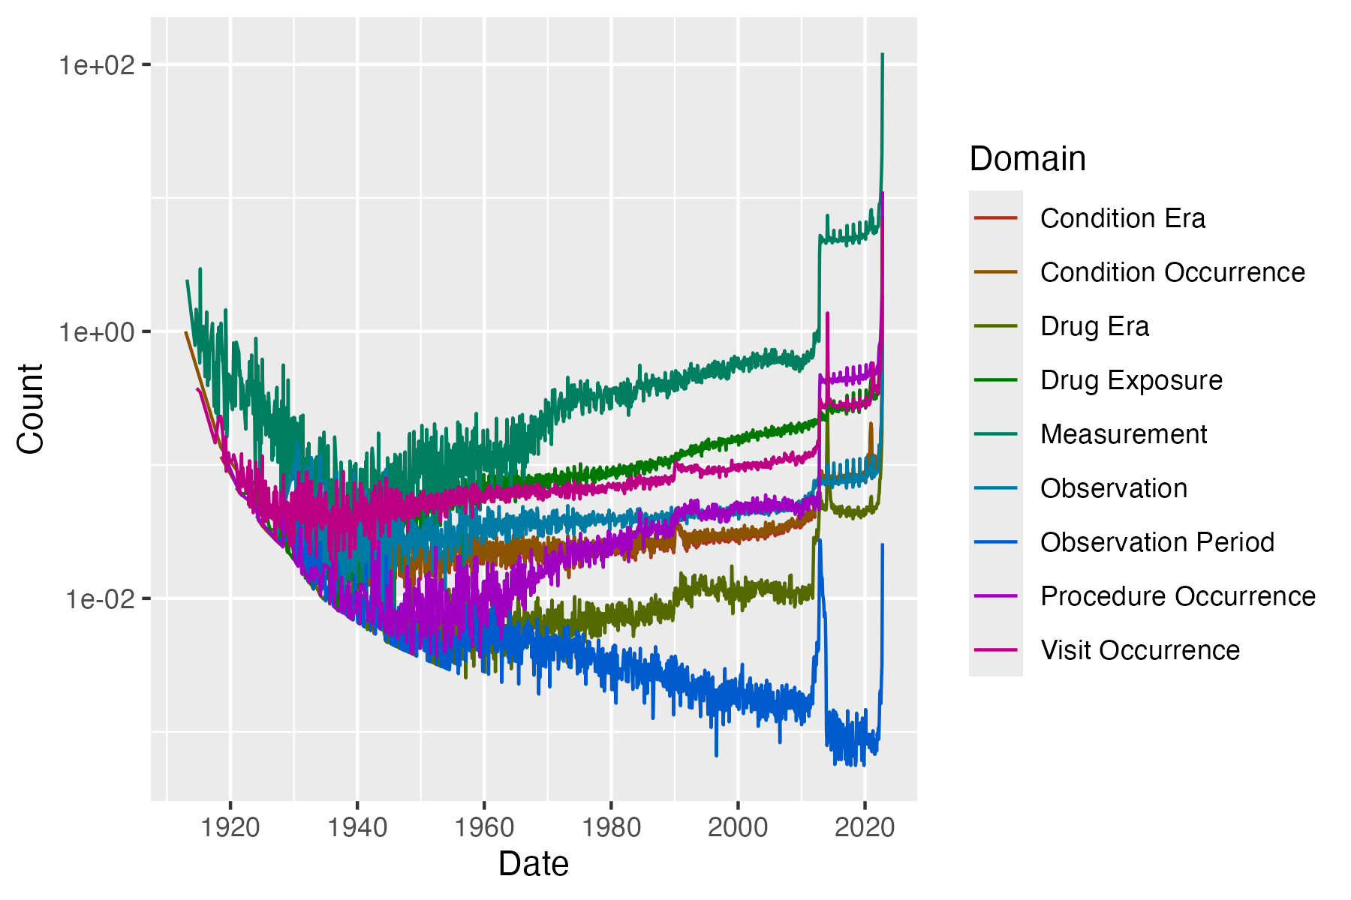
- Number of records per person over time per OMOP data domain. Note: using analysis 110 as denominator as of v4.0 (instead of 117). Ⓐ
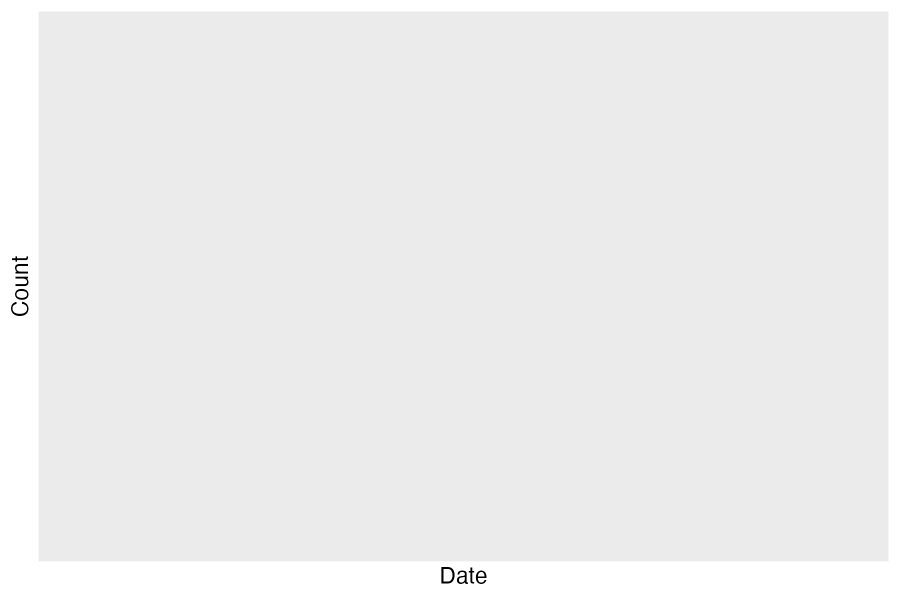
- Number of deaths in each month. Overall mortality: 0%. Ⓐ

  - Distinct concepts per person
- The number of distinct concepts per person per OMOP data domains. Only persons with at least one record in that domain are included in the calculation. Ⓐ
DOMAIN | N_PERSONS | MIN | P10 | P25 | MEDIAN | P75 | P90 | MAX
Visit Occurrence | 23,517 | 1 | 1 | 2 | 2 | 3 | 3 | 3
Condition Occurrence | 23,242 | 1 | 4 | 7 | 10 | 14 | 18 | 45
Procedure Occurrence | 23,484 | 1 | 3 | 6 | 8 | 13 | 19 | 36
Drug exposure | 22,478 | 1 | 2 | 3 | 5 | 7 | 10 | 25
Observation | 19,804 | 1 | 3 | 4 | 6 | 7 | 9 | 21
Drug era | 22,478 | 1 | 2 | 3 | 5 | 8 | 11 | 28
Condition era | 23,242 | 1 | 4 | 7 | 10 | 13 | 18 | 45
Measurement | 23,517 | 1 | 2 | 5 | 6 | 7 | 22 | 36
Query executed in 0.00 seconds

  - Observation Period
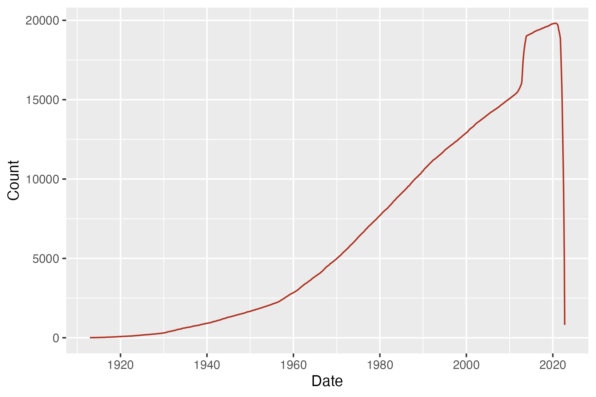
- Persons with continuous observation by month.Ⓐ In the last 6 months (before 2022-11-06), there are 13,332 persons with an active observation period.Ⓞ

- Length of first observation period (years). Ⓐ
AVG | STDEV | MIN | P10 | P25 | MEDIAN | P75 | P90 | MAX
30.8 | 21.4 | 0 | 8 | 9.9 | 28.1 | 46.5 | 60.8 | 109.7
Query executed in 0.00 seconds
- Number of observation periods per person Ⓐ and overlapping observation periods Ⓞ.
Field | Value | %Persons
Persons with 1 observation period(s) | 23,517 | 100%
Persons with overlapping observation periods | 0 | NA
Number of overlapping observation periods | 0 | NA
Queries executed in 0.00 seconds and 0.01 seconds
  - Date Range
- Minimum and maximum event start date in each table, within an observation period and at least 5 records. Floored to the nearest month. Ⓞ
Domain | Type | #Records | Start date [Min, Max] | End date [Min, Max]
Condition | Prescription dispensed in pharmacy (-) | 402,721 | [1912-06, 2022-11] | [1913-01, 2022-11]
Drug | Pharmacy claim (S) | 1,483,659 | [1912-06, 2022-11] | [1912-08, 2022-11]
Measurement | Outpatient detail - 1st position (-) | 15,072,717 | [1912-02, 2022-11] | [NA, NA]
Obs. Period | Period covering healthcare encounters (-) | 23,517 | [1912-02, 2022-10] | [1913-10, 2022-11]
Observation | Observation recorded from EHR (-) | 465,207 | [1913-06, 2022-11] | [NA, NA]
Procedure | Outpatient detail - 1st position (-) | 1,296,930 | [1912-02, 2022-11] | [1912-02, 2022-11]
Visit | Visit derived from encounter on claim (-) | 1,276,461 | [1912-02, 2022-11] | [1912-02, 2022-11]
Visit Detail | Visit derived from encounter on claim (-) | 1,276,461 | [1912-02, 2022-11] | [1912-02, 2022-11]
Query executed in 2.29 seconds
- Length of stay by visit concept. The length should be interpreted as number of nights, meaning a length of 0 is a same-day visit. Ⓐ
Domain | Concept Name | AVG | STDEV | MIN | P10 | P25 | MEDIAN | P75 | P90 | MAX
Visit | Inpatient Visit | 22.1 | 285.4 | 1 | 1 | 1 | 1 | 1 | 2 | 19,589
Visit | Outpatient Visit | 0.7 | 65.2 | 0 | 0 | 0 | 0 | 0 | 0 | 19,957
Visit | Emergency Room Visit | 2.7 | 210.0 | 0 | 0 | 0 | 0 | 0 | 0 | 28,202
Visit Detail | Inpatient Visit | 22.1 | 285.4 | 1 | 1 | 1 | 1 | 1 | 2 | 19,589
Visit Detail | Outpatient Visit | 0.7 | 65.2 | 0 | 0 | 0 | 0 | 0 | 0 | 19,957
Visit Detail | Emergency Room Visit | 2.7 | 210.0 | 0 | 0 | 0 | 0 | 0 | 0 | 28,202
Query executed in 0.17 seconds
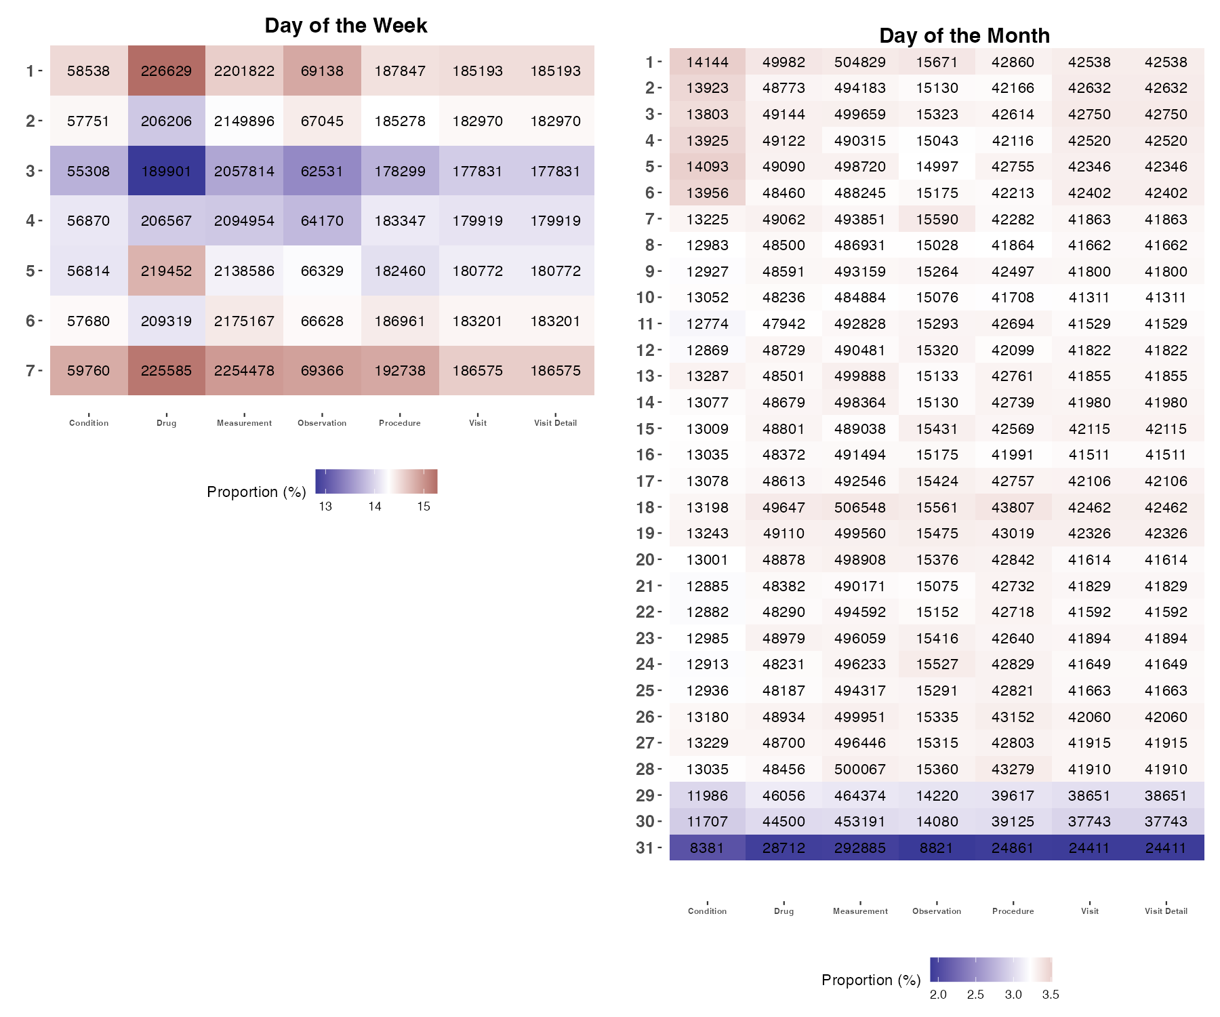
- Day of the Week and Day of the Month distribution of event start dates after 1900-01-01 per domain. 1 = Monday ... 7 = Sunday. Ⓞ
Queries executed in 2.42 seconds and 2.98 seconds
  - Day, Month, Year of Birth
- Distribution of day, month and year of birth of persons. Ⓞ
 | %Missing | MIN | P10 | P25 | MEDIAN | P75 | P90 | MAX
Year | 0% | 1912 | 1943 | 1959 | 1978 | 1999 | 2012 | 2022
Month | 0% | 1 | 2 | 4 | 7 | 10 | 11 | 12
Day | 0% | 1 | 4 | 8 | 16 | 23 | 28 | 31
Query executed in 0.03 seconds
- Vocabulary mappings
Vocabulary version: v5.0 31-OCT-22
Pre-processing query executed in 12.51 seconds
  - Mapping Completeness
- The number and percentage of codes and records that are mapped to an OMOP concept (not 0 and <2B). Note: for one-to-many mappings, the source codes will be counted multiple times so the reported total source codes could be bigger than actual number of unique source codes. Ⓞ
Domain | #Codes Source | #Codes Mapped | %Codes Mapped | #Records Source | #Records Mapped | %Records Mapped
Condition | 231 | 222 | 96.1% | 402,721 | 398,328 | 98.9%
Condition status | 1 | 0 | 0% | 402,721 | 0 | 0%
Death cause | 0 | NA | NA | NA | NA | NA
Device | 0 | NA | NA | NA | NA | NA
Drug | 256 | 256 | 100% | 1,483,659 | 1,483,659 | 100%
Drug Route | 1 | 0 | 0% | 1,483,659 | 0 | 0%
Episode | 0 | NA | NA | NA | NA | NA
Measurement | 331 | 51 | 15.4% | 15,072,717 | 656,289 | 4.4%
Measurement Unit | 48 | 32 | 66.7% | 15,072,717 | 6,958,240 | 46.2%
Measurement value | 43,822 | 0 | 0% | 15,072,717 | 0 | 0%
Observation | 45 | 39 | 86.7% | 465,207 | 463,209 | 99.6%
Observation Unit | 1 | 0 | 0% | 465,207 | 0 | 0%
Observation value | NA | NA | NA | 465,207 | 0 | 0%
Procedure | 176 | 172 | 97.7% | 1,296,930 | 1,285,642 | 99.1%
Provider Specialty | 1 | 1 | 100% | 1,181 | 1,181 | 100%
Specimen | 0 | NA | NA | NA | NA | NA
Visit | 1,276,461 | 1,276,461 | 100% | 1,276,461 | 1,276,461 | 100%
Visit detail | 1,276,461 | 1,276,461 | 100% | 1,276,461 | 1,276,461 | 100%
Query executed in 0.22 seconds
  - Drug Mappings
- The level of the drug mappings Ⓞ
Class | #Records | #Patients | #Codes | %Records
Clinical Drug | 1,079,385 | 89,653 | 167 | 72.8%
Branded Drug | 169,419 | 7,271 | 19 | 11.4%
Quant Branded Drug | 113,674 | 1,622 | 12 | 7.7%
Quant Clinical Drug | 80,694 | 9,056 | 40 | 5.4%
Clinical Drug Comp | 25,227 | 983 | 2 | 1.7%
Branded Pack | 14,893 | 11,547 | 11 | 1.0%
Ingredient | 348 | 190 | 1 | 0.0%
Branded Drug Comp | 12 | 7 | 2 | 0.0%
Branded Drug Form | 7 | 5 | 1 | 0.0%
Query executed in 0.03 seconds
  - Unmapped Codes
- Omitted because no unmapped drugs were found with a count >5. Ⓞ
Query executed in 0.01 seconds
- All 7 unmapped conditions. Counts are rounded up to the nearest hundred. Values with a record count <=5 are omitted. Ⓞ
# | Source Value | Source Concept id | Source Concept Name | #Records | %Records
1 | 428251008 | 4323208 | History of appendectomy | 1,100 | 0.3%
2 | 55680006 | 4208104 | Drug overdose | 1,100 | 0.3%
3 | 703151001 | 45766064 | History of single seizure | 900 | 0.2%
4 | 429007001 | 4324181 | History of cardiac arrest | 900 | 0.2%
5 | 399211009 | 4163874 | History of myocardial infarction | 600 | 0.1%
6 | 161622006 | 4058850 | H/O: lower limb amputation | 100 | 0.0%
7 | 429280009 | 4323766 | History of amputation of foot | 100 | 0.0%
Query executed in 0.00 seconds
- Top 25 unmapped measurements. Counts are rounded up to the nearest hundred. Values with a record count <=5 are omitted. Ⓞ
# | Source Value | Source Concept id | Source Concept Name | #Records | %Records
1 | 72514-3||Pain severity - 0-10 verbal numeric ratin | 0 | No matching concept | 406,900 | 2.7%
2 | 8462-4||Diastolic Blood Pressure | 0 | No matching concept | 324,600 | 2.2%
3 | 8480-6||Systolic Blood Pressure | 0 | No matching concept | 324,600 | 2.2%
4 | 29463-7||Body Weight | 0 | No matching concept | 299,600 | 2.0%
5 | 8867-4||Heart rate | 0 | No matching concept | 295,100 | 2.0%
6 | 9279-1||Respiratory rate | 0 | No matching concept | 295,100 | 2.0%
7 | 8302-2||Body Height | 0 | No matching concept | 288,900 | 1.9%
8 | 72166-2||Tobacco smoking status | 0 | No matching concept | 287,900 | 1.9%
9 | 39156-5||Body Mass Index | 0 | No matching concept | 265,000 | 1.8%
10 | 38483-4||Creatinine | 0 | No matching concept | 245,300 | 1.6%
11 | 2947-0||Sodium | 0 | No matching concept | 245,300 | 1.6%
12 | 2069-3||Chloride | 0 | No matching concept | 245,300 | 1.6%
13 | 6299-2||Urea Nitrogen | 0 | No matching concept | 245,300 | 1.6%
14 | 6298-4||Potassium | 0 | No matching concept | 245,300 | 1.6%
15 | 2339-0||Glucose | 0 | No matching concept | 245,300 | 1.6%
16 | 49765-1||Calcium | 0 | No matching concept | 245,300 | 1.6%
17 | 20565-8||Carbon Dioxide | 0 | No matching concept | 245,300 | 1.6%
18 | 93029-7||How often do you see or talk to people th | 0 | No matching concept | 212,800 | 1.4%
19 | 56051-6||Are you Hispanic or Latino? | 0 | No matching concept | 212,800 | 1.4%
20 | 63586-2||During the past year what was the total | 0 | No matching concept | 212,800 | 1.4%
21 | 54899-0||What language are you most comfortable sp | 0 | No matching concept | 212,800 | 1.4%
22 | 76437-3||What is your main insurance? | 0 | No matching concept | 212,800 | 1.4%
23 | 76501-6||In the past year have you been afraid of | 0 | No matching concept | 212,800 | 1.4%
24 | 63512-8||How many family members including yourse | 0 | No matching concept | 212,800 | 1.4%
25 | 93038-8||Stress is when someone feels tense nervo | 0 | No matching concept | 212,800 | 1.4%
Query executed in 0.00 seconds
- All 6 unmapped observations. Counts are rounded up to the nearest hundred. Values with a record count <=5 are omitted. Ⓞ
# | Source Value | Source Concept id | Source Concept Name | #Records | %Records
1 | 1191||Aspirin | NA | NA | 800 | 0.2%
2 | 29046||Lisinopril | NA | NA | 500 | 0.1%
3 | 7984||Penicillin V | NA | NA | 500 | 0.1%
4 | 10831||Sulfamethoxazole / Trimethoprim | NA | NA | 200 | 0.0%
5 | 25037||cefdinir | NA | NA | 100 | 0.0%
6 | 5640||Ibuprofen | NA | NA | 100 | 0.0%
Query executed in 0.00 seconds
- All 3 unmapped procedures. Counts are rounded up to the nearest hundred. Values with a record count <=5 are omitted. Ⓞ
# | Source Value | Source Concept id | Source Concept Name | #Records | %Records
1 | 399014008 | 4163708 | Administration of diphtheria, pertussis, and tetanus vaccine | 6,300 | 0.5%
2 | 66348005 | 40623280 | Parturition | 5,100 | 0.4%
3 | 71121004 | NA | NA | 100 | 0.0%
Query executed in 0.00 seconds
- Omitted because no unmapped devices were found with a count >5. Ⓞ
Query executed in 0.00 seconds
- Omitted because no unmapped visits were found with a count >5. Ⓞ
Query executed in 0.07 seconds
- Omitted because no unmapped visit details were found with a count >5. Ⓞ
Query executed in 0.07 seconds
- All 16 unmapped measurement units. Counts are rounded up to the nearest hundred. Values with a record count <=5 are omitted. Ⓞ
# | Source Value | Source Concept id | Source Concept Name | #Records | %Records
1 |  | NA | NA | 5,063,900 | 33.6%
2 | {nominal} | NA | NA | 1,181,100 | 7.8%
3 | {score} | NA | NA | 1,179,000 | 7.8%
4 | {#} | NA | NA | 263,300 | 1.7%
5 | /a | NA | NA | 212,800 | 1.4%
6 | U/L | NA | NA | 143,900 | 1.0%
7 | mL/min/{1.73_m2} | NA | NA | 30,400 | 0.2%
8 | kU/L | NA | NA | 24,600 | 0.2%
9 | n/a | NA | NA | 7,100 | 0.0%
10 | {INR} | NA | NA | 2,900 | 0.0%
11 | [pH] | NA | NA | 2,600 | 0.0%
12 | {T-score} | NA | NA | 1,700 | 0.0%
13 | {count} | NA | NA | 1,600 | 0.0%
14 | ratio | NA | NA | 200 | 0.0%
15 | ng/dl | NA | NA | 100 | 0.0%
16 | m[IU]/L | NA | NA | 100 | 0.0%
Query executed in 0.00 seconds
- All 1 unmapped observation units. Counts are rounded up to the nearest hundred. Values with a record count <=5 are omitted. Ⓞ
# | Source Value | Source Concept id | Source Concept Name | #Records | %Records
1 |  | NA | NA | 465,300 | 100%
Query executed in 0.00 seconds
- Top 25 unmapped measurement values. Counts are rounded up to the nearest hundred. Values with a record count <=5 are omitted. Ⓞ
# | Source Value | Source Concept id | Source Concept Name | #Records | %Records
1 | No | NA | NA | 1,506,900 | 10.0%
2 |  | NA | NA | 656,300 | 4.4%
3 | 1.0 | NA | NA | 516,500 | 3.4%
4 | Yes | NA | NA | 376,900 | 2.5%
5 | 0.0 | NA | NA | 273,000 | 1.8%
6 | 2.0 | NA | NA | 264,700 | 1.8%
7 | Never smoked tobacco (finding) | NA | NA | 214,100 | 1.4%
8 | I have housing | NA | NA | 211,500 | 1.4%
9 | English | NA | NA | 194,100 | 1.3%
10 | 3.0 | NA | NA | 189,300 | 1.3%
11 | White | NA | NA | 175,900 | 1.2%
12 | I choose not to answer this question | NA | NA | 162,000 | 1.1%
13 | 4.0 | NA | NA | 149,000 | 1.0%
14 | Full-time work | NA | NA | 135,400 | 0.9%
15 | More than high school | NA | NA | 124,000 | 0.8%
16 | Cloudy urine (finding) | NA | NA | 97,800 | 0.6%
17 | Urine nitrite negative (finding) | NA | NA | 97,500 | 0.6%
18 | Urine leukocyte test negative (finding) | NA | NA | 97,500 | 0.6%
19 | Urine glucose test = ++ (finding) | NA | NA | 97,500 | 0.6%
20 | Finding of bilirubin in urine (finding) | NA | NA | 97,500 | 0.6%
21 | Urine smell ammoniacal (finding) | NA | NA | 97,200 | 0.6%
22 | Brown color (qualifier value) | NA | NA | 97,200 | 0.6%
23 | Urine blood test = negative (finding) | NA | NA | 97,200 | 0.6%
24 | Translucent (qualifier value) | NA | NA | 97,200 | 0.6%
25 | 5.0 | NA | NA | 97,100 | 0.6%
Query executed in 0.01 seconds
- All 1 unmapped observation values. Counts are rounded up to the nearest hundred. Values with a record count <=5 are omitted. Ⓞ
# | Source Value | Source Concept id | Source Concept Name | #Records | %Records
1 |  | NA | NA | 465,300 | 100%
Query executed in 0.00 seconds
- All 1 unmapped drug route. Counts are rounded up to the nearest hundred. Values with a record count <=5 are omitted. Ⓞ
# | Source Value | Source Concept id | Source Concept Name | #Records | %Records
1 |  | NA | NA | 1,483,700 | 100%
Query executed in 0.00 seconds
- Omitted because no unmapped specialty were found with a count >5. Ⓞ
Query executed in 0.00 seconds
- Omitted because no unmapped episode were found with a count >5. Ⓞ
Query executed in 0.00 seconds
  - Mapped Codes
- Top 25 mapped drugs. Counts are rounded up to the nearest hundred. Values with a record count <=5 are omitted. Ⓞ
# | Concept id | Concept Name | #Records | %Records
1 | 19080128 | lisinopril 10 MG Oral Tablet | 228,200 | 15.4%
2 | 19078106 | hydrochlorothiazide 25 MG Oral Tablet | 188,600 | 12.7%
3 | 19073094 | amlodipine 2.5 MG Oral Tablet | 179,000 | 12.1%
4 | 19009384 | insulin isophane, human 70 UNT/ML / insulin, regular, human 30 UNT/ML Injectable Suspension [Humulin] | 120,600 | 8.1%
5 | 19030765 | 1 ML epoetin alfa 4000 UNT/ML Injection [Epogen] | 88,100 | 5.9%
6 | 1511248 | NDA020503 200 ACTUAT albuterol 0.09 MG/ACTUAT Metered Dose Inhaler | 51,500 | 3.5%
7 | 19126352 | nitroglycerin 0.4 MG/ACTUAT Mucosal Spray | 41,900 | 2.8%
8 | 1539463 | simvastatin 10 MG Oral Tablet | 39,800 | 2.7%
9 | 1539411 | simvastatin 20 MG Oral Tablet | 36,600 | 2.5%
10 | 40163924 | 24 HR metformin hydrochloride 500 MG Extended Release Oral Tablet | 35,600 | 2.4%
11 | 1332419 | amlodipine 5 MG Oral Tablet | 34,700 | 2.3%
12 | 19075601 | clopidogrel 75 MG Oral Tablet | 32,900 | 2.2%
13 | 40163554 | warfarin sodium 5 MG Oral Tablet | 25,900 | 1.7%
14 | 19018935 | digoxin 0.125 MG Oral Tablet | 25,900 | 1.7%
15 | 40171902 | verapamil hydrochloride 40 MG | 25,100 | 1.7%
16 | 40173590 | alendronic acid 10 MG Oral Tablet | 20,300 | 1.4%
17 | 40169217 | 120 ACTUAT fluticasone propionate 0.044 MG/ACTUAT Metered Dose Inhaler [Flovent] | 16,500 | 1.1%
18 | 1154380 | albuterol 5 MG/ML Inhalation Solution | 15,900 | 1.1%
19 | 40169281 | 60 ACTUAT fluticasone propionate 0.25 MG/ACTUAT / salmeterol 0.05 MG/ACTUAT Dry Powder Inhaler | 15,700 | 1.1%
20 | 40162606 | acetaminophen 300 MG / hydrocodone bitartrate 5 MG Oral Tablet | 14,600 | 1.0%
21 | 19098138 | budesonide 0.25 MG/ML Inhalation Suspension | 13,400 | 0.9%
22 | 1127433 | acetaminophen 325 MG Oral Tablet | 12,600 | 0.8%
23 | 19033893 | ibuprofen 400 MG Oral Tablet [Ibu] | 12,300 | 0.8%
24 | 19041324 | acetaminophen 325 MG Oral Tablet [Tylenol] | 12,100 | 0.8%
25 | 35604087 | cisplatin 50 MG Injection | 11,200 | 0.7%
Query executed in 0.00 seconds
- Top 25 mapped conditions. Counts are rounded up to the nearest hundred. Values with a record count <=5 are omitted. Ⓞ
# | Concept id | Concept Name | #Records | %Records
1 | 4251306 | Stress | 110,800 | 27.5%
2 | 4309238 | Social isolation | 27,400 | 6.8%
3 | 4172829 | Limited social contact | 27,300 | 6.8%
4 | 40481087 | Viral sinusitis | 24,600 | 6.1%
5 | 45768458 | Victim of intimate partner abuse | 19,100 | 4.7%
6 | 4112343 | Acute viral pharyngitis | 14,100 | 3.5%
7 | 260139 | Acute bronchitis | 11,600 | 2.9%
8 | 4217975 | Normal pregnancy | 10,600 | 2.6%
9 | 4311629 | Impaired glucose tolerance | 9,000 | 2.2%
10 | 439777 | Anemia | 8,200 | 2.0%
11 | 320128 | Essential hypertension | 8,100 | 2.0%
12 | 4059650 | Risk activity involvement | 7,500 | 1.8%
13 | 257012 | Chronic sinusitis | 5,000 | 1.2%
14 | 436940 | Metabolic syndrome X | 4,300 | 1.1%
15 | 4132891 | Chronic low back pain | 4,100 | 1.0%
16 | 372328 | Otitis media | 4,000 | 1.0%
17 | 4078393 | Miscarriage in first trimester | 3,800 | 0.9%
18 | 28060 | Streptococcal sore throat | 3,400 | 0.8%
19 | 140352 | Acute myeloid leukemia, disease | 3,100 | 0.8%
20 | 4214746 | Severe anxiety (panic) | 3,000 | 0.7%
21 | 43530622 | Chronic neck pain | 2,600 | 0.6%
22 | 432867 | Hyperlipidemia | 2,500 | 0.6%
23 | 81151 | Sprain of ankle | 2,400 | 0.6%
24 | 4250734 | Febrile neutropenia | 2,400 | 0.6%
25 | 192279 | Disorder of kidney due to diabetes mellitus | 2,300 | 0.6%
Query executed in 0.03 seconds
- Top 25 mapped measurements. Counts are rounded up to the nearest hundred. Values with a record count <=5 are omitted. Ⓞ
# | Concept id | Concept Name | #Records | %Records
1 | 4064377 | Depression screening | 189,600 | 1.3%
2 | 765449 | Assessment using PHQ-2 questionnaire | 164,700 | 1.1%
3 | 37016945 | Screening for drug abuse | 64,800 | 0.4%
4 | 3661628 | Screening for domestic abuse | 64,200 | 0.4%
5 | 37395717 | Depression screening using PHQ-9 (Patient Health Questionnaire 9) score | 25,300 | 0.2%
6 | 4015052 | Hemogram, automated, with RBC, WBC, Hgb, Hct, Indices, Platelet count, and manual WBC differential | 12,700 | 0.1%
7 | 4091461 | Standard pregnancy test | 9,700 | 0.1%
8 | 4133840 | Spirometry | 8,200 | 0.1%
9 | 4024958 | Throat culture | 6,600 | 0.0%
10 | 4018595 | Measurement of Varicella-zoster virus antibody | 6,500 | 0.0%
11 | 4102154 | Skin test for tuberculosis, Tine test | 6,500 | 0.0%
12 | 4211845 | Urine protein measurement | 6,500 | 0.0%
13 | 4191851 | Urine screening test for diabetes | 6,500 | 0.0%
14 | 4136494 | HIV antigen test | 6,500 | 0.0%
15 | 4149631 | Chlamydia antigen test | 6,500 | 0.0%
16 | 4151408 | Syphilis infectious titer test | 6,500 | 0.0%
17 | 4258677 | Blood group typing | 6,500 | 0.0%
18 | 4018603 | Hepatitis C antibody, confirmatory test | 6,500 | 0.0%
19 | 4014117 | Gonorrhea infection titer test | 6,500 | 0.0%
20 | 4024509 | Urine culture | 6,500 | 0.0%
21 | 4168615 | Hepatitis B surface antigen measurement | 6,500 | 0.0%
22 | 4149386 | Urine screening for glucose | 6,300 | 0.0%
23 | 4078285 | Alpha-fetoprotein test - antenatal | 6,300 | 0.0%
24 | 4052083 | Measurement of respiratory function | 6,100 | 0.0%
25 | 4304821 | Streptococcus pneumoniae group B antigen assay | 5,800 | 0.0%
Query executed in 0.01 seconds
- Top 25 mapped observations. Counts are rounded up to the nearest hundred. Values with a record count <=5 are omitted. Ⓞ
# | Concept id | Concept Name | #Records | %Records
1 | 4053118 | Full-time employment | 305,500 | 65.6%
2 | 4059634 | Part-time employment | 54,200 | 11.6%
3 | 42538208 | Not in labor force | 24,400 | 5.2%
4 | 4313322 | Reports of violence in the environment | 12,500 | 2.7%
5 | 4076230 | Received higher education | 11,000 | 2.4%
6 | 4060985 | Body mass index 30+ - obesity | 10,800 | 2.3%
7 | 765457 | Received certificate of high school equivalency | 5,500 | 1.2%
8 | 4145802 | Has a criminal record | 4,600 | 1.0%
9 | 36712761 | Unhealthy alcohol drinking behavior | 4,000 | 0.9%
10 | 4022661 | Housing problem | 3,000 | 0.6%
11 | 37017222 | Lack of access to transportation | 2,300 | 0.5%
12 | 4072733 | Only received primary school education | 2,300 | 0.5%
13 | 4141789 | Transport problems | 2,200 | 0.5%
14 | 4224654 | Mold | 2,200 | 0.5%
15 | 4138133 | Animal dander | 2,100 | 0.4%
16 | 37311060 | Suspected COVID-19 | 2,100 | 0.4%
17 | 36684363 | Tree pollen | 1,700 | 0.4%
18 | 4117479 | Grass pollen | 1,700 | 0.4%
19 | 4251171 | Unemployed | 1,600 | 0.3%
20 | 4125382 | House dust mite | 1,600 | 0.3%
21 | 4074924 | Served in armed forces | 1,300 | 0.3%
22 | 40488824 | Refugee | 1,100 | 0.2%
23 | 42536288 | Shellfish | 900 | 0.2%
24 | 4008070 | Latex | 700 | 0.1%
25 | 42538933 | Peanut | 700 | 0.1%
Query executed in 0.01 seconds
- Top 25 mapped procedures. Counts are rounded up to the nearest hundred. Values with a record count <=5 are omitted. Ⓞ
# | Concept id | Concept Name | #Records | %Records
1 | 46272459 | Assessment of health and social care needs | 213,200 | 16.4%
2 | 762506 | Assessment of substance use | 143,500 | 11.1%
3 | 4326177 | Medication reconciliation | 136,500 | 10.5%
4 | 46272472 | Assessment of anxiety | 113,500 | 8.7%
5 | 4146536 | Renal dialysis | 103,300 | 8.0%
6 | 35621997 | Assessment using AUDIT-C (Alcohol Use Disorders Identification Test - Consumption) | 65,300 | 5.0%
7 | 4075363 | Auscultation of the fetal heart | 56,400 | 4.3%
8 | 4168236 | Evaluation of uterine fundal height | 56,400 | 4.3%
9 | 35621755 | Assessment using Morse Fall Scale | 50,300 | 3.9%
10 | 4107731 | Subcutaneous immunotherapy | 31,100 | 2.4%
11 | 4295880 | Intramuscular injection | 27,900 | 2.1%
12 | 4078793 | Direct current cardioversion | 22,300 | 1.7%
13 | 4240345 | Physical examination | 16,100 | 1.2%
14 | 3655745 | Assessment using Car, Relax, Alone, Forget, Friends, Trouble Screening Test | 13,500 | 1.0%
15 | 4016390 | Sleep apnea assessment | 13,400 | 1.0%
16 | 45766298 | Combined chemotherapy and radiation therapy | 12,500 | 1.0%
17 | 4249893 | Colonoscopy | 11,200 | 0.9%
18 | 4298386 | Anticipatory guidance | 10,600 | 0.8%
19 | 4060626 | Ultrasound scan for fetal viability | 9,700 | 0.7%
20 | 4234541 | Cytopathology procedure, preparation of smear, genital source | 7,900 | 0.6%
21 | 4162736 | Oxygen administration by mask | 7,700 | 0.6%
22 | 4196006 | Placing subject in prone position | 7,500 | 0.6%
23 | 4153050 | Development of individualized plan of care | 7,400 | 0.6%
24 | 4151779 | Initial patient assessment | 7,400 | 0.6%
25 | 4043071 | Cognitive and behavioral therapy | 7,300 | 0.6%
Query executed in 0.02 seconds
- Omitted because no mapped devices were found with a count >5. Ⓞ
Query executed in 0.01 seconds
- All 3 mapped visits. Counts are rounded up to the nearest hundred. Values with a record count <=5 are omitted. Ⓞ
# | Concept id | Concept Name | #Records | %Records
1 | 9202 | Outpatient Visit | 1,198,800 | 93.9%
2 | 9203 | Emergency Room Visit | 42,000 | 3.3%
3 | 9201 | Inpatient Visit | 35,800 | 2.8%
Query executed in 0.35 seconds
- All 3 mapped visit details. Counts are rounded up to the nearest hundred. Values with a record count <=5 are omitted. Ⓞ
# | Concept id | Concept Name | #Records | %Records
1 | 9202 | Outpatient Visit | 1,198,800 | 93.9%
2 | 9203 | Emergency Room Visit | 42,000 | 3.3%
3 | 9201 | Inpatient Visit | 35,800 | 2.8%
Query executed in 0.35 seconds
- Top 25 mapped measurement units. Counts are rounded up to the nearest hundred. Values with a record count <=5 are omitted. Ⓞ
# | Concept id | Concept Name | #Records | %Records
1 | 8840 | milligram per deciliter | 1,823,500 | 12.1%
2 | 8753 | millimole per liter | 1,018,800 | 6.8%
3 | 8876 | millimeter mercury column | 654,500 | 4.3%
4 | 8541 | per minute | 590,100 | 3.9%
5 | 9448 | year | 425,300 | 2.8%
6 | 9529 | kilogram | 402,900 | 2.7%
7 | 8554 | percent | 383,300 | 2.5%
8 | 8582 | centimeter | 323,700 | 2.1%
9 | 9531 | kilogram per square meter | 265,000 | 1.8%
10 | 8583 | femtoliter | 219,300 | 1.5%
11 | 8713 | gram per deciliter | 215,100 | 1.4%
12 | 8848 | thousand per microliter | 151,600 | 1.0%
13 | 8795 | milliliter per minute | 127,100 | 0.8%
14 | 8482 | pH | 97,500 | 0.6%
15 | 8815 | million per microliter | 61,400 | 0.4%
16 | 8564 | picogram | 61,400 | 0.4%
17 | 8636 | gram per liter | 37,400 | 0.2%
18 | 8723 | milligram per gram | 30,400 | 0.2%
19 | 586323 | degree Celsius | 25,200 | 0.2%
20 | 8845 | picogram per milliliter | 10,000 | 0.1%
21 | 8837 | microgram per deciliter | 7,100 | 0.0%
22 | 8842 | nanogram per milliliter | 6,800 | 0.0%
23 | 8748 | microgram per liter | 6,500 | 0.0%
24 | 9289 | degree Fahrenheit | 3,100 | 0.0%
25 | 8751 | milligram per liter | 2,900 | 0.0%
Query executed in 0.00 seconds
- Omitted because no mapped observation units were found with a count >5. Ⓞ
Query executed in 0.00 seconds
- Omitted because no mapped measurement values were found with a count >5. Ⓞ
Query executed in 0.00 seconds
- Omitted because no mapped observation values were found with a count >5. Ⓞ
Query executed in 0.00 seconds
- Omitted because no mapped drug route were found with a count >5. Ⓞ
Query executed in 0.00 seconds
- All 1 mapped specialty. Counts are rounded up to the nearest hundred. Values with a record count <=5 are omitted. Ⓞ
# | Concept id | Concept Name | #Records | %Records
1 | 38004446 | NA | 1,200 | 100%
Query executed in 0.00 seconds
- Omitted because no mapped episode were found with a count >5. Ⓞ
Query executed in 0.00 seconds
  - Source to concept map
- The number of records per source concept. Ⓞ
SOURCE_VOCABULARY_ID | TARGET_VOCABULARY_ID | COUNT
Query executed in 0.00 seconds

Note that the full source_to_concept_map table is added in the results rds

- Data Quality Dashboard
DataQualityDashboard Version: 2.0.0
DataQualityDashboard executed at 2022-12-05 11:52:57 in 8 mins.
- Number of total, applicable, passed and failed DQD checks per category. Pass percentage is calculated from total applicable checks. Checks can be not applicable if table/field it is applied to is empty.
Category | Total | Applicable | Pass | Fail | %Pass
Plausibility | 2,500 | 149 | 141 | 8 | 94.6%
Conformance | 1,072 | 794 | 791 | 3 | 99.6%
Completeness | 464 | 257 | 202 | 55 | 78.6%
Total | 4,036 | 1,200 | 1,134 | 66 | 94.5%

- Drug Exposure Diagnostics
- Drug Exposure Diagnostics results for selected ingredients, covering different types of products. Executed with minCellCount = 5, sample = NULL, earliestStartDate = 2005-01-01. #Records = Number of records. #Persons = Number of unique persons. Type (n,%) = Frequency and percentage of available drug types. Route (n,%) = Frequency and percentage of available routes. Dose Form present n (%) = Frequency and percentage with dose form present. Missingness n (%) = Independent missingness of quantity, drug exposure start date, drug exposure end date, and days supply. Dose available = The count of records for which dose estimation is theoretically possible and how many of are missing due to missing values. Dose distrib. = Distribution of calculated daily dose per unit (media q05-q95 [unit]). Quantity distrib. = Distribution of quantity (median q05-q95), frequency and percentage of null or missing quantity. Exposure days distrib. = Distribution of exposure days (median q05-q95), frequency and percentage of null days_supply or missing exposure dates. Neg. Days n (%) = Frequency and percentage of negative exposure days. More information: https://darwin-eu.github.io/DrugExposureDiagnostics/articles/DiagnosticsSummary.html DrugExposureDiagnostics version: 1.1.2 Ⓞ
Ingredient | #Records | #Persons | Type | Route | Dose Form present | Missingness [quantity, start, end, days_supply] | Dose availability | Dose distrib. | Quantity distrib. | Exposure days distrib. | Neg. Days
acetaminophen | 68266 | 21108 | Pharmacy claim (64617, 100%) | No matching concept (64617, 100%) | 68266 (100%) | 0 (0%), 0 (0%), 0 (0%), 0 (0%) | 68266 (68266, 100%) | NA (NA-NA) [missing] | 0 (0-0) | 36 (1-372) | 5 (0%)
albuterol | 67308 | 1985 | Pharmacy claim (32767, 100%) | No matching concept (32767, 100%) | 67308 (100%) | 0 (0%), 0 (0%), 0 (0%), 0 (0%) | 67308 (67308, 100%) | NA (NA-NA) [missing] | 0 (0-0) | 302 (1-372) | 2 (0%)
Query executed in 76.39 seconds
- Target concept classes of selected ingredients. Ⓞ
Ingredient | Concept Class | #Concepts | #Records
acetaminophen | Branded Drug | 2 | 22,860
acetaminophen | Clinical Drug | 11 | 45,410
albuterol | Clinical Drug | 2 | 67,310

- Technical Infrastructure
  - R packages
- Installed versions of R packages from DARWIN EU® and the OHDSI Health Analytics Data-to-Evidence Suite (HADES). Ⓢ
Organisation | Package | Version
DARWIN EU® | CDMConnector | 2.2.0
DARWIN EU® | CdmOnboarding | 4.0.0
DARWIN EU® | CodelistGenerator | 3.5.0
DARWIN EU® | DashboardExport | 1.3.1.900
DARWIN EU® | DrugExposureDiagnostics | 1.1.2
DARWIN EU® | DrugUtilisation | 1.0.2
DARWIN EU® | IncidencePrevalence | 1.2.0
DARWIN EU® | PaRe | 0.1.15
DARWIN EU® | PatientProfiles | 1.3.1
DARWIN EU® | ReportGenerator | 0.0.0.9000
DARWIN EU® | TreatmentPatterns | 2.6.2
DARWIN EU® | CohortSurvival | Not installed
DARWIN EU® | OMOPGenerics | Not installed
OHDSI HADES | Achilles | 1.8
OHDSI HADES | Andromeda | 0.6.6
OHDSI HADES | CirceR | 1.3.3
OHDSI HADES | CohortDiagnostics | 3.2.5
OHDSI HADES | CohortGenerator | 0.11.2
OHDSI HADES | DataQualityDashboard | 2.8.0
OHDSI HADES | DatabaseConnector | 7.0.0
OHDSI HADES | Eunomia | 2.0.0
OHDSI HADES | FeatureExtraction | 3.5.2
OHDSI HADES | OhdsiSharing | 0.2.2
OHDSI HADES | OhdsiShinyModules | 3.0.0
OHDSI HADES | ParallelLogger | 3.5.1
OHDSI HADES | ROhdsiWebApi | 1.3.3
OHDSI HADES | ResultModelManager | 0.5.8
OHDSI HADES | SqlRender | 1.19.4
OHDSI HADES | BigKnn | Not installed
OHDSI HADES | BrokenAdaptiveRidge | Not installed
OHDSI HADES | Capr | Not installed
OHDSI HADES | Characterization | Not installed
OHDSI HADES | CohortExplorer | Not installed
OHDSI HADES | CohortIncidence | Not installed
OHDSI HADES | CohortMethod | Not installed
OHDSI HADES | Cyclops | Not installed
OHDSI HADES | DeepPatientLevelPrediction | Not installed
OHDSI HADES | EmpiricalCalibration | Not installed
OHDSI HADES | EnsemblePatientLevelPrediction | Not installed
OHDSI HADES | EvidenceSynthesis | Not installed
OHDSI HADES | Hydra | Not installed
OHDSI HADES | IterativeHardThresholding | Not installed
OHDSI HADES | Keeper | Not installed
OHDSI HADES | MethodEvaluation | Not installed
OHDSI HADES | PatientLevelPrediction | Not installed
OHDSI HADES | PheValuator | Not installed
OHDSI HADES | PhenotypeLibrary | Not installed
OHDSI HADES | SelfControlledCaseSeries | Not installed
OHDSI HADES | SelfControlledCohort | Not installed
OHDSI HADES | ShinyAppBuilder | Not installed
  - System Information
Installed R version: R version 4.4.1 (2024-06-14)
System CPU vendor:
System CPU model: Apple M1 Pro
System CPU number of cores: 10
System RAM: 17.18 GB
DBMS: PostgreSQL 17.0 (Postgres.app) on aarch64-apple-darwin23.6.0, compiled by Apple clang version 15.0.0 (clang-1500.3.9.4), 64-bit
WebAPI version: 2.14.0

  - Query Performance
The number of 'Maps To' relations is equal to 1,117,767 and queried in 2.15 seconds (1.92345e-06 s/#).
- CDMConnector benchmark of the OMOP CDM tables. Ⓞ
Task | Duration
distinct count of concept relationship table | 5.2s
count of different relationship IDs in concept relationship table | 1.3s
join of concept and concept class computed to a temp table | 825ms
concept table collected into memory | 5.7s
join of person and observation period collected into memory | 109ms
summary of observation period start and end dates by gender concept id | 76ms
Query executed in 13.27 seconds
- Results from generating cohort benchmark. Ⓞ
Cohort | #Persons | Duration
Visits to the Intensive Care Unit | NA | 1.1s
Type 2 Diabetes | 1k-10k | 2.2s
Guillain Barré syndrome | NA | 3.1s
Kawasaki | NA | 2.3s
Myocarditis | NA | 637ms
Haemorrhagic stroke | NA | 650ms
COVID-19 | 1k-10k | 3.5s
BMI measurement in range | NA | 1.2s
Pregnant Female | 1k-10k | 1.1s
Exposure to Anticoagulants | NA | 931ms
  - Applied indexes
- The number of indexes applied on the OMOP CDM tables. xpk=primary key, idx=index. Ⓢ
TABLENAME | xpk - Applied | xpk - Expected | idx - Applied | idx - Expected
care_site | 1 | 1 | 1 | 1
concept | 0 | 1 | 0 | 5
concept_ancestor | 0 | 0 | 0 | 2
concept_class | 0 | 1 | 0 | 1
concept_relationship | 0 | 0 | 0 | 3
concept_synonym | 0 | 0 | 0 | 1
condition_era | 1 | 1 | 2 | 2
condition_occurrence | 1 | 1 | 3 | 3
cost | 1 | 1 | 1 | 0
cost_event | 0 | 0 | 0 | 1
death | 0 | 0 | 1 | 1
device_exposure | 1 | 1 | 3 | 3
domain | 0 | 1 | 0 | 1
dose_era | 1 | 1 | 2 | 2
drug_era | 1 | 1 | 2 | 2
drug_exposure | 1 | 1 | 3 | 3
drug_strength | 0 | 0 | 0 | 2
episode | 1 | 1 | 0 | 2
episode_event | 0 | 0 | 0 | 2
fact_relationship | 0 | 0 | 3 | 3
location | 1 | 1 | 1 | 1
measurement | 1 | 1 | 3 | 3
metadata | 1 | 1 | 1 | 1
note | 1 | 1 | 3 | 5
note_nlp | 1 | 1 | 2 | 0
observation | 1 | 1 | 3 | 3
observation_period | 1 | 1 | 1 | 1
payer_plan_period | 1 | 1 | 1 | 1
person | 1 | 1 | 2 | 2
procedure_occurrence | 1 | 1 | 3 | 3
provider | 1 | 1 | 1 | 1
relationship | 0 | 1 | 0 | 1
source_to_concept_map | 0 | 0 | 0 | 4
specimen | 1 | 1 | 2 | 2
visit_detail | 1 | 1 | 3 | 3
visit_occurrence | 1 | 1 | 2 | 2
vocabulary | 0 | 1 | 0 | 1
Total | 23 | 28 | 49 | 74
Query executed in 0.01 seconds
  - Achilles Query Performance
- Execution time of Achilles analyses. Total: 30.8s. Median: 106ms. Longest duration: 22.4s (analysis 117). Ⓐ
ID | NAME | DURATION
0 | Source name | 0.04
110 | Number of persons with continuous observation in each month | 1.62
111 | Number of persons by observation period start month | 0.02
113 | Number of persons by number of observation periods | 0.01
117 | Number of persons with at least one day of observation in each month | 22.42
220 | Number of visit occurrence records by visit occurrence start month | 0.21
420 | Number of condition occurrence records by condition occurrence start month | 0.1
502 | Number of persons by death month | 0.01
620 | Number of procedure occurrence records by procedure occurrence start month | 0.22
720 | Number of drug exposure records by drug exposure start month | 0.26
820 | Number of observation records by observation start month | 0.11
920 | Number of drug era records by drug era start month | 0.09
1,020 | Number of condition era records by condition era start month | 0.12
1,320 | Number of visit detail records by visit detail start month | 0.23
1,411 | Number of persons by payer plan period start month | 0.01
1,820 | Number of measurement records by measurement start month | 5.32
2,102 | Number of persons by device records start month, by device_concept_id | 0.01
2,120 | Number of device_exposure records by device_exposure start month | 0.01
Query executed in 0.01 seconds
- Appendix
  - Vocabulary table counts
- The number of records in all vocabulary tables. Ⓞ
TABLENAME | COUNT
concept_relationship | 19,269,350
concept_ancestor | 10,909,302
concept | 1,575,149
concept_synonym | 1,419,014
drug_strength | 200,666
relationship | 672
concept_class | 416
domain | 50
vocabulary | 44
concept_recommended | NA
Query executed in 0.70 seconds
  - Vocabulary concept counts
Vocabulary version: v5.0 31-OCT-22
- The vocabularies available in the CDM with concept count. Note that this does not reflect which concepts are actually used in the clinical CDM tables. S=Standard, C=Classification and '-'=Non-standard Ⓞ
ID | Name | Version | S | C | -
ATC | WHO Anatomic Therapeutic Chemical Classification | RxNorm 20210907 | 0 | 6,509 | 231
CDM | OMOP Common DataModel | CDM v6.0.0 | 1,045 | 0 | 0
Cohort Type | OMOP Cohort Type | NA | 0 | 0 | 1
Concept Class | OMOP Concept Class | NA | 0 | 0 | 416
Condition Status | OMOP Condition Status | NA | 22 | 0 | 0
Condition Type | OMOP Condition Occurrence Type | NA | 0 | 0 | 118
Cost | OMOP Cost | NA | 51 | 0 | 0
Cost Type | OMOP Cost Type | NA | 0 | 0 | 8
Death Type | OMOP Death Type | NA | 0 | 0 | 14
Device Type | OMOP Device Type | NA | 0 | 0 | 4
Domain | OMOP Domain | NA | 0 | 0 | 65
Drug Type | OMOP Drug Exposure Type | NA | 0 | 0 | 16
Episode | OMOP Episode | Episode 20201014 | 14 | 0 | 4
Ethnicity | OMOP Ethnicity | NA | 2 | 0 | 0
Gender | OMOP Gender | NA | 2 | 0 | 3
Korean Revenue Code | Korean Revenue Code | NA | 7 | 0 | 0
Language | Language (OMOP) | Language 20221030 | 1 | 0 | 0
Meas Type | OMOP Measurement Type | NA | 0 | 0 | 12
Metadata | Metadata | NA | 1 | 0 | 1
None | OMOP Standardized Vocabularies | v5.0 31-OCT-22 | 0 | 0 | 1
Note Type | OMOP Note Type | NA | 0 | 0 | 10
Obs Period Type | OMOP Observation Period Type | NA | 0 | 0 | 6
Observation Type | OMOP Observation Type | NA | 0 | 0 | 29
OMOP Extension | OMOP Extension (OHDSI) | OMOP Extension 20221026 | 1,158 | 0 | 53
OSM | OpenStreetMap | OSM Release 2019-02-21 | 203,339 | 0 | 0
Plan | Health Plan - contract to administer healthcare transactions by the payer, facilitated by the sponsor | NA | 11 | 0 | 0
Plan Stop Reason | Plan Stop Reason - Reason for termination of the Health Plan | NA | 13 | 0 | 0
Procedure Type | OMOP Procedure Occurrence Type | NA | 0 | 0 | 97
Race | Race and Ethnicity Code Set (USBC) | Version 1.0 | 50 | 0 | 3
Relationship | OMOP Relationship | NA | 14 | 0 | 680
RxNorm | RxNorm (NLM) | RxNorm 20221003 | 149,688 | 35,316 | 119,254
SNOMED | Systematic Nomenclature of Medicine - Clinical Terms (IHTSDO) | 2021-07-31 SNOMED CT International Edition; 2021-09-01 SNOMED CT US Edition; 2021-11-24 SNOMED CT UK Edition | 538,283 | 0 | 516,652
SOPT | Source of Payment Typology (PHDSC) | SOPT Version 9.2 | 162 | 0 | 6
Sponsor | Sponsor - institution or individual financing healthcare transactions | NA | 6 | 0 | 0
Type Concept | OMOP Type Concept | Type Concept 20221030 | 80 | 0 | 0
UB04 Point of Origin | UB04 Claim Source Inpatient Admission Code (CMS) | NA | 0 | 0 | 23
UB04 Pri Typ of Adm | UB04 Claim Inpatient Admission Type Code (CMS) | NA | 6 | 0 | 0
UB04 Pt dis status | UB04 Patient Discharge Status Code (CMS) | NA | 0 | 0 | 55
UB04 Typ bill | UB04 Type of Bill - Institutional (USHIK) | NA | 4 | 0 | 294
UCUM | Unified Code for Units of Measure (Regenstrief Institute) | Version 1.8.2 | 1,029 | 0 | 89
US Census | United States Census Bureau | US Census 2017 Release | 13 | 0 | 0
Visit | OMOP Visit | Visit 20211216 | 19 | 0 | 0
Visit Type | OMOP Visit Type | NA | 0 | 0 | 18
Vocabulary | OMOP Vocabulary | NA | 0 | 0 | 142
Query executed in 0.41 seconds
  - Table hashes
- MD5 Hashes of the CDM tables, as computed by CdmConnector::dataHashByTable using table names, row count, unique column and unique count. Ⓞ
Table | #Records | Unique Column | #Unique | Hash | Duration
person | 23517 | person_id | 23517 | 4bc6ff77576ac40e26f8bcd4f4c7e5fe | 17ms
observation_period | 23517 | person_id | 23517 | 297b2845318850f80037bd88e9a576fd | 16ms
visit_occurrence | 1276461 | visit_concept_id | 3 | e2abf46303447c87d583c698887d167d | 83ms
condition_occurrence | 402721 | condition_concept_id | 222 | c9ea675a3f77b77d01a1e212b120d067 | 25ms
drug_exposure | 1483659 | drug_concept_id | 256 | 4a3c7ed2b1fc9f9d65b8770dd39ec646 | 68ms
procedure_occurrence | 1296930 | procedure_concept_id | 173 | 9b29d1ad0d4789ee3118053f4898767a | 59ms
measurement | 15072717 | measurement_concept_id | 52 | 9ada71a4f2cae3386ade74407b81e7bf | 585ms
observation | 465207 | observation_concept_id | 40 | 9e31ec351a25fd41847cc072b3aa6160 | 29ms
death | 0 | person_id | 0 | d14098609dcab3ee6d1564717bc0506a | 8ms
location | 0 | NA | -1 | 74b732f062cf03d67cdc68c0581990dd | 7ms
care_site | 0 | NA | -1 | 95fe692e399cfd19c7f01cc2f8c453a3 | 7ms
provider | 1181 | NA | -1 | 209e7f5f65e5dcd6399df1bdb0c619f3 | 8ms
drug_era | 178000 | drug_concept_id | 194 | 0af612d3380dca2e7b256ec6d7600a71 | 14ms
dose_era | 0 | NA | -1 | 5be0ad26bc89883375a59343ac967116 | 7ms
condition_era | 389210 | condition_concept_id | 221 | 07d8ba0441ea9dfd8968bf62bcbd5c33 | 30ms
concept | 1575149 | concept_id | 1575149 | 40d8fc8a7cfa88981e12a744a6ed3e7d | 104ms
vocabulary | 44 | vocabulary_id | 44 | 051bf5803e8a822ca9b2273f05ea1582 | 8ms
concept_relationship | 19269350 | concept_id_1 | 1542641 | e91a630e785c7027929a85adf3c5e220 | 809ms
concept_ancestor | 10909302 | ancestor_concept_id | 936845 | 28d93e7cb5f615f2407ffde3f8e7a8aa | 466ms
concept_synonym | 1419014 | concept_id | 1048173 | dc4ae6e99d5d386647868efd6e3c5d5f | 90ms
drug_strength | 200666 | drug_concept_id | 149545 | d87838a23a2f3c16ece5dcdc799bf219 | 23ms
cdm_source | 1 | NA | -1 | f191460221fc0dbe1474c8a748c2e8e2 | 8ms

