# **Objective:**

To receive funding, the project must meet or exceed an initial goal, so many organizations dedicate considerable resources to looking through old projects to discover “the trick” to finding success. For this week's Challenge, you will organize and analyze a database of 1,000 sample projects to uncover any hidden trends.

# **Method:**

Excel, Pivot Table

# **Result:**

First chart:

* High correlation is seen between entertainment and the number of backers, most backers are funding theater, music, film, and video. So, these are good categories for campaign fundraising.
* Number of backers is a significant factor leading to a successful outcome in the Parents’ categories.
* No failed projects are seen in journalism, but it has the lowest number of funding (low-risk category)

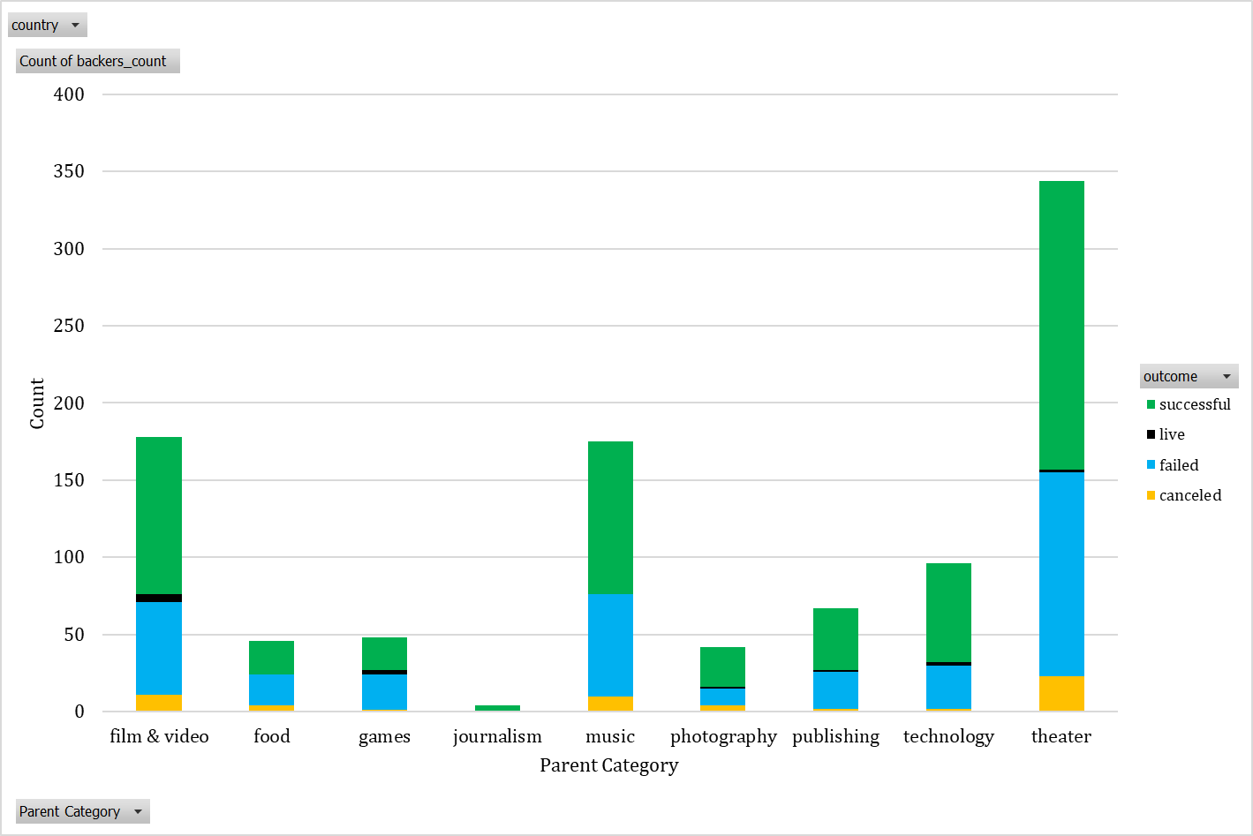

Second and third charts:

* Most backers contribute to plays, rock, and documentary sub-categories.
* Variation of outcome per month for ALL Country and Year is constant, and it is biased toward the US trend. For example, other countries such as Canada do not have a significant effect on the overall trend.

|  |  |
| --- | --- |
|  |  |
| Second | Third-All |
|  |  |
| Third-US | Third-CA |

Bonus 1:

According to the line chart shows, a high percentage of goals succeed. Also putting goal funding between 15000 to 35000 is a significant factor to reach the success point. In addition, selecting a goal of more than 40000 increases the probability of failing the project.

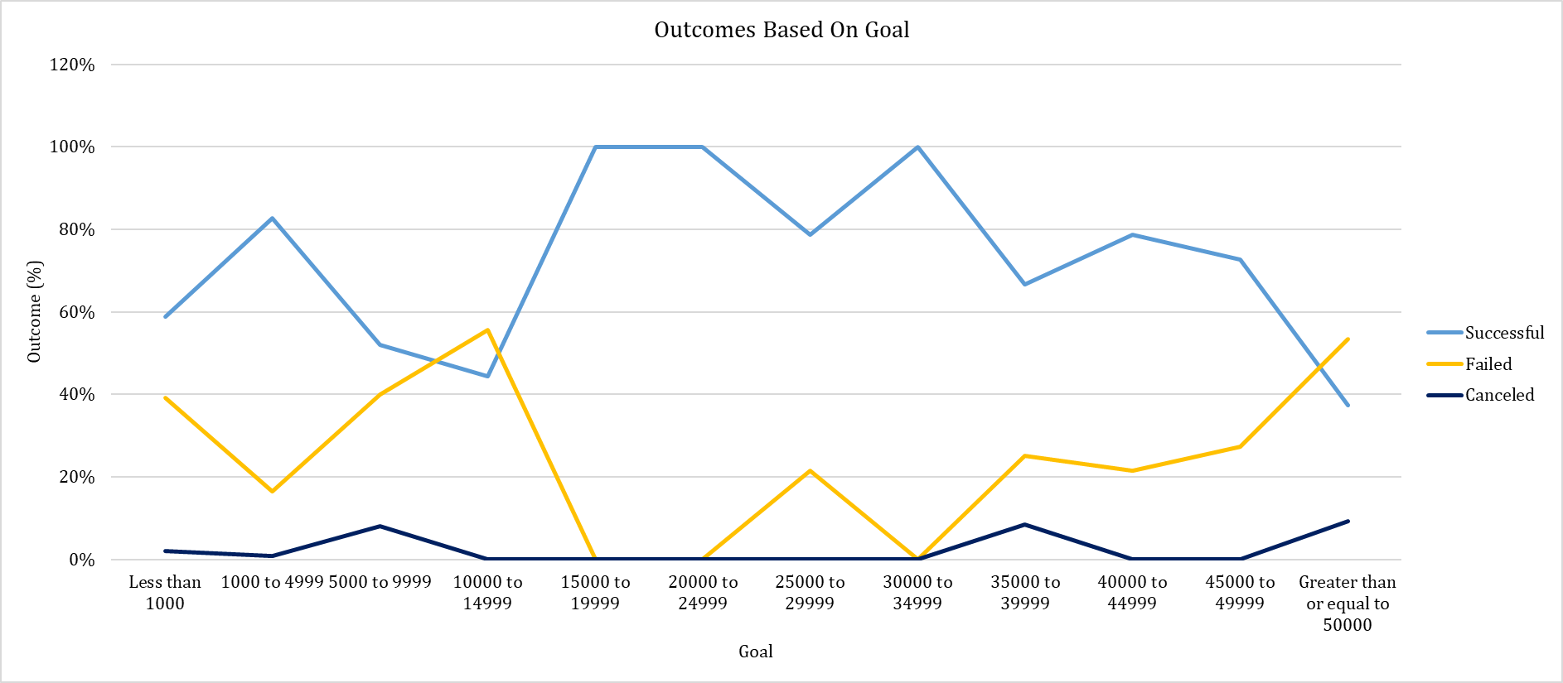

Bonus 2:

According to the Quartile chart and bar chart, there is no significant difference between the number of backers in failed and successful projects.

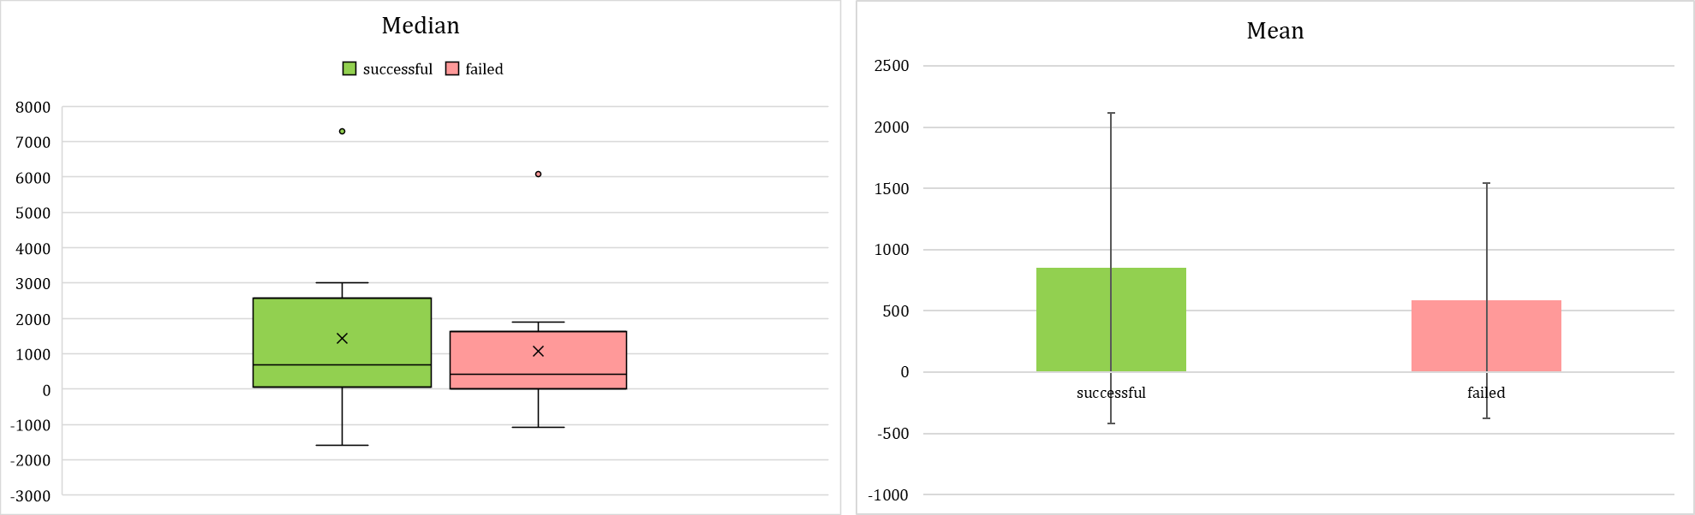

# **Limitations:**

It is not possible to fully discover the trick and generalize it because:

* According to the following chart, 76.3% of all data (77.1 canceled, 77.1 successful, 75.2 failed) comes from the US data! Therefore, any trend would be biased toward geographic locations.

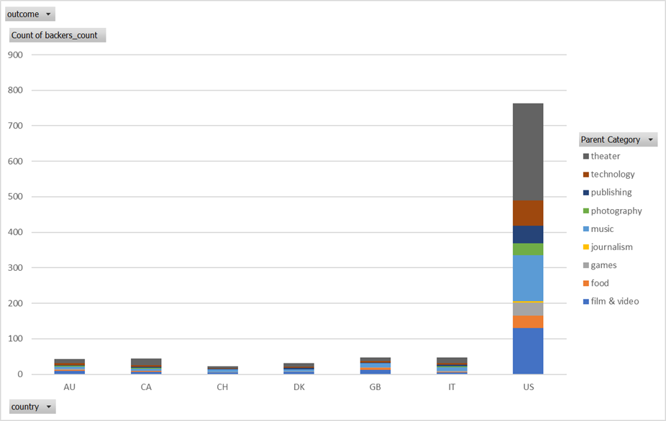

* In the below chart, there is no significant correlation between the percent funded and failed outcomes.

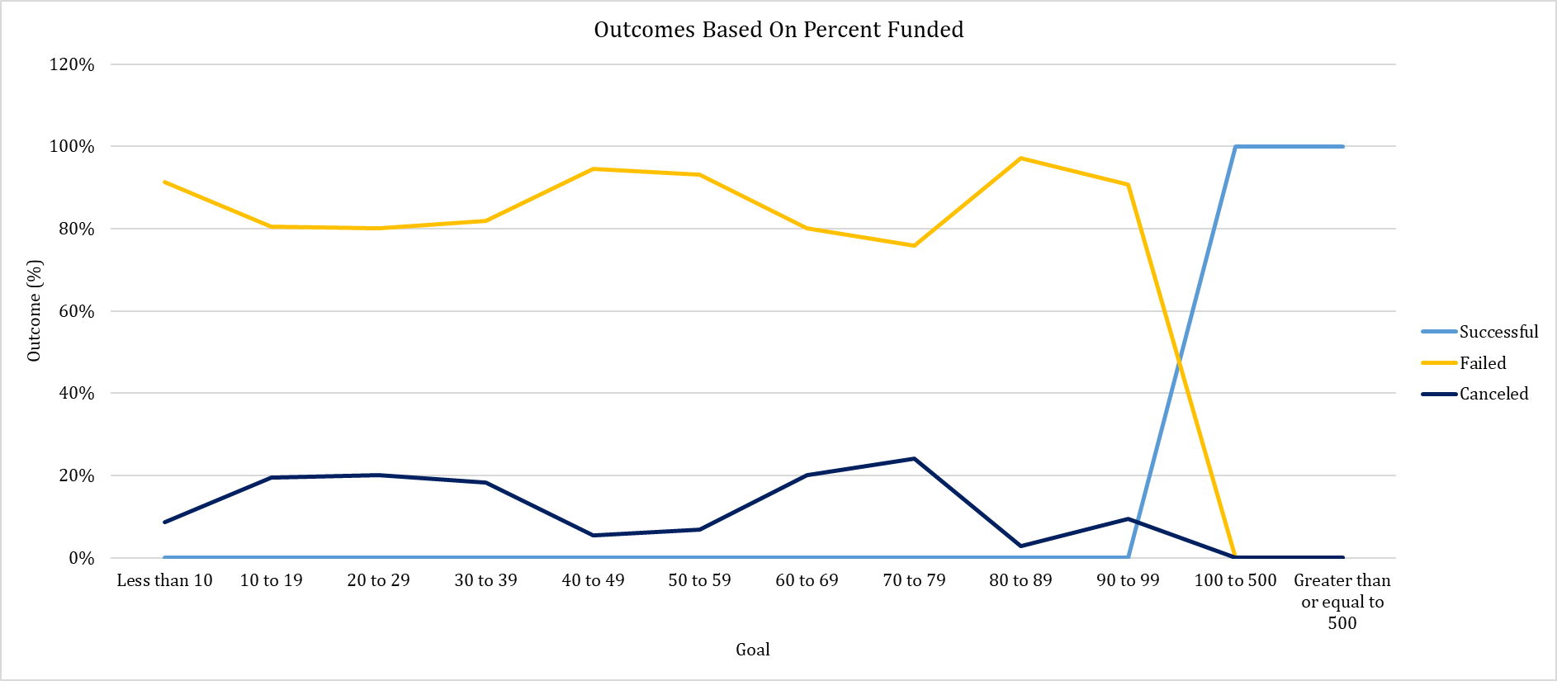

* Different currencies make a wrong assumption when aggregating goals at different geographic zones.
* More information is needed regarding cultural preference and campaign position on the website. For example, according to the below chart, many categories are missing from music genres and just popular American styles are published.

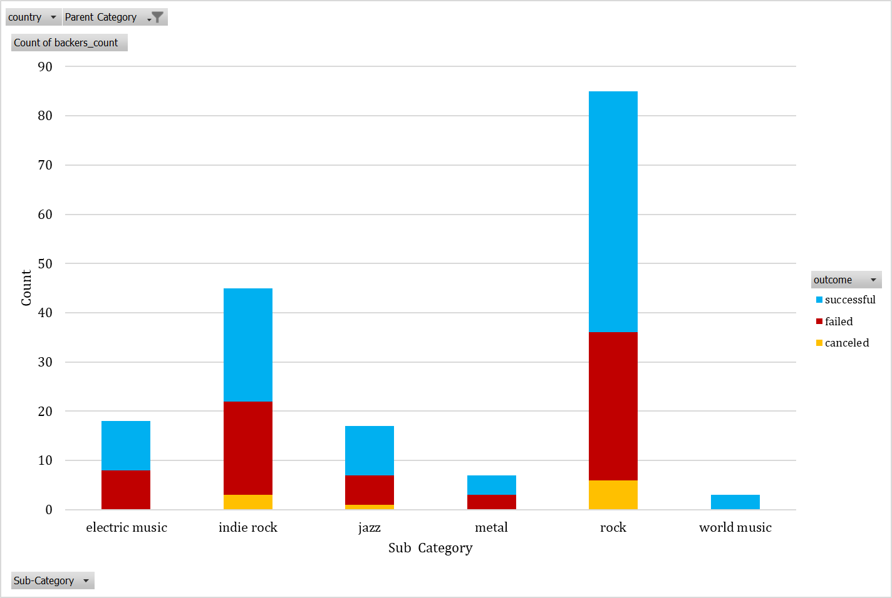

# **Suggestion:**

* Depending on different campaign durations, we can demonstrate category per time period pivot table and chart.
* According to the outcome and total amount of fundraising illustrated below, we can identify most of the unrealistically high goals are canceled before reaching the result (yellow dotted line).

